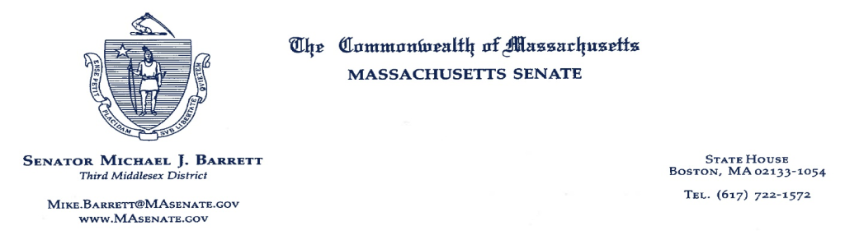

To all those interested:

An extraordinary commission has produced an extraordinary report.

Commission members have brought to the task their professional expertise but also their lived experience, a rare quality in bodies of this kind. As it happens, the majority of members are people with disabilities, and some have spent time living in institutions or under state guardianship. Together, they also have decades of experience in law, policy, education, and advocacy.

Given a big job, this Special Commission on State Institutions has begun its work on a strong note, re-opening a long-neglected inquiry into Massachusetts facilities for people with mental health issues or intellectual or developmental disabilities. These institutions held people of all ages who were not asked their consent even when they were capable of expressing it. To compound the moral failure, the Fernald School in Waltham served as the site of medical experiments on the effects of radiation on human beings, exercises viewed today as ghastly violations of human rights. Yet Fernald’s story, and others like it, remains unknown to the broader public.

Aided by the UMass Center for Developmental Disabilities Evaluation and Research, the Commission has put the finishing touches on its report. To its great credit, it details the troubling history of state institutions in Massachusetts. And it examines the barriers that persist today for members of the public -- including relatives and researchers -- who have tried and failed to access the records of people who lived and died there.

The Commission has assembled a list of recommendations based on its findings. Each recommendation touches on the same fundamental question: *What can Massachusetts do to uncover these people’s stories and share them with the world?*

A handful of recommendations address the issue of records access. Most of these records remain in the custody of the state but, due to privacy laws, remain largely inaccessible to the public. One potential solution: Each of us has filed a bill in our respective chambers to open these records to the public after a certain amount of time has passed.

Another issue involves the development of a “framework of remembrance” for those who lived in institutions. The relevant proposals are based in part on the Commission’s conversations with organizations that have undertaken similar projects, including the Belchertown State School Friends Association and the Danvers State Memorial Committee.

The Commission's cardinal recommendation is for the state to issue a formal apology. In order to move forward, we need to acknowledge our past.

Massachusetts prides itself on sharing its rich history with the world. As a matter of fact, we’re presently engaged in doing precisely that: The 250th Anniversary of the American Revolution is celebrated across the state this year. But not all of our stories are so uplifting. In the interests of paying a debt to history and learning from our mistakes, we should hesitate before picking and choosing only the nice ones to tell.

The past can be a guide, but only if we truly know it.

Sincerely,

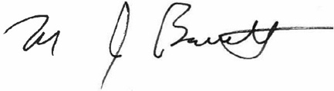 

State Sen. Mike Barrett State Rep. Sean Garballey