*Special Emphasis Report:*

2018-2022

**MASSACHUSETTS**

Unintentional Pedestrian

Injuries

**Pedestrians include people traveling by foot or using small personal conveyances, such as a scooter or skateboard. Injuries to pedestrians struck by a motor vehicle traveling on a public roadway are referred to as “motor vehicle-traffic (MVT) related.” “Other pedestrian” injuries include those in which a person is struck by a motor vehicle NOT traveling on a public roadway (“nontraffic-related”) or by non-motorized vehicles such as a bicycle, or by an animal. Data presented in this report includes both traffic and nontraffic-related pedestrian injuries.**

INJURIES

UNDERSTANDING PEDESTRIAN

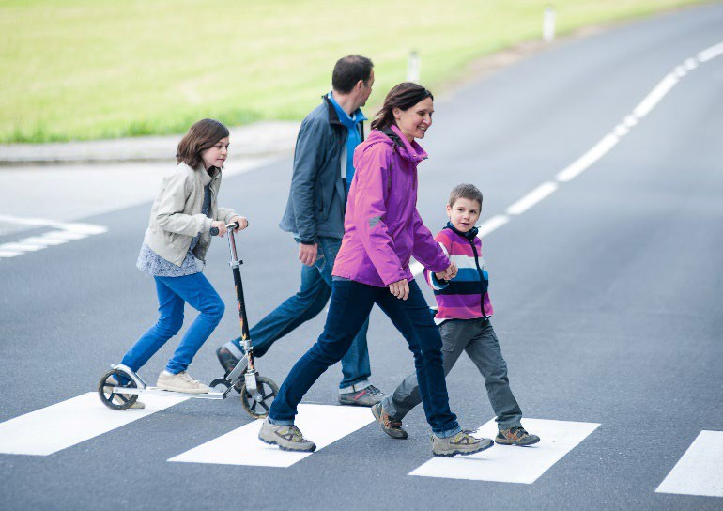

# Impact and Magnitude of Pedestrian Injuries

As shown in Figure 1, there were 119 pedestrian deaths (1.5 per 100,000 residents), 525 nonfatal injury-related hospital stays (6.9 per 100,000 residents), and 2,553 nonfatal injury-related emergency department (E.D.) visits (36.4 per 100,000 residents) for pedestrian injuries among Massachusetts residents in 2022*.

From 2018 through 2022, the number of pedestrian deaths among Massachusetts residents increased by 20% from 99 in 2018 to 119 in 2022 as shown in Figure 2. Pedestrian

injury-related hospital stays were highest in 2019 and lowest in 2021 amid the pandemic.

Total hospital charges for hospital stays and E.D. visits for nonfatal pedestrian injuries in 2022* were $70 million.

# Causes of Pedestrian Injuries

Motor vehicle traffic-related injuries were more common than other types of pedestrian injuries (nontraffic-related or not involving a motor vehicle) in Massachusetts, accounting for 88% of deaths, 80% of hospital stays, and 75% of E.D. visits for pedestrian injuries in 2022*. The majority of traffic-related and other pedestrian injuries involved being struck by a car, pick-up truck, or van (data not shown).

**Figure 1: Burden of Pedestrian Injury-Related Deaths, Hospital Stays, and Emergency Department Visits among Massachusetts Residents, 2022\***

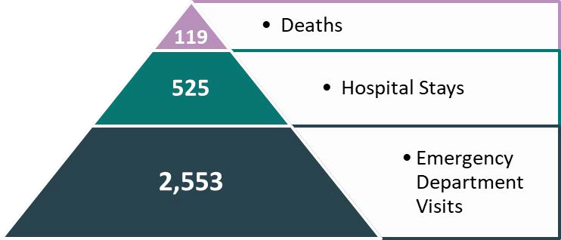

**Figure 2: Five-Year Trend of Pedestrian Injury-Related Deaths (N=487) and Hospital Stays (N=2,590) among Massachusetts Residents, 2018-2022\***

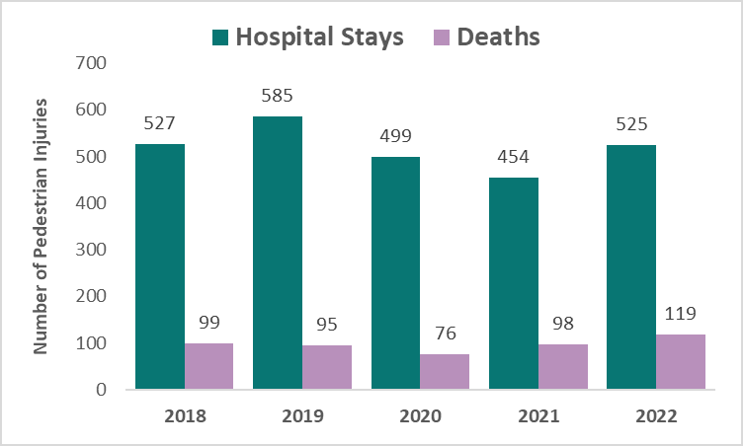

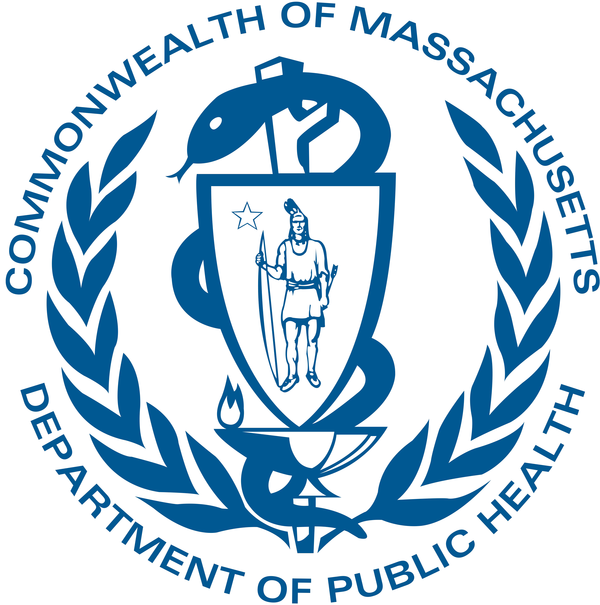

This template was produced by the CSTE Injury Surveillance Workgroup with support from CDC Cooperative Agreement Number NU38OT000297-04-00. Massachusetts analysis and content provided by the Injury Surveillance Program, DPH.

# Pedestrian Injuries by Age Group and Sex

In 2022*, males had higher rates than females of pedestrian injury-related deaths (2.0 and 1.0 per 100,000 residents,

respectively), nonfatal hospital stays (8.8 and 5.2 per 100,000 residents, respectively) and nonfatal E.D. visits (43.7 and 29.5 per 100,000 residents, respectively). The highest rate of E.D. visits was among age groups 25-44 and 45-64 years for both sexes, as shown in Figure 3. These age groups also had the highest rates of pedestrian injury deaths and hospital stays.

**Figure 3: Rate of Pedestrian Injury-Related Emergency Department Visits among Massachusetts Residents by Sex and Age Group, 2022*, N=2553**

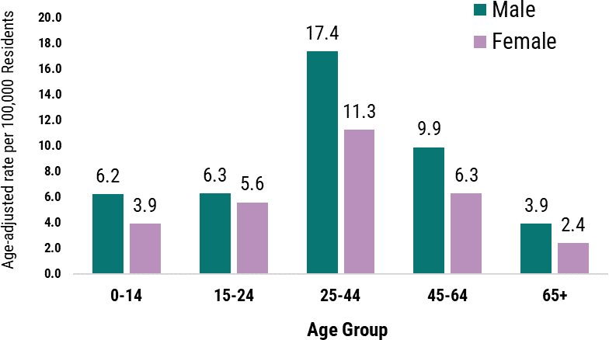

# Pedestrian Injuries by Race and Ethnicity

In 2022,* age-adjusted rates of pedestrian injury-related deaths were two times higher among Black, non-Hispanic/non-Latine/a/o (nH/nL) residents (3.0 per 100,000 residents) than the statewide rate (1.5 per 100,000 residents). Rates of nonfatal pedestrian injury-related hospital stays were nearly two times as high among Black, nH/nL and Hispanic/Latine/a/o residents (13.3 and 11.7 per 100,000 residents, respectively) than the statewide rate of 6.9 per 100,000 residents. As shown in Fig.4, E.D. visits for nonfatal pedestrian injuries were three times higher among Black, nH/nL residents and two times higher among Hispanic/Latine/a/o residents (114.3 and 66.9 per 100,000 residents, respectively) than the statewide rate of 36.4 per 100,000 residents. Research shows that poor road infrastructure (lack of crosswalks, crosswalk signals, streetlights), low investment in poorer neighborhoods for safe transportation options, faster roads and highways through communities of color, and policies such as redlining are factors that contribute to the racial and ethnic inequities among pedestrian deaths and injuries (endnotes 1-3).

**Figure 4: Age-Adjusted Rate of Pedestrian Injury-Related Emergency Department Visits among Massachusetts Residents by Race and Ethnicity, 2022*, N=2553**

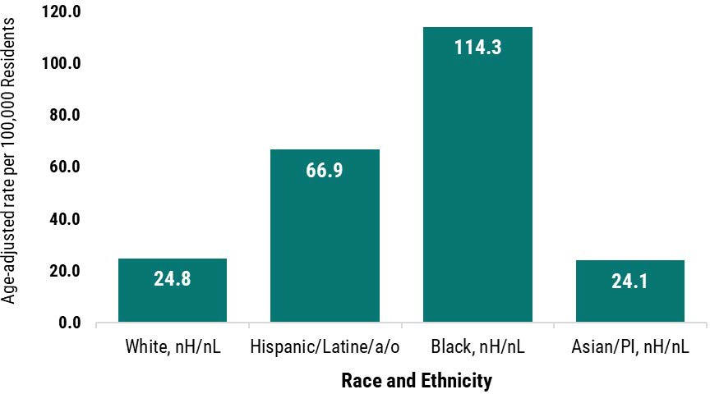

*Data Sources*

*-- Deaths: Massachusetts Registry of Vital Records and Statistics. Mass Department of Public Health.*

*-- Hospital Stays: Mass Inpatient Hospital Discharges and Mass Observation Stays Databases, Center for Health Information and Analysis (CHIA)*

*-- Emergency Department Visits: Mass Emergency Department Discharges Database, (CHIA).*

*\* Death data is for calendar year and nonfatal data from CHIA are submitted and presented by Federal Fiscal Year (e.g., Oct.1, 2021 - Sept. 30, 2022).*

*Throughout this report, nH/nL refers to Non-Hispanic/Non-Latine/a/o. Instructions and methodology for this report can be found on-line at* [*CSTE Injury Surveillance Methods Toolkit.*](https://www.cste.org/page/injury-surv-toolkit) (see Injury Reporting Frameworks)

# Pedestrian Injuries Prevention Resources

* **Centers for Disease Control and Prevention** [https://www.cdc.gov/transportationsafety/pedestrian_](https://www.cdc.gov/transportationsafety/pedestrian_safety/index.html) [safety/index.html](https://www.cdc.gov/transportationsafety/pedestrian_safety/index.html)

## National Highway Traffic Safety Administration

<https://www.nhtsa.gov/road-safety/pedestrian-safety>

## Federal Highway Administration

<https://safety.fhwa.dot.gov/ped_bike/>

* **Safe Routes to Schools** [https://www.fhwa.dot.gov/environment/safe_routes_t](https://www.fhwa.dot.gov/environment/safe_routes_to_school/) [o_school/](https://www.fhwa.dot.gov/environment/safe_routes_to_school/)
* **Vision Zero** [https://visionzeronetwork.org/about/what-is-vision-](https://visionzeronetwork.org/about/what-is-vision-zero/) [zero/](https://visionzeronetwork.org/about/what-is-vision-zero/)

Page 2

**Pedestrian Injury Prevention Activities in Massachusetts**

The Massachusetts Department of Public Health's (DPH) Injury Prevention and Control Program (IPCP) and Injury Surveillance Program (ISP) work to reduce unintentional injuries, including those involving pedestrians, in Massachusetts. IPCP and ISP center the reduction of racial inequities in all their work. IPCP and ISP’s work to reduce pedestrian injuries includes:

* Chairing the statewide Massachusetts Traffic Safety Coalition and the Massachusetts Prevent Injuries Now! Network. Coalition members include state and local agency representatives, transportation safety professionals, injury prevention advocates, healthcare providers, and others involved in pedestrian safety. These coalitions share information on community-based injury prevention activities, data trends, resources, and other information through meetings and monthly newsletters.
* Maintaining webpages to provide the public with statewide data on transportation-related injuries—including racial, geographic, and socioeconomic disparities—and prevention resources.
* Conducting ongoing surveillance of pedestrian injuries among Massachusetts residents using statewide databases to inform planning, prevention programming, policy development, and for evaluation. With support from the Massachusetts Department of Transportation (MassDOT), ISP has developed the Massachusetts Crash Reporting Injury Surveillance System, a newer, linked database that focuses exclusively on motor vehicle crashes, including those involving a pedestrian.

OTHER RESOURCES in Massachusetts and KEY COLLABORATORS on Pedestrian Safety:

* [WalkMassachusetts](https://walkmass.org/) is a statewide pedestrian advocacy group that works with state and local groups to make walking safer, easier, and more inclusive. Recently, WalkMassachusetts has trained residents in diverse communities to lead walk audits and collaborated with partners to improve walkability and social infrastructure in low-income communities.
* Mass in Motion is a statewide evidence-based initiative, supported by MDPH, CDC, and private funding, that works with communities to promote healthy eating and active living and address racial disparities in places where people live, work, play, and learn. Community-level projects have included improving walkable access to healthy foods in low-income neighborhoods and developing a complete streets design manual for use across four neighboring communities to facilitate pedestrian-friendly urban planning across the region.
* MassDOT is working to implement its [Pedestrian Plan,](https://www.mass.gov/info-details/pedestrian-plan) a roadmap to make walking a safe, comfortable, and convenient option for short trips for all people, while eliminating pedestrian deaths and serious injuries and increasing the percentage of short trips made by walking. Additionally, MassDOT manages [Safe Routes to School,](https://www.mass.gov/info-details/safe-routes-to-school-pedestrian-and-bike-safety-resources) the state chapter of a national initiative that provides transportation safety education for school-age children and funds pedestrian safety infrastructure projects near schools.
* In 2023, Massachusetts passed a vulnerable road user (VRU) law to better protect road users at greater risk of injuries in a collision, including pedestrians. The law requires motorists to pass vulnerable road users at a "safe passing distance" of at least four feet and requires more detailed reporting on crashes involving VRUs.

*Endnotes: 1).* [*https://www.law.cornell.edu/wex/redlining.*](http://www.law.cornell.edu/wex/redlining) *2). Taylor, N. L., et.al. (2023). Structural Racism and Pedestrian Safety: Measuring the Association Between Historical Redlining and Contemporary Pedestrian Fatalities Across the United States, 2010*‒*2019. AJPH, 113(4), 420–428. 3). Lin, P.-S., et.al. (2019). Development of countermeasures to effectively improve pedestrian safety in low-income areas. (English Edition), 6(2), 162–174.*

[Injury Surveillance Program](https://www.mass.gov/injury-surveillance-program) and [Injury Prevention and Control Program](https://www.mass.gov/orgs/injury-prevention-and-control-program) Massachusetts Department of Public Health

August 2025 3

Page