
Massachusetts State Public Health Laboratory (MA SPHL)
Dr. Alfred DeMaria Jr. Campus
305 South St, Jamaica Plain, MA 02130
617-983-6200

CLIA # 22D0650270

INSTRUCTIONS FOR SPECIMEN COLLECTION & SUBMISSION FOR RESPIRATORY VIRUS TESTING

Testing & Storage:
Refer to Manual of Laboratory Tests and Services: https://www.mass.gov/doc/massachusetts-state-public-health-laboratory-manual-of-laboratory-tests-and-services/download
Specimens should only be collected on patients who meet the following criteria: Acute onset of influenza-like illness within the previous 5 days with symptoms of fever >100°F (37.8°C), and a cough or sore throat. Fever does not have to be present at the time of specimen collection.
For atypical or suspect antiviral resistant influenza, contact the DPH Epidemiology Program at (617) 983-6800 prior to specimen submission for special instructions.
Prior to use, store Viral Transport Media (VTM) at 2-25°C; freeze gel packs that are provided in the insulated cooler.

Specimen Types:
- A single nasopharyngeal swab (NPS) is the preferred specimen for influenza. Note: Influenza negatives will be reflexed to the Respiratory Panel.
- A throat swab (TS) is acceptable only for influenza testing.
Specimen Collection Instructions (Pictorial Instructions on page 2):
- Assemble all supplies including the respiratory virus kit, gloves, patient label, etc.
- Collect specimen:
  - NPS: Tilt the patient’s head back slightly and gently insert the sterile NPS into the nasal passage until a slight resistance is met. Rotate the swab 2-3 times and hold in place for 5 seconds to ensure maximum absorbency.
  - TS: Swab the posterior pharynx and tonsillar areas, avoiding the tongue (tongue depressor may be helpful). The mucosa behind the uvula and between the tonsils should also be swabbed with a back-and-forth motion.
- Insert the swab into the VTM, snapping the excess shaft at the break point to fit inside the tube. Firmly screw cap back on the tube and ensure it’s secure.
- Label the specimen with two patient identifiers (i.e. patient’s name, date of birth, medical record number), source, and date of collection. Confirm this information matches the submission form. UNLABELED SPECIMENS WILL BE REJECTED.
- After specimen collection and prior to shipment, refrigerate at 2-8°C or freeze at <-20°C (note on submission form).
- Specimen Submission Form: Complete all required fields on Respiratory Specimen Submission Form, sections 1-11. Use one form for each specimen.
- Place the specimen in the sealable specimen bag and the submission form in the outer sleeve of the bag.
- Place the specimen bag(s) into the insulated cooler between four frozen gel packs. Container fits up to 5 specimen bags.
- Close the insulated cooler and seal the cardboard box.
- Ensure the return address is written on the box and add the shipping label and postage to the outside of the box.
Shipping Instructions (Pictorial Instructions on page 2):
Ship up to five specimens in individual specimen bags sandwiched between four FROZEN 8 oz gel packs in the insulated cooler. Refrigerated specimens MUST be received the same day. NOTE: Specimens collected greater than 5 days from symptom onset are unsuitable for testing. If shipped to MA SPHL greater than or equal to 3 days from collection or on a Friday, specimen(s) must be frozen below -20°C and shipped frozen with dry ice the following week. Specimen temperature upon receipt is critical for testing acceptance. Specimens should be sent to MA SPHL via the testing facility's courier or UPS CampusShip (ILINet sites). If neither option is feasible, contact the DPH Epidemiology Program (617) 983-6800 for courier arrangements.
Mail or deliver to:
MA State Public Health Laboratory
Specimen Triage Accessioning & Receipt (STAR) Lab
305 South Street, Rm 1060
Jamaica Plain, MA 02130

Results Reporting: Test reports can be retrieved via ELR upon test completion.
Questions:
For testing related inquiries, call DPH Epidemiology Program at (617) 983-6800
For kit supplies, email MASPHL.SpecimenKitOrders@mass.gov or call (617) 983-6640 to leave a voicemail
For ELR Access & Reporting, email ELR.Support@mass.gov or call (617) 983-6907

Instructions for RESPIRATORY Specimen Collection, Packaging and ShippinG
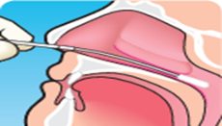
STEP 1:
NASOPHARYNGEAL SWAB COLLECTION
Tilt the patient’s head back slightly and gently insert the NPS into the nasal passage until a slight resistance is met. Rotate the swab 2-3 times and hold in place for 5 seconds to ensure maximum absorbency.

OR
THROAT SWAB COLLECTION
With a throat swab, swab the posterior pharynx and tonsillar areas, avoiding the tongue (tongue depressor may be helpful). The mucosa behind the uvula and between the tonsils should also be swabbed with a back-and-forth motion.
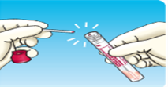
STEP 2:
Insert the swab into the VTM, snapping the excess shaft at the break point to fit inside the tube. Firmly screw the cap back on and ensure it is secure.


STEP 3:
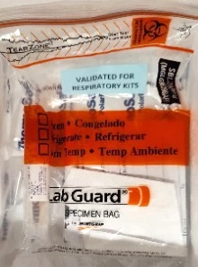
Label the specimen with two patient identifiers (i.e. patient’s name, Date of Birth, Medical Record Number), source and date of collection. Confirm this information matches the submission form. UNLABELED SPECIMENS WILL BE REJECTED.

STEP 4:
Place the specimen in the sealable specimen bag and the submission form in the outer sleeve of the bag.
After collection and prior to shipment, keep specimen refrigerated at 2-8°C or frozen below -20°C (If frozen, check box on the submission form).

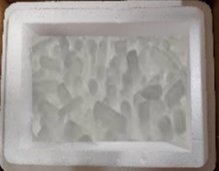
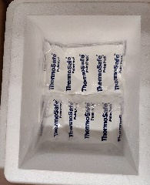
Refrigerated (SAME DAY) OR FROZEN SPECIMEN (OVERNIGHT) shipping
STEP 1:
Use an insulated cooler to send specimens.
Place two ice packs OR dry ice on the bottom of the cooler.

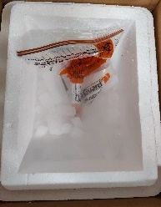
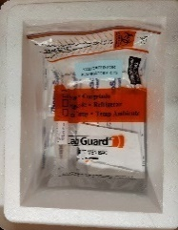
STEP 2:
Place the specimen(s) on top of the ice packs/ dry ice.
Note: Ship up to five specimens in the same cooler.

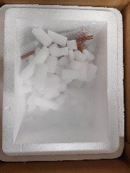
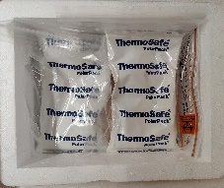
STEP 3:
Sandwich the specimens(s) by putting two ice packs/ dry ice on top.

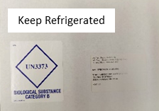
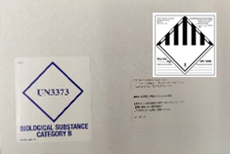
STEP 4:
Affix UN3373 Category B label to the box. Ensure return address, shipping label, and postage (if applicable) are present.
For refrigerated specimens: Affix a Keep Refrigerated label.
For frozen specimens: Affix a Class 9 dry ice label.

If you return a cooler and need a replacement, email the Kit Room to request one: masphl.specimenkitorders@mass.gov

