The Commonwealth of Massachusetts

Executive Office of Health and Human Services

Department of Public Health

Bureau of Infectious Disease and Laboratory Sciences

305 South Street, Jamaica Plain, MA 02130



KATHLEEN E. WALSH

Secretary

ROBERT GOLDSTEIN, MD, PhD Commissioner

**Tel: 617-624-6000**

**www.mass.gov/dph**

MAURA T. HEALEY

Governor

KIMBERLEY DRISCOLL

Lieutenant Governor

FROM: Nicolas Epie, Ph.D., HCLD, TS(ABB); MLS(ASCP)

Director, MA State Public Health Laboratory

Date: July 9, 2024

Attention all MA SPHL Couriers and Customers:

The STAR lab (Specimen Triage Accessioning & Receipt) lab will be moving to its new location on **July 17th, 2024**. The new location is at the back of the MA SPHL tower building on the first floor directly above the loading dock.

**We will no longer accept specimens in the old location starting on July 17th.**

**NOTE:** Parking spaces will be available in the new location. Follow the short path to the STAR lab drop off location and Specimen Collection Kit Pickup.

Below is an aerial view of the new location:

STAR lab is highlighted with a green arrow and the parking spaces are highlighted in blue.

The yellow arrow shows the walking path to STAR lab.

The new driving path is outlined in red – starting from the old Specimen Receiving location

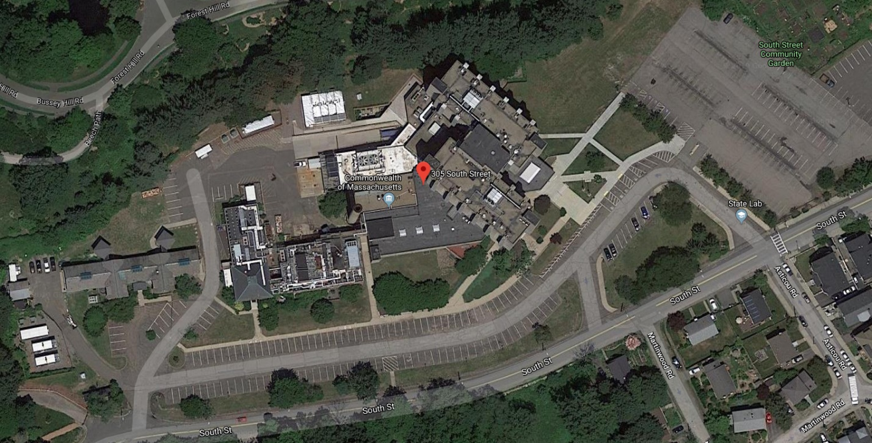

**Old Specimen Receiving Lab**

**New STAR Lab: Specimen dropoff and Kit Pickup**

**Parking for Specimen Dropoff**

**Walking path to STAR lab**

If you have any questions or comments, please email [MASPHL.Laboratory@mass.gov](mailto:MASPHL.Laboratory@mass.gov)

or reach out to Director of Central Lab Support: Cynthia Condon ph: 617-983-6675 email: [cynthia.condon@mass.gov](mailto:cynthia.condon@mass.gov)