INDOOR AIR QUALITY ASSESSMENT

Spencer Town Hall
157 Main Street
Spencer, Massachusetts



Prepared by:
Massachusetts Department of Public Health
Center for Environmental Health
Emergency Response/Indoor Air Quality Program
March 2007

Background/Introduction
At the request of Lee Jarvis, Spencer Board of Health Agent, the Massachusetts Department of Public Health (MDPH), Center for Environmental Health (CEH) provided assistance and consultation regarding indoor air quality concerns at Spencer Town Hall (the town hall), 157 Main Street, Spencer, Massachusetts. On December 27, 2006, a visit was made to this building by Michael Feeney, Director of CEH’s Emergency Response/Indoor Air Quality (ER/IAQ) Program to conduct an indoor air quality assessment. Concerns about poor air exchange and water damage prompted the assessment.
The town hall is a two-story red brick building constructed in 1927 (see cover Picture). The first and second floors contain town offices. The basement is made up of town offices, a meeting room, utility closet and boiler room. Windows are openable and consist of single paned glass in wooden window frames.

Methods
Air tests for carbon dioxide, temperature and relative humidity were taken with the TSI, Q-Trak, IAQ Monitor. CEH staff also performed visual inspection of building materials for water damage and/or microbial growth.

Results
These offices have an employee population of approximately 20. The tests were taken under normal operating conditions. Test results appear in Table 1.

Discussion
Ventilation
It can be seen from Table 1 that carbon dioxide levels were below 800 parts per million (ppm) in all areas sampled, which indicates adequate air exchange. It is important to note that no general mechanical ventilation systems exist on the first and second floors. Basement offices however, were retrofitted with a mechanical ventilation system. Air is distributed to offices by an air handling unit (AHU) ducted to ceiling or wall-mounted fresh air diffusers. The system was not functioning during the assessment. Examination of the interior of the AHU found the fan motor deactivated and the fan belt disconnected from its flywheels (Picture 1). In this condition, no fresh air is supplied to basement offices.
No identifiable mechanical exhaust system could be identified in the basement. A large grill that may have once served as a gravity exhaust air shaft was observed in a basement conference room (Picture 2), but the vent is separated from all other basement areas and cannot provide exhaust ventilation. Without adequate supply and/or exhaust ventilation, normally occurring pollutants or odors can build-up and lead to indoor air quality/comfort complaints.
During summer months, ventilation in the town hall is controlled by the use of openable windows. The town hall was configured in a manner to use cross-ventilation to provide comfort for building occupants. The building is equipped with windows on opposing exterior walls. In addition, the building has hinged windows located above the hallway doors. This hinged window (called a transom) enables the occupants to close the hallway door while maintaining a pathway for airflow (Picture 3). This design allows for airflow to enter an open window (windward side), pass through a room, pass through the open transom, enter the hallway, pass through the opposing open room transom, into the opposing room and exit the building on the leeward side (opposite the windward side) (Figure 1). With all windows and transoms open, airflow can be maintained in a building regardless of the direction of the wind. This system fails if the windows or transoms are closed (Figure 2).
In order to have proper ventilation with a mechanical supply and exhaust system, the systems must be balanced to provide an adequate amount of fresh air to the interior of a room while removing stale air. It is recommended that HVAC systems be rebalanced every five years (SMACNA, 1994). The mechanical ventilation system in its current state cannot be balanced.
The Massachusetts Building Code requires a minimum ventilation rate of 15 cubic feet per minute (cfm) per occupant of fresh outside air or have openable windows in each room (SBBRS, 1997; BOCA, 1993). The ventilation must be on at all times that the room is occupied. Providing adequate fresh air ventilation with open windows and maintaining the temperature in the comfort range during the cold weather season is impractical. Mechanical ventilation is usually required to provide adequate fresh air ventilation.
Carbon dioxide is not a problem in and of itself. It is used as an indicator of the adequacy of the fresh air ventilation. As carbon dioxide levels rise, it indicates that the ventilating system is malfunctioning or the design occupancy of the room is being exceeded. When this happens, a buildup of common indoor air pollutants can occur, leading to discomfort or health complaints. The Occupational Safety and Health Administration (OSHA) standard for carbon dioxide is 5,000 parts per million parts of air (ppm). Workers may be exposed to this level for 40 hours/week, based on a time-weighted average (OSHA, 1997).
The MDPH uses a guideline of 800 ppm for publicly occupied buildings. A guideline of 600 ppm or less is preferred in schools due to the fact that the majority of occupants are young and considered to be a more sensitive population in the evaluation of environmental health status. Inadequate ventilation and/or elevated temperatures are major causes of complaints such as respiratory, eye, nose and throat irritation, lethargy and headaches. For more information concerning carbon dioxide, consult Appendix A.
Temperature measurements ranged from 64º F to 75º F, which were below the MDPH recommended comfort guidelines in several areas on the day of the assessment. The MDPH recommends that indoor air temperatures be maintained in a range of 70 º F to 78 º F in order to provide for the comfort of building occupants. It is important to note that the 1st floor woman’s restroom, which is located on an exterior wall, does not appear to have a radiator or other mechanical heat source. In many cases concerning indoor air quality, fluctuations of temperature in occupied spaces are typically experienced, even in a building with an adequate fresh air supply.
The relative humidity ranged from 32 to 36 percent, which was below the MDPH recommended comfort range in all areas surveyed during the assessment. The MDPH recommends that indoor air relative humidity is comfortable in a range of 40 to 60 percent. During the heating season, relative humidity levels would be expected to drop below the recommended comfort range. The sensation of dryness and irritation is common in a low relative humidity environment. For buildings in New England, periods of low relative humidity during the winter are often unavoidable.

Microbial/Moisture Concerns
A number of conditions were identified around the exterior of the building that tend to make the building susceptible to water penetration. Offices on the first floor had water damaged ceiling tiles below areas that directly correspond to accumulated debris on the roof. Accumulated debris can hold water against the roof. Over time, repeated freezing and thawing can damage rubber membrane roofing materials and lead to water penetration.
Water damaged carpeting, walls and ceiling tiles was observed in several offices along the western side of the building. The damage is likely related to the deterioration of mortar between brick (Picture 4) as well as dissimilar building materials that make up the exterior walls of the town hall. The wall outside of offices with water damaged carpeting (Picture 5) and ceiling tiles (Picture 6) consists of brick, cement, wood framed windows and wrought iron bars (Pictures 7 and 8). The seams between each of these dissimilar materials have likely failed, resulting in water penetration. The eastern wall of the building was examined, which showed deterioration of the window frames, open seams between the cement, window frames and brick, as well as plants growing from a seam in the window casement (Picture 9). Similar types of breaches would be expected in window seams of the western wall (which could not be examined due to their height). Therefore, when the western wall was subjected to wind-driven rain, water likely entered the interior through these breaches, resulting in the repeated wetting of carpets in ground floor offices, particularly in areas beneath the wrought iron bars on the exterior wall.
The US Environmental Protection Agency (US EPA) and the American Conference of Governmental Industrial Hygienists (ACGIH) recommends that porous materials be dried with fans and heating within 24 to 48 hours of becoming wet (US EPA, 2001; ACGIH, 1989). If carpeting is not dried within this time frame, mold growth may occur. Since carpeting is porous surfaces; disinfection is likely to be ineffective. Removal of these materials is recommended to prevent exposure of building occupants to mold and other associated pollutants.
Water coolers were located over carpeting in some areas. Water spillage or overflow of cooler catch basins can result in the wetting of the carpet. In addition, some of the coolers had residue/build-up in the reservoir. These reservoirs are designed to catch excess water during operation and should be emptied/cleaned regularly to prevent microbial and/or bacterial growth.

Other IAQ Evaluations
Boiler room odors were detected in the board of health/inspectional services area. The door to the boiler room is located in this area (Picture 10). The fire door to the boiler room was reportedly in disrepair and propped was also open at the time of the assessment (Picture 11). If boiler room doors are left open, the combination of heat/oil vapor can migrate into occupied areas (i.e. the board of health/inspectional services area). Both doors should be kept closed, since oil vapors and particulates related to combustion can be irritating to the eyes, nose and throat.

Conclusions/Recommendations
The conditions noted at the Spencer Town Hall raise a number of indoor air quality issues. The lack of mechanical ventilation on the first and second floors and the design/limitations of the basement mechanical ventilation system and its components can limit air exchange in the building. Lack of environmental pollutant dilution and/or removal by the ventilation system can result in the build up and concentration of such pollutants in occupied areas. General building conditions, design and the operation (or lack) of HVAC equipment, if considered individually, present conditions that could degrade indoor air quality. When combined, these conditions can serve to further negatively affect indoor air quality. Some of these conditions can be remedied by actions of building occupants. Other remediation efforts will require alteration to the building structure and equipment. For these reasons a two-phase approach is suggested. This approach consists of short-term measures to improve air quality and long-term measures that will require planning and resources to adequately address overall indoor air quality concerns.
The following short-term measures should be considered:
- Remove water-damaged materials (e.g., carpeting and ceiling tiles) in a manner consistent with recommendations found in “Mold Remediation in Schools and Commercial Buildings” published by the US Environmental Protection Agency (US EPA, 2001). Consider replacing carpeting with a non-slip, nonporous material (e.g., rubber matting, tile).
- Repair the fan belt for the ventilation system. Once repaired, ensure the HVAC system operates appropriately.
- Change filters in the HVAC system at least twice a year. Ensure that room exists above the ceiling system so that air filters may be slid into place without bending or folding the cardboard frames.
- Remove plants and debris from exterior wall seams. Consult with a building engineer of the best solution to temporality seal leaking seams along the western wall of the building beneath the wrought iron bars until a comprehensive repair solution for the exterior wall system is formulated and implemented.
- Remove debris from the flat roofs. Repair the roof membrane as needed.
- Repair the boiler room door and keep closed. Install weather-stripping and a door sweep of the door in the board of health/inspectional services areas. Keep these doors closed during business hours.
- For buildings in New England, periods of low relative humidity during the winter are often unavoidable. Therefore, scrupulous cleaning practices should be adopted to minimize common indoor air contaminants whose irritant effects can be enhanced when the relative humidity is low. To control for dusts, a HEPA filter equipped vacuum cleaner in conjunction with wet wiping of all surfaces is recommended. Drinking water during the day can help ease some symptoms associated with a dry environment (throat and sinus irritations).
- Use windows and transoms to enhance airflow during warm weather if window-mounted air conditioners are not used. Be sure to close at the end of business hours. To aid in the draw of fresh outdoor air in warm weather, use portable fans directing air out windows on the leeward side (opposite the windward side) of the building. Fans positioned in this manner will serve to increase the draw of outdoor air across the first and second floors without interfering with the natural internal airflow pattern of the building.
- Place rubber/plastic matting beneath water coolers to prevent water damage to carpeting. Clean and disinfect reservoir periodically to prevent mold/bacterial growth.
- Refer to resource manuals and other related indoor air quality documents for further building-wide evaluations and advice on maintaining public buildings. Copies of these materials are located on the MDPH’s website: http://mass.gov/dph/indoor_air

Long Term Recommendations
- Consult with a building engineer concerning repointing of the exterior brickwork of the building.
- Consult with a building engineer to provide appropriate exhaust for the basement office HVAC system.
- Examine the feasibility of providing a mechanical heat source to the women’s restroom.

References
ACGIH. 1989. Guidelines for the Assessment of Bioaerosols in the Indoor Environment. American Conference of Governmental Industrial Hygienists, Cincinnati, OH.
BOCA. 1993. The BOCA National Mechanical Code-1993. 8th ed. Building Officials & Code Administrators International, Inc., Country Club Hills, IL. M-308.1

OSHA. 1997. Limits for Air Contaminants. Occupational Safety and Health Administration. Code of Federal Regulations. 29 C.F.R. 1910.1000 Table Z-1-A.

SBBRS. 1997. Mechanical Ventilation. State Board of Building Regulations and Standards. Code of Massachusetts Regulations. 780 CMR 1209.0

SMACNA. 1994. HVAC Systems Commissioning Manual. 1st ed. Sheet Metal and Air Conditioning Contractors’ National Association, Inc., Chantilly, VA.

US EPA. 2001. Mold Remediation in Schools and Commercial Buildings. US Environmental Protection Agency, Office of Air and Radiation, Indoor Environments Division, Washington, D.C. EPA 402-K-01-001. March 2001.
http://www.epa.gov/iaq/molds/mold_remediation.html

Picture 1

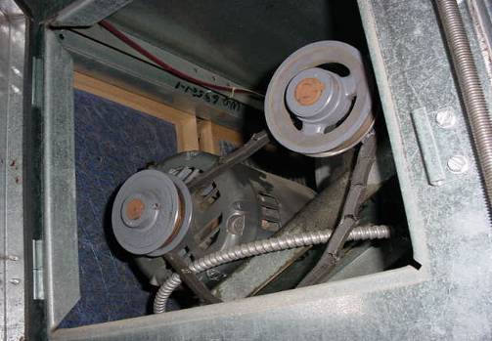

Fan Motor Deactivated and the Fan Belt Disconnected From its Flywheels

Picture 2

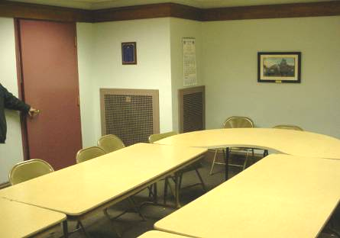

Possible Gravity Exhaust Air Shaft in Basement Conference Room
Picture 3

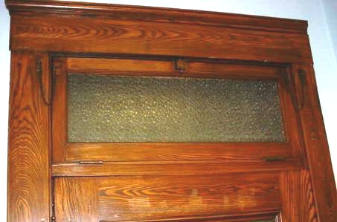

Transom

Picture 4

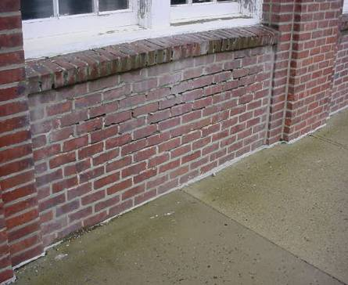

Missing/Damaged Mortar around Brick beneath Auditorium Window
Picture 5

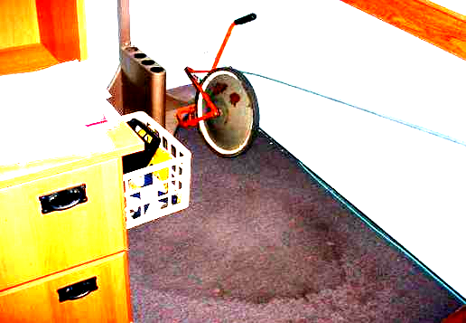

Water Damaged Carpet

Picture 6

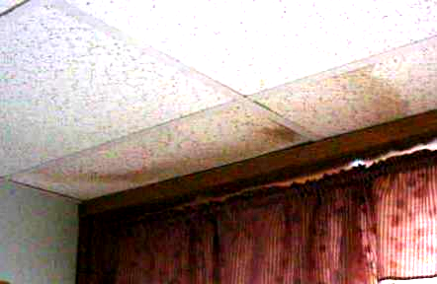

Water Damaged Ceiling Tiles

Picture 7

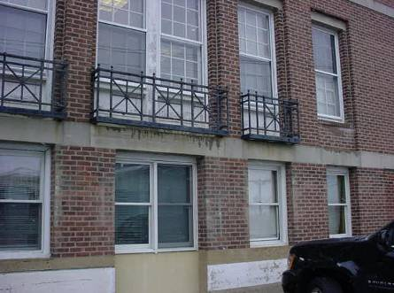

Exterior of the STH (Note Wooden Window Frames, Cement Window Casement with a Flat Sill, Wrought Wire Bars and Wall Brick)

Picture 8

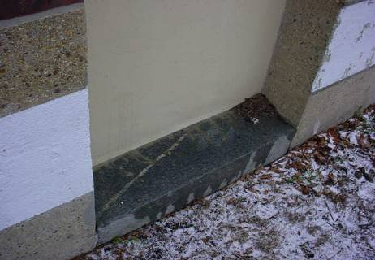

Close-Up of Flat Window Casement Sill
(Note Moistening of Surface and Debris Accumulation)
Picture 9

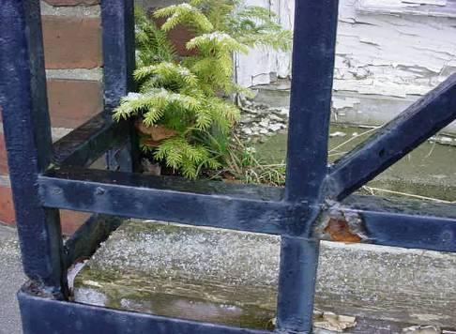

The STH Eastern Wall, Plant Growing from Seam in the Window Casement

Picture 10

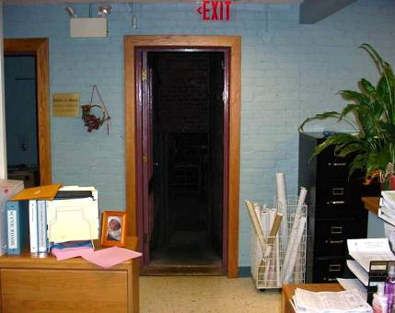

Door to Boiler Room from the Board of Health/Inspectional Services Area
Picture 11

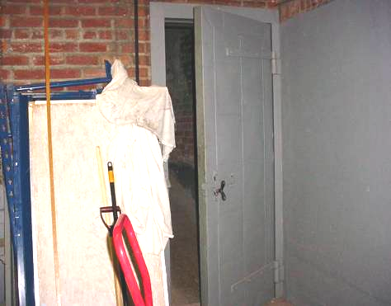

Boiler Room Door Propped Open
Location | Carbon  Dioxide  (*ppm) | Temp  (°F) | Relative  Humidity  (%) | Occupants  in Room | Windows  Openable | Ventilation |  | Remarks
 |  |  |  |  |  | Supply | Exhaust | Remarks
Outside  (Background) | 345 | 34 | 45
Inspectional Services | 560 | 73 | 35 | 2 | Y | Y | N | 10 water damaged ceiling tiles
Town planner | 580 | 69 | 34 | 0 | Y | N | N | Plants
Building inspector | 617 | 70 | 33 | 0 | N | N | N | 2 water damaged ceiling tiles
Board of health | 622 | 70 | 33 | 1 | Y | N | N
Balcony-auditorium | 611 | 66 | 35 | 0 | Y | Y | Y | Water damaged plaster
Photo | 441 | 66 | 34 | 0 | N | Y | Y | Transom closed
Town clerk | 585 | 71 | 35 | 2 | Y | N | N | Transom closed
Town selectmen office | 736 | 73 | 36 | 1 | Y | N | N | Transom closed
Town selectmen private office | 588 | 75 | 35 | 0 | Y | N | N | Transom closed  4 water damaged ceiling tiles
Auditorium | 414 | 65 | 35 | 0 | Y | N | N | 3 water damaged ceiling tiles
Veteran’s office | 391 | 62 | 34 | 0 | Y | N | N | 3 water damaged ceiling tiles
Mainframe room | 378 | 67 | 36 | 0 | Y | N | N | Hallway outside this area 8 water damaged ceiling tiles
Tax collector | 674 | 69 | 36 | 2 | Y | N | N | Water cooler on carpet  Humidifier
1st floor women’s restroom | 432 | 63 | 33 | 0 | N | N | N
Rotunda | 479 | 64 | 35 | 0 | N | N | N
Accounting | 383 | 64 | 33 | 0 |  |  |  | Water cooler on carpet
Assessor | 563 | 65 | 36 | 0 | Y | N | N | Water damaged carpet  2 water damaged ceiling tiles
Assessor, main office | 462 | 68 | 32 | 0 | Y | N | N | Water damaged carpet  1 missing ceiling tile
Large meeting room | 437 | 65 | 32 | 0 | N | Y | Y
Conference room A | 492 | 65 | 34 | 0 | N | Y | N | Dry erase board
Recreation and Culture | 495 | 66 | 34 | 0 | N | Y | N | 4 water damaged ceiling tiles
Human resources | 458 | 66 | 34 | 0 | N | Y | N
Conference room B | 458 | 66 | 33 | 0 | N | Y | N

