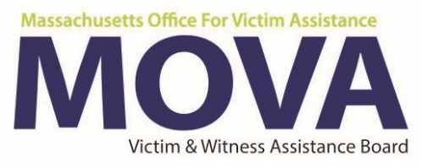

FY19 Spending Report
Due Date: June 14, 2019
This form must be completed by all programs.
MOVA reserves the right to adjust your approved FY19/FY20 budget.

Agency Information
Agency Name | Agency Name
Program Name | Program Name
Is the program is 100% operational? (i.e. has no vacant positions to fill.) |  |  | Yes as of: Date | No

FY19 Spending Report
- Indicate the number of vacant positions, job title, and length of time each position was vacant.
Response | Type here
- If applicable, describe steps taken to fill vacant positions, past or current during FY19.
Response | Type here
- If unspent funding is not due to a vacancy, describe which budget category and/or item went unspent and why.

Response | Type here
- Is the program requesting to re-allocate funding from FY19 to FY20?
Yes No
If yes, include justification. Note: MOVA will not allow a decrease in FTEs in FY20 or new positions.
Response | Type here

