 | Massachusetts Department of Environmental Protection  Environmental Results Program  Spill or Release Report Summary |  | Facility Name  Facility ID#  Town
 | Instructions
Complete one report for each spill or discharge. If you had more than two such events attach additional copies of this form.

Note: only report those spills or releases that were required to be reported to DEP at the time of the event.

Please see the workbook for more information on the types of spills or releases that must be reported.
Important: When filling out forms on the computer, use only the tab key to move your cursor - do not use the return key.
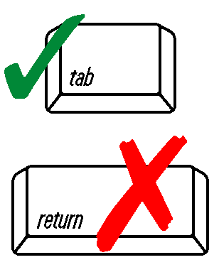
DEP USE ONLY

Date Received

 | Reportable Spill or Release #1
 | 1. Name of pollutant released or chemical spilled:
 | Pollutant or Chemical
 | Date of Spill Release (MM/DD/YYYY)
 | Date of Report to DEP (MM/DD/YYYY)
 | Reportable Spill or Release #2
 | 2. Name of pollutant released or chemical spilled:
 | Pollutant or Chemical
 | Date of Spill Release (MM/DD/YYYY)
 | Date of Report to DEP (MM/DD/YYYY)

