Massachusetts Department of Public Health

Spinal Cord Injuries in Massachusetts and the Thomas P. Kennedy Spinal Cord Injury Trust Fund
Spinal Cord Injury Awareness Day | September 17, 2025


Kelley Cunningham
Director, Division of Violence and Injury Prevention Bureau of Community Health and Prevention
Jeanne Hathaway Epidemiologist, Injury Surveillance Program, Bureau of Community Health and Prevention

Hospital Stays¹ for Nonfatal Spinal Cord Injuries

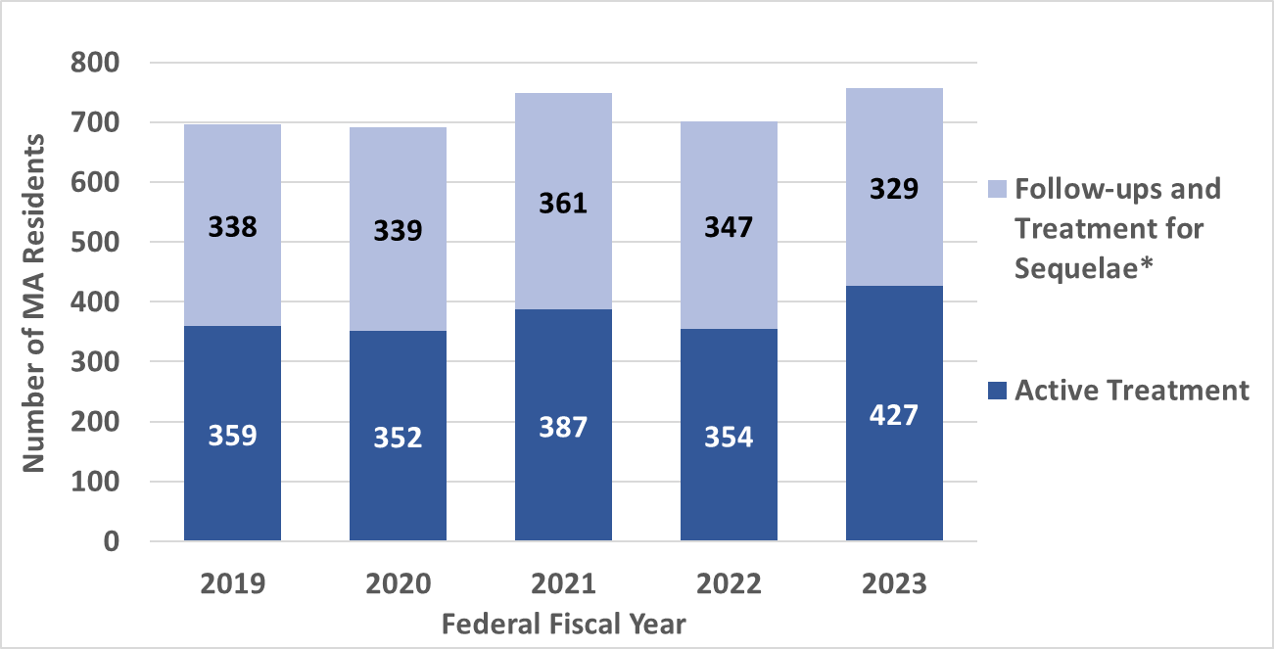
By Treatment Type, Individual-level Counts, MA Residents, FFY2019-FFY2023²
697
691
701
756
748

- Hospital Stays include hospital discharges and observation stays at all MA acute care hospitals.
- FFY = Federal fiscal year (Oct. 1 – Sep. 30).
* Follow-up treatment and treatment for sequela were combined due to relatively low counts for follow-up treatments
Data Sources: Inpatient Hospital Discharge and Outpatient Observation Stay data, MA Center for Health Information and Analysis. Data are collected and reported by FFY.
Analysis : MA Department of Public Health Injury Surveillance Program.

Emergency Department (ED) Visits for Nonfatal Spinal Cord Injuries

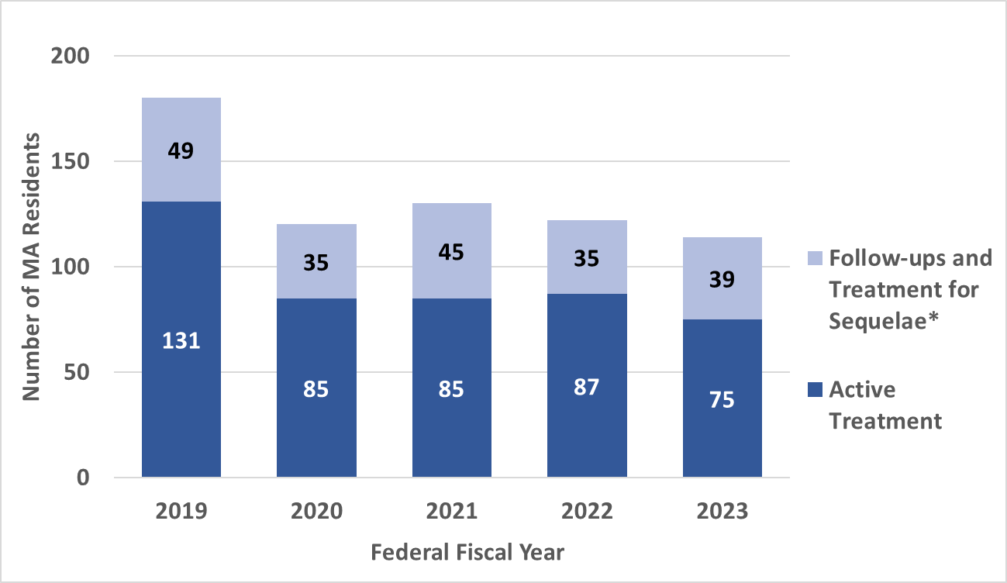
By Treatment Type, Individual-level Counts, MA Residents, FFY2019-FFY2023¹
180
120
130
122
114

1. FFY = Federal fiscal year (Oct. 1 – Sep. 30)
*Follow-up treatment and treatment for sequelae were combined due to low counts for follow-up treatment.
Data Source: Emergency Department Discharge data, MA Center for Health Information and Analysis. Data are collected and reported by FFY.
Analysis: MA Department of Public Health Injury Surveillance Program.

Highest Level of Nonfatal Spinal Cord Injury

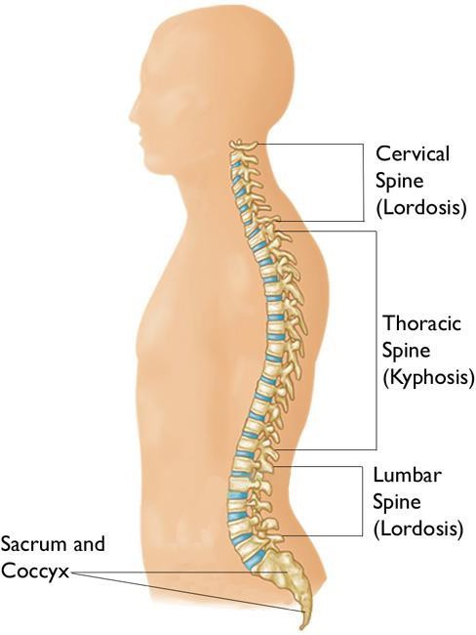
Combined Hospital Stays and ED Visits¹, Active Treatment, Individual- Level, FFY2023¹ N = 492 MA Residents
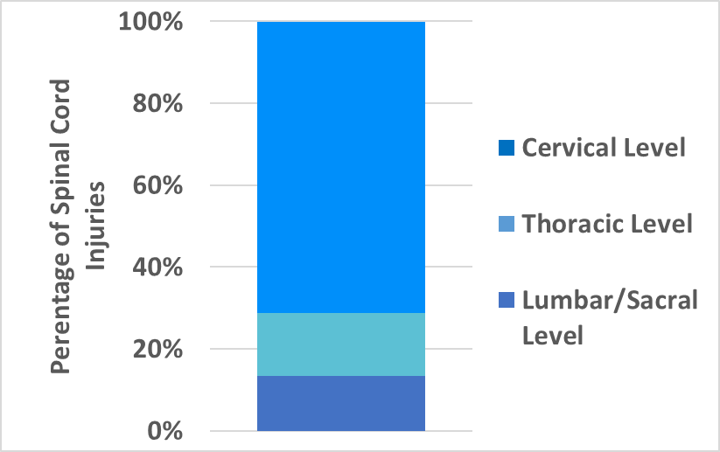
71.1%, n=350
15.4%, n=76
13.4%, n=66
1. FFY = Federal fiscal year (Oct. 1 – Sep. 30).
Data Sources: Inpatient Hospital Discharge, Outpatient Observation Stay, and ED Discharge data, MA Center for Health Information and Analysis
Analysis: MA Department of Public Health Injury Surveillance Program.

Groups at Highest Risk of Nonfatal Spinal Cord Injury (SCI)

Combined Hospital Stays and ED Visits, Active Treatment, Individual-Level, FFY2023¹, N=492 MA Residents
35.0
SCI Rates by Sex and Age Group
33.0
25.2
14.2
8.9
7.6
5.3
3.8
1.9

30.0
Rate per 100,000 MA Residents

25.0

20.0

15.0

10.0

5.0

0.0
Female Male <24 25-44 45-64 65-74 75-84 85+
Age in Years
- FFY = Federal fiscal year (Oct. 1 – Sep. 30).

Groups at Highest Risk of Nonfatal Spinal Cord Injury (SCI)

Combined Hospital Stays and ED Visits, Active Treatment, Individual-Level, FFY2023¹
N=492 MA Residents

14.0
Rate per 100,000 MA Residents
12.0
SCI Rates by Race and Ethnicity²

12.4

10.0
7.2
3.3
3.4
8.0
6.0
4.0
2.0

0.0

Asian, nH/nL 3

Hispanic White, nH/nL Black, nH/nL

- FFY = Federal fiscal year (Oct. 1 – Sep. 30).
- Includes only groups where counts were 11 are greater due to confidentiality guidelines.
- nH/nL = non-Hispanic/non-Latinx

Leading Causes of Nonfatal Spinal Cord Injury

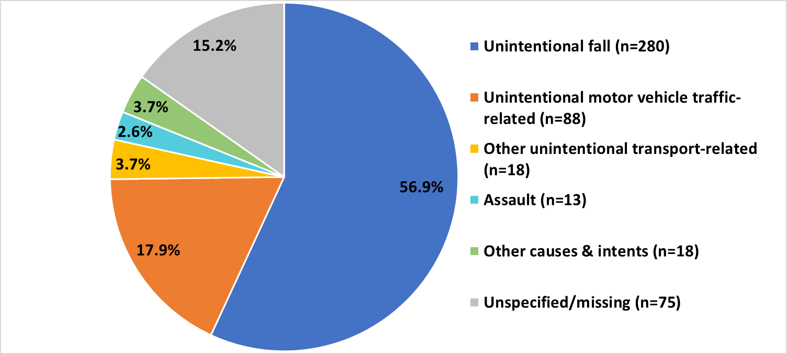
Combined Hospital Stays and ED Visits, Active Treatment, Individual-Level, FFY2023¹ N=492 MA Residents
2
- FFY = Federal fiscal year (Oct. 1 – Sep. 30).
- Includes 65 motor vehicle (MV) occupants, 13 motorcyclists, fewer than 11 pedestrians, and fewer than 11 pedal cyclists.
Data Sources: Inpatient Hospital Discharge, Outpatient Observation Stay, and ED Discharge data, MA Center for Health Information and Analysis
Analysis: MA Department of Public Health Injury Surveillance Program.

Age Differences in Nonfatal Spinal Cord Injury by Race & Ethnicity,

Combined Hospital Stays and ED Visits, Active Treatment, Individual-Level, FFY2023¹ N = 492 MA Residents

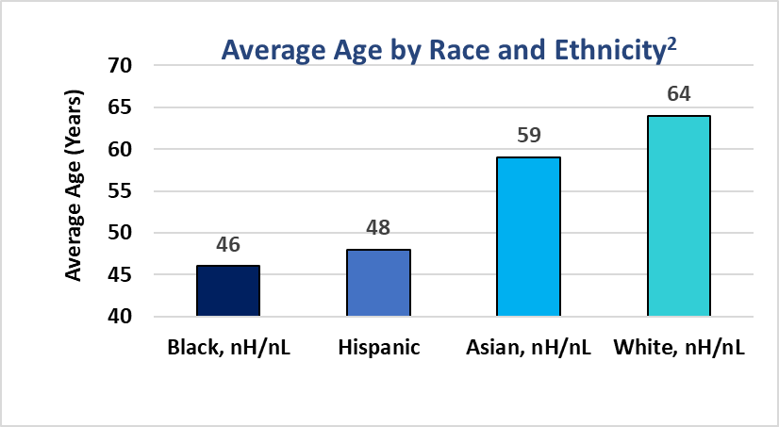
- FFY = Federal fiscal year (Oct. 1 – Sep. 30).
- The average age of
Black, nH/nL and Hispanic residents who experienced spinal cord injury was significantly younger than that of White, nH/nL residents (46 and 48 years vs. 64 years).³
- There were no significant differences across racial and ethnic groups in terms
of sex distribution or highest level of spinal cord injury.

- Includes only groups where counts were 11 are greater due to confidentiality guidelines. nH/nL = non-Hispanic/non-Latinx
- Tukey post-hoc comparisons (conducted as part of an ANOVA) indicate that the mean ages of 46 (Black, nH/nL) and 48 (Hispanic) were statistically significantly
different from the mean age of 64 (White, nH/nL) (p < .0001), but no other statistically significant differences in mean ages between these four groups were found.
Data Sources: Inpatient Hospital Discharge, Outpatient Observation Stay, and ED Discharge data, MA Center for Health Information and Analysis
Analysis: MA Department of Public Health Injury Surveillance Program.

Leading Causes of Nonfatal Spinal Cord Injury by Race & Ethnicity¹,

Combined Hospital Stays and ED Visits, Active Treatment, Individual-Level, FFY2023²
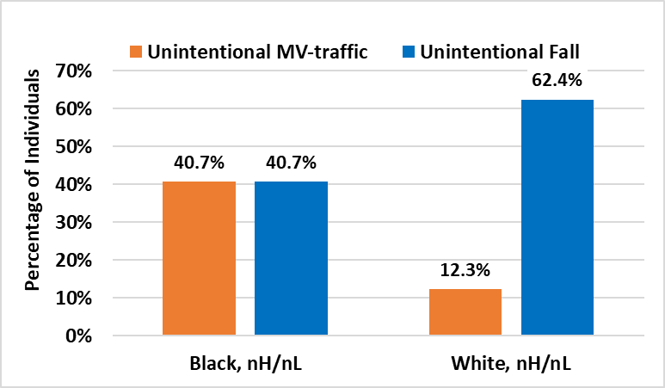
N = 492 MA Residents
  - Among Black, nH/nL³ residents, unintentional MV-traffic crashes and unintentional falls contributed equally to nonfatal SCIs (both 40.7%).
  - Among White, nH/nL residents, nonfatal SCIs resulted more often from unintentional falls than unintentional MV-traffic crashes (62.4% vs. 12.3%).

- Counts for other leading causes of SCI and among other race and ethnicity groups were too low to report.
- FFY = Federal fiscal year (Oct. 1 – Sep. 30).
- nH/nL: non-Hispanic/non-Latinx
Data Sources: Inpatient Hospital Discharge, Outpatient Observation Stay, and ED Discharge data, MA Center for Health Information and Analysis
Analysis: MA Department of Public Health Injury Surveillance Program.

Financial Costs Associated with Spinal Cord Injury Cases:
Hospital Charges

Combined Hospital Stays and ED Visits, MA Residents, FFY2023¹

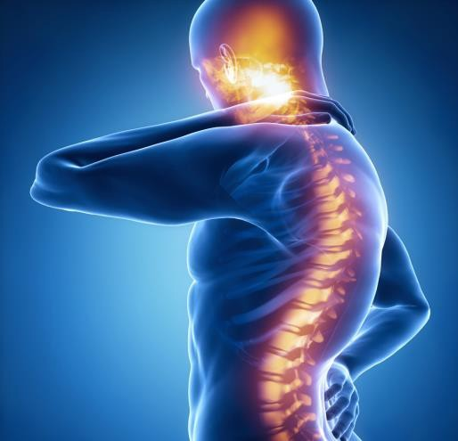
119 ED Visits2
976 Hospital Stays2
~$917,000
~$107 Million
$108 Million
in Hospital Charges at MA Acute Care Hospitals

These costs do not include those associated with rehabilitation, outpatient treatment, long-term care, lost wages, or the intangible costs of pain and suffering.

- FFY = Federal fiscal year (Oct. 1 – Sep. 30).
- These counts differ from those on previous slides in this presentations because they Include all SCI visits, including deaths and transfers, multiple visits for the same person, and active treatment, follow-up visits, and treatment for SCI sequelae. Some charges may be related to the treatment of other medical conditions or injuries.
Data Sources: Injuries - Inpatient Hospital Discharge, Outpatient Observation Stay, and ED Discharge data, MA Center for Health Information and Analysis
Analysis: MA Department of Public Health Injury Surveillance Program..


Thomas P. Kennedy
Spinal Cord Injury Trust Fund

To promote treatments to overcome the effects of chronic
spinal cord injury.

Revenue obtained from a $50 surcharge to persons seeking to
reinstate their driver’s licenses after suspension for multiple moving violations.

FY25 (July 1, 2024) Starting Balance: $1,162,560.26

Deposited FY25 (July 1, 2024-June 30, 2025): $782,653.00

Massachusetts Department of Public Health | mass.gov/dph 11
11

Previous SCI Contracts: FY20-FY24
Program to be reprocured.

Organization
Principal
Investigator
Boston
Children's
Hospital
Zhigang He
Boston
University
Christopher
Gabel
Harvard
University
Jeffrey
Macklis
Massachusetts
General
Hospital
Andrew
Reisner
Spaulding
Rehab
Hospital
Yang (Ted)
Teng

Future RFR

- Keep a look out on COMMBuys for new procurement (date to be determined) https://www.commbuys.com/bso/
- We anticipate posting sometime in 2026
- Interested in receiving link when the RFR is posted? Please see sheet by registration table

Connect with DPH
Massachusetts Department of Public Health | mass.gov/dph
14


@MassDPH



Massachusetts Department of Public Health mass.gov/dph

Contacts
Kelley Cunningham
Kelley.Cunningham@mass.gov
Director, Division of Violence and Injury Prevention Bureau of Community Health and Prevention Massachusetts Department of Public Health

Jeanne Hathaway Jeanne.Hathaway@mass.gov Epidemiologist, Injury Surveillance Program Bureau of Community Health and Prevention Massachusetts Department of Public Health
15
Massachusetts Department of Public Health | mass.gov/dph
15

