Massachusetts Freshwater Sportfishing Awards Program
Catch and Release Affidavit
A Sportfishing Awards Program pin will be issued to qualified anglers who catch and report a freshwater fish which equals or exceeds the minimum weight for the species listed on the reverse side of this form, provided any such angler has conformed to the rules of the program. Those catching the largest fish in each category during each calendar year will be recognized at an annual award ceremony.
Save time and a stamp by submitting your entry using the easy online affidavit.
Go to Mass.gov/dfw/sportfishing-awards to use the online form.

ALL items on this form MUST be filled out. Please print clearly.
Angler’s Name: _____________________________________________ Age:
Address:

Phone: ____________________________________ E-mail:
Fish Species:
Fish Length: __________________ inches Date of Catch:
Type of Tackle: ___________________________ Bait/Lure:
Where Caught:
(name of waterbody) (city./.town of waterbody)

I hereby swear, under the pains and penalties of perjury, that the above statements are true, that this entry complies with all rules on the reverse side, that this fish was caught in a legal manner in Massachusetts.
Angler’s Signature (parent’s signature if under 18):
Fishing/Sporting License Number:

Comments on the Catch (optional):

Effective 04/23
Catch and Release Program Rules and Eligibility
- All legally licensed anglers are eligible for the Massachusetts Freshwater Sportfishing Awards.
- Anglers aged 17 or under are eligible for Youth Sportfishing Awards. Anglers aged 15-17 must have a license to fish.
- Fish must be taken from Massachusetts waters (or from one of the interstate ponds listed in the Guide to Hunting, Fishing and Trapping) that are open to the public at all times. Fish taken from private ponds or fish and game club ponds are NOT eligible for awards. This rule does not apply to the Wachusett or Quabbin Reservoirs or other public bodies of water which are closed on a seasonal basis.
- Fish must be caught on hook and line.
- For the Catch and Release category, fish must be measured at the site of capture, photographed against a standard measuring device, then immediately released. Transportation of live fish is prohibited without a permit.
- A clear, side view, close-up photograph of the fish against a flat, clearly labeled measuring device must be included with all affidavits. The photo must include the entire fish and the measurement must be clearly discernible. Affidavits for catfish and bullheads must also include a photograph of the top view of the fish (see website for an example).
- A total length measurement will be used (see diagram below). All fish measurements will be rounded up to the nearest ¼ inch.
- Completed affidavits and all required photos must be submitted within 30 days of the date of catch. Note: December affidavits must be submitted no later than January 10th of the following year. We encourage online submissions at www.mass.gov/dfw/sportfishing-awards for faster processing.
- All photos or images associated with the program, including those submitted by anglers or taken by MassWildlife staff, become property of MassWildlife. Names of anglers and images may be used in agency publications, promotional materials, or for other non-commercial use.
- MassWildlife reserves the right to change or modify the program rules at any time. All decisions are final.

Minimum Lengths (in inches) to Qualify for an Award
Species Adult Youth Species Adult Youth
Bowfin 26 20 Northern Pike 36 28
Brook Trout 16 14 Rainbow Trout 20 16
Brown Trout 22 18 Shad 22 18
Bullhead 15 12 Smallmouth Bass 20 17
Carp 31 27 Sunfish* 10 8
Chain Pickerel 25 20 Tiger Muskellunge 34 26
Channel Catfish 25 20 Tiger Trout 16 12
Crappie 14 11 Walleye 24 18
Fallfish 15 12 White Catfish 19 15
Lake Trout 30 25 White Sucker 19 16
Landlocked Salmon 22 18 White Perch 14 11
Largemouth Bass 21 18 Yellow Perch 14 11
*Includes Bluegill, Pumpkinseed, Redbreast Sunfish, Green Sunfish, and Rock Bass
How to measure your fish
- Lay the fish on top of or beside a measuring device
- Do not measure over the curve of the body

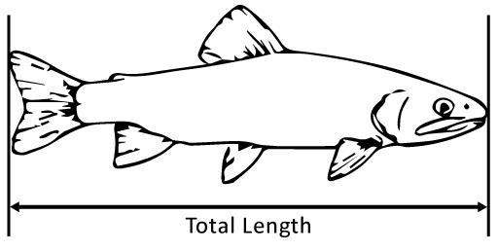

If there is ANY question about identification, bring the (entire) fish to a MassWildlife office.
If you have questions, call (508) 389-6300 any weekday between 8 and 4:30, or visit mass.gov/masswildlife.

Send completed affidavits and photos to: MassWildlife
Sportfishing Awards Program
1 Rabbit Hill Road, Westborough, MA 01581
Effective 04/23

