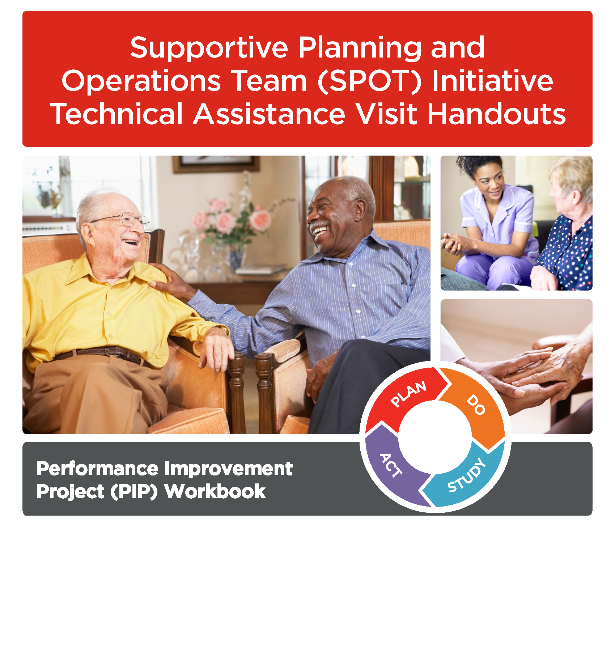

Supportive Planning and Operations Team (SPOT) Initiative Technical Assistance Visit Handouts

Table of Contents
Glossary of Terms 1
Introduction 3
Performance Improvement Project Prioritization 4
Getting at the Root of an Issue 7
Addressing Root Causes through Corrective Action 10
Measuring Quality 12
Setting Goals 16
Performance Improvement Project (PIP) Documentation 19
Telling Your Story 23
Appendix A: PIP Launch Check List 27
Appendix B: NCPS Patient Safety Intervention Hierarchy 29
Appendix C: PDSA Cycle Template 31
Appendix D: QAPI Leadership Rounding Guide 35

SPOT Initiative Performance Improvement Project (PIP) Workbook Page i

Glossary of Terms

Failure Mode and Effects Analysis: Failure Mode and Effects Analysis (FMEA) is a structured way to identify and address potential problems, or failures and their resulting effects on the system or process before an adverse event occurs. In comparison, root cause analysis (RCA) is a structured way to address problems after they occur. FMEA involves identifying and eliminating process failures for the purpose of preventing an undesirable event.

Fish Bone Diagram: A cause and effect diagram, often called a “fishbone” diagram, can help in brainstorming to identify possible causes of a problem and in sorting ideas into useful categories. A fishbone diagram is a visual way to look at cause and effect. It is a more structured approach than some other tools available for brainstorming causes of a problem (e.g., the Five Whys tool). The problem or effect is displayed at the head or mouth of the fish. Possible contributing causes are listed on the smaller “bones” under various cause categories. A fishbone diagram can be helpful in identifying possible causes for a problem that might not otherwise be considered by directing the team to look at the categories and think of alternative causes. Include team members who have personal knowledge of the processes and systems involved in the problem or event to be investigated.

Five Whys: The Five Whys is a simple problem-solving technique that helps to get to the root of a problem quickly. The Five Whys strategy involves looking at any problem and drilling down by asking: "Why?" or "What caused this problem?" While you want clear and concise answers, you want to avoid answers that are too simple and overlook important details. Typically, the answer to the first "why" should prompt another "why" and the answer to the second "why" will prompt another and so on; hence the name Five Whys. This technique can help you to quickly determine the root cause of a problem. It's simple, and easy to learn and apply.

Flowchart (Also called “Process Map”): A flowchart is a tool that allows you to break any process down into individual events or activities and shows the logical relationships between them. Flowcharting is often used by PIP teams when conducting root cause analysis (RCA) and/or failure mode effects analysis (FMEA).

Outcome Measure: Outcome measures focus on the product (or outcome) of a process or system of care or services, which can identify different or more complex underlying causes. Example: The rate or incidence of nursing home acquired pressure ulcers. See Measure/Indicator Development Worksheet page 22 for more information.

Performance Improvement Projects (PIPs): A Performance Improvement Project (PIP) is a concentrated effort on a particular problem in one area of the facility or facility wide; it involves gathering information systematically to clarify issues or problems, and intervening for improvements. The facility conducts PIPs to examine and improve care or services in areas that the facility identifies as needing attention. Areas that need attention will vary depending on the type of facility and the unique scope of services they provide.

Process Measure: Process measures assess the steps or activities carried out in order to deliver care or services. These measures focus on the action by professionals and staff. Consideration should be given to sample sizes for denominators, exclusion criteria, and alternative processes or work-arounds that may exist. Example: The percentage of newly admitted residents receiving admission skin assessments. See Measure/Indicator Development Worksheet page 22 for more information.

Project Charter: A project charter clearly establishes the goals, scope, timing, milestones, and team roles and responsibilities for an Improvement Project (PIP). The charter is typically developed by the QAPI team and then given to the team that will carry out the PIP, so that the PIP team has a clear understanding of what they are being asked to do. The charter is a valuable document because it helps a team stay focused. However, the charter does not tell the team how to complete the work; rather, it tells them what they are trying to accomplish.

Quality Assurance and Performance Improvement (QAPI): QAPI is a data-driven, proactive approach to improving the quality of life, care, and services in nursing homes. The activities of QAPI involve members at all levels of the organization to: identify opportunities for improvement; address gaps in systems or processes; develop and implement an improvement or corrective plan; and continuously monitor effectiveness of interventions.

Root Cause Analysis (RCA): Root cause analysis is a term to describe a systematic process to get to the underlying cause of a problem.⁷

SMART Goals: Specific, Measurable, Attainable, Relevant and Time-Bound Goals. See Goal Setting Worksheet page 26 for more information.

Supportive Planning Operations Team (SPOT): The SPOT Initiative was a three-year collaborative effort by BHCSQ and the Centers for Medicare & Medicaid Services (CMS) to support 60 nursing home teams to develop effective quality assurance and performance improvement (QAPI) programs. SPOT was made possible by the Massachusetts Department of Health, Bureau of Health Care Safety and Quality (BHCSQ).

Structural Measure: Structural measures focus on the fixed characteristics of an organization, its professionals and staff. These measures distinguish between a capability or asset and the activity that may rely on that structure. In addition, structural measures are typically based on the organization or professional as the unit of assessment in the denominator. Example: The extent to which a facility use of electronic health records is implemented facility-wide. Numerator = Number of departments with EHR; Denominator = Number of all departments in facility. See Measure/Indicator Development Worksheet page 22 for more information.

Introduction

Nursing homes can use this workbook as a guide when implementing quality improvement practices (i.e., performance improvement programs or PIPs) to improve resident care delivery and outcomes. The systems that can most affect quality include leadership, communication, quality of care and quality of life indicators, and clinical practice models.

This workbook was developed during the Supportive Planning Operations Team (SPOT) Initiative in 2017 and 2018, which was made possible by the Massachusetts Department of Health, Bureau of Health Care Safety and Quality (BHCSQ). SPOT was a three-year collaborative effort by BHCSQ and the Centers for Medicare & Medicaid Services (CMS) to support 60 nursing home teams to develop effective quality assurance and performance improvement (QAPI) programs. DPH contracted with Abt Associates, Inc., of Cambridge, MA to accomplish this work.

Effective QAPI programs can prevent adverse events, promote safety and quality, and reduce risks to residents and caregivers. The SPOT Initiative aligns with the CMS principles that effective QAPI programs are essential to improving and maintaining the quality of life and quality of care of nursing home residents. Many of the SPOT tools and resources were created or come directly from the CMS QAPI website: https://www.cms.gov/Medicare/Provider- Enrollment-and-Certification/QAPI/nhqapi.html

The workbook is organized to walk readers through a thorough, systematic PIP process. Except for the Storyboard and PIP Documentation worksheet, each successive tool builds on the previous tool. Additional resources may be found in the appendix.

We gratefully acknowledge the contributions of the nursing homes that participated in the SPOT Initiative and shared best practices, and their experiences throughout the Initiative.

Performance Improvement Project Prioritization

To address systems that impact adverse events and errors, start by proactively looking for opportunities for improvement. Although it can be tempting to try to address multiple opportunities at once, oftentimes staff resources are limited. Identifying one or two priority areas allows nursing homes to designate a more comprehensive effort towards individual initiatives.

The following worksheet will assist nursing homes in choosing potential areas for improvement and prioritize them based on the needs of the residents and the organization. Once an area with the highest priority is identified, it can be the focus of a performance improvement project, or PIP.

Prioritization Worksheet for Performance Improvement Projects

Directions: This tool will assist in choosing which potential areas for improvement are the highest priority based on the needs of the residents and the organization. Follow this systematic assessment process below to identify potential areas for PIPs. This process will consider such factors as high-risk, high-volume, or problem-prone areas that affect health outcomes and quality of care. This tool is intended to be completed and used by the QAPI team that determines which areas to select for PIPs. Begin by listing potential areas for improvement in the left-hand column. Then score each area in the following columns based on a rating system of 1 to 5 as defined below:

1 = very low | 2 = low | 3 = medium | 4 = high | 5 = very high

Rating is subjective and is meant to be a guide and to stimulate discussion. Once all columns have been rated, add the scores across the row and tally in the final column. Potential improvement areas with a higher score indicate a higher priority.

POTENTIAL  AREAS FOR  IMPROVEMENT  Consider areas  identified through: Dashboard(s) Feedback from staff, families, residents, other Incidents, near misses, unsafe conditions Survey deficiencies | PREVALENCE  The frequency at  which this issue arises in our organization. | RISK  The level to which  this issue poses a risk to the well- being of our residents. | COST  The cost incurred  by our organization each time this issue occurs. | RELEVANCE  The extent to  which addressing this issue would affect resident quality of life and/or quality of care. | RESPONSIVENESS  The likelihood an  initiative on this issue would address a need expressed  by residents, family and/or staff. | FEASIBILITY  The ability of our  organization to implement a PIP on this issue, given current resources. | CONTINUITY  The level to which an  initiative on this issue would support our organizational goals and priorities. | TOTAL  SCORE  TALLY

Additional factors to take into account:
- What existing standards or guidelines are available to provide direction for this initiative?
- What measures can be used to monitor progress?
- Is the topic publicly reported on Nursing Home Compare and/or is it a goal of the Advancing Excellence in America’s Nursing Homes campaign?
- Which type of changes primarily will be involved (i.e., system changes, environmental changes, staffing changes)?
- Which staff will be most affected by the initiative? What training needs will this initiative present?
- Is there an identified champion(s) for this initiative?

Getting at the Root of an Issue

A very important piece of quality and performance improvement is to identify the driving factors or causes that underlie issues of process or system breakdown. This is commonly known as root cause analysis (RCA). Without conducting a RCA prior to identifying corrective actions, a nursing home does not know if its actions are addressing the real cause of the problem.

There are many methods that can be used to look deeper into issues identified for improvement. The two methods used in the SPOT Initiative, and that are included in the following worksheets, are the Fishbone Diagram and the Five Whys. Both methods are effective ways to identify causes of issues, and thus lead to the development and implementation of actions and interventions that can address - and hopefully solve - broken processes and systems.

The fishbone diagram can help in brainstorming possible causes of a problem and in sorting ideas into useful categories. A fishbone diagram is a visual way to look at cause and effect. The problem or effect is displayed at the head (or mouth) of the fish. Possible contributing causes are listed on the smaller “bones” under various cause categories. A fishbone diagram can be helpful in identifying possible causes for a problem that might not otherwise be considered, by directing the team to look at the categories and think of alternative causes.

The Five Whys is a simple method that begins with the question “Why” a specific issue is occurring. Then the question “Why?” is repetitively asked to build on the previous response until the nursing home is satisfied that the root cause has been uncovered, or the reasons an issue is occurring. Once the root cause is identified, approaches can be put into place to address the issue.

Root Cause Analysis

What is a Root Cause Analysis?

Just as you would pull a weed out of your garden by its root to ensure that it doesn’t grow back, getting to the root cause of a system’s issue is important to prevent the problem from returning. There are many formalized root cause analysis tools.

Two easy-to-use tools are the fishbone diagram and the Five Whys.

Fishbone (Cause-and-Effect) Diagram

  - Begin the fishbone diagram by placing the problem at the head of the “fish.”
  - Under each general category of the fishbone, answer the question, “Why?” for the identified problem. For example, “Why are people the cause of this problem?”
  - Once your team has completed the fishbone diagram, discuss the various causes to get to the root of the problem. It is from this discussion that the focus for the improvement plan can begin.

Equipment
Process
People

Problem

Materials
Environment
Management

atomAlliance.org

Five Whys

The Five Whys tool aids in identifying the root cause(s) of a problem. Begin by identifying a specific problem, and ask why it is occurring. Continue to ask “Why?” to identify causes until the underlying cause is determined. Each “Why?” should build on the previous response. There is nothing magical about the number five. Sometimes a root cause may be reached after asking “Why?” just a few times; at other times, deeper questioning is needed.

- Define a problem; be specific.
- Ask why this problem occurs, and list the reasons in Box 1.
- Select one of the reasons from Box 1 and ask, “Why does this occur?” List the reasons in Box 2.

Continue this process of questioning until you have uncovered the root cause of the problem. If there are no identifiable answers or solutions, address a different problem or reason.

This material was prepared by atom Alliance, the Quality Innovation Network-Quality Improvement Organization (QIN-QIO), coordinated by Qsource for Tennessee, Kentucky, Indiana, Mississippi and Alabama, under a contract with the Centers for Medicare & Medicaid Services (CMS), a federal agency of the U.S. Department of Health and Human Services. Content does not necessarily reflect CMS policy. 16.ASE1.03.003

atomAlliance.org

Addressing Root Causes through Corrective Action

Once the root cause of an issue is identified, the next step is to consider how to reduce or prevent each root cause. The best way to do this is to identify key corrective actions that address the root cause(s) of the issue identified.

Many times, corrective actions will either change steps in existing processes or systems, or create entirely new processes or systems. When choosing corrective actions, it is very important to have the input of those staff who are part of the process that is being changed. This will help to ensure that the actions identified make sense within the current workflow or organizational system.

For each root cause, the nursing home team should identify at least one corrective action. Be aware that some actions will be short-term solutions and others will be those that are regularly incorporated into how the nursing home does business (i.e., some actions might require capital investments and strategic planning).

The following worksheet groups corrective actions into the following categories: Weak, Intermediate and Strong. Try to choose interventions that not only address the issue, but have safeguards for prevention, and address long-lasting sustainability once implemented. Such actions will likely be those that are in the intermediate or stronger categories.

Classifications of Corrective Actions

Weak: Weak actions are intended to enhance or enforce existing processes. However, their effectiveness is dependent on staff remembering a policy and procedure or information they received during training.

Examples of weak actions:
- Double checks
- Warnings/labels
- New policies/procedures/memoranda
- Training/education
- Additional study
Intermediate: Intermediate actions help staff to remember and/or modify existing processes. Additionally, some intermediate actions promote clear communication and, therefore, help to reduce errors.

Examples of intermediate actions:
- Decrease workload
- Software enhancements/modifications
- Eliminate/reduce distraction
- Checklists/cognitive aids/triggers/prompts
- Eliminate look alike and sound alike
- Read back
- Enhanced documentation/communication
- Build in redundancy
Stronger: Stronger actions may not eliminate the potential for issues to occur but they lessen reliance on staff remembering to do the right thing. They may significantly change or redesign the process, warn staff
such that they can take corrective action before proceeding, or provide a hard stop in a process until something changes.

Examples of strong actions:
- Physical changes: grab bars, nonslip strips on tubs/showers
- Engineering controls: sharps containers, sharps with engineered sharp injury protection (SESIPs) and needleless systems
- Usability testing of devices before purchasing
- Forcing functions or constraints: design of gas lines so that only oxygen can be connected to oxygen lines, electronic medical records in which users cannot continue charting unless all fields are filled in
- Simplifying processes and removing unnecessary steps: unit dose vials, using kits for various procedures
- Tangible involvement and action by leadership in support of resident safety: leaders are seen and heard making or supporting the change
References
Centers for Medicare & Medicaid Services. (n.d.). QAPI at a glance: A step-by-step guide to implementing quality assurance and performance improvement (QAPI) in your nursing home. Retrieved from https://www.cms.gov/Medicare/Provider-Enrollment-and-Certification/QAPI/Downloads/QAPIAtaGlance.pdf
Centers for Medicare & Medicaid Services. (n.d.). Guidance for Performing Root Cause Analysis (RCA) with Performance Improvement Projects (PIPs). Retrieved from https://www.cms.gov/medicare/provider-enrollment-and- certification/qapi/downloads/guidanceforrca.pdf

Disclaimer: Use of tools, policies and procedures, etc. referred to in this document are not mandatory for regulatory compliance nor do their completion ensure regulatory compliance.

Measuring Quality

To determine if a corrective action is working, the nursing home team should identify measures to assess that the new process is being followed, and whether the team has achieved its goal.

Measures indicate if the corrective action made a difference in outcomes, and if staff are complying with changes that have been made to processes or systems. The nursing home team will need to create ways (if none currently exist) to gather data that will be used to evaluate the measures.

Data collection and tracking occurs during the implementation phase of the PIP, but routine monitoring should be ongoing following its conclusion to ensure the sustainability of the changes made (i.e., permanency of the change).

The following worksheet will help to develop performance measures (process, outcome and/or structural measures*) for a quality improvement PIP and/or as part of overall QAPI monitoring.

- Note that structural measures are generally focused on the organizational level and therefore not frequently used to measure or monitor the success of a PIP initiated by nursing home teams.

Measure/Indicator Development Worksheet

Directions: Use this worksheet to develop a performance measure/indicator. A new measure/indicator might be created as part of your overall QAPI monitoring or for a Performance Improvement Project. You will likely want to use existing measures when possible, but there may be times when you want to develop a new measure/indicator that is specific to your needs.

Note: What is the difference between an indicator and a measure? An indicator provides evidence that a certain condition exists but does not clearly identify the situation or issue in any detail. Indicators enable decision-makers to assess progress towards the achievement of intended outputs, outcomes, goals, and objectives. A measure is a stronger reflection of the underlying concept; a more developed and tested way of describing the concept that is being evaluated. However, in practice the two terms are used interchangeably.

MEASURE/INDICATOR OVERVIEW

NAME OF MEASURE/INDICATOR:
Example: Residents with a completed skin assessment within 12 hours of admission.

PURPOSE OR INTENT FOR MEASURE/INDICATOR:
Example: The purpose of this measure is to make sure our process of completing a skin assessment within 12 hours of admission is done consistently.

MEASURE/INDICATOR TYPE:
Structural Measure: Structural measures focus on the fixed characteristics of an organization, its professionals and staff. These measures distinguish between a capability or asset and the activity that may rely on that structure. In addition, structural measures are typically based on the organization or professional as the unit of assessment in the denominator. Example: The extent to which use of electronic health records is implemented facility-wide. Numerator = Number of departments with EHR; Denominator = Number of all departments in facility.
Process Measure: Process measures assess the steps or activities carried out to deliver care or services. These measures focus on the action by professionals and staff. Consideration should be given to sample sizes for denominators, exclusion criteria, and alternative processes or work-arounds that may exist. Example: The percentage of newly admitted residents receiving admission skin assessments.
Outcome Measure: Outcome measures focus on the product (or outcome) of a process or system of care
or services, which can identify different or more complex underlying causes. Example: The rate or incidence of nursing home acquired pressure ulcers.

The measure in the example above (residents with a completed skin assessment within 12 hours of admission) is a process measure.

Disclaimer: Use of this tool is not mandated by CMS, nor does its completion ensure regulatory compliance.

DEFINING THE MEASURE/INDICATOR SPECIFICATIONS

NUMERATOR:  (i.e., when will a person or event be counted as having met the desired result – this is the top number of the fraction you will calculate) | Example: any resident with a completed skin assessment within 12  hours of admission Numerator: 19
DENOMINATOR:  (i.e., what is the total pool of persons or events you will be counting – this is the bottom number of the fraction you will calculate) | Example: all residents admitted in last month. Denominator= 23
EXCLUSION CRITERIA:  (i.e., is there any reason you would exclude a particular person or event from the denominator count?] | Example: exclude those residents in the nursing home for less than  24 hours because all assessment data not available Denominator after exclusions: 20
RESULT CALCULATION:  (i.e., typically expressed as Numerator/Denominator x 100 = rate %) | Example: 19 / 20 X 100 = 90%
INDICATOR/MEASURE GOAL:  (i.e., the numerical goal aimed for – may be based on an already- established goal for the particular indicator) | Example: Goal = 100%
INDICATOR/MEASURE THRESHOLD:  (i.e., the minimum acceptable level of performance) | Example: Threshold = 95%

MEASURE/INDICATOR DATA COLLECTION

DATA SOURCE: | Example: Medical records, admission skin assessment form
SAMPLE SIZE AND METHODOLOGY:  (i.e., will you measure the total population under study or draw a sample to represent the whole? If sampling, how large will the sample size be? How will you determine the sample?) | Example: The total population admitted in the last month who were  in the nursing home for at least 24 hours will be reviewed.
FREQUENCY OF MEASUREMENT:  (i.e., how frequently will the indicator result be calculated: daily, weekly, monthly, quarterly, annually?) | Example: Monthly
DURATION:  (i.e., what is the timeframe for which | Example: Will collect this data for three consecutive months; then based on findings, will either develop corrective action and continue

Disclaimer: Use of this tool is not mandated by CMS, nor does its completion ensure regulatory compliance.

the data will be collected: number of cases/events in the past weeks, months, quarters? This will depend on how frequently cases/events occur.)
monitoring monthly, or consider decreasing frequency of monitoring.

Disclaimer: Use of this tool is not mandated by CMS, nor does its completion ensure regulatory compliance.

Setting Goals

When initiating a quality improvement program, it is important to establish goals that are not only relevant to processes related to the PIP, but that are relevant and meaningful to the residents and organization itself. Goal-setting establishes the objective a nursing home wishes to achieve because of the PIP.

The following worksheet will help the nursing home create goals that are SMART – Specific, Measurable, Attainable, Relevant and Time-Bound. Here are a few important things to think about in terms of setting goals:

- Creating goals is not a one-person job! Anyone can be involved including all levels of staff, residents, families, and even volunteers.
- Goals that include national, state and/or local performance benchmarks allow the nursing home to set “stretch” goals so that there are thresholds to strive towards, or to not fall below.
- Goals can be shared on the PIP Storyboards and recorded in the PIP Documentation Worksheet along with the data the nursing home is tracking associated with those goals.

Goal Setting Worksheet

Directions: Goal setting is important for any measurement related to performance improvement. This worksheet is intended to help QAPI teams establish appropriate goals for individual measures and also for performance improvement projects. Goals should be clearly stated and describe what the organization
or team intends to accomplish. Use this worksheet to establish a goal by following the SMART formula outlined below. Note that setting a goal does not involve describing what steps will be taken to achieve the goal.

Describe the business problem to be solved:

Use the SMART formula to develop a goal:

SPECIFIC

Describe the goal in terms of 3 ‘W’ questions:

What do we want to accomplish?
Who will be involved/affected?
Where will it take place?

MEASURABLE

Describe how you will know if the goal is reached:

What is the measure you will use?
What is the current data figure (i.e., count, percent, rate) for that measure?
What do you want to increase/decrease that number to?

Disclaimer: Use of this tool is not mandated by CMS, nor does its completion ensure regulatory compliance.

ATTAINABLE
Goal Setting Worksheet
Defend the rationale for setting the goal measure above:

Did you base the measure or figure you want to attain on a particular best practice/average score/ benchmark?
Is the goal measure set too low that it is not challenging enough?
Does the goal measure require a stretch without being too unreasonable?

RELEVANT

Briefly describe how the goal will address the business problem stated above.

TIME-BOUND

Define the timeline for achieving the goal:

What is the target date for achieving this goal?

Write a goal statement, based on the SMART elements above. The goal should be descriptive, yet concise enough that it can be easily communicated and remembered.

[Example: Increase the number of long-term residents with a vaccination against both influenza and pneumococcal disease documented in their medical record from 61 percent to 90 percent by December 31, 2011.]

Tip: It’s a good idea to post the written goal somewhere visible and regularly communicate the goal during meetings to stay focused and remind caregivers that everyone is working toward the same aim.

Disclaimer: Use of this tool is not mandated by CMS, nor does its completion ensure regulatory compliance.

Performance Improvement Project (PIP) Documentation

The PIP Documentation Worksheet on the next page is a tool that encourages the nursing home to document components of a PIP as each step along the process is completed. As a PIP is implemented, it is important to document key aspects to guide and support its development and progress. Instructions on the worksheet urge the inclusion of all levels of staff, residents and families on PIP teams and recommend that all team members contribute to completing the Documentation Worksheet.

Clear documentation of all aspects of a PIP ensures that performance improvement is a sustainable, ongoing process, even if there is staff turnover.

Performance Improvement Project (PIP) Documentation Worksheet

Performance Improvement Project (PIP) teams can use this documentation worksheet when developing and implementing a PIP to address an identified quality improvement issue. PIP teams should fill out this worksheet with input from nursing home management, various levels of staff, and residents/family, if applicable. Management and staff are encouraged to use this worksheet as a guide to support them in developing a PIP that best meets the unique needs of the nursing home.

Identify the Problem. One or two sentences on the issue or opportunity being addressed by this PIP.

Identify the Goal. One sentence on what this PIP aims to achieve.

Identify Causes and Contributing Factors of the Issue. Conduct a root cause analysis and document all potential causes and contributing factors.

Describe Potential Intervention(s). List all potential interventions or changes that the team could introduce to address the root cause of the problem or opportunity.

Formalize the Intervention(s). Describe who will be responsible for the intervention, where the team will implement it, and the timeline for implementation. Focus on interventions that promote sustainable change.

Describe the Measures/Indicators that the PIP Team Will Use. List what measure(s) or indicator(s) the team will use to monitor whether the change is effective. Be sure to list and describe both process measures and outcome measures.

Process Measures. Describe how the team will know the intervention(s) is/are occurring as planned.

Outcome Measures. Describe how the team will know the intervention(s) is/are having the desired effect.

Identify How the PIP Team Will Inform Residents, Families, and All Levels of Staff of the PIP:

Determine How the Team Will Identify an Evolving Problem. Describe what means the team will use to identify an evolving problem before audit results and outcomes might identify problems.

Document Lessons Learned. After completing the PIP, document key lessons that the team learned through the PIP.

Determine Next Steps. Performance improvement is a continuous process. In one to two sentences, indicate the follow-up steps that the team will implement to ensure the intervention is working and performance improvement will be sustained.

Telling Your Story

The following worksheet is a guide to assist nursing homes in simply and clearly communicating their PIP “story.”

The Storyboard walks the reader through the PIP, beginning with the problem statement and concluding with lessons learned and next steps*. The example provided shows just how simple and straight-forward documenting the steps can be.

The structure of the Storyboard allows for sharing a brief story regarding the changes the nursing home made and the success achieved (i.e., demonstrated improvement in the PIP focus area). The Storyboard should share the most essential information in a simple way using graphs or photos and even quotes from staff, residents, family members and volunteers who may have participated in the effort.

Sharing these simple messages and depictions is important because they can help to track interventions that positively impacted an area for improvement. These stories facilitate transparency and communication with staff, residents and families, and promote a culture of quality within the organization. They also give everyone a chance to celebrate milestones and achievements on quality initiatives.

*One note of caution: The Storyboard does not include a root cause analysis, which is a very important step prior to identifying an intervention(s) or process change. For more information on Root Cause Analysis, refer to the Root Cause Analysis section on page 7.

Storyboard Guide for PIPs

Directions: A storyboard is a tool that can be used to simply and clearly communicate the story of a performance improvement project (PIP). The aim of a storyboard is to allow audiences to quickly grasp the main points of the story by providing only the most essential information and including one or more easy-to- understand charts that demonstrate the impact of the effort.

Storyboards may be presented in various formats, such as a one-two page handout, a large display poster, or even as presentation slides. The same key content should be presented in each. This guide is intended to be used by the person leading QAPI efforts in your facility, administrative leaders, or any other staff needing to communicate to an audience the results of a specific performance improvement project. An example of a storyboard is included in this guide.

Key Content to Include in your Storyboard:

- Problem. One sentence on the issue or opportunity being addressed by this PIP.
- Aim. One sentence on what this PIP aims to achieve.
- Intervention(s). Briefly describe what change was introduced to address the problem or opportunity.
If there was more than one change, use bullet points to list the multiple interventions.
- Measures/Indicators. List what measure(s) or indicator(s) are being used to monitor whether the change is effective.
- Results. One to two sentences on the results. Consider including a graph with notes that gives a picture of the impact of the changes over time, or stories that describe the success.
- Lessons Learned. Document 1-2 key lessons that were learned through the PIP.
- Next Steps. Performance improvement is a continuous process. In one to two sentences, describe the next steps (e.g., to further refine the intervention; to introduce the change in other parts of the nursing home; to take steps to standardize the change).

Depending on space limitations and the nature of your audience, you may choose to include additional information such as pictures or images that help bring the story to life; the names of the PIP team members; a description or visual of any quality improvement tools utilized; specific references from the literature that support the change approach.

Example of a storyboard starts on the next page:

Disclaimer: Use of this tool is not mandated by CMS, nor does its completion ensure regulatory compliance.

Sunnyside Nursing Home Busy City, Massachusetts November 21, 2018

Problem: Beginning in April 2017, Sunnyside began to see an increase in pressure ulcers among its high-risk residents; in June 2017, more than 10% of high-risk residents had been diagnosed with a pressure ulcer.

Aim: To reduce the occurrence of pressure ulcers in high-risk residents to less than 5% by November 2017.

Interventions:
- Redesign admissions packet to include the comprehensive pressure ulcer risk assessment form, to be completed within a resident’s first 24 hours of admission;
- Require a half day in-service training for all nursing assistants and licensed nursing staff on assessment for pressure ulcer risk and prevention;
- Utilize pressure redistribution mattresses for all residents at high-risk for pressure ulcers.
- Utilize pressure redistribution wheel chair cushions as applicable for all residents at high-risk for pressure ulcers.

Measures:
- Process measure: Number of new residents with completed pressure ulcer risk assessment with 24 hours of admission (Measure Goal: 100% of new residents by March 2018).
- Process measure: Number of residents at high risk for pressure ulcers with pressure redistribution mattresses. (Measure Goal: 100% of residents at high risk for pressure ulcers will have pressure redistribution mattresses by May 2018)
- Process measure: Number of residents at high risk for pressure ulcers and that use a wheel chair, with pressure redistribution wheel chair cushions. (Measure Goal: 100% of high risk residents using wheel chairs will have pressure redistribution cushions for their wheelchairs by May 2018)
- Outcome measure: Percent of high-risk residents with new, nursing home-acquired pressure ulcers (Measure Goal: Less than 5% by November 2018).

Results: As of April 2018, all new residents at Sunnyside received a comprehensive pressure ulcer risk assessment with 24 hours of admission. 100% of high risk residents have pressure redistribution mattresses. 100% of high risk residents that use a wheel chair have a pressure redistributing wheelchair cushion. The facility experienced a reduction in new pressure ulcers among high-risk residents over the 18-month period, from a high of 12% in August 2017 to a low of 5% in November 2018.

Disclaimer: Use of this tool is not mandated by CMS, nor does its completion ensure regulatory compliance.

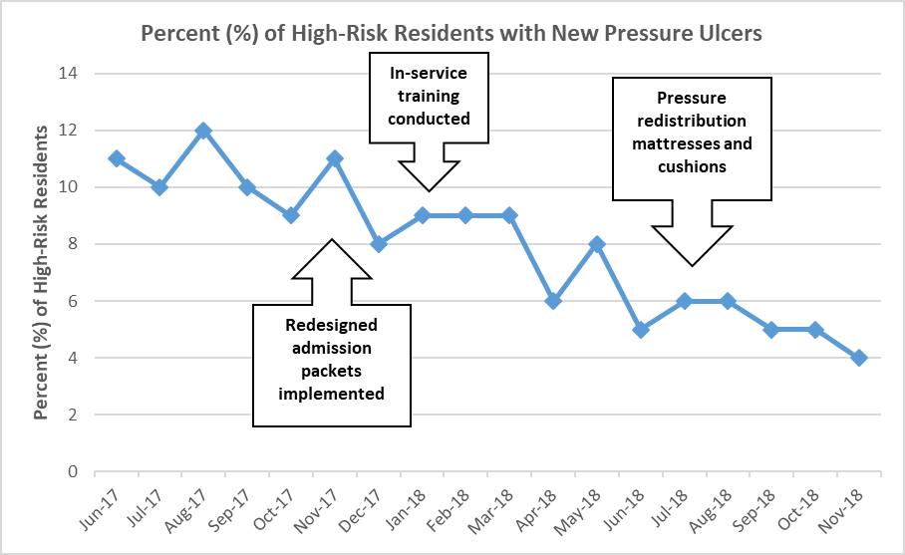

Lessons Learned:
- Although Sunnyside had a policy in place that each new resident should receive a pressure ulcer risk assessment, the admission packets were not set-up to help prompt staff to do so consistently with each admission.
- Nursing staff need more frequent training on pressure ulcer risk assessment and prevention.

Next Steps:
- Continue monitoring to make sure current pressure ulcer rates are maintained or improve.
- Integrate the pressure ulcer assessment tool into the facility’s electronic resident records system.
- Develop a more frequent training program on pressure ulcers for nursing staff.

Contact Information:
If you have any questions about this information, please contact xxx at xxx.

Source: Adapted with permission from the Institute for Healthcare Improvement (http://www.IHI.org).

Disclaimer: Use of this tool is not mandated by CMS, nor does its completion ensure regulatory compliance.

Appendix A: PIP
Launch Checklist

Performance Improvement Project (PIP) Launch Check List: Helpful hints for project leaders, managers, or coordinators

Directions: Use this check list to ensure you have covered important steps in launching your performance improvement project. This tool is intended to be used by the person asked to lead a PIP or any project where a team has been formed. Use this check list to make sure you have everything you need in place when you start a project. Ensuring you have these steps in place can help you save time and confusion down the road.

Project Name:

Project Stakeholders and Team Members

  - The team has received a project charter that has been approved by the leadership.
  - The project team has been assembled and roles and responsibilities have been assigned.
  - The project charter is understood and accepted by all project team members.
  - The project team understands how the project fits with the overall goals of the organization.
  - Each project team member understands how his/her assignment fits into the overall project.
  - The project and its goals have been communicated to stakeholders outside of the project team, as needed (e.g., residents and families, staff, board of directors, owners).

Project Resources

  - Financial support for the project has been obtained.
  - A project budget has been established.
  - Staff time to work on the project has been allocated.
  - Material resources required for the project have been identified and secured.

Project Process

  - A detailed timeline and work plan have been created.
  - Training needs have been identified and training has been conducted.
  - A schedule for regular project team meetings has been set.
  - Indicators/measures have been established to monitor project goals (see Goal Setting Worksheet).
  - The format and frequency for documenting project status has been defined.
  - The format, frequency, and audiences for communicating project status has been defined.
  - A process to identify issues that come up during this project is established (e.g., unintended consequences, new opportunities for process changes, surprises).
  - The location for storing all project documents, and processes for file naming conventions and version control has been established.
  - The time for project kickoff has been identified and any related activity required (e.g., announcement, meeting, event) has been planned.

Disclaimer: Use of this tool is not mandated by CMS, nor does its completion ensure regulatory compliance.

Appendix B: NCPS Patient
Safety Intervention Hierarchy

NCPS Patient Safety Intervention Hierarchy

Stronger Actions  (focused on system change, not reliant on individual memory/vigilance) | Architectural/physical plant changes  - New devices with usability testing before purchasing  - Engineering control or interlock (forcing functions)  - Simplify the process and remove unnecessary steps  - Standardize equipment on process or care maps  - Tangible involvement and action by leadership in support of patient safety
Intermediate Actions | - Redundancy  - Increase in staffing/decrease in workload  - Software enhancements/modifications  - Eliminate/reduce distractions  - Checklist/cognitive aid  - Eliminate look and sound-alikes  - Read back  - Enhanced documentation/communication
Weaker Actions  (reliant on memory/vigilance) | - Double checks  - Warnings and labels  - New procedure/memorandum/policy  - Training  - Additional study/analysis

Appendix C: PDSA Cycle
Template

PDSA Cycle Template

Directions: Use this Plan-Do-Study-Act (PDSA) tool to plan and document your progress with tests of change conducted as part of chartered performance improvement projects (PIPs). While the charter will have clearly established the goals, scope, timing, milestones, and team roles and responsibilities for a project, the PIP team asked to carry out the project will need to determine how to complete the work. This tool should be completed by the project leader/manager/coordinator with review and input by the project team. Answer the first two questions below for your PIP. Then as you plan to test changes to meet your aim, answer question 3 below and plan, conduct, and document your PDSA cycles. Remember that a PIP will usually involve multiple PDSA cycles in order to achieve your aim. Use as many forms as you need to track your PDSA cycles.

Model for Improvement: Three questions for improvement
1. What are we trying to accomplish (aim)?
State your aim (review your PIP charter – and include your bold aim that will improve resident health outcomes and quality of care)
2. How will we know that change is an improvement (measures)?
Describe the measurable outcome(s) you want to see
- What change can we make that will result in an improvement?

Define the processes currently in place; use process mapping or flow charting

Identify opportunities for improvement that exist (look for causes of problems that have occurred – see Guidance for Performing Root Cause Analysis with Performance Improvement Projects; or identify potential problems before they occur – see Guidance for Performing Failure Mode Effects Analysis with Performance Improvement Projects) (see root cause analysis tool):
  - Points where breakdowns occur
  - “Work-a-rounds” that have been developed
  - Variation that occurs
  - Duplicate or unnecessary steps

Decide what you will change in the process; determine your intervention based on your analysis
  - Identify better ways to do things that address the root causes of the problem
  - Learn what has worked at other organizations (copy)
  - Review the best available evidence for what works (literature, studies, experts, guidelines)
  - Remember that solution doesn’t have to be perfect the first time
Disclaimer: Use of this tool is not mandated by CMS, nor does its completion ensure regulatory compliance.

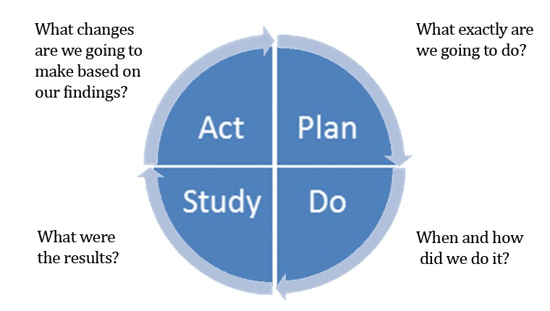

Plan  What change are you testing with the PDSA cycle(s)?  What do you predict will happen and why?  Who will be involved in this PDSA? (e.g., one staff member or resident, one shift?). Whenever feasible, it will be helpful to involve direct care staff.  Plan a small test of change.  How long will the change take to implement?  What resources will they need? What data need to be collected? |  | List your action steps along with person(s) responsible and  time line.
Do | Carry out the test on a small scale. Document observations, including any problems and unexpected findings.  Collect data you identified as needed during the “plan” stage. | Describe what actually happened when you ran the test.

Disclaimer: Use of this tool is not mandated by CMS, nor does its completion ensure regulatory compliance.

Study  Study and analyze the data. Determine if the change resulted in the expected outcome.  Were there implementation lessons?  Summarize what was learned. Look  for: unintended consequences, surprises, successes, failures. | Describe the measured results and how they compared to the  predictions.
Act  Based on what was learned from the test: Adapt – modify the changes and repeat PDSA cycle.  Adopt – consider expanding the  changes in your organization to additional residents, staff, and units. Abandon – change your approach and repeat PDSA cycle. | Describe what modifications to the plan will be made for the  next cycle from what you learned.

Disclaimer: Use of this tool is not mandated by CMS, nor does its completion ensure regulatory compliance.

Appendix D: QAPI
Leadership Rounding Guide

QAPI Leadership Rounding Guide

Directions: Leadership rounding is a process where leaders (e.g., administrator, department heads, and nurse managers) are out in the building with staff and residents, talking with them directly about care and services provided in the organization including QAPI initiatives. Rounding with staff and residents is an effective method for leaders to hear firsthand what is going well and what issues need to be addressed within the organization. It serves as an important signal of leadership’s commitment to performance improvement, and promotes a culture of QAPI in the organization. Use this to guide your rounds to monitor the progress of QAPI initiatives.

Questions to Consider Before Rounding

- Which leader(s) will conduct rounds?
- How frequently will rounds take place?
- What questions do you want to ask? What do you want to learn? (See sample questions below.)
- What barriers/issues have already been identified that employees should be asked about in order to gather input on solutions?

Rounding

- Leaders conduct rounds as planned, maintaining a positive tone, building relationships with staff by taking the time to listen and respond to employees’ and residents’ needs.
- Ask questions and document key points. See optional rounding form below.
- When employees raise issues or ask for help, assure them you will follow up.
- Follow up on previous issues or requests —share with staff how the issues were addressed or resolved.

To Do After Rounding

- Identify frequently noted issues/themes.
- Prioritize issues (e.g., by level of urgency, threat, ability to resolve).
- Conduct follow-up to show responsiveness to the issues raised (note: this may involve following up with employees individually, developing an organizational report that outlines the input collected and proposed solutions—potentially utilizing the priority levels developed in step #2—or including the findings as a component to be communicated during the next rounding session).
- Consider ways to acknowledge outstanding employee/unit efforts (e.g., thank you notes or other rewards/recognition).
- Identify training or coaching opportunities for employees/units. Plan next rounding session.

Disclaimer: Use of this tool is not mandated by CMS, nor does its completion ensure regulatory compliance.

Rounding Form

PERSON CONDUCTING ROUNDS: DATE: UNIT(S):

BACKGROUND: (to be completed prior to rounding)
TOPIC
Specific PIP(s):
Specific aspect of care (e.g., bathing, medication reconciliation)
Specific work place or workflow issue
Other

Information needed prior to rounding: What is your organization trying to achieve? How will improvement be recognized? Current data or description of performance: Improvements made to-date:

BARRIERS/ISSUES ALREADY KNOWN: (sharing these may be an opportunity to ask for staff input on solutions)

PREVIOUS BARRIERS/ISSUES THAT HAVE BEEN ADDRESSED BY LEADERSHIP: (reporting these back to staff shows responsiveness)

Questions for leaders to ask staff (include any qualitative and quantitative information obtained).
What things are going well  around this initiative or this aspect of care or service? What evidence do you see of success? | Notes:
What is frustrating you with  the work around this initiative or this aspect of care or service?  What barriers/issues do you  see threatening this initiative or aspect of care or service?  How should they be addressed? | Notes:

Disclaimer: Use of this tool is not mandated by CMS, nor does its completion ensure regulatory compliance.

What additional  resources/tools/equipment are needed? | Notes:
Are there any colleagues  who deserve special recognition for their efforts on this initiative or this aspect of care or service? | Notes:
Are there any colleagues who could be helped through coaching/training to make this initiative or aspect of care or service more successful? | Notes:
What feedback, if any, have  you heard from residents and families about changes taking place as part of this initiative or this aspect of care or service? | Notes:
What else would you like  the leadership to know about this initiative or this aspect of care or service? | Notes:

Leaders –summarize notes from conversations you had with residents or families on this topic:

Disclaimer: Use of this tool is not mandated by CMS, nor does its completion ensure regulatory compliance.

https://www.cms.gov/Medicare/Provider-Enrollment-and-Certification/QAPI/downloads/GuidanceForFMEA.pdf
https://www.cms.gov/Medicare/Provider-Enrollment-and-Certification/QAPI/downloads/FishboneRevised.pdf
https://www.cms.gov/Medicare/Provider-Enrollment-and-Certification/QAPI/downloads/FiveWhys.pdf
https://www.cms.gov/Medicare/Provider-Enrollment-and-Certification/QAPI/downloads/FlowchartGuide.pdf
https://www.cms.gov/Medicare/Provider-Enrollment-and-Certification/QAPI/downloads/qapifiveelements.pdf
https://www.cms.gov/Medicare/Provider-Enrollment-and-Certification/QAPI/downloads/PIPCharterWkshtdebedits.pdf
https://www.cms.gov/Medicare/Provider-Enrollment-and-Certification/QAPI/downloads/QAPIAtaGlance.pdf

