
Occupational Lung Disease Bulletin

Massachusetts Department of Public Health

Occupational Health Surveillance Program, 250 Washington St, 4th Floor, Boston, MA 02108
Tel: (617) 624-5632  Fax: (617) 624-5696  www.mass.gov/dph/ohsp

SENSOR
Spring 2015

Work-Related Asthma Surveillance Classification
1. Work-aggravated asthma
2. New-onset asthma
a) Occupational asthma
b) Reactive airways dysfunction syndrome (RADS)

Dear Healthcare Provider,

This Bulletin includes a summary of cases of work-related asthma (WRA) identified in Massachusetts from 2003-2013. Although the number of cases identified by the surveillance system is likely only a small fraction of the total number of persons with WRA in the state, the data provide important information about the industries and occupations where workers are at risk and about workplace exposures that need to be addressed.

A copy of the “Occupational Disease and Injury Reporting Form” is also provided. Please continue to report confirmed and suspected cases of WRA using the enclosed form.

To receive your Bulletin by e-mail, to provide comments, or to contribute an article to the Bulletin, contact us at MDPH.OHSP@state.ma.us

Kathleen Fitzsimmons, MPH
Epidemiologist

Work-Related Asthma Surveillance
Massachusetts, 2003 – 2013

Cases of work-related asthma (WRA) are sentinel health events that indicate a need for preventive intervention. Massachusetts and four other states, with funding from the National Institute for Occupational Safety and Health, conduct surveillance to identify cases of WRA and describe industries, occupations and exposures that require attention. For surveillance purposes, a case of WRA is defined as an individual with a healthcare provider’s diagnosis of asthma and an association between asthma symptoms and work.

WRA can be classified into two main categories: 1) work-aggravated asthma, or pre-existing asthma

exacerbated by workplace exposures, and 2) new-onset asthma. New-onset asthma can be further classified into occupational asthma (new asthma caused by sensitizers or irritants in the workplace) and reactive airways dysfunction syndrome (persistent asthma symptoms caused by a one-time high level irritant exposure).

In Massachusetts, physicians (since 1992) and other healthcare providers (since 2003) are required by public health regulations (105 CMR 300.180) to report patients with confirmed or suspected WRA to the Massachusetts Department of Public Health (MDPH). Healthcare provider (HCP) reports are a critical source of information about WRA in the state. These reports are supplemented by other data sources that the MDPH Occupational Health Surveillance Program (OHSP) uses to identify individuals with potential WRA. These include the statewide inpatient hospital discharge (HD) dataset (since 1996), the statewide emergency department (ED) visit dataset (since 2005), and workers’ compensation (WC) indemnity claim records (since 2008).

OHSP staff conduct follow-up telephone interviews with workers with probable WRA to learn more about their job environment and confirm the association of asthma with work. For select workers that OHSP staff are unable to reach, case confirmation is attempted based on the medical record. Data on confirmed cases are used to identify suspect asthma-causing agents and to inform intervention activities at both an individual worksite level and more broadly.
Work-Related Asthma Cases at a Glance

From January 2003 through December 2013, OHSP identified 1,100 Massachusetts workers with probable WRA; an average of 100/year. While there has been a decline in the number of WRA cases reported to MDPH by healthcare providers over the years, a large proportion of cases are identified through the three supplemental data sources. HCP reports accounted for only a quarter (24.9%) of probable cases during the 11-year period, while ED data accounted for the majority (53.6%), WC for 16.8%, and HD data for 4.6%.

Of the workers with probable WRA, 481 (44%) met the surveillance case definition for WRA; an additional 33 were still in process at the time of analysis. Following are the summary findings on the 481 confirmed cases.

Workers with confirmed WRA had a median age of 46 years, were predominantly female (66.1%) and white (73.4%); ten percent were Hispanic. Less than half (41.2%) reported that they had applied for workers’ compensation. The majority of WRA cases were new-onset asthma (Figure 1). Most new-onset WRA cases (56.6%) were ascertained from HCP reports, which highlights the important role that providers play in recognizing and reporting WRA.

Figure 1. Distribution of confirmed cases by WRA classification, Massachusetts, 2003-2013, N=481
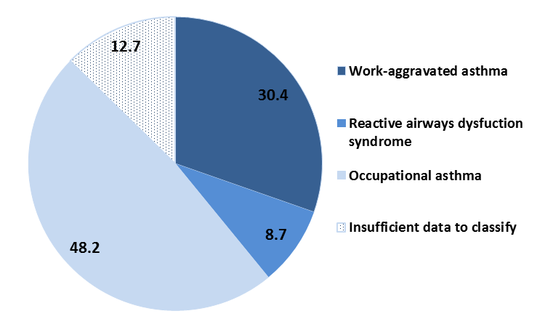
As shown in Table 1, nearly a third (30.4%) of all workers with confirmed WRA were employed in the Health Care and Social Assistance industry sector, mostly in hospitals. Manufacturing accounted for 17.5% of all cases, with cases distributed among many different industries within this sector. Public Administration employed another 11.0% of cases, followed by Educational Services (10.2%). Comparison with the distribution of the Massachusetts workforce (Table 1) suggests that workers in Health Care and Social Assistance, Manufacturing and Public Administration are overrepresented among the confirmed WRA cases. However, given the case-based nature of this surveillance system, it is not known whether these patterns reflect increased risks or better recognition and reporting of cases in these industries.

Table 1. Distribution of confirmed WRA cases by industry, Massachusetts, 2003-2013, N=481

Table 2 presents the occupation groups of the workers with confirmed WRA; example occupations in each group are provided. The largest proportion (29.7%) worked in the major group of Professional and Related occupations. Within this group, nearly half worked as healthcare practitioners or in health technical roles, most frequently as nurses. An additional 27.3% of cases in the Professional and Related group worked in Education, Training and Library occupations, the majority of whom were teachers. One-fifth (20.8%) of workers with confirmed WRA worked in a broad range of Service occupations, followed by Production (15.4%)
Table 2. Distribution of confirmed WRA cases by occupation, Massachusetts, 2003-2013, N=481

and Office and Administrative Support (12.7%) occupations.

During the interviews, workers were asked about the exposures associated with their breathing problems (Figure 2). Up to three suspected agents were recorded for each individual. A total of 957 exposures were recorded, for an average of two per individual.

Worth noting, workers were often unable to identify a specific agent of concern, and instead reported general exposure categories. The most frequently reported exposures were cleaning products (18.0%) and indoor air pollutants (12.9%). Mineral and inorganic dusts, mold and other microorganisms, miscellaneous chemicals, and pyrolysis products were also commonly reported. The distribution of WRA classification varied by exposure category (Figure 2).

Figure 2. Most frequently reported exposures among confirmed cases by WRA classification, Massachusetts, 2003-2013 (N=957)
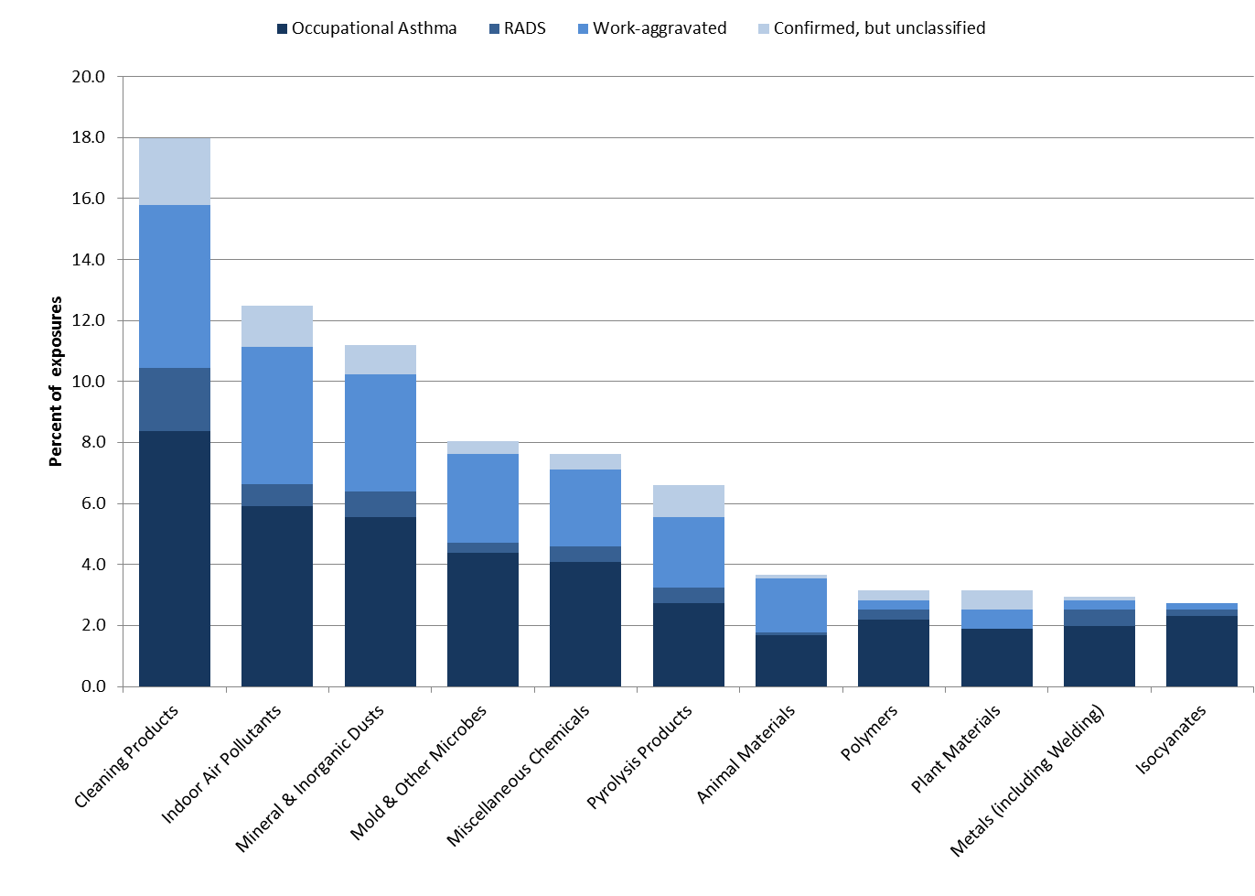
Note: Exposures coded according to Association of Occupational and Environmental Clinics criteria. At least one exposure reported for each case; a maximum of three reported per case.

Known asthma-causing agents (asthmagens) were identified using criteria developed by the Association of Occupational and Environmental Clinics. The most frequently recorded asthmagens were bleach, isocyanates, quaternary ammonium compounds in disinfectants, animals, epoxies, flour, formaldehyde, latex, and ammonia.

Sentinel WRA cases captured by our surveillance system are not necessarily representative of all Massachusetts workers with WRA due to well documented under-recognition and under-reporting of WRA. However, the leading industries, occupations and exposures provide important information about where workers are at risk and workplace conditions that need to be addressed. Summary data on WRA in Massachusetts workers have informed a variety of prevention efforts, including the following:
- Changing requirements for 3rd party certifiers of green cleaning products. Both Green Seal and UL/EcoLogo ensure that cleaning products for a variety of uses do not contain sensitizing asthmagens.
- Heightening awareness of the risks of polyurethane foam for workers who spray insulation into buildings, as well as for residents who may also be exposed.
- Developing guidance on cleaning, sanitizing or disinfecting in healthcare, childcare and in public parks and other public facilities.

Healthcare providers continue to play an essential role in primary and secondary prevention of WRA in Massachusetts. The summary data presented here are a reminder to providers about jobs with exposures that may cause or exacerbate asthma in their patients. Providers should ask each adult patient with asthma about potential associations between symptoms and work., This information can be used by providers to better manage their patients’ asthma, and promote changes in their workplaces that may also protect coworkers. The data also inform broad-based prevention activities of MDPH and public health partners. We urge you to ask your patients about work, and report confirmed and suspected WRA to MDPH.

OSHA and NIOSH HAZARD ALERT:
Silica in countertop work www.osha.gov/Publications/OSHA3768.pdf

OSHA and NIOSH issued a Hazard Alert about the risks of exposure to airborne silica among workers who manufacture, finish and install granite and engineered stone countertops.

- The 8-page Hazard Alert details steps to prevent hazardous silica exposures including water sprays, local exhaust ventilation and personal protective equipment, used in combination. OSHA and NIOSH offer services to assess exposures and controls. Worker education materials are being developed and translated into Spanish and Portuguese.

- Engineered stone such as Silestone, Caesarstone, and others, are 93% silica. Sandstone is 60% and granite is 10-45% silica.
- Very small inhalable crystalline silica particles are generated during manufacturing, finishing and installing natural and manufactured stone countertops. These particles can cause inflammation and scarring in the lungs of workers, leading to increased risk for lung cancer, chronic obstructive pulmonary disease and kidney disease.
- A February 2015 MMWR described a 37-year-old Texas man who developed progressive massive fibrosis after working for an engineered stone countertop company as a polisher, laminator, and fabricator for ten years.
www.cdc.gov/mmwr/preview/mmwrhtml/mm6405a5.htm

http://www.aoec.org/tools.htm
http://www.dol.gov/osha/report/20150304-inequality.htm
Expert Panel Report 3 (EPR-3) Full Report 2007: Guidelines for the Diagnosis and Management of Asthma. http://www.nhlbi.nih.gov/guidelines/asthma/asthgdln.htm
American College of Chest Physicians Consensus Statement. http://chestjournal.chestpubs.org/content/134/3_suppl/1S.full.pdf+html

