Occupational Lung Disease Bulletin, SPRING 2017
New Silica Standards Will Prevent Disease

Dear Health Care Provider,

Silicosis has reemerged in at least two industries. New OSHA standards will help prevent new disease and raise awareness. This Bulletin provides an update about the hazards associated with silica.
Remember to report cases of suspect and confirmed work-related lung disease to us by fax (617) 624-5696 or phone (617) 624-5632. The confidential reporting form is available on our website at www.mass.gov/dph/ohsp.

Sincerely, Elise Pechter MPH, CIH

REMINDER: To receive your Bulletin by e-mail, please send a message to occupational.asthma@state.ma.us

In 2016, the US Occupational Safety and Health Administration (OSHA) issued new workplace standards for silica in general industry/maritime and in construction. The timing is crucial, because silica-related lung disease is back in the news in two very different work settings. Mining through silica-laden stone may be contributing to a resurgence of coal workers pneumoconiosis (black lung disease) which was nearly eradicated 15 years ago. The prevalence of black lung disease fell sharply after the Coal Act of 1969 and reached historic lows in the 1990s. But a cluster of 60 cases identified by one radiologist in eastern Kentucky (2015-6) highlighted new cases and the role silica is playing in this coal disease. The upsurge in black lung disease among US workers is likely associated with slope mining through sandstone, which in Eastern Kentucky is more than 90% quartz— the most common variety of silica.

At the same time, silicosis has been diagnosed in workers in the granite and engineered stone countertop industry both abroad and in the US. Recent articles from Spain, Italy and Israel noted cases of silicosis and impaired pulmonary function among workers who cut and polished countertops in shops without protection from silica dust. ,, In the US, a recent case report described a 37 year-old Hispanic male in Texas who developed silicosis with progressive massive fibrosis after working for 10 years at an engineered stone countertop manufacturer as a polisher, laminator and fabricator. The reemergence of an old hazard indicates that the current control methods in the countertop industry may not be sufficient to prevent disease.

Silicosis

Silicosis is a pneumoconiosis—a dust-related lung fibrotic reaction, which may be localized or diffuse. The onset may be chronic, accelerated, or acute depending on the duration and intensity of exposure. Radiologically, nodules, from microscopic to 1 cm in diameter, usually are seen in the upper lobes of the lungs bilaterally. In severe cases, nodules coalesce and become fibrotic masses several centimeters across. Pulmonary function testing may show restrictive, or mixed obstructive and restrictive patterns, and reduced diffusing capacity. Silicosis may be chronic, occurring 10-30 years after exposure. Acute cases may occur within months after exposure; accelerated cases after a few years. Regardless of onset, silicosis results in lung scarring, productive cough, weight loss, pleuritic pain, and fatigue. Silicosis is incurable and often fatal. Overall cases have declined, but silicosis deaths in young adults (15-44) in the US have not fallen since 1995.

What is silica?

Crystalline silica is ubiquitous in the earth’s crust and silica-containing material is used in a wide range of industries. It is a common component of sand, stone, concrete, brick and mortar. Exposures occur when workplace operations, such as cutting, sawing, drilling, sandblasting or crushing create fine dust, which is very hazardous. Inhalation of tiny particles (1-2 micrometers—100 times smaller than sand on the beach) can cause disabling lung diseases. The American Lung Association estimates that 2 million workers in the US are exposed to silica. Workers can be exposed while working on road refinishing, tunneling, quarries, sandblasting (e.g. on jewelry, metals, denim jeans) glass and brick manufacturing, in foundries, construction, fracking, and in the granite and manufactured stone countertop industry.

Breathing in crystalline silica also increases the risk of developing lung cancer, chronic obstructive pulmonary disease and asthma, as well as kidney disease and autoimmune disorders.

http://www.nbcnews.com/health/health-news/dangerous-dust-government-pushes-improve-workplace-safety-n72121

New OSHA Silica Standards

In 2014, Sean Barrett, 41, testified during hearings about the proposed OSHA silica standards. This Massachusetts terrazzo/ tile worker developed asthma from exposure to dust with silica. Barrett stated that employers often overlook basic safety measures. Workers get used to being surrounded by silica dust. Now he is unable to work in his trade and earning half of what he previously did; his testimony was part of the successful effort to pass the new standards.

In June 2016, the new OSHA silica standard for general industry went into effect; the construction standard will be effective September 2017. The new standards lower the amount of silica allowed in the air during the workday; the new permissible exposure limit is 50 micrograms per cubic meter as an 8-hour time-weighted average, replacing a 1971 rule. The new silica rules cut permissible dust exposures in half for manufacturing workers and even more for construction workers. The new standards require employers to: (1) establish a written exposure control plan, including designating a competent person who is responsible for implementation; (2) provide respirators where needed; (3) restrict housekeeping practices that expose employees to respirable silica; (4) provide medical exams to employees who are required to wear a respirator 30 or more days a year; (5) maintain medical exam records; and (6) communicate the hazard and train affected employees.,

An important aspect of the new standards is the requirement for medical surveillance of all workers exposed over the permissible limit, more than 350,000 workers nationwide, primarily in construction. Baseline TB tests, spirometry performed by NIOSH-certified technicians, and x-ray interpretation by a NIOSH-certified B reader are required. A written medical report summarizing the results must be provided within 30 days of the examination. The standard’s Appendix B provides physicians and other licensed healthcare professionals with information about signs, symptoms, clinical course and guidance. Physicians who evaluate symptomatic silica-exposed patients, or oversee workers exposed to silica should be familiar with silica-related health effects, take a thorough medical and work history and know the employees’ anticipated exposures and assigned personal protective equipment.
While there is no cure, silicosis and other silica-related lung diseases are preventable. Protective measures, such as dust control and respirators, and the policies that support intervention are crucial to prevent disease.

The new standards will result in use of better technology to prevent dust exposure, provide medical surveillance for exposed workers and improve worker protection. OSHA estimates that the new rules will save over 600 lives, prevent more than 900 new cases of silicosis each year, and provide benefits of nearly $8 billion, annually.

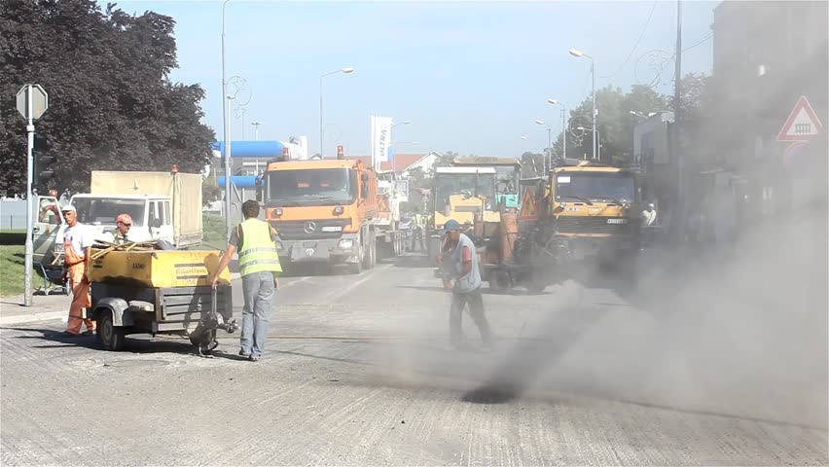
https://www.google.com/search?hl=en&site=imghp&tbm=isch&source=hp&biw=1600&bih=770&q=silica+shutterstock&oq=silica+shutterstock&gs_l=img.3...2017.6269.0.6981.20.11.0.9.0.0.137.756.9j1.10.0....0...1ac.1.64.img..1.9.689.0..0j0i8i30k1j0i30k1j0i24k1j0i10i24k1.o1wjgWaWup0#hl=en&tbm=isch&q=construction+dust+shutterstock&imgrc=8YYEy0aTBQm31M%3A

Blackley DJ, Halldin CN. 2014. Prevalence of a debilitating and entirely preventable respiratory disease among coal miners. Letter to the editor. Am J Resp Crit Care Med 190(6):708-9 http://big.assets.huffingtonpost.com/NIOSHletter.pdf
Blackley DJ, Crum JB, et al. 2016. Resurgence of Progressive Massive Fibrosis in Coal Miners — Eastern Kentucky, 2016. CDC Morbidity and Mortality Weekly Report 65(49) https://www.cdc.gov/mmwr/volumes/65/wr/pdfs/mm6549a1.pdf
https://www.osha.gov/Publications/OSHA3768.pdf
Grubstein A et al. Radiological evaluation of artificial stone silicosis outbreak: emphasizing findings in lung transplant recipients. J Comput Assist Tomogr 2016. DOI: 10.1097/RCT.0000000000000454
Ophir N et al. Artificial stone dust-induced functional and inflammatory abnormalities in exposed workers monitored quantitatively by biometrics. ERJ Open Research 2016
Friedman GK, Harrison R et al 2015. Notes from the Field: Silicosis in a countertop fabricator—Texas, 2014. MMWR 64(5);129-130. https://www.cdc.gov/Mmwr/preview/mmwrhtml/mm6405a5.htm
Leung CC et al. 2012. Silicosis. Lancet 379:2008-18.
http://www.lung.org/lung-health-and-diseases/lung-disease-lookup/silicosis/learn-about-silicosis.html
Hnizdo E et al. 2003. Chronic obstructive pulmonary disease due to occupational exposure to silica dust: a review of epidemiological and pathological evidence. Occup Environ Med 60:237-242
Maeda M et al. 2010. Dysregulation of the immune system caused by silica and asbestos. Jour Immunotox 7(4):268-278
https://bacweb.org/train_edu_safety/safetyhealth/silica/mar_2014/docs/OSHA%20Testimony%20Sean%20Barrett.pdf
http://www.nbcnews.com/health/health-news/dangerous-dust-government-pushes-improve-workplace-safety-n72121
OSHA https://www.osha.gov/silica/
OSHA https://www.osha.gov/Publications/OSHA3902.pdf
https://www.osha.gov/silica/AppendixBtosect1910.1053.pdf

