Spring 2023 2022
First Do No Harm

Quality & Patient Safety Division Massachusetts Board of Registration in Medicine

In This Issue

Message from QPSD Leadership
Booker T. Bush, MD Daniela Brown, MSN, RN, CIC
Chair, Quality & Patient Safety Committee Director, Quality & Patient Safety Division

Dear Colleagues,

The provision of safe, effective care to patients has become increasingly complex in the current healthcare environment. We recognize that optimizing the safe and effective delivery of patient care requires a multidisciplinary team approach. It is essential that the knowledge and expertise of each member of the multidisciplinary team be maximally utilized. Promoting collaboration among colleagues, teamwork is crucial to creating an environment whereby patients receive safe, effective, high-quality care.

The Agency of Healthcare Research and Quality (AHRQ) has provided teamwork tools that are evidenced-based in their TeamSTEPPS curriculum. TeamSTEPPS (TeamSTEPPS® | Agency for Healthcare Research and Quality (ahrq.gov) is one resource healthcare facilities may use to improve communication and collaboration among team members. There are several other resources available to assist and support healthcare facilities in promoting teamwork. The QPSD encourages facilities to research evidenced-based tools and resources as they embark on foundational learning and planning for organizational implementation. It is also recommended that healthcare facilities consider utilizing Culture of Safety survey and employee satisfaction survey results, as well as input from employees during leadership rounding and patient safety huddles, to tailor team-based initiatives to the issues and opportunities regarding teamwork and communication identified by the healthcare facility’s own staff.

In this issue, we offer examples of teamwork efforts at several of the Massachusetts hospitals that report to the QPSD. We also have provided an overview of our own approach to teamwork between the members of the QPSD and the Board’s Quality and Patient Safety (QPS) Committee. The QPS Committee members are volunteers who support the work and mission of the QPSD. Members of the Committee include physicians representing several specialties as well as representatives from nursing, pharmacy, and patient advocacy. A list of current members can be found on page nine of this newsletter.

It is with great enthusiasm that the QPS Committee is pleased to announce the appointment of Yvonne Cheung, MD, MPH, MBA, as Vice Chair of the QPS Committee. Dr. Cheung has been a member since 2020 and is currently the Associate Chief Medical Officer and Vice President of Quality and Safety at Newton-Wellesley Hospital. We would also like to thank Leslie Selbovitz, MD, who has served as Vice Chair of the Committee for the past three years, for his time, expertise, and dedication to the work of the Committee. We are fortunate that Dr. Selbovitz will remain on the Committee as a valued member.

Lastly, there are several advancements planned to improve efficiency related to Patient Care Assessment reporting. The proposed changes were communicated via an email message in February to the Patient Care Assessment Coordinators and to the Chief Medical Officers of the healthcare facilities that report to the QPSD. Thank you to the health care facilities that provided feedback. It is our hope to improve the user experience and reduce the administrative burden related to reporting. Additional information will be communicated in the coming weeks.

Best Regards,

Booker T. Bush, MD, Chair, QPSC and Daniela Brown, RN, Director, QPSD

Ldlddldd

Dddd

- Message from the QPSD
Leadership
- QPSD Team Approach
3 Baystate Medical Center
5 Boston Medical Center
8 Signature Healthcare
9 QPS Committee Member List
9 Noted Trend

Quality & Patient Safety Division
Massachusetts Board of Registration in Medicine
Team Approach to SQR Report Review
Trinh Ly-Lucas, MSN, AGNP-BC, Quality Nurse Analyst
Erin C. Long, MSN, RN, Quality Nurse Analyst
Dorothy Doweiko, MHA, BSN, RN, Quality Nurse Analyst
Mali Gunaratne, QPSD Program Coordinator
Daniela Brown, MSN, RN, CIC, Director

The members of the Board of Registration in Medicine’s Quality and Patient Safety Division (BORIM QPSD) are impressed by the work being done in healthcare facilities across the Commonwealth to improve the quality of care delivered to patients. The QPSD, like many of the facilities that report to us, utilizes a team-based approach for many of our own work processes. Capitalizing on our team members’ individual strengths and experiences, our division is positioned to accomplish our goals set forth in the Division’s mission.

One aspect of our work involves reviewing Safety Quality Review (SQR) reports submitted to the QPSD. SQR reports are reports of unexpected patient outcomes and are required as part of a healthcare facility’s Patient Care Assessment (PCA) program. The PCA program is a program of quality assurance, risk management, peer review, and credentialing. The goal of the PCA program is to ensure that healthcare facilities within the Commonwealth are continually improving and implementing system-related changes, where appropriate. Information, and records necessary to comply with the PCA program, and necessary to the work product of medical peer review committees, including major incident reports required to be submitted to the Board, are afforded statutory confidentiality protections. (M.G.L. c. 111, § 204 & 205).
Of note, the QPSD does NOT share any reports or information related to regulatory reporting with other divisions of the Board. It is also important to note that when submitting SQR reports, only de-identified credentialed provider information is to be included. The QPSD is interested in the healthcare facility’s internal and peer review processes and not in the individual providers. Clinician names are not to be included the SQR reports submitted to the QPSD.

SQR reports assist the QPSD in understanding an institution’s quality assurance processes. The SQR reports are processed and coded by our Program Coordinator before they are reviewed by a nurse analyst. At times, there is information that is missing or questions that arise upon review of the report. These reports are reviewed and discussed at the weekly QPSD team meeting.

SQR reports requiring additional consideration may also be submitted to the Quality Patient Safety Committee (QPSC) members for review. The QPSC is a subcommittee of the Board that is comprised primarily of volunteer physician colleagues and includes two nurses (including a PCA Coordinator), a pharmacist, and a patient advocate. A list of current members may be found on page nine. Reports are referred for QPS Committee member for review if the event is of a greater complexity and/or may benefit from additional perspectives. Through a collaborative team process, the QPSD and the QPSC, review and discuss select reports and generate recommendations and/or requests for additional information. This robust review process ensures that the reviews are comprehensive and include multi-disciplinary viewpoints. Graph 1 represents the annual volume of SQR reports.

Graph 1. Volume of SQR Reports by Year
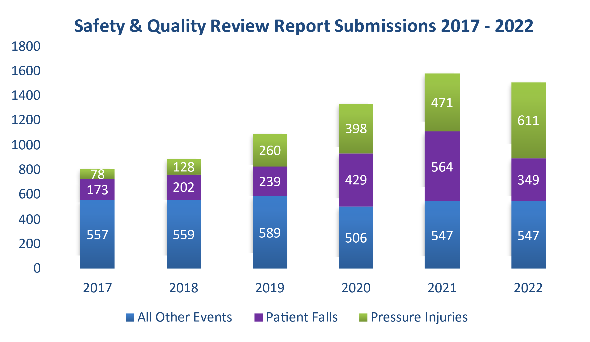
Graph 2 represents the frequency in which follow-up of the SQR reports occurs. The dark blue bar represents the percentage of reports in which the QPSD requested additional information from healthcare facilities. As shown,
in 2022, the QPSD requested additional information for 11% of all SQR reports submitted. The light blue bar represents the percentage of reports that were referred to the Quality and Patient Safety Committee for review.

The gray bar represents the percentage of reports in which a meeting between QPS Committee members and the healthcare facility was requested. This is a small number, however the number of meetings nearly doubled from CY2021 to CY 2022. This is felt to be due to the QPSD receiving reports that appear to be of a higher complexity than previous years as well as feedback that many new quality and risk management colleagues are now submitting reports. Graph 3 represents the types of events referred to the QPS Committee in the past two years.

Graph 2. Percentage of SQR Reports Requiring Follow-up

Meetings between the QPSC members and healthcare facilities are intended to be collegial and collaborative bidirectional discussions focused primarily on system level perspectives and less so on one event. The meeting provides an opportunity for the QPSD and the healthcare facility leaders to share perspectives and learn more about each other’s role in supporting patient safety and positive patient outcomes . Often, the relationship between the healthcare facility and the QPSD is strengthened after the meeting. It is important to note that the QPSD does NOT share information with other divisions of the Board. The QPSD does not discipline individual physicians or regulate their licensure.

The QPSD aims to be collaborative and educational when working with health care facilities, specifically their physician and administrative leaders, to ensure compliance with PCA regulations which apply to all health care facilities licensed by the DPH including hospitals and ambulatory clinics.

Graph 3. Event Types Referred to the QPS Committee

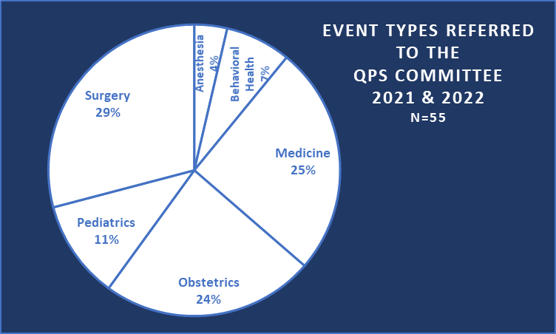

The QPSD is motivated by its philosophy of positive and collegial collaboration both within the division and with all our external stakeholders, including acute and non-acute care facilities. Please do not hesitate to reach out to your nurse analyst with any questions, comments, or concerns.

Questions and comments may be directed to
Daniela Brown

Quality & Patient Safety Division
Massachusetts Board of Registration in Medicine

daniela.brown@mass.gov

Baystate Medical Center
Daily Management System: A Foundational Platform to Advance Patient Safety
Lisa Demko, VP, Operations Excellence and
Karen Johnson, RN, BSN, CCMSCP, Sr. Director, Patient Safety Baystate Health

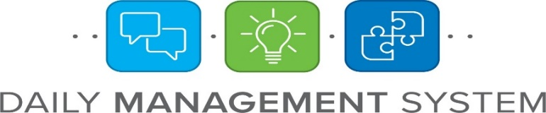

Daily Management System, commonly referred to as DMS, is a structure used to manage daily work, monitor performance, and continuously improve by engaging and empowering team members in collaborative problem solving. In December 2021, Baystate Health began to implement their Daily Management System. One goal was to improve patient safety. As noted in a New England Journal of Medicine article, Health Care Safety during the Pandemic and Beyond-Building a System That Ensures Resilience (Fleisher et al., 2022), “The fact that the pandemic degraded patient safety so quickly and severely suggests our healthcare system lacks a sufficiently resilient safety culture and infrastructure.”

DMS is the most comprehensive and rigorous approach to achieving high reliability used to date at Baystate Health. It gives leaders and team members skills and behaviors to proactively engage our workforce in improvement and sustaining advancements, harnessing the power of everyone to achieve our goals. DMS can be summarized in three simple concepts: it creates transparency, drives accountability, and leverages problem-solving with continuous improvement to make things better.

DMS bolsters and advances a culture of safety through continuous improvement, where safety is embedded in every step of the process, with clear metrics that are aggregated, assessed, and acted upon.

Key components of the DMS include Tiered Huddles and Visual Management. These two components support transparency, daily accountability, and communication. Every day, tiered huddles, short, fast-paced meetings, take place where the teams throughout the system

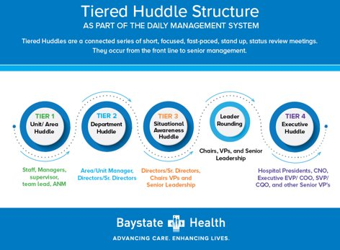

review performance measures, surface operational issues, discuss readiness, identify issues requiring escalations, and empower each other through meaningful problem solving. These huddles interlock staff and leadership accountability.

Tier 1 huddles occur at the unit/area level and includes front-line staff with their leader. Tier 1 huddles continue to be where prevention and correction occurs, where problems are identified for resolution or escalation, and where Tier 1 leaders engage and develop their staff in problem-solving. Tier 2 is the directors/senior director meeting with unit/area-based leadership where key process indicators are reviewed, daily challenges are discussed, best practices are shared, and standards are reviewed for gap identification, created, and reinforced.
Tier 3 is a situational awareness huddle that operational leaders participate with senior leaders which includes metrics encompassing the entire hospital. This huddle continues to promote cross-functional accountability and problem solving of issues with multi-departmental impact. Tier 3 members are the leaders that conduct Leader Rounding. Leader Rounding is a structured yet informal and psychologically safe mechanism for front line staff to interact with leaders, with a focus on safety and quality so that leaders can better provide support to those closest to the work.

Tier 4 is the senior most leaders in the organization with the focus on system-wide strategic operations and initiatives and addressing escalations from Tier 3.

Tier 1 Huddle
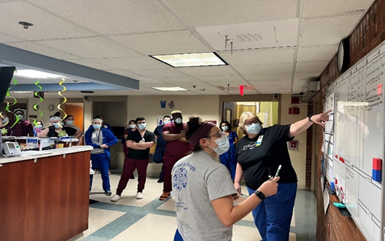

To date, Baystate Medical Center has implemented Tier 1 huddles in 29 areas for multiple shifts, including Nursing units, Cardiac unit, Surgical units, Critical Care Units, Women’s units, Pharmacy, Transfer Center, Social Work and Case Management. There are currently seven Tier 2 huddles and one Tier 3 huddle at each of our four Baystate Health hospitals. There is one Senior Leader Tier 4 Huddle for Baystate Health.

Tier 2 Huddle
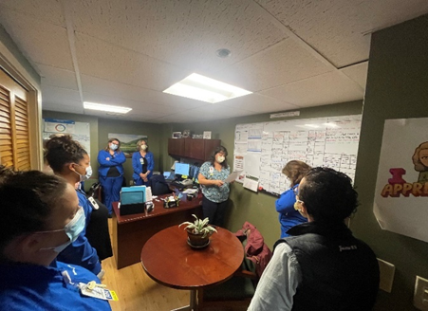

Tier 1 Huddle Board
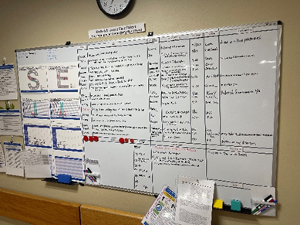

At each huddle, teams share good catches. An issue related to management of diabetic patients and prevention of DKA was raised at a Tier 1 & 2 huddles and brought to the Tier 3 huddle where a team was formally chartered. This team has worked on revision of clinical practice guidelines and development of an EMR alert and PowerPlans to improve care of this high-risk patient population. Data collection processes have been established and education material developed. Status updates are provided back to Tier 3 Huddles and communicated thru the tiered huddles.

As communication, issues, good catches, and recognitions flow throughout the DMS tiered huddles, we are seeing breakdowns in operational silos and interprofessional collaboration that has led to impactful issue resolution and problem solving. In year two of our DMS journey, we will work to mature current practices and continue to spread throughout all of Baystate Health.

Lisa Demko: Lisa.demko@baystatehealth.org
Karen Johnson: Karen.johnson@baystatehealth.org

References:
Fleisher, L.A., Schreiber, M., Cardo, D., & Srinivasan, A. (2022). Health Care Safety during the Pandemic and Beyond — Building a System That Ensures Resilience. N Engl J Med (386),609-611. https://doi.org/10.1056/NEJMp2118285

Boston Medical Center
Our team-based approach to quality improvement
Karolina Brook, MD, Director, Quality & Safety
R. Mauricio Gonzalez, MD, Vice Chair, Clinical Affairs
Department of Anesthesiology, Boston Medical Center
Department of Anesthesiology, Boston University School of Medicine, Boston, MA

Our anesthesiology department has a relatively unique history in that it was served by a private practice from 1999 to 2019, when it became a clinical academic department within our hospital medical group. Since that time, we have implemented several quality and safety initiatives in our department, anchored on the framework of promoting Just Culture and maintaining psychological safety.

The vision statement for our quality and safety activities is to have a hospital with no preventable harm - emphasizing hospital, recognizing that our department works symbiotically with many other departments. The corresponding mission statement is that everyone - including residents, nurse anesthetists and anesthesiologists, and not just our quality leaders - are all working together as part of a team to achieve our vision statement.

In our department, we like to view all quality initiatives as a “house” of quality (see Figure 1). Notably, the quality home’s foundation is data collection, which fundamentally drives all our other quality activities. To that end, to increase data collection, we have implemented two large projects in the last three years. Hospital-wide, we use the RL6 incident reporting system (RL Datix, Chicago, Illinois) for adverse event reporting. RL6 is geared towards reporting near misses, events that cause patient harm and events that are related to inter-departmental or system-wide issues. We had noticed very low levels of reporting by members of our anesthesiology department; we identified that part of the issue was that most anesthesia-related events were scattered throughout the RL6 system and required the provider to “hunt” for them, which took time and effort. Additionally, all the events reported had minimal granularity and were categorized simply as “Anesthesia-related” or “Complications of anesthesia”, limiting in-depth data analysis without extensive manual recategorization.

Consequently, we worked with our Information Technology (IT) team , as well as Laura Harrington and the Quality and Safety team at Boston Medical Center, and created a new Anesthesia RL6 tile that now contains all the anesthesia-related events that exist in one location (see Figure 2). Since the rollout of the anesthesia icon, we have seen a 13-fold increase in RL6 events reported per month. As many quality leaders know, an increase in reports reflects a good culture of safety and comfort in the members of the department to report issues. Additionally, we now have the ability to analyze the data more effectively, looking at both major categories (e.g. Respiratory, Cardiac) and subcategories (e.g. Difficult airway, Myocardial infarction), which allows us to assess for any trends and develop new quality initiatives.

Not all unanticipated events reach the threshold for reporting to RL6. In our opinion, these represent lost opportunities to engage in sound practice-based learning and meaningful quality improvement. To fill that void, we worked with hospital leadership, the IT team, and an outside vendor to implement a mandatory Quality Assurance (QA) form to be completed for every anesthetic (see Figure 3). This QA form launches directly from the post-operative navigator of the electronic anesthesia record, without the need for additional logins. Each anesthesia record necessitates the selection of the “no event” option or documentation of an adverse event. An attestation of completion is required prior to closing the anesthesia encounter. The information collected via the QA form is kept outside the patient’s medical record in a secure server, under peer review protection. Aside from the technical aspects of completing the form, emphasis during training was placed on the power of reporting and transparency in shoring up our culture of safety.

Consequently, the initiative has been wholly embraced, and
strengthened the notion that everyone in the Department plays a key role in achieving our safety vision. This tool went live in October 2022, and we are now starting to collect data. We plan to use the knowledge we gain to analyze trends and develop targeted quality improvement projects.

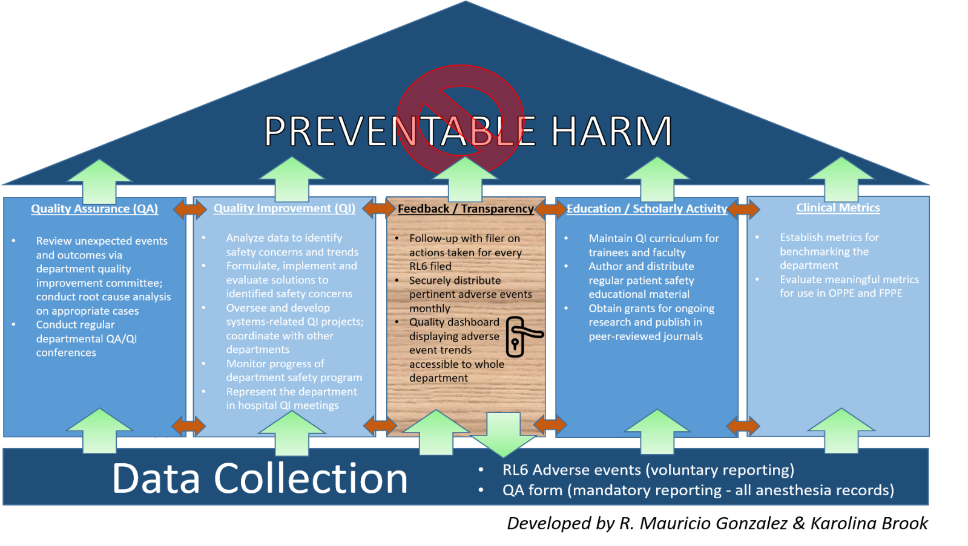

Transparency and trust fostered by closed loop communication between the Quality leaders and the frontline providers are critical for the success of the program. Consequently, we established formal channels to feed the knowledge acquired from reviewing and analyzing the data back to all members of the Department. Two of such channels are already in place: a monthly patient safety newsletter (which includes a video on a patient safety topic), and a monthly report of adverse events and near misses. We recently received a hospital Patient Safety Grant to create a Departmental Quality Dashboard to display the most common events reported, as well as actions targeting the most impactful ones.

We are excited by our growing quality division and anticipate new and innovative quality projects from our department.

Figures:

Figure 1: Our departments “quality home”.
Abbreviations: QA (Quality Assurance); QI (Quality Improvement); FPPE (Focused Professional Practice Evaluation); OPPE (Ongoing Professional Practice Evaluation)

Figure 2: Anesthesia RL6 tile.

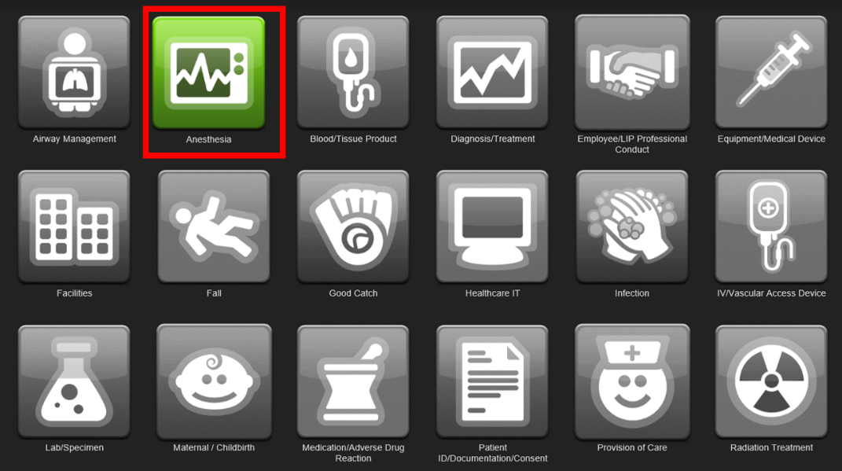

Figure 3a: Anesthesia QA form opens from Post-Procedure tab in Epic.

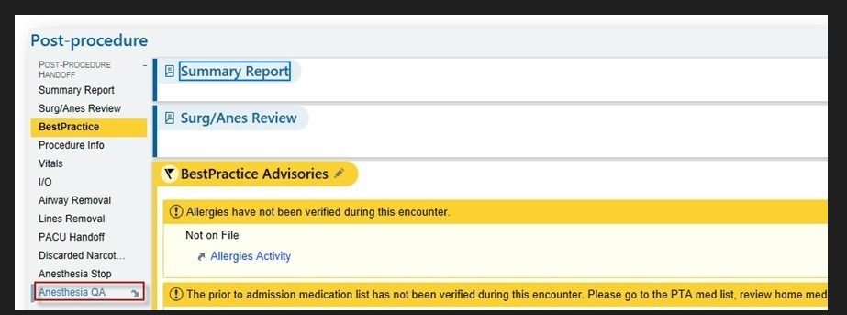

Figure 3b: When users document ‘Yes’, a large list of major and minor categories opens up. Filling out the form requires just several clicks.

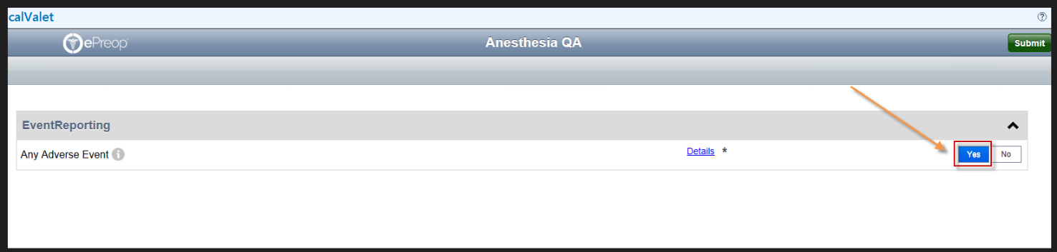

Figure 3c: An example of a major category (“Administrative”) with several subcategories.

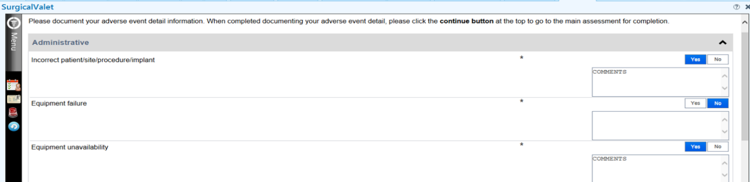

Signature Healthcare
Re-envision, Refresh, and Renew
Melissa A. DeMayo, MSN, RN, LNC
VP of Quality, Chief Quality Officer
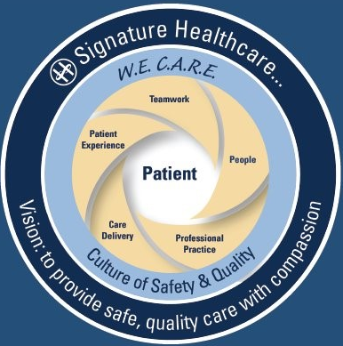

Does anyone contest that the COVID-19 pandemic changed healthcare? How we responded to events during this time left an indelible impact on our organizations. Our team at Signature Healthcare was subtly eroded in the aftermath. Uncharacteristic of our independent, community-based organization, we became less tolerant and caring toward each other, and sometimes, even toward our patients. There was a desire to understand how this happened.

Like many other organizations, we experienced high staff and provider turn-over in the past two years, heavily relying on temporary help to fill the clinical and leadership gaps. Not only was this reliance on agency staff and contractors budget-crushing, but our teams were quite literally fractured. The direct result of these structural breaks was the palpable loss of connection with each other, and
anecdotally, the disruption of native teams negatively affected the Staff’s satisfaction and sense of belonging.

In response to these dynamics, our CEO called leaders to action. We are tasked with re-rebuilding our teams, picking up the pieces and moving forward to strengthen relationships not only at the point of patient care, but throughout the organization.

We started our organization’s fiscal year with a new and aspirational vision statement. It is refreshing, on-point, and elegant in its simplicity. We want to provide safe, quality care with compassion. To be sure, having a new vision statement is energizing, though, on its own, not nearly enough to create and sustain a cultural change.

Therefore, a point person was named to coordinate our on-going teamwork efforts, and focused work began. Marketing put our new vision into a graphic model that depicts how we want to wrap our collective teams around each patient we serve. The visual has several components anchored in a new-found understanding of Relationship-Based Care®. Part of this understanding came from the results of our CEO’s interviews with the front-line staff where we discovered a collective desire to focus on teamwork; people as individuals; professional practice and opportunity; safe and effective care delivery, and cultivating the patient experience. We hope our visual model reflects this!

Additionally, we refreshed our WeCare values and Culture of Safety (COS) Tones and Tools, taking these historical models on our aspirational journey into the future. They fit nicely into the plan and vision, as WeCare values represent our being Welcoming, showing Empathy, Compassion, Accountability, Respect, and Excellence in everything we do. Our COS “Tones and Tools” support these values and structure communication processes across the organization. Staff with institutional knowledge of the values and COS behaviors will be called upon to reinforce them and the common language and behavior expectations they provide.

Maturity of our teams also depends on structural support, starting with modeling at the executive level. Strategic goals are set and include the formation of Triads across the organization. Medicine, Nursing/Operations, and Quality are forming tight working relationships, meeting frequently and showing unity to the frontlines. They are using meaningful and relevant data to drive team goal setting for their own units and departments with respect for the fact that those closest to the work know best how to improve it.

A nursing unit volunteered to pilot opportunities for staff to share ideas and have input into decisions that impact workflow and patient care. These staff are working together toward continuous improvement, posting statistics, and updating huddle boards at scheduled intervals, keeping the work visible to all of us. Again, we are directing a small shift in a long-standing system (Lean Management) by taking from the manager and putting onus on the team doing the work to solve problems and improve outcomes.

Signature Healthcare is coming into a new space. We emerge now from a crippling healthcare crisis and look forward to a brighter future with shared vision under unified leadership. We cultivate caring relationships and teamwork throughout our organization. We define behavior expectations, identify meaningful goals, and build upon our strengths to become a place where staff want to work, and want to stay, a place where teams deliver safe, quality care with compassion.

QPS Committee Member | Specialty
Booker T. Bush, MD, Chair | Internal Medicine
Yvonne Y. Cheung, MD, MPH, MBA, Vice Chair | Anesthesiology
James V. Bono, MD | Orthopedic Surgery
Audrey C. Bosse, Patient Advocate | Patient Advocate
Michelle Chan, RPh | Board of Pharmacy
Sarah Rae Easter, MD | Obstetrics/Gynecology, Maternal Fetal Medicine, Critical Care
Diane Hanley, MSN, RN-BC, EJD | Board of Nursing
Michael E. Henry, MD | Psychiatry
Karen M. Johnson, BSN, RN, CCMSCP | PCA Coordinator Representative
Pardon R. Kenney MD, MMSc, FACS | General Surgery
Arthur M. Lauretano, MD, MS, FACS | Otolaryngologist, Informatics
Julian N. Robinson, MD | Obstetrics/Gynecology, Maternal Fetal Medicine
Marc S. Rubin, MD | General Surgery
Leslie G. Selbovitz, MD | Internal Medicine
Melissa Sundberg, MD, MPH | Pediatric Emergency Medicine
Meghna C. Trivedi, MD, FACP, FHM | Hospitalist Medicine

Noted Trends: Medications and Fluids

The QPSD has recently received several Safety and Quality Review (SQR) Reports involving medication-related events. Examples include:

- IV pumps programmed with the incorrect concentration or volume to be administered
- Unintended boluses of high-risk medications such as anticoagulants, vasodilators, and vasopressors both on and off IV pumps
- Insulin administered via incorrect syringes (U-100, U-500, and tuberculin syringes) resulting in incorrect dose
- Inadvertent repeat administration of medications in high-risk areas due to lack of communication and documentation resulting in incorrect dosages
- IV contrast administered to incorrect patient or to patient with known allergy to IV contrast

These events are occurring primarily in high-risk areas such as intensive care, procedural areas such as the operating room and interventional areas, and the emergency department.
QPSD recommends increased awareness of high-risk medications policies, re-education on IV pump usage and pause points when alerted by pump, ensuring IV lines are labeled, and ensuring timely and thorough documentation and communication especially during of transitions of care.

.

This newsletter is issued by the Board of Registration in Medicine (BORIM), Division of Quality and Patient Safety (QPSD). The newsletter allows BORIM to share the practices and experiences of the healthcare clinicians and facilities that report to the Board. It does not necessarily include a comprehensive review of literature. Publication of this newsletter does not constitute an endorsement by the BORIM of any practices described in the newsletter and none should be inferred.

