**2022**

Massachusetts Board of Registration in Medicine

Quality & Patient Safety Division

Spring 2025 **2022**

Spotlight on Quality & Patient Safety

*Spotlight on Quality & Patient Safety* is issued by the Massachusetts Board of Registration in Medicine Quality & Patient Safety Division (QPSD) to share aggregate Safety and Quality Review (SQR) report data and to share performance improvement initiatives being achieved by some of the hospitals, ambulatory surgery centers, and clinics in the Commonwealth. The QPSD would like to thank **Boston Medical Center** for contributing to this issue of *Spotlight*.

As part of regulatory reporting, healthcare organizations submit events of unexpected patient outcomes (SQR reports) to the QPSD. The first graph represents a breakdown of the major categories reported via SQR submissions. There were 574 SQR reports submitted in the calendar year (CY) 2024. Within those 574 SQR reports, 692 events were reported. This is because some reports included more than one event. Additional aggregate data is also provided. Trends noted in SQR reporting are listed on page nine.

**Save the Date:** **The 2025 BORIM QUALITY & PATIENT SAFETY COMMITTEE CONFERENCE.**

**See page 9 for details!**

**BE FEATURED IN THE FALL 2025 SPOTLIGHT**

If you/your healthcare facility are interested in submitting an article for publication,

please reach out to Trinh Ly-Lucas, MSN, AGNP-BC

[Trinh.ly-lucas@mass.gov](mailto:Trinh.ly-lucas@mass.gov)

Trinh Ly-Lucas, MSN, AGNP-BC

[Trinh.ly-lucas@mass.gov](mailto:Trinh.ly-lucas@mass.gov)











Questions and comments may be directed to

Trinh Ly-Lucas, MSN, AGNP-BC

Quality Nurse Analyst

Quality & Patient Safety Division

Massachusetts Board of Registration in Medicine

[trinh.ly-lucas@mass.gov](mailto:trinh.ly-lucas@mass.gov)

QPS Committee members (Front l, r) William Goodman, MD; Booker T. Bush, MD; Yvonne Y. Cheung, MD, Diane Hanley, RN; Sarah Rae Easter, MD, (Back l, r) Julian N. Robinson, MD; Melissa Sundberg, MD; Pardon Kenney, MD; Michelle Chan, RPh; Michael Henry, MD.

Missing from photo: Marc S. Rubin, MD, Leslie Selbovitz, MD; Meghna Trivedi, MD; Karen Johnson, RN

Patient Care Assessment (PCA) program and online reporting guidance including video tutorials, examples of fictitious SQR reports, and an overview of Patient Care Assessment may be found at:

[Patient Care Assessment Program | Mass.gov](https://www.mass.gov/patient-care-assessment-program)

**PATIENT SAFETY ALERT: CENTRAL LINE-RELATED EVENTS**

**In the fall of 2024, the QPSD provided the advisory below regarding events related to central line insertions. In the three months that followed, QPSD received eleven (11) additional reports of adverse events involving central lines.**

**The QPSD is appreciative of the additional education provided by Boston Medical Center in this issue. Please consider distributing the alert and the article to high-risk areas such as interventional radiology, operating rooms, and intensive care units.**

The QPSD has received several reports of events involving central line insertions. These events are occurring in interventional areas and at the bedside. The events include:

* **Retained foreign objects: guidewires**
* **Wrong site procedure: lines inserted into an artery instead of a vein, when the error was not corrected before the line was utilized.**
* **Complications: neurologic injury, arterial injury, pneumothorax, tracheal injury, and perforation of adjacent structures.**

Recommendations:

* Utilize line insertion checklist. Consider audit of checklists.
* Standardize the use of ultrasound for vessel localization and guiding the needle to its intended venous location.
* Maintain hold of the guidewire while it is inside the patient.
* Announce ‘Guidewire is out” when it has been completely removed.
* Utilize a standardized equipment set for insertion and an appropriately stocked line cart.
* Select the smallest size catheter appropriate for the clinical situation.
* Ensure the post insertion CXR is completed, and the results are communicated and documented BEFORE use.
* Consider the implementation of central venous access line teams if possible.

Resources:

Agency for Healthcare Research and Quality. Central Line Insertion Care Team Checklist. [Central Line Insertion Care Team Checklist | Agency for Healthcare Research and Quality (ahrq.gov)](https://www.ahrq.gov/hai/patient-safety-resources/cli-checklist/index.html)

Kolikof J, Peterson K, Baker AM. Central Venous Catheter. [Updated 2023 Jul 26]. In: StatPearls [Internet]. Treasure Island (FL): StatPearls Publishing; 2024 Jan-. Available from: https://www.ncbi.nlm.nih.gov/books/NBK557798/ [Central Venous Catheter - StatPearls - NCBI Bookshelf (nih.gov)](https://www.ncbi.nlm.nih.gov/books/NBK557798/)

Practice Guidelines for Central Venous Access 2020: **An Updated Report by the American Society of Anesthesiologists Task Force on Central Venous Access**. *Anesthesiology* 2020; 132:8–43 doi: <https://doi.org/10.1097/ALN.0000000000002864>



**SPOTLIGHT: Boston Medical Center**

**Hospital-wide Standardization of Central Venous Catheter Techniques, Training, and Credentialing**

**Jeffrey J. Siracuse, MD, MBA,** Associate Chair of Surgery for Quality and Patient Safety and Chief of Vascular and Endovascular Surgery

**Alik Farber, MD, MBA,** Chair of Surgery and Surgeon-in-Chief

**David McAneny, MD,** Chief Medical Officer

**Sabine Clasen, PHD, MSN, RN,** Senior Quality and Patient Safety Specialist

Central venous catheter (CVC) placement, for intravenous or hemodialysis access, can be associated with a range of adverse events, including infection, thrombosis, or mechanical complications. The last group includes arterial or venous injury, unintended arterial placement, catheter malposition, hematoma, and pneumothorax or hemothorax. An inadvertent arterial placement can cause adverse consequences such as bleeding, stroke, and harm to adjacent structures, requiring a major operation or intervention to remove the catheter and repair the injury. During a two-year period, we observed a higher-than-expected rate (7.2 versus 1.5-4.6 per 1,000 patients) of vascular mechanical complications following CVC placements. This experience prompted the development of a program for targeted improvement across all specialties that place CVCs.

In 2021, a multidisciplinary group, comprised of specialists who place CVCs, standardized CVC insertion techniques, training, and institutional privileging for attending surgeons and physicians, advanced practice providers (APP), and trainees (fellows and residents). The curriculum requires viewing a video with an imbedded exam that was created internally, a *hands-on* simulation module with expert assessment, and hospital-based clinical proctoring (Figure 1). 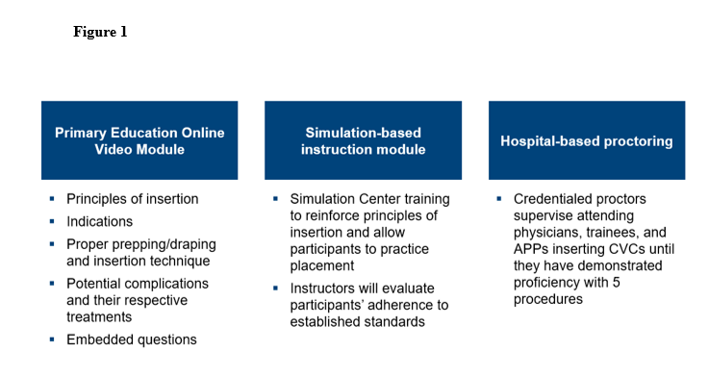

We also designed a three-tiered credentialing framework, based upon the candidate’s specialty and experience (Figure 2).

We also designed a three-tiered credentialing framework, based upon the candidate’s specialty and experience (Figure 2).

Spotlight on Quality & Patient Safety

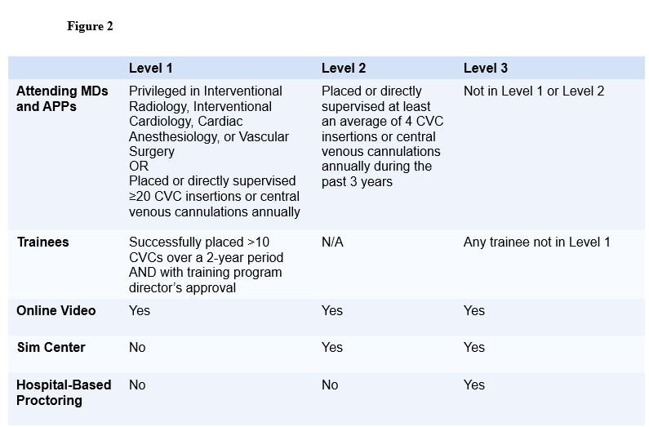

A quality committee oversees outcomes and adjudicates cases as needed. A recredentialing process was also designed with recredentialing predicated on a minimum number of CVCs placed annually and complication rates. Since program enrollment began in October 2023, nearly 200 attending physicians and APPs have completed the program and been credentialed for placing CVCs. Importantly, no mechanical vascular CVC complications have occurred following implementation of this protocol. This experience affirms that standardization of CVC techniques, training, and credentialing is possible and is associated with improved patient safety. Our next steps include finishing credentialing of trainees as well as ongoing monitoring.

This issue is provided by the Board of Registration in Medicine (BORIM), Division of Quality and Patient Safety (QPSD). The issue allows BORIM to share the practices and experiences of the healthcare clinicians and facilities that report to the QPSD. It does not necessarily include a comprehensive review of literature. Publication of this issue does not constitute an endorsement by the BORIM of any practices described in the issue and none should be inferred.

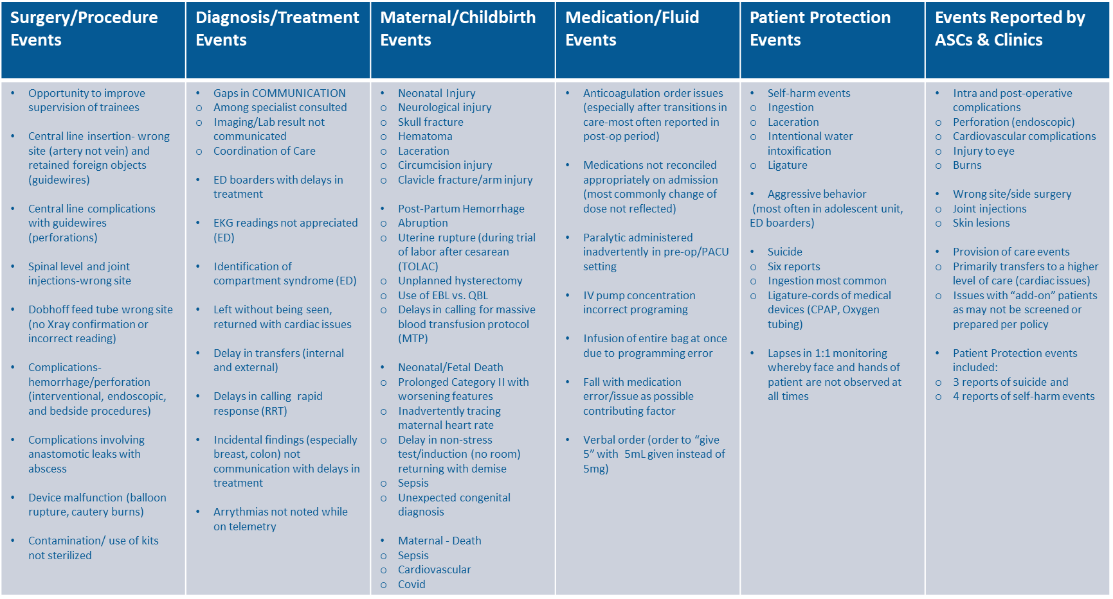

*Trends Noted in 2024 SQR Reporting Summary*

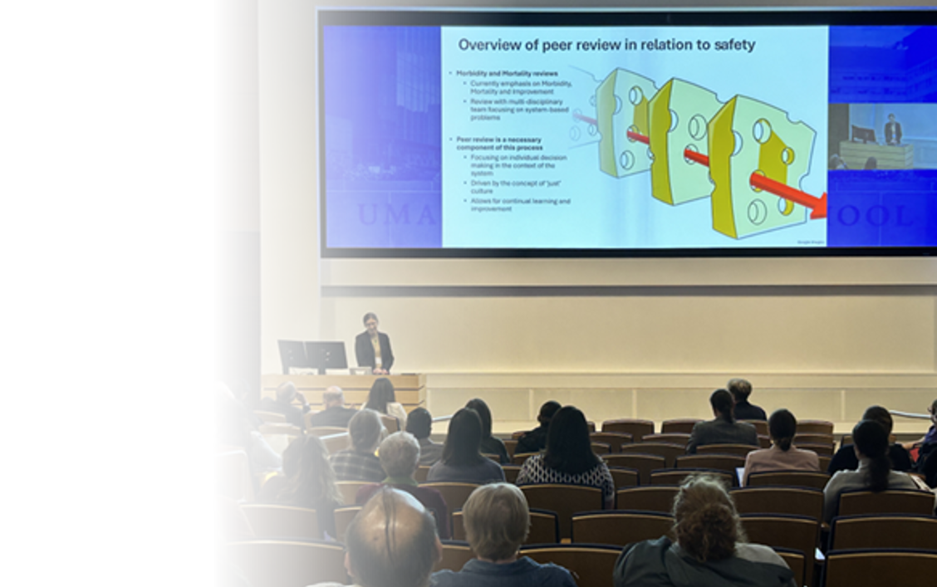

**The 2025 BORIM QUALITY & PATIENT SAFETY COMMITTEE CONFERENCE**

Save the date: October 17, 2025

Full-day conference

More information will be provided this summer.

Registration is NOT currently open.

Chief Executive Officers, Chief Medical Officers, Chief Quality Officers, PCA Coordinators, and Quality and Risk Management colleagues that report to the QPSD will have priority registration. If space is available, conference will be open to all others.