INDOOR AIR QUALITY ASSESSMENT

Spring Street Elementary School
2 Spring Street
West Bridgewater, MA

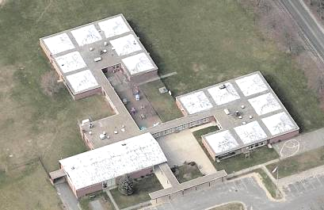

Prepared by:
Massachusetts Department of Public Health
Bureau of Environmental Health
Indoor Air Quality Program
July 2014

Background/Introduction
At the request of Julie Hamblin, Director of Buildings and Grounds for West Bridgewater Public Schools, the Massachusetts Department of Public Health (MDPH), Bureau of Environmental Health (BEH) provided assistance and consultation regarding indoor air quality (IAQ) at the Spring Street Elementary School, 2 Spring Street, West Bridgewater, Massachusetts. On February 7, 2014, Sharon Lee, an Environmental Analyst within BEH’s IAQ Program, visited the school to perform a general IAQ assessment. BEH/IAQ staff previously visited the building on June 24, 2013 to conduct a limited assessment. Conditions and recommendations made at that time are available in a previously released report (MDPH, 2013). Appendix A shows the recommendations from the 2013 report and actions that have been taken.
The school is a one-story brick building constructed in 1960. The school contains general classrooms, several resource rooms, office space, and cafeteria. Windows throughout the building are openable.

Methods
Air tests for carbon monoxide, carbon dioxide, temperature and relative humidity were conducted with the TSI, Q-Trak, IAQ Monitor, Model 7565. Air tests for airborne particle matter with a diameter less than 2.5 micrometers were taken with the TSI, DUSTTRAK™ Aerosol Monitor Model 8520. BEH/IAQ staff also performed visual inspection of building materials for water damage and/or microbial growth.

Results
The school houses approximately 150 students in grades pre-kindergarten to kindergarten with a staff of approximately 25. Tests were conducted under normal operating conditions, and results appear in Table 1.

Discussion

Ventilation
It can be seen from Table 1 that carbon dioxide levels were above 800 parts per million (ppm) in 4 of 8 areas at the time of assessment, indicating less than optimal air exchange in half of the areas surveyed. Most classrooms do not have any mechanical ventilation to provide fresh air, instead rely on openable windows and passive vents located above the door (Picture 1). Cross ventilation can be created when windows on opposing sides of the building are open, allowing movement of air through the passive vents.
In many classrooms, exhaust ventilation is provided by exhaust openings located in closets. Some of these units are switch-activated (Picture 2); however, they were not operating at the time of assessment. Exhaust ventilation is necessary for reducing the accumulation of normally-occurring indoor pollutants, including water vapor from occupants/respiration. Operating the exhaust system can also increase the draw of fresh air in through open windows or passive vents. Blockages to ventilation should be removed to allow for adequate airflow.
Window-mounted air conditioners were observed in a few areas. When operating in the “fan only” mode, these units can provide a limited amount of fresh air and increase airflow. BEH/IAQ staff examined air-conditioning units and observed filters occluded with dust/debris. Filters should be cleaned as per manufacturer’s recommendations or more frequently if needed.
One classroom was retrofitted with an air-handling unit (AHU; Pictures 3 and 4). Air is provided by a supply vent and returned to the AHU via a return vent. At the time of assessment, the return vent appeared to be backdrafting, indicating that air from the outside is penetrating into the building. This system should be operated continuously during school hours to ensure the provision of fresh air and prevent backdrafting.
To maximize air exchange, the MDPH recommends that both supply and exhaust ventilation operate continuously during periods of occupancy. In order to have proper ventilation with a mechanical supply and exhaust system, the systems must be balanced to provide an adequate amount of fresh air to the interior of a room while removing stale air from the room. It is recommended that HVAC systems be re-balanced every five years to ensure adequate air systems function (SMACNA, 1994). The last balancing of these systems was not known at the time of assessment.
Minimum design ventilation rates are mandated by the Massachusetts State Building Code (MSBC). Until 2011, the minimum ventilation rate in Massachusetts was higher for both occupied office spaces and general classrooms, with similar requirements for other occupied spaces (BOCA, 1993). The current version of the MSBC, promulgated in 2011 by the State Board of Building Regulations and Standards (SBBRS), adopted the 2009 International Mechanical Code (IMC) to set minimum ventilation rates. Please note that the MSBC is a minimum standard that is not health-based. At lower rates of cubic feet per minute (cfm) per occupant of fresh air, carbon dioxide levels would be expected to rise significantly. A ventilation rate of 20 cfm per occupant of fresh air provides optimal air exchange resulting in carbon dioxide levels at or below 800 ppm in the indoor environment in each area measured. MDPH recommends that carbon dioxide levels be maintained at 800 ppm or below. This is because most environmental and occupational health scientists involved with research on IAQ and health effects have documented significant increases in indoor air quality complaints and/or health effects when carbon dioxide levels rise above the MDPH guidelines of 800 ppm for schools, office buildings and other occupied spaces (Sundell et al., 2011). The ventilation must be on at all times that the room is occupied. Providing adequate fresh air ventilation with open windows and maintaining the temperature in the comfort range during the cold weather season is impractical. Mechanical ventilation is usually required to provide adequate fresh air ventilation.
Carbon dioxide is not a problem in and of itself. It is used as an indicator of the adequacy of the fresh air ventilation. As carbon dioxide levels rise, it indicates that the ventilating system is malfunctioning or the design occupancy of the room is being exceeded. When this happens, a buildup of common indoor air pollutants can occur, leading to discomfort or health complaints. The Occupational Safety and Health Administration (OSHA) standard for carbon dioxide is 5,000 parts per million parts of air (ppm). Workers may be exposed to this level for 40 hours/week, based on a time-weighted average (OSHA, 1997).
The MDPH uses a guideline of 800 ppm for publicly occupied buildings. A guideline of 600 ppm or less is preferred in schools due to the fact that the majority of occupants are young and considered to be a more sensitive population in the evaluation of environmental health status. Inadequate ventilation and/or elevated temperatures are major causes of complaints such as respiratory, eye, nose and throat irritation, lethargy and headaches. For more information concerning carbon dioxide, consult Appendix B.
Indoor temperature measurements the day of assessment ranged from 68F to 72F (Table 1), which were within or very close to the MDPH recommended comfort range. The MDPH recommends that indoor air temperatures be maintained in a range of 70F to 78F in order to provide for the comfort of building occupants. In many cases concerning indoor air quality, fluctuations of temperature in occupied spaces are typically experienced, even in a building with an adequate fresh air supply. In addition, it is difficult to control temperature and maintain comfort without operating the ventilation equipment as designed (e.g., exhaust vents deactivated/obstructed).
The indoor relative humidity measured during the assessment ranged from 21 to 34 percent, which was below the MDPH recommended comfort range (Table 1). The MDPH recommends a comfort range of 40 to 60 percent for indoor relative humidity. Relative humidity levels in the building would be expected to drop during the winter months due to heating. The sensation of dryness and irritation is common in a low relative humidity environment. Low relative humidity is a very common problem during the heating season in the northeast part of the United States.

Microbial/Moisture Concern
As mentioned, BEH/IAQ staff previously visited the building to assess conditions related to water intrusion through heating ductwork in some areas of the building. At the time of the previous assessment, BEH/IAQ staff recommended that filter medium be installed to prevent the distribution of materials from the heating ductwork (MDPH, 2013). The filters were in place at the time of the current assessment (Picture 5).
The school is built directly on slab. In some areas, gypsum wallboard (GW) is used to create walls/dividers. Slight musty odors were observed in these areas. During the summertime, condensation that forms on the floor can be drawn up into the GW. Vinyl coving used along the base of the wall prevents air movement and drying of wet GW. Repeated exposure of GW to moisture without adequate drying can result in microbial growth. At the time of the assessment, BEH/IAQ staff recommended that a couple of inches of GW be removed at the base of the walls, and the vinyl coving be joined to the floors. This would prevent repeated moistening of GW, while maintaining the integrity of the walls.
The US Environmental Protection Agency (US EPA) and the American Conference of Governmental Industrial Hygienists (ACGIH) recommend that porous materials be dried with fans and heating within 24 to 48 hours of becoming wet (US EPA, 2001; ACGIH, 1989). If not dried within this time frame, mold growth may occur. Once mold has colonized porous materials, they are difficult to clean and should be removed/discarded.
An examination of the building exterior revealed missing mortar in a few areas (Picture 6). Breaches can allow water to penetrate the building. Continued degradation of brick/mortar can also result in damage to exterior walls/structural supports. A damaged gutter can also contribute to degradation of the building’s exterior (Picture 7). Gutters should be repaired to ensure proper drainage of water away from the building.
Plants were observed on heating unit diffusers (Picture 8). Plants can be a source of pollen and mold which can be respiratory irritants to some individuals. Plants should be properly maintained and equipped with drip pans. They should also be located away from diffusers to prevent the aerosolization and distribution of dirt, pollen, and mold.

Other IAQ Evaluations
Indoor air quality can be negatively influenced by the presence of respiratory irritants, such as products of combustion. The process of combustion produces a number of pollutants. Common combustion emissions include carbon monoxide, carbon dioxide, water vapor, and smoke (fine airborne particle material). Of these materials, exposure to carbon monoxide and particulate matter with a diameter of 2.5 micrometers (μm) or less (PM2.5) can produce immediate, acute health effects upon exposure. To determine whether combustion products were present in the indoor environment, BEH/IAQ staff obtained measurements for carbon monoxide and PM2.5.

Carbon Monoxide
Carbon monoxide is a by-product of incomplete combustion of organic matter (e.g., gasoline, wood, and tobacco). Exposure to carbon monoxide can produce immediate and acute health effects. Several air quality standards have been established to address carbon monoxide and prevent symptoms from exposure to these substances. The MDPH established a corrective action level concerning carbon monoxide in ice skating rinks that use fossil-fueled ice resurfacing equipment. If an operator of an indoor ice rink measures a carbon monoxide level over 30 ppm, taken 20 minutes after resurfacing within a rink, that operator must take actions to reduce carbon monoxide levels (MDPH, 1997).
The American Society of Heating Refrigeration and Air-Conditioning Engineers (ASHRAE) has adopted the National Ambient Air Quality Standards (NAAQS) as one set of criteria for assessing indoor air quality and monitoring of fresh air introduced by HVAC systems (ASHRAE, 1989). The NAAQS are standards established by the US EPA to protect the public health from six criteria pollutants, including carbon monoxide and particulate matter (US EPA, 2006). As recommended by ASHRAE, pollutant levels of fresh air introduced to a building should not exceed the NAAQS levels (ASHRAE, 1989). The NAAQS were adopted by reference in the Building Officials & Code Administrators (BOCA) National Mechanical Code of 1993 (BOCA, 1993), which is now an HVAC standard included in the Massachusetts State Building Code (SBBRS, 2011). According to the NAAQS, carbon monoxide levels in outdoor air should not exceed 9 ppm in an eight-hour average (US EPA, 2006).
Carbon monoxide should not be present in a typical, indoor environment. If it is present, indoor carbon monoxide levels should be less than or equal to outdoor levels. On the day of assessment, outdoor carbon monoxide concentrations were measured at 1.5 ppm (Table 1). No measurable levels of carbon monoxide were detected inside the building (Table 1).

Particulate Matter
The US EPA has established NAAQS limits for exposure to particulate matter. Particulate matter includes airborne solids that can be irritating to the eyes, nose, and throat. The NAAQS originally established exposure limits to PM with a diameter of 10 μm or less (PM10). In 1997, US EPA established a more protective standard for fine airborne particulate matter with a diameter of 2.5 μm or less (PM2.5). This more stringent PM2.5 standard requires outdoor air particle levels be maintained below 35 μg/m³ over a 24-hour average (US EPA, 2006). Although both the ASHRAE standard and BOCA Code adopted the PM10 standard for evaluating air quality, MDPH uses the more protective PM2.5 standard for evaluating airborne PM concentrations in the indoor environment.
Outdoor PM2.5 concentrations were measured at 12 μg/m³ (Table 1). PM2.5 levels measured in the school ranged from 6 to 15 μg/m³ (Table 1), which were below the NAAQS PM2.5 level of 35 μg/m³. Frequently, indoor air levels of particulates (including PM2.5) can be at higher levels than those measured outdoors. A number of activities that occur indoors and/or mechanical devices can generate particulate matter during normal operations. Sources of indoor airborne particulates may include but are not limited to particles generated during the operation of fan belts in the HVAC system, use of stoves and/or microwave ovens in kitchen areas; use of photocopiers, fax machines and computer printing devices; operation of an ordinary vacuum cleaner and heavy foot traffic indoors.

Volatile Organic Compounds
Indoor air concentrations can be greatly impacted by the use of products containing volatile organic compounds (VOCs). VOCs are carbon-containing substances that have the ability to evaporate at room temperature. Frequently, exposure to low levels of total VOCs (TVOCs) may produce eye, nose, throat, and/or respiratory irritation in some sensitive individuals. For example, chemicals evaporating from a paint can stored at room temperature would most likely contain VOCs. In an effort to identify materials that can potentially increase indoor VOC concentrations, BEH/IAQ staff examined rooms for products containing these respiratory irritants.
Cleaning products were found in some classrooms. Cleaning products contain chemicals that can be irritating to the eyes, nose and throat of sensitive individuals. These products should be properly labeled and stored in an area inaccessible to children. Additionally, a material safety data sheet (MSDS) should be available at a central location for each product in the event of an emergency. Consideration should be given to providing teaching staff with school-issued cleaning products and supplies to ensure that MSDS information is available for all products used at the school and to prevent chemical interactions between janitorial cleaners and cleaners brought in by others.

Other Conditions
Fans were observed in the cafeteria at the time of the assessment (and in other areas during the previous visit). Dust/debris can collect along the edges of fan blades. When re-activated, fans can re-aerosolize the accumulated dust/debris and be a source of eye and respiratory irritation.

Conclusions/Recommendations
In view of the findings at the time of the visit, the following is recommended:
- Remove all blockages/items from the surface of heat diffusers to ensure adequate airflow.
- Continue maintaining filtration material installed directly below the air diffuser.
- Consider operating window-mounted air-conditioning units as a means for providing fresh filtered air.
- Use openable windows to supplement fresh air in classrooms as necessary. Opening windows on opposite sides of the building can create cross-ventilation to improve airflow within the school. Ensure that all windows opened are equipped with intact screens to prevent insect entry and that all windows are closed at the end of each day to prevent security issues and freezing of pipes in colder weather.
- Operate all exhaust vents to ensure removal of air and typical indoor air pollutants from classrooms. Ensure switch-activated exhaust fans are turned on during the school day. Ensure airflow is not obstructed by stored items.
- For buildings in New England, periods of low relative humidity during the winter are often unavoidable. Therefore, scrupulous cleaning practices should be adopted to minimize common indoor air contaminants whose irritant effects can be enhanced when the relative humidity is low. To control dusts, a high efficiency particulate arrestance (HEPA) filter equipped vacuum cleaner in conjunction with wet wiping of all surfaces is recommended. Avoid the use of feather dusters. Drinking water during the day can help ease some symptoms associated with a dry environment (throat and sinus irritations).
- If not already completed, consider removing 1 to 2 inches of GW from the base of the walls to prevent condensation from the slab being drawn into the GW and repeated water damage to GW. If GW is removed, ensure the baseboard wall coving is adhered to the slab, creating a continuous wall.
- Examine and repair missing mortar from the building exterior to prevent water penetration and damage.
- Repair damaged gutters to allow proper drainage of water away from the building.
- Relocate plants away from the air diffusers to prevent aerosolization of mold and debris.
- Store cleaning products properly and out of reach of students. Ensure spray bottles are properly labeled. All cleaning products used at the facility should be approved by the school department with MSDS available at a central location. Consider providing teaching staff with approved cleaning products.
- Clean fans periodically to prevent dust settled on the unit from being re-aerosolized.
- Consider adopting the US EPA (2000) document, “Tools for Schools.” This document is available at: http://www.epa.gov/iaq/schools/index.html.
- Refer to MDPH’s resource manuals and other related indoor air quality documents located on the department’s website for further building-wide evaluations and advice on maintaining public buildings. These documents are available at: http://mass.gov/dph/iaq.

References
ACGIH. 1989. Guidelines for the Assessment of Bioaerosols in the Indoor Environment. American Conference of Governmental Industrial Hygienists, Cincinnati, OH.
ASHRAE. 1989. Ventilation for Acceptable Indoor Air Quality. American Society of Heating, Refrigeration and Air Conditioning Engineers. ANSI/ASHRAE 62-1989.
BOCA. 1993. The BOCA National Mechanical Code/1993. 8th ed. Building Officials and Code Administrators International, Inc., Country Club Hill, IL.
MDPH. 1997. Requirements to Maintain Air Quality in Indoor Skating Rinks (State Sanitary Code, Chapter XI). 105 CMR 675.000. Massachusetts Department of Public Health, Boston, MA.
MDPH. 2013. Indoor Air Quality Assessment: Spring Street School. Available at http://www.mass.gov/eohhs/docs/dph/environmental/iaq/2013/west-bridgewater-spring-st-school-oct-2013.pdf.
OSHA. 1997. Limits for Air Contaminants. Occupational Safety and Health Administration. Code of Federal Regulations. 29 C.F.R 1910.1000 Table Z-1-A.
SMACNA. 1994. HVAC Systems Commissioning Manual. 1st ed. Sheet Metal and Air Conditioning Contractors’ National Association, Inc., Chantilly, VA.
Sundell, et. al., 2011. Sundell, J., H. Levin, W. W. Nazaroff, W. S. Cain, W. J. Fisk, D. T. Grimsrud, F. Gyntelberg, Y. Li, A. K. Persily, A. C. Pickering, J. M. Samet, J. D. Spengler, S. T. Taylor, and C. J. Weschler. 2011. Ventilation rates and health: multidisciplinary review of the scientific literature. Indoor Air, Volume 21: pp 191–204.
US EPA. 2000. Tools for Schools. Office of Air and Radiation, Office of Radiation and Indoor Air, Indoor Environments Division (6609J). EPA 402-K-95-001, Second Edition. http://www.epa.gov/iaq/schools/actionkit.html.
US EPA. 2001. Mold Remediation in Schools and Commercial Buildings. US Environmental Protection Agency, Office of Air and Radiation, Indoor Environments Division, Washington, D.C. EPA 402-K-01-001. March 2001.
US EPA. 2006. National Ambient Air Quality Standards (NAAQS). US Environmental Protection Agency, Office of Air Quality Planning and Standards, Washington, DC. http://www.epa.gov/air/criteria.html.
Picture 1

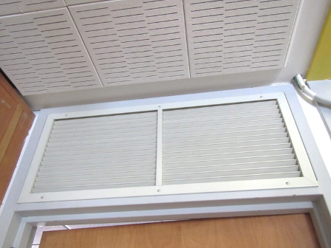

Passive vent above door

Picture 2

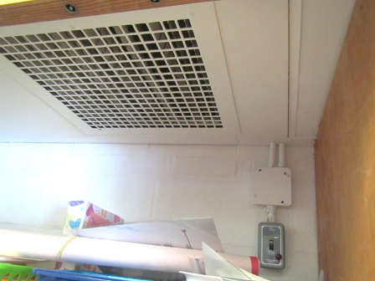

Switch-activated exhaust fan

Picture 3

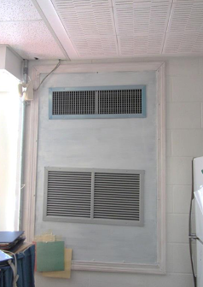

AHU supply (top) and return (bottom) vents

Picture 4

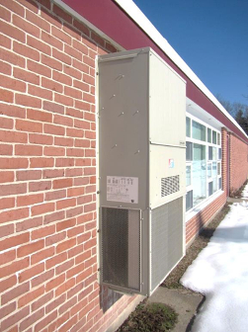

AHU

Picture 5

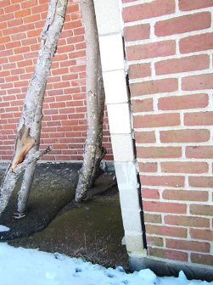

Missing mortar on exterior wall

Picture 6

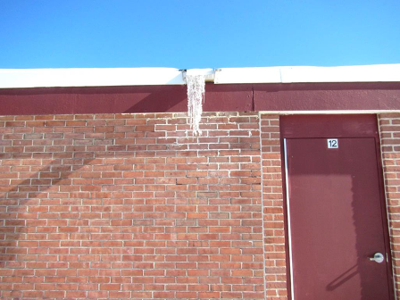

Damaged gutter

Picture 7

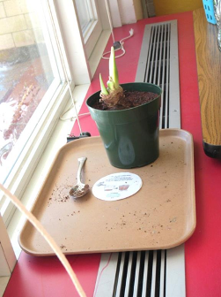

Plants on air diffuser

Location | Carbon  Dioxide  (ppm) | Carbon Monoxide  (ppm) | Temp  (°F) | Relative  Humidity  (%) | PM2.5  (µg/m³) | Occupants  in Room | Windows  Openable | Ventilation |  | Remarks
 |  |  |  |  |  |  |  | Supply | Exhaust | Remarks
Background | 349 | 1.5 | 40 | 13 | 12
B2 | 452 | ND | 72 | 21 | 6 | 0 | Y | Y  Passive
B3 | 812 | ND | 70 | 27 | 9 | 25 | Y | Y  Passive | Y  BD | CPs, plants, DO, AHU
B4 | 664 | ND | 68 | 34 | 15 | 13 | Y | Y  Passive | Y  Off | CPs, plant on diffuser
C2 | 997 | ND | 69 | 26 | 8 | 20 | Y | Y  Passive | Y | WAC
C3 | 997 | ND | 69 | 26 | 8 | 0 | Y | Y  Passive | Y | Items, WAC
C4 | 725 | ND | 70 | 27 | 8 | 3 | Y | Y  Passive | Y | Items, WAC
C5 | 1240 | ND | 70 | 28 | 9 | 15 | Y | Y  Passive | Y | WAC
Cafeteria | 738 | ND | 68 | 23 | 9 | 25 | Y | Y | Y | DO, fan

Actions on MDPH Recommendations at
Spring St. Elementary School, West Bridgewater, MA

The following is a status report of action(s) taken on MDPH recommendations made in the October 2013 MDPH report (in bold) based on reports from school officials, maintenance staff, and MDPH staff observations made during the February 2014 visit.
- Remove all blockages/items from the surface of heat diffusers and return vents (along front/bottom) to ensure adequate airflow.
Action: Staff are reportedly told to remove items placed on heat diffusers. At the time of the assessment, items were observed on some classroom diffusers.

- Vacuum the interior of ductwork with equipment fitted with a high-efficiency particulate air (HEPA) filter. Cleaning should be conducted periodically to prevent accumulation of dirt/dust, which can be a source of irritation.
Action: Ductwork is reportedly vacuumed periodically to prevent buildup of dust.

- Consider installing filtration material directly below the diffuser to allow removal of larger materials that may be accumulated in the ductwork. Please note, filtration can reduce the airflow. Take care to ensure enough heated air penetrates the classroom.
Action: BEH/IAQ staff observed filter medium in place at the time of assessment (Picture 1).

- Use openable windows to supplement fresh air in classrooms as necessary. Ensure that all windows opened are equipped with intact screens to prevent insect entry and that all windows are closed at the end of each day to prevent security issues and freezing of pipes in colder weather.
Action: Windows are reportedly used to supplement airflow during warmer weather, since the majority of the building is not equipped with mechanical ventilation.

Picture 1

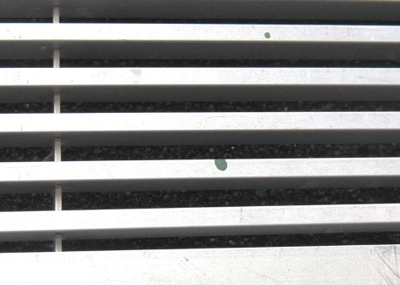

Filter media installed below air diffuser

