|  |
| --- |
| INDOOR AIR QUALITY ASSESSMENT  **Spring Street School**  **2 Spring Street**  **West Bridgewater, Massachusetts**  *Aerial view of the Spring Street Elementary School; 2 Spring Street, West Bridgewater, Massachusetts*  Prepared by:  Massachusetts Department of Public Health  Bureau of Environmental Health  Indoor Air Quality Program  November 2015 |

**Background**

|  |  |
| --- | --- |
| **Building:** | Spring Street School (SS) |
| **Address:** | 2 Spring Street, West Bridgewater, MA |
| **Assessment Requested by:** | Julie Hamblin, Director of Facilities  Town of West Bridgewater |
| **Date of Assessment:** | October 30, 2015 |
| **Bureau of Environmental Health/Indoor Air Quality (BEH/IAQ) Program Staff Conducting Assessment:** | Ruth Alfasso, Environmental Engineer/Inspector |
| **Date of Building Construction:** | 1958 |
| **Reason for Request:** | Odors/general assessment |

**Building Description**

The SS is a one-story brick building constructed in 1958; the most recent renovation was performed in 1995. The school contains general classrooms, several resource rooms, office space, and a cafeteria. Windows throughout the building are openable.

# Results and Discussion

Approximately 120 students in pre-kindergarten and kindergarten occupy this space, as well as approximately 25 staff including some administration offices for the district. Test results are presented in Table 1. Methods and indoor air related sampling information can be found in the IAQ Manual and Appendices for IAQ Reports, which can be found at:

<http://www.mass.gov/eohhs/gov/departments/dph/programs/environmental-health/exposure-topics/iaq/iaq-rpts/general-appendices-for-iaq-reports.html>

Note that this building had previously been visited by the BEH/IAQ program in 2014 to perform a general IAQ inspection. The report from that visits can also be accessed on the IAQ website.

Note that the focus for this most recent visit is an intermittent odor that was reported in the classroom areas of the school. The odor was not present on the day of the assessment; therefore the source could not be located. School officials had been working on a variety of measures to track and eliminate the odor, including testing and repairing plumbing, cleaning of grease traps and other efforts. Since the odor was sometimes described as “sewer-like”, a smoke test of the sewer and vent system occurred following the IAQ assessment. This test showed that the likely source of odors was a cleanout with a hole its cap as well as improperly capped piping in the wall of the kindergarten. Ms. Hamblin reported that repair of these issues was underway.

## Ventilation

It can be seen from Table 1 that carbon dioxide levels were above 800 parts per million (ppm) in 8 out of 18 areas surveyed, indicating a lack of ventilation in about half the areas tested, mostly in classrooms. The majority of classrooms do not have mechanical ventilation to provide fresh air, and instead rely on openable windows and passive vents located in walls (Picture 1). Cross ventilation can be created when windows on opposing sides of the building are open, allowing movement of air through the passive vents.

Classroom exhaust ventilation was originally designed to be provided by exhaust openings located in closets. These units were not operating at the time of assessment and are reported to have been turned off. Exhaust ventilation is also present, and was found to be operating in the restrooms located inside classrooms. Exhaust ventilation is necessary for reducing the accumulation of normally-occurring indoor pollutants, including water vapor from occupants/respiration. Operating the exhaust system can also increase the draw of fresh air through open windows and passive vents.

One of the classroom areas was retrofitted with an air-handling unit (AHU; Picture 2). Air is provided by a supply vent and returned to the AHU via a return vent. This system should be operated continuously during school hours to ensure provision of fresh air and prevent backdrafting. It was reported that due to allergy concerns in the area served by this AHU, it was recently fitted with a MERV (Minimum Efficiency Rating Value) 11 filter (Picture 3). The dust spot efficiency is the ability of a filter to remove particulate matter of a certain diameter from air passing through the filter. Filters that have been determined by the American Society of Heating, Air-conditioning Engineers (ASHRAE) to meet its standard for a dust spot efficiency of a minimum of 40 percent are considered sufficient to reduce many airborne particulates (Thornburg, 2000; MEHRC, 1997; ASHRAE, 1992); this would conform to a MERV 9 filter which is the minimum typically recommended in schools and commercial buildings. A MERV 11 filter would remove more and smaller particles, including dust. Note however, that the housing has accumulations of dust and debris which may become entrained in the air supply by short-circuiting the filter. Filter housings should be cleaned and filters changed at least twice a year.

Window-mounted air conditioners were observed in a few areas (Picture 4). When operating in the “fan only” mode, these units can provide a limited amount of fresh air and increase airflow. Filters should be cleaned as per manufacturer’s recommendations or more frequently if needed.

## Temperature and Relative Humidity

Indoor temperature measurements ranged from 70°F to 72°F (Table 1), which were within the MDPH recommended comfort range. The MDPH recommends that indoor air temperatures be maintained in a range of 70°F to 78°F in order to provide for the comfort of building occupants.

Indoor relative humidity ranged from 25 to 49 percent (Table 1); more than half were below the MDPH comfort range. The MDPH recommends a comfort range of 40 to 60 percent for indoor air relative humidity. Relative humidity levels in the building would be expected to drop during winter months due to heating. The sensation of dryness and irritation is common in a low relative humidity environment. Low relative humidity is a very common problem during the heating season in the northeast part of the United States.

## Microbial/Moisture Concerns

Water-damaged ceiling tiles were observed in some areas (Picture 5; Table 1). These likely originate from intermittent roof leaks. The roof is scheduled for replacement over the summer of 2016. An area of wet carpeting and staining was observed adjacent to a door to the outside of one of the classrooms (Picture 6). This was reportedly the result of roof drainage issues during heavy rains the day before the visit. The US Environmental Protection Agency (US EPA) and the American Conference of Governmental Industrial Hygienists (ACGIH) recommend that porous materials (e.g., carpeting, gypsum wallboard) be dried with fans and heating within 24 to 48 hours of becoming wet (US EPA, 2001; ACGIH, 1989). If not dried within this time frame, mold growth may occur. Once mold has colonized porous materials, they are difficult to clean and should be removed.

In the hallway/enclosed breezeway from the main office area to the classroom area, a faint musty odor was noted. The breezeway floor is directly on slab, which will be colder than the air inside during warmer weather, and may be prone to condensation. This area is currently carpeted, reportedly because of slippery conditions created due to condensation that had occurred on the floor when it was tiled. There are also signs of water penetration due to wind-driven rain, in the form of damaged paint at the top of the walls. Although a dehumidification unit has recently been added to this area (Picture 7) to help reduce humidity and the potential for condensation, it is likely that the carpeting has been repeatedly moistened and mold-colonized, and will need to be replaced. In general, carpeting should not be used in areas subject to chronic moistening.

An additional dehumidification unit was observed in a classroom as well. These units need to be regularly drained and maintained so that they don’t become a source of leaks/spills and odors from stagnant water.

The exterior of the building was examined for potential water penetration and drainage issues. Plants were seen to be growing very close to the exterior, including long grass outside a fire door which may prevent it from closing properly (Picture 8), and vines up against the foundation and near windows (Picture 9). Plants hold water against the building, and the growth of roots may cause and widen cracks in foundation, brick and other parts of the building envelope, allowing for penetration of water and pests. In addition, plants can be a source of pollen or mold that may enter through windows or air intakes. Plants should be trimmed away from the building about five feet.

Indoor plants were also observed in some areas, which can introduce pollen or mold indoors (Table 1). Plants should be kept away from sources of airflow which may distribute particles, pollen, mold and odors. Plants should be properly maintained, over-watering of plants should be avoided and drip pans should be inspected periodically for mold growth and cleaned or replaced as necessary.

Water dispensing equipment was observed in carpeted areas (Table 1). Spills or leaks from this equipment can moisten carpet and lead to microbial growth and carpet degradation.

Some sinks were found to have backsplashes which had gaps where water can penetrate the seam and cause damage to underlying wood. These should be repaired with appropriate caulking material.

## Other IAQ Evaluations

IAQ can be negatively influenced by the presence of respiratory irritants, such as products of combustion. The process of combustion produces a number of pollutants. Common combustion emissions include carbon monoxide, carbon dioxide, water vapor, and smoke (fine airborne particle material). Of these materials, exposure to carbon monoxide and particulate matter with a diameter of 2.5 micrometers (μm) or less (PM2.5) can produce immediate, acute health effects upon exposure. To determine whether combustion products were present in the indoor environment, BEH/IAQ staff obtained measurements for carbon monoxide and PM2.5

### Carbon Monoxide

*Carbon monoxide should not be present in a typical, indoor environment.* If it *is* present, indoor carbon monoxide levels should be less than or equal to outdoor levels. Carbon monoxide levels outdoors were measured at 1.1 ppm likely from traffic. Low levels of carbon monoxide of 1 ppm or less were detected inside the building during the assessment.

### Particulate Matter

Outdoor PM2.5 concentrations were measured at 30 μg/m3 (Table 1), which were below the NAAQS limit of 35 μg/m3. Indoor PM2.5 levels ranged from 1 to 28 μg/m3 (Table 1), which were also below the NAAQS PM2.5 level of 35 μg/m3. Frequently, indoor air levels of particulate matter (including PM2.5) can be at higher levels than those measured outdoors.

### Volatile Organic Compounds (VOCs)

Exposure to low levels of total VOCs (TVOCs) may produce eye, nose, throat and/or respiratory irritation in some sensitive individuals. In order to determine if VOCs were present, BEH/IAQ staff examined rooms for products containing VOCs. BEH/IAQ staff noted air fresheners, hand sanitizer, cleaners (Picture 10) and dry erase materials in use within the space (Table 1). All of these have the potential to be irritants to the eyes, nose, throat and respiratory system of sensitive individuals.

## Other Concerns

Other conditions that can affect IAQ were observed during the assessment. Some personal fans and vents were observed to be dusty (Picture 11). Dust on these items can be reaerosolized and cause irritation or odors.

In some areas, accumulation of items, including papers, boxes, and personal items, were stored on floors desks, tables, and counters. Large numbers of items provide a source for dusts to accumulate. These items make it difficult for custodial staff to clean.

Ongoing construction was observed on adjacent land to the SS, which may produce particulates, odors and noise. Heavy construction should be limited to non-occupied hours whenever possible. Good construction practices should be followed at all times, including: covering piles of sand, dirt and other loose materials to prevent them becoming airborne, keeping soil damp to prevent dust generation, and keeping powered equipment in good repair. Doors and windows on the side of the school next to the construction area should be kept closed when active construction is occurring. A pile of tires was observed in this area (Picture 12). Used tires can be a source of rubber odors and may also collect water, which can become stagnant and cause odors as well as becoming a breeding ground for mosquitoes. This tire pile should be covered with a tarp.

# Conclusions/Recommendations

In view of the findings at the time of the visit, the following recommendations are made:

1. Complete repairs indicated by the smoke test. If necessary/odors reoccur, continue the work investigating the source of the odors, and continue to document the dates, times and weather/other conditions when the odors are detected.
2. Replace water-damaged ceiling tiles promptly. A thorough systematic replacement of ceiling tiles, including an examination of the area above the ceiling tile systems, should be conducted once the planned roof repairs have been completed.
3. Ensure that the carpeting in the area of the leak shown in Picture 6 has been thoroughly dried. If it has been colonized by mold, replace it.
4. Continue to use the dehumidification unit in the breezeway to control humidity and condensation. Maintain dehumidifiers by emptying collected water and cleaning them regularly.
5. Consider replacing the carpeting in the breezeway with a non-porous, non-slip surface.
6. Trim plants away from the exterior of the building to a distance of approximately five feet.
7. Maintain indoor plants, use non-porous drips pans, prevent overwatering and refrain from placing them near ventilation equipment.
8. Consider placing water dispensers/small refrigerators in non-carpeted areas or place a waterproof mat underneath them.
9. Repair backsplashes on sinks to prevent water penetration.
10. Reduce the use of items containing VOCs including scented cleaners, air fresheners, dry erase materials and hand sanitizer. Only school-issued products should be used and products should not be brought in from outside.
11. Clean surfaces, carpets and vents on a preventative maintenance schedule.
12. Store items in an organized manner and move them to clean periodically to prevent a buildup of dust.
13. Ensure that construction outside is being performed with good work practices and request that heavy construction and any activities involving the use of fume-generating materials take place during non-occupied times. Keep doors and windows on the near side of the building closed when construction is occurring to prevent the infiltration of dust as well as noise concerns.
14. Remove the pile of tires shown in Picture 12 unless it is needed, in which case cover it with a tarp to prevent the creation of stagnant water and mosquito breeding.
15. For buildings in New England, periods of low relative humidity during the winter are often unavoidable. Therefore, scrupulous cleaning practices should be adopted to minimize common indoor air contaminants whose irritant effects can be enhanced when the relative humidity is low. To control for dusts, a high efficiency particulate arrestance (HEPA) filter equipped vacuum cleaner in conjunction with wet wiping of all surfaces is recommended. Avoid the use of feather dusters. Drinking water during the day can help ease some symptoms associated with a dry environment (throat and sinus irritations).
16. Refer to resource manuals and other related indoor air quality documents for further building-wide evaluations and advice on maintaining public buildings. These materials are located on the MDPH’s website: <http://mass.gov/dph/iaq>.

# References

ACGIH. 1989. Guidelines for the Assessment of Bioaerosols in the Indoor Environment. American Conference of Governmental Industrial Hygienists, Cincinnati, OH.

ASHRAE. 1992. Gravimetric and Dust-Spot Procedures for Testing Air-Cleaning Devices Used in General Ventilation for Removing Particulate Matter. American Society of Heating, Refrigeration and Air Conditioning Engineers. ANSI/ASHRAE 52.1-1992.

MEHRC. 1997. Indoor Air Quality for HVAC Operators & Contractors Workbook. MidAtlantic Environmental Hygiene Resource Center, Philadelphia, PA.

Thornburg, D. 2000. Filter Selection: a Standard Solution. Engineering Systems 17:6 pp. 74-80.

US EPA. 2001. Mold Remediation in Schools and Commercial Buildings. US Environmental Protection Agency, Office of Air and Radiation, Indoor Environments Division, Washington, DC. EPA 402-K-01-001. March 2001.

**Picture 1**

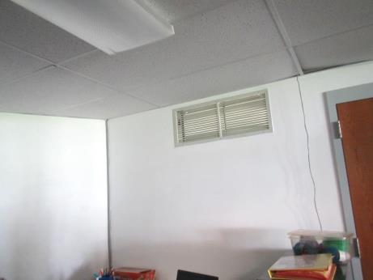

**Passive vent in wall of classroom**

**Picture 2**

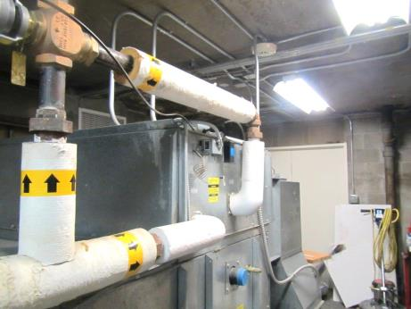

**Air-handling unit**

**Picture 3**

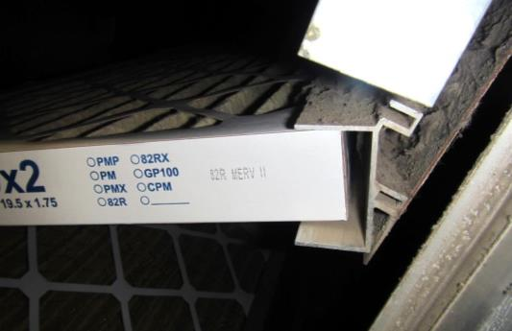

**MERV 11 filter, but note dust and debris in filter housing**

**Picture 4**

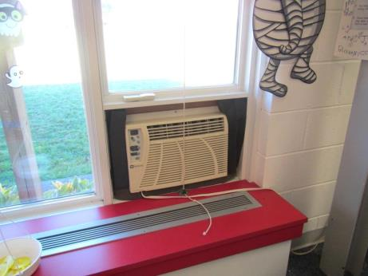

**Window air conditioning unit**

**Picture 5**

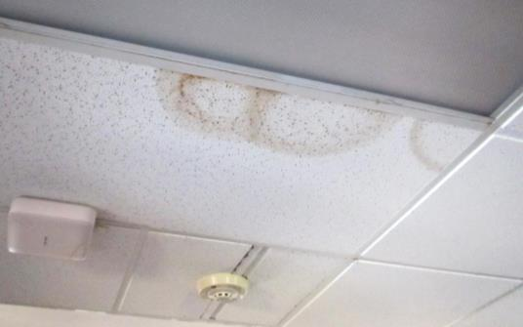

**Water-damaged ceiling tile**

**Picture 6**

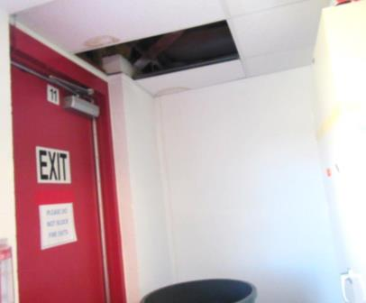

**Missing ceiling tile and stained tile where water infiltration had occurred; carpet next to this door was also wet at the time of the visit**

**Picture 7**

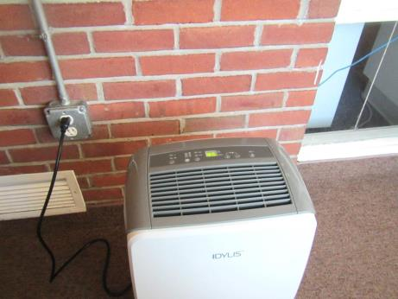

**Dehumidifier in enclosed breezeway**

**Picture 8**

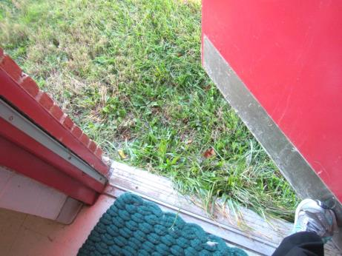

**Long grass outside fire door from classroom**

**Picture 9**

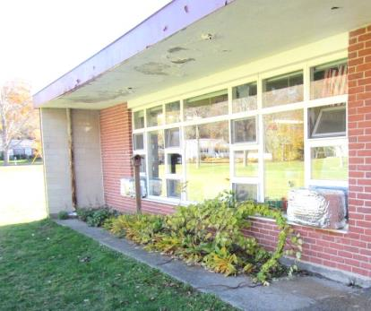

**Plants next to foundation and windows**

**Picture 10**

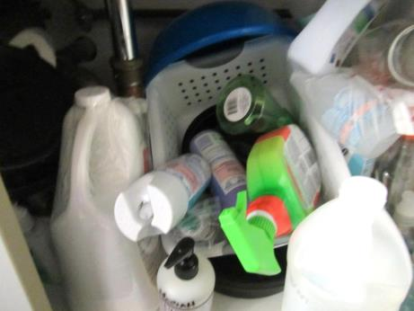

**Cleaners found under a sink**

**Picture 11**

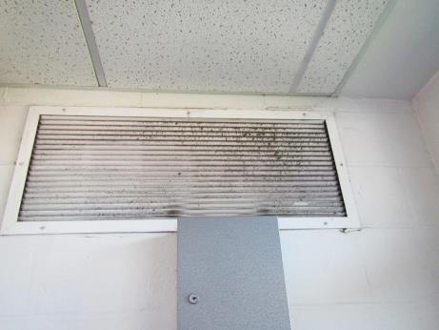

**Dusty vent**

**Picture 12**

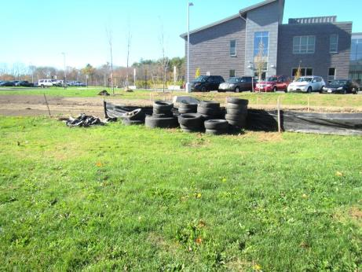

**Pile of tires**

| Location | **Carbon**  **Dioxide**  **(ppm)** | **Carbon Monoxide**  **(ppm)** | **Temp**  **(°F)** | **Relative**  **Humidity**  **(%)** | **PM2.5**  **(µg/m3)** | **Occupants**  **in Room** | **Windows**  **Openable** | **Ventilation** | | | **Remarks** |
| --- | --- | --- | --- | --- | --- | --- | --- | --- | --- | --- | --- |
| **Intake** | **Exhaust** | |
| Background | 374 | 1.1 | 64 | 32 | 30 |  |  |  | |  |  |
| Boys restroom in C3 |  |  |  |  |  | 0 | Y | Y | | Y | MT |
| C central area | 1046 | 0.7 | 70 | 46 | 6 | 14 | Y | Y | | Y | NC |
| C2 | 1118 | 0.7 | 71 | 46 | 7 | 11 | Y | Y | | Y | DEM, carpet |
| C3 | 1167 | 0.7 | 72 | 45 | 2 |  | Y | Y | | Y | DEM, WD CT, MT, leak by doorway and wet carpet |
| C4 | 1178 | 0.7 | 71 | 44 | 22 | 1 (many just left) | Y | Y | | Y | WAC, open backsplash on sink |
| C5 | 1163 | 0.7 | 72 | 49 | 4 |  | Y | Y | | Y | Carpet, WAC (2), backsplash open on sink, dehumidifier |
| Cafeteria | 925 | 0.7 | 71 | 36 | 28 | 28 | Y | Y | | Y | Food odors |
| Girls restroom |  |  |  |  |  |  | Y | Y | | Y | WD CT |
| Hallway next to C4 |  |  |  |  |  |  | Y | Y | | Y | WD CT |
| Hallway/breezeway | 823 | 0.5 | 70 | 32 | 12 | 0 | Y | Y | | Y | Dehumidifier |
| Health | 784 | 1 | 71 | 25 | 19 | 1 | Y | Y | | Y | Water cooler on carpeting |
| Special Education | 767 | 1 | 71 | 32 | 10 | 0 | Y | Y | | Y |  |
| Teachers Planning | 795 | 1 | 71 | 35 | 18 | 0 | Y | Y | | Y | WD CT |
| B1 | 645 | 0.7 | 72 | 36 | 10 | 0 | Y | Y | | Y | PC |
| B2 | 664 | 0.7 | 72 | 36 | 2 | 0 | Y | Y | | Y |  |
| B4 | 780 | 0.2 | 72 | 38 | 8 | ~50 | Y | Y | | Y |  |
| B-section Teachers room | 1183 | 0.7 | 72 | 45 | 7 | 3 | Y | Y | | Y |  |
| Central office | 690 | 0.5 | 72 | 36 | 5 | 5 | Y | Y | | Y | Water cooler on carpeting, AF odors, PC |
| Director of Special Education office | 666 | 0.6 | 72 | 37 | 2 | 4 | Y | Y | | Y |  |
| Payroll | 640 | 0.4 | 72 | 36 | 2 | 1 | Y | Y | | Y | AP, plants and fake plants, CP, HS |
| Staff restroom |  |  |  |  | 1 | 0 | Y | Y | | Y | CP |
| Superintendent’s office | 652 | 0.4 | 72 | 36 | 2 | 0 | Y | Y | | Y | PF, plant |