INDOOR AIR QUALITY ASSESSMENT

Spring Street School
2 Spring Street
West Bridgewater, MA

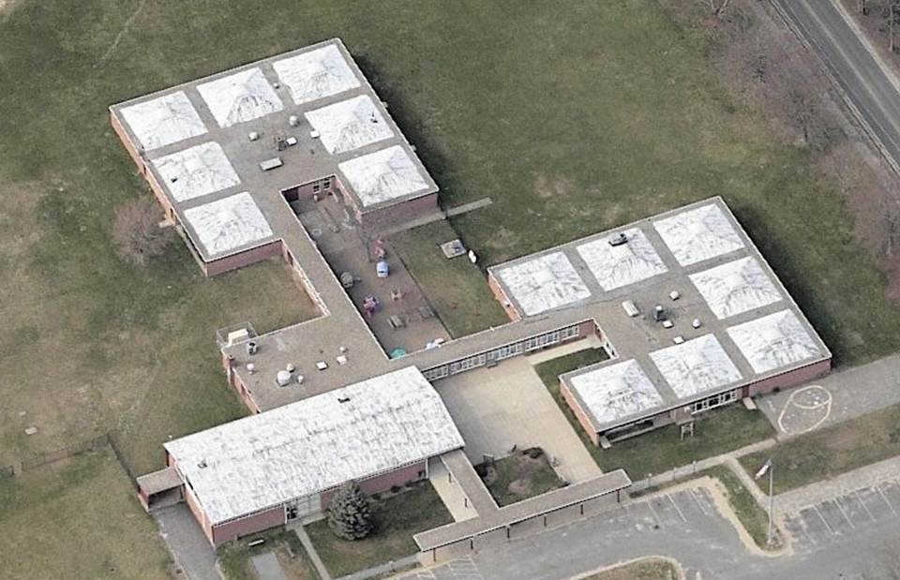

Prepared by:
Massachusetts Department of Public Health
Bureau of Environmental Health
Indoor Air Quality Program
October 2013

Background/Introduction
At the request of Julie Hamblin, Director of Buildings and Grounds for West Bridgewater Public Schools, the Massachusetts Department of Public Health (MDPH), Bureau of Environmental Health (BEH) provided assistance and consultation regarding indoor air quality (IAQ) at the Spring Street Elementary School, 2 Spring Street, West Bridgewater, Massachusetts. The assessment was prompted by concerns of potential exposure to allergens and mold in a classroom. This classroom reportedly has periodic penetration of water in below-grade ductwork due to meteorological conditions. The duct of concern is used to provide warm air during the heating season. On July 24, 2013, Sharon Lee, an Environmental Analyst within BEH’s IAQ Program visited the school to perform a limited assessment in an effort to identify sources of water vapor/moisture and respiratory irritants. General conditions related to indoor air quality were not assessed at that time because the building was largely unoccupied.
The school is a one-story brick building constructed in 1960. The school contains general classrooms, several resource rooms, office space, and cafeteria. Windows throughout the building are openable.

Methods
Air tests for temperature and relative humidity were conducted with the TSI, Q-Trak, IAQ Monitor, Model 7565. Air tests for airborne particle matter with a diameter less than 2.5 micrometers were taken with the TSI, DUSTTRAK™ Aerosol Monitor Model 8520. BEH/IAQ staff also performed visual inspection of building materials for water damage and/or microbial growth.

Results
The school houses approximately 150 students in grades pre-kindergarten to kindergarten with a staff of approximately 25. Tests were conducted while school was out of session. Results appear in Table 1.

Discussion

Microbial/Moisture Concern
As reported by Ms. Hamblin, water will periodically penetrate a chaseway for ductwork that provides heated air to some classrooms. To prevent standing water in the ductwork, a motorized pump was installed to remove water from the chaseway where the ductwork is located. This pump is reportedly activated daily to ensure any water is removed. Ms. Hamblin reported that there has not been any water penetration in recent months.
BEH/IAQ staff examined diffusers in classrooms where water had been reported. The ductwork appeared dry and free of musty odors. Dust/debris was observed on the floor of the ductwork. Since the supply diffusers are located on flat surfaces, materials can readily fall through the opening of the diffusers when the heating system is deactivated. Dust, debris, and other materials can be a source of irritation when aerosolized. When moistened, these materials may also be a source for potential mold growth.
Indoor temperature measurements for four areas tested ranged from 74°F to 81°F (Table 1), three of 0which were within the MDPH recommended comfort range the day of assessment. The MDPH recommends that indoor air temperatures be maintained in a range of 70°F to 78°F in order to provide for the comfort of building occupants. In many cases concerning indoor air quality, fluctuations of temperature in occupied spaces are typically experienced, even in a building with an adequate fresh air supply.
The relative humidity measured in the building ranged from 46 to 59 percent, which was within the MDPH recommended comfort range in all areas surveyed at the time of the assessment (Table 1). The MDPH recommends a comfort range of 40 to 60 percent for indoor relative humidity. Relative humidity levels in the building would be expected to drop during the winter months due to heating. The sensation of dryness and irritation is common in a low relative humidity environment. Low relative humidity is a very common problem during the heating season in the northeast part of the United States.

Volatile Organic Compounds
Indoor air concentrations can be greatly impacted by the use of products containing volatile organic compounds (VOCs). VOCs are carbon-containing substances that have the ability to evaporate at room temperature. Frequently, exposure to low levels of total VOCs (TVOCs) may produce eye, nose, throat and/or respiratory irritation in some sensitive individuals. For example, chemicals evaporating from a paint can stored at room temperature would most likely contain VOCs. In an effort to identify materials that can potentially increase indoor VOC concentrations, BEH/IAQ staff examined rooms for products containing these respiratory irritants.
Hand sanitizer was noted in a few areas of the school. These products may contain ethyl alcohol and/or isopropyl alcohol, which are highly volatile and may be irritating to the eyes and nose, and may also contain fragrances to which some people may be sensitive.
Other cleaning products were also found in classrooms. Cleaning products contain chemicals that can be irritating to the eyes, nose and throat of sensitive individuals. These products should be properly labeled and stored in an area inaccessible to children. Additionally, an MSDS should be available at a central location for each product in the event of an emergency. Consideration should be given to providing teaching staff with school-issued cleaning products and supplies to ensure that MSDS information is available for all products used at the school and to prevent chemical interactions between janitorial cleaners and cleaners brought in by others.

Conclusions/Recommendations
As noted previously, this assessment was limited to sources of moisture/water vapor and respiratory irritants because the building was not occupied during summer vacation. Upon request, the BEH IAQ Program can return to the building when it is fully occupied and the heating system is activated in order to conduct a complete IAQ investigation. In view of the findings at the time of the visit, the following recommendations are provided:
- Remove all blockages/items from the surface of heat diffusers and return vents (along front/bottom) to ensure adequate airflow.
- Vacuum the interior of ductwork with equipment fitted with a high-efficiency particulate air (HEPA) filter. Cleaning should be conducted periodically to prevent accumulation of dirt/dust, which can be a source of irritation.
- Consider installing filtration material directly below the diffuser to allow removal of larger materials that may be accumulated in the ductwork. Please note, filtration can reduce the airflow. Take care to ensure enough heated air penetrates the classroom.
- Use openable windows to supplement fresh air in classrooms as necessary. Ensure that all windows opened are equipped with intact screens to prevent insect entry and that all windows are closed at the end of each day to prevent security issues and freezing of pipes in colder weather.
- For buildings in New England, periods of low relative humidity during the winter are often unavoidable. Therefore, scrupulous cleaning practices should be adopted to minimize common indoor air contaminants whose irritant effects can be enhanced when the relative humidity is low. To control dusts, a high efficiency particulate arrestance (HEPA) filter equipped vacuum cleaner in conjunction with wet wiping of all surfaces is recommended. Avoid the use of feather dusters. Drinking water during the day can help ease some symptoms associated with a dry environment (throat and sinus irritations).
- Consider adopting the US EPA (2000) document, “Tools for Schools.” This document is available at: http://www.epa.gov/iaq/schools/index.html
- Refer to MDPH’s resource manuals and other related indoor air quality documents located on the department’s website for further building-wide evaluations and advice on maintaining public buildings. These documents are available at: http://mass.gov/dph/iaq.

References
US EPA. 2000. Tools for Schools. Office of Air and Radiation, Office of Radiation and Indoor Air, Indoor Environments Division (6609J). EPA 402-K-95-001, Second Edition. http://www.epa.gov/iaq/schools/actionkit.html.
Location/ Room | Temp (°F) |  | Relative Humidity (%) |  | Occupants  in Room |  | Windows Openable |  | Ventilation |  |  |  | Remarks
 |  |  |  |  |  |  |  |  | Supply |  | Exhaust
Background |  | 83 |  | 71 |  |  |  |  |  |  |  |  |  | Sunny, slight breeze
B-2 |  | 74 |  | 46 |  | 0 |  | Y |  | N |  | Y |  | Window-mounted air conditioner
B-3 |  | 76 |  | 59 |  | 5 |  | Y |  | N |  | Y |  | Window-mounted air conditioner, cleaning products
B-4 |  | 81 |  | 55 |  | 0 |  | Y |  | N |  | Y  Closet, items |  | Cleaning products, debris in ductwork
B-5 |  | 77 |  | 50 |  | 2 |  | Y |  | N |  | Y |  | Window-mounted air conditioner, items on radiators

