Special Edition

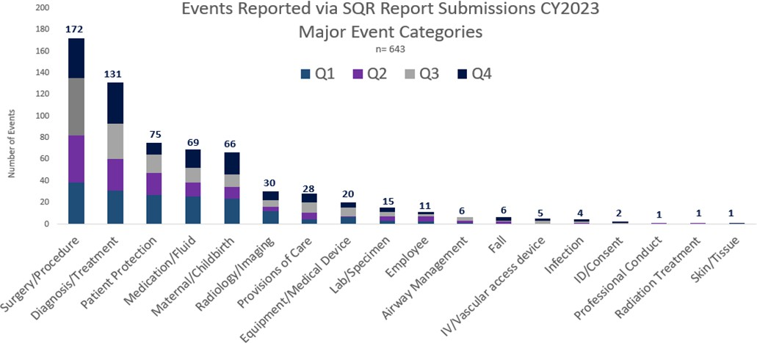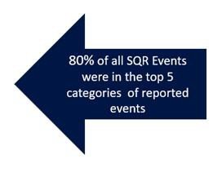

Massachusetts Board of Registration in Medicine

Quality & Patient Safety Division

Spring/Summer 2024

Spotlight on Quality & Patient Safety is issued by the Massachusetts Board of Registration in Medicine Quality & Patient Safety Division (QPSD) to share aggregate Safety and Quality Review (SQR) report data and to share some of the quality work being done by the hospitals, ambulatory surgery centers, and ambulatory clinics in the Commonwealth. Healthcare facilities submit events of unexpected patient outcomes (SQR reports) to the QPSD. In this issue, the QPSD is providing data regarding the major categories of SQR reports submitted in calendar year 2023. The first graph represents a breakdown of the major categories reported via SQR submissions. There were 580 SQR reports submitted in CY 2023. Within those 580 SQR reports, 643 events were reported. This is because some report submissions included more than one event. Of all the events submitted, 80% were in the top five categories of submitted SQR reports. Additional data related to subcategories is also provided.

Spotlight on Quality & Patient Safety

The QPSD held a virtual Patient Care Assessment Boot Camp program in February, which was followed by two interactive, in-person workshops held in Wakefield and in Holyoke respectively in March. Many thanks to Baystate Medical Center for providing the venue for our Holyoke session.

The Quality & Patient Safety (QPS) Committee would like to congratulate Yvonne Y. Cheung, MD, MPH, MBA, who was recently appointed Chair of the Board’s QPS Committee. Dr.

Cheung has been a member of the committee since 2020. We welcome Dr. Cheung in her new role. We also thank Dr. Booker T. Bush who has served as Chair of the Committee since 2021. Dr. Bush will remain a member of the committee to support the work of the QPSD.

The QPSD also thanks Southcoast Health for sharing an important performance improvement initiative and information regarding their participation in the Massachusetts Health Care Safety and Quality Consortium which has been led by the Betsy Lehman Center ([Betsy Lehman Center | Roadmap to Health Care Safety (betsylehmancenterma.gov)](https://betsylehmancenterma.gov/initiatives/roadmap-to-health-care-safety)). If your organization would like to be featured in an issue of Spotlight, please contact the QPSD.

**QPSD Mission is to assist Massachusetts healthcare facilities in maintaining and improving systems for patient care that are evidence and team based, sustainable, safe, and inclusive. We achieve this by reviewing data, listening, collaborating, and educating teams in healthcare facilities throughout the state.**

Most Commonly Reported Events By Surgical Service/Location

CY 2023

7

Foreign Object Retained

3

Number of events

14 5

3

1 3 1

2

3

7 10 12 8 5 1

Wrong Site, Side, Procedure

Intra-op Complications

2 1 2

1 5 1 1

2

1 4 3 1 3 3 1 2 1 1 1 1

Location for Delays in Diagnosis/Treatment 2023 n= 86

Spotlight on Quality & Patient Safety

27

16

Number of events reported

11 9

5 5 3 3

2

1 1 1 1 1

Self-Harm and Suicide Events By Location CY2023 n=39 (33 self-harm and 6 suicide)

15

10

9

Number of events reported

4

1

Behavioral Health Unit

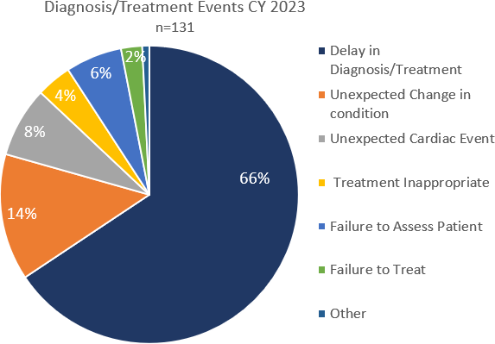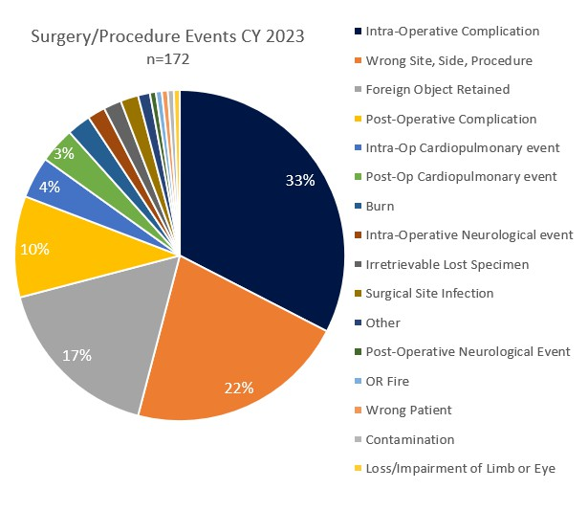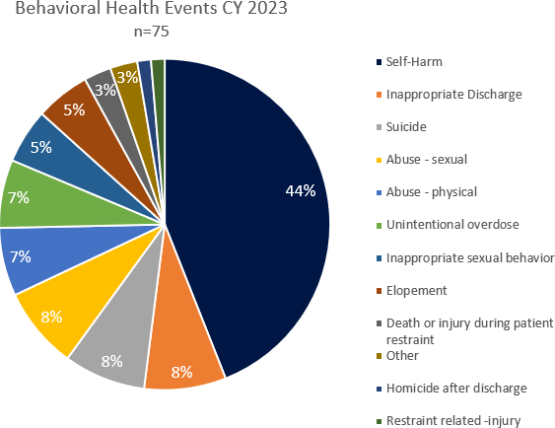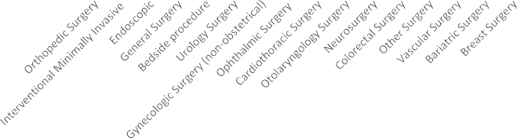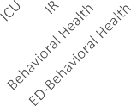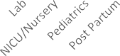

Inpatient Unit ED-Behavioral

Health

Emergency Department

Pediatric Unit

Location of Medication Events CY 2023 n= 69

21

10 9 9 8

Number of reported events

3 2 2 2 1 1 1

Level of Harm for Maternal/Childbirth Events CY2023 n=66

38

15

Number of reported events

12

1

Temporary Permanent Death-Fetal/Neonate Death-Maternal

**\*30 total post-partum hemorrhage (PPH) events reported which included 12 unplanned hysterectomies**

## Level of Reported Harm CY 2023 n=580

2%

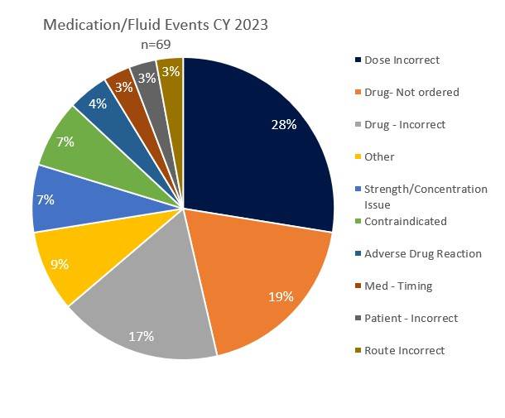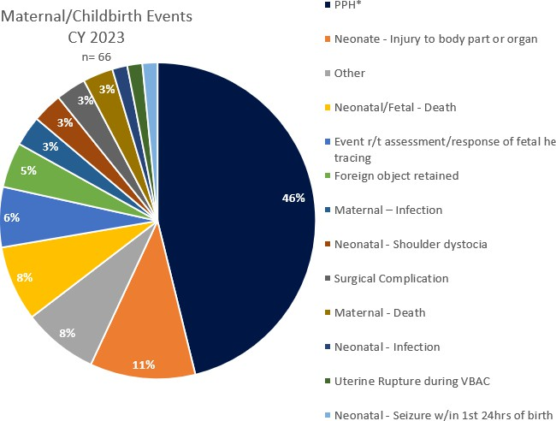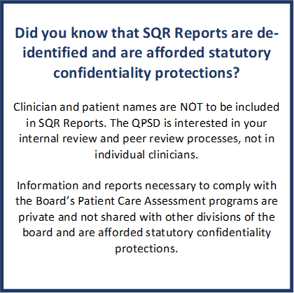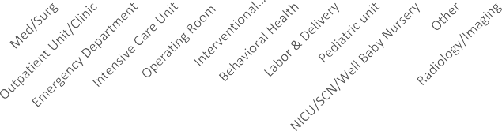

14%

20%

62%

Temporary Death Permanent Employee No harm Unknown

SQR Report Submissions By Race CY 2023 n=580

Caucasian

Massachusetts Population by Race/Ethnicity 2020*

White, non-

**7%**

**16%**

**6% 4%**

**67%**

Unknown

Black or African American

Hispanic or Latino

Asian

American Indian or Alaska Native

**5%**

**13%**

**7%**

**7%**

**69%**

hispanic

Black, non- hispanic

Asian, non- hispanic

Hispanic

Other, non- hispanic

Specific demographic information related to the population of the Commonwealth and SQR Report submissions in 2023 is show above. There is an opportunity to improve SQR data collection to eliminate “unknown” as a choice in selecting demographic data. The goal is to have more accurate data to ensure the reports are reflective of the population in the Commonwealth. Minoritized patients are more likely to experience adverse events but are less likely to have events reported.1

In 2023, the Healey-Driscoll Administration introduced *Advancing Health Equity in Massachusetts*, which is an initiative aimed at eliminating racial, economic, and regional disparities in health outcomes. Two areas of initial focus include maternal health and social determinants of health. Learn more here: [Advancing Health Equity in MA | Mass.gov](https://www.mass.gov/advancing-health-equity-in-ma)

1 Hoops K, Pittman E, Stockwell DC. Disparities in patient safety voluntary event reporting: a scoping review. Joint Comm Journal on Qual Patient Saf. 2024;50(1):41-48. doi:10.1016/j.jcjq.2023.10.009. [https://www.jointcommissionjournal.com/article/S1553-](https://www.jointcommissionjournal.com/article/S1553-7250(23)00260-X/fulltext) [7250(23)00260-X/fulltext](https://www.jointcommissionjournal.com/article/S1553-7250(23)00260-X/fulltext)

Patient Safety Alert: Sepsis

*Source: Commonwealth of Massachusetts. [Massachusetts Population by Race/Ethnicity |](https://www.mass.gov/info-details/massachusetts-population-by-raceethnicity) [Mass.gov.](https://www.mass.gov/info-details/massachusetts-population-by-raceethnicity) Accessed March 29, 2024.

**Other includes American Indian, Alaska Native, Native Hawaiian, and Other Pacific Islander. Population estimates from University of Massachusetts Donahue Institute

Questions and comments may be directed to Trinh Ly-Lucas, MSN, AGNP-BC

Quality Nurse Analyst Quality & Patient Safety Division

Massachusetts Board of Registration in Medicine

[trinh.ly-lucas@mass.gov](mailto:trinh.ly-lucas@mass.gov)

The QPSD has received several reports of delays in diagnosis and treatment related to sepsis. These events have occurred in inpatient obstetrical units, inpatient medical/surgical units, and emergency departments and caused serious harm. Many healthcare facilities have implemented sepsis protocols in inpatient and emergency department settings. We are seeing a delay in implementation of the sepsis protocol in the emergency departments such as delays in obtaining lactate levels, providing intravenous fluid boluses, and initiating intravenous antibiotics. Sepsis protocols often have not been extended to Labor & Delivery and Post Partum Units. The QPSD strongly advises increased awareness of the potential for sepsis and the implementation of evidence-based sepsis protocols. The use of early warning systems (EWS) and implementation of IT integrated sepsis protocols are advised. Please also consider incorporating simulation and mock scenarios related to early identification of sepsis.



Resources:

Betsy Lehman Center for Patient Safety. The Massachusetts Sepsis Consortium. [Betsy Lehman Center | Massachusetts Sepsis](https://betsylehmancenterma.gov/initiatives/sepsis)

[Consortium (betsylehmancenterma.gov)](https://betsylehmancenterma.gov/initiatives/sepsis) Accessed April 1, 2024.

California Maternal Qualitative Care Collaborative. [Sepsis | California Maternal Quality Care Collaborative (cmqcc.org).](https://www.cmqcc.org/content/sepsis) Accessed March 27, 2024.

Society for Maternal-Fetal Medicine (SMFM); Shields AD, Plante LA, Pacheco LD, Louis JM; SMFM Publications Committee. Electronic address: [pubs@smfm.org.](mailto:pubs@smfm.org) Society for Maternal-Fetal Medicine Consult Series #67: Maternal sepsis. Am J Obstet Gynecol. 2023 Sep;229(3):B2-B19. doi: 10.1016/j.ajog.2023.05.019. Epub 2023 May 24. PMID: 37236495.[Society for Maternal-Fetal Medicine](https://www.ajog.org/action/showPdf?pii=S0002-9378%2823%2900327-7) [Consult Series #67: Maternal sepsis (ajog.org)](https://www.ajog.org/action/showPdf?pii=S0002-9378%2823%2900327-7) Accessed March 27, 2024.

Surviving Sepsis Campaign. [Surviving Sepsis Campaign (SSC) | SCCM.](https://www.sccm.org/SurvivingSepsisCampaign/Home) Accessed March 27, 2024.

# SPOTLIGHT: Southcoast Health

**Southcoast Health: Weaving a Durable Fabric of Care Across the Continuum Dani Hackner, MD, MBA**

Chief Clinical Officer, Southcoast Health

In the past three years, at the busiest Atlantic fishery and renewables port, Southcoast Hospitals Group (SHG) and Southcoast Physicians Group (SPG) have embarked on an ambitious journey to integrate quality, safety, and professional practice activities across the continuum of care. Serving a catchment of over 300,000 persons, more than 125,000 lives in the Physician’s Group, approximately 160,000 emergency visits a year, and in excess of 47,000 hospital discharges a year, leaders of the 1400 physicians and advanced practitioners in our open medical staff model have recognized the increasing value of collaboration across locations, departments and disciplines. The Massachusetts Health Care Safety and Quality Consortium, in which we participated, addressed the importance of spreading best practices in safety and professional practice across diverse settings—from highly structured hospitals to small office settings. In the last year, our team has screened 7,074 cases, identifying 734 needing deeper review, with regular debriefing, apparent cause analysis or root cause investigations. Whether in the clinic, OR, or ER, we have joined in the journey to high reliability bringing together the structures, governance, culture, and operations of our safety and professional practice efforts across the continuum.

Spotlight on Quality & Patient Safety

At Southcoast, we had already seen positive results from a system-wide approach to “The Roadmap,” starting with Workforce Well-being initiatives such as Peer Support (Roadmap Goal 4). We have progressively applied high reliability principles and the “Roadmap” goals to drive a One Southcoast approach to quality and safety. Addressing Leadership/Governance Goal (1), we integrated Medical Executive Committees for the three hospitals, with unified PCA reporting, and strengthened Board reporting. We also prepared our PCA committee on core safety principles and tools such as cause-and-effect (herringbone) diagrams and applied the learning across the continuum of care. For Goal (2), we streamlined quality and safety operations. We joined Quality Outcomes, Professional Practice, Credentialing, and Risk Services functionally with reporting to the “Board Quality Committee” and a single Patient Care Assessment Coordinator (Chief Clinical Officer). We hardwired formal policy and sharing agreements, merging the ambulatory Patient Safety Organization and the system quality outcomes and professional practice infrastructure. Whether a specialty-related or primary care opportunity, we apply common systems to debrief, mitigate, learn, and prevent together.

We are now in the process of doubling our stitches on the “Roadmap”, including reinforcing Patient and Family Support (Goal 3), Workforce Well-being (Goal 4), and Measurement and Transparency (Goal 5) across the continuum. An important thread has been enhancing community representation and embracing individuals with “lived experience” at multiple safety, quality, and equity committees across the system. We continue to

remind ourselves that leaders must wear ‘deference to expertise’; it is equally important to empower a patient as well as a provider or a nurse to speak about how we care and how we repair. In many cases, that work begins with understanding: enabling participants to understand our approaches and preparing clinical leaders to better understand the community we serve. For Goal 4 (Workforce Well-being), one of the bright threads is a nimble response to events wherever they occur. With greater emphasis on timely huddles and broadening the group of quality and safety specialists able to lead debriefs, we hope to mitigate 2nd victim harm and initiate system-based practice plans across the continuum.

Supporting transparency (Goal 5), Southcoast’s senior leadership team has endorsed the responsive, transparent, and just-culture approach across the system. But more importantly, frontline providers, nurses, and other staff have embraced the non-punitive and transparent approach from office to ER, from OR to ICU. In the ambulatory space, we have observed a 40% increase in professional practice reporting and increasing participation in multi-disciplinary huddles and de-briefs. Along with increased engagement, we have observed lower rates of harm, fewer HACs/PSI’s, and increased reporting of Good Catches. Once home to 3.7 million textile spindles, our region and the Southcoast Health System weave our strands into a single, durable fabric of safety and clinical practice across the continuum. We hope others will appreciate our design for our small, not- for-profit system by Buzzards Bay serving the diverse gateway cities and surrounding communities.

Resources:



SURGERY/PROCEDURE:

Many of the reported surgery/procedure events were related to intraoperative complications and often involved perforation and/or hemorrhage. These events were most often seen with endoscopy and interventional procedures. Enhanced Recovery After Surgery (ERAS) refers to patient-centered, evidence-based, multidisciplinary team developed pathways which may assist to optimize patients prior to surgery. References are included below. Reported Wrong site surgery (WSS) events were most often related to spinal level procedures, ophthalmology procedures, and joint injections.

**Race**

American Association of Nurse Anesthesiology: [Enhanced Recovery After Surgery - AANA - American Association of Nurse](https://www.aana.com/practice/clinical-practice/clinical-practice-resources/enhanced-recovery-after-surgery/) [Anesthesiology.](https://www.aana.com/practice/clinical-practice/clinical-practice-resources/enhanced-recovery-after-surgery/) Accessed December 28, 2023.

ERAS® Society: [Guidelines - ERAS® Society (erassociety.org).](https://erassociety.org/guidelines/) Accessed December 28, 2023.

DIAGNOSIS/TREATMENT:

Reported events involving diagnosis/treatment most often involved delays. Inpatient areas were the areas most reported to experience delays in diagnosis/treatment.

The Betsy Lehman Center. *Diagnostic error.* [Betsy Lehman Center | Diagnostic error (betsylehmancenterma.gov).](https://betsylehmancenterma.gov/initiatives/diagnostic-error) Accessed March 29, 2024.

The Joint Commission Journal on Quality and Patient Safety 2022; 48:581–590. *Developing the Safer Dx Checklist of Ten Safety Recommendations for Health Care Organizations to Address Diagnostic Errors.* *Developing-the-Safer-Dx-Checklist-of-Ten-Safety-**Re.pdf.*Accessed March 21, 2024.

Society to Improve Diagnosis in Medicine. *Clinical Reasoning Toolkit.* [Clinical Reasoning Toolkit - How We Make Decisions](https://www.improvediagnosis.org/clinical-reasoning-toolkit-how-we-make-decisions/) [(improvediagnosis.org).](https://www.improvediagnosis.org/clinical-reasoning-toolkit-how-we-make-decisions/) Accessed March 16, 2024.

BEHAVIORAL HEALTH (Patient Protection):

The majority of reported behavioral health events involved self-harm such as ingestion of foreign objects and lacerations. The QPSD recommends ensuring observers are educated and aware of policies surrounding 1:1 observation. Trends were noted whereby the patient’s hands and face where not directly visible and monitored while 1:1 observation was performed.

National Action Alliance for Suicide Prevention: Transforming Health Systems Initiative Work Group. (2018). Recommended standard care for people with suicide risk: Making health care suicide safe. Washington, DC: Education Development Center, Inc.

Suicide Prevention Resource Center. (n.d.-a). Caring for adult patients with suicide risk: A consensus guide for emergency departments. Retrieved from [http://www.](http://www/) sprc.org/edguide

The Joint Commission. *Quick Safety Issue 68: Utilizing validated tools for suicide risk screening* . https:[//www.jointcommission.org/resources/news-and-multimedia/newsletters/newsletters/quick-safety/quick-safety-issue-](http://www.jointcommission.org/resources/news-and-multimedia/newsletters/newsletters/quick-safety/quick-safety-issue-) 68#.ZCLvO3ZOm5c [Quick Safety Issue 68: Utilizing validated tools for suicide risk screening | The Joint Commission](https://www.jointcommission.org/resources/news-and-multimedia/newsletters/newsletters/quick-safety/quick-safety-issue-68#.ZCLvO3ZOm5c)

MEDICATION/FLUID:

Reported medication events occurred most often in inpatient areas and involved the wrong dose being administered or the medication not ordered.

Institute for Safe Medication Practices. *Targeted Medication Safety Best Practices for Hospitals.*

[https://www.ismp.org/guidelines/best-practices-hospitals.](https://www.ismp.org/guidelines/best-practices-hospitals) Accessed March 28th, 2024.

Institute for Safe Medication Practices. *Guidelines for Safe Medication Use in Perioperative and Procedural Settings. (*Retrieved March 28th, 2024). <https://www.ismp.org/resources/guidelines-safe-medication-use-perioperative-and-procedural-settings>

MATERNAL/CHILDBIRTH:

Post partum hemorrhage continues to be the most frequently reported obstetrical event. In CY 2023, thirty events with serious harm were reported including 12 unplanned hysterectomies. Ensuring that multidisciplinary safety huddles are conducted, assessment and communication of risk assessment for hemorrhage is completed appropriately, quantitative rather than estimated blood loss is implemented, and ongoing education with simulation is routinely provided, will be helpful in an organization’s readiness and response to hemorrhage events.

California Maternal Quality Care Collaborative. *Improving Health Care Response to Obstetric Hemorrhage, V2.0* Toolkit. [OB](https://www.cmqcc.org/resources-tool-kits/toolkits/ob-hemorrhage-toolkit) [Hemorrhage Toolkit V3.0 Errata 7.18.22 | California Maternal Quality Care Collaborative (cmqcc.org).](https://www.cmqcc.org/resources-tool-kits/toolkits/ob-hemorrhage-toolkit) Accessed March 8, 2024

Alliance for Innovation on Maternal Health. *Patient Safety Bundles.* [Patient Safety Bundles For Safer Birth | AIM.](https://saferbirth.org/patient-safety-bundles/) Accessed March 28, 2024.

The Betsy Lehman Center. *Levels of Maternal Care.* [Betsy Lehman Center | Levels of Maternal Care (betsylehmancenterma.gov).](https://betsylehmancenterma.gov/initiatives/maternal-health/levels-of-maternal-care) Accessed April 1, 2024.





L to R (front row; Dr. Booker Bush, Dr Yvonne Cheung, Dr. Marc Rubin, Dr. Micheal Henry, Back row: Audrey Bosse, Michelle Chan, Dr. Sarah Rae Easter, Dr. Melissa Sundberg, Dr. William Goodman, Karen Johnson. Missing: Dr. Pardon Kenney, Diane Hanley, Dr. Julian Robinson, Dr. Leslie Selbovitz, Dr. Arthur Lauretano, Dr. Megna Trivedi

**Massachusetts Board of Registration in Medicine Quality & Patient Safety Committee**

|  |  |
| --- | --- |
| Member | Specialty |
| Yvonne Y. Cheung, MD, MPH, MBA, Chair | Anesthesiology |
| Booker T. Bush, MD | Internal Medicine |
| Marc S. Rubin, MD | General Surgery |
| Michael E. Henry, MD | Psychiatry |
| Diane Hanley, MSN, RN-BC, EJD | Board of Registration in Nursing |
| Pardon R. Kenney, MD, MMSc, FACS | General Surgery |
| Melissa Sundberg, MD, MPH | Pediatric Emergency Medicine |
| Karen M. Johnson, BSN, RN, CCMSCP | PCA Coordinator Representative |
| Julian N. Robinson, MD | Obstetrics/Gynecology, Maternal Fetal Medicine |
| Arthur Lauretano, MD, MS, FACS | Otolaryngology, Informatics |
| Michelle Chan, RPh | Board of Registration in Pharmacy |
| Leslie G. Selbovitz, MD | Internal Medicine |
| Meghna Trivedi, MD, FACP, FHM | Hospitalist Medicine |
| Sarah Rae Easter, MD | Obstetrics/Gynecology, Maternal Fetal Medicine, and Critical Care |
| Audrey Bosse | Patient Advocate |
| William H. Goodman, MD, MPH | Internal Medicine, Pulmonary, and Critical Care Medicine |

## Massachusetts Board of Registration in Medicine Quality & Patient Safety Division



|  |  |
| --- | --- |
|  |  |
| Daniela Brown, MSN, RN, CIC, Director | [daniela.brown@mass.gov](mailto:daniela.brown@mass.gov) |
| Dorothy T. Doweiko, MHA, BSN, RN, Nurse Consultant | [dorothy.t.doweiko@mass.gov](mailto:dorothy.t.doweiko@mass.gov) |
| Erin C. Long, MSN, RN, Quality Analyst | [erin.c.long@mass.gov](mailto:erin.c.long@mass.gov) |
| Trinh Ly-Lucas, MSN, AGNP-BC, Quality Analyst | [trinh.ly-lucas@mass.gov](mailto:trinh.ly-lucas@mass.gov) |
| Daniel J. Kumin, Assistant General Counsel |  |

Patient Care Assessment (PCA) program and online reporting guidance, including video tutorials, may be found at:

[Patient Care Assessment Program | Mass.gov](https://www.mass.gov/patient-care-assessment-program)

Questions and comments may be directed to Trinh Ly-Lucas, MSN, AGNP-BC

Quality Nurse Analyst

Quality & Patient Safety Division

Massachusetts Board of Registration in Medicine

[trinh.ly-lucas@mass.gov](mailto:trinh.ly-lucas@mass.gov)

This issue is provided by the Board of Registration in Medicine (BORIM), Division of Quality and Patient Safety (QPSD). The issue allows BORIM to share the practices and experiences of the healthcare clinicians and facilities that report to the QPSD. It does not necessarily include a comprehensive review of literature. Publication of this issue does not constitute an endorsement by the BORIM of any practices described in the issue and none should be inferred.