INDOOR AIR QUALITY ASSESSMENT

Massachusetts Department of Children and Families
140 High Street
Springfield, MA

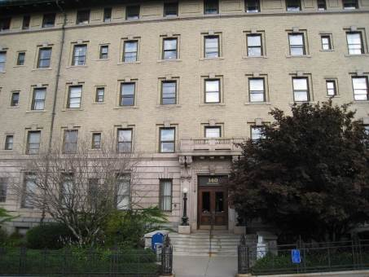

Prepared by:
Massachusetts Department of Public Health
Bureau of Environmental Health
Indoor Air Quality Program
December 2012

Background/Introduction
At the request of Gerald Covino, Project Manager, Office of Leasing, Division of Capital Asset Management (DCAM), the Massachusetts Department of Public Health (MDPH), Bureau of Environmental Health (BEH) conducted air testing at the Department of Children and Families (DCF) located at 140 High Street, Springfield, Massachusetts. The purpose of the visit was to assess the indoor air quality (IAQ) of occupied space leased by Massachusetts state agencies. On November 9, 2012, a visit to conduct IAQ testing was made by Kathleen Gilmore, Environmental Analyst/Regional Inspector within BEH’s IAQ Program. Mr. Covino and Mr. Vincent Laberinto, Construction Project Manager for the Office of Leasing and State Owned Property accompanied Ms. Gilmore during the assessment.
The DCF occupies the fourth and partial fifth floor of a former hospital originally constructed in the early 1900s, with a west wing addition built in 1968. The DCF has occupied the space since July, 2008; the space consists of offices, open work areas/cubicles, conference rooms, storage and common areas. Floors are carpeted in most areas. Windows are openable in some areas.

Methods
Air tests for carbon dioxide, carbon monoxide, temperature and relative humidity were taken with the TSI, Q-Trak, IAQ Monitor 7565. Air tests for airborne particle matter with a diameter less than 2.5 micrometers were taken with the TSI, DUSTTRAK™ Aerosol Monitor Model 8520. BEH/IAQ staff also performed visual inspection of building materials for water damage and/or microbial growth.

Results
The DCF offices have an employee population of approximately 200 and up to 60 people may visit the building daily. Tests were taken during normal operations. Test results appear in Table 1.

Discussion

Ventilation
It can be seen from Table 1 that carbon dioxide levels were below 800 parts per million (ppm) in all areas tested at the time of assessment, indicating good air exchange throughout the building. It is important to note that a number of areas were empty or sparsely populated during this visit, which can greatly reduce carbon dioxide levels. Carbon dioxide levels would be expected to be higher with full occupancy.
The heating, ventilating and air conditioning (HVAC) system consists of air-handling units (AHU) located in a closet. The AHUs draw in fresh air and distribute it to occupied areas via ceiling-mounted air diffusers and fresh air intake vents (Pictures 1 and 2). The offices do not have return ventilation; rather the HVAC system exhausts air via vents located in the ceiling and/or walls (Pictures 3 and 4) which are ducted directly to the outside and powered by rooftop motors. Of note, several ceiling-mounted air diffusers were partially blocked with plastic or cardboard, hence they were not operating as designed (Picture 5 and 6; Table 1). In addition, many wall exhaust vents are located near hallway doors, which can limit the effectiveness of exhausting stale air from the room when the door is open. Some of the exhaust vents were also located in areas partially or fully obstructed by items (Table 1).
Fan coil units (FCUs) are located along the base of walls under windows and/or mounted to ceilings (Pictures 7 and 8) and provide supplemental heating or cooling to perimeter areas. FCUs do not introduce outside air; these units are limited to recirculating air. The FCUs were operating in all of the areas surveyed during the assessment. In some areas, FCUs were blocked/obstructed by several items including cardboard boxes, books and other stored materials (Picture 9). In order for FCUs to facilitate airflow as designed, they must remain free of obstructions. FCUs located at the base of walls appear to be original to the building, which would make them approximately 50 years old. Mechanical ventilation equipment of this age is difficult to maintain because replacement parts are often unavailable.
In order to have proper ventilation with a mechanical supply and exhaust system, the systems must be balanced to provide an adequate amount of fresh air to the interior of a room while removing stale air from the room. It is recommended that HVAC systems be re-balanced every five years to ensure adequate air systems function (SMACNA, 1994). It was reported that the system was balanced prior to occupancy in 2008.
Minimum design ventilation rates are mandated by the Massachusetts State Building Code (MSBC). Until 2011, the minimum ventilation rate in Massachusetts was higher for both occupied office spaces and general classrooms, with similar requirements for other occupied spaces (BOCA, 1993). The current version of the MSBC, promulgated in 2011 by the State Board of Building Regulations and Standards (SBBRS), adopted the 2009 International Mechanical Code (IMC) to set minimum ventilation rates. Please note that the MSBC is a minimum standard that is not health-based. At lower rates of cubic feet per minute (cfm) per occupant of fresh air, carbon dioxide levels would be expected to rise significantly. A ventilation rate of 20 cfm per occupant of fresh air provides optimal air exchange resulting in carbon dioxide levels at or below 800 ppm in the indoor environment in each area measured. MDPH recommends that carbon dioxide levels be maintained at 800 ppm or below. This is because most environmental and occupational health scientists have documented significant increases in indoor air quality complaints and/or health effects when carbon dioxide levels rise above the MDPH guidelines of 800 ppm for schools, office buildings and other occupied spaces (Sundell et al., 2011). The ventilation must be on at all times that the room is occupied. Providing adequate fresh air ventilation with open windows and maintaining the temperature in the comfort range during the cold weather season is impractical. Mechanical ventilation is usually required to provide adequate fresh air ventilation.
Carbon dioxide is not a problem in and of itself. It is used as an indicator of the adequacy of the fresh air ventilation. As carbon dioxide levels rise, it indicates that the ventilating system is malfunctioning or the design occupancy of the room is being exceeded. When this happens, a buildup of common indoor air pollutants can occur, leading to discomfort or health complaints. The Occupational Safety and Health Administration (OSHA) standard for carbon dioxide is 5,000 parts per million parts of air (ppm). Workers may be exposed to this level for 40 hours/week, based on a time-weighted average (OSHA, 1997).
The MDPH uses a guideline of 800 ppm for publicly occupied buildings. A guideline of 600 ppm or less is preferred in schools due to the fact that the majority of occupants are young and considered to be a more sensitive population in the evaluation of environmental health status. Inadequate ventilation and/or elevated temperatures are major causes of complaints such as respiratory, eye, nose and throat irritation, lethargy and headaches. For more information concerning carbon dioxide, please see Appendix A.
Indoor temperature measurements ranged from 72 °F to 76 °F (Table 1), which were within the MDPH recommended comfort range at the time of assessment. The MDPH recommends that indoor air temperatures be maintained in a range of 70 ºF to 78 °F in order to provide for the comfort of building occupants. In many cases concerning indoor air quality, fluctuations of temperature in occupied spaces are typically experienced, even in a building with an adequate fresh air supply.
Relative humidity measurements ranged from 13 to 18 percent (Table 1), which were below the MDPH recommended comfort range. The MDPH recommends a comfort range of 40 to 60 percent for indoor air relative humidity. The sensation of dryness and irritation is common in a low relative humidity environment. Low relative humidity is a very common problem during the heating season in the northeast part of the United States. Therefore, scrupulous cleaning practices should be adopted to minimize common indoor contaminants whose irritant effects can be enhanced when the relative humidity is low.

Microbial/Moisture Concerns
Water-damaged ceiling tiles were observed in some areas (Picture 10). Water-damaged ceiling tiles can stem from roof leaks, leaks in the plumbing system and/or leaks and condensation from air-conditioning systems and can provide a source of mold. These tiles should be replaced after a water leak is discovered and repaired.
Water dispensers were located on carpeted areas (Picture 11). Spills/condensation from these units can be a source of moisture in carpeting that can lead to water damage and mold growth. When possible, these units should be located in tiled areas or placed on a waterproof mat.
Plants were observed in office areas (Picture 12). Plants should be properly maintained and equipped with drip pans. Plants should be located away from ventilation sources (e.g., FCUs) to prevent aerosolization of dirt, pollen or mold. Plants should not be placed on porous materials, since water damage to porous materials may lead to microbial growth.

Other IAQ Evaluations
Indoor air quality can be negatively influenced by the presence of respiratory irritants, such as products of combustion. The process of combustion produces a number of pollutants. Common combustion emissions include carbon monoxide, carbon dioxide, water vapor, and smoke (fine airborne particle material). Of these materials, exposure to carbon monoxide and particulate matter with a diameter of 2.5 micrometers (μm) or less (PM2.5) can produce immediate, acute health effects upon exposure. To determine whether combustion products were present in the indoor environment, BEH/IAQ staff obtained measurements for carbon monoxide and PM2.5.

Carbon Monoxide
Carbon monoxide is a by-product of incomplete combustion of organic matter (e.g., gasoline, wood and tobacco). Exposure to carbon monoxide can produce immediate and acute health affects. Several air quality standards have been established to address carbon monoxide and prevent symptoms from exposure to these substances. The MDPH established a corrective action level concerning carbon monoxide in ice skating rinks that use fossil-fueled ice resurfacing equipment. If an operator of an indoor ice rink measures a carbon monoxide level over 30 ppm, taken 20 minutes after resurfacing within a rink, that operator must take actions to reduce carbon monoxide levels (MDPH, 1997).
The American Society of Heating Refrigeration and Air-Conditioning Engineers (ASHRAE) has adopted the National Ambient Air Quality Standards (NAAQS) as one set of criteria for assessing indoor air quality and monitoring of fresh air introduced by HVAC systems (ASHRAE, 1989). The NAAQS are standards established by the US EPA to protect the public health from six criteria pollutants, including carbon monoxide and particulate matter (US EPA, 2006). As recommended by ASHRAE, pollutant levels of fresh air introduced to a building should not exceed the NAAQS levels (ASHRAE, 1989). The NAAQS were adopted by reference in the Building Officials & Code Administrators (BOCA) National Mechanical Code of 1993 (BOCA, 1993), which is now an HVAC standard included in the Massachusetts State Building Code (SBBRS, 1997). According to the NAAQS, carbon monoxide levels in outdoor air should not exceed 9 ppm in an eight-hour average (US EPA, 2006).
Carbon monoxide should not be present in a typical, indoor environment. If it is present, indoor carbon monoxide levels should be less than or equal to outdoor levels. On the day of the assessment, outdoor carbon monoxide concentrations were non-detect (ND). No measureable levels of carbon monoxide were detected inside the building during the assessment (Table 1).

Particulate Matter
The US EPA has established NAAQS limits for exposure to particulate matter. Particulate matter is airborne solids that can be irritating to the eyes, nose and throat. The NAAQS originally established exposure limits to particulate matter with a diameter of 10 μm or less (PM10). According to the NAAQS, PM10 levels should not exceed 150 micrograms per cubic meter (μg/m³) in a 24-hour average (US EPA, 2006). These standards were adopted by both ASHRAE and BOCA. Since the issuance of the ASHRAE standard and BOCA Code, US EPA established a more protective standard for fine airborne particles. This more stringent PM2.5 standard requires outdoor air particle levels be maintained below 35 μg/m³ over a 24-hour average (US EPA, 2006). Although both the ASHRAE standard and BOCA Code adopted the PM10 standard for evaluating air quality, MDPH uses the more protective PM2.5 standard for evaluating airborne particulate matter concentrations in the indoor environment.
During the November 9, 2012 assessment, outdoor PM2.5 was measured at 10 μg/m³ (Table 1). PM2.5 levels measured indoors ranged from 5 to 8 μg/m³ (Table 1), which were below the NAAQS PM2.5 level of 35 μg/m³. Frequently, indoor air levels of particulates (including PM2.5) can be at higher levels than those measured outdoors. A number of mechanical devices and/or activities that occur in buildings can generate particulate during normal operations. Sources of indoor airborne particulates may include but are not limited to particles generated during the operation of fan belts in the HVAC system, use of stoves and/or microwave ovens in kitchen areas; use of photocopiers, fax machines and computer printing devices; operation of an ordinary vacuum cleaner and heavy foot traffic indoors.

Volatile Organic Compounds
Indoor air concentrations can be greatly impacted by the use of products containing volatile organic compounds (VOCs). VOCs are carbon-containing substances that have the ability to evaporate at room temperature. Total volatile organic compounds (TVOCs) can result in eye and respiratory irritation if exposure occurs. For example, chemicals evaporating from a paint can stored at room temperature would most likely contain VOCs. In an effort to identify materials that can potentially increase indoor VOC concentrations, BEH/IAQ staff examined rooms for products containing these respiratory irritants.
Photocopiers were observed in hallways and administration areas of the building. VOCs and ozone can be produced by photocopiers, particularly if the equipment is older and in frequent use. Ozone is a respiratory irritant (Schmidt Etkin, 1992).
Air deodorizers and scented candles (Picture 13; Table 1) were noted in several areas of the building. Scented candles contain chemicals that can be irritating to the eyes, nose and throat of sensitive individuals. Scented products were also noted in restrooms. Deodorizing agents do not remove materials causing odors, but rather mask odors that may be present in the area.
Several rooms contained dry erase boards and related materials (Picture 14). Materials such as dry erase markers and dry erase board cleaners may contain VOCs, such as methyl isobutyl ketone, n-butyl acetate and butyl-cellusolve (Sanford, 1999), which can be irritating to the eyes, nose and throat.

Other Conditions
Missing and ajar ceiling tiles were observed in some areas (Picture 15). Breaches in the ceiling tile system can provide pathways for dust, dirt, odors and other pollutants to move into occupied areas.
In several offices, items were observed on the FCUs, floors, windowsills, tabletops, counters, bookcases and desks (Picture 16). The large number of items stored in offices provides a source for dusts to accumulate. These items (e.g., papers, folders, boxes, books) make it difficult for custodial staff to clean. Items should be relocated and/or be cleaned periodically to avoid excessive dust build up. In addition, these materials can accumulate on flat surfaces (e.g., desktops, shelving and carpets) in occupied areas and subsequently be re-aerosolized causing further irritation.
A number of FCUs, air diffusers, exhaust vents and personal fans were observed to have accumulated dust/debris (Picture 17; Table 1). These diffusers, vents and fans should be cleaned in order to prevent dust/debris from being aerosolized and redistributed throughout the room.

Conclusions/Recommendations
In view of the findings at the time of the visit, the following recommendations are made:

- Remove materials and obstructions from air supply, exhaust vents and FCU intakes and diffusers.
- Consider adopting a balancing schedule of every 5 years for all mechanical ventilation systems, as recommended by ventilation industrial standards (SMACNA, 1994).
- For buildings in New England, periods of low relative humidity during the winter are often unavoidable. Therefore, scrupulous cleaning practices should be adopted to minimize common indoor air contaminants whose irritant effects can be enhanced when the relative humidity is low. To control for dusts, a high efficiency particulate arrestance (HEPA) filter equipped vacuum cleaner in conjunction with wet wiping of all surfaces is recommended. Avoid the use of feather dusters. Drinking water during the day can help ease some symptoms associated with a dry environment (throat and sinus irritations).
- Remove water-damaged ceiling tiles and examine for source of water. Monitor for future leaks.
- Consider moving water dispensing equipment to areas with tiled floors instead of carpeting, or installing waterproof mats to prevent leaks from damaging carpet.
- Avoid overwatering of plants. Ensure flat surfaces around plants are free of potting soil and other plant debris. Examine drip pans periodically for mold growth and disinfect with an appropriate antimicrobial where necessary. Do not place plants on porous materials (e.g., paper/cardboard).
- Refrain from having scented candles or using air fresheners/deodorizers to prevent exposure to VOCs.
- Replace missing ceiling tiles. Ensure all ceiling tiles are flush to prevent movement of materials from the plenum.
- Relocate or consider reducing the amount of materials stored in offices and common areas to allow for more thorough cleaning.
- Clean FCUs, air vents and personal fans periodically of accumulated dust.
- Refer to resource manual and other related indoor air quality documents located on the MDPH’s website for further building-wide evaluations and advice on maintaining public buildings. These documents are available at: http://mass.gov/dph/iaq.

References
ASHRAE. 1989. Ventilation for Acceptable Indoor Air Quality. American Society of Heating, Refrigeration and Air Conditioning Engineers. ANSI/ASHRAE 62-1989.
BOCA. 1993. The BOCA National Mechanical Code/1993. 8th ed. Building Officials and Code Administrators International, Inc., Country Club Hill, IL.
IMC, 2009. 2009 International Mechanical Code. International Code Council Inc., Country Club Hills, IL.
MDPH. 1997. Requirements to Maintain Air Quality in Indoor Skating Rinks (State Sanitary Code, Chapter XI). 105 CMR 675.000. Massachusetts Department of Public Health, Boston, MA.
OSHA. 1997. Limits for Air Contaminants. Occupational Safety and Health Administration. Code of Federal Regulations. 29 C.F.R 1910.1000 Table Z-1-A.
Sanford. 1999. Material Safety Data Sheet (MSDS No: 198-17). Expo® Dry Erase Markers Bullet, Chisel, and Ultra Fine Tip. Sanford Corporation, Bellwood, IL.
Schmidt Etkin, D. 1992. Office Furnishings/Equipment & IAQ Health Impacts, Prevention & Mitigation. Cutter Information Corporation, Indoor Air Quality Update, Arlington, MA.
SBBRS. 2011. Mechanical Ventilation. State Board of Building Regulations and Standards. Code of Massachusetts Regulations. 780 CMR 1209.0
SMACNA. 1994. HVAC Systems Commissioning Manual. 1st ed. Sheet Metal and Air Conditioning Contractors’ National Association, Inc., Chantilly, VA.
Sundell, J., H. Levin, W. W. Nazaroff, W. S. Cain, W. J. Fisk, D. T. Grimsrud, F. Gyntelberg, Y. Li, A. K. Persily, A. C. Pickering, J. M. Samet, J. D. Spengler, S. T. Taylor, and C. J. Weschler. 2011. Ventilation rates and health: multidisciplinary review of the scientific literature. Indoor Air, Volume 21: pp 191–204.
US EPA. 2006. National Ambient Air Quality Standards (NAAQS). US Environmental Protection Agency, Office of Air Quality Planning and Standards, Washington, DC. http://www.epa.gov/air/criteria.html.

Picture 1
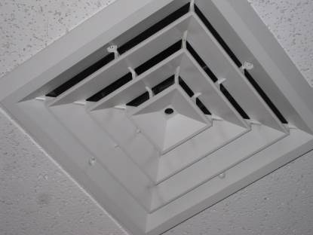
Typical Fresh Air Supply Diffuser
Picture 2
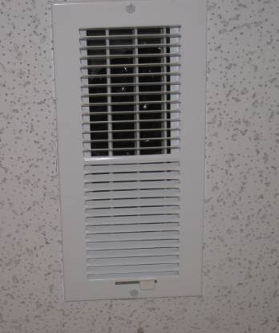
Typical Fresh Air Supply Vent

Picture 3
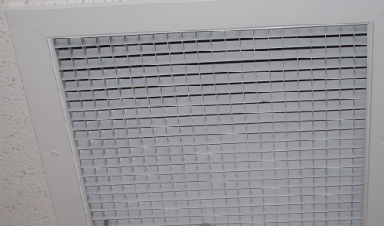
Ceiling Exhaust Vent
Picture 4
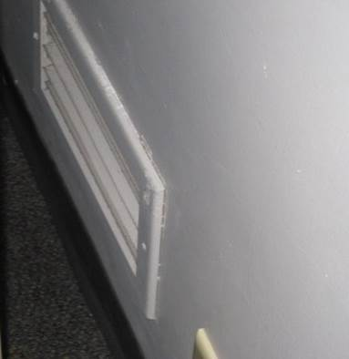
Typical Wall Exhaust Vent

Picture 5
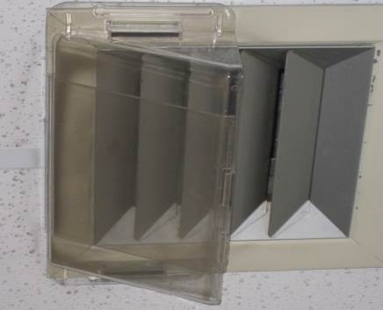
Ceiling Supply Vent Partially Blocked with Plastic
Picture 6
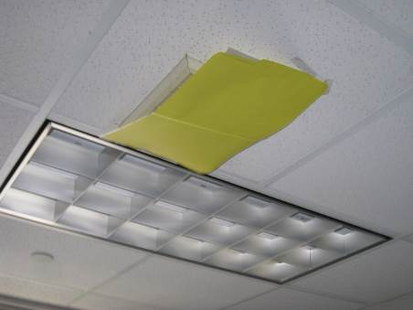
Supply Vent Blocked with Cardboard
Picture 7
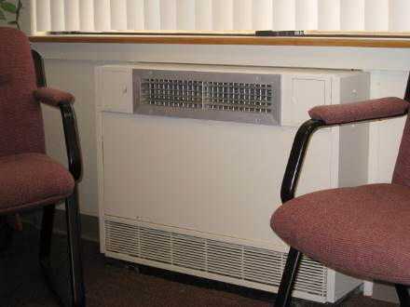
Typical Fan Coil Unit
Picture 8
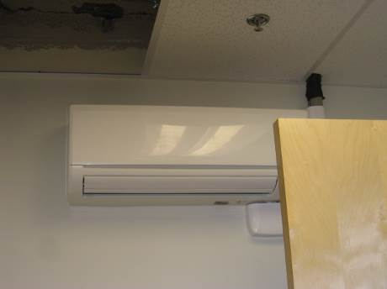
Typical Wall-Mounted Fan Coil Unit

Picture 9
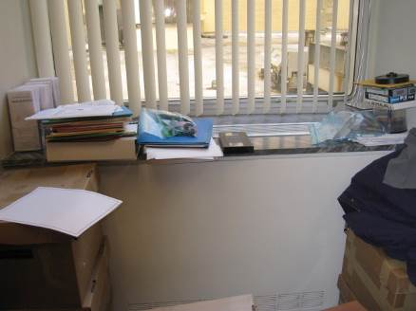
Obstructed Fan Coil Unit
Picture 10
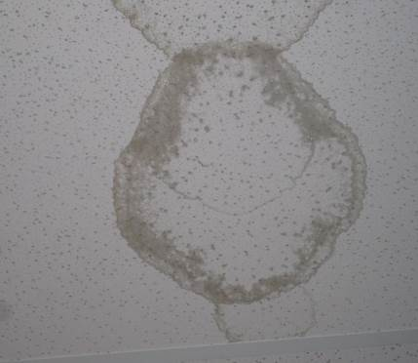
Water-damaged Ceiling Tile
Picture 11
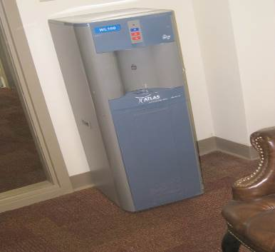
Water Dispenser on Carpet
Picture 12
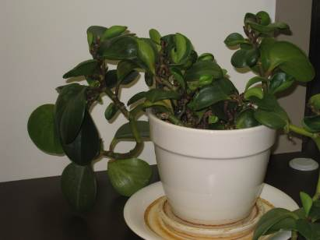
Plant in Office

Picture 13
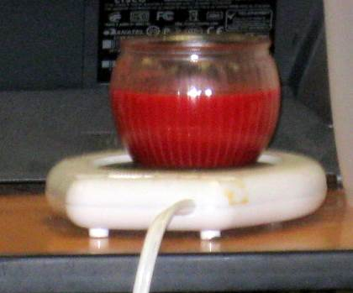
Scented Candle in Office
Picture 14
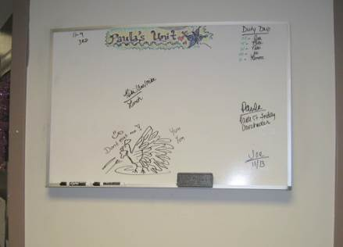
Dry Eraser Board and Materials

Picture 15
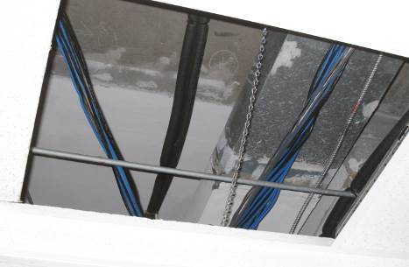
Missing Ceiling Tile
Picture 16
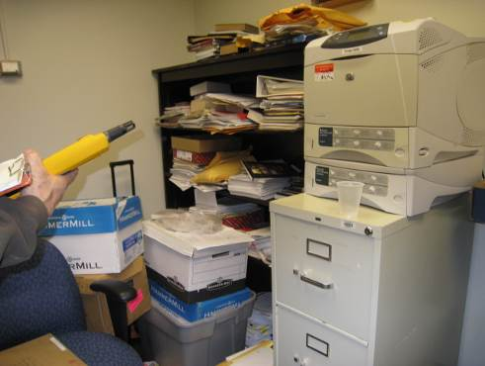
Large Amount of Items Stored on Floor and Bookcases

Picture 17
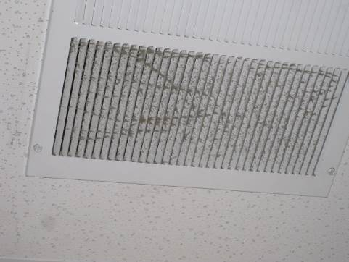
Example of Dirty Exhaust Vent
Location | Carbon  Dioxide  (*ppm) | Carbon Monoxide  (*ppm) | Temp  (°F) | Relative  Humidity  (%) | PM2.5  (ug/m3) | Occupants  in Room | Windows  Openable | Ventilation |  |  | Remarks
 |  |  |  |  |  |  |  | Intake | Exhaust |  | Remarks
Background | 492 | ND | 38 | 35 | 10 |  |  |  |  |  | Sunny, breezy
400 | 649 | ND | 72 | 15 | 8 | 0
401 Waiting Room | 760 | ND | 73 | 15 | 8 | 2 | N | Y |  | Y
402 Interview Room | 689 | ND | 74 | 14 | 7 | 0 | N | Y |  | Y
403 Interview Room | 573 | ND | 72 | 17 | 7 | 1 | N | Y |  | Y | PF, AD, clutter
404 Women’s Rest Room | 649 | ND |  |  | 8 | 0 | N | N |  | Y
406 Interview Room | 678 | ND | 73 | 15 | 7 | 0 | N | Y |  | Y
407 Family Room | 589 | ND | 73 | 14 | 8 | 0 | N | Y |  | Y
408 File Room | 612 | ND | 72 | 16 | 7 | 2 | N | Y |  | Y | DO, boxes on floor
409 | 678 | ND | 75 | 16 | 7 | 0 | N | Y |  | Y | Exhaust dirty
410 Family room | 611 | ND | 74 | 15 | 8 | 0 | N | Y |  | Y | DO
411 Hearing Room | 573 | ND | 75 | 16 | 7 | 0 | N | Y |  | Y
412 Reception | 543 | ND | 73 | 15 | 7 | 1 | N | Y |  | Y | DO, AD, PF, plants
415 Staff Support | 570 | ND | 74 | 16 | 8 | 3 | N | Y |  | Y | DO, FCU blocked, AD, PF, personal heaters, clutter
416 Storage Supply | 602 | ND | 73 | 14 | 7 | 0 | N | N |  | N | DO, boxes on floor
417 Records | 544 | ND | 73 | 16 | 7 | 0 | N | Y |  | Y
421 Conference Room | 462 | ND | 73 | 13 | 8 | 0 | N | Y |  | Y | FCU blocked, exhaust dirty
422 | 578 | ND | 74 | 15 | 7 | 3 | N | Y |  | Y | DO, AD, FCU blocked
425 | 515 | ND | 73 | 15 | 8 | 1 | N | Y |  | Y | AF, clutter, water dispenser on carpet
430 | 559 | ND | 74 | 14 | 8 | 1 | N | Y |  | Y | FCU blocked, AD, PF, personal heater, clutter
431 | 472 | ND | 74 | 13 | 8 | 3 | N | Y |  | Y | Supply vent partially covered with plastic, AD, PF, refrigerator
435 | 545 | ND | 73 | 16 | 7 | 0 | N | Y |  | Y | DO, exhaust vent blocked DEM
438 | 589 | ND | 74 | 15 | 7 | 3 | N | Y |  | Y | DO, AD, scented candles
445 | 550 | ND | 74 | 14 | 7 | 2 | N | Y |  | Y | DO, FCU blocked, AD, scented candles
448 Conference Room | 519 | ND | 74 | 14 | 7 | 0 | N | Y |  | Y | DO, FCU blocked, refrigerator, microwave,
449 Director’s Room | 584 | ND | 73 | 14 | 6 | 0 | N | Y |  | Y | Exhaust vent blocked, DEM
455 Men’s Room | 589 | ND | 74 | 17 | 6 | 0 | N | N |  | Y
457 Women’s Rest Room | 602 | ND | 75 | 16 | 8 | 0 | N | N |  | Y
459 | 540 | ND | 75 | 14 | 7 | 2 | N | Y |  | Y | WD CT (2), DEM, refrigerator
464 | 495 | ND | 75 | 14 | 7 | 2 | N | Y |  | Y | Exhaust vent blocked
467 | 575 | ND | 74 | 15 | 8 | 2 | N | Y |  | Y | DO, clutter
470 | 554 | ND | 75 | 14 | 7 | 7 | N | N |  | Y
473 | 592 | ND | 75 | 17 | 5 | 2 | Y | Y |  | Y | Microwave, refrigerator
479 | 621 | ND | 74 | 18 | 5 | 2 | Y | Y |  | Y | Plants
481 | 655 | ND | 72 | 18 | 6 | 1 | Y | Y |  | Y | DO, window open
482 Copy/Mail | 636 | ND | 76 | 17 | 7 | 0 | N | Y |  | Y | DO, boxes on floor
484 | 529 | ND | 75 | 16 | 8 | 1 | Y | Y |  | Y
487 | 601 | ND | 74 | 15 | 7 | 1 | Y | Y |  | Y | DO, plants
488 | 620 | ND | 75 | 18 | 8 | 0 | Y | Y |  | Y
491 | 603 | ND | 75 | 17 | 8 | 1 | Y | Y |  | Y | Supply and exhaust vents blocked, AD, plants
501 Reception | 588 | ND | 74 | 16 | 7 | 0 | N | Y |  |  | Plants, PC
502 Conference Room | 515 | ND | 73 | 17 | 7 | 0 | N | Y |  | Y | FCU blocked, exhaust vent blocked/dirty
508 | 489 | ND | 77 | 14 | 6 | 3 | N | N |  | Y | FCU blocked, Clutter
510 | 554 | ND | 76 | 14 | 7 | 1 | N | Y |  | Y | FCU blocked, plants
514 Kitchen | 597 | ND | 75 | 13 | 8 | 4 | N | Y |  | Y | WD CT, FCU blocked, plants, refrigerator
517 Law Library | 644 | ND | 73 | 14 | 7 | 0 | N | Y |  | Y
520 | 576 | ND | 74 | 13 | 6 | 1 | N | Y |  | Y
523 | 522 | ND | 74 | 15 | 7 | 0 | N | Y |  | Y | Exhaust vent blocked, boxes on floor, clutter
524 | 566 | ND | 73 | 14 | 7 | 1 | N | Y |  | Y
527 Staff support | 512 | ND | 74 | 14 | 5 | 2 | N | Y |  | Y | Plants
532 Men’s Rest Room | 547 | ND |  |  | 6 | 0 |  | N |  | Y
534 Women’s rest Room | 585 | ND | 74 |  | 7 | 0 |  | N |  | Y
537 storage | 631 | ND | 75 | 15 | 7 | 0 | N | N |  | Y | Boxes on floor, clutter
539 | 523 | ND | 74 | 13 | 7 | 2 | N | Y |  | Y | Exhaust vent dirty
540 CAP Director | 541 | ND | 74 | 14 | 7 | 1 | N | Y |  | Y | FCU blocked
546 Conference Room | 586 | ND | 75 | 13 | 8 | 2 | N | Y |  | Y | DEM
548 Regional Director | 611 | ND | 74 | 13 | 6 | 0 | N | Y |  | Y | FCU blocked, exhaust vent blocked
552 | 633 | ND | 75 | 15 | 7 | 0 | N | Y |  | Y
554 | 646 | ND | 74 | 15 | 7 | 5 | N | Y |  | Y | Plants, AD, scented candles
555 Files/Storage | 588 | ND | 74 | 14 | 6 | 0 | N | Y |  | Y

