INDOOR AIR QUALITY ASSESSMENT

Springfield Hall of Justice
50 State Street
Springfield, Massachusetts

Prepared by:
Massachusetts Department of Public Health
Bureau of Environmental Health
Indoor Air Quality Program
March 2013

Background/Introduction
At the request of Michael Lane, Administrative Officer at the Massachusetts Office of the Trial Court (OTC), the Massachusetts Department of Public Health (MDPH), Bureau of Environmental Health (BEH) provided assistance and consultation regarding indoor air quality (IAQ) at the Hall of Justice (HOJ), 50 State Street, Springfield, Massachusetts. The visit was prompted by concerns over general indoor air quality and specifically mold. On January 18, 2013, Michael Feeney, Director of BEH’s IAQ Program, made a visit to HOJ to conduct an assessment. Mr. Feeney was accompanied by Kathleen Gilmore, Environmental Analyst/Regional Inspector within BEH’s IAQ Program.
This assessment was limited to specific areas of concern including: the second floor judge’s lobby, adjacent areas, and courtrooms.

Methods
Air tests for carbon dioxide, carbon monoxide, temperature and relative humidity were taken with the TSI, Q-Trak, IAQ Monitor 7565. Air tests for airborne particle matter with a diameter less than 2.5 micrometers were taken with the TSI, DUSTTRAK™ Aerosol Monitor Model 8520. BEH/IAQ staff also performed visual inspection of building materials for water damage and/or microbial growth.

Results
The HOJ has an employee population of over 200 with several hundred visitors on a daily basis. Tests were taken under normal operating conditions and results appear in Table 1.

Discussion

Ventilation
It can be seen from Table 1 that carbon dioxide levels were below 800 parts per million (ppm) in all the areas surveyed on the January 18, 2013 visit, indicating adequate air exchange at the time of the assessment. It is important to note that a number of areas were sparsely populated or unoccupied at the time measurements were taken, which may result in reduced carbon dioxide levels.
The heating, ventilating and air-conditioning system (HVAC) in the HOJ has ducted supply and return vents and does not use a ceiling plenum for return air (MPDH, 2006). Fresh air is supplied to the second floor space through intake vents to an air-handling unit (AHU) which is then distributed into the space via ducted ceiling supply vents and air diffusers. Return air is then ducted back to the AHU via ceiling or wall mounted vents.
To maximize air exchange, the MDPH recommends that both supply and exhaust ventilation operate continuously during periods of occupancy. In order to have proper ventilation with a mechanical supply and exhaust system, the systems must be balanced to provide an adequate amount of fresh air to the interior of a room while removing stale air from the room. It is recommended that HVAC systems be re-balanced every five years to ensure adequate air systems function (SMACNA, 1994). The date of the last balancing of this system was not available at the time of the assessment.
Minimum design ventilation rates are mandated by the Massachusetts State Building Code (MSBC). Until 2011, the minimum ventilation rate in Massachusetts was higher for both occupied office spaces and general classrooms, with similar requirements for other occupied spaces (BOCA, 1993). The current version of the MSBC, promulgated in 2011 by the State Board of Building Regulations and Standards (SBBRS), adopted the 2009 International Mechanical Code (IMC) to set minimum ventilation rates. Please note that the MSBC is a minimum standard that is not health-based. At lower rates of cubic feet per minute (cfm) per occupant of fresh air, carbon dioxide levels would be expected to rise significantly. A ventilation rate of 20 cfm per occupant of fresh air provides optimal air exchange resulting in carbon dioxide levels at or below 800 ppm in the indoor environment in each area measured. MDPH recommends that carbon dioxide levels be maintained at 800 ppm or below. This is because most environmental and occupational health scientists involved with research on IAQ and health effects have documented significant increases in indoor air quality complaints and/or health effects when carbon dioxide levels rise above the MDPH guidelines of 800 ppm for schools, office buildings and other occupied spaces (Sundell, J. et al., 2011). The ventilation must be on at all times that the room is occupied. Providing adequate fresh air ventilation with open windows and maintaining the temperature in the comfort range during the cold weather season is impractical. Mechanical ventilation is usually required to provide adequate fresh air ventilation.
Carbon dioxide is not a problem in and of itself. It is used as an indicator of the adequacy of the fresh air ventilation. As carbon dioxide levels rise, it indicates that the ventilating system is malfunctioning or the design occupancy of the room is being exceeded. When this happens, a buildup of common indoor air pollutants can occur, leading to discomfort or health complaints. The Occupational Safety and Health Administration (OSHA) standard for carbon dioxide is 5,000 parts per million parts of air (ppm). Workers may be exposed to this level for 40 hours/week, based on a time-weighted average (OSHA, 1997).
The MDPH uses a guideline of 800 ppm for publicly occupied buildings. A guideline of 600 ppm or less is preferred in schools due to the fact that the majority of occupants are young and considered to be a more sensitive population in the evaluation of environmental health status. Inadequate ventilation and/or elevated temperatures are major causes of complaints such as respiratory, eye, nose and throat irritation, lethargy and headaches. For more information concerning carbon dioxide, please see Appendix A.
Indoor temperature measurements ranged from 71°F to 75°F (Table 1), which were within the MDPH recommended comfort range at the time of assessment. The MDPH recommends that indoor air temperatures be maintained in a range of 70°F to 78°F in order to provide for the comfort of building occupants. In many cases concerning indoor air quality, fluctuations of temperature in occupied spaces are typically experienced, even in a building with an adequate fresh air supply.
Relative humidity measurements ranged from 11 to 15 percent, which were below the MDPH recommended comfort range on the day of assessment (Table 1). The MDPH recommends a comfort range of 40 to 60 percent for indoor air relative humidity. Relative humidity levels in the building would be expected to drop during the winter months due to heating. The sensation of dryness and irritation is common in a low relative humidity environment. Low relative humidity is a very common problem during the heating season in the northeast part of the United States.

Microbial/Moisture Concerns
Water-damaged ceiling tiles were observed in the second floor staff break room and spaces on the third floor (Picture 4). Water-damaged ceiling tiles can stem from roof leaks, leaks in the plumbing system and/or leaks and condensation from air-conditioning systems and can provide a source of mold. These tiles should be replaced after a water leak is discovered and repaired.
BEH/IAQ also staff noted cardboard boxes stored in a closet in room 330 (Picture 5) with evidence of water damage and possible mold colonization/growth.
In order to become colonized with mold, a material must be exposed to water and remain moist. If sufficiently moistened, porous materials such as books, paper, insulation covering, and carpeting can support mold growth (US EPA, 2001). The US EPA and the American Conference of Governmental Industrial Hygienists (ACGIH) recommend that porous materials be dried with fans and heating within 24 to 48 hours of becoming wet (US EPA, 2001; ACGIH, 1989). If porous materials are not dried within this time frame, mold growth may occur. Once mold has colonized porous materials, they are difficult to clean and should be removed and discarded.
Mold and other microbial growth can have a pronounced negative impact on indoor air quality in buildings. Mold growth in buildings typically occurs when water, as either liquid or vapor (e.g., steam or high relative humidity) moistens organic-based material for an extended period of time. In response to building occupant concerns, it may seem helpful to use mold sampling to quantify whether a mold hazard exists within a building. However, in most cases, if visible mold growth is present, sampling is unnecessary. The Massachusetts Department of Health, Bureau of Environmental Health (MDPH/BEH) does not recommend sampling for mold as part of a routine assessment; decisions about appropriate remediation strategies often can be made on the basis of a visual inspection.
In addition, there are no health-based regulatory standards or other guidelines for levels of mold in the indoor environment such that results can be meaningfully evaluated. For these reasons, MDPH recommends the identification of water sources and moistened materials that can support fungal growth as the most appropriate means for ascertaining whether water damage in a building is related to health effects.
Based on the observations in the judge’s lobby offices, the most likely source of mold in these locations is the plant soil. Plants can be a source of pollen and mold, which can serve as respiratory irritants for some sensitive individuals. Numerous plants were located in the office space (Pictures 1 and 2) and many were observed on windowsills directly beneath fresh air supply vents (Picture 3), which would direct air downwards onto the plants and in turn aerosolize particulates in the soil which likely include mold spores. Plants should not be located within any airstream created by the building’s HVAC system (e.g., ceiling mounted pressure diffusers, exhaust vents or fan coil units) or equipment that can create air currents (e.g., refrigerators, fans, microwave ovens, photocopiers, floor heater, etc.). BEH/IAQ staff recommends limiting the number of plants in the indoor environment. It is also worthy to mention that plants should not be placed on carpets since water-damaged porous materials may lead to mold colonization/growth.

Other IAQ Evaluations
Indoor air quality can be negatively influenced by the presence of respiratory irritants, such as products of combustion. The process of combustion produces a number of pollutants. Common combustion emissions include carbon monoxide, carbon dioxide, water vapor and smoke (fine airborne particle material). Of these materials, exposure to carbon monoxide and particulate matter with a diameter of 2.5 micrometers (μm) or less (PM2.5) can produce immediate, acute health effects upon exposure. To determine whether combustion products were present in the indoor environment, BEH/IAQ staff obtained measurements for carbon monoxide and ultrafine particles and PM2.5.

Carbon Monoxide
Carbon monoxide is a by-product of incomplete combustion of organic matter (e.g., gasoline, wood and tobacco). Exposure to carbon monoxide can produce immediate and acute health effects. Several air quality standards have been established to address carbon monoxide and prevent symptoms from exposure to these substances. The MDPH established a corrective action level concerning carbon monoxide in ice skating rinks that use fossil-fueled ice resurfacing equipment. If an operator of an indoor ice rink measures a carbon monoxide level over 30 ppm, taken 20 minutes after resurfacing within a rink, that operator must take actions to reduce carbon monoxide levels (MDPH, 1997).
The American Society of Heating Refrigeration and Air-Conditioning Engineers (ASHRAE) has adopted the National Ambient Air Quality Standards (NAAQS) as one set of criteria for assessing indoor air quality and monitoring of fresh air introduced by HVAC systems (ASHRAE, 1989). The NAAQS are standards established by the US EPA to protect the public health from six criteria pollutants, including carbon monoxide and particulate matter (US EPA, 2006). As recommended by ASHRAE, pollutant levels of fresh air introduced to a building should not exceed the NAAQS levels (ASHRAE, 1989). The NAAQS were adopted by reference in the Building Officials & Code Administrators (BOCA) National Mechanical Code of 1993 (BOCA, 1993), which is now an HVAC standard included in the Massachusetts State Building Code (SBBRS, 2011). According to the NAAQS, carbon monoxide levels in outdoor air should not exceed 9 ppm in an eight-hour average (US EPA, 2006).
Carbon monoxide should not be present in a typical, indoor environment. If it is present, indoor carbon monoxide levels should be less than or equal to outdoor levels. On the day of the assessment, outdoor carbon monoxide concentrations measured 2 ppm (Table 1). Indoor carbon monoxide measurements ranged from non-detect (ND) to 2 ppm (Table 1), which were reflective of outdoor conditions at the time of the assessment, most likely due to idling vehicles parked near the building at the time of the assessment.

Particulate Matter
The US EPA has established NAAQS limits for exposure to particulate matter. Particulate matter (PM) is airborne solids that can be irritating to the eyes, nose and throat. The NAAQS originally established exposure limits to PM with a diameter of 10 μm or less (PM10). In 1997, US EPA established a more protective standard for fine airborne particulate matter with a diameter of 2.5 μm or less (PM2.5). The NAAQS has subsequently been revised, and PM2.5 levels were reduced. This more stringent PM2.5 standard requires outdoor air particle levels be maintained below 35 μg/m³ over a 24-hour average (US EPA, 2006). Although both the ASHRAE standard and BOCA Code adopted the PM10 standard for evaluating air quality, MDPH uses the more protective PM2.5 standard for evaluating airborne PM concentrations in the indoor environment.
During the January 18, 2013 assessment, outdoor PM2.5 concentrations were measured at 4 μg/m³ (Table 1). PM2.5 levels measured in the HOJ on that day ranged from 1 to 4 μg/m³ (Table 1), which were below the NAAQS PM2.5 level of 35 μg/m³. Frequently, indoor air levels of particulates (including PM2.5) can be at higher levels than those measured outdoors. A number of mechanical devices and/or activities that occur indoors can generate particulate during normal operations. Sources of indoor airborne particulates may include but are not limited to particles generated during the operation of fan belts in the HVAC system, use of stoves and/or microwave ovens in kitchen areas; use of photocopiers, fax machines and computer printing devices; operation of an ordinary vacuum cleaner and heavy foot traffic indoors.

Other Conditions
Ceiling tiles were ajar in a few areas of the building (Picture 6). Ceiling tiles should be flush with the tile system to prevent movement of materials into occupied space. Accumulated dust, dirt and particulates may be disturbed and serve as a source of eye and respiratory irritation.
A number of air vents and ceiling fans were observed to have accumulated dust (Picture 7). Vents, fans and other surfaces should be cleaned of dust regularly using a damp cloth to prevent this material from being repeatedly aerosolized.

Conclusions/Recommendations
In view of the findings at the time of the visit, the following recommendations are made:

- For buildings in New England, periods of low relative humidity during the winter are often unavoidable. Therefore, scrupulous cleaning practices should be adopted to minimize common indoor air contaminants whose irritant effects can be enhanced when the relative humidity is low. To control for dusts, a high efficiency particulate arrestance (HEPA) filter equipped vacuum cleaner in conjunction with wet wiping of all surfaces is recommended. Drinking water during the day can help ease some symptoms associated with a dry environment (throat and sinus irritations).
- Consider adopting a balancing schedule of every 5 years for all mechanical ventilation.
- Remove or limit plants from office spaces. Move plants away from air ventilation supply sources and carpets. Ensure plants are equipped with drip pans. Examine drip pans periodically for mold growth and disinfect with an appropriate antimicrobial, as needed.
- Remove water-damaged or mold-contaminated cardboard boxes stored in the third floor office space.
- Remove water-damaged ceiling tiles and examine for source of water. Replace all missing and ajar ceiling tiles and monitor for future leaks.
- Clean air diffusers, return vents and ceiling fans periodically of accumulated dust/debris.
- Refer to resource manuals and other related indoor air quality documents for further building-wide evaluations and advice on maintaining public buildings. Copies of these materials are located on the MDPH’s website: http://mass.gov/dph/iaq.

References
ACGIH. 1989. Guidelines for the Assessment of Bioaerosols in the Indoor Environment. American Conference of Governmental Industrial Hygienists, Cincinnati, OH.
ASHRAE. 1989. Ventilation for Acceptable Indoor Air Quality. American Society of Heating, Refrigeration and Air Conditioning Engineers. ANSI/ASHRAE 62-1989.
BOCA. 1993. The BOCA National Mechanical Code/1993. 8th ed. Building Officials and Code Administrators International, Inc., Country Club Hill, IL. Section M-308.1.1.
MDPH. 1997. Requirements to Maintain Air Quality in Indoor Skating Rinks (State Sanitary Code, Chapter XI). 105 CMR 675.000. Massachusetts Department of Public Health, Boston, MA.
MDPH. 2006. Indoor Air Quality Assessment Springfield Hall of Justice, Springfield, MA. Massachusetts Department of Public Health, Bureau of Environmental Health, Indoor Air Quality Program. Boston, MA. May 2006.
MDPH. 2012. Indoor Air Quality Assessment Springfield Hall of Justice, Hamden County Registry of Deeds, Springfield, MA. Massachusetts Department of Public Health, Bureau of Environmental Health, Indoor Air Quality Program. Boston, MA. February 2012.
OSHA. 1997. Limits for Air Contaminants. Occupational Safety and Health Administration. Code of Federal Regulations. 29 C.F.R 1910.1000 Table Z-1-A.
SBBRS. 2011. Mechanical Ventilation. State Board of Building Regulations and Standards. Code of Massachusetts Regulations, 8th edition. 780 CMR 1209.0.
SMACNA. 1994. HVAC Systems Commissioning Manual. 1st ed. Sheet Metal and Air Conditioning Contractors’ National Association, Inc., Chantilly, VA.
Sundell, J. 2011. Sundell, J., H. Levin, W. W. Nazaroff, W. S. Cain, W. J. Fisk, D. T. Grimsrud, F. Gyntelberg, Y. Li, A. K. Persily, A. C. Pickering, J. M. Samet, J. D. Spengler, S. T. Taylor, and C. J. Weschler. Ventilation rates and health: multidisciplinary review of the scientific literature. Indoor Air, Volume 21: pp 191–204.
US EPA. 2001. Mold Remediation in Schools and Commercial Buildings. US Environmental Protection Agency, Office of Air and Radiation, Indoor Environments Division, Washington, DC. EPA 402-K-01-001. March 2001.
US EPA. 2006. National Ambient Air Quality Standards (NAAQS). US Environmental Protection Agency, Office of Air Quality Planning and Standards, Washington, DC. http://www.epa.gov/air/criteria.html.
Picture 1

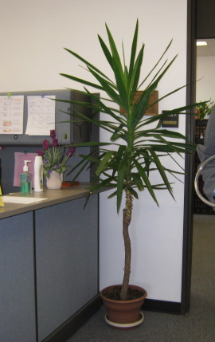

Plant Located on Floor in Judge’s Lobby

Picture 2

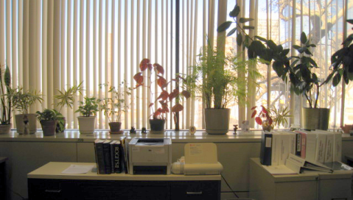

Plants Located on Windowsill in Judge’s Lobby
Picture 3

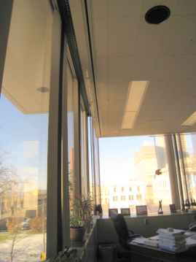

Plants Located Below Air Supply Ventilation (Note Arrow)

Picture 4

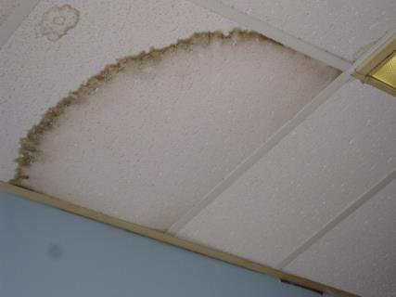

Water-Damaged Ceiling Tile
Picture 5

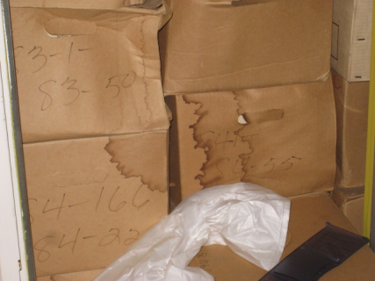

Water-Damaged Cardboard Boxes

Picture 6

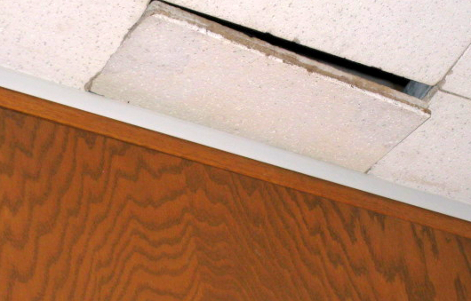

Ajar Ceiling Tile

Picture 7

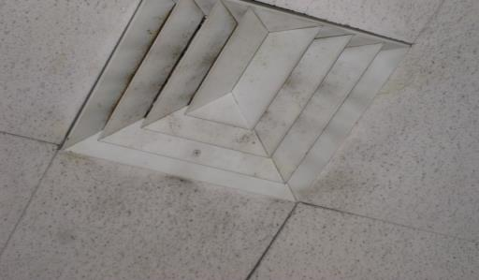

Dirty Air Supply Vent

Location | Carbon  Dioxide  (ppm) | Carbon Monoxide  (ppm) | Temp  (°F) | Relative  Humidity  (%) | PM2.5  (µg/m³) | Occupants  in Room | Windows  Openable | Ventilation |  | Remarks
 |  |  |  |  |  |  |  | Supply | Exhaust
Background | 388 | 2 | 31 | 15 | 4 |  |  |  |  | Sunny, cold
207 Judge’s Lobby | 631 | 1 | 73 | 15 | 2 | 2 | N | N | Y | DO, plant on carpet
207 Lobby A | 610 | 1 | 72 | 14 | 1 | 2 | N | Y | Y | DO, PC, numerous plants on windowsill
207 Lobby B | 662 | 1.2 | 71 | 15 | 3 | 3 | N | Y | Y | DO, plant
330 (Holding Cells) | 737 | ND | 75 | 12 | 2 | 0 | N | Y | Y | WD CT (2), CT ajar (2), ceiling fan, supply and exhaust vents, WD cardboard boxes in closet
Courtroom 2 | 602 | ND | 74 | 13 | 3 | 1 | N | Y | Y
Courtroom 3 | 738 | 1.3 | 75 | 13 | 3 | 11 | N | Y | Y
Second Floor Main Lobby | 654 | ND | 74 | 11 | 3 | 0 | N | Y | Y

