INDOOR AIR QUALITY ASSESSMENT

Hall of Justice
50 State Street
Springfield, Massachusetts

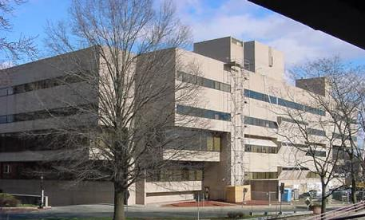

Prepared by:
Massachusetts Department of Public Health
Center for Environmental Health
Emergency Response/Indoor Air Quality Program
May 2006

Background/Introduction
In response to a request from the Hampden County District Attorneys Office and Jim Pagliaro, Regional Court Facilities Manager, the Massachusetts Department of Public Health’s (MDPH), Center for Environmental Health (CEH) conducted an indoor air quality assessment at the Hall of Justice (HOJ), 50 State Street, Springfield, Massachusetts. Concerns about indoor air quality, water damage and temperature control as well the former use of the site prompted the request.
On April 21-22, 2005, Michael Feeney, Director of CEH’s Emergency Response/Indoor Air Quality (ER/IAQ) Program, made an initial visit to this building. Mr. Feeney returned on February 7, 2006 to complete the assessment and to observe the operation of the heating, ventilating and air-conditioning (HVAC) system during the heating season.
The HOJ is a four-story, tiered, cement and steel frame building constructed in 1973 as an energy efficient facility. A gasoline service station existed on the HOJ site prior to construction (Blueprint 1). According to HOJ staff, the building was originally designed to have a fifth floor. A number of characteristics were found in the building that support this hypothesis:
- The penthouse for the roof top HVAC system and elevators is over two stories tall (Picture 1). In similar facilities evaluated by CEH staff, such structures of this type are usually one story tall.
- The elevator floor indicator has an unlabelled light button (Picture 2).
- The roof has a number of protrusions through the deck the size of the I-beam steel girders that make up the frame of the building (Picture 3). It appears that the existing roof membrane was installed over these roof protrusions.
- The decking below the roof does not appear to have any insulation.
At the time of the February 2006 visit, a project to renovate the roof had begun (Picture 4). The project includes reconfiguring the roof to provide appropriate insulation, which will help to regulate the temperature of the building.
The upper floors of the building have a larger footprint than the base of the building, which creates significant areas that overhang on the north (Picture 5), east (Picture 6) and south (Picture 7) exterior walls of the building. The windows are openable in some areas and consist of a single pane of glass in a metal frame (Picture 8). An underground parking garage exists between the HOJ and the Housing Court building. The parking garage does not appear to be located beneath the footprint of the building.

Methods
Air tests for carbon dioxide, temperature and relative humidity were taken with the TSI, Q-Trak, IAQ Monitor. Screening for total volatile organic compounds (TVOCs) was conducted using a HNu Photo Ionization Detector (PID). Surface temperature of building components were taken with a Thermotrace laser thermometer.

Results
The HOJ has an employee population of over 200 with several hundred visitors on a daily basis. Tests were taken under normal operating conditions and results appear in Tables 1 through 4. Air sampling results are listed in the Tables by location that the air sample was taken.

Discussion
Ventilation
It can be seen from Tables 1 and 2 that carbon dioxide levels were below 800 parts per million parts (ppm) in all areas sampled during the April 2005 assessment. During the February 7, 2006 air sampling, carbon dioxide levels were above 800 parts per million (ppm) parts of air in all areas sampled (Table 3). As reported by HOJ facilities staff, the boiler was not operating during the February 7, 2006 visit. To maintain heat in the building, the HVAC system was operating, but the fresh air supply intakes were intentionally closed. Without the introduction of fresh, outside air, carbon dioxide levels would be expected to increase. With the HVAC system operating and fresh air intake dampers open, carbon dioxide levels would be expected to decrease.
The April 2005 measurements indicate that the heating, ventilating and air-conditioning (HVAC) system is providing an adequate amount of fresh air when operating as designed (i.e., with fresh air intakes open). Please note that a number of areas that had carbon dioxide levels below 800 ppm were measured in unoccupied areas or with low population, which can greatly decrease carbon dioxide levels.
As described by HOJ facilities staff, the ventilation system is separated into three zones: the building core, western and eastern sides. The building core includes the courtrooms in the center of the building on multiple floors. The western side includes all of the areas that are located on the side of the building closest to Interstate 91. The eastern side includes the offices located in the half of the building closest to the Housing Court building. Fresh air intakes are located in a variety of areas, including the rooftop penthouse and at ground level. Fresh air is supplied by ceiling or wall mounted fresh air supply vents. Each area adjacent to windows is equipped with fan coil units (FCUs) (Picture 9). The FCUs do not provide fresh air, but rather help to heat or cool air. Therefore, FCUs recirculate air only.
Exhaust ventilation is provided by ceiling mounted exhaust vents. Of note were the holding cells located in the western side of the building. Above the hallway door to the cells is a retrofitted fan that appears to exhaust air from the cells into the hallway (Picture 10). Each cell appears to be equipped with exhaust vents that did not appear to be drawing air. In this condition, odors within the holding cells can be directed into the hallway by these fans.
The fourth floor registry of deeds office had a series of retrofitted wall fans installed and were operating during the CEH visits. According to Registry of Deeds staff, a fan was placed in the suspended ceiling to provide heat relief (Picture 11). CEH staff recommended the removal of the fan from the ceiling since it could be a fire hazard.
The garage contains a series of exhaust vents that were not activated during any of the CEH visits. It is likely that these vents were deactivated since the air from the garage appears to exhaust at a ground level bus stop (Picture 12).
To maximize air exchange, the MDPH recommends that all components of the ventilation system (e.g., supply ventilation, exhaust ventilation and FCUs) operate continuously during business hours. Without the HVAC system operating as designed, normally occurring pollutants cannot be diluted or removed, allowing them to build up and lead to indoor air quality/comfort complaints. In order to have proper ventilation, the systems should also be balanced to provide an adequate amount of fresh air to the interior of a room while removing stale air from the room. It is recommended that HVAC systems be re-balanced every five years to ensure adequate air systems function (SMACNA, 1994). The date of the last balancing of these systems was not available at the time of the assessment.
The Massachusetts Building Code requires that each room have a minimum ventilation rate of 20 cubic feet per minute (cfm) per occupant of fresh outside air or openable windows (SBBRS, 1997). The ventilation must be on at all times that the room is occupied. Providing adequate fresh air ventilation with open windows and maintaining the temperature in the comfort range during the cold weather season is impractical. Mechanical ventilation is usually required to provide adequate fresh air ventilation.
Carbon dioxide is not a problem in and of itself. It is used as an indicator of the adequacy of the fresh air ventilation. As carbon dioxide levels rise, it indicates that the ventilating system is malfunctioning or the design occupancy of the room is being exceeded. When this happens a buildup of common indoor air pollutants can occur, leading to discomfort or health complaints. The Occupational Safety and Health Administration (OSHA) standard for carbon dioxide is 5,000 parts per million parts of air (ppm). Workers may be exposed to this level for 40 hours/week based on a time-weighted average (OSHA, 1997).
The MPDH uses a guideline of 800 ppm for publicly occupied buildings. A guideline of 600 ppm or less is preferred in schools due to the fact that the majority of occupants are young and considered to be a more sensitive population in the evaluation of environmental health status. Inadequate ventilation and/or elevated temperatures are major causes of complaints such as respiratory, eye, nose and throat irritation, lethargy and headaches. For more information concerning carbon dioxide, see Appendix A.
The following temperature ranges were measured within the HOJ.
April 21, 2005 72º to 84º F
April 22, 2005 72º to 77º F
February 7, 2006 71º to 77º F
Temperature readings on both April 2005 visits were above or mostly in the upper part of the MDPH recommended temperature range of 70º to 78º F. Employees expressed concerns about temperature control in the building (e.g., not enough heat in winter, not enough cooling in hot weather). There are a number of factors that are either heat sources or contribute to these temperature control difficulties.
- The building was originally designed to have large open floors that would be heated or cooled by both the AHU and FCUs located around the perimeter of each office below windows. After the building was constructed, a number of areas were subdivided into offices without taking into consideration the design of the HVAC system. In a number of areas, the FCUs are now separated from the main floor by floor to ceiling, prefabricated walls. These walls disrupt the intended airflow pattern, making temperature control difficult. In an effort to decrease temperature, a fan was installed to exhaust air into the ceiling plenum (Picture 11). Room 421was a newly created room that was separated from the FCUs by an interior wall with windows. During the April 21, 2005 visit, CEH staff suggested removing one of these windows to improve airflow. When CEH returned to the building in February 2006, the windows remained in place.
- As mentioned previously, the portion of the building that serves as the roof does not appear to be designed as a roof, but rather is a rubber membrane installed over an uninsulated structure. Without insulation, heat from the sun would heat the cement decking of the fourth floor, which would subsequently heat the ceiling plenum and the office space below the suspended ceiling.
- The window system of the building consists of a single pane of glass installed inside a metal frame. When exposed to direct sunlight in warm weather, the glass and metal of the windows become a significant heat source (during the April 2005 visits, surface temperature of windows in sunlight was measured over 100ºF in an office on the south wall of the HOJ). Conversely, windows that are not exposed to sunlight and are exposed to northwesterly winds during frigid weather have a significantly lower temperature than interior walls (window frame temperatures ranged from 48ºF to 74ºF; windowpane temperatures ranged from 43ºF to 75ºF) during the February 2006 visit. In both instances, the location of the room and weather conditions will have a significant influence on room temperature.
- The floors of offices that overhang the ground had a temperature in a range of 57ºF to 59ºF, which were lower than temperatures of the floor in areas that exist toward the building core. It could not be determined whether the floor of overhanging offices are insulated.
- In areas where the FCUs are installed, a significant number of large computer monitors exist. The air temperature measured in the vent at the top of a monitor was 115ºF.
- Some areas had thermostats installed in a manner that limits their ability to measure air temperature. Some thermostats were installed behind shelves filled with files (Picture 13). In one case, a computer monitor was directly below the thermostat (Picture 14). Thermostats need to be installed in a location that can measure airflow representative of the area and not be in close proximity to a heat source (computer monitors, photocopiers, etc.).
Therefore, a number of factors exist that contribute to the difficulty in controlling temperature in this building. Please note that even without these design and construction issues, fluctuations of temperature in occupied spaces are typically experienced, even in a building with an adequate fresh air supply.
The following relative humidity ranges were measured within the HOJ.
April 21, 2005 13% to 21%
April 22, 2005 16% to 28%
February 7, 2006 19% to 31%
The relative humidity in the HOJ was below the MDPH recommended range of 40 to 60 percent in all areas sampled. Relative humidity in the building would be expected to drop during the winter months due to heating. The sensation of dryness and irritation is common in a low relative humidity environment. Low relative humidity is a common problem during the heating season in the northeast part of the United States.

Microbial/Moisture Concerns
The east wall of the fourth floor consists of a short wall with large sloping windows. The window system was designed to direct rainwater onto a short roof behind a parapet (Picture 15). Heavy moss growth was noted on this roof, particularly around drains (Picture 16). Moss growth around these drains is an indication of chronic water pooling on the roof. The freezing and thawing of water during winter months can lead to roof leaks and subsequent water penetration into the interior of the building. Areas in the District Attorney’s office and law library had extensive water damage (Pictures 17 and 18).
The American Conference of Governmental Industrial Hygienists (ACGIH) and the United States Environmental Protection Agency (US EPA) recommend that porous materials be dried with fans and heating within 24 to 48 hours of becoming wet (ACGIH, 1989; US EPA, 2001). If porous materials are not dried within this time frame, mold growth may occur. Water-damaged porous materials cannot be adequately cleaned to remove mold growth. The application of a mildewcide to moldy porous materials is not recommended.
The Registry of Deeds built a server room that requires air conditioning (AC) for computer equipment. A self-contained AC system was installed in this room. As air conditioning equipment operates, moisture accumulates in the cooling coils that require a drain to remove water from the cabinet. CEH staff located the drain, but could not identify if the drainpipe was connected to a building drainage system. If not connected to a building drainage system, water likely accumulates and pools within the AC unit. Pooling water of this nature can serve as a mold growth medium. CEH staff inspected several FCUs, which were equipped with drip pans and drains connected to a drainage system (Picture 19).
Plants were observed in a number of rooms. Moistened plant soil and drip pans can provide a source of mold growth. Plants are also a source of pollen. Plants should be located away from the air stream of ventilation sources to prevent the aerosolization of mold, pollen or particulate matter. Plants should have drip pans to prevent wetting of porous building materials and subsequent mold colonization. Over watering of plants should be avoided and drip pans should be inspected periodically for mold growth.
A large planter is located along the western wall of the HOJ (Picture 20). A public records area exists beneath and adjacent to the planter. The ceiling in this area appeared to be water damaged in a manner similar to the third floor of the HOJ. As with roofs, planters of this type must adequately drain in order to prevent water damage to adjacent walls and ceilings.

Other Concerns
Building occupants expressed concerns about a possible chemical exposure within the HOJ resulting from the past use of the site. As revealed by HOJ facilities staff, the HOJ was built on the site of a former gasoline service station (Blueprint 1). Gasoline is a complex mixture of a variety of volatile organic compounds (VOCs). In order to assess whether residual contamination was present within the HOJ, air sampling for the presence of volatile organic compounds (VOCs) was conducted. VOCs are substances that have the ability to evaporate at room temperature. For example, solvent-based chemicals that rapidly evaporate at room temperature and would likely contain VOCs. Frequently, exposure to low levels of total VOCs (TVOCs) may produce eye, nose, throat and/or respiratory irritation in some sensitive individuals.
CEH staff conducted TVOC sampling in offices and all common areas (Table 1). Air sampling was also conducted in areas that would be most likely impacted by VOCs from a high water table (e.g., the basement). A likely route for odor and vapors to enter into the HOJ would be through floor penetrations (e.g. access ports, drains or cracks). Background (i.e. outdoor) TVOC sampling was conducted for comparison. No measurable levels of TVOCs were detected inside the HOJ or outdoors on the day of assessment. Therefore, it does not appear likely that any residual contamination from possible gasoline contamination exists.
The location of the HOJ however, does make it prone to entraining outdoor pollutants into the building via the HVAC system. In Massachusetts, the wind direction is predominantly from a westerly direction. A number of sources that produce pollutants were observed west/southwest (upwind) from the HOJ. The following conditions were either reported to or directly observed by CEH staff:
- A major truck route intersects State Street and E. Columbus Avenue at a stop light to the southwest of the building (Picture 21). Exhaust from idling vehicles is directed toward the HOJ under certain wind conditions.
- Building occupants reported periodic odors, mainly during southwest winds, from Bondi Island, which contains the Springfield Regional Wastewater Treatment Facility (Map 1).
- Approximately 30 feet above E. Columbus Street is an elevated portion of Interstate-91 (Picture 22).
- A construction project was observed beneath an Interstate 91 overpass west of the building (Picture 23).
Under certain wind patterns, each of these pollutants sources has likely had some influence on the indoor air quality at the HOJ. As reported by HOJ facilities staff, when odors from Bondi Island are reported, the ventilation system fresh air intakes are closed, which would be the most appropriate procedure since HVAC system filters do not have the ability to remove gaseous materials from air. The HOJ uses a roller filter system, which also does not likely filter extremely fine dust, such as vehicle exhaust particulates.
FCUs are normally equipped with filters that strain particulates from airflow. Filter materials cut to size were found inside the FCUs (Picture 24). Air may bypass improperly sized filters through spaces in the frame and result in aerosolization of dust. In order to decrease aerosolized particulates, disposable filters with an adequate dust spot efficiency should be installed. The dust spot efficiency is the ability of a filter to remove particulates of a certain diameter from air passing through the filter. Filters that have been determined by ASHRAE to meet its standard for a dust spot efficiency of a minimum of 40 percent would be sufficient to reduce airborne particulates (Thornburg, 2000; MEHRC, 1997; ASHRAE, 1992).
The interiors of a number of FCUs were examined. An antimicrobial agent was found in FCU drip pans (Picture 25). The use of this product in FCU drip pans is not necessary. In order to support bacteria growth such as L. pneumophila, moisture within a certain temperature range must be achieved. The ideal temperature for this microorganism to grow is at temperatures between 80 to 120º F (27 to 49º C) in the presence of sunlight, oxygen, and nutrients such as phosphorous, nitrogen, sulfate and carbon dioxide (Lane, R.W., 1993). Organisms such as algae, mold, Legionella pneumophila (Gold, D. 1992) and other microbes have been found to grow within HVAC equipment that reuses water, such as cooling towers. The purpose of cooling towers in an HVAC system is to remove heat from coolant, which warms water to the requisite temperature for microbial growth. The purpose of drip pans is to drain moisture generated by cooling coils. The temperature of FCU coils in the cooling mode during the summer is less than 60º F. Lower temperature and removal of moisture through proper drainage would limit microbial growth in FCUs, rendering the use of the antimicrobial agent unnecessary.
Of note are the constituents of the antimicrobial product that are frequently alkaline materials. The odor produced by this product is characterized as a “mothball-like” odor. As condensation comes into contact with the antimicrobial ingredients they form a solution. This solution may become aerosolized during FCU operation if standing water exists in drip pans. Exposure to this product may cause irritation to the eyes and skin.
A number of offices contained photocopiers, which can produce irritating odors during use. VOCs and ozone can be produced by photocopiers, particularly if the equipment is older and in frequent use. Ozone is a respiratory irritant (Schmidt Etkin, 1992). These areas are not equipped with local exhaust ventilation to help reduce excess heat and odors.
Of note was a variety of break rooms that were equipped with stoves or microwave ovens. Each of these areas appear not to have exhaust vents designed to remove cooking odors. Cooking odors can enter the general ventilation system and be subsequently distributed to other areas serviced by the general HVAC system.
An unused drain was found in the floor of a room in the Registry of Deeds (Picture 26). The drain likely has a dry trap, which can allow sewer gases/odors to migrate from the drain system into occupied space. The drain should be filled regularly with water or sealed to prevent this contingency.

Conclusions/Recommendations
The indoor air quality conditions at the HOJ are somewhat complex and interconnected. Decisions made concerning the design and construction of the building make it prone to entraining a variety of odors and pollutants from surrounding sources. In addition, the configuration of the roof and the type of window system installed make it difficult to control temperatures in the building. The subsequent subdivision of floors without consideration for the adequacy of ventilation also plays a significant role in temperature control. The lack of measurable TVOC levels would indicate that the HOJ does not appear to be impacted from the previous use of this site.
While some problems can be addressed as soon as practicable, others will require planning and resources. For this reason, a two-phase approach consisting of short-term measures to improve air quality and long-term measures to address the overall indoor air quality concerns is recommended.

Short Term Recommendations

In view of the findings at the time of the visit, the following recommendations are made:
- During times of odors from the Bondi Island area, continue to limit fresh air intake into the HOJ until the odor passes.
- Do not install fans into the suspended ceiling as depicted in Picture 11.
- Discuss with the City of Springfield the feasibility of decreasing the length of time that traffic is stopped at the State Street intersection.
- No further subdivision of floor space should be conducted by building occupants unless this reconfiguration is done in consultation with the Bureau of Court Facilities to ensure that adequate airflow and temperature control can be provided for such space.
- Consideration should be give to relocating thermostats to locations that have free airflow, or that materials obstructing airflow to thermostats be relocated.
- Remove all waste heat producing electronic devices from close proximity to thermostats.
- Use window shades/blinds as much as practical to reduce heat/cold transmission into offices. Operate the FCUs in a manner to heat/temper air in perimeter areas.
- Seal the drain shown in Picture 26.
- Remove antimicrobial pads from all FCUs.
- Relocate photocopiers from vicinity of FCUs.
- Remove the window from the interior wall of the Registry of Deeds room to facilitate airflow.
- Examine the feasibility of connecting the self-contained air conditioner in the Registry of Deeds’ server room to the drain system. Connect this drain to the main HVAC/FCU drain system. Any installation of air chilling equipment must provide for adequate means to drain condensation. Any installation of such equipment should be done in consultation with the Bureau of Court Facilities to ensure that adequate drainage for equipment exists.
- Install properly fitted filters for FCUs. Consult with a ventilation engineer concerning the appropriate filter media for the FCUs.
- Consult a ventilation engineer concerning re-balancing of the ventilation systems. Ventilation industrial standards recommend that mechanical ventilation systems be balanced every five years (SMACNA, 1994).
- Repair the exhaust vent system for holding cells.
- For buildings in New England, periods of low relative humidity during the winter are often unavoidable. Therefore, scrupulous cleaning practices should be adopted to minimize common indoor air contaminants whose irritant effects can be enhanced when the relative humidity is low. To control for dusts, a high efficiency particulate arrestance (HEPA) filter equipped vacuum cleaner in conjunction with wet wiping of all non-porous surfaces is recommended. Drinking water during the day can help ease some symptoms associated with a dry environment (throat and sinus irritations).
- Remove debris from the short roof.
- Continue with replacement of wet ceiling tiles and channel leaking water into collection containers until roof repairs are complete. Once the roof repair is complete, repair the water damaged areas in the building in a manner consistent with guidelines set forth in “Mold Remediation in Schools and Commercial Buildings” published by the US Environmental Protection Agency (US EPA, 2001).

Long Term Recommendations
- Continue with repairs to establish a functional, insulated roof to eliminate water leaks and improve temperature control.
- Consideration should be given to replacing the existing window system with an energy efficient, double-paned type in order to eliminate heat/cold transmission into exterior walls.
- In order to improve air distribution from FCUs, consideration should be given to replacing floor-to-ceiling retrofitted walls with barriers that are open at the top to increase airflow.
- Examine the feasibility of installing dedicated exhaust vents for all areas with cooking equipment.
- While the parking garage does not appear to have an impact on the HOJ, consideration should be given to reconfiguring the exhaust system to eliminate its venting at sidewalk level.
References
ACGIH. 1989. Guidelines for the Assessment of Bioaerosols in the Indoor Environment. American Conference of Governmental Industrial Hygienists, Cincinnati, OH.
ASHRAE. 1992. Gravimetric and Dust-Spot Procedures for Testing Air-Cleaning Devices Used in General Ventilation for Removing Particulate Matter. American Society of Heating, Refrigeration and Air Conditioning Engineers. ANSI/ASHRAE 52.1-1992.

BOCA. 1993. The BOCA National Mechanical Code/1993. 8th ed. Building Officials and Code Administrators International, Inc., Country Club Hill, IL. Section M-308.1.1.
Gold, D. 1992. Indoor Air Pollution. Occupational Lung Diseases. 13(2):224-225.

Lane, R.W. 1993. Control of Scale and Corrosion in Building Water Systems. McGraw-Hill, Inc. New York, NY.

MEHRC. 1997. Indoor Air Quality for HVAC Operators & Contractors Workbook. MidAtlanatic Environmental Hygiene Resource Center, Philadelphia, PA.

OSHA. 1997. Limits for Air Contaminants. Occupational Safety and Health Administration. Code of Federal Regulations. 29 C.F.R 1910.1000 Table Z-1-A.
SBBRS. 1997. Mechanical Ventilation. State Board of Building Regulations and Standards. Code of Massachusetts Regulations. 780 CMR 1209.0
Schmidt Etkin, D. 1992. Office Furnishings/Equipment & IAQ Health Impacts, Prevention & Mitigation. Cutter Information Corporation, Indoor Air Quality Update, Arlington, MA.
SMACNA. 1994. HVAC Systems Commissioning Manual. 1st ed. Sheet Metal and Air Conditioning Contractors’ National Association, Inc., Chantilly, VA
Thornburg, D. 2000. Filter Selection: a Standard Solution. Engineering Systems 17:6 pp. 74-80.

US EPA. 2001. “Mold Remediation in Schools and Commercial Buildings”. Office of Air and Radiation, Indoor Environments Division, Washington, DC. EPA 402-K-01-001. March 2001. Available at: http://www.epa.gov/iaq/molds/mold_remediation.html

Blueprint 1
Blueprint of Hall Of Justice Plot, Indicating a Gasoline Station Existed on the Site Previous to Construction
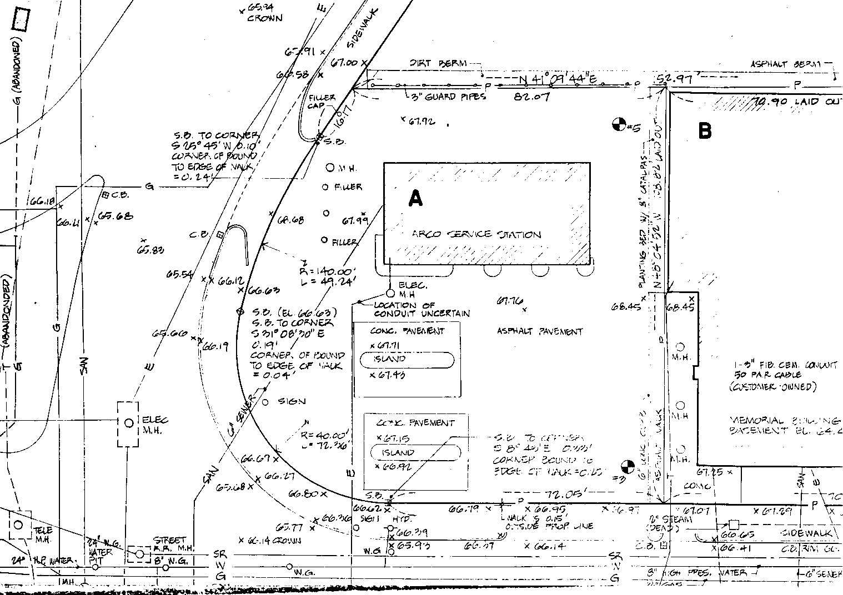

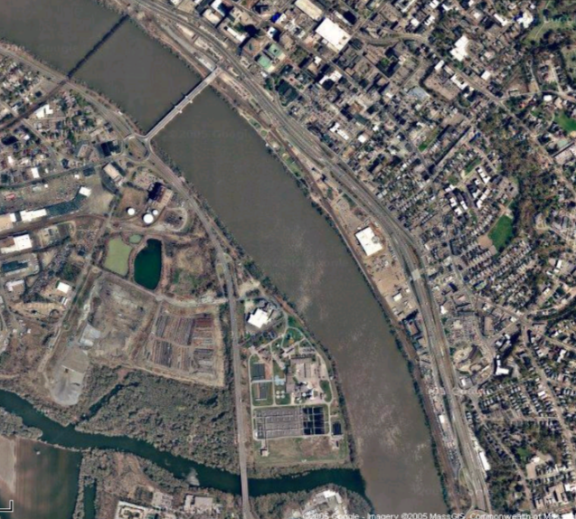
Wastewater Treatment Plant
Hall of Justice

Picture 1

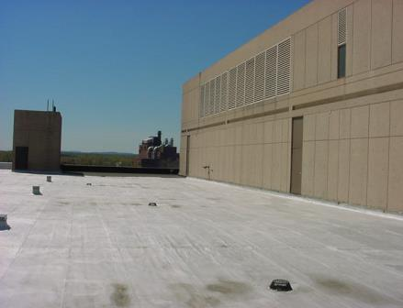

Two-Story Rooftop Penthouse

Picture 2
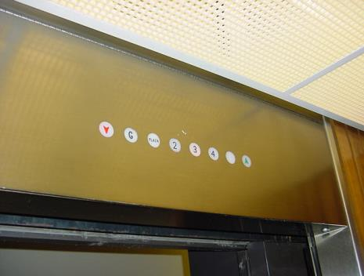

Elevator Floor Indicator Has an Extra-Unlabelled Light
Picture 3

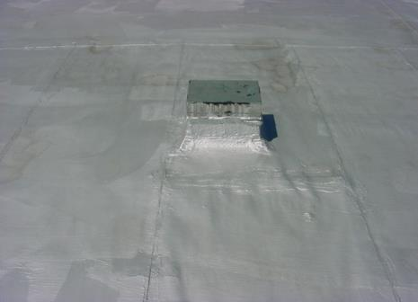

Roof Membrane, Note I-Beams Installed Through Roof

Picture 4

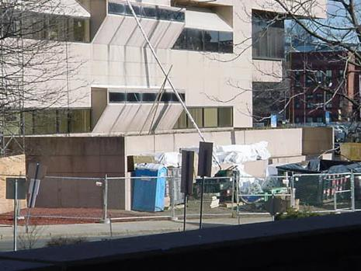

Roof Work Staging Area
Picture 5

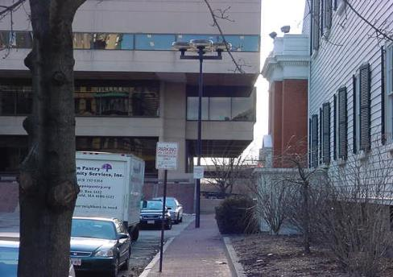

Floor Overhang over Driveway, North

Picture 6

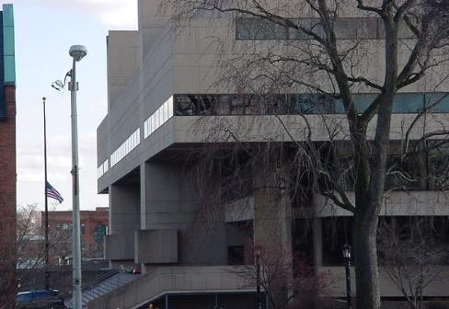

Floor Overhang, East
Picture 7

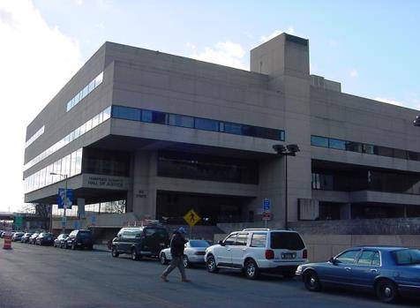

Floor Overhang, South

Picture 8

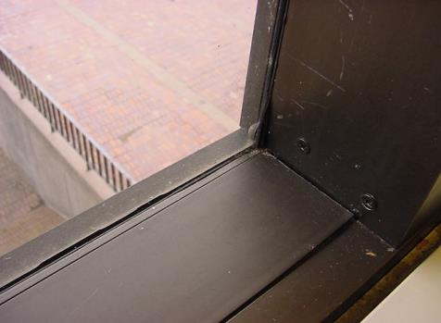

Windows Are Single Glass Panes in Metal Frames
Picture 9

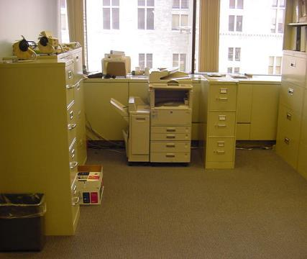

Fan Coil Unit (Arrow) Blocked By Photocopier

Picture 10

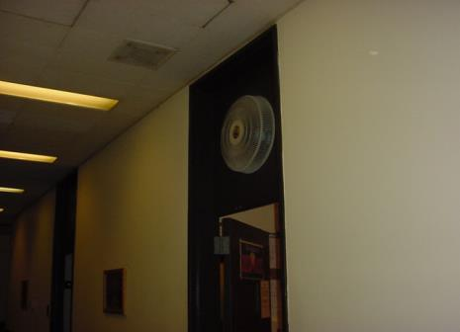

Fan Retrofitted Into the Top of Doorway Leading to the Holding Cells
Picture 11

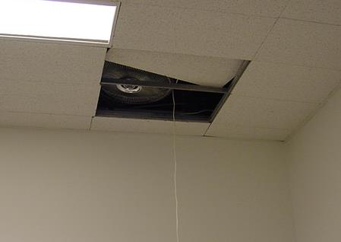

Fan Placed In Ceiling Plenum in Room Of Registry of Deeds

Picture 12

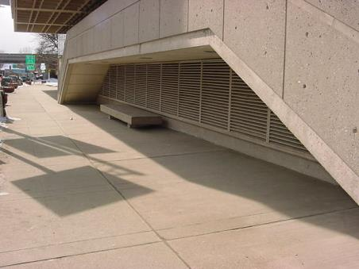

Exhaust Vent for Parking Garage
Picture 13

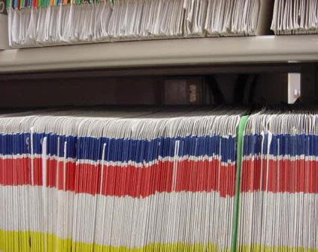

Thermostat Located Behind Files on Shelf

Picture 14

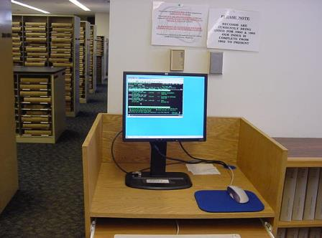

Thermostat Located Above Computer Monitor in Registry of Deeds

Picture 15

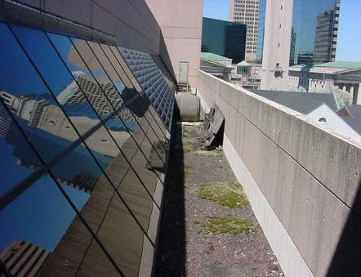

Short Roof over Library at Fourth Floor Level, Note Moss and Debris on Roof

Picture 16

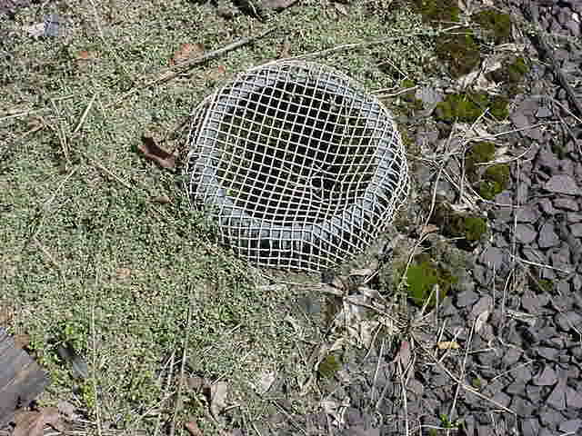

Roof Membrane Damage and Moss Growth
Picture 17

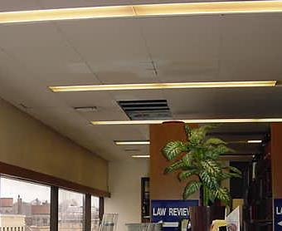

Water Damage on Ceiling in Library

Picture 18

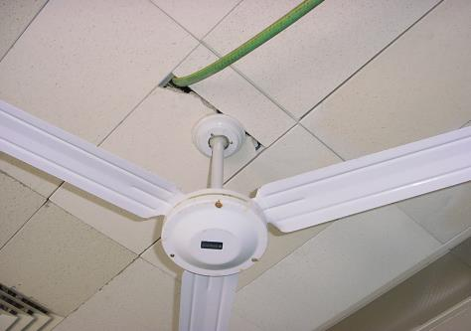

Water Damage on Ceiling in DA’s Office Suite, East Wall

Picture 19

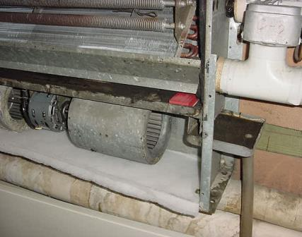

Drip Pan and Drain in FCU (Arrows)

Picture 20

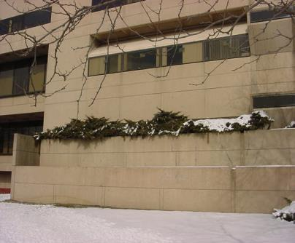

Planter Built Into Building

Picture 21

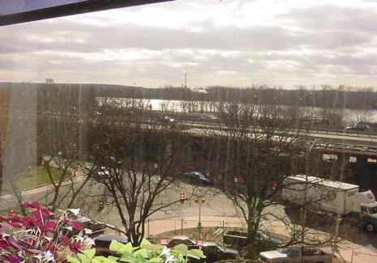

Intersection of E. Columbus Avenue and State Street, Southwest of HOJ, Second Floor Judge’s Lobby

Picture 22

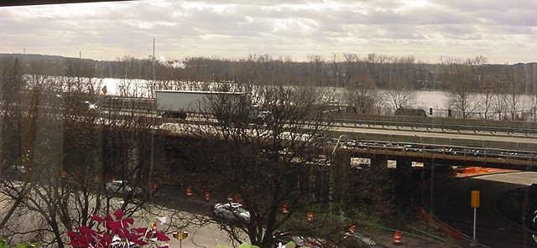

Interstate 91, View from inside HOJ, Second Floor Judge’s Lobby
Picture 23

Construction beneath I-91 Overpass, West Of HOJ

Picture 24

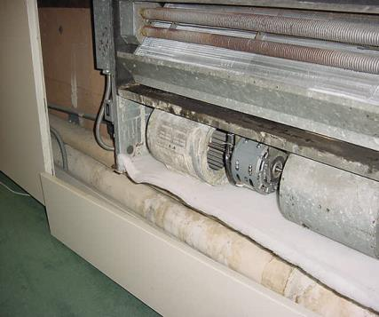

Filter Media Cut To Fit FCU
Picture 25

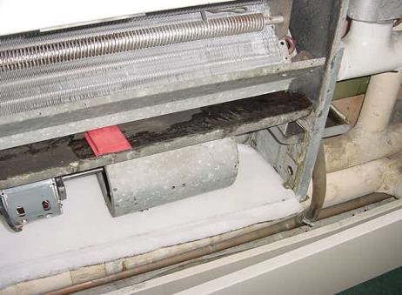

Antimicrobial Agent in FCU Drip Pan

Picture 26

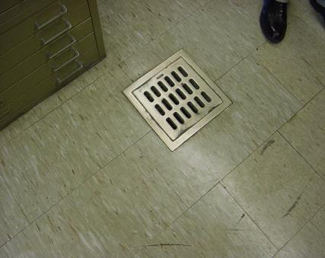

Drain In Floor of Registry of Deeds
Location | Carbon  Dioxide  (*ppm) | Temp.  (°F) | Relative  Humidity  (%) | Total Volatile Organic Compound(*ppm) | Occupants  in Room | Windows  Openable | Ventilation |  | Remarks
 |  |  |  |  |  |  | Supply | Exhaust
Outside  (Background) | 457 | 68 | 18 | ND
Jury pool | 700 | 77 | 21 | ND | 3 | N | Y | Y | Floor fans
Hall 437 | 656 | 81 | 19 | ND | 0 | N | Y | Y | 3 missing ceiling tiles
Vault 440 | 652 | 81 | 18 | ND | 3 | N | Y | Y | 8 water damaged ceiling tiles  door open
431 | 660 | 81 | 18 | ND | 0 | Y | Y | Y | Fan coil unit off
Registry rear office | 742 | 81 | 19 | ND | 0 | N | Y | Y | Computers
428 | 773 | 81 | 18 | ND | 2 | N | Y | Y | Fan coil unit off  Door open
428B | 674 | 81 | 19 | ND | 0 | N | Y | Y
423 | 631 | 81 | 18 | ND | 1 | N | Y | Y | Floor fans  Door open
Parking garage | 420 | 64 | 29 | ND | 4 | N | N | Y | Exhaust system off  Carbon monoxide non-detectable  1 van idling in garage
Registry of Deeds main desk | 625 | 81 | 21 | ND | 10+ | N | Y | Y | 30 computers  retrofitted fans operating  ceiling fans operating  door open
Registry of Deeds outside 402 | 597 | 81 | 20 | ND | 5 | N | Y | Y | Ceiling fans on
401A | 631 | 81 | 20 | ND | 1 | Y | N | N | Ceiling fan on  Door open
402 | 601 | 81 | 20 | ND | 0 | N | Y | Y
403A | 671 | 81 | 20 | ND | 3 | N | Y | Y
403 | 668 | 81 | 20 | ND | 2 | N | Y | Y | 4 computers  1 scanner  1 photocopier  plants
403B | 644 | 81 | 19 | ND | 0 | N | Y | Y
403C | 767 | 77 | 21 | ND | 0 | N | Y | Y | Interior air conditioning unit with no condensation
411 | 615 | 82 | 19 | ND | 2 | N | Y | Y | Missing ceiling tile  4 computers  2 photocopiers  odor complaints
422 | 749 | 82 | 19 | ND | 1 | N | Y | Y | Floor fan
420 | 746 | 82 | 19 | ND | 1 | N | Y | Y | Fan coil unit blocked  Door open
421 | 724 | 82 | 19 | ND | 1 | N | Y | Y | Fan coil unit blocked  Door open
421 | 716 | 81 | 18 | ND | 2 | N | Y | Y | Fan in ceiling  Door open
416 | 695 | 82 | 18 | ND | 0 | N | Y | Y | Fan coil unit off  Floor fan
Probate court | 494 | 79 | 14 | ND | 0 | N | Y | Y
Jury pool | 787 | 82 | 21 | ND | 1 | N | Y | Y | Fan coil unit off  Floor fan
412 | 643 | 82 | 18 | ND | 2 | Y | Y | Y | Floor fans  Door open
414 | 599 | 84 | 18 | ND | 0 | Y | Y | Y | Floor drain  Door open
415 | 614 | 81 | 18 | ND | 1 | N | Y | Y | Floor fan  Door open
413A | 635 | 82 | 18 | ND | 0 | N | Y | Y | Portable fan placed in ceiling  Plants
408 | 611 | 82 | 17 | ND | 0 | N | Y | Y | Ceiling fan  Door open
408A | 652 | 81 | 17 | ND | 0 | N | Y | Y | Door open
407 | 624 | 81 | 17 | ND | 1 | N | Y | Y | Floor fan
427 break room | 752 | 79 | 18 | ND | 20+ | N | Y | Y | Microwave  Stove  No dedicated exhaust, odors drawn into general ventilation
Registry of Probate | 744 | 80 | 19 | ND | 20+ | N | Y | Y | Floor fan
365 | 465 | 72 | 16 | ND | 0 | N | Y | Y | Door open
373 | 488 | 73 | 15 | ND | 0 | N | Y | Y | 4 water damaged ceiling tiles  Fan coil unit off  Door open
Dineen office | 487 | 72 | 15 | ND | 0 | N | y | Y | Drainage hose in ceiling  4 water damaged ceiling tiles  Door open
DA main Office | 654 | 73 | 15 | ND | 7 | N | Y | Y | Ceiling fan
354 | 488 | 73 | 14 | ND | 2 | N | Y | Y | Door open
DA Cafeteria | 516 | 73 | 15 | ND | 3 | N | y | N | No dedicate exhaust vent for cooking  Microwave oven  Food storage
366 | 533 | 74 | 14 | ND | 3 | N | Y | Y | Door open
DA’s Private Office | 582 | 78 | 14 | ND | 3 | N | Y | Y | Water damaged wall material
DA Waiting Area | 588 | 75 | 13 | ND | 4 | N | Y | N
347 | 551 | 74 | 14 | ND | 0 | N | Y | Y | Plants
330 | 612 | 74 | 14 | ND | 3 | N | Y | Y | Ceiling fans on  Door open
Superior Court 1 | 487 | 74 | 13 | ND | 6 | N | Y | Y
320 | 320 | 75 | 15 | ND | 0 | N | Y | Y | Door open
317 | 553 | 76 | 14 | ND | 2 | N | Y | Y | Door open
315 | 511 | 74 | 13 | ND | 1 | N | Y | Y | Water cooler on carpet  Plants  Door open
314 | 501 | 74 | 13 | ND | 1 | N | Y | Y | 10+ water damaged ceiling tiles
313 | 417 | 74 | 13 | ND | 0 | N | Y | Y | 10+ water damaged ceiling tiles  door open
Court stenographer | 518 | 74 | 13 | ND | 0 | N | Y | Y | 5 water damaged ceiling tiles  1 missing ceiling tile

Location | Carbon  Dioxide  (*ppm) | Temp.  (°F) | Relative  Humidity  (%) | Total Volatile Organic Compound(*ppm) | Occupants  in Room | Windows  Openable | Ventilation |  | Remarks
 |  |  |  |  |  |  | Supply | Exhaust
Outside  (Background) | 422 | 61 | 34 | ND
Recorder of Land Court | 651 | 75 | 19 | ND | 1 | Y | N | Y | 5 water damaged ceiling tiles  Photocopier
Lounge 228 | 549 | 75 | 16 | ND | 1 | Y | N | Y | Fan coil units off  No dedicated exhaust vents  Door open
210A | 572 | 73 | 16 | ND | 0 | Y | N | Y | Fan coil units off  Door open
210 | 538 | 72 | 16 | ND | 1 | Y | N | Y | Water cooler on carpet  Door open
209 | 495 | 72 | 16 | ND | 0 | Y | N | Y | Fan coil unit off
208 | 496 | 72 | 16 | ND | 1 | N | Y | Y | Photocopier  Fan coil unit off
207 A + B | 691 | 72 | 18 | ND | 2 | N | Y | Y | Plants
206 | 528 | 72 | 17 | ND | 0 | N | Y | Y
204A | 586 | 72 | 20 | ND | 0 | Y | Y | Y | Plants  Fan coil unit off
204 | 575 | 72 | 21 | ND | 1 | Y | Y | Y | Plants  Fan coil unit off
Stenographer | 592 | 72 | 19 | ND | 2 | Y | Y | Y | Fan coil unit off
Civil clerks main office | 592 | 73 | 19 | ND | 13 | N | Y | Y | 16 computers
212 | 557 | 73 | 18 | ND | 0 | N | Y | Y | Door open
216 | 558 | 73 | 18 | ND | 0 | N | Y | Y | Clutter  Door open
Vault 221 | 478 | 72 | 19 | ND | 0 | N | Y | Y | Door open
219 | 491 | 72 | 18 | ND | 0 | N | Y | Y | Door open
222 | 471 | 73 | 17 | ND | 0 | N | Y | Y
225 | 572 | 72 | 18 | ND | 2 | N | Y | Y | Door
224A credit union | 747 | 73 | 18 | ND | 1 | N | Y | Y | Door open
224A retirement board | 652 | 73 | 18 | ND | 2 | N | Y | Y | Photocopier next to fan coil unit  Door open
202B | 532 | 73 | 17 | ND | 0 | N | Y | Y
202A | 528 | 73 | 17 | ND | 0 | N | Y | Y
246C | 506 | 73 | 17 | ND | 0 | N | Y | Y
246 | 583 | 75 | 19 | ND | 0 | N | Y | Y
246B | 523 | 75 | 17 | ND | 0 | N | Y | Y | 2 water damaged ceiling tile
247 | 532 | 75 | 18 | ND | 0 | N | Y | Y | 1 water damaged ceiling tile  door open
248 | 527 | 75 | 18 | ND | 0 | n | Y | Y | 1 water damaged ceiling tile  peeling wallpaper  water damaged hard ceiling/wall material
249 | 513 | 75 | 17 | ND | 1 | N | Y | Y | 5 water damaged ceiling tiles  floor fan
249B | 515 | 75 | 18 | ND | 2 | N | Y | Y | Peeling wallpaper
249A | 503 | 75 | 18 | ND | 0 | N | Y | Y | 4 water damaged ceiling tiles
Monitor room | 486 | 73 | 18 | ND | 1 | N | Y | Y | Microwave oven  Fan coil unit off
Chief of court officers office | 503 | 73 | 19 | ND | 1 | N | Y | Y | Fan coil unit off
Main lobby  balcony | 574 | 73 | 19 | ND | 5 | N | Y | Y
Main lobby  first floor | 570 | 73 | 19 | ND | 20+ | N | Y | Y
Public Prosecutor Main Office | 656 | 75 | 19 | ND | 5 | N | Y | Y | Fan coil unit blocked by stored materials
117 | 623 | 75 | 19 | ND | 0 | N | Y | Y | Photocopier  Door open
120 | 577 | 75 | 19 | ND | 1 | N | Y | Y | 1 missing ceiling tile  door open
114 | 651 | 75 | 19 | ND | 2 | N | Y | Y | Toaster
DA office southeast wall | 567 | 75 | 18 | ND | Y | N | Y | Y | 3 Fan coil units blocked by stored
Operations | 605 | 75 | 20 | ND | 5 | N | Y | Y
Attorney lounge | 593 | 75 | 19 | ND | 0 | N | Y | Y
137 | 589 | 75 | 19 | ND | 1 | N | Y | Y | Ceiling fan on  Photocopier
138 | 552 | 75 | 19 | ND | 0 | N | Y | Y | Ceiling fan on  Floor fan on
135 | 547 | 75 | 19 | ND | 2 | N | Y | Y | Door open
District Court Probation | 573 | 75 | 23 | ND | 4 | N | Y | Y | Fan coil unit blocked
146 | 535 | 75 | 22 | ND | 0 | N | Y | Y | Fan coil unit off
149 | 516 | 75 | 23 | ND | 0 | N | Y | Y | Fan coil unit off
151 | 536 | 75 | 22 | ND | 0 | N | Y | Y | Fan coil unit off
152 | 562 | 75 | 23 | ND | 1 | N | Y | Y
158 | 558 | 75 | 23 | ND | 1 | N | Y | Y
Probation Lounge | 539 | 73 | 24 | ND | 0 | N | Y | Y | Fan coil unit blocked  Microwave oven  Electric stove  No dedicated exhaust vent for cooking
164 | 503 | 73 | 23 | ND | 0 | N | Y | Y
162 | 523 | 73 | 24 | ND | 1 | N | Y | Y | Door open
141 | 522 | 75 | 24 | ND | 1 | N | Y | Y | Door open
140 | 495 | 73 | 24 | ND | 1 | N | Y | Y | Door open
131 | 596 | 73 | 25 | ND | 7 | N | Y | Y | Door open
121A | 657 | 75 | 24 | ND | 0 | N | Y | Y | Fan coil unit off  Door open
121B | 514 | 75 | 24 | ND | 0 | N | Y | Y | Fan coil unit off  Door open
110 | 578 | 73 | 23 | ND | 3 | N | Y | Y | Door open
Duplicating room | 558 | 75 | 23 | ND | 1 | N | Y | Y | Photocopier
District Court Criminal | 598 | 75 | 23 | ND | 8 | N | Y | Y | Fan coil unit blocked
111 vault | 529 | 75 | 22 | ND | 0 | N | Y | Y | Door open
102 | 567 | 75 | 22 | ND | 1 | N | Y | Y | Door open
Cash office | 587 | 77 | 23 | ND | 5 | N | Y | Y | Ceiling fan on
File room | 666 | 77 | 22 | ND | 1 | N | Y | Y | Fan coil unit off
101 | 634 | 75 | 21 | ND | 0 | N | Y | Y | Fan coil unit off  Plants
Mail room | 531 | 72 | 24 | ND | 1 | N | Y | Y | Door open
Cafeteria | 701 | 73 | 26 | ND | 3 | N | Y | Y | 5 vending machines  microwave oven
G-03 | 541 | 72 | 24 | ND | 0 | N | Y | Y
G-17 | 765 | 73 | 28 | ND | 6 | N | Y | Y
G-06 | 783 | 73 | 27 | ND | 2 | N | Y | Y
G-39 | 675 | 73 | 24 | ND | 5 | N | Y | Y | Water damage hard ceiling
G-40 | 556 | 72 | 25 | ND | 0 | N | Y | Y

Remarks | Carbon  Dioxide  (*ppm) | Temp.  (°F) | Relative  Humidity  (%) | Occupants  in Room | Windows  Openable | Ventilation |  | Remarks
 |  |  |  |  |  | Supply | Exhaust
Outside  (Background) | 489 | 47 | 14
District Court 8 | 1170 | 77 | 23 | 8 | N | Y | Y
District Court 7 | 1159 | 77 | 22 | 0 | N | Y | Y
Superior Court 1 | 1154 | 76 | 22 | 0 | N | Y | Y
Superior Court 5 | 1118 | 77 | 21 | 3 | N | Y | Y
Superior Court 6 | 1092 | 77 | 21 | 0 | N | Y | Y
Superior Court 2 | 1194 | 76 | 21 | 10 | N | Y | Y
Superior Court 3 | 1142 | 77 | 22 | 11 | N | Y | Y
Superior Court 4 | 1172 | 77 | 22 | 11 | N | Y | Y
Probate Court 4 | 1426 | 74 | 24 | 6 | N | Y | Y
Hallway outside Probate Court, 4th floor | 1650 | 75 | 26 | 10+ | N | Y | Y
District Court 1 | 1337 | 74 | 31 | 60+ | N | Y | Y
Hall outside District Court 1 | 975 | 73 | 23 | 30+ | N | Y | Y
District Court 2 | 1356 | 74 | 27 | 50+ | N | Y | Y
District Court 3 | 1312 | 74 | 25 | 9 | N | Y | Y
District Court 4 | 1192 | 75 | 25 | 19 | N | Y | Y
District Court 5 | 1072 | 75 | 24 | 11 | N | Y | Y
District Court 6 | 947 | 75 | 22 | 0 | N | Y | Y
District Court 10 | 1179 | 75 | 24 | 20 | N | Y | Y
District Court 9 | 1135 | 76 | 24 | 11 | N | Y | Y
Probate Court 4 | 1183 | 74 | 23 | 0 | N | Y | Y
Jury Pool | 1495 | 74 | 26 | 60+ | N | Y | Y
Registry of Probate main office | 1515 | 75 | 26 | 50+ | N | Y | Y
Registry of Probate south wall | 1330 | 74 | 25 | 7 | N | Y | Y
Registry of Probate north wall | 1364 | 74 | 25 | 12+ | N | Y | Y
Registry of Probate east wall | 1366 | 74 | 24 | 5+ | N | Y | Y
Registry of Probate center | 1402 | 73 | 25 | 5+ | N | Y | Y
371 | 827 | 75 | 20 | 1 | N | Y | Y
366 | 944 | 77 | 22 | 1 | N | Y | Y
347 | 955 | 75 | 20 | 0 | N | Y | Y
208 | 1022 | 75 | 21 | 0 | N | Y | Y
206 | 941 | 71 | 20 | 0 | N | Y | Y
Meeting room 2nd floor, east wall | 1089 | 72 | 22 | 0 | N | y | Y
Hampden County Commissioners meeting room | 821 | 71 | 20 | 0 | N | Y | Y
Superior Court clerks office | 888 | 74 | 20 | 9 | N | Y | Y
Law Library | 805 | 72 | 19 | 5 | N | Y | Y
Main lobby | 842 | 72 | 19 | 20+ | N | Y | Y
District Court Criminal | 900 | 73 | 21 | 6 | N | Y | Y
District Court break room | 952 | 74 | 22 | 2 | N | Y | Y
District Court Probation | 829 | 74 | 19 | 5 | N | Y | Y

