INDOOR AIR QUALITY REASSESSMENT

Springfield Hall of Justice
50 State Street
Room 204
Springfield, Massachusetts

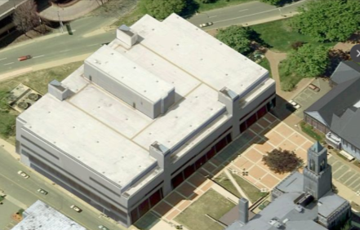

Prepared by:
Massachusetts Department of Public Health
Bureau of Environmental Health
Indoor Air Quality Program
October 2017

Background
Building: | Springfield Hall of Justice (HOJ)
Address: | 50 State Street  Springfield, Massachusetts
Assessment Requested by: | Michael Lane, Administrative Officer at the Massachusetts Office of the Trial Court (OTC),
Reason for Request: | General indoor air quality (IAQ) assessment and chronic disease
Date of Assessment: | June 16, 2017
Massachusetts Department of Public Health/Bureau of Environmental Health (MDPH/BEH) Staff Conducting Assessment: | Michael Feeney, Director, IAQ Program
Building Description: | The HOJ is a four-story, tiered, cement and steel frame building constructed in 1973 as an energy efficient facility.
Windows: | Not openable

Methods
Please refer to the IAQ Manual for methods, sampling procedures, and interpretation of results (MDPH, 2015).

IAQ Testing Results
The following is a summary of indoor air testing results (Table 1).
- Carbon dioxide levels were below 800 parts per million (ppm) in all areas assessed.
- Temperature was within the recommended range of 70°F to 78°F in most areas assessed.
- Relative humidity was within the recommended range of 40% to 60% in all areas assessed.
- Carbon monoxide levels were non-detectable in all indoor areas assessed.
- Fine particulate matter (PM2.5) concentrations measured were below the National Ambient Air Quality Standard (NAAQS) level of 35 micrograms per cubic meter (μg/m³) in all areas assessed.
- Volatile Organic Compound (VOC) levels were non-detectable in all areas assessed.
Note that only one area of this building was assessed during this visit. Previous visits have been made to this building. Reports from previous visits can be obtained on the IAQ website at: http://www.mass.gov/eohhs/gov/departments/dph/programs/environmental-health/exposure-topics/iaq/iaq-rpts/cities-and-towns-s.html#springfield

Ventilation
A heating, ventilating and air conditioning (HVAC) system has several functions. First it provides heating and, if equipped, cooling. Second, it is a source of fresh air. Finally, an HVAC system will dilute and remove normally-occurring indoor environmental pollutants by not only introducing fresh air, but by filtering the airstream and ejecting stale air to the outdoors via exhaust ventilation. Even if an HVAC system is operating as designed, point sources of respiratory irritation may exist and cause symptoms in sensitive individuals.
The heating, ventilating and air-conditioning system (HVAC) in the HOJ has ducted supply and return vents and does not use a ceiling plenum for return air. Fresh air is supplied to the second floor space through intake vents to an air-handling unit (AHU) which is then distributed into the space via ducted ceiling supply vents and air diffusers. Return air is then ducted back to the AHU via ceiling or wall-mounted vents. To provide heating and cooling, fan coil units (FCUs) were installed along exterior walls (Picture 1).

The FCU System
The operation of FCUs during hot, humid weather creates a significant source of water that can cause damage to building components. FCUs with cooling capacity are equipped with drip pans that drain condensation. The pan is located beneath the cooling coils and empties into a condensation collector, which is connected to a plastic drainage hose within the pipe chase. The following FCU conditions were noted:
- The FCU configuration makes accessing drip pans labor intensive. IAQ staff could not examine the drip pans of FCUs since it would necessitate disassembly of the FCU. Considering this difficulty, it is unlikely that the drip pan or coils of each FCU are cleaned routinely.
- The condensation collectors were uniformly coated with scale (Picture 2). Scale refers to metal corrosion and mineral deposits that can occur when standing water remains in drip pans or on coils. Standing water can cause metal corrosion. As water evaporates over time, mineral and debris can coat the drip pans, coils, and pipes. This can lead to odors, microbial growth, and inefficient operation.
- The FCU motor cover, flexible steel electric conduit and the underside of the drip pan were corroded (Picture 3).
- Fiberglass insulation appears to have been moistened through contact with an uninsulated copper pipe (Picture 4). This pipe appears to be connected to the drip pan collector. Uninsulated pipes can generate condensation and cause water damage to adjacent materials that can support mold growth, such as the paper on insulation.
- The insulation on the FCU cover is frayed (Picture 5).
Water damage occurring due to the conditions described above has also impacted materials on or adjacent to the FCUs.
The FCUs had a filter medium that needs to be physically cut to size (Picture 6) which makes it difficult to get a tight fit. This filter material also appears to provide minimal filtration. MDPH recommends filters of a Minimum Efficiency Reporting Value (MERV) of 8, which are adequate in filtering out pollen and mold spores (ASHRAE, 2012). Filters should fit flush in the cabinets without spaces for air to go around the filter.
Due to design, lack of routine maintenance, and equipment deterioration, it is likely that the FCU and its surroundings may be a source of microbial growth and airborne pollutants when operating. These conditions will become more prominent when the FCUs are in cooling mode.
It is also important to note that the FCUs are over 40 years old. Efficient function of equipment of this age is difficult to maintain, since compatible replacement parts are often unavailable. According to the American Society of Heating, Refrigeration and Air-Conditioning Engineering (ASHRAE), the service life for a unit heater, hot water or steam is 20 years, assuming routine maintenance of the equipment (ASHRAE, 1991). Despite attempts to maintain the equipment, the optimal operational lifespan of this equipment has been exceeded.

Conclusions/Recommendations
Although the air measurements were within the BEH/IAQ program guidelines, the condition of the FCUs and the surrounding materials located in this office suite may be a source of microbial growth, which may cause exacerbation of respiratory symptoms in certain individuals, including exacerbation of asthma or other pulmonary conditions. Based on observations at the time of the assessment, the following is recommended:
- Replace damaged insulation in FCUs.
- Determine if FCUs can be outfitted with more efficient filters, MERV 8 or higher. Ensure all filters used fit flush and tightly in the cabinets.
- Have an HVAC engineering firm evaluate FCUs for proper operation and future replacement, including the addition of exhaust vents in rooms containing FCUs.
- Clean FCUs and change filters 2 to 4 times a year. Ensure FCUs and supply vents are cleaned periodically to prevent buildup and re-circulation of dust and debris.
- Check FCU condensation drains, pans, and hoses periodically to ensure that water is draining properly and clogging or leaking is not occurring.
- Remove any water-damaged materials in a manner consistent with recommendations found in the US EPA document, “Mold Remediation in Schools and Commercial Buildings” (USEPA, 2008).
- For buildings in New England, periods of low relative humidity during the winter are often unavoidable. Therefore, scrupulous cleaning practices should be adopted to minimize common indoor air contaminants whose irritant effects can be enhanced when the relative humidity is low. To control for dusts, a high efficiency particulate arrestance (HEPA) filter equipped vacuum cleaner in conjunction with wet wiping of all surfaces is recommended. Drinking water during the day can help ease some symptoms associated with a dry environment (e.g., throat and sinus irritations).
- Refer to resource manual and other related IAQ documents located on the MDPH’s website for further building-wide evaluations and advice on maintaining public buildings. These documents are available at: http://mass.gov/dph/iaq.

References
ASHRAE. 1991. ASHRAE Applications Handbook, Chapter 33 “Owning and Operating Costs”. American Society of Heating, Refrigeration and Air Conditioning Engineers, Atlanta, GA.
ASHRAE. 2012. American Society of Heating, Refrigeration and Air Conditioning Engineers (ASHRAE) Standard 52.2-2012 -- Method of Testing General Ventilation Air-Cleaning Devices for Removal Efficiency by Particle Size (ANSI Approved). 2012.
MDPH. 2015. Massachusetts Department of Public Health. Massachusetts Department of Public Health Indoor Air Quality Manual: Chapters I-III. Available at: http://www.mass.gov/eohhs/gov/departments/dph/programs/environmental-health/exposure-topics/iaq/iaq-manual/.
US EPA. 2008. “Mold Remediation in Schools and Commercial Buildings”. Office of Air and Radiation, Indoor Environments Division, Washington, DC. EPA 402-K-01-001. September 2008. Available at: http://www.epa.gov/mold/mold-remediation-schools-and-commercial-buildings-guide.
Picture 1
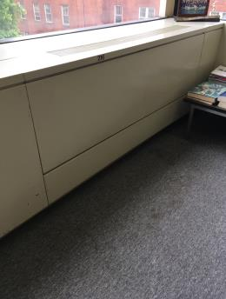
Fan coil unit (FCU)
Picture 2
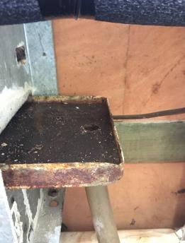
Condensation collector coated with scale
Picture 3
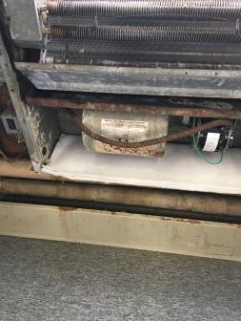
Corrosion on FCU motor cover, flexible steel electric conduit, and the underside of the drip pan Picture 4
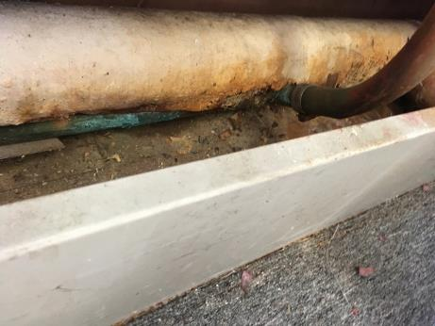
An uninsulated copper pipe beneath water-damaged fiberglass insulation
Picture 5
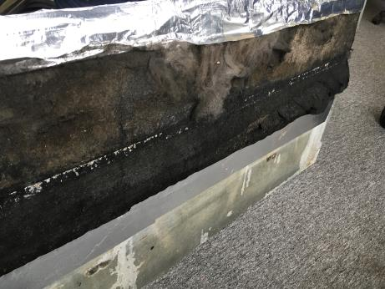
Frayed insulation on FCU cover
Picture 6
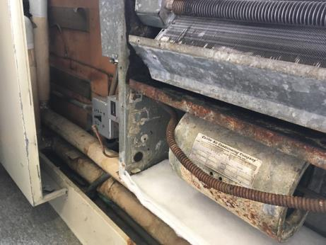
FCU filter medium that needs to be physically cut to size
Location | Carbon  Dioxide  (ppm) | Carbon Monoxide  (ppm) | Temp  (°F) | Relative  Humidity  (%) | PM2.5  (µg/m³) | Occupants  in Room | TVOCs (ppm) | Windows  Openable | Ventilation |  | Remarks
 |  |  |  |  |  |  |  |  | Supply | Exhaust
Background (outdoors) | 391 | ND | 70 | 60 | 12
205 Hall | 634 | ND | 71 | 56 | 8 | 0 | ND | N | Y | Y
204 Lobby B | 589 | ND | 70 | 54 | 8 | 0 | ND | N | Y | Y
204 Reception | 588 | ND | 70 | 56 | 8 | 1 | ND | N | Y | Y
204 Lobby A | 740 | ND | 70 | 56 | 12 | 0 | ND | N | Y | Y | Fan coil unit

The service life is the median time during which a particular system or component of …[an HVAC]… system remains in its original service application and then is replaced. Replacement may occur for any reason, including, but not limited to, failure, general obsolescence, reduced reliability, excessive maintenance cost, and changed system requirements due to such influences as building characteristics or energy prices (ASHRAE, 1991).

