Learning Session:
Supporting the needs of long term care residents receiving medication for opioid use disorder

- This nursing continuing professional development activity was approved by Northeast Multistate Division, an accredited approver of the American Nurses Credentialing Center’s Commission on Accreditation for 4.50 contact hours.
Continuing Education

- This live activity, Medication for Opioid Use Disorder in Long Term Care Facilities Learning Session (01/21/2020 - 01/30/2020), has been reviewed and are acceptable for up to 4.50 prescribed credit(s) by the American Academy of Family Physicians. Physicians should claim only the credit commensurate with the extent of their participation in the activity.

Disclosure:
Disclosure of Financial Relationships & Commercial Support
- It is the policy of the contract team (Abt Associates and Healthcentric Advisors) to ensure independence, balance, objectivity, scientific rigor, and integrity in all of its continuing education activities. Our presenters will disclose any significant relationships with commercial interests whose products or devices may be mentioned in the activity or with the commercial supporter of this continuing education activity. Identified conflicts of interest were resolved prior to accreditation of the activity and may include any of or combination of the following: attestation to non-commercial content; notification of independent and certified CME/CE expectations; restriction of topic area or content; restriction to discussion of science only; amendment of content to eliminate discussion of device or technique; use of other author for discussion of recommendations; independent review against criteria ensuring evidence support recommendation; moderator review; and peer review.

Disclaimer:
- This program is designed solely to provide the healthcare professional with information to assist in his/her practice and professional development and is not to be considered a diagnostic tool to replace professional advice or treatment. The program serves as a general guide to the healthcare professional, and therefore, cannot be considered as giving legal, nursing, medical, or other professional advice in specific cases. Abt Associates and Healthcentric Advisors specifically disclaim responsibility for any adverse consequences resulting directly or indirectly from information in the course, for undetected error, or through participant's misunderstanding of the content.

Call to Action
Chiara Moore, MPH
Department of Public Health, Bureau of Health Care Safety and Quality

Age-Adjusted Opioid-Related Death Rate by Year
The Opioid Epidemic: Nationally and Locally
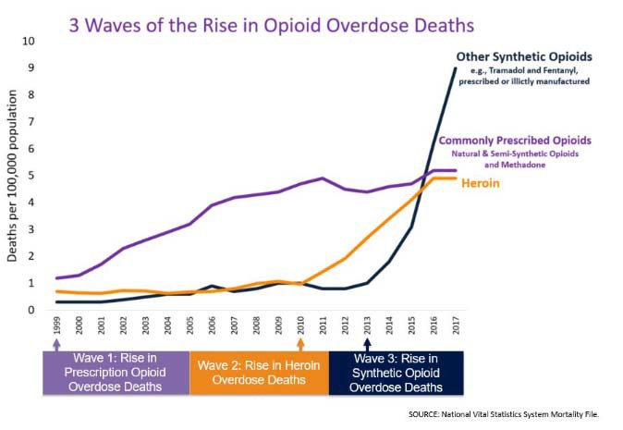
35
Age-Adjusted Opioid-Related Death Rate per
100,000 People

30

25

20
Massachusetts
15 United States
10

5

0
1999
2001
2003
2005
2007
2009
2011
2013
2015
2017

MA statistics from https://www.mass.gov/doc/opioid-related-overdose-deaths-among-ma-residents-november-2019/download; U.S statistics from CDC WONDER Online Database, released December, 2018. Data are from the Multiple Cause of Death Files, 1999-2017, as compiled from data provided by the 57 vital statistics jurisdictions through the Vital Statistics Cooperative Program. Accessed at http://wonder.cdc.gov/mcd-icd10.html on Dec 26, 2019

Springfield Community of Practice

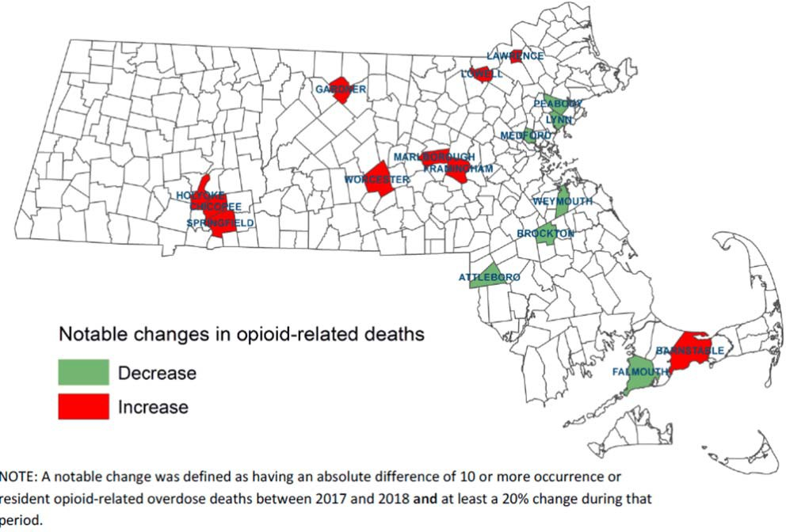

Dr. Wakeman’s Natural History of OUD

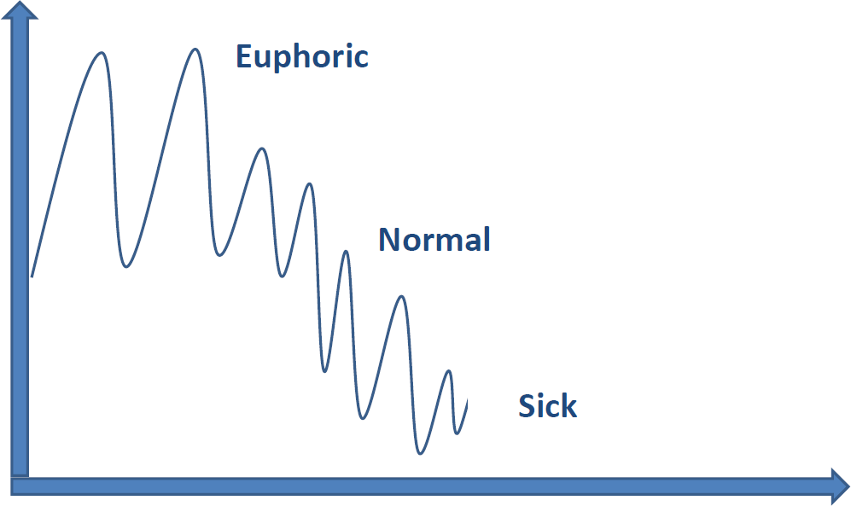

Dr. Wakeman’s Natural History of OUD:
Goals of Treatment Medications

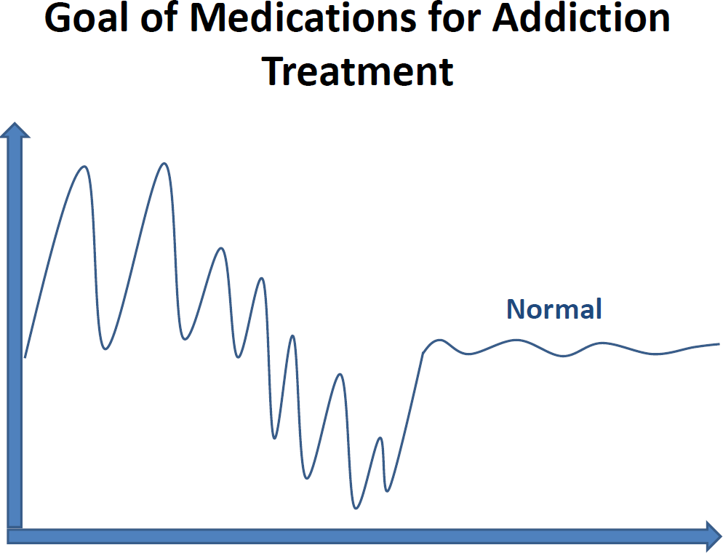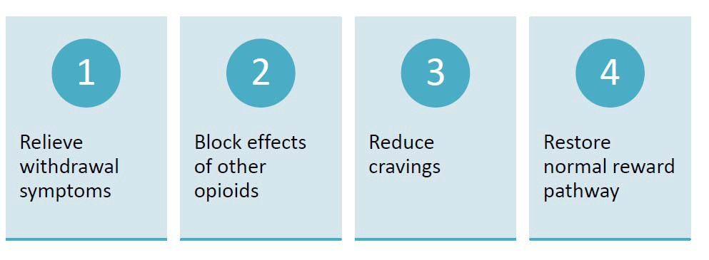

Similar to management of other chronic health conditions such as Diabetes or HIV
MOUD is Effective and…
  - No cure
  - Goal is to prevent acute and chronic complications
  - Individualized treatment plans and goals
  - Treatment includes:
    - Medication
    - Lifestyle changes
    - Regular monitoring for complications
    - Behavioral support

MOUD Saves Lives

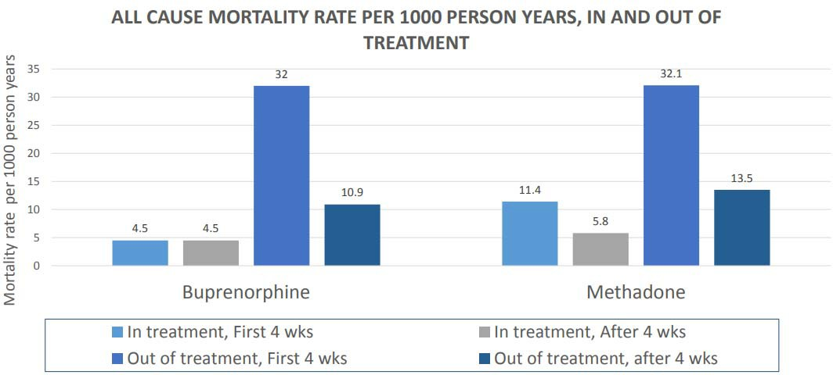

Source: Sordo L, Barrio G, Bravo MJ, Indave BI, Degenhardt L, Wiessing L, Ferri M, Pastor-Barriuso R. Mortality risk during and after opioid substitution treatment: Systematic review and meta-analysis of cohort studies. BMJ 2017 Apr 26;357:j1550. https://www.mass.gov/files/documents/2019/02/04/Walley-MAT-Commission-190124.pdf

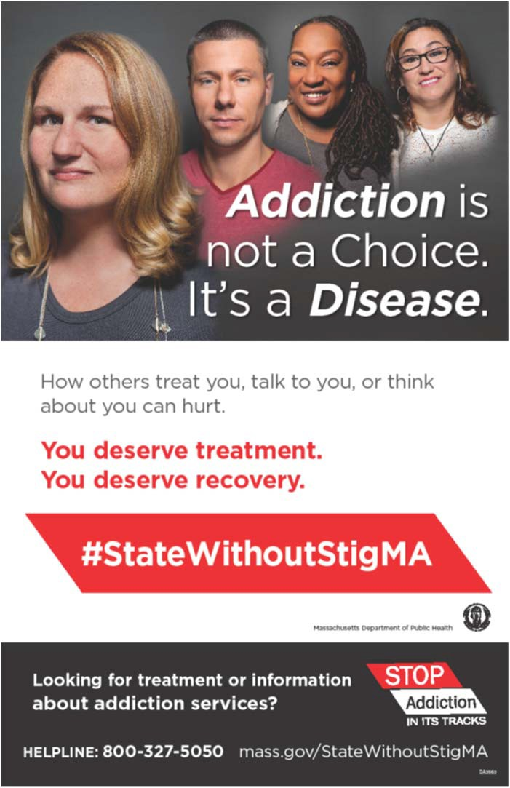
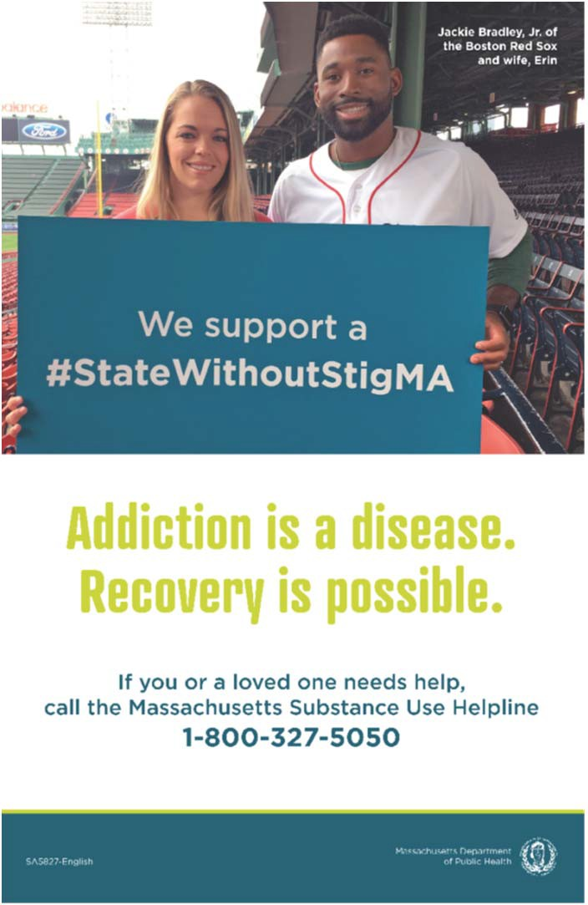
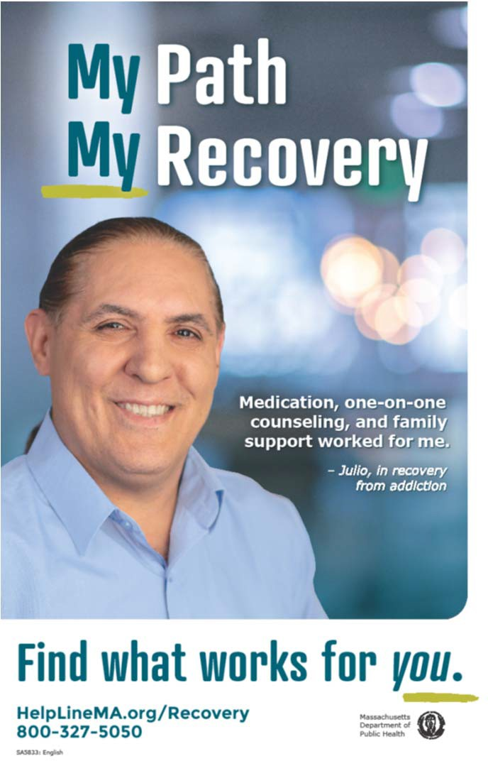

MA Resources for Addiction

12
Access to MOUD
Source: https://mahelplineonline.custhelp.com/app/account/opa_result

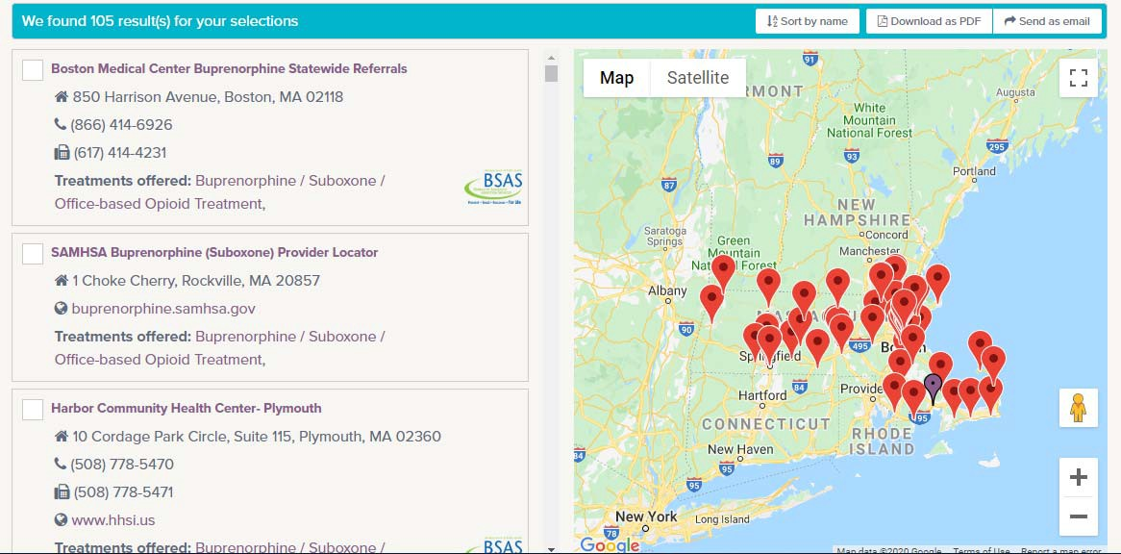

Number of Individuals Receiving MOUD Nationally

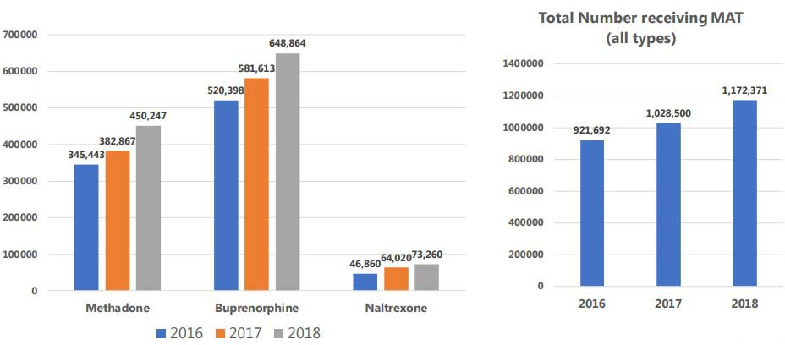

Source: https://www.samhsa.gov/data/sites/default/files/cbhsq-reports/Assistant-Secretary-nsduh2018_presentation.pdf
13

A Journey Through the Care Continuum

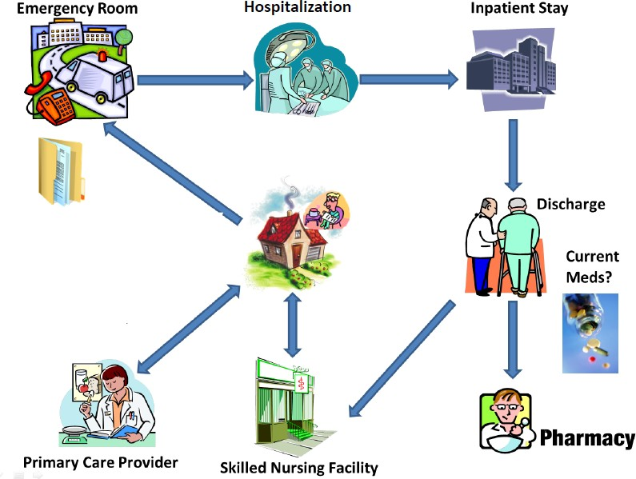
OBOT/ OTP

Long Term Care Facilities

14

Pathways of Recovery-
Personal Story
Julio Torres
Mercy Medical Center Providence Behavioral Health Hospital

- Recognize and address the stigma of opioid use disorder (OUD) in long term care facilities (LTCFs)
Learning Objectives
- Discuss how OUD presents; biological effects and underlying causes
- Gain knowledge of the different types of OUD treatment including medications for opioid use disorder (MOUD)
- Identify strategies to enhance best practices across the continuum of care

Agenda
10:00 AM – 10:15 AM | Call to Action
10:15 AM – 10:45 AM | Pathways to Recovery
10:45 AM – 11:30 AM | Understanding OUD
11:30 AM – 12:15 PM | An Overview of Medication to Treat OUD
12:15 PM – 12:45 PM | Lunch
12:45 PM – 1:30 PM | Approaches to Care
1:30 PM – 2:15 PM | Community Resources
2:15 PM – 2:45 PM | Implementation of the Toolkit
2:45 PM – 3:00 PM | Leaving in Action

Understanding
Opioid Use Disorder
Ari Kriegsman, MD Mercy Medical Center
Providence Behavioral Health Hospital

- Discuss how residents present; biological effects and underlying causes
Objectives
- Recognize stigma of addiction
- Dispel misconceptions of persons with OUD

Source: Grayken Center for Addiction and RIZE Massachusetts 20

Source: Grayken Center for Addiction and RIZE Massachusetts 21

Source: Grayken Center for Addiction and RIZE Massachusetts 22

- Why does the human brain develop a substance use disorder?
Biological Background

- Why can we only develop addictive behaviors in response to some substances?

The Reward Pathway
Biological Background
- A particular pathway in the brain is activated by all of the activities that we find pleasurable
  - Food, water, sex; “appetites”
  - Interpersonal relationships, spirituality, exercise, art, music, beauty
- The common reward pathway in the brain for all pleasurable activities involves the neurotransmitter dopamine

The drugs that can cause addictive behaviors are those that hijack the natural pleasure circuitry of the brain
Biological Background

Source: Grayken Center for Addiction and RIZE Massachusetts

Addiction is Chronic Brain Disease

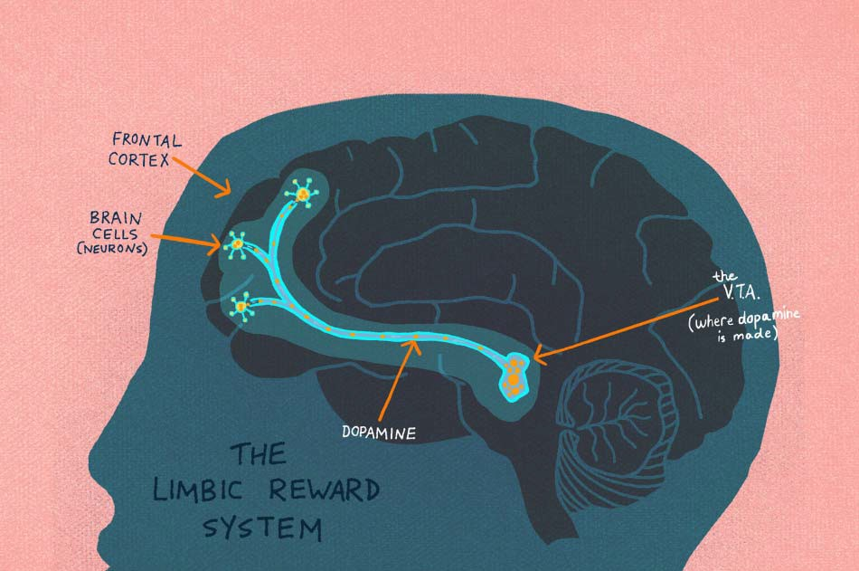
SOURCE: Trinity Health Presentation

Addiction is Chronic Disease

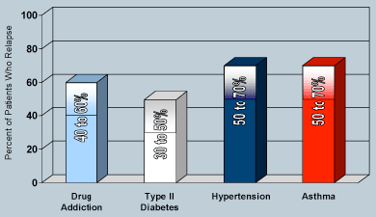

SOURCE: https://www.drugabuse.gov/publications/drugs-brains-behavior-science-addiction/treatment-recovery, pulled from Trinity Health Presentation

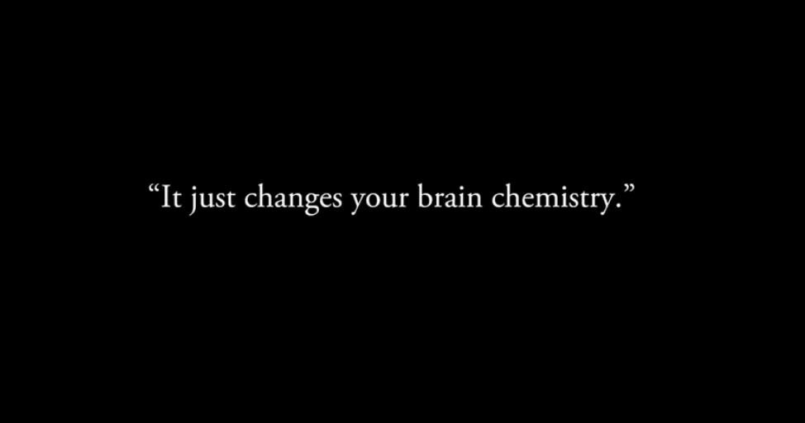
https://youtu.be/H7HfmYDkBzg

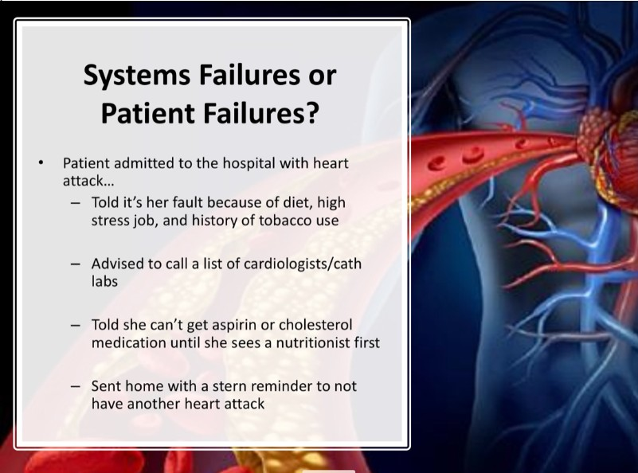
Source: Trinity Health Slides
29

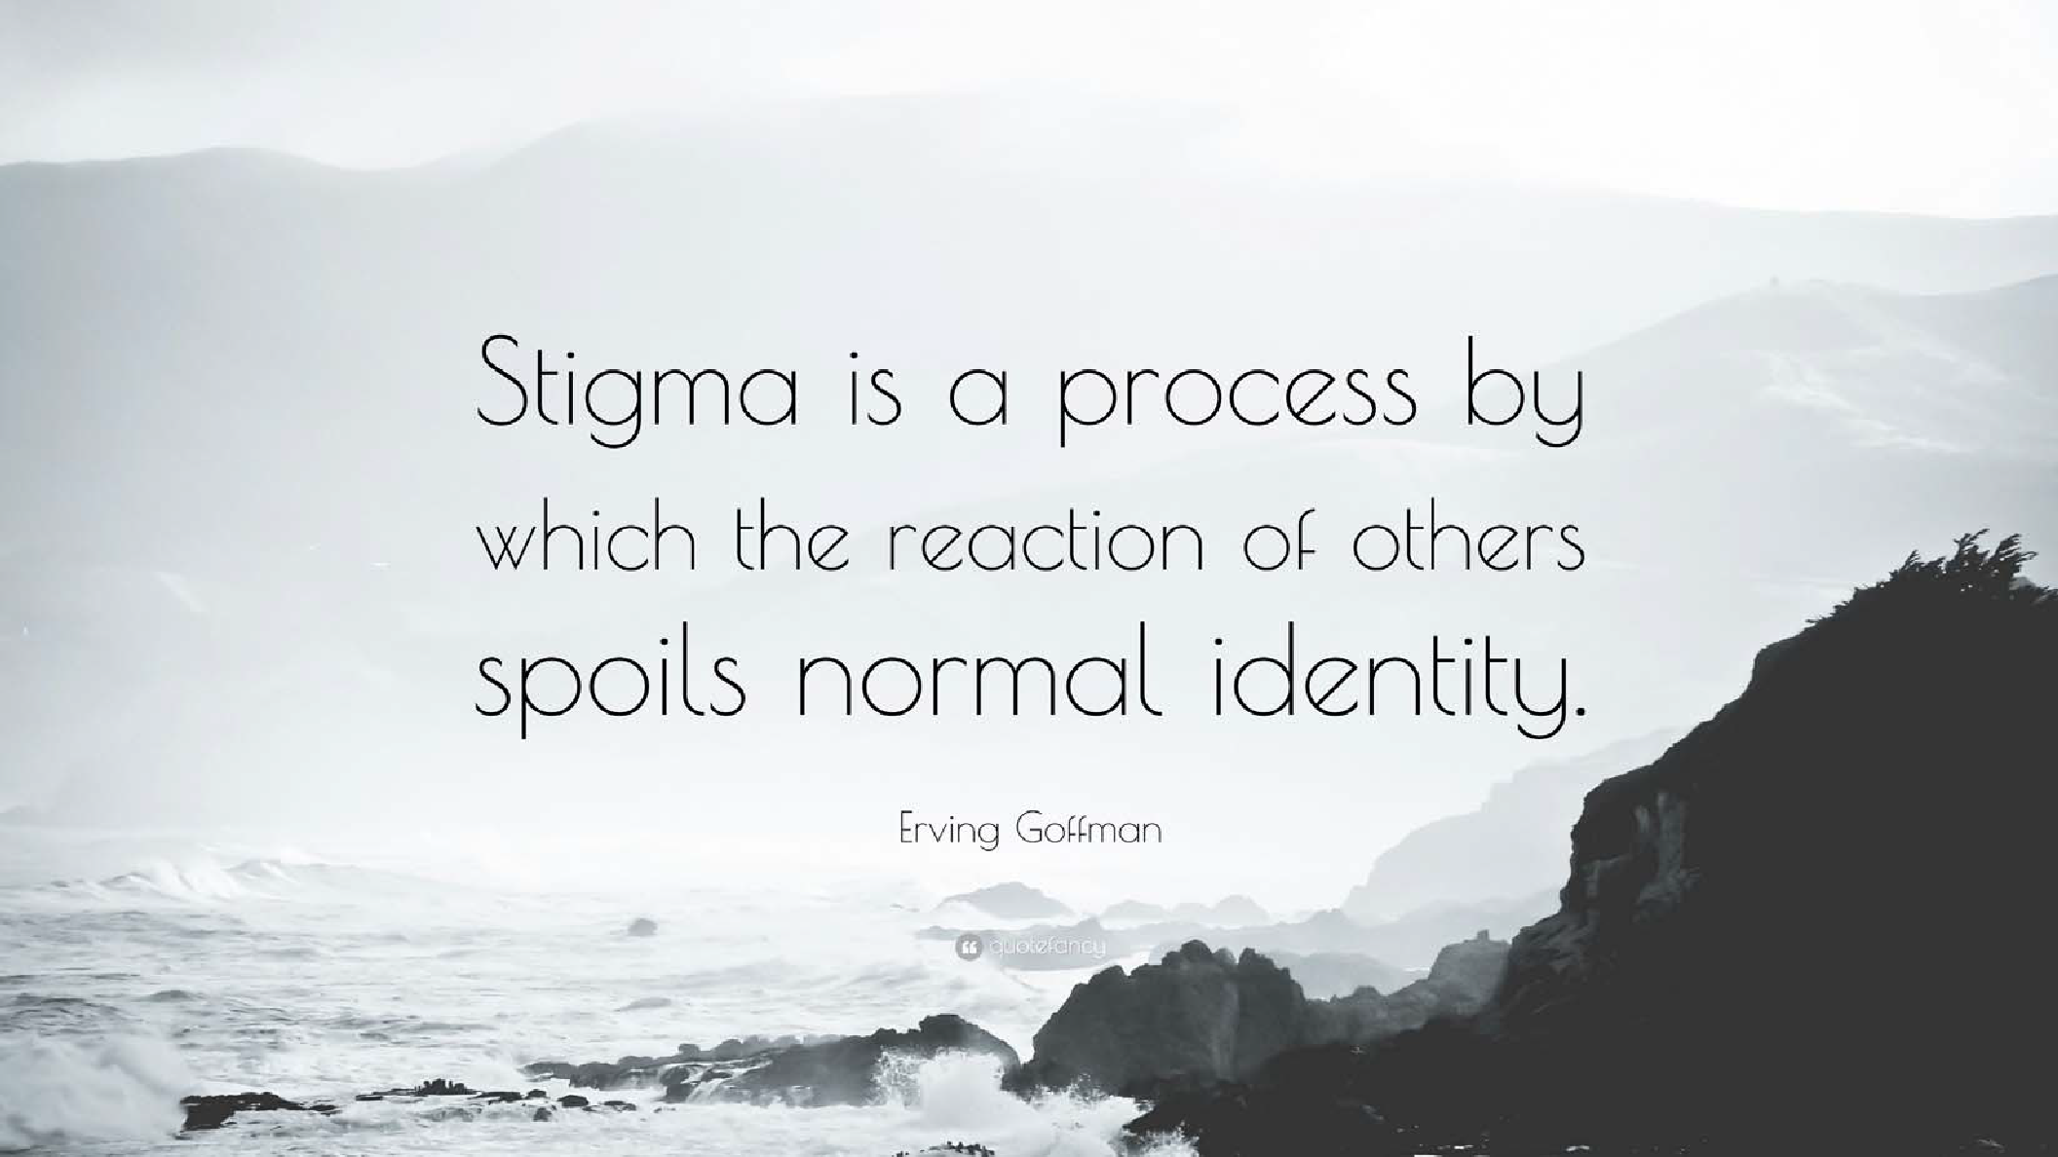
30

Why is it socially “ok” to express stigma
Stigma
toward a few groups, such as people who use drugs or are obese, but not so much toward others, such as people with physical disabilities?

Source: Grayken Center for Addiction and RIZE Massachusetts

What are some examples of stigmatizing language used by professionals about people who have substance use disorders?
Stigma
Junkie
Addict
Alcoholic
Abuser
Drug of choice
Shooter
Dirty

Source: Grayken Center for Addiction and RIZE Massachusetts
Clean

- “Substance Abuser” vs. “Substance Use Disorder”
Stigma
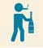

- Example:
  - Mr. Williams is a substance abuser and is attending a treatment program through court…
  - Mr. Williams has a substance use disorder and is attending a treatment program through the court…

Source: Kelly JR, 2010, Int J Drug Policy, adapted from Grayken Center for Addiction and RIZE Massachusetts

Avoid Stigmatizing Language - Words Matter

The language we choose shapes the way we treat our residents…
Instead of: | You can say….
“drug abuse” | Substance use disorder
“addict” or “junkie” | Person with a substance use disorder
“alcoholic” | Person with alcohol use disorder
“dirty urine” | Abnormal, positive, or unexpected urine test result
“clean urine” | Normal or negative urine test result
“clean” (referring to a person) | Abstinent, in remission, or in recovery
“dirty” (referring to a person) | In a period of disease exacerbation, or relapse
“shooting up” | Injecting
“shooter” | Person who injects drugs
SOURCE: Boston Medical Center- https://www.bmc.org/addiction/reducing-stigma

Dependence and Addiction

How OUD is Diagnosed (DSM-5)

Category | Criteria
Impaired control | - Opioids used in larger amounts or for longer than intended  - Unsuccessful efforts or desire to cut back or control opioid use  - Excessive amount of time spent obtaining, using, or recovering from opioids  - Craving to use opioids
Social impairment | - Failure to fulfill major role obligations at work, school, or home as a result of recurrent opioid use  - Persistent or recurrent social or interpersonal problems that are exacerbated by opioids or continued use of opioids despite these problems  - Reduced or given up important social, occupational, or recreational activities because of opioid use
Risky use | - Opioid use in physically hazardous situations  - Continued opioid use despite knowledge of persistent physical or psychological problem that is likely caused by opioid use
Pharmacological properties | - Tolerance as demonstrated by increased amounts of opioids needed to achieve desired effect; diminished effect with continued use of the same amount  - Withdrawal as demonstrated by symptoms of opioid withdrawal syndrome; opioids taken to relieve or avoid withdrawal

Source: https://www.psychiatrictimes.com/special-reports/opioid-use-disorder-update-diagnosis-and-treatment

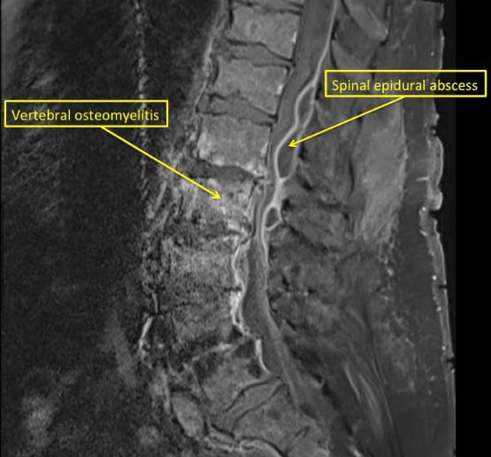
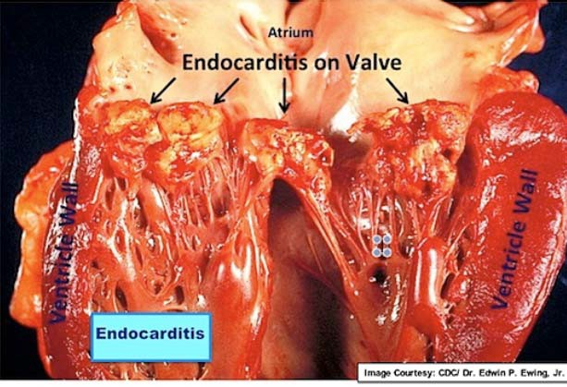
- 40 year old female with history of intravenous drug use (IVDU) presents with back pain
Case Example – Approach 1
- Has left against medical advice (AMA) from two local hospitals where she was diagnosed with endocarditis and spinal osteomyelitis
- She left due to untreated pain and withdrawal; “It was just too much for me to take”
- She had not been offered medication for OUD at the other hospitals

- Resident was started on methadone in hospital day 1, as well as dilaudid to treat her acute pain
Case Example – Approach 2
- Was transferred to LTCF to complete her six weeks of IV antibiotics
- She reconnected with her family and children while at the LTCF
- From LTCF transferred to residential drug treatment program
- Remained in treatment and was in recovery at six month follow-up

How to approach residents with compassion:
Communication Strategies
- Use medically accurate, person-first, non-stigmatizing language
- Be aware of one’s own anxieties, feelings, and non-verbal communication
- Convey warmth and care for a resident’s well being
- Ask permission to discuss sensitive topics
- Reflect on treatment progress thoughtfully while using language that demonstrates respect
- Use open-ended questions
- Engage with the resident as a partner in treatment planning
Source: https://www.bmcobat.org/resources/?category=8#Challenging+Patient+Conversations

Include reflective listening and empathetic statements to destigmatize OUD diagnosis and treatment; use statements such as:
Relationship-Building Skills

- "My primary motivation is to provide care that leads to the healthiest version of 'you' in the long term."
- "Getting help for this is like getting help for any other chronic medical problem."
- "I want you to have the best possible care, and this difficult but productive conversation is a first step for us."

Source: https://www.cdc.gov/drugoverdose/training/oud/accessible/index.html

Use statements such as:
Explaining Treatment Methods

- "There are a number of treatment options. Let's explore them together."
- "We will work together to find a treatment plan that works best for you."

Source: https://www.cdc.gov/drugoverdose/training/oud/accessible/index.html

Strategies for Managing Reactions

Reactions | Management Strategy
The resident is anxious, agitated, or panicking | Approach the resident in a calm and confident manner Reduce the number of people attending to the resident Carefully explain any interventions and what is going on Minimize the risk of self-harm
The resident is confused or  disoriented | Ensure the resident is frequently supervised  Provide reality orientation – explain to the resident where they are and what is going on
The resident is experiencing hallucinations | Talk to the resident about what they are experiencing and explain what is and isn't real Ensure the environment is simple, uncluttered and well lit  Protect the resident from harming him or herself, and others
The resident is angry or aggressive | Ensure that staff and other resident are protected and safe When interacting with the resident remain calm and reassuring Listen to the resident  Use the resident’s name to personalize the interaction Use calm open-ended questions  Use a consistent and even tone of voice, even if the resident becomes hostile and is shouting Acknowledge the resident 's feelings  Do not challenge the resident Remove source of anger if possible

- Switching gears….

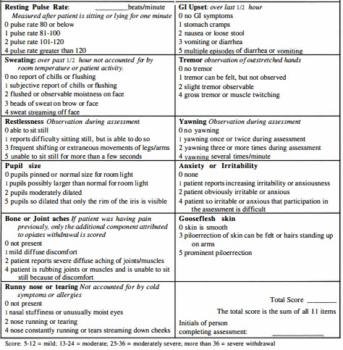

Symptoms of Withdrawal
- Nausea and vomiting
- Anxiety
- Insomnia
- Hot and cold flashes
- Perspiration
- Muscle cramps
- Watery discharge from eyes and nose
- Diarrhea

Source: World Health Organization. (2009). Clinical Guidelines for Withdrawal Management

How To Recognize an Opioid Overdose

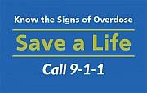
- Blue lips and fingertips
- Limp and pale
- Small pupils
- Breathing slow, irregular or has stopped
- Pulse slow, erratic, absent
- Nonresponsive to voice or sternal rub

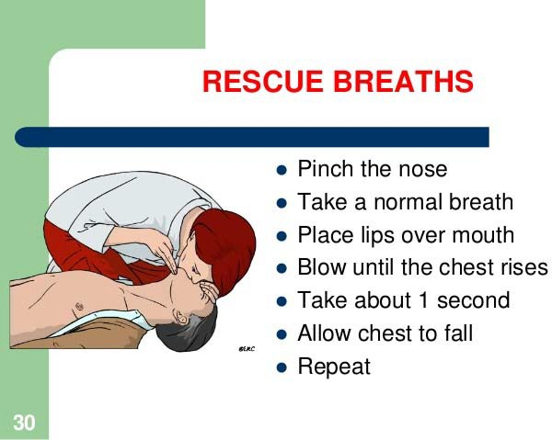
  - Assess the scene
What To Do If Suspected Overdose
  - Assess the person
  - Call 911
  - Rescue breathing
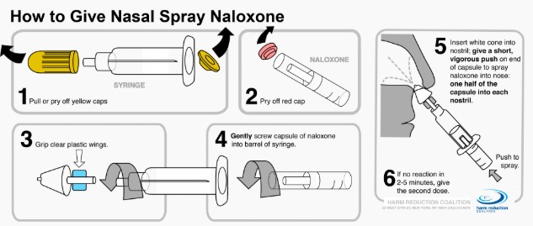
  - Administer Naloxone
  - Stay with the person until help arrives
  - Continue rescue breathing

Harm Reduction

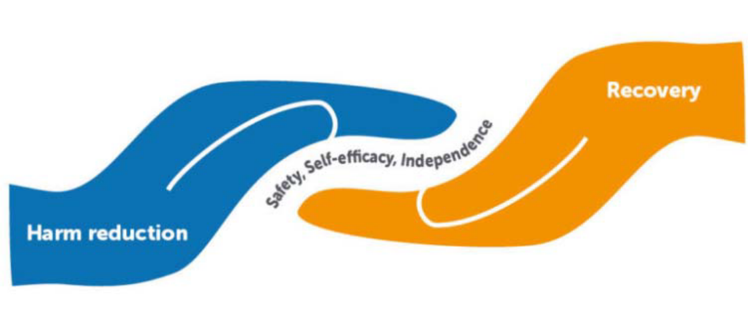

Harm Reduction Principles

Accepts that drug misuse is part of our world and chooses to work to minimize its harmful effects rather ignore or condemn them.
Understands drug use as a complex, multi-faceted phenomenon that encompasses a continuum of behaviors.
Establishes quality of individual and community life and well-being for successful interventions and policies.
Ensure residents have a real voice in the creation of programs and policies designed to serve them.
Empower users to share information and support each other in strategies which meet their actual conditions of use.
Does not attempt to minimize or ignore the real and tragic harm and danger associated with drug misuse.

- Incorporate harm reduction principles throughout your organization and within your existing policies.
Policy Considerations at Your Organization
- Incorporate a section on OUD into your internal discrimination policy to reduce stigma and to help foster a positive culture that strives to ensure that staff see addiction as a medical condition.
- Integrate the use of the Clinical Opiate Withdrawal Scale (COWS) as a method to help identify opioid withdrawal and guide the care for the resident.

- Addressing stigma; involve all staff
Key Points and Who Should Be Involved
- Harm reduction principles; identify a champion, involve all staff
- Understanding how OUD presents and screening; involve all staff
- Recognize symptoms of withdrawal; all staff
- Strategies for managing difficult reactions; all staff
- What to do if suspected overdose; involve all staff in training
- Naloxone stored/accessible on site

- Boston Medical Center OBAT Training and Technical Assistance www.bmcobat.org
Many Slides Adapted From The Following Presentations

- Boston and Cambridge Hospital Consortium presentation developed by Miriam Komaromy, MD, Medical Director, Grayken Center for Addiction at Boston Medical Center, with the support of Scott Weiner, MD; Lorraine Magner, NP; Claudia Rodriguez, MD; and Maia Gottlieb, MPH

- Medical Director of Addiction Medicine Consult Services, Ari Kriegsman, MD, from Trinity Health, presentation given to Skilled Nursing Services in the Springfield and Holyoke region
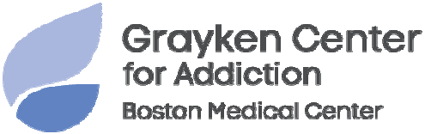

An Overview of Medication to
Treat Opioid Use Disorder
Marghie Giuliano, R. Ph. Healthcentric Advisors

  - Identify the Myths about Medication for Opioid Use Disorder (MOUD)
Objectives
  - Review the types of medications used for MOUD
  - Identify roles in supporting the delivery of MOUD in the Long Term Care Setting

  - MOUD just trades one addiction for another
Dispelling Myths
The Top 7:
    - A combination of medication and behavioral therapies can successfully treat OUD
  - MOUD is only for the short term
    - Persons on MOUD for at least 1-2 years have the greatest rates of long- term success
  - My patient’s condition is not severe enough to require MOUD
    - MOUD adds another tool in the toolbox to help achieve individualized goals
  - MOUD increases the risk of overdose in patients
    - Persons prescribed MOUD experience less cravings and withdrawal and are significantly less likely to overdose

  - Providing MOUD will only disrupt and hinder a patient’s recovery process
Dispelling Myths
    - Improves quality of life, level of functioning, ability to handle stress, helps reduce mortality
  - There isn’t any proof that MOUD is better than abstinence
    - Now evidence to consider MOUD as a best practice
  - Most insurance plans don’t cover MOUD
    - Individualized by plans
    - Progress in this area

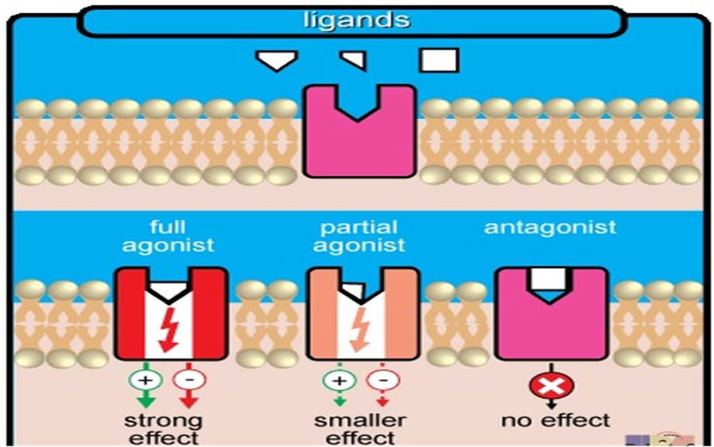
  - More than medication
MOUD
    - Person-centered approach
    - Appropriate medication choice
    - Resident counseling and support

  - Three medications used for MOUD
    - Methadone (full agonist)
    - Buprenorphine (partial agonist)
    - Naltrexone (antagonist)

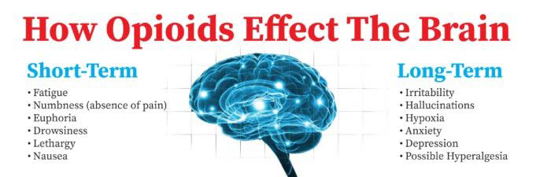
Methadone

  - Synthetic opioid
    - Used for pain
    - Used for MOUD
  - Long-acting
  - Full agonist - full activation of opioid receptors in the brain
  - Administered by Opioid Treatment Program (OTP)
    - Dosing is managed and monitored by OTP
      - Typically daily
    - Must be dispensed at OTP clinic for the treatment of OUD

  - First line of treatment for MOUD; reduces desire for other opioids (full agonist)
Methadone - Benefits
  - Eliminates withdrawal symptoms from discontinuation of opioid (anxiety, nausea/vomiting/abdominal pain, etc.)
  - Administered in controlled setting by OTP (reduces risk of overdose)

  - Overdose risk - Sedation, slowed breathing, respiratory depression
Methadone – Potential Challenges
    - Always a risk with any opioid
  - Diversion possibility
  - Must go to OTP for treatment
    - Positive due to oversight, creates a supportive/structured setting
    - Could be a challenge due to access/stigma

Methadone Recap

  - Can you name some benefits of using Methadone as a treatment for MOUD?
Question:

61
61

- Structured treatment/dispensing with daily interaction
Answer:
- Eliminates withdrawal symptoms
- Helps people function better

  - Can you name some challenges of Methadone use for MOUD?
Question:

- Overdose risk
Answer:
- Diversion possibility
- Requires OTP visit

  - Semi-synthetic opioid
Buprenorphine (or buprenorphine/naloxone combination)
    - Used for treatment of OUD
    - Can be used for pain
  - Long-acting
  - Partial agonist
    - Binds to opioid receptors in brain but only causes limited or partial opioid effect
in body relative to full agonist
  - Community pharmacists CAN dispense this medication with a prescription
  - Comes in many forms:
    - Sublingual tablet, sublingual film, buccal film, transdermal patch (pain only), injectable (sub-cutaneous)

  - Available at community pharmacy
Buprenorphine Benefits
  - Lower misuse potential than full agonist
  - Lower opioid overdose symptom risk
  - Various dosage forms and options to choose from in consultation with medical provider

  - Overdose (risk is low)
Buprenorphine Potential Challenges
  - Diversion

Buprenorphine Recap

  - Does a resident need to go to an OTP to receive buprenorphine?
Question:

  - No; Buprenorphine can be dispensed at a community pharmacy with a prescription from an authorized prescriber
Answer:

  - Approved for opioid use disorder and alcohol use disorder
Naltrexone
  - Long acting
  - Opioid antagonist - blocks activation of opioid receptor
    - Prevents opioid like-effects
    - Reduces desire to take opioids
  - Currently available as tablet or injectable
  - Before starting Naltrexone, a resident needs to be opioid free for a minimum of 7-10 days due to risk of withdrawal symptom exacerbation

  - Blocks the effects of opioids
Naltrexone Benefits
  - Can reduce cravings for residents with OUD
  - Can be dispensed at a community/specialty pharmacy
  - Low diversion risk
  - Low/no overdose risk

  - Can trigger withdrawal
Naltrexone Potential Challenges
  - Blocks pain management effects of opioids
  - May not eliminate cravings
  - Will reduce tolerance to opioids
    - High risk of overdose if there is a relapse
  - Could cause hepatotoxicity (liver toxicity)

Naltrexone Recap

Question:
- What rare but serious condition can
naltrexone cause?

  - Hepatotoxicity (Liver Toxicity)
Answer:
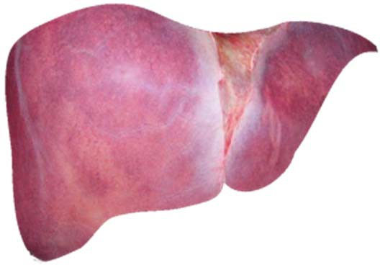

How you and your staff can support residents
MOUD in LTCF
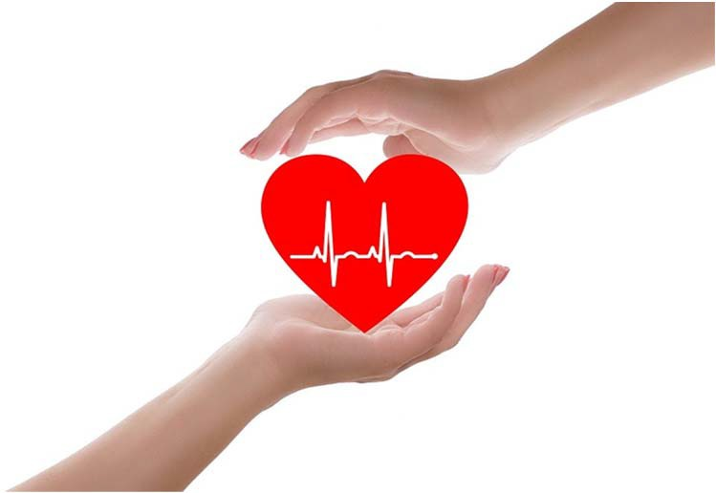
on MOUD...

- Team Approach: All healthcare staff work together as a team with the resident to put together best treatment plan
Support and Empathy

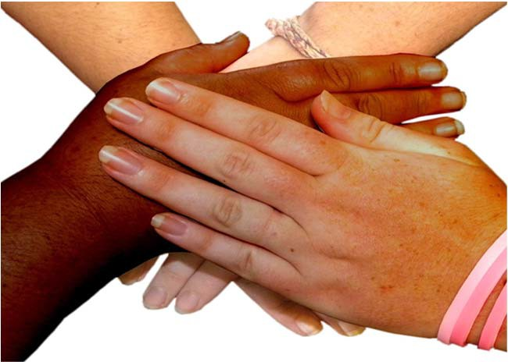
- Empathy and support builds trust; if resident feels they can trust staff they are more likely to be open and honest about their MOUD

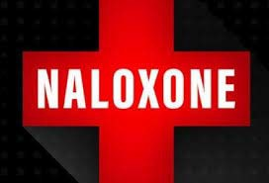
  - All staff members are up to date with latest clinical data and protocol concerning MOUD
Education
  - Staff members familiarize themselves with common opioid overdose symptoms, medication options/side effects, risk of diversion
  - Staff members should be trained on Naloxone administration to address overdose

Better informed staff makes a better informed resident

- If residents in LTCFs can and do receive methadone as part of their care, who is in charge of handling methadone from OTP to resident’s hands?
Chain of Custody for Methadone
- Potential role in LTCF that describes one who is responsible for overseeing the chain of custody of methadone:
  - OTP manage pre-poured doses administration destruction
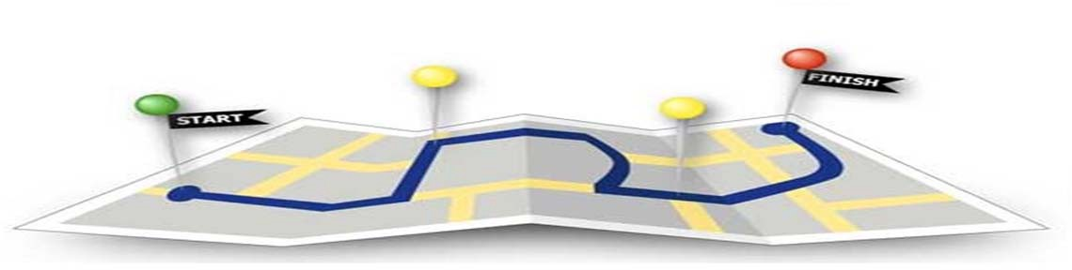

  - Licensed independent practitioners in LTCF can receive waiver to prescribe buprenorphine
DATA 2000 Waiver
  - To apply, practitioner must submit intent to SAMHSA Center for Substance Abuse Treatment (CSAT)
    - Complete online waiver request form
  - This could potentially open doors and opportunities for practitioners in LTCF to directly treat residents with MOUD
    - Can potentially lead the way for future similar advances for medications such as methadone/naltrexone

How can you support your
residents on MOUD?

Questions?

Approaches to Delivering
Person-Centered Care
Annie Huppert, MPH, CPHQ Healthcentric Advisors

- Creating a person-centered culture that includes residents with OUD
Objectives
- Raise staff awareness of range of approaches to caring for residents on MOUD including trauma-informed care
- Identify techniques to foster a therapeutic environment

- Wellness
Wellness and Person-Centeredness
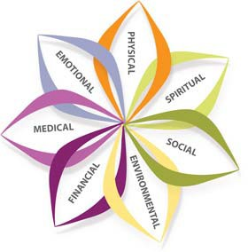
  - “A state of complete physical, mental, and social well- being, and not merely the absence of disease or infirmity.”

- Person-centeredness
  - “The need to focus on the resident as the locus of control and support the resident in making their own choices and having control over their daily lives.”

- Part of a multi-layered, interdisciplinary, person-centered approach to supporting residents
Person-centered Care is Trauma-Informed
  - Especially residents on MOUD
- Trauma-informed care as part of an organization’s culture
- Crucial to supporting both residents and staff
  - Help to reduce fatigue, burnout, and turnover

- The facility must ensure that residents who are trauma survivors receive culturally competent, trauma-informed care in accordance with professional standards of practice and accounting for residents’ experience and preferences in order to eliminate or mitigate triggers that may cause retraumatization of the resident.
Requirements of Participation: Phase 3
- Implemented November 28, 2019

- What do you think of when you hear the word: trauma?
What is Trauma?

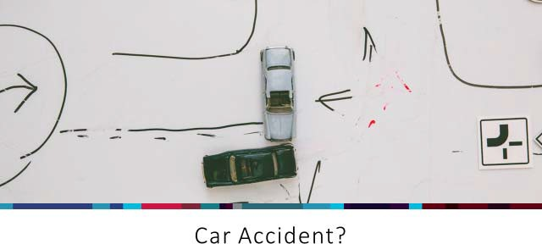

- Medical trauma
What is Trauma?
- Physical abuse
- Refugee trauma
- Sexual abuse
- Terrorism and violence
- Traumatic grief
- Early childhood trauma
- Military service trauma
- Bullying
- Community violence
- Complex trauma
- Disasters
- Domestic violence
- Transfer trauma
- Historical trauma

- Have you ever worked with a resident who has experienced trauma? What did you notice?
Discussion Questions
- When you work with a resident who is acting out or showing puzzling reactions, what are some things to consider?
- Give an example of a time when you had trouble understanding a resident’s reactions. What did you learn?
- Why might residents be reluctant to talk about their trauma histories?
- In what ways have you seen society view PTSD or mental health conditions?
- How can we prevent residents from being triggered in the environment?

SAMHSA’s Definition of Trauma: The Three E’s

An event of actual or extreme threat of physical or psychological harm which an individual experiences as traumatic, and which causes long-lasting effects.

Who Experiences Trauma?

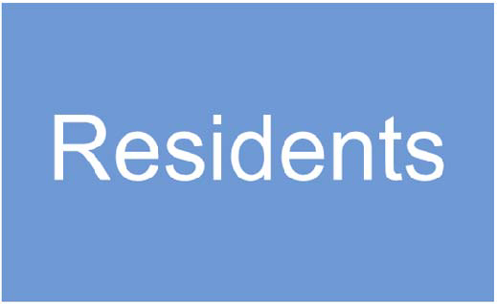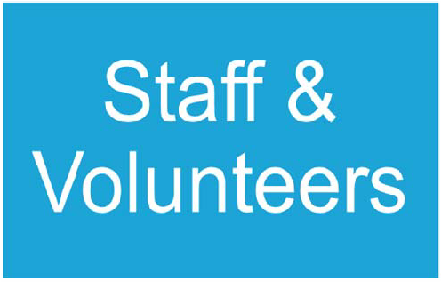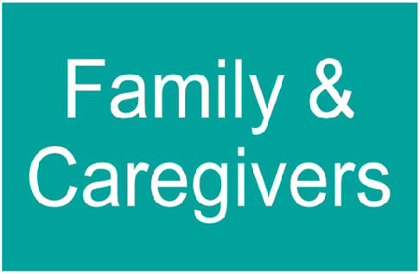

- Centers for Disease Control and Prevention and Kaiser Permanente collaboration (1995-1997)
What are Adverse Childhood Experiences (ACEs)?
- Largest study ever done on this subject, involved 17,000 people, two waves of data collection
- Participants were given a survey that listed 10 types or categories of trauma

1 in 4
exposed to 2 categories of ACEs

1 in 16
was exposed to 4 categories

22%
were sexually abused as children

66%
of the women experienced abuse, violence or family issues in childhood
Women were 50%
more likely than men to have experienced
5 or more ACEs

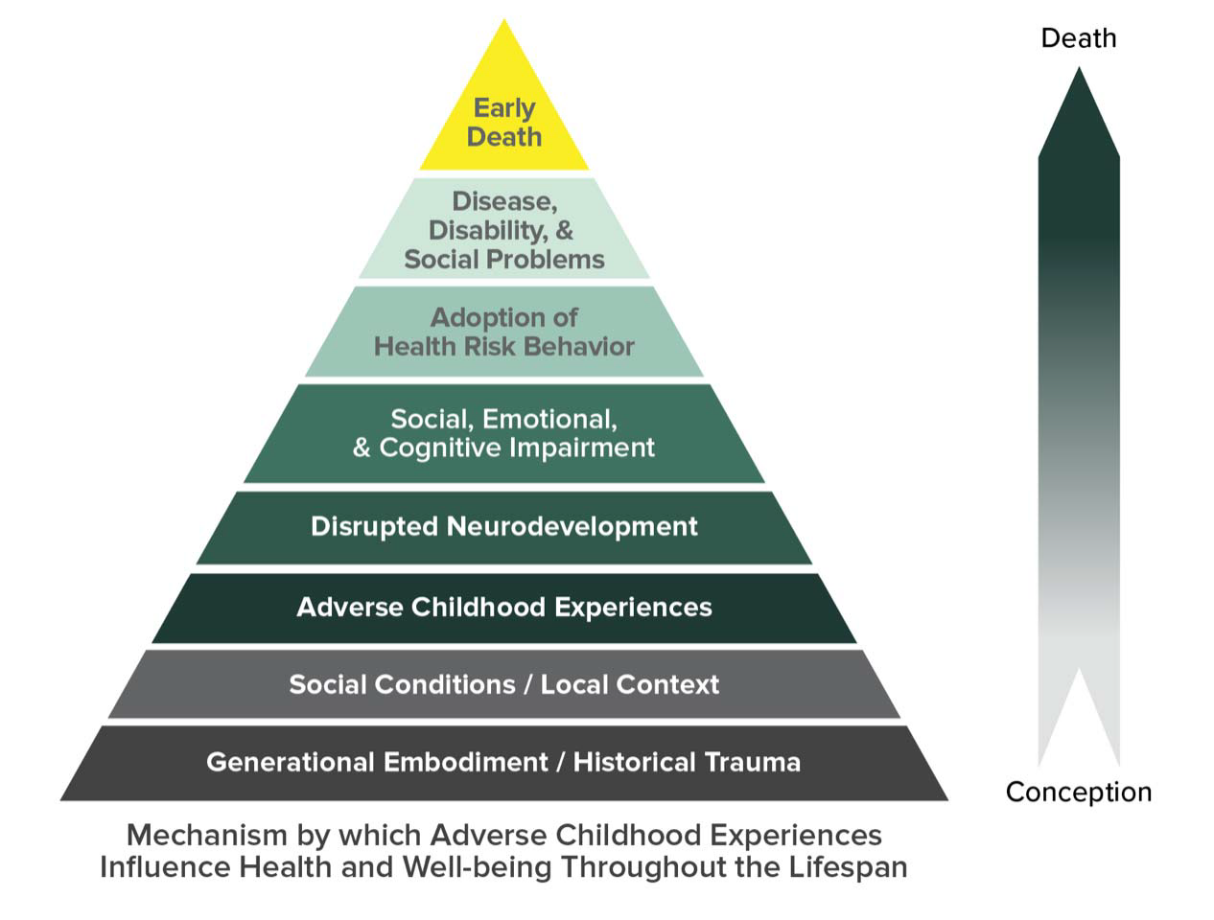

How do ACEs and Adverse Events Affect People?

Source: https://www.cdc.gov/violencepr evention/childabuseandneglect/ acestudy/ace-graphics.html

Early Adversity has Lasting Impacts

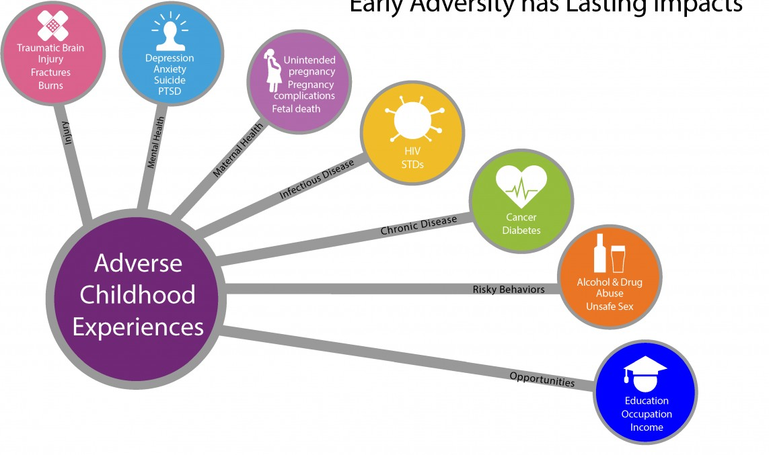
Source: https://www.cdc.gov/violencepr evention/childabuseandneglect/ acestudy/ace-graphics.html

What damages relationships?
What builds relationships?

  - Interactions that are humiliating, harsh, impersonal, disrespectful, critical, demanding, judgmental
Importance of Communication and Relationships
  - Language barriers
  - Referring to people by their condition
  - “It’s not that bad”
  - “Worse things have happened to people”
  - Interactions that express kindness,
patience, reassurance, acceptance, listening
  - Asking for clarification
  - Person-first language
  - “I’m sorry this happened to you”
  - “That must have been very scary!”

What’s wrong with you? vs. What’s happened to you?

Importance of Understanding Trauma History

Dementia
Psychosis
Personality
disorders
Mood
disorders (depression, bipolar disorder)
Oppositional
Hoarding/
Collecting
Common misdiagnoses when a trauma history is not considered:

Screening

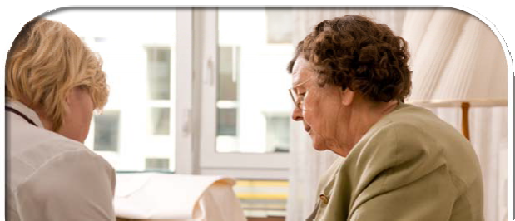
Find out if the resident may have experienced trauma
If so, what triggers the resident? Find ways to help de-escalate if
he/she does feel triggered

- Resident-related flashbacks: troubling dreams, intrusive thoughts, sudden recall of frightening experiences, losing sleep
Compassion Fatigue
- Burnout: feelings of being trapped, hopeless, tired, depressed, worthless, unsuccessful at separating work from personal life
- Budget constraints: limited leave, supervision, increased caseloads
- Personal trauma history: ineffective coping skills, current stressors in personal life

  - Recognizes and supports all residents, regardless of diagnosis, culture, and language
What is a Therapeutic Environment?
  - Actively reduce stigma and myths associated with certain diagnoses
  - Centers the resident’s needs and interests
  - Involves family and caregivers
  - Minimizes external stressors i.e. noise, clutter, chaos
    - Acknowledges specific vulnerabilities of residents with dementia
  - Utilizes individualized, flexible designs to support range of functional levels

  - Work with residents to ensure that their well-being is prioritized
Prioritize Well-being of Residents and Staff
    - Social engagement, meaningful activities, sense of purpose
    - Quality sleep, positive sleep environment
    - Adequate nutrition, healthy diet
  - Involve staff in discussions of well-being – what does this mean to them?
    - Solicit the input of all levels of staff on vision and mission statement discussions
    - Illustrate how to shift the culture and care of your residents – to help it to resonate with every staff member
    - Provide residents with OUD information to empower them to be partners in their care
    - Identify a champion who will assist in creating culture change

  - Brainstorm
Engagement Strategies
    - What are examples of strategies and activities to engage residents?

  - Views or pictures of nature
Engagement Strategies
  - Chapel, meditation room
  - Music
  - Access to nature
  - Physical exercise
  - Pets and other elements that allow for sense of stimulation
  - Privacy and control
  - Schedule of daily tasks and activities to foster sense of purpose and good habits
  - Light jobs
  - Invite residents to utilize talents/skills on behalf of the community.

  - Resident and Family Advisory Councils
Other Approaches
  - Set appropriate expectations for visitors and guests
    - Provide list of prohibited items to bring in while visiting
  - Educate regarding stigmatizing language and bias that can be harmful to the resident
  - Reducing environmental stressors pertaining to the resident

  - Integrate and train staff on a trauma-informed approach to caring for residents with OUD,
Policy Considerations at Your Organization
  - Incorporate development of a therapeutic environment into your existing orientation polices, and,
  - Review and incorporate a person-centered approach into existing policies.

  - Trauma-informed care approach; involve all staff
Key points and who should be involved?
  - Staff training; leadership team
  - Positive engagement strategies; all staff
  - Non-medication approaches; all staff

- Partnering with Patients and Families to Strengthen Approaches to the Opioid Epidemic - Institute for Patient and Family-Centered Care.
Resources
- Tribal Healing to Wellness Court Series - this resource provides an overview of Tribal Healing to Wellness Courts and some evidence based programs or practices of Wellness.
- Resources for Families Coping with Mental and Substance Use Disorders
- Recovery and Recovery Support Resources

Questions?

Community Resources

  - Describe Opioid Treatment Programs (OTPs) and Office-Based Opioid Treatments (OBOTs)
Objectives
  - Identify common community resources

Opioid Treatment Programs
Gwendolyn Fenton, BSN, RN Mercy Medical Center
Providence Behavioral Health Hospital

  - An outpatient program that provides services to treat and manage OUD in a clinical setting
Opioid Treatment Programs
  - Regulated by SAMHSA
  - Directory of clinics by state can be found here: https://dpt2.samhsa.gov/treatment/directory.aspx

  - Dispense or administer medications including:
Opioid Treatment Program Services
    - Methadone (currently)
    - Buprenorphine, Buprenorphine and Naloxone combination, and/or Naltrexone (coming soon)
  - Administration of medications occurs either:
    - On-site (majority of the time)
    - Take-home pre-poured doses
  - Admission criteria for OTPs:
    - One year history of opiate dependence documented
    - Exclusions to criteria for pregnant residents and just released from incarceration

  - Admission process includes drug screens, in-depth clinical evaluation & medical screening and physical examination.
Opioid Treatment Program Services
  - Integrated emotional, social, and behavioral health services that are required by SAMHSA include:
    - Counseling
    - Treatment
    - Care planning
    - Diversion control

*Department of Public Health (DPH)* Drug Enforcement Agency (DEA)* The Joint Commission (TJC)* Commission on Accreditation of Rehabilitation Facilities (CARF)*
Methadone Treatment: Highly Regulated Care
- Clinics provide: Medical examinations, lab assessments, daily nurse assessments, weekly counseling, education
- Relationship building, vocational, educational and employment referrals related to quarterly treatment plans
- Drug testing at least 15/year: oral fluid, blood, urine
- Observed daily medication based on safety and assessment
- Take-home medication may be prescribed but is limited

  - Develop a Qualified Services Organization Agreement (QSOA)
How Can You Work with Your Local OTP
    - Should include types of services QSOA provides, medical services (example counseling services, on-site call coverage, treatment plan, etc.)
    - Discussions between LTCF and OTP administrators should occur prior to admission of residents on MOUD
    - Should be completed prior to admission
  - Release of Information (ROI)
    - Consent is required to share information from the OTP to the LTCF and other providers

- Determine how the methadone will be dispensed to the resident
How Can You Work with Your Local OTP, Cont’d
  - Take-home waiver (with or without the waiver)
    - LTCF nurse picks up the take home doses (daily or 1x weekly)
    - Client comes in weekly to pick up one week’s worth of take-home doses
  - Methadone delivery
    - OTP nurse delivers and administers the methadone daily

Exception requests are required when an OTP treatment team proposes a deviation from limitations or protocols established by regulation (42 CFR Part 8 and 105 CMR 164.300 et seq.). The most common reasons for these requests are to permit exceptions to the number of allowed take home doses, and exceptions to detoxification limits. There are regulations r/t :
42 CFR EXCEPTION Process: Chain of custody dosing

- Authorization to submit exception requests
- Assessing and documenting justification for an exception request
- Process of submission, including how to complete the on-line form
- BSAS and SAMHSA Responses and action required

(see sample justification on next slide)
Entry into Long Term Care Facility
- Name and location of residential program
- Schedule of OTP supervised doses
- Schedule of doses at LTCF
- Dosing procedure at LTCF
- Details of plan for transportation between LTCF program and OTP
- Provision for safe management of pre-poured doses
- Plan for ensuring and maintaining chain of custody
- Plan for termination (for any reason)
- Plan for managing remaining doses after resident’s termination/discharge

Per agreement between this OTP and [name of program], the resident will pick up 6 TH's on [specify day each week] in the company of staff from [name of program]. On [specify day of pick up], he/she will be dosed at [name of OTP]. Six methadone doses will be placed in a locked box and will be transported back to the LTCF by staff from [name of program] with the resident. The resident and a staff member from the LTCF will sign a chain of custody for these take homes. The resident will receive his/her daily methadone doses at the LTCF. After each daily ingestion, the resident will sign that s/he received the dose. On [specify day each week] the resident will return to the OTP with the locked box with the empty methadone bottles and chain of custody form. The LTCF and the resident have been made aware that if the resident leaves the program at any point in time (whether for voluntary or administrative) all take homes will be automatically terminated. Any remaining doses will be disposed of in accordance with the LTCF’s policy on disposal of medication left behind.
Sample Justification

Office Based Opioid
Treatment Program
James Biscoe Clean Slate

- Outpatient facility
Office Based Opioid Treatment (OBOTs)
- Primary care or general health care practitioners provide care, after obtaining a waiver to prescribe Buprenorphine

- Evidence-based model of care to treat substance use disorders
OBOT Model
- Addiction trained and specialty licensed providers treating substance use disorders within an office based setting.
- Resident-centered, utilizing medication for addiction treatment
  - Buprenorphine and/or naltrexone formulations; not methadone

- Resident must have a DSM-5 diagnosis of OUD or other Substance Use Disorder (SUD)
Candidates for OBOT Treatment
- Resident is interested in medication for addiction treatment
- Resident is able to come to visits during office hours of operation
- Resident is able to be treated in clinic setting safely without harm to self or others
- Resident should be willing to address use of other harmful and/or substances they may be misusing

Follow-up visit flow:
OBOTs Provide Comprehensive Services
- Assess and address recent substance use
- Assess medication dose, adherence, cravings, withdrawal
- Provide ongoing education: medication administration, side effects, interactions, support
- Provide or connect a patient with counseling services
- Arrange for psychiatric evaluation with follow up as needed
- Medical issues: HIV, HCV, routine health maintenance, acute needs
- Family planning
- Social supports: housing, employment, family, friends, recovery coach
- Labs as clinically indicated
- Support the recovery process and build trust

- Licensed provider with DEA registration
DATA 2000 – Practitioner Waiver Requirements
- Subspecialty training in addictions or completion of an 8-hour course for physicians or 24 hour course for nurse practitioners and physician assistants
- Registration with SAMHSA and DEA
- Must affirm the capacity to refer residents for appropriate counseling and ancillary services
- Must adhere to resident panel size limits
- Recent CARA and SUPPPORT legislations passed permitting advanced practice providers (APPs) prescriptive authority to prescribe buprenorphine
- Requires a total of 24hrs of addiction training for waiver

- A substance use disorder is a chronic medical condition that responds best when treated with evidence-based, resident-centered, ongoing, comprehensive medical care.
OBOT Treatment Philosophy
- Patient/client with substance use disorders deserve to be treated with dignity and respect.
- The goals of treatment include:
  - Cessation or reduction in harmful substance use,
  - Active participation and engagement in treatment,
  - Restoration physiologic functions, and
  - Improvement in one’s quality of life.
- Strives for lowest possible barrier, treatment on demand

- Develop a Qualified Services Organization Agreement (QSOA)
How Can You Work with Your Local OBOT
  - Should include types of services QSO provides, medical services (example counseling services, on-site call coverage, treatment plan, etc.)
  - Discussions between LTCF and OBOT administrators should occur prior to admission of residents on MOUD
  - Should be completed prior to admission
- Release of Information (ROI)
  - This form helps to designate what information can be released
- Determine how the medication will be prescribed/dispensed to the resident

Additional Community
Supports

- Discussion Question
Community Supports

–What have been some valuable resources within your community?

- Peer Recovery Coaches
Community Resources
  - Develop recovery plans and own recovery pathways and emotional support, information, concrete support, and connections.
- Patient Navigators
  - Identify resident needs and direct to sources of emotional, financial, administrative, legal, social, or cultural support.

“Peer support helped me see that I was not hopeless. It gave me my voice back and bolstered my self-worth.” – Michelle

West Tennessee Area of Narcotics Anonymous. (n.d.) My Story. Retrieved October 2019, from https://www.na-wt.org/blog/my-story

- RECOVER Project, Greenfield
Peer-driven Recovery Support Centers
- Everyday Miracles, Worcester
- The Recovery Connection, Marlborough
- Holyoke Recovery Support Center, Holyoke

www.helpline-online.com for locations

- Local services
Community Supports
  - Massachusetts Substance Use Helpline, 1-800-327-5050
    - English https://helplinema.org/
    - Spanish https://helplinema.org/?lang=es
- National Helpline
  - SAMHSA’s National Helpline, 1-800-662-HELP (4357)
- Learn to Cope
  - Is a non-profit support network for parents, family members, and friends coping with a loved one addicted to opiates or other drugs.
  - (508) 738-5148 or https://www.learn2cope.org/

Mutual Help Groups
Community Supports, Cont’d
- Narcotics Anonymous (NA) – 12-step recovery program
- Nar-Anon – 12-step recovery program for family and friends
- SMART Recovery® – recovery program for all addictive behaviors focusing on self-regulating thoughts, emotions, and actions
- Dual Recovery Anonymous – 12-step recovery program for people with substance use disorders with simultaneous emotional or psychiatric illness
“Going to meetings has kept me clean when nothing else could, talking to other addicts, service work and surrounding myself with this program has been invaluable." – Terry

Source: https://www.na-wt.org/blog/my-story

Access to Treatment for SUD:
Additional Resources
- SAMHSA National Hotline: www.samhsa.gov/find-help/national-helpline 1-800-662-HELP (4357)
- Massachusetts Treatment Resource linkage: https://helplinema.org/
- PAATHs: http://www.bphc.org/whatwedo/Recovery-Services/paaths-connect-to- services/Pages/paaths.aspx

Harm Reduction Education and Materials:
- Harm Reduction Coalition: http://harmreduction.org/
- Needle Exchange Sites: http://harmreduction.org/connect-locally/massachusetts/ahope/
- BSAS Clearing House: https://massclearinghouse.ehs.state.ma.us/category/CTGY-PLST.html

Overdose Education and Naloxone:
- Prescribe to Prevent: http://prescribetoprevent.org/
- Office Based Addiction Treatment Training and Technical Assistance https://www.bmcobat.org/
- Where to access Naloxone in MA: https://www.mass.gov/service-details/how-to-get-naloxone

Additional Education Resources

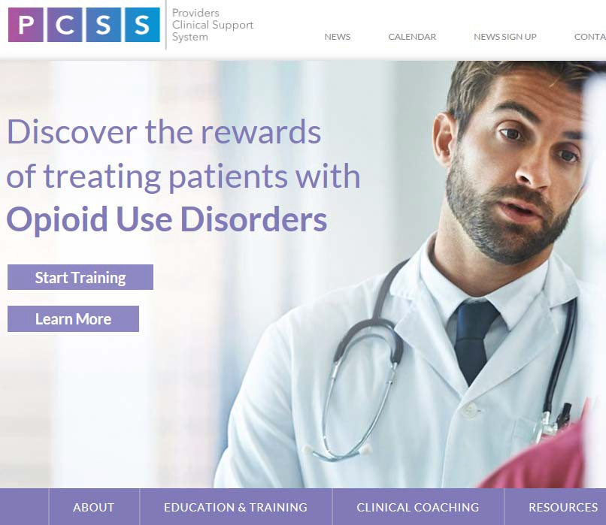
Learn More About Opioid Use Disorder
•
•
•
•
•
Free Online Courses CME/CE Credit
Harvard Medical School Faculty Best Practices & Latest Research
Self-Paced and Modular
globalacademy.hms.harvard.edu/OUDEP3

MISSION: To support primary care teams in increasing their capacity for, and comfort in, using evidence-based practices in screening for, diagnosing, treating and managing care of all patients with chronic pain and/or SUD.
  - Real-time phone consultation on safe prescribing and managing care for adults with chronic pain, SUD or both
Massachusetts Consultation Service for the Treatment of Addiction and Pain (MCSTAP)
  - Information on community-based resources to address patient needs
  - Free consultations on all patients statewide, regardless of insurance
  - Call 1-833-PAIN-SUD (1-833-724-6783), Monday to Friday, 9 a.m. – 5 p.m.
  - Consults on questions across a broad range of topics, from managing medications (including opioids, MAT and non-opioid pain medications) to pain management strategies
  - Staffed by physician consultants with expertise in treating addiction and pain
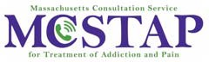
  - Funded by Massachusetts Executive Office of Health and Human Services

- Incorporate within policies a communication strategy and develop a plan of how you’ll utilize community-wide resources in care of residents on MOUD.
Policy Considerations at Your Organization

Implementation of the
Toolkit
Stephanie Baker, MHA, CPHQ

- Identify available supporting resources
Objectives
- Understand the layout and content of the toolkit
- Consider how to use the toolkit

- MOUD comparison chart
Using the Toolkit
- Tip 1- Understanding OUD
- Tip 2- Creating a therapeutic environment
- Tip 3- Organizational and workforce approaches
- Tip 4- Competencies
- Tip 5- Community-wide partnerships
- Tip 6- Transitions of care

- Suggested policies
Using the Toolkit
- Background information
- Resources/educational materials
- Implementation key point chart

- Core competencies checklist- knowledge, skill, or attitude
Core Competencies Checklist
- Understanding OUD
- Special considerations
- Resident’s social environment
- Caring for individual on MOUD
- Caring for the caregivers

- Process Maps
Care Transitions
  - Resident is on Methadone Maintenance (only for residents on methadone maintenance)
  - Resident is newly inducted on Methadone (only for residents newly inducted on methadone)
    - Note: Residents newly inducted on methadone will require more coordinated efforts between LTCFs and the OTP. Be sure to reach out to your community OTP regarding their admission process. Residents must be transported to the OTP the morning after they’ve been discharged from the hospital.
  - Resident is on Buprenorphine (only for residents on Buprenorphine or Vivitrol, newly inducted or maintenance)

Resident is Inducted on Methadone
Resident is
*inducted on Methadone
*Induction on methadone should not be started until there is a plan in place and an OTP has clearly been identified
SUD must
be secondary diagnosis

The LTCF accepts the resident
Hospital makes referral to LTCF clearly identifying that resident is being inducted on Methadone

If applicable to LTCF, LTCF liaison has resident sign SUD agreement

Hospital to initiate referral to OTP closest to the SNF or to the OTP the LTCF has a relationship with prior to hospital discharge
If LTCF already has a
relationship with an OTP, send information to the hospital
146

OTP complies release of information for LTCF and sends to hospital

OTP confirms and accepts referral

Start dates of methadone from hospital must be clearly identified
Methadone Induction, continued

*Hospital d/c is dependent on OTP admission dates

Hospital presents release of information to be signed by the resident and included in discharge paperwork
Hospital medicates the resident with last dose of methadone, includes last dose date, amount, and time in d/c paperwork, along with medication list
Hospital **discharges the resident to the LTCF and includes OTP contact information, ROI, last dose info and med list

LTCF admits resident

Methadone Induction, continued

LTFC admits resident

LTCF confirms release of information has been signed and received

The following day after admission to LTCF, LTCF transports resident to the OTP for dispensing and admission
Confirm mobility of resident, if extra space is needed due to stretcher or wheelchair alert OTP or if resident is on any cautions

LTCF receives resident back from OTP

LTCF and OTP determine communication process around coordination of care

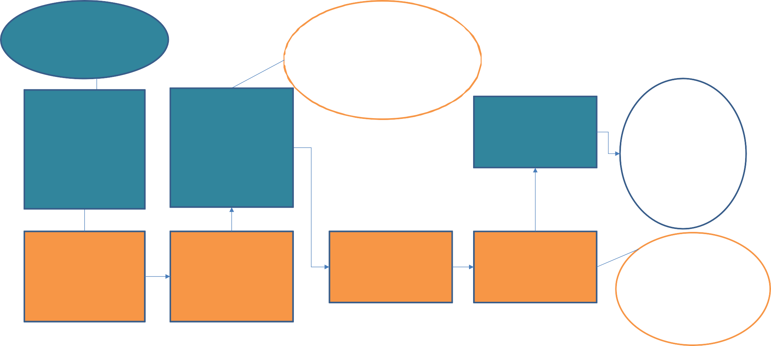
OTP confirms release of information has been signed and received
OTP conducts a full admission and determines treatment course (how often needs to be seen at OTP)
OTP determines if a waiver is warranted, if yes, the OTP submits waiver SAMSHA

OTP communicates with LTCF on travel dispensing time/day
Due to new induction on methadone, treatment plan may consist of travel to OTP every day for 10 days

- QSOA
Care Transitions
- ROI
- OUD agreement
- Management of pre-poured doses
- Self-administration
- Discharge planning

- Transportation to and from OTP is not a covered service under Medicare or Medicaid
Transportation
  - $180/day- average daily Medicaid reimbursement
  - $50-$100 plus mileage- average cost of round trip transportation

- Medical Necessity Form – if resident needs chair service
Transportation Options - No Take-home Waiver
- PT-1 Transportation (more relevant for when resident is discharged)
- Public transportation
- UberHealth
- LTCF own transportation

- Diversion trained RN/LPN
Transportation - Take-home Waiver in Place
- Coordinate with OTP for the best time
- Chain of custody form
- Lock boxes

Leaving in Action
Rosanna Bertrand, PhD

- OTP and OBOT resources
Opportunity to utilize resources
- Community resources such as recovery coaches
- LTCF resources

- Follow-up Technical Assistance via
Our Next Steps
  - Phone
  - Email
  - In-person visit

- Webinar
  - Peer-to-Peer opportunity to share case examples
  - Topic based on needs of the communities

- Review the toolkit
Your Next Steps
- Consider applying for DATA waiver
- Review facility policies and procedures
- Discuss opportunities to support residents on MOUD with other staff at your facility

Questions/Discussion

A Few Logistics:

Thank you!

- Please remember to turn in your evaluation

- Continuing education certificates will be distributed electronically following the program

- For questions reach out to: nursinghomeqi@state.ma.us

@MassDPH
Connect with DPH
Massachusetts Department of Public Health DPH blog
https://blog.mass.gov/publichealth

www.mass.gov/dph
159

