INDOOR AIR QUALITY ASSESSMENT

Registry of Motor Vehicles
1250 St. James Avenue
Springfield, Massachusetts

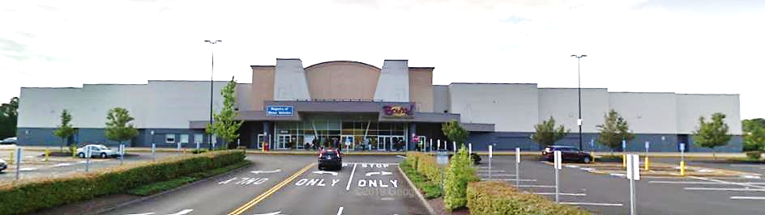

Prepared by:
Massachusetts Department of Public Health
Bureau of Environmental Health
Indoor Air Quality Program
September 2022

BACKGROUND
Building: | Registry of Motor Vehicles (RMV)  Springfield, MA
Address: | 1250 St. James Avenue, Springfield, MA
Assessment Requested by: | Aric Warren, Deputy Director of Facilities, Department of Transportation (DOT)
Reason for Request: | Indoor air quality (IAQ) concerns
Date of Assessment: | July 29, 2022
Massachusetts Department of Public Health/Bureau of Environmental Health (MDPH/BEH) Staff Conducting Assessment: | Michael Feeney, Director, IAQ  Program and Stefanie Santora,  Environmental Analyst, IAQ Program
Building Description: | The RMV is located in the Springfield  Plaza in a single story building shared  with Bounce Trampoline. Constructed  as a movie theater in the 1990s, the  building was renovated in 2017. It  occupies 17,000 square feet including  16 workstations for public service in  the lobby and multiple interior  employee offices.
Windows: | Windows are not openable.

METHODS
Please refer to the IAQ Manual for methods, sampling procedures, and interpretation of results (MDPH, 2015).

RESULTS and DISCUSSION
The following is a summary of indoor air testing results (Table 1).
- Carbon dioxide levels were above the MDPH guideline of 800 parts per million (ppm) in most of areas assessed. This is likely due to lack of airflow in the building.
- Temperature was within the MDPH recommended range of 70°F to 78°F in all areas.
- Relative humidity was slightly above the MDPH recommended range of 40% to 60% in most of the areas tested.
- Carbon monoxide levels were non-detectable (ND) in all indoor areas assessed.

Ventilation
A heating, ventilating, and air conditioning (HVAC) system has several functions. First it provides heating and, if equipped, cooling. Second, it is a source of fresh air. Finally, an HVAC system will dilute and remove normally occurring indoor environmental pollutants by not only introducing fresh air, but by filtering the airstream and ejecting stale air to the outdoors via exhaust ventilation. Even if an HVAC system is operating as designed, point sources of respiratory irritation may exist and cause symptoms in sensitive individuals.
The HVAC system consists of large rooftop air handling units (AHUs) manufactured in 1999, that are designed to draw in fresh air from intakes on the roof (Pictures 1 and 2). Supply air is ducted to ceiling-mounted supply diffusers throughout the space. Return air is brought back to the AHUs through ducted return vents. AHUs do not have fan-driven exhaust vents. Some AHUs have a barometric relief blade {barometric damper [a louvered vent that is freely opened by air pressure inside the AHU (Picture 3)]}. The purpose of this vent is to relieve air pressure in the system and provide some exhaust ventilation.
Exhaust ventilation for the complex consists of a significant number of mechanical exhaust fans on the roof (Picture 4). Most of these vents were not functioning at the time of this assessment and are presumed to have been installed at the same time as the AHUs. Without functioning exhaust ventilation, normally occurring indoor pollutants can build up, which can be reflected in carbon dioxide testing, particularly when the number of patrons in the building increases.
To maximize air exchange, the MDPH recommends that both supply and exhaust ventilation operate continuously during periods of occupancy. In order to have proper ventilation with a mechanical supply and exhaust system, the systems must be balanced to provide an adequate amount of fresh air to the interior of a room while removing stale air from the room. It is recommended that HVAC systems be re-balanced every five years to ensure adequate air systems function (SMACNA, 1994).
Note that all but one AHU was operational during the time of the assessment therefore, there is limited fresh air supply to the building. Only two of the eighteen exhaust fans were operational, so little indoor air is being exhausted out of the building. Carbon dioxide results are reflective of this lack of air exchange.

Microbial/Moisture Concerns
No moisture related issues were observed at the time of this assessment.

Other Conditions
Most flooring is covered with carpet tile. The Institute of Inspection, Cleaning and Restoration Certification (IICRC), recommends that carpeting be cleaned annually (or semi-annually in soiled high traffic areas) (IICRC, 2012).

CONCLUSIONS and RECOMMENDATIONS
Based on the observations made during the visit, the following is recommended:
- Inspect all rooftop AHUs and exhaust vents for proper function. Make repairs or replace as necessary.
- Operate the HVAC system to provide for continuous fresh air ventilation during occupied hours. Inspect all thermostats to ensure that they are set for fan “On” instead of the “Auto” setting.
- Consider adopting a balancing schedule of every 5 years for all mechanical ventilation systems, as recommended by ventilation industrial standards (SMACNA, 1994).
- For buildings in New England, periods of low relative humidity during the winter are often unavoidable. Therefore, scrupulous cleaning practices should be adopted to minimize common indoor air contaminants whose irritant effects can be enhanced when the relative humidity is low. To control dusts, a high efficiency particulate arrestance (HEPA) filter equipped vacuum cleaner in conjunction with wet wiping of all surfaces is recommended. Avoid the use of feather dusters. Drinking water during the day can help ease some symptoms associated with a dry environment (throat and sinus irritations).
- Deep clean carpeting annually or semi-annually in high traffic areas as per the recommendations of the Institute of Inspection, Cleaning and Restoration Certification (IICRC).
- Refer to resource manuals and other related IAQ documents for further building-wide evaluations and advice on maintaining public buildings. Copies of these materials are located on the MDPH’s website: http://mass.gov/dph/iaq.

REFERENCES
IICRC. 2012. Institute of Inspection, Cleaning and Restoration Certification. Carpet Cleaning: FAQ.
MDPH. 2015. Massachusetts Department of Public Health. Indoor Air Quality Manual: Chapters I-III. Available at: https://www.mass.gov/lists/indoor-air-quality-manual-and-appendices.
SMACNA. 1998. Indoor Air Quality: A Systems Approach. 3rd ed. Sheet Metal and Air Conditioning Contractors’ National Association, Inc, Chantilly, VA.

Picture 1

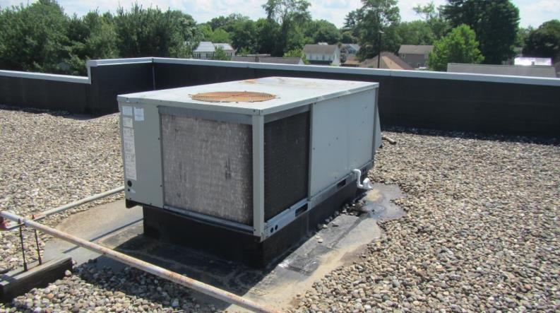
Rooftop AHU

Picture 2

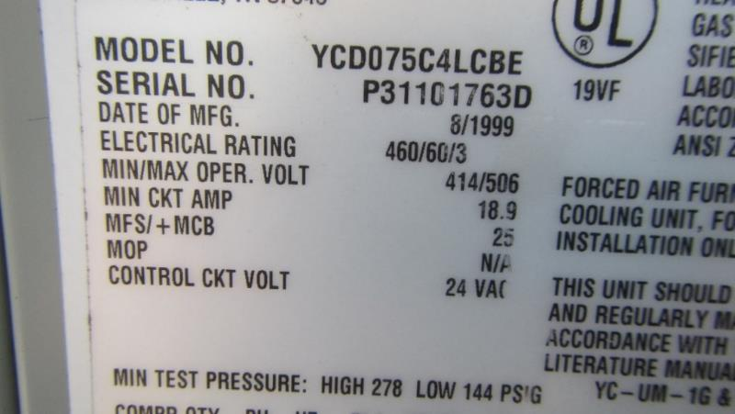
Label on rooftop AHU indicating date of manufacture as 1999

Picture 3

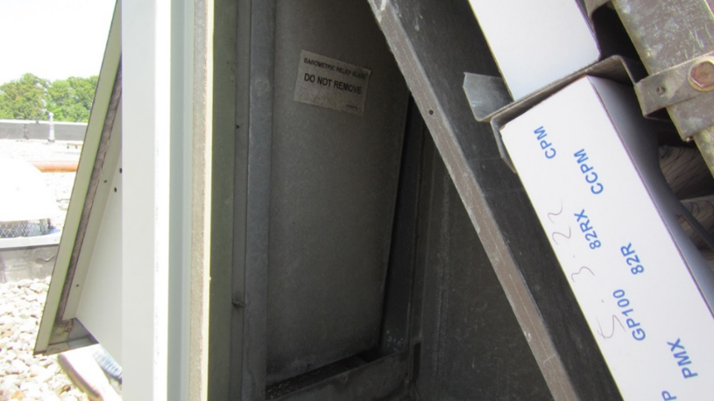
Barometric relief blade

Picture 4

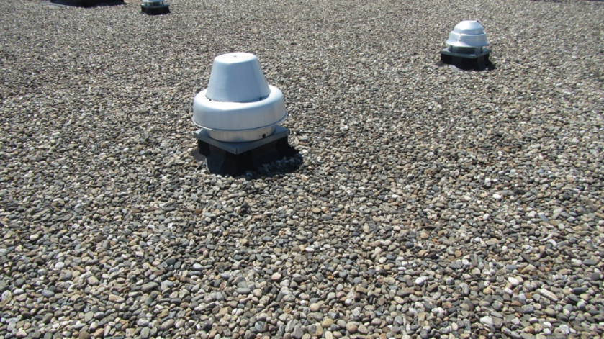
Rooftop exhaust vents

Location | Carbon  Dioxide  (ppm) | Carbon Monoxide  (ppm) | Temp  (°F) | Relative  Humidity  (%) | Bowed CT (No.) | Windows  Openable | Ventilation |  | Remarks
 |  |  |  |  |  |  | Supply | Exhaust
Background | 360 | ND | 89 | 45
Lobby | 770 | ND | 78 | 58 | 19 | N | Y | Y
Lobby areas adjacent to:
Cubicle 3 | 878 | ND | 78 | 57 | 9 | N | Y | Y
Cubicle 5 | 920 | ND | 77 | 59 | 12 | N | Y | Y
Cubicle 10 | 958 | ND | 73 | 63 | 15 | N | Y | Y
Cubicle 16 | 968 | ND | 73 | 63 | 16 | N | Y | Y
Cubicle 22 | 857 | ND | 74 | 59 | 20 | N | Y | Y
Lobby area walls adjacent to:
Cubicle 3 | 911 | ND | 75 | 63 | 7 | N | Y | Y
Cubicle 6 | 886 | ND | 76 | 61 | 10 | N | Y | Y
Cubicle 12 | 1051 | ND | 76 | 62 | 14 | N | Y | Y
Cubicle 16 | 932 | ND | 73 | 62 | 7 | N | Y | Y
Cubicle 22 | 870 | ND | 73 | 62 | 3 | N | Y | Y
Interior Office Space:
Printer/Copy Room | 820 | ND | 74 | 60 | 3 | N/A | Y | Y
Hallway adjacent to Copy Room | 808 | ND | 74 | 60 | 2 | N/A | Y | Y
Business Office | 666 | ND | 72 | 62 | 5 | N/A | Y | Y
Offices 3-5 | 880 | ND | 74 | 63 | 3 | N | Y | Y
Offices 10-15 | 843 | ND | 73 | 62 | 4 | N | Y | Y
Offices 16-21 | 839 | ND | 72 | 61 | 4 | N | Y | Y
Offices 22-24 | 867 | ND | 72 | 61 | 2 | N | Y | Y

