Background/Introduction

INDOOR AIR QUALITY ASSESSMENT

Springfield School Department
195 State Street
Springfield, Massachusetts



Prepared by:
Massachusetts Department of Public Health
Bureau of Environmental Health
Indoor Air Quality Program
January 2010

In response to a request from Steve Stathis, Director, Division of Environmental Health, City of Springfield Health Department, the Massachusetts Department of Public Health’s (MDPH), Bureau of Environmental Health (BEH) conducted an indoor air quality assessment at the Springfield School Department Headquarters (SSD/HQ) located at 195 State Street, Springfield, Massachusetts. The request was prompted by employee complaints of symptoms thought to be related to indoor air quality concerns in the building. On April 24, 2009, a visit to assess the SSD/HQ was made by Michael Feeney, Director, Indoor Air Quality Program and Lisa Hébert, Regional Indoor Air Quality (IAQ) Inspector within BEH’s IAQ Program.
The SSD/HQ is a two-story brick building originally constructed in 1905 as an insurance company building. The first floor of the building is divided into two sections: the front and back. The front section was constructed as a large, two story room with balconies. Prior to occupancy by the SSD, the balconies above the front section were connected to form a one story, unsupported ceiling. The back section was constructed as two separate floors. The basement contains a lunchroom, office space and storage areas. Windows are openable.

Methods
Air tests for carbon dioxide, carbon monoxide, temperature and relative humidity were taken with the TSI, Q-TRAK™ IAQ Monitor, Model 8551. Air tests for airborne particle matter with a diameter less than 2.5 micrometers were taken with the TSI, DUSTTRAK™ Aerosol Monitor Model 8520. BEH staff also performed visual inspection of building materials for water damage and/or microbial growth.

Results
The SSD/HQ houses approximately 110 staff members. On average the building has 10 visitors a day. Tests were conducted under normal operating conditions and results appear in Table 1.

Discussion

Ventilation
It can be seen from Table 1 that carbon dioxide levels were below 800 parts per million parts (ppm) in all areas sampled at the time of the assessment, indicating adequate air exchange in the majority of areas in the building. It is important to note, however, that several rooms had open windows and were empty/sparsely populated; each of these factors can result in reduced carbon dioxide levels. Carbon dioxide levels would be expected to increase with full occupancy and with windows closed.
This building does not have a functional mechanical ventilation system. Fresh air supply and exhaust (Picture 1) vents were identified, but were found not operating. Exhaust ventilation non-motorized vent termini exist on the roof (Picture 2). Of note is the ductwork connected to these rooftop vents. It appeared that sections of ductwork had been disconnected in a crawlspace that exists between the roof and second floor ceiling (Picture 3). This open ductwork would allow unconditioned cold air from the ceiling crawlspace as well as dust, dirt and other attic crawlspace pollutants to migrate into the occupied space during cold weather. Dust and dirt can be respiratory irritants.
The only means for creating airflow in this building is the use of openable windows. Rooms are heated using wall-mounted radiators (Picture 4). During summer months, ventilation in the SSD/HQ was controlled by the use of openable exterior windows in rooms. The building was configured in a manner to use cross-ventilation to provide comfort for building occupants. It is equipped with windows on opposing exterior walls. Another set of openable sash windows bisect the floor space on both the first and second floors (Picture 5). In addition, the building has hinged windows located above the office doors (Picture 6).
The hinged windows (called transoms) enable room occupants to close the hallway door while maintaining a pathway for airflow. This design allows airflow to enter an open window, pass through a room and subsequently pass through the open transom. Airflow then enters the hallway, passing through the opposing open room transom and into the room, finally exiting the building on the leeward side (opposite the windward side) (see Figure 1). With all windows and transoms open, airflow can be maintained in a building regardless of the direction of the wind. The system fails if the windows or transoms were closed (see Figure 2). Rooms that are not opposite other rooms would have increased difficulty in creating cross-ventilation and some means to increase air movement is warranted (e.g., floor fan in an open window). Transoms were closed in most locations. In order to create airflow, hallway doors need to be open. Open windows may also allow rainwater to penetrate through windows. Pests, such as birds, bats and insects, also have access to the interior if windows left open overnight.
To maximize air exchange, the MDPH recommends that both supply and exhaust ventilation operate continuously during periods of occupancy. In order to have proper ventilation with a mechanical supply and exhaust system, the systems must be balanced to provide an adequate amount of fresh air to the interior of a room while removing stale air from the room. It is recommended that HVAC systems be re-balanced every five years to ensure adequate air systems function (SMACNA, 1994). Due to inactive or missing components, the HVAC system in the SSD cannot be balanced.
The Massachusetts Building Code requires that each room have a functioning mechanical ventilation system to supply fresh outside air or openable windows (SBBRS, 1997). The ventilation must be on at all times that the room is occupied. Providing adequate fresh air ventilation with open windows and maintaining the temperature in the comfort range during the cold weather season is impractical. Mechanical ventilation is usually required to provide adequate fresh air ventilation.
Carbon dioxide is not a problem in and of itself. It is used as an indicator of the adequacy of the fresh air ventilation. As carbon dioxide levels rise, it indicates that the ventilating system is malfunctioning or the design occupancy of the room is being exceeded. When this happens, a buildup of common indoor air pollutants can occur, leading to discomfort or health complaints. The Occupational Safety and Health Administration (OSHA) standard for carbon dioxide is 5,000 parts per million parts of air (ppm). Workers may be exposed to this level for 40 hours/week, based on a time-weighted average (OSHA, 1997).
The MDPH uses a guideline of 800 ppm for publicly occupied buildings. A guideline of 600 ppm or less is preferred in schools due to the fact that the majority of occupants are young and considered to be a more sensitive population in the evaluation of environmental health status. Inadequate ventilation and/or elevated temperatures are major causes of complaints such as respiratory, eye, nose and throat irritation, lethargy and headaches. For more information concerning carbon dioxide, consult Appendix A.
Temperature readings in the building ranged from 67° F to 76° F, which were within the MDPH recommended range for comfort in the majority of areas (Table 1). The MDPH recommends that indoor air temperatures be maintained in a range of 70° F to 78° F in order to provide for the comfort of building occupants. In many cases concerning indoor air quality, fluctuations of temperature in occupied spaces are typically experienced, even in a building with an adequate fresh air supply.
The relative humidity measured in the building ranged from 25 to 35 percent, which was below the MDPH recommended comfort range (Table 1). The MDPH recommends a comfort range of 40 to 60 percent for indoor air relative humidity. It is important to note however, that relative humidity measured indoors exceeded outdoor measurement of 23 percent (range +2-12 percent). This increase in relative humidity can indicate that the removal of moisture and normal indoor air pollutants (e.g., water vapor from respiration) warrants enhancement. Moisture removal is important since the sensation of heat conditions increases as relative humidity increases (the relationship between temperature and relative humidity is called the heat index). As indoor temperature rises, the addition of more relative humidity will make occupants feel hotter. If moisture is removed, the comfort of the individuals is increased. Removal of moisture from the air, however, can have some negative effects. The sensation of dryness and irritation is common in a low relative humidity environment. Low relative humidity is a very common problem during the heating season in the northeast part of the United States.

Microbial/Moisture Concerns
Several potential sources of water damage/water infiltration were observed in the building. The second floor ceiling showed signs of water damage to plaster (Pictures 7 and 8), ceiling tiles and peeling paint, which can indicate roof leaks. A substantial number of interlocking ceiling tiles are missing (Picture 9). Water-damaged ceiling tiles can provide a source of mold and should be replaced after a water leak is discovered and repaired.
The basement contains a storage area that has water running through the foundation into a drain system (Pictures 10 through 12) that terminates into a sump pump. The basement walls show signs of flooding. A large number of materials that can support mold growth are stored in this area, including upholstered furniture (Picture 13) and rolled-up carpeting (Picture 14). All porous materials stored in this location have the potential for mold colonization and should be discarded.
Offices in the northwest corner of the building have fireplaces. These fireplaces are connected to chimneys located on the northwest corner of the roof (Pictures 15). The chimneys’ flues appeared to be ajar and show signs of water intrusion (Picture 16) and efflorescence. Water intrusion is likely the resulted from the lack of chimney caps (Picture 17) over the flue openings. Since the fireplaces are not used, sealing the chimney openings would prevent further water intrusion.
The mainframe room on the second floor has a free standing air-conditioning system that has exposed pipe for coolant supply and condensation drainage. The dew point is a temperature determined by air temperature and relative humidity. For example, at a temperature of 73º F and relative humidity of 57 percent indoors, the dew point for water to collect on a surface is approximately 57º F (IICRC, 2000). Therefore, any surface that had a temperature below the dew point would be prone to condensation generation under these temperature and relative humidity conditions. In order to prevent this contingency, insulating chilled pipes will prevent condensation generation.
The American Conference of Governmental Industrial Hygienists (ACGIH) and the US Environmental Protection Agency (US EPA) recommend that porous materials be dried with fans and heating within 24 to 48 hours of becoming wet (ACGIH, 1989; US EPA, 2001). If porous materials are not dried within this time frame, mold growth may occur. Water-damaged porous materials cannot be adequately cleaned to remove mold growth. The application of a mildewcide to porous materials is not recommended.
Plants were located in a number of rooms, many without drip pans. In some areas, soil has spilled onto windowsills. Plants, soil, and drip pans can serve as sources for mold growth and should be properly maintained. Over watering of plants should be avoided and drip pans should be inspected periodically for mold growth. In addition, flowering plants can be a source of pollen. Therefore, plants should be located away from the air stream of ventilation sources to prevent aerosolization of mold, pollen and particulate matter.

Other IAQ Evaluations
Indoor air quality can be negatively influenced by the presence of respiratory irritants, such as products of combustion. The process of combustion produces a number of pollutants. Common combustion emissions include carbon monoxide, carbon dioxide, water vapor and smoke (fine airborne particle material). Of these materials, exposure to carbon monoxide can produce immediate, acute health effects upon exposure. To determine whether combustion products were present in the environment, BEH staff obtained measurements for carbon monoxide.

Carbon Monoxide
Carbon monoxide is a by-product of incomplete combustion of organic matter (e.g., gasoline, wood and tobacco). Exposure to carbon monoxide can produce immediate and acute health affects. Several air quality standards have been established to address carbon monoxide and prevent symptoms from exposure to these substances. The MDPH established a corrective action level concerning carbon monoxide in ice skating rinks that use fossil-fueled ice resurfacing equipment. If an operator of an indoor ice rink measures a carbon monoxide level over 30 ppm, taken 20 minutes after resurfacing within a rink, that operator must take actions to reduce carbon monoxide levels (MDPH, 1997).
The American Society of Heating Refrigeration and Air-Conditioning Engineers (ASHRAE) has adopted the National Ambient Air Quality Standards (NAAQS) as one set of criteria for assessing indoor air quality and monitoring of fresh air introduced by HVAC systems (ASHRAE, 1989). The NAAQS are standards established by the US EPA to protect the public health from six criteria pollutants, including carbon monoxide and particulate matter (US EPA, 2006). As recommended by ASHRAE, pollutant levels of fresh air introduced to a building should not exceed the NAAQS levels (ASHRAE, 1989). The NAAQS were adopted by reference in the Building Officials & Code Administrators (BOCA) National Mechanical Code of 1993 (BOCA, 1993), which is now an HVAC standard included in the Massachusetts State Building Code (SBBRS, 1997). According to the NAAQS, carbon monoxide levels in outdoor air should not exceed 9 ppm in an eight-hour average (US EPA, 2006).
Carbon monoxide should not be present in a typical, indoor environment. If it is present, indoor carbon monoxide levels should be less than or equal to outdoor levels. On the day of assessment, outdoor carbon monoxide concentrations were non-detect (ND) (Table 1). Carbon monoxide levels measured in the SSD/HQ were also ND.

Particulate Matter (PM2.5)
The US EPA has established NAAQS limits for exposure to particulate matter. Particulate matter is airborne solids that can be irritating to the eyes, nose and throat. The NAAQS originally established exposure limits to particulate matter with a diameter of 10 μm or less (PM10). According to the NAAQS, PM10 levels should not exceed 150 microgram per cubic meter (μg/m3) in a 24-hour average (US EPA, 2006). These standards were adopted by both ASHRAE and BOCA. Since the issuance of the ASHRAE standard and BOCA Code, US EPA established a more protective standard for fine airborne particles. This more stringent PM2.5 standard requires outdoor air particle levels be maintained below 35 μg/m3 over a 24-hour average (US EPA, 2006). Although both the ASHRAE standard and BOCA Code adopted the PM10 standard for evaluating air quality, MDPH uses the more protective PM2.5 standard for evaluating airborne particulate matter concentrations in the indoor environment.
Outdoor PM2.5 concentrations the day of the assessment were measured at 10 μg/m3. PM2.5 levels measured inside the building were 5 to 11 μg/m3 (Table 1), which were below the NAAQS PM2.5 level of 35 μg/m3. Frequently, indoor air levels of particulates can be at higher levels than those measured outdoors. A number of mechanical devices and/or activities that occur in buildings can generate particulate matter during normal operations. Sources of indoor airborne particulates may include but are not limited to particles generated during the operation of fan belts in an HVAC system, use of microwave ovens; use of photocopiers, fax machines and computer printing devices; operation of an ordinary vacuum cleaner and heavy foot traffic indoors.

Volatile Organic Compounds
Indoor air concentrations can be greatly impacted by the use of products containing volatile organic compounds (VOCs). VOCs are carbon-containing substances that have the ability to evaporate at room temperature. Frequently, exposure to low levels of total VOCs (TVOCs) may produce eye, nose, throat and/or respiratory irritation in some sensitive individuals. For example, chemicals evaporating from a paint can stored at room temperature would most likely contain VOCs. In an effort to identify materials that can potentially increase indoor VOC concentrations, BEH staff examined the building for products containing these respiratory irritants.
Several rooms contained dry erase boards and related materials. Materials such as dry erase markers and dry erase board cleaners may contain VOCs, such as methyl isobutyl ketone, n-butyl acetate and butyl-cellusolve (Sanford, 1999), which can be irritating to the eyes, nose and throat.
Cleaning products were found in a number of rooms. Like dry erase materials, cleaning products contain VOCs and other chemicals. These chemicals can be irritating to the eyes, nose and throat. Products should be kept in their original containers, or should be clearly labeled as to their contents, for identification purposes in the event of an emergency. Further, material safety data sheets (MSDS) for all cleaning products must be available at a central location.
In the basement, containers of kerosene were observed. In addition to posing a potential fire hazard, the vapors contain VOCs, which can also lead to respiratory irritation.

Other Conditions
Other conditions that can affect indoor air quality were observed during the assessment. The floor of the SSD/HQ contains a number of damaged floor tiles. Given the building’s age, these tiles may contain asbestos and should be examined by a licensed asbestos abatement contractor to identify and, if necessary, remediate potential exposure issues with regard to these materials. Where asbestos-containing materials are found damaged, these materials should be removed/remediated in a manner consistent with Massachusetts asbestos remediation laws (MDLI, 1993).
Open utility holes and penetrations of pipes and conduits through floors, walls and ceilings were not properly sealed (Picture 18), which can provide pathways for drafts, dust and particulates to migrate into occupied areas.
Upholstered furniture was observed in many areas of the building. Upholstered furniture is covered with fabric in contact with human skin. This type of contact can leave oils, perspiration, hair and skin cells. Dust mites feed upon human skin cells and excrete waste products that contain allergens. In addition, if relative humidity levels increase above 60 percent, dust mites tend to proliferate (US EPA, 1992). In order to remove dust mites and other pollutants, frequent vacuuming of upholstered furniture is recommended (Berry, 1994). If an excessively dusty environment exists due to outdoor conditions or indoor activities (e.g., renovations), cleaning frequency should be increased (every six months) (IICR, 2000).

Conclusions/Recommendations
The conditions noted at the SSD/HQ raise a number of indoor air quality issues. The general building conditions, the poor condition of the natural/gravity ventilation system, maintenance and work hygiene practices, if considered individually, present conditions that impact indoor air quality. When combined, these conditions can serve to further degrade indoor air quality. Some of these conditions can be remedied by actions of building occupants. Other remediation efforts will require alteration to the building structure and equipment. For these reasons, a two-phase approach is required for remediation. The first consists of short-term measures to improve air quality and the second consists of long-term measures that will require planning and resources to address the overall indoor air quality concerns within the building.
The following short-term measures should be considered for implementation:
- Seal both fresh air supply and exhaust vents with plywood to prevent attic crawlspace and basement air entering occupied space.
- Supplement airflow in rooms by using openable windows to control for comfort. Care should be taken to ensure windows are properly closed at night and on weekends to avoid the freezing of pipes and potential flooding.
- Determine composition of damaged floor tiles. If tiles contain asbestos material, remove in accordance with applicable federal and state hazardous waste laws and regulations.
- Remove all porous materials from the sump pump basement area. Do not use this area for storage. Examine options for providing proper drainage for water entering the foundation.
- Insulate all pipes carrying either coolant or chilled water to and from the mainframe air conditioning unit.
- Ensure leaks are isolated and repaired. Repair/replace any wall/ceiling plaster and/or other damaged building materials. Examine above and around these areas for mold growth. Disinfect areas of water leaks with an appropriate antimicrobial.
- Repair water damaged plaster. Remove peeling paint.
- For buildings in New England, periods of low relative humidity during the winter are often unavoidable. Therefore, scrupulous cleaning practices should be adopted to minimize common indoor air contaminants whose irritant effects can be enhanced when the relative humidity is low. To control for dusts, a high efficiency particulate arrestance (HEPA) filter equipped vacuum cleaner in conjunction with wet wiping of all surfaces is recommended. Avoid the use of feather dusters. Drinking water during the day can help ease some symptoms associated with a dry environment (throat and sinus irritations).
- Consider re-pointing exterior of building in areas where mortar has deteriorated.
- Plants should be properly maintained and be equipped with drip pans. Drip pans should be monitored and cleaned as necessary.
- Repair/replace damaged exterior doors and woodwork.
- Clean dry erase trays to prevent accumulation of materials.
- Seal penetrations of pipes through walls, floors and ceilings throughout the building.
- Consider cleaning carpets and all upholstered furniture on a more frequent basis.
- Consult with local fire prevention officer regarding appropriate storage of flammable materials within the building.
- Consider sealing chimney openings to prevent further water intrusion.
- Refer to resource manual and other related indoor air quality documents located on the MDPH’s website for further building-wide evaluations and advice on maintaining public buildings. These documents are available at: http://mass.gov/dph/indoor_air.
- Obtain MSDS sheets for all chemicals used in the SSD/HQ and make available at a central location.
The following long-term measures should be considered:
- Consider having exterior walls re-pointed and waterproofed to prevent water intrusion. This measure should include a full building envelope evaluation.
- Based on the age, physical deterioration and availability of parts for ventilation components, the BEH strongly recommends that an HVAC engineering firm fully evaluate the ventilation system, if longer-term use is planned.
- Examine the feasibility of providing mechanical supply and exhaust ventilation in the building. Determine if existing airshafts, vents, ductwork, etc. can be retrofitted for (modern) mechanical ventilation.

References
ASHRAE. 1989. Ventilation for Acceptable Indoor Air Quality. American Society of Heating, Refrigeration and Air Conditioning Engineers. ANSI/ASHRAE 62-1989
Berry, M.A. 1994. Protecting the Built Environment: Cleaning for Health, Michael A. Berry, Chapel Hill, NC
BOCA. 1993. The BOCA National Mechanical Code/1993. 8th ed. Building Officials and Code Administrators International, Inc., Country Club Hill, IL.
Burge, H.A. 1995. Bioaerosols. Lewis Publishing Company, Boca Raton, FL
IICR. 2000. IICR S001 Reference Guideline for Professional On-Location Cleaning of Textile Floor Covering Materials Institute of Inspection, Cleaning and Restoration Certification. Institute of Inspection Cleaning and Restoration, Vancouver, WA.
Krylon. 2008. Material Safety Data Sheet: Workable Fixitif Spray Coating. The Sherwin Williams Company. Krylon Products Group, Cleveland, Ohio. http://www.paintdocs.com/webmsds/webPDF.jsp?SITEID=DBS&UPC=724504013068.
Lstiburek, J. & Brennan, T. 2001. Read This Before You Design, Build or Renovate. Building Science Corporation, Westford, MA. U.S. Department of Housing and Urban Development, Region I, Boston, MA
Mass. Act. 2000. An Act Protecting Children and families from Harmful Pesticides. 2000 Mass Acts c. 85 sec. 6E.
MDFA. 1996. Integrated Pest Management Kit for Building Managers. Massachusetts Department of Food and Agriculture, Pesticide Bureau, Boston, MA.
MDLI. 1993. Regulation of the Removal, Containment or Encapsulation of Asbestos, Appendix 2. 453 CMR 6,92(I)(i).
MDPH. 1997. Requirements to Maintain Air Quality in Indoor Skating Rinks (State Sanitary Code, Chapter XI). 105 CMR 675.000. Massachusetts Department of Public Health, Boston, MA.
OSHA. 1997. Limits for Air Contaminants. Occupational Safety and Health Administration. Code of Federal Regulations. 29 C.F.R 1910.1000 Table Z-1-A.
Sanford. 1999. Material Safety Data Sheet (MSDS No: 198-17). Expo® Dry Erase Markers Bullet, Chisel, and Ultra Fine Tip. Sanford Corporation. Bellwood, IL.
SBBRS. 1997. Mechanical Ventilation. State Board of Building Regulations and Standards. Code of Massachusetts Regulations. 780 CMR 1209.0
US EPA. 1992. Indoor Biological Pollutants. US Environmental Protection Agency, Environmental Criteria and Assessment Office, Office of Health and Environmental Assessment, Research Triangle Park, NC. ECAO-R-0315. January 1992.
US EPA. 2006. National Ambient Air Quality Standards (NAAQS). US Environmental Protection Agency, Office of Air Quality Planning and Standards, Washington, DC. http://www.epa.gov/air/criteria.html.
Picture 1

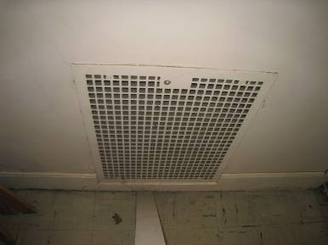

Exhaust Vent

Picture 2

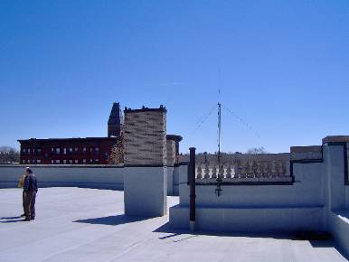

Likely Non-Motorized Exhaust Vent On Roof

Picture 3

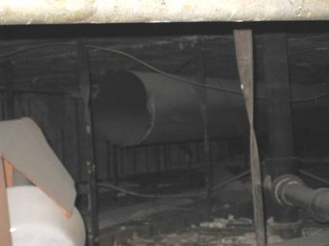

Disconnected Ductwork in Attic

Picture 4

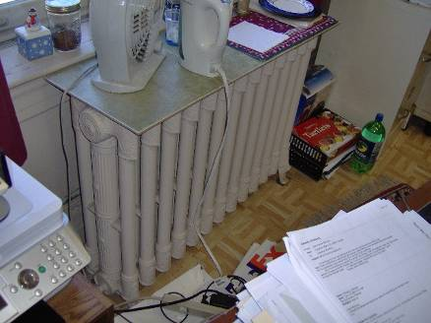

Example of Building Radiator

Picture 5

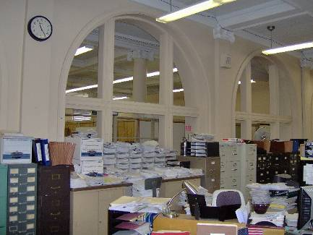

Openable Sash Windows on the First Floor

Picture 6

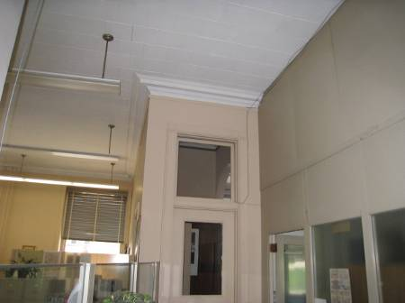

Transom

Picture 7

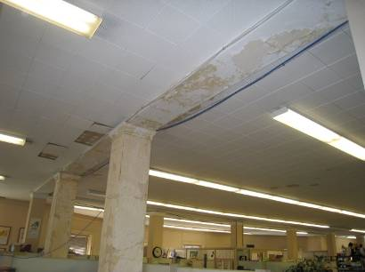

Water Damaged Plaster, 3rd Floor

Picture 8

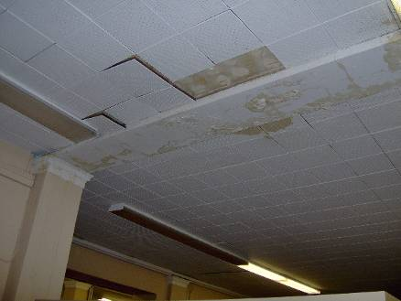

Water Damaged Plaster, 3rd Floor

Picture 9

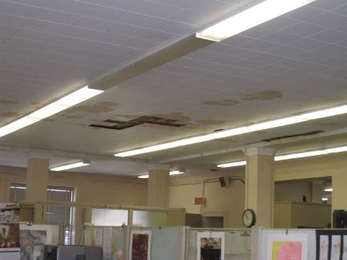

Missing Interlocking Ceiling Tiles

Picture 10

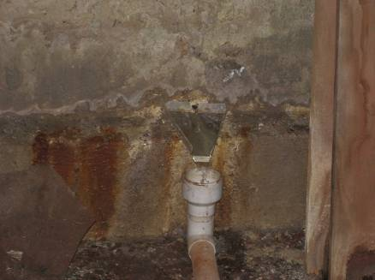

Hole In Foundation Wall Leaking Water, Note Jury Rigged Water Collector

Picture 11

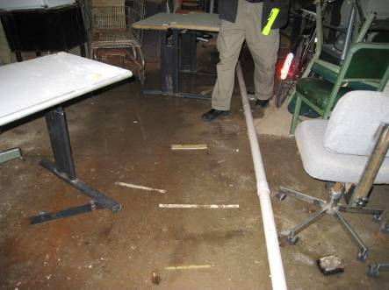

Pipe Connected To Water Collector in Picture 10

Picture 12

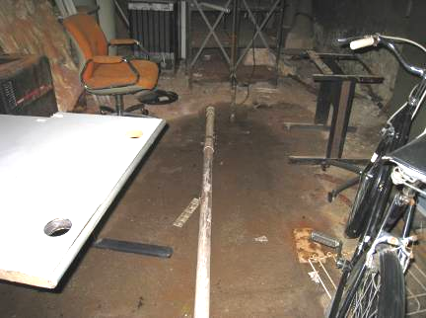

Pipe Terminus over Drain

Picture 13

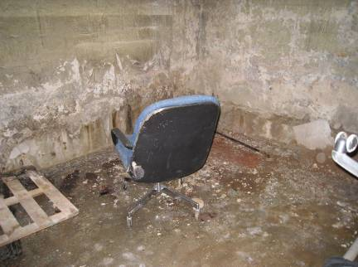

Upholstered Furniture in Basement

Picture 14

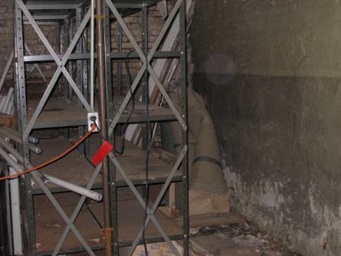

Rolled Up Carpet in Basement

Picture 15

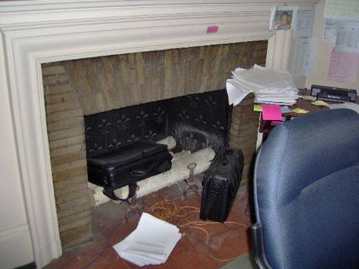

Fireplace in Office

Picture 16

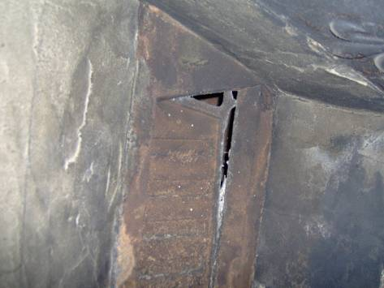

Ajar Flue in Chimney
Picture 17

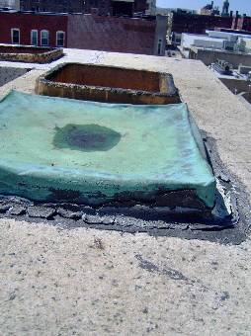

Chimney Openings on Roof, Note Lack Of Chimney Cap

Picture 18

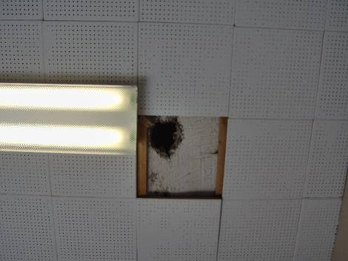

Hole through Ceiling
Location | Occupants  in Room | Carbon  Dioxide  (ppm) | Temp  (°F) | Relative  Humidity  (%) | Carbon Monoxide  (ppm) | PM2.5  (µg/m3) | Windows  Openable | Ventilation |  | Remarks
 |  |  |  |  |  |  |  | Supply | Exhaust | Remarks
Outside  (Background) | - | 380 | 70 | 23 | ND | 10 | - | - | -
3rd Floor  Marie Santos Office | 1 | 593 | 72 | 35 | ND | 6 | Y |  |  | Worn floor tiles
Office 1 | 0 | 584 | 72 | 35 | ND | 5 | Y |  |  | DO, FC, Windows boarded
Office 2 | 0 | 602 | 72 | 35 | ND | 7 | Y |  |  | DO, AP, Open end of pipe in corner of room
Dir. Guidance | 0 | 693 | 72 | 35 | ND | 9 | Y |  |  | Efflorescence around seal of fireplace, carpet
Middle Section | 0 | 653 | 73 | 32 | ND | 6 | Y
Janice Sanchez Office | 1 | 665 | 73 | 31 | ND | 5 | N
Bathroom | 0 |  |  |  |  |  |  |  |  | Plants, peeling paint
Kathy McCarthy Office | 2 | 604 | 74 | 29 | ND | 8 | Y |  |  | Plants, Floor tiles in disrepair, WDCTs, WD plaster, missing CT, PFs
Center of Main Room | 2 | 639 | 75 | 29 | ND | 8 | Y
3rd Floor (rear area) | 2 | 579 | 75 | 28 | ND | 6 | Y
Sheryl Stevens Off. | 3 | 566 | 74 | 28 | ND | 6 | Y |  |  | PFs, Peeling paint
Director’s Off. | 0 | 619 | 73 | 30 | ND | 5 | Y |  |  | Flap open to flue, DO, DEM
Valles Off. | 0 | 602 | 73 | 29 | ND | 7 | Y |  |  | DO, WDCTs, missing CTs
Break Area | 0 | 619 | 74 | 30 | ND | 6 | N |  |  | WDCT
Foreign Lang. | 0 | 647 | 74 | 30 | ND | 10 | N |  |  | DO
2nd floor  Payroll Dept. (front reception) | 6 | 594 | 74 | 28 | ND | 7 | Y |  |  | DO, Plants
Budgeting | 3 | 572 | 74 | 27 | ND | 10 | Y |  |  | DO, PF, Pivot windows, Blinds dusty, open utility holes
Payroll (middle section) | 4 | 574 | 75 | 27 | ND | 10 | Y |  |  | DO, Many PFs
Human Resources | 2 | 620 | 76 | 26 | ND | 7 | Y
Mainframe Room | 0 | 594 | 75 | 27 | ND |  | N
IT Room | 0 | 590 | 67 | 30 | ND | 5 | Y |  |  | AC, WDCTs, PFs, Copper pipe sloping backwards on AC
IT Office | 3 | 619 | 68 | 34 | ND | 7 | Y |  |  | DO, AC – wall mounted, open utility holes
Conference Room | 0 | 678 | 74 | 28 | ND | 8 | N
Technology Research | 4 | 560 | 75 | 27 | ND | 8 | N |  |  | PFs, plants, DEM
Accounting | 2 | 518 | 75 | 25 | ND | 11 | Y |  |  | DEM, PFs, Plants, WC
1st Floor Main Room (reception) | 0 | 729 | 75 | 30 | ND | 6 | Y |  |  | DO
Safety and Security | 1 | 526 | 75 | 25 | ND | 5 | Y |  |  | DO, Plants, PF
Main Room (Center) | 0 | 489 | 75 | 25 | ND | 6 | Y |  |  | DO
Main Room (Rear) | 1 | 540 | 74 | 25 | ND | 5 | Y |  |  | DO, Plants, blinds, PFs
Conference Room | 3 | 476 | 74 | 26 | ND | 9 | Y |  |  | DO, UF, WDCTs, carpet
Dir. Of Mathematics | 0 | 519 | 74 | 25 | ND | 9 | Y  (center)
School Volunteers A | 1 | 498 | 74 | 25 | ND | 5 | Y  (center)
School Volunteers B | 0 | 461 | 74 | 25 | ND | 6 | Y |  |  | PFs, Plants
Area near Fan | 0 | 443 | 74 | 25 | ND | 7 | Y |  |  | Plants
Basement Break Room | 5 | 590 | 73 | 32 | ND | 5 | N |  |  | DO

Efflorescence is a characteristic sign of water damage to building materials, but it is not mold growth. As moisture penetrates and works its way through building materials (e.g., plaster), water-soluble compounds dissolve, creating a solution. As this solution moves to the surface, the water evaporates, leaving behind white, powdery mineral deposits.

