INDOOR AIR QUALITY ASSESSMENT

Department of Elementary and Secondary Education Suite B040
Springfield State Office Building
436 Dwight Street
Springfield, MA

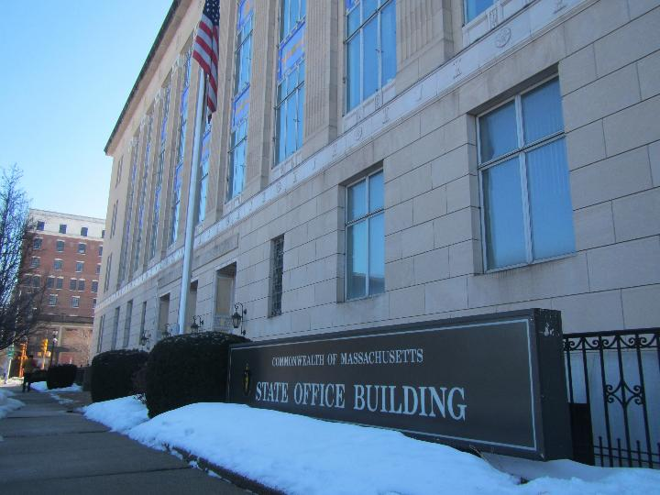

Prepared by:
Massachusetts Department of Public Health
Bureau of Climate and Environmental Health
Division of Environmental Health Regulations and Standards
March 2026

BACKGROUND
Building: | Department of Elementary and Secondary Education (DESE) Suite B040 inside Springfield State Office Building (SSOB)
Address: | 436 Dwight Street, Springfield, MA
Assessment Requested by: | Kelly Flaherty, Western Region Facility Manager, Division of Capital Asset Management and Maintenance (DCAMM)
Reason for Request: | General indoor air quality (IAQ) and respiratory issues
Date of Assessment: | March 4, 2026
Massachusetts Department of Public Health/Bureau of Climate and Environmental Health/Division of Environmental Health Regulations and Standards (MDPH/BCEH/EHRS) Staff Conducting Assessment: | Thomas Murphy, Environmental  Analyst, EHRS
Building Description: | The DESE suite is located in the basement of the SSOB which is a multi-story stone and cement building originally constructed in 1931. The building has several other state office tenants.
Windows: | Windows are not openable in this building.

METHODS
Please refer to the IAQ Manual for methods, sampling procedures, and interpretation of results (MDPH, 2015).

RESULTS AND DISCUSSION
The following is a summary of indoor air testing results (Table 1).
- Carbon dioxide levels were below the MDPH guideline of 800 parts per million (ppm) in all areas assessed indicating adequate air exchange at the time of assessment. However, the space was less than half occupied at the time of testing. Carbon dioxide levels would be expected to be higher with increased occupancy.
- Temperature was within the recommended range of 70°F to 78°F in all areas assessed.
- Relative humidity was below the MDPH recommended range of 40 to 60% in all areas assessed. Low relative humidity is common indoors during the heating season. Note that low relative humidity can lead to common symptoms such as: dry skin, lips, and scalp; dry/scratchy throats and noses (nose bleeds); exacerbation of asthma, eczema, or allergies; dry/irritated eyes; and irritation of respiratory tract.
- Carbon monoxide was not detected (ND) in all areas tested. Carbon monoxide should not be present in a typical, indoor environment. If it is present, indoor carbon monoxide levels should be less than or equal to outdoor levels.
- Fine particulate matter (PM2.5) concentrations measured inside the DESE suite were ND which is below the National Ambient Air Quality Standard (NAAQS) level of 35 μg/m³ in all areas assessed.
- Volatile Organic Compounds (TVOC) concentrations were ND in all areas tested.

Ventilation
A heating, ventilating, and air conditioning (HVAC) system has several functions. First, it provides heating and, if equipped, cooling. Second, it is a source of fresh air. Finally, an HVAC system will dilute and remove normally occurring indoor environmental pollutants by introducing fresh air, filtering the airstream and ejecting stale air to the outdoors via exhaust ventilation. Even if an HVAC system is operating as designed, point sources of respiratory irritation may exist and lead to symptoms in sensitive individuals.
Fresh air is provided to the DESE suite by air-handling units (AHUs). Fresh air is then ducted to ceiling-mounted supply air vents located in the space (Picture 1). Air is returned to the AHUs via ceiling plenum return vents (Picture 2). DCAMM staff reported the system is a variable air volume (VAV) HVAC system with a minimum setting of 20% outside air. The AHU air intake percent varies up or down given outdoor temperatures, but never below 20%.
The AHUs for this building were not assessed during this visit. The MDPH/BCEH recommends that AHU filters be changed 2-4 times a year (or per the manufacturer’s recommendations) and be at least a minimum efficiency reporting value (MERV) 8, or higher if the equipment can handle them without a degradation in airflow, as these are adequate to filter out pollen, mold, and similar particulates (ASHRAE, 2012). It was reported that the SSOB including the DESE suite uses MERV 8 pleated filters.
Initially during the assessment, it did not appear the supply vents were providing fresh air to the DESE space. This was reported to a DCAMM staff member who stated the system should be operating. A short time later, fresh air was felt coming from the supply vents and a DESE staff member observed dust/debris coming from a supply vent in the ceiling. DCAMM staff stated the system runs on an occupancy schedule of 5:30 AM to 5:30 PM. Each VAV operates independently and has automated damper actuators and heat valves which vary according to space temperature based on thermostat setting.
The ventilation system should be on and operational to supply fresh air continuously during occupied periods. Without adequate fresh air supply and removal of stale air, common indoor air pollutants can build up and cause irritation.
To have proper ventilation with a mechanical supply and exhaust system, the systems must be balanced to provide an adequate amount of fresh air to the interior of a room while removing stale air from the room. It is recommended that HVAC systems be re-balanced every five years to ensure adequate air systems function (SMACNA, 1994). DCAMM staff reported it has been over five years since the system was balanced.

Microbial/Moisture Concerns

Sources of moisture
Water-damaged ceiling tiles were noted in the DESE suite (Table 1; Pictures 3 and 4). All water-damaged ceiling tiles were found away from windows, indicating the cause could be from plumbing or HVAC leaks, or condensation on components. Water-damaged ceiling tiles should be replaced once an issue has been identified and repaired. During replacement, the area above the ceiling tiles should be examined for additional water-damaged materials and sources of water, such as plumbing leaks, uninsulated pipes or ducts, or other issues.
A small refrigerator, water dispenser, and large water replacement jugs were found in carpeted areas (Pictures 5 through 7). Leaks or spills from these can damage and moisten carpeting. Use of a waterproof mat underneath these items or moving them to a non-carpeted area, can help prevent water damage.
Evidence of previous food/liquid spills were observed in a small refrigerator (Picture 8). The interior of a microwave was dirty (Picture 9). Food storage and preparation equipment should be kept clean and free from spills to prevent mold growth, pests, and odors. Note that while refrigerators in this office building are not covered by the food code, it is good practice to have a thermometer in each refrigerator that is visible to ensure refrigerated food temperatures are kept at 5ºC (41ºF) or less (US FDA, 2022).
Plants and shrubbery were observed near the exterior foundation (Picture 10). Plants near the building can cause water damage to the building envelope. In addition, plants and small trees shading exterior walls can slow drying and allow moss/algae to grow along the building’s foundation (Picture 11). Water can also eventually penetrate the building envelope, subsequently freezing and thawing during the winter. This freezing/thawing action can weaken damage building components.
Another possible source of moisture is water penetration through below-grade windows (Pictures 12 and 13) and/or migration through below-grade building foundation components. The accumulation and melting of snow can result in water infiltration into the building/DESE suite. Removal of snow and routine examining of the exterior of the building for any seams/cracks/openings is recommended.
A water-damaged cardboard box was observed in a cubicle (Picture 14). The US Environmental Protection Agency (US EPA) and the American Conference of Governmental Industrial Hygienists (ACGIH) recommend that porous materials (e.g., cardboard boxes, ceiling tiles, carpet) be dried with fans and heating within 24 to 48 hours of becoming wet (US EPA, 2008; ACGIH, 1989). If not dried within this time frame, mold growth may occur. Once mold has colonized porous materials such as cardboard, books, or ceiling tiles, they are difficult to clean and should be discarded. Frequently solid/non-porous items can be cleaned to remove water stains and microbial growth.

Building materials prone to condensation/water damage
Although this assessment was done during winter weather, the DESE suite is still susceptible to condensation during hot, humid weather. The key to managing condensation in hot, humid weather indoors is understanding dew point. Condensation is the collection of moisture on a surface at or below the dew point. The dew point is the temperature that air must reach for saturation to occur. If a building material/component has a temperature below the dew point, condensation will accumulate on that material. Over time, condensation can collect and form water droplets.
Even though the DESE suite is equipped with air conditioning, the basement could still experience condensation on below grade floors and walls, particularly in areas where walls and floors have direct contact with soil, or where plumbing pipes with chilled water are present without adequate insulation. EHRS staff did not observe any visual evidence of condensation on the DESE suite basement floor during the time of the assessment.
In general, any material that is porous and capable of supporting mold growth should not be stored on floors and against walls capable of becoming moistened by condensation. Such materials include: cardboard, cloth, paper, books, soft plastics (e.g., polyurethane), leather, upholstered furniture, and jute or latex-backed carpeting.

Other IAQ issues
The entire DESE suite is carpeted including at least one area carpet. Carpets should be cleaned annually (or semi-annually in soiled/high traffic areas) in accordance with Institute of Inspection, Cleaning and Restoration Certification (IICRC) recommendations, (IICRC, 2012). All carpeting and area carpets should be routinely vacuumed and cleaned to ensure proper removal of dirt and debris. Regular cleaning with a high efficiency particulate air (HEPA) filtered vacuum in combination with an annual cleaning will help to reduce accumulation and potential aerosolization of materials from carpeting. Area carpets should be replaced when worn out.
Personal products, particularly those with volatile organic compounds (VOCs) including scents, can also be a source of respiratory irritation. VOCs are carbon-containing substances that can evaporate at room temperature. Exposure to low levels of total-VOCs (TVOCs) may produce eye, nose, throat and/or respiratory irritation in some sensitive individuals. While TVOCs measured in the office were all ND, products were noted in the DESE suite that can be sources of VOCs. These include cleaning/disinfecting wipes, glass/surface cleaners, and hand sanitizers (Pictures 15 through 17). They should be used with good ventilation, and kept closed when not in use. Products with strong scents, including scent sprays and essential oils should not be used in a shared office space as many people are sensitive to fragrance compounds. Consult “Clean Air Is Odor Free” for more information on fragrances in buildings.
A few holes/openings in the wall/ceiling were found in the DESE suite (Picture 18 and 19). These openings can allow the entry of odors, fumes, pests, drafts, dust, and debris from the interior of the wall. All holes/openings in the suite should be sealed accordingly.
It was reported that there were renovations taking place elsewhere in the SSOB. Use the guidance, Construction and Renovation Generated Pollutants in Occupied Buildings, to reduce the impact of renovations on staff.
A personal fan was noted in the DESE suite. If dust is accumulated on the blades, it can be aerosolized during use. Fans should be checked and cleaned periodically to remove any dust.
Air purifiers were observed in the DESE suite (Picture 20). One air purifier had a filter replacement light illuminated indicating it needed to be changed (Picture 21). DESE staff were able to replace the filter during the assessment. These should be maintained, including filter changes, in accordance with manufacturer’s instructions. Air purifiers that may produce ozone should not be used in any occupied areas (EPA, 2003).
Lastly, the MDPH EHRS recommends that occupied basement areas be tested for radon, and that this testing be conducted during the heating season while the building is normally occupied in a manner consistent with US EPA radon testing guidelines. Radon measurement specialists and other information can be found at www.nrsb.org and http://aarst-nrpp.com/wp, with additional information at: https://www.mass.gov/radon.

CONCLUSIONS/RECOMMENDATIONS
In view of the findings at the time of the visit, the following recommendations are made:

Ventilation recommendations
- Operate the HVAC system (supply/exhaust) to provide continuous fresh air ventilation during occupied hours.
- Clean supply vents on a consistent basis to remove any dust/debris.
- Continue to change filters for HVAC units at least two to four times a year or as per the manufacturers’ recommendations using filters with a Minimum Efficiency Rating Value (MERV) of 8 or better. Ensure HVAC cabinets are cleaned of debris during filter changes.
- Have the HVAC system balanced every 5 years in accordance with SMACNA recommendations (SMACNA, 1994).
- For buildings in New England, periods of low relative humidity during the winter are often unavoidable. Therefore, scrupulous cleaning practices should be adopted to minimize common indoor air contaminants whose irritant effects can be enhanced when the relative humidity is low. To control dust, a high efficiency particulate arrestance (HEPA) filter equipped vacuum cleaner in conjunction with wet wiping of all surfaces is recommended. Avoid the use of feather dusters. Drinking water during the day can help ease some symptoms associated with a dry environment (throat and sinus irritations).

Water damage recommendations
- Replace water-damaged ceiling tiles. Investigate stained tiles for additional water damage and for sources of water including plumbing leaks, water infiltration into building envelope, HVAC leaks, or piping/ducts in need of insulation, and repair as needed.
- Consider placing the refrigerator, water jugs, and water dispenser on waterproof mats or move them to non-carpeted areas to help prevent leaks/spills/moistening from causing water damage.
- Routinely clean food/liquid stains from the refrigerator and microwave. Ensure there is a process for food storage/preparation appliances to be cleaned out regularly to avoid odors, mold growth, and pests.
- It is good practice to have a visible thermometer in each refrigerator to ensure they are kept at an appropriate temperature, 5ºC (41ºF) or less (US FDA, 2022).
- Trim plants, bushes, and small trees at least 5 feet away from the building.
- Remove moss/algae off the exterior of the building to improve drying of the exterior.
- Have the building exterior including areas near below-grade windows examined by a building envelope contractor to determine if repointing or other work is needed to increase water-tightness.
- Remove accumulations of snow against the exterior of the building.
- Handle porous items such as the water-damaged carboard box in accordance with US EPA recommendations.
- Consideration should be given to replacing the wall-to-wall carpeting in the basement with a non-porous material to prevent moistening due to condensation during hot, humid weather.

Other recommendations
- Have the carpets vacuumed regularly and deep cleaned once or twice a year. Replace area carpets when worn out.
- Use VOC-containing products in areas with good ventilation and keep tightly closed when not in use. Avoid products with strong scents and avoid mixing incompatible products.
- Refer to “Clean Air Is Odor Free” for more information on fragrances in buildings.
- Seal any openings/holes within the DESE suite to prevent the entry of odors, fumes, pests, drafts, dust and debris.
- Refer to the guidance in https://www.mass.gov/info-details/construction-and-renovation-generated-pollutants-in-occupied-buildings to reduce the impact of any ongoing renovations in the SSOB.
- Periodically check and clean the blades of the personal fan.
- Clean/replace filters and equipment in air purifiers in accordance with manufacturers’ instructions. Continue to provide them to DESE staff if they do not have them. While air purifiers do not supply fresh air, they can remove particles including mold spores and microbes. Avoid the use of air purifiers that may produce ozone.
- Consider installing digital sensor technology readouts in the DESE suite and SSOB to provide continuous monitoring of the indoor air parameters, particularly temperature and relative humidity. Sensors should be re-calibrated quarterly or according to manufacturers’ specifications and building management software updated as per manufacturers’ instructions, industrial standards, and/or change in operating systems. As an example, the following link illustrates how this technology is serving Boston Public Schools to improve air quality (i.e., carbon dioxide, temperature, relative humidity, carbon monoxide, and particulate matter). COVID-19 Health & Safety Information / Indoor Air Quality Sensor Dashboard (bostonpublicschools.org)
- Consider having the basement suite tested for radon. Radon measurement specialists and other information can be found at www.nrsb.org and http://aarst-nrpp.com/wp, with additional information at: https://www.mass.gov/radon.
- Please refer to resource manual and other related IAQ documents located on the MDPH’s website for further building-wide evaluations and advice on maintaining public buildings. These documents are available at: http://mass.gov/dph/iaq.

REFERENCES
ACGIH.1989. Guidelines for the Assessment of Bioaerosols in the Indoor Environment. American Conference of Governmental Industrial Hygienists, Cincinnati, OH
ASHRAE. 2012. American Society of Heating, Refrigeration and Air Conditioning Engineers (ASHRAE) Standard 52.2-2012 -- Method of Testing General Ventilation Air-Cleaning Devices for Removal Efficiency by Particle Size (ANSI Approved).
IICRC. 2012. Institute of Inspection, Cleaning and Restoration Certification. Carpet Cleaning: FAQ.

MDPH. 2015. Massachusetts Department of Public Health. Indoor Air Quality Manual: Chapters I-III. Available at: https://www.mass.gov/lists/indoor-air-quality-manual-and-appendices.
SMACNA. 1994. HVAC Systems Commissioning Manual. 1st ed. Sheet Metal and Air Conditioning Contractors’ National Association, Inc., Chantilly, VA.
US EPA. 2003. “Ozone Generators that are Sold as Air Cleaners: An Assessment of Effectiveness and Health Consequences”. United States Environmental Protection Agency, Office of Air and Radiation, Indoor Environments Division, Washington, DC. Last updated September, 2018. https://www.epa.gov/indoor-air-quality-iaq/ozone-generators-are-sold-air-cleaners.
US EPA. 2008. “Mold Remediation in Schools and Commercial Buildings”. Office of Air and Radiation, Indoor Environments Division, Washington, DC. EPA 402-K-01-001. September 2008. Available at: http://www.epa.gov/mold/mold-remediation-schools-and-commercial-buildings-guide.
US FDA. 2022. 2022 Food Code. U.S. Department of Health and Human Services. U.S. Food and Drug Administration. College Park, MD January 18, 2023 Version. https://www.fda.gov/media/164194/download

Picture 1
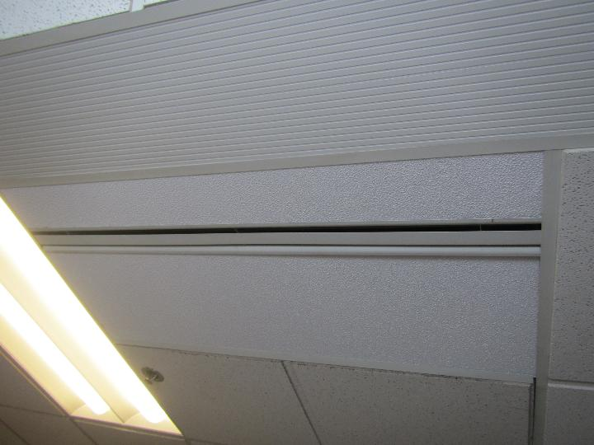
Ceiling mounted supply vent
Picture 2
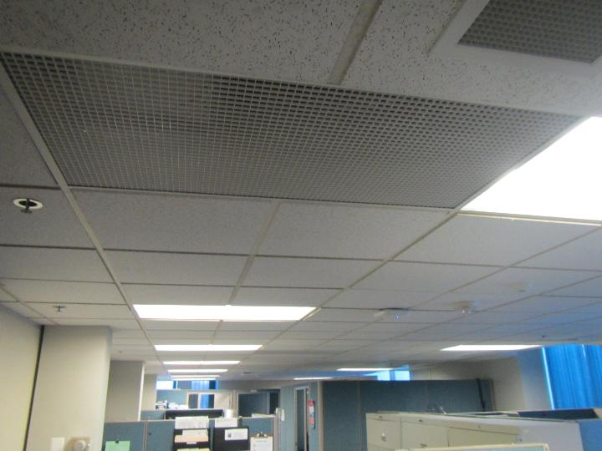
Ceiling plenum return vent

Picture 3
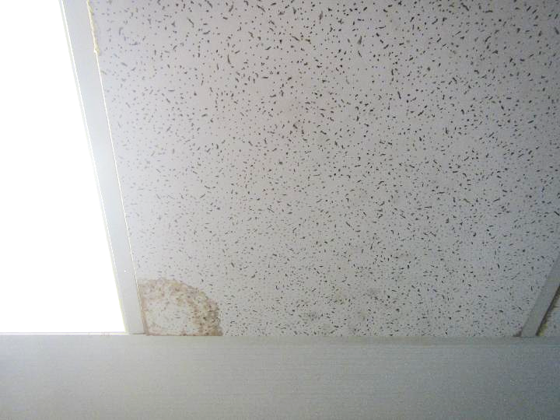
Water-damaged ceiling tile
Picture 4
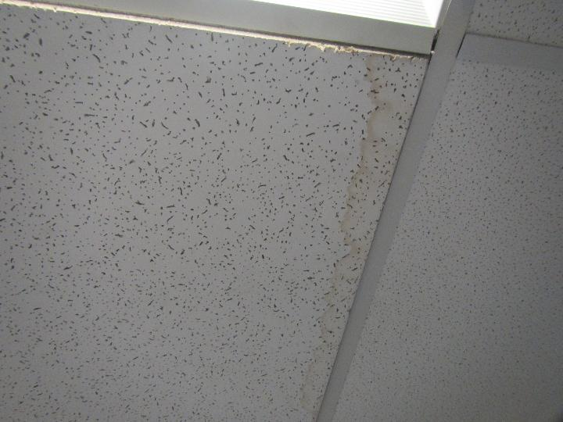
Water-damaged ceiling tile

Picture 5
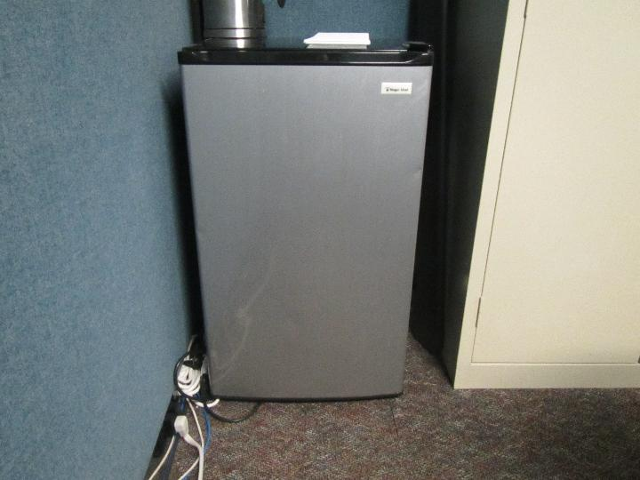
Small refrigerator on carpet
Picture 6
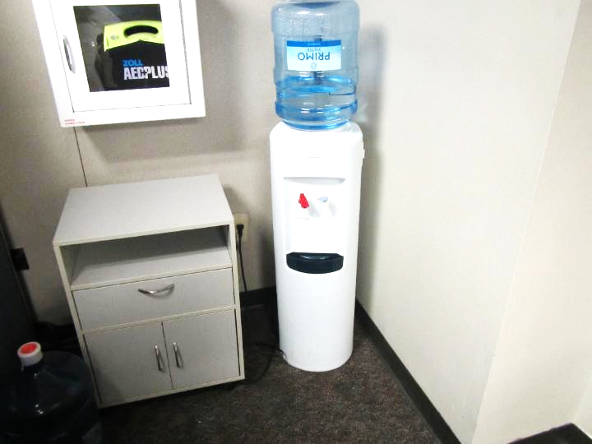
Water dispenser on carpet

Picture 7
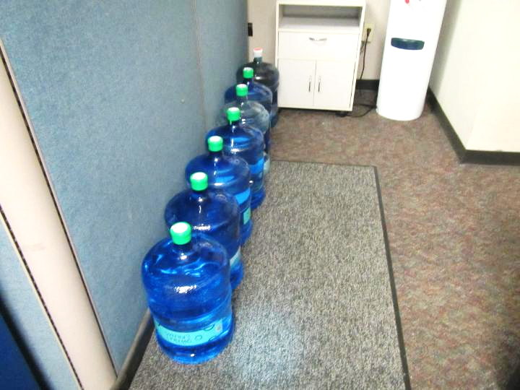
Water replacement jugs on carpet
Picture 8
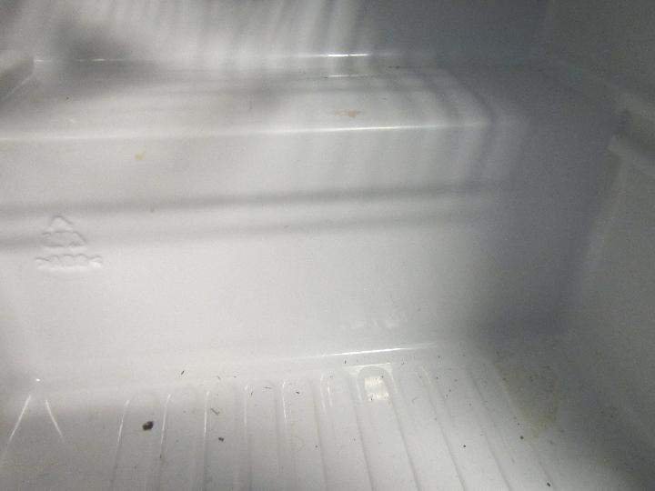
Previous food/liquid spills in small refrigerator

Picture 9
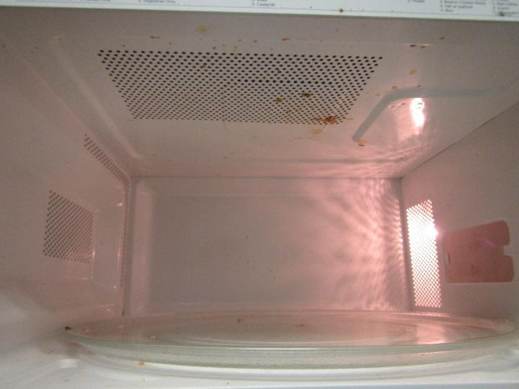
Interior of microwave dirty
Picture 10
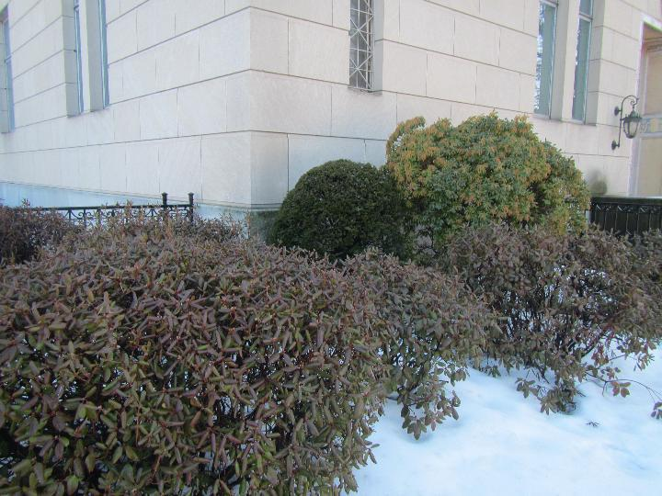
Plants and shrubbery close to building

Picture 11
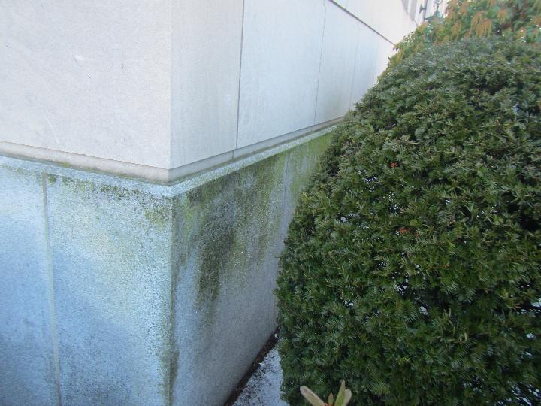
Moss/algae growth along building exterior
Picture 12
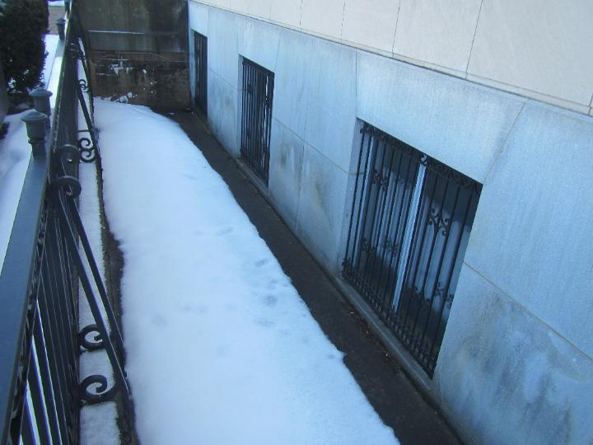
Exterior view of DESE suite below-grade windows and snow accumulation

Picture 13
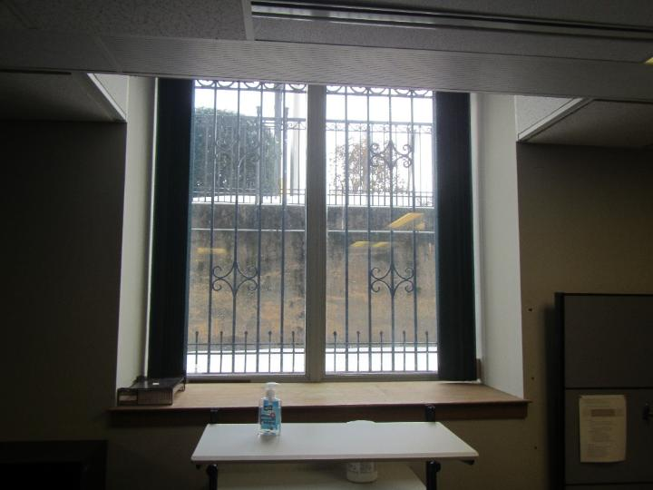
Interior view of below-grade windows
Picture 14
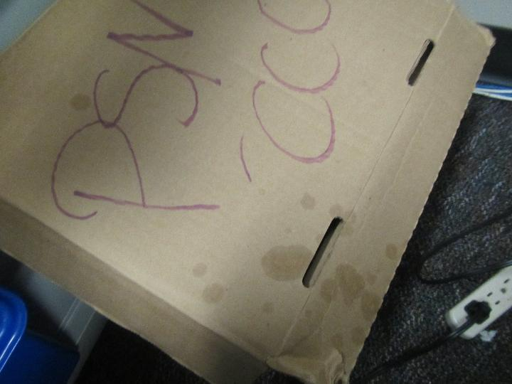
Water-damaged cardboard box

Picture 15
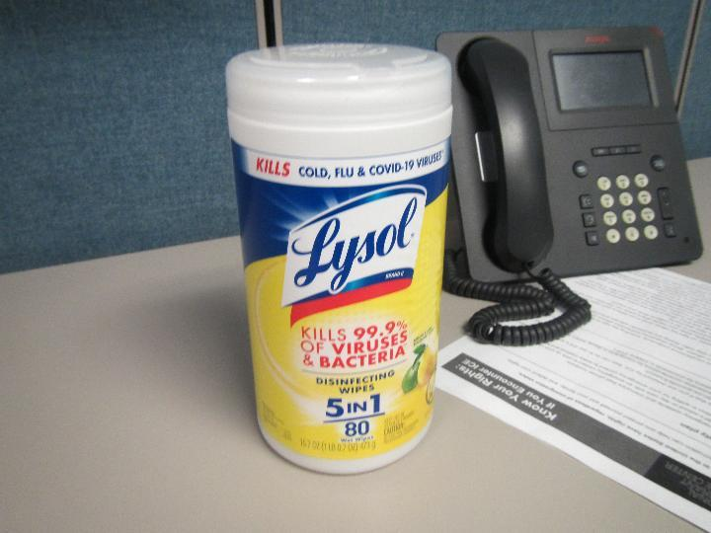
Cleaning/disinfecting wipes
Picture 16
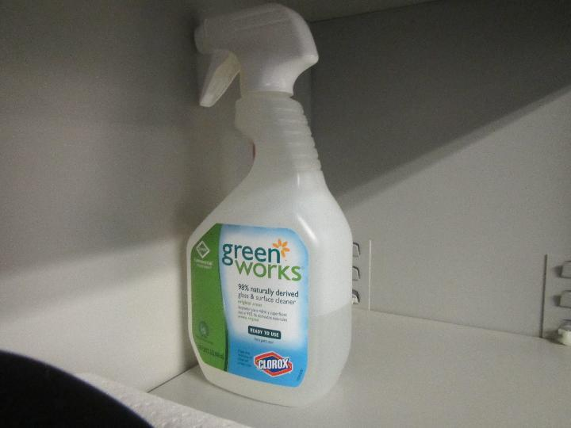
Glass and surface cleaner

Picture 17
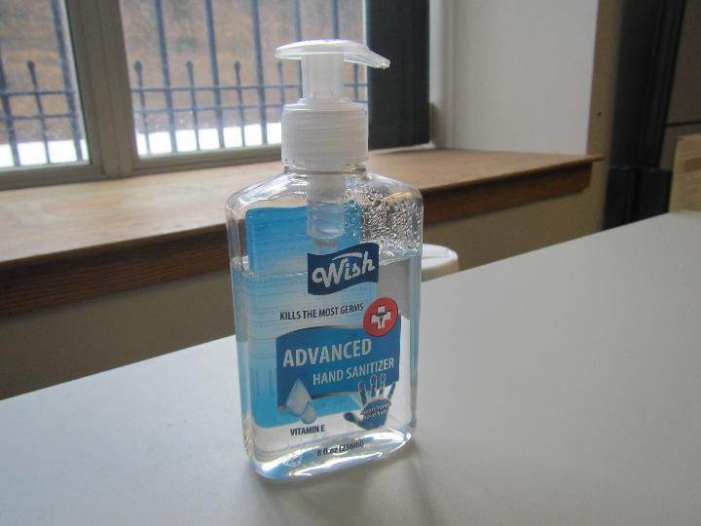
Hand sanitizer
Picture 18
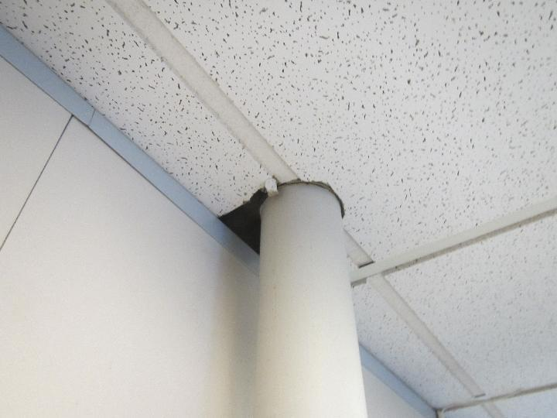
Opening in ceiling

Picture 19
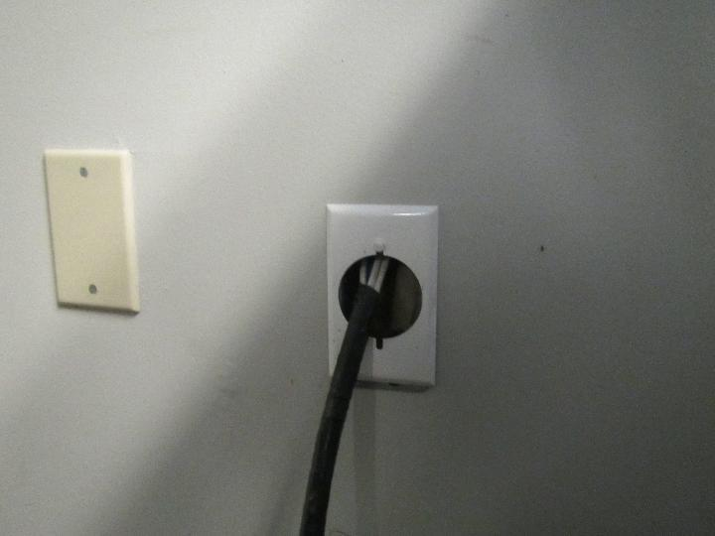
Opening in wall
Picture 20
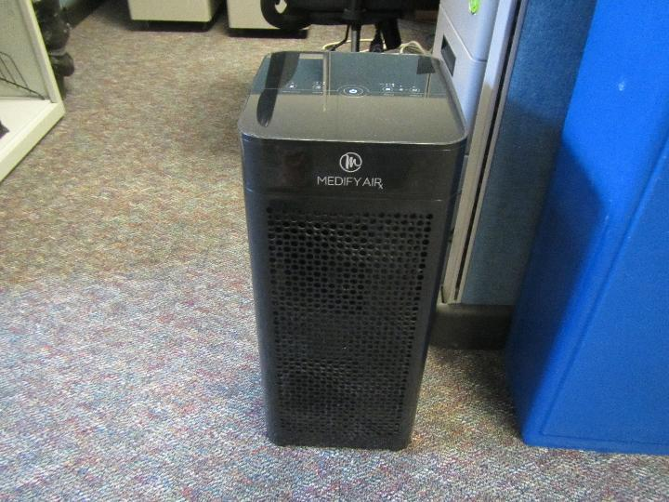
Air purifier

Picture 21
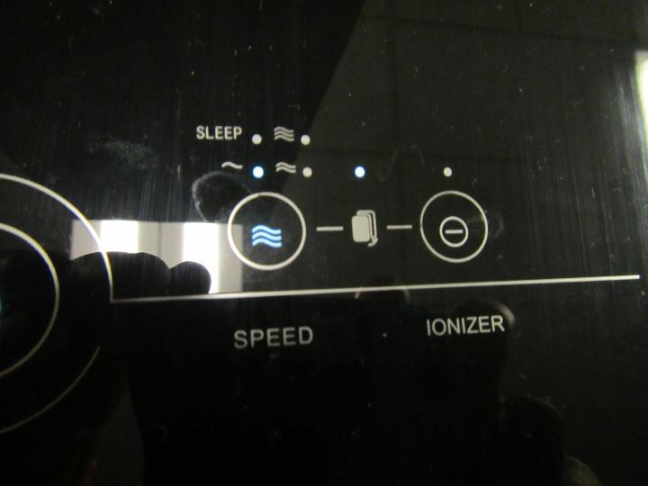
Filter replacement light illuminated (blue arrow)

Location | Carbon  Dioxide  (ppm) | Carbon Monoxide  (ppm) | Temp  (°F) | Relative  Humidity  (%) | PM2.5  (µg/m³) | TVOC  (ppm) | Occupants  in Room | Windows  Openable | Ventilation |  | Remarks
 |  |  |  |  |  |  |  |  | Supply | Exhaust | Remarks
Background | 482 | ND | 46 | 65 | 17 | ND |  |  |  |  | Busy street, traffic lights/intersections close by, snow melting around building
Suite Entrance | 640 | ND | 73 | 23 | ND | ND | 0 | N | Y | Y | Water dispenser on carpet, water jugs on carpet, hand sanitizer, printer, scanner, fax machine
Cubicle 9 | 630 | ND | 73 | 24 | ND | ND | 0 | N | Y | Y | Air purifier, cleaning wipes
Cubicle 8 | 684 | ND | 73 | 24 | ND | ND | 0 | N | Y | Y | PF, cleaning wipes
Cubicle 7 | 671 | ND | 73 | 24 | ND | ND | 0 | N | Y | Y
Cubicle 6 | 672 | ND | 73 | 24 | ND | ND | 1 | N | Y | Y | Cleaning wipes, hand sanitizer, desk cleaner, hole in wall where cables go through
Cubicle 5 | 686 | ND | 73 | 24 | ND | ND | 0 | N | Y | Y | Cleaning wipes, air purifier
Cubicle 4 | 650 | ND | 74 | 23 | ND | ND | 0 | N | Y | Y | Cleaning wipes, hand sanitizer, glass/surface cleaner, water-damaged CT, water-damaged cardboard box
Conference Cubicle | 676 | ND | 74 | 25 | ND | ND | 0 | N | Y | Y | Small refrigerator on carpet (liquid/food spill inside), glass/surface cleaner, hand sanitizer, water-damaged CT
Cubicle 3 | 720 | ND | 74 | 24 | ND | ND | 1 | N | Y | Y
Office/Cubicle 2 | 712 | ND | 75 | 25 | ND | ND | 1 | N | Y | Y | Water-damaged CT
Office/Cubicle 1 | 771 | ND | 75 | 25 | ND | ND | 1 | N | Y | Y
Food Prep Area | 608 | ND | 74 | 25 | ND | ND | 0 | N | Y | Y | Dirty microwave, glass/surface cleaner, coffee maker, toaster, opening near pipe in ceiling

