INDOOR AIR QUALITY ASSESSMENT

Squantum Elementary School
50 Huckins Avenue
Quincy, MA

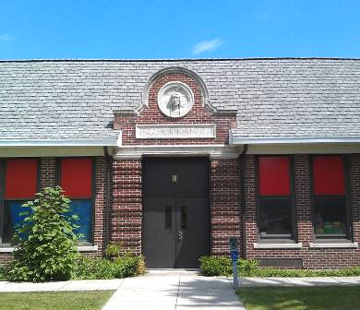

Prepared by:
Massachusetts Department of Public Health
Bureau of Environmental Health
Indoor Air Quality Program
October 2012

Background/Introduction
At the request of Kevin Segalla, Director of Custodians, Quincy Public Schools (QPS), the Massachusetts Department of Public Health (MDPH), Bureau of Environmental Health (BEH) provided assistance and consultation regarding indoor air quality (IAQ) at the Squantum Elementary School (SES) located at 50 Huckins Avenue, Quincy, Massachusetts. The assessment was prompted by parental concerns regarding symptoms attributed to the indoor environment. On June 7, 2012, a visit to conduct an assessment of the SES was made by Sharon Lee, an Environmental Analyst within BEH’s IAQ Program.
The SES is a single-story, brick building constructed in 1919. An addition was built in 1949, and renovations, including replacement of ventilation equipment, were conducted in 1971. The school houses general classrooms, small rooms for specialized instruction, a cafeteria/gymnasium, media center, art/music room, teacher’s workrooms and office space. Reportedly, the roof in the original section of the building was recently replaced. Windows are openable throughout the building.

Methods
Air tests for carbon dioxide, carbon monoxide, temperature and relative humidity were conducted with the TSI, Q-Trak, IAQ Monitor, Model 7565. Air tests for airborne particle matter with a diameter less than 2.5 micrometers were taken with the TSI, DUSTTRAK™ Aerosol Monitor Model 8520. MDPH staff also performed visual inspection of building materials for water damage and/or microbial growth.

Results
The school houses approximately 375 students in grades K to 5 with approximately 50 staff members. Tests were taken during normal school operations and results appear in Table 1.

Discussion

Ventilation
It can be seen from Table 1 that carbon dioxide levels were above 800 parts per million (ppm) in 20 of 31 areas, indicating poor air exchange in the majority of the areas surveyed. Elevated carbon dioxide levels appeared to be directly related to deactivated and/or blocked ventilation equipment, particularly in rooms with full occupancy. Several areas had open windows or were empty/sparsely populated at the time measurements were taken, which can greatly reduce carbon dioxide levels. Carbon dioxide levels would be expected to increase with windows closed and greater occupancy.
Fresh air is supplied to classrooms by unit ventilator (univent) systems (Picture 1). A univent draws outdoor air through an air intake located on the exterior wall of the building and returns air from the room through an air intake located at the base of the unit (Figure 1). Fresh and return air are mixed, filtered, heated and then delivered to the room through an air diffuser located in the top of the unit.
Univents have control settings of “off”, “low” and “high”. At the time of assessment, BEH/IAQ staff found univent cabinets opened and in the “off” position in a number of areas. When univents are deactivated, no fresh air is introduced (Table 1). In addition, univent air diffusers and return intakes were blocked by books, furniture and other items placed in front and on top of the unit, thereby limiting airflow (Picture 1). In order for univents to provide fresh air as designed, air diffusers and intakes must remain free of obstructions. Importantly, these units must remain on and be allowed to operate while rooms are occupied.
Exhaust ventilation is provided by passive exhaust vents located in classroom walls or ceilings (Picture 2). Some exhaust vents were found sealed at the time of assessment. As originally designed, fresh air was intended to be mechanically introduced into classrooms via the univents, which “pressurized” the room forcing stale classroom air and excess heat into the exhaust vents and up the ventilation shaft to an exhaust terminus on the roof. As the air rose up the ventilation shaft, negative pressure was created in the room, facilitating the draw of air from the room into the exhaust shaft resulting in air exchange. Without properly functioning supply and exhaust ventilation systems, normally occurring environmental pollutants can build up.
Ceiling fans were noted in a number of classrooms (Picture 3). These ceiling fans enhance air circulation within the room, especially during warmer months when windows are open. At the time of assessment, classroom ceiling fans were not operating.
To maximize air exchange, the MDPH recommends that both supply and exhaust ventilation operate continuously during periods of school occupancy. In order to have proper ventilation with a mechanical supply and exhaust system, the systems must be balanced to provide an adequate amount of fresh air to the interior of a room while removing stale air from the room. It is recommended that HVAC systems be re-balanced every five years to ensure adequate air systems function (SMACNA, 1994).
The Massachusetts Building Code requires that each room have a minimum ventilation rate of 15 cubic feet per minute (cfm) per occupant of fresh outside air or openable windows (SBBRS, 1997; BOCA, 1993). The ventilation must be on at all times that the room is occupied. Providing adequate fresh air ventilation with open windows and maintaining the temperature in the comfort range during the cold weather season is impractical. Mechanical ventilation is usually required to provide adequate fresh air ventilation.
Carbon dioxide is not a problem in and of itself. It is used as an indicator of the adequacy of the fresh air ventilation. As carbon dioxide levels rise, it indicates that the ventilating system is malfunctioning or the design occupancy of the room is being exceeded. When this happens, a buildup of common indoor air pollutants can occur, leading to discomfort or health complaints. The Occupational Safety and Health Administration (OSHA) standard for carbon dioxide is 5,000 parts per million parts of air (ppm). Workers may be exposed to this level for 40 hours/week, based on a time-weighted average (OSHA, 1997).
The MDPH uses a guideline of 800 ppm for publicly occupied buildings. A guideline of 600 ppm or less is preferred in schools due to the fact that the majority of occupants are young and considered to be a more sensitive population in the evaluation of environmental health status. Inadequate ventilation and/or elevated temperatures are major causes of complaints such as respiratory, eye, nose and throat irritation, lethargy and headaches. For more information concerning carbon dioxide, consult Appendix A.
Temperature measurements in the building ranged from 69° F to 74° F, which were within or very close to the MDPH recommended temperature range (Table 1). The MDPH recommends that indoor air temperatures be maintained in a range of 70º F to 78º F in order to provide for the comfort of building occupants. In many cases concerning indoor air quality, fluctuations of temperature in occupied spaces are typically experienced, even in a building with an adequate fresh air supply. In addition, it is difficult to control temperature and maintain comfort without operating the ventilation equipment as designed (e.g., univents/exhaust vents deactivated/obstructed).
The relative humidity measured in the building ranged from 55 to 68 percent, which were within or slightly above the MDPH recommended comfort range (Table 1). The MDPH recommends a comfort range of 40 to 60 percent for indoor air relative humidity. Relative humidity levels in the building would be expected to drop during the winter months due to heating. The sensation of dryness and irritation is common in a low relative humidity environment. Low relative humidity is a very common problem during the heating season in the northeast part of the United States.

Microbial/Moisture Concerns
In order for building materials to support mold growth, a source of water exposure is necessary. Identification and elimination of the source of water moistened building materials is necessary to control mold growth. Water-damaged ceiling and wall plaster was observed in a number of areas, indicating roof leaks and/or water penetration through the brick exterior. Water penetration has resulted in staining and some efflorescence on both interior and exterior walls (Picture 4). Efflorescence is a characteristic sign of water damage to brick and mortar, but it is not mold growth. As moisture penetrates and works its way through mortar, brick or plaster, water-soluble compounds dissolve, creating a solution. As the solution moves to the surface of the material, the water evaporates, leaving behind white, powdery mineral deposits. At the time of the assessment, missing mortar and cracks in the building’s foundation were observed, which can contribute to water penetration to the building. Since a new roof was installed over the original portion of the building, this should have removed/repaired the major source of water leaks and the water-damaged ceiling tiles should be replaced.
The US Environmental Protection Agency (US EPA) and the American Conference of Governmental Industrial Hygienists (ACGIH) recommend that porous materials be dried with fans and heating within 24 to 48 hours of becoming wet (US EPA, 2001; ACGIH, 1989). If not dried within this time frame, mold growth may occur. Once mold has colonized porous materials, they are difficult to clean and should be removed/discarded.
A number of classrooms had plants (Picture 5; Table 1), some of which were flowering. Plants can be a source of pollen and mold, which can serve as respiratory irritants for some sensitive individuals. Plants should be properly maintained and equipped with drip pans to prevent water damage to porous building materials. Plants should also be located away from ventilation sources (e.g., univent air diffusers) to prevent the aerosolization of dirt, pollen or mold.
An exterior door frame appeared to be corroded and damaged at the time of assessment (Picture 6). Consideration should be given to replacing this doorframe to prevent moisture and pests from entering the building. A hole as small as a quarter inch in diameter is sufficient for rodents to enter (MDFA, 1996).
A number of plants were growing in close proximity to the building’s exterior (Picture 7). In some areas, plants were in front of univent fresh air intakes, which can entrain and distribute plant pollen into a classroom. The growth of roots against exterior walls can bring moisture in contact with the foundation. Plant roots can eventually penetrate the wall, leading to cracks and/or fissures in the sublevel foundation. The freezing and thawing action of water during the winter months can also create cracks and fissures in the foundation resulting in additional water penetration points. These breaches in exterior areas can also provide a means of drafts and pest entry into the building. In concert, conditions can undermine the integrity of the building envelope and provide a means of water entry by capillary action into the building through exterior walls, foundation concrete and masonry (Lstiburek & Brennan, 2001).

Other IAQ Evaluations
Indoor air quality can be negatively influenced by the presence of respiratory irritants, such as products of combustion. The process of combustion produces a number of pollutants. Common combustion emissions include carbon monoxide, carbon dioxide, water vapor and smoke (fine airborne particle material). Of these materials, exposure to carbon monoxide and particulate matter with a diameter of 2.5 micrometers (μm) or less (PM2.5) can produce immediate, acute health effects upon exposure. To determine whether combustion products were present in the indoor environment, BEH/IAQ staff obtained measurements for carbon monoxide and PM2.5.

Carbon Monoxide
Carbon monoxide is a by-product of incomplete combustion of organic matter (e.g., gasoline, wood and tobacco). Exposure to carbon monoxide can produce immediate and acute health affects. Several air quality standards have been established to address carbon monoxide and prevent symptoms from exposure to these substances. The MDPH established a corrective action level concerning carbon monoxide in ice skating rinks that use fossil-fueled ice resurfacing equipment. If an operator of an indoor ice rink measures a carbon monoxide level over 30 ppm, taken 20 minutes after resurfacing within a rink, that operator must take actions to reduce carbon monoxide levels (MDPH, 1997).
The American Society of Heating Refrigeration and Air-Conditioning Engineers (ASHRAE) has adopted the National Ambient Air Quality Standards (NAAQS) as one set of criteria for assessing indoor air quality and monitoring of fresh air introduced by HVAC systems (ASHRAE, 1989). The NAAQS are a reference standard used by the US EPA and others to protect the public health from six criteria pollutants, including particulate matter (US EPA, 2006). As recommended by ASHRAE, pollutants in indoor air should not exceed the NAAQS levels (ASHRAE, 1989). The NAAQS were adopted by reference in the Building Officials & Code Administrators (BOCA) National Mechanical Code of 1993 (BOCA, 1993), which is now an HVAC standard included in the Massachusetts State Building Code (SBBRS, 1997). According to the NAAQS, carbon monoxide levels in outdoor air should not exceed 9 ppm in an eight-hour average (US EPA, 2006).
Carbon monoxide should not be present in a typical, indoor environment. If it is present, indoor carbon monoxide levels should be less than or equal to outdoor levels. Outdoor carbon monoxide concentrations were non-detect (ND) at the time of assessment (Table 1). No measurable levels of carbon monoxide were detected in the building during the assessment (Table 1).
Please note, some parking spots were in close proximity to a univent fresh air intake (Picture 8). Carbon monoxide from idling vehicles can become entrained by univents and distributed to classrooms. School personnel should refrain from idling vehicles in order to prevent classroom occupants from being exposed to vehicle exhaust.

Particulate Matter
The US EPA has established NAAQS limits for exposure to particulate matter. Particulate matter (PM) is airborne solids that can be irritating to the eyes, nose and throat. The NAAQS originally established exposure limits to PM with a diameter of 10 μm or less (PM10). According to the NAAQS, PM10 levels should not exceed 150 micrograms per cubic meter (μg/m³) in a 24-hour average (US EPA, 2006). These standards were adopted by both ASHRAE and BOCA. Since the issuance of the ASHRAE standard and BOCA Code, US EPA established a more protective standard for fine airborne particles. This more stringent PM2.5 standard requires outdoor air particle levels be maintained below 35 μg/m³ over a 24-hour average (US EPA, 2006). Although both the ASHRAE standard and BOCA Code adopted the PM10 standard for evaluating air quality, MDPH uses the more protective PM2.5 standard for evaluating airborne PM concentrations in the indoor environment.
Outdoor PM2.5 concentrations the day of the assessment were measured at 35 μg/m³. PM2.5 levels measured in occupied areas ranged from 5 to 24 μg/m³ (Table 1). Indoor PM 2.5 levels were below the NAAQS PM2.5 level of 35 μg/m³ in all surveyed at the time of assessment. Frequently, indoor air levels of particulates (including PM2.5) can be at higher levels than those measured outdoors. A number of mechanical devices and/or activities that occur indoors can generate particulate during normal operations. Sources of indoor airborne particulates may include but are not limited to: particles generated during the operation of fan belts in the HVAC system; cooking in the cafeteria stoves and microwave ovens; use of photocopiers, fax machines and computer printing devices; operation of an ordinary vacuum cleaner; and, heavy foot traffic indoors.

Volatile Organic Compounds
Indoor air concentrations can be greatly impacted by the use of products containing volatile organic compounds (VOCs). VOCs are carbon-containing substances that have the ability to evaporate at room temperature. Frequently, exposure to low levels of total VOCs (TVOCs) may produce eye, nose, throat and/or respiratory irritation in some sensitive individuals. For example, chemicals evaporating from a paint can stored at room temperature would most likely contain VOCs. In an effort to identify materials that can potentially increase indoor VOC concentrations, BEH/IAQ staff examined rooms for products containing these respiratory irritants.
Cleaning products were found on countertops in several rooms (Picture 9; Table 1). Cleaning products contain chemicals that can be irritating to the eyes, nose and throat of sensitive individuals. These products should be properly labeled and stored in an area inaccessible to children. Additionally, an MSDS should be available at a central location for each product in the event of an emergency. Consideration should be given to providing teaching staff with school issued cleaning products and supplies to ensure that MSDS information is available for all products used at the school.
Air deodorizing products were found to be in use in some areas (Table 1). Air fresheners contain chemicals that can be irritating to the eyes, nose and throat of sensitive individuals. Many air fresheners contain 1,4-dichlorobenzene, a VOC which may cause reductions in lung function (NIH, 2006). Furthermore, deodorizing agents do not remove materials causing odors, but rather mask odors that may be present in the area.
Several classrooms contained dry erase boards and related materials. Materials such as dry erase markers and dry erase board cleaners may contain VOCs, such as methyl isobutyl ketone, n-butyl acetate and butyl-cellusolve (Sanford, 1999), which can be irritating to the eyes, nose and throat.
Photocopiers and laminators at the SES are not equipped with local mechanical exhaust ventilation to help reduce excess heat and odors. Lamination machines melt plastic and give off odors and VOCs. VOCs and ozone can be produced by photocopiers, particularly if the equipment is older and in frequent use. Ozone is a respiratory irritant (Schmidt Etkin, 1992).
In an effort to reduce noise from sliding chairs, tennis balls were found sliced open and placed on chair legs in some classrooms (Picture 10). Tennis balls are made of a number of materials that are a source of respiratory irritants. Constant wearing of tennis balls can produce fibers and off-gas VOCs. Tennis balls are made with a natural rubber latex bladder, which becomes abraded when used as a chair leg pad. Use of tennis balls in this manner may introduce latex dust into the school environment. Some individuals are highly allergic to latex (e.g. spina bifida patients) (SBAA, 2001). It is recommended that the use of materials containing latex be limited in buildings to reduce the likelihood of symptoms in sensitive individuals (NIOSH, 1997).

Other Conditions
Other conditions that can affect indoor air quality were observed during the assessment. In several classrooms, items were observed on windowsills, tabletops, counters, bookcases and desks. The large number of items stored in classrooms provides a source for dusts to accumulate. These items (e.g., papers, folders, boxes) make it difficult for custodial staff to clean. Items should be relocated and/or be cleaned periodically to avoid excessive dust build up. In addition, these materials can accumulate on flat surfaces (e.g., desktops, shelving and carpets) in occupied areas and subsequently be re-aerosolized causing further irritation.
A number of personal fans, exhaust vents, air diffusers and surrounding ceiling tiles were observed to have accumulated dust/debris (Picture 11; Table 1). Re-activated diffusers, vents or fans can aerosolize accumulated dust. If exhaust vents are not functioning, backdrafting can occur, which can re-aerosolize dust particles.
In addition to blockages and dust observed in/around univents, other debris occluding/on univents could become aerosolized. For example, a pencil sharper was observed on a univent (Picture 12). Pencil shavings that settle on/into the univent can be aerosolized when the univent is activated, resulting in eye and respiratory irritation. When the system is operating in the heating mode, such debris could also create odors. The univent air return at the base of the univent was observed to be occluded with debris, including crayons (Picture 13), which could also contribute to noxious odors. Such material can reduce airflow, cause damage to the univent, and give off odors when heated.
Finally, restrooms are equipped with mechanical exhaust vents that were drawing air weakly at the time of assessment. Exhaust ventilation is necessary in restrooms to remove excess moisture and to prevent odors from penetrating into adjacent areas. Consideration for installing passive ventilation in the door to aid in dilution of bathroom odors may be important.

Conclusions/Recommendations
In view of the findings at the time of the assessment, the following recommendations are made to improve indoor air quality in the building:
- Operate all ventilation systems (e.g., univents, exhaust vents and AHUs) throughout the building continuously during periods of occupancy. To increase airflow in classrooms, set univent controls to “high”. School staff should be encouraged not to deactivate classroom univents and to report any temperature/comfort complaints to the facilities department.
- Remove all blockages from the top and front of univents and exhaust vents to ensure adequate airflow. Ensure plants and dust generating items (i.e., pencil sharpeners) are located away from univents.
- Clean and vacuum univent main and side compartments to remove dust/debris that may be occluding or entrained in the system.
- Use openable windows in conjunction with mechanical ventilation to facilitate air exchange. Care should be taken to ensure windows are properly closed at night and weekends to avoid the freezing of pipes and potential flooding.
- Consider adopting a balancing schedule of every 5 years for all mechanical ventilation systems, as recommended by ventilation industrial standards (SMACNA, 1994).
- Consider installing passive ventilation (e.g., door vent or door undercut) in bathroom doors to aid in dilution of bathroom odors.
- For buildings in New England, periods of low relative humidity during the winter are often unavoidable. Therefore, scrupulous cleaning practices should be adopted to minimize common indoor air contaminants whose irritant effects can be enhanced when the relative humidity is low. To control for dusts, a high efficiency particulate arrestance (HEPA) filter equipped vacuum cleaner in conjunction with wet wiping of all surfaces is recommended. Avoid the use of feather dusters. Drinking water during the day can help ease some symptoms associated with a dry environment (throat and sinus irritations).
- Consider repointing damaged mortar and sealing any breaches/cracks to prevent water intrusion.
- Remove plants close to the exterior of the school.
- Examine exterior doors and repair damage to prevent water and pest entry.
- Ensure vehicles parked near univent intakes refrain from idling.
- Store cleaning products properly and out of reach of students. Ensure spray bottles are properly labeled. All cleaning products used at the facility should be approved by the school department with MSDS’ available at a central location.
- Refrain from using air fresheners and deodorizers to reduce exposure to VOCs.
- Clean dry erase marker trays regularly to prevent the build-up of excessive particulates.
- Consider installing a mechanical exhaust ventilation system. Determine if existing airshafts, vents, ductwork, etc. can be retrofitted for (modern) mechanical ventilation.
- Relocate photocopiers and lamination machines to areas with local exhaust ventilation or install local exhaust ventilation in areas where this equipment is used to reduce excess heat and odors.
- Replace tennis balls on chair legs with latex-free tennis balls or glides.
- Relocate or consider reducing the amount of materials stored in classrooms to allow for more thorough cleaning of classrooms. Clean items regularly with a wet cloth or sponge to prevent excessive dust build-up.
- Clean air diffusers, exhaust vents and personal fans periodically of accumulated dust.
- Consider adopting the US EPA document, “Tools for Schools” to maintain a good indoor air quality environment on the building (US EPA, 2000). This document can be downloaded from the Internet at: http://www.epa.gov/iaq/schools/index.html.
- Refer to resource manual and other related indoor air quality documents located on the MDPH’s website for further building-wide evaluations and advice on maintaining public buildings. These documents are available at: http://mass.gov/dph/iaq.

References
ACGIH. 1989. Guidelines for the Assessment of Bioaerosols in the Indoor Environment. American Conference of Governmental Industrial Hygienists, Cincinnati, OH.
ASHRAE. 1989. Ventilation for Acceptable Indoor Air Quality. American Society of Heating, Refrigeration and Air Conditioning Engineers. ANSI/ASHRAE 62-1989.
BOCA. 1993. The BOCA National Mechanical Code/1993. 8th ed. Building Officials and Code Administrators International, Inc., Country Club Hill, IL.
Lstiburek, J. & Brennan, T. 2001. Read This Before You Design, Build or Renovate. Building Science Corporation, Westford, MA. U.S. Department of Housing and Urban Development, Region I, Boston, MA.
MDFA. 1996. Integrated Pest Management Kit for Building Managers. Massachusetts Department of Food and Agriculture, Pesticide Bureau, Boston, MA.
MDPH. 1997. Requirements to Maintain Air Quality in Indoor Skating Rinks (State Sanitary Code, Chapter XI). 105 CMR 675.000. Massachusetts Department of Public Health, Boston, MA.
NIH. 2006. Chemical in Many Air Fresheners May Reduce Lung Function. NIH News. National Institute of Health. July 27, 2006. http://www.nih.gov/news/pr/jul2006/niehs-27.htm
NIOSH. 1997. NIOSH Alert Preventing Allergic Reactions to Natural Rubber latex in the Workplace. National Institute for Occupational Safety and Health, Atlanta, GA.
OSHA. 1997. Limits for Air Contaminants. Occupational Safety and Health Administration. Code of Federal Regulations. 29 C.F.R 1910.1000 Table Z-1-A.
Sanford. 1999. Material Safety Data Sheet (MSDS No: 198-17). Expo Dry Erase Markers Bullet, Chisel, and Ultra Fine Tip. Sanford Corporation. Bellwood, IL.
SBAA. 2001. Latex In the Home And Community Updated Spring 2001. Spina Bifida Association of America, Washington, DC.
SBBRS. 1997. Mechanical Ventilation. State Board of Building Regulations and Standards. Code of Massachusetts Regulations. 780 CMR 1209.0
Schmidt Etkin, D. 1992. Office Furnishings/Equipment & IAQ Health Impacts, Prevention & Mitigation. Cutter Information Corporation, Indoor Air Quality Update, Arlington, MA.
SMACNA. 1994. HVAC Systems Commissioning Manual. 1st ed. Sheet Metal and Air Conditioning Contractors’ National Association, Inc., Chantilly, VA.
US EPA. 2000. Tools for Schools. Office of Air and Radiation, Office of Radiation and Indoor Air, Indoor Environments Division (6609J). EPA 402-K-95-001, Second Edition. http://www.epa.gov/iaq/schools/tools4s2.html
US EPA. 2001. Mold Remediation in Schools and Commercial Buildings. US Environmental Protection Agency, Office of Air and Radiation, Indoor Environments Division, Washington, D.C. EPA 402-K-01-001. March 2001.
US EPA. 2006. National Ambient Air Quality Standards (NAAQS). US Environmental Protection Agency, Office of Air Quality Planning and Standards, Washington, DC. http://www.epa.gov/air/criteria.html
Picture 1

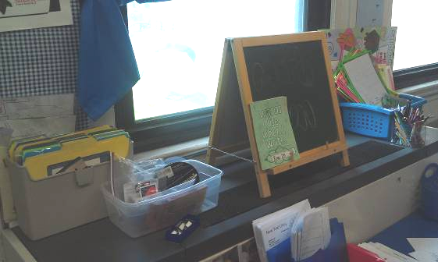

Classroom univent, note items on top and in front of unit

Picture 2

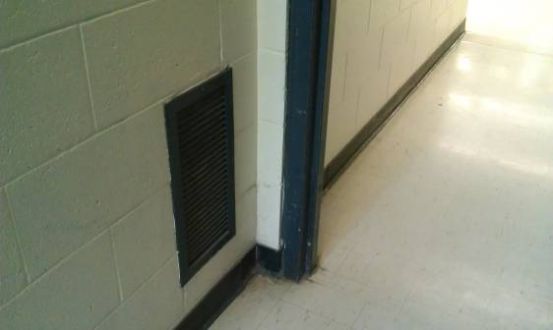

Classroom exhaust vent

Picture 3

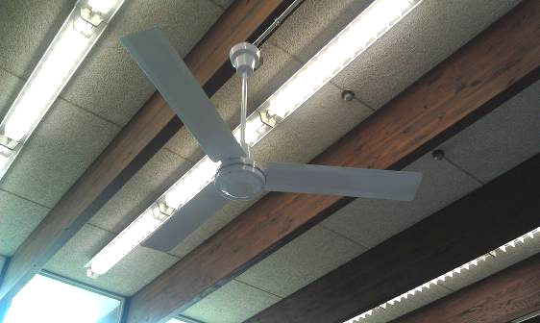

Ceiling fan in classroom

Picture 4

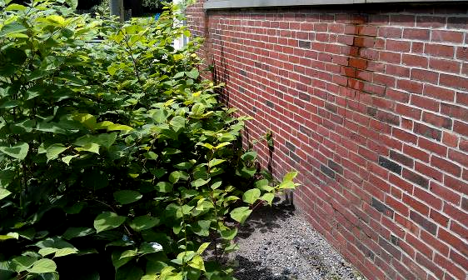

Signs of water damage on exterior bricks

Picture 5

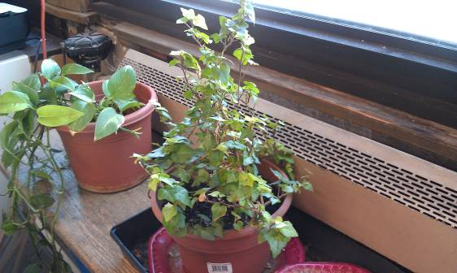

Plants in classroom

Picture 6

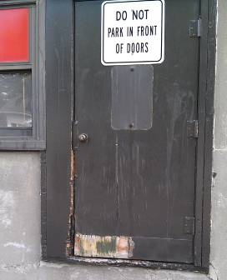

Corroded exterior door

Picture 7

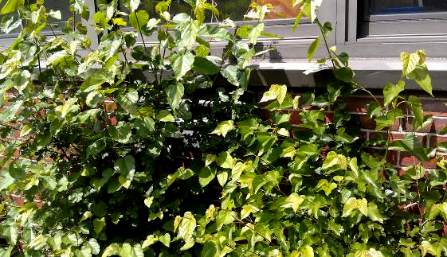

Plants growing in close proximity to building exterior,
note univent fresh air intake behind plant

Picture 8

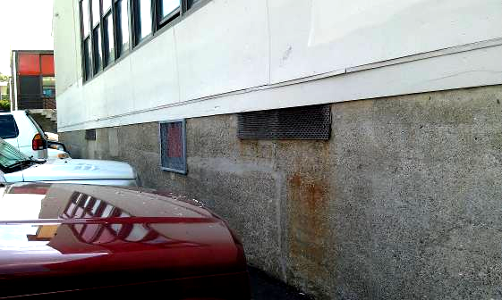

Car parked near univent fresh air intake

Picture 9

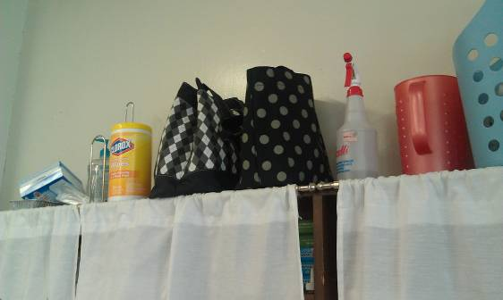

Cleaning products in classroom

Picture 10

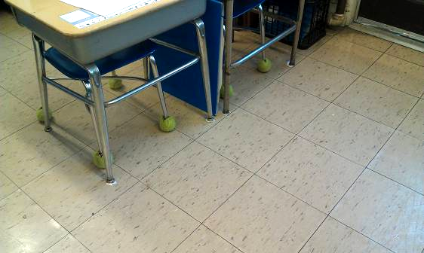

Chairs with tennis balls used as glides

Picture 11

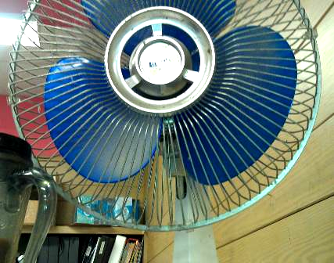

Dusty personal fan

Picture 12

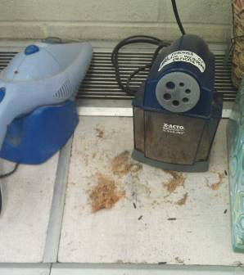

Pencil sharpener and shavings near univent

Picture 13

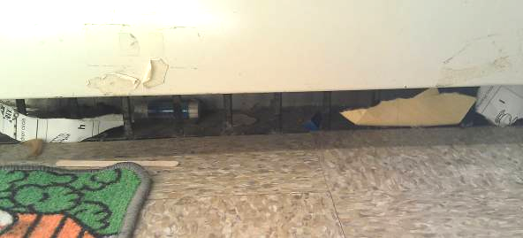

Base of univent with debris inside
Location | Carbon  Dioxide  (ppm) | Carbon Monoxide  (ppm) | Temp  (°F) | Relative  Humidity  (%) | PM2.5  (µg/m³) | Occupants  in Room | Windows  Openable | Ventilation |  | Remarks
 |  |  |  |  |  |  |  | Supply | Exhaust | Remarks
Background | 386 | ND | 69 | 61 | 35
Literacy | 656 | ND | 72 | 58 | 8 | 1 | Y | Y  items | Y | UV dusty and has paper and crayons, CF, papers, DO, exhaust weak/off
Gym | 535 | ND | 69 | 58 | 5 | 14 | N | Y | Y gravity | WD-ceiling plaster
Bathroom near gym |  | ND |  |  |  |  | Y |  | Y ceiling | Recommend passive door vent
OT/speech | 1003 | ND | 71 | 58 | 17 | 2 | Y | Y | N | DO
Nurse | 991 | ND | 71 | 60 | 16 | 2 | Y | N | N | DO
Boys room near office | 999 | ND | 72 | 60 | 13 | 0 | N | N | Y
Teacher’s Lounge | 812 | ND | 73 | 56 | 10 | 0 | Y | Y | N | PC, laminator, 2 WD-CT, CPs
Computer | 770 | ND | 73 | 58 | 16 | 1 | N | Y | N
Resource Room | 745 | ND | 73 | 55 | 12 | 0 | N | Y | N
Media | 722 | ND | 74 | 55 | 15 | 3 | N | Y | Y | New carpet, recommend carpet tiles
8 | 1172 | ND | 71 | 61 | 14 | 20 | Y | Y | Y  off | CF
9 | 791 | ND | 72 | 58 | 15 | 22 | Y | Y | Y off | CF, CPs
10 | 1099 | ND | 73 | 57 | 11 | 20 | Y | Y | Y | CF, DO
11 | 957 | ND | 72 | 58 | 19 | 21 | Y  open | Y  off | Y  off | Plants, DEM, CPs, CF
12 | 902 | ND | 72 | 59 | 21 | 25 | Y  open | Y blocked | Y  off | CF, cleaners/AD, items on UV
13 | 613 | ND | 72 | 59 | 15 | 0 | Y | Y | Y  off
14 | 854 | ND | 72 | 60 | 24 | 21 | Y  open | Y  off |  | CF, CPs
15 | 978 | ND | 72 | 62 | 12 | 16 | Y | Y | Y  off | Plants, CF, DO
16 | 523 | ND | 72 | 60 | 13 | 0 | Y | Y | Y  off | CF, CPs, MT
17 | 699 | ND | 72 | 61 | 22 | 23 | Y  open | Y  items | Y  off | CPs, CF, AC, items
18 | 1256 | ND | 71 | 63 | 15 | 22 | Y | Y Items/ debris | Y gravity | Plants
19 | 1134 | ND | 70 | 62 | 13 | 17 | Y | Y  weak | Y gravity | Clutter, plants, items, CPs
21 | 1331 | ND | 72 | 64 | 10 | 21 | Y | Y | Y | Water-stained walls, DO
22 | 942 | ND | 72 | 68 | 16 | 22 | Y | Y blocked | N | CPs, WD-CT
23 | 762 | ND | 71 | 62 | 19 | 3 | Y | Y | N | Generator outside, plants, PF, WD-CT
24 | 1005 | ND | 71 | 68 | 14 | 1 | Y | Y | Y gravity | 2 WD-CT broken CT, DO, CPs, microwave
27 | 934 | ND | 70 | 63 | 12 | 17 | Y | Y  dusty | Y gravity | Pollen/flowering plant odor, WD-CT, WD-ceiling plaster, plants,
28 | 984 | ND | 72 | 60 | 12 | 15 | Y | Y  items | Y gravity, sealed | Plants on exterior of building blocking fresh air intake
29 | 686 | ND | 71 | 59 | 17 | 9 | Y | Y | Y gravity | TB
30 | 1082 | ND | 72 | 59 | 18 | 22 | Y | Y blocked | Y | 2 WD CT, CPs
31 | 1130 | ND | 71 | 61 | 18 | 22 | Y | Y | Y gravity | CPs, WD-wall plaster, DO
32 | 1182 | ND | 72 | 63 | 14 | 23 | Y | Y  items | Y | PF, plant, CPs

