WATER DAMAGE/MOLD INVESTIGATION

Stacy Middle School
66 School Street
Milford, Massachusetts

Prepared by:
Massachusetts Department of Public Health
Bureau of Environmental Health
Indoor Air Quality Program
October 2018

BACKGROUND
Building: | Stacy Middle School (SMS)
Address: | 66 School Street, Milford, MA
Assessment Requested by: | Paul A. Mazzuchelli, Agent, Milford Board of Health
Reason for Request: | Mold/water damage concerns
Date of Assessment: | October 10, 2018
Massachusetts Department of Public Health/Bureau of Environmental Health (MDPH/BEH) Staff Conducting Assessment: | Cory Holmes, Environmental Analyst/Inspector, Indoor Air Quality (IAQ) Program
Building Description: | Basement classroom of middle school in downtown Milford. The SMS is a three-story granite block building that was constructed in the early 1900s as a high school. The building underwent complete interior renovations in the mid-1990s.
Windows: | Windows are openable/open at the time of assessment.

IAQ Testing Results
Please refer to the IAQ Manual for methods, sampling procedures, and interpretation of results (MDPH, 2015). The following is a summary of indoor air testing results (Table 1).
- Moisture Measurements were all dry (i.e., within normal parameters) at the time of the assessment.
- Carbon dioxide levels were below 800 parts per million (ppm) indicating adequate air exchange. Note that the classroom was empty at the time of the visit.
- Temperature was within the recommended range of 70°F to 78°F the day of assessment.
- Relative humidity was above the recommended range of 40 to 60% the day of assessment.
- Carbon monoxide levels were non-detectable (ND) in the area tested.
- Fine particulate matter (PM2.5) concentrations measured indoors were below the National Ambient Air Quality (NAAQS) limit of 35 μg/m³.

Microbial/Moisture Concerns
Relative Humidity
The BEH/IAQ Program was asked to examine the basement classroom (091) for the presence of water damage/mold growth. It is important to note that the Boston area experienced an unprecedented period of extended hot, humid weather. According to the Washington Post, “[d]ata…show[s]…cities in the Northeast have witnessed such humidity levels for record-challenging duration...[i]ncluding Albany, Boston, Burlington Portland and Providence” during the summer of 2018 (WP, 2018). “Boston and nearby locations… [saw]…historic numbers of those warm nights with low temperatures at or above 70 degrees…Providence and Blue Hill Observatory have already broken their annual records” (WP, 2018). If a building does not have either adequate exhaust ventilation and/or air chilling capacity to remove/reduce relative humidity from outside air, then hot, moist air can be introduced into a building and linger to increase occupant discomfort as well as possibly moisten materials that may lead to mold growth.
The MDPH recommends a comfort range of 40 to 60 percent for indoor air relative humidity. Elevated relative humidity levels were observed within the classroom during the visit, with outdoor relative humidity measured at 75 percent and indoor relative humidity at 86 percent.
High relative humidity indoors can indicate that the HVAC system is insufficient to remove water vapor without the aid of air conditioning or dehumidification. Mr. Robert Quinn, Facilities Director reported that several dehumidifiers were being used previously; but they were not in use at the time of the assessment. Moisture removal is important since higher humidity at a given temperature reduces the ability of the body to cool itself by sweating. “Heat index” and “apparent temperature” are measurements that take into account the impact of a combination of heat and humidity on how individuals perceive heat. At a given indoor temperature, the addition of humid air increases occupant discomfort and may generate heat complaints. If moisture levels are decreased, the comfort of the individuals can increase. Relative humidity in excess of 70 percent for extended periods of time can provide an environment for mold and fungal growth (ASHRAE, 1989).
Although relative humidity measurements were elevated, no visible mold growth was observed on building components (e.g., walls, floors, ceilings), however some classroom items, such as books/binders, had a dark substance/staining that may have been mold growth (Pictures 1 and 2). It was recommended that these items be removed and discarded if not needed. The room also contained significant amounts of paper/porous items that appeared to have become moistened due to elevated humidity conditions (Picture 3). If these materials are not to be used, they should be limited/discarded to prevent mold growth during summer months.
MDPH recommends pleated filters with a Minimum Efficiency Reporting Value (MERV) of 8, which are adequate in filtering out pollen and mold spores (ASHRAE, 2012). Filters should also be changed two to four times a year, or per the manufacturer’s recommendations. BEH/IAQ staff examined filters in the air handling unit (AHU) that services this area, which appeared to be a mid-grade/pleated-type (Picture 4) that are reportedly changed three times per year (i.e., vacations).

Conclusions/Recommendations
Based on the observations made during the visit, the following recommendations are made:
- Ensure classroom items that may appear to have mold growth are cleaned/removed.
- During periods of elevated humidity (i.e., >70 % for extended periods of time), continue to utilize dehumidifiers as needed. Ensure windows are shut and classroom doors are closed when using these units. All filters and water reservoirs should be cleaned and maintained as per the manufacturer’s instructions.
- Use MERV 8 (or higher) filters in AHUs. Continue to change filters 2-4 times a year, or as manufacture recommends.
- To control for dusts, a high efficiency particulate arrestance (HEPA) filter equipped vacuum cleaner in conjunction with wet wiping of all surfaces is recommended. Avoid the use of feather dusters.
- Relocate or consider reducing the amount of materials stored in classrooms to allow for more thorough cleaning, particulary paper/porous items. Clean non-porous items regularly with a wet cloth or sponge to prevent excessive dust build-up.
- For more information on mold refer to the US EPA’s “Mold Remediation in Schools and Commercial Buildings”. Available at: http://www.epa.gov/mold/mold-remediation-schools-and-commercial-buildings-guide.
- Refer to resource manuals and other related IAQ documents for further building-wide evaluations and advice on maintaining public buildings. Copies of these materials are located on the MDPH’s website: http://mass.gov/dph/iaq.

REFERENCES
ASHRAE. 1989. Ventilation for Acceptable Indoor Air Quality. American Society of Heating, Refrigeration and Air Conditioning Engineers. ANSI/ASHRAE 62-1989.
ASHRAE. 2012. American Society of Heating, Refrigeration and Air Conditioning Engineers (ASHRAE) Standard 52.2-2012 -- Method of Testing General Ventilation Air-Cleaning Devices for Removal Efficiency by Particle Size (ANSI Approved).
MDPH. 2015. Massachusetts Department of Public Health. “Indoor Air Quality Manual: Chapters I-III”. Available at: http://www.mass.gov/eohhs/gov/departments/dph/programs/environmental-health/exposure-topics/iaq/iaq-manual/.
WP. 2018. ‘It’s been relentless’: Smothering summer humidity in the Northeast has crushed records. Washington Post, Washington, DC. https://www.washingtonpost.com/news/capital-weather-gang/wp/2018/08/30/its-been-relentless-smothering-summer-humidity-in-the-northeast-has-crushed-records/
Picture 1
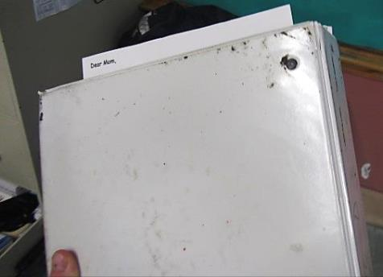
Binder with dark staining
Picture 2
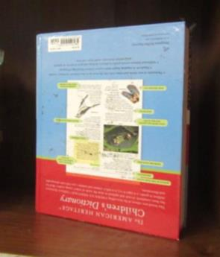
Book with some debris/staining on cover
Picture 3
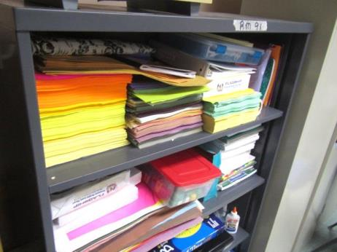
Paper/porous items in classroom
Picture 4
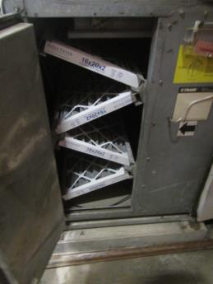
Pleated filters in air handling unit
Location | Carbon  Dioxide  (ppm) | Carbon Monoxide  (ppm) | Temp  (°F) | Relative  Humidity  (%) | PM2.5  (µg/m³) | Occupants  in Room | Windows  Openable | Ventilation |  | Remarks
 |  |  |  |  |  |  |  | Supply | Exhaust
Background (outdoors) | 436 | ND | 77 | 75 | 34-40 |  |  |  |  | Unseasonably warm/humid
091 | 760 | ND | 72 | 86 | 9 | 0 | Y open | Y | Y | Personal fan-dusty, tile floor, white ceiling tiles, books/binders-debris/staining (possible mold growth on surface), porous items (paper, books, cardboard), all walls dry/normal moisture measurements, no visible mold growth on building components

