INDOOR AIR QUALITY ASSESSMENT

Stacy Middle School
66 School Street
Milford, MA 01757



Prepared by:
Massachusetts Department of Public Health
Bureau of Environmental Health
Indoor Air Quality Program
September 2007

Background/Introduction
At the request of Paul Mazzuchelli, Director, Milford Board of Health, the Massachusetts Department of Public Health (MDPH), Bureau of Environmental Health (BEH) provided assistance and consultation regarding indoor air quality at the Stacy Middle School (SMS), 66 School Street, Milford, Massachusetts. On August 22, 2007, Cory Holmes and Sharon Lee, Environmental Analysts in BEH’s Indoor Air Quality (IAQ) Program conducted an assessment. Robert Quinn, Facilities Director of Milford Public Schools, accompanied BEH staff for portions of the assessment.
The SMS is a three-story granite block building that was constructed in the early 1900s as a high school. The building underwent complete interior renovations in the mid-1990s. Over the summer of 2007 the roof was replaced and the exterior of the building was re-pointed. The repointing project included the physical removal of existing mortar (e.g., grinding), which reportedly generated dust and debris. Given the renovation activities conducted, the MDPH assessment focused on the presence of airborne (respirable) particulates, settled dust and general cleanliness. At the time of the assessment, both the roof and repointing projects were near completion, and remaining work included punch list items. It was reported to BEH staff that window replacement would be conducted while the school is fully occupied by students and staff. Window replacement is tentatively scheduled to be completed by November 2007.

Methods
Air tests for airborne particle matter with a diameter less than 2.5 micrometers were taken with the TSI, DUSTTRAK™ Aerosol Monitor Model 8520. Tests were conducted prior to school opening, therefore the building was not occupied by students, however faculty were present at the time of the assessment. BEH staff also conducted a visual assessment of settled dust and flat surfaces for general cleanliness. Test results are included in Table 1.

Results and Discussion
Airborne Particulate Matter (PM 2.5)
Indoor air quality can be negatively influenced by the presence of respiratory irritants, such as fine airborne particulates. Exposure to particulate matter with a diameter of 2.5 micrometers (μm) or less (PM2.5) can provide a source of eye and respiratory irritation. To determine whether measurable levels of fine, airborne particulates were present in the school environment, BEH staff conducted air measurements for particulate matter with a diameter of 2.5 micrometers (μm) or less (PM2.5).
The American Society of Heating Refrigeration and Air-Conditioning Engineers (ASHRAE) has adopted the National Ambient Air Quality Standards (NAAQS) as one set of criteria for assessing indoor air quality and monitoring of fresh air introduced by HVAC systems (ASHRAE, 1989). The NAAQS are standards established by the US EPA to protect the public health from 6 criteria pollutants, including carbon monoxide and particulate matter (US EPA, 2006). As recommended by ASHRAE, pollutant levels of fresh air introduced to a building should not exceed the NAAQS (ASHRAE, 1989). The NAAQS were adopted by reference in the Building Officials & Code Administrators (BOCA) National Mechanical Code of 1993 (BOCA, 1993), which is now an HVAC standard included in the Massachusetts State Building Code (SBBRS, 1997).
The US EPA has established NAAQS’ to address human exposure to particulate matter. Particulate matter is airborne solids that can be irritating to the eyes, nose and throat. The NAAQS originally established exposure limits to particulate matter with a diameter of 10 μm or less (PM10). According to the NAAQS, PM10 levels should not exceed 150 microgram per cubic meter (μg/m³) in a 24-hour average (US EPA, 2006). These standards were adopted by both ASHRAE and BOCA. Since the issuance of the ASHRAE standard and BOCA Code, US EPA established a more protective standard for fine airborne particles. This more stringent PM2.5 standard requires outdoor air particle levels be maintained below 35 μg/m³ over a 24-hour average (US EPA, 2006). Although both the ASHRAE standard and BOCA Code adopted the PM10 standard for evaluating air quality, MDPH uses the more protective proposed PM2.5 standard for evaluating airborne particulate matter concentrations in the indoor environment.
Outdoor PM2.5 concentrations were measured at 10 μg/m³ (Table 1). PM2.5 levels measured indoors ranged from 2 to 9 μg/m³. At the time of the assessment, all PM2.5 measurements were below the NAAQS of 35 μg/m³. Frequently, indoor air levels of particulates (including PM2.5) can be at higher levels than those measured outdoors. A number of mechanical devices and/or activities that occur in schools can generate particulate during normal operations. Sources of indoor airborne particulates may include but are not limited to particles generated during the operation of fan belts in the HVAC system, cooking in the cafeteria stoves and microwave ovens; use of photocopiers, fax machines and computer printing devices; operation of an ordinary vacuum cleaner and heavy foot traffic indoors.

Other IAQ Evaluations
Although indoor PM2.5 concentrations were below the NAAQS, settled dust and efflorescence (e.g., mineral deposits), was observed on flat surfaces in many areas (Table 1/Pictures 1-4). Dust can be irritating to eyes, nose and respiratory tract. Efflorescence is a characteristic sign of water damage to building materials, but it is not mold growth. As moisture penetrates and works its way through building materials (e.g., plaster), water-soluble compounds dissolve, creating a solution. As this solution moves to the surface, the water evaporates, leaving behind white, powdery mineral deposits. Chronic water penetration through the building envelope that has damaged building materials throughout the building (Pictures 5 through 8), should be alleviated by both the repointing of the exterior of the building (Picture 9) and roof replacement.

Settled dust and debris was also observed within univent cabinets (Pictures 10 and 11) and on supply diffusers (Picture 12) and exhaust vents (Picture 13). Dust and particulate matter accumulated on diffusers or within a univent can be aerosolized when these units are activated. In addition, odors and fumes can be generated from heating of materials on or in close proximity to univent heating elements. Supply diffusers can accumulate dust. In contrast, exhaust vents typically accumulate dust and debris because the draw of air through the vents is also removing airborne materials from the building. If rooftop exhaust motors are deactivated, backdrafting can occur, and materials accumulated on the exhaust vent can be reaerosolized into occupied areas.
BEH staff examined several filters installed in rooftop air handling units and univents. All filters observed were found to be clean and appeared to have been recently changed. However, filters at the SMS are of a fibrous mesh type that provides minimal filtration (Pictures 14 and 15). In order to decrease aerosolized particulates, disposable filters with an increased dust spot efficiency can be installed. The dust spot efficiency is the ability of a filter to remove particulates of a certain diameter from air passing through the filter. Filters that have been determined by ASHRAE to meet its standard for a dust spot efficiency of a minimum of 40 percent (Minimum Efficiency Reporting Value equal to 9) would be sufficient to reduce many airborne particulates (Thornburg, 2000; MEHRC, 1997; ASHRAE, 1992). Note that increasing filtration can reduce airflow (called pressure drop), which can subsequently reduce efficiency due to increased resistance. Prior to any increase of filtration, each univent/AHU should be evaluated by a ventilation engineer to ascertain whether it can maintain function with more efficient filters.
Finally, in an effort to reduce noise from sliding chairs, tennis balls had been spliced open and placed on chair legs in a several areas (Table 1/Picture 16). Tennis balls are made of a number of materials that are a source of respiratory irritants. Constant wearing of tennis balls can produce fibers and off gas VOCs. Tennis balls are made with a natural rubber latex bladder, which becomes abraded when used as a chair leg pad. Use of tennis balls in this manner may introduce latex dust into the school environment. Some individuals are highly allergic to latex (e.g., spina bifida patients) (SBAA, 2001). It is recommended that the use of materials containing latex be limited in buildings to reduce the likelihood of symptoms in sensitive individuals (NIOSH, 1997). A question and answer sheet concerning latex allergy is attached as Appendix B (NIOSH, 1998).

Conclusions/Recommendations
Test results indicated that no elevated levels of airborne particulates (PM2.5) were measured at the time of the assessment. However, settled dust on flat surfaces and accumulated dust and debris in classroom univents and exhaust vents were observed. At the conclusion of the assessment, BEH staff verbally provided a number of recommendations to school officials to improve conditions prior to the opening of school. In addition, due to pending window replacement that will be conducted while the school is occupied, the MDPH document Methods Used to Reduce/Prevent Exposure to Construction/Renovation Generated Pollutants in Occupied Buildings is included in Appendix A.
In view of the findings at the time of the visit, the following recommendations are made:
- Scrape/remove loose/hanging plaster and paint on ceiling and around window sills.
- Clean flat surfaces using a high efficiency particulate arrestance (HEPA) filter equipped vacuum cleaner in conjunction with wet wiping.
- Clean and vacuum univent air diffusers and the interior of univent air handling cabinets.
- Clean supply air diffusers, exhaust grates and cubbies (Picture 3).
- Continue with plans to finalize roof and repointing. Once completed, repair/replace any remaining water-damaged building materials (e.g., wall/ceiling plaster).
- Consider discontinuing the use of tennis balls on chair legs to prevent latex dust generation. Alternative “glides” can commonly be purchased from office supply stores; refer to Picture 17 for an example.
- Consider increasing the dust-spot efficiency of HVAC filters. Prior to any increase of filtration, each piece of air handling equipment should be evaluated by a ventilation engineer as to whether it can maintain function with more efficient filters.
- Consider adopting the US EPA document, “Tools for Schools”, to maintain a good indoor air quality environment on the building. This document can be downloaded at: http://www.epa.gov/iaq/schools/index.html.
- Refer to resource manuals and other related indoor air quality documents for further building-wide evaluations and advice on maintaining public buildings. These materials are located on the MDPH’s website at http://mass.gov/dph/indoor_air
References
ACGIH. 1989. Guidelines for the Assessment of Bioaerosols in the Indoor Environment. American Conference of Governmental Industrial Hygienists, Cincinnati, OH.
ASHRAE. 1992. Gravimetric and Dust-Spot Procedures for Testing Air-Cleaning Devices Used in General Ventilation for Removing Particulate Matter. American Society of Heating, Refrigeration and Air Conditioning Engineers. ANSI/ASHRAE 52.1-1992.
ASHRAE. 1992. Gravimetric and Dust-Spot Procedures for Testing Air-Cleaning Devices Used in General Ventilation for Removing Particulate Matter. American Society of Heating, Refrigeration and Air Conditioning Engineers. ANSI/ASHRAE 52.1-1992.
BOCA. 1993. The BOCA National Mechanical Code/1993. 8th ed. Building Officials and Code Administrators International, Inc., Country Club Hill, IL
MEHRC. 1997. Indoor Air Quality for HVAC Operators & Contractors Workbook. MidAtlantic Environmental Hygiene Resource Center, Philadelphia, PA.
NIOSH. 1997. NIOSH Alert Preventing Allergic Reactions to Natural Rubber latex in the Workplace. National Institute for Occupational Safety and Health, Atlanta, GA.
NIOSH. 1998. Latex Allergy A Prevention. National Institute for Occupational Safety and Health, Atlanta, GA.
SBAA. 2001. Latex In the Home And Community Updated Spring 2001. Spina Bifida Association of America, Washington, DC.
SBBRS. 1997. Mechanical Ventilation. State Board of Building Regulations and Standards. Code of Massachusetts Regulations. 780 CMR 1209.0.
Thornburg, D. Filter Selection: a Standard Solution. Engineering Systems 17:6 pp. 74-80.
US EPA. 2006. National Ambient Air Quality Standards (NAAQS). US Environmental Protection Agency, Office of Air Quality Planning and Standards, Washington, DC. http://www.epa.gov/air/criteria.html.

Picture 1

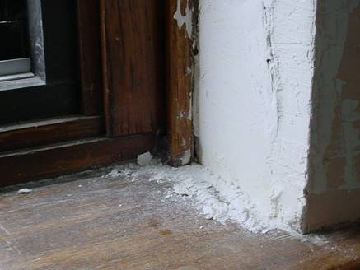

Plaster Dust on Classroom Window Sill

Picture 2

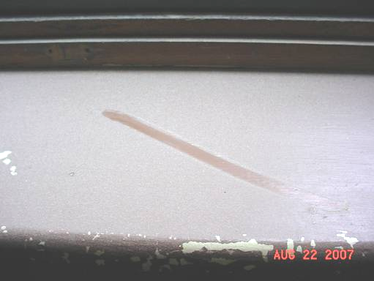

Settled Dust on Classroom Window Sill

Picture 3

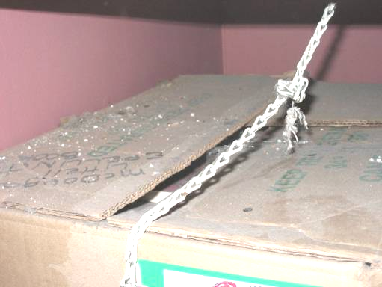

Settled Dust/Debris on Box in Classroom Exhaust Cubby

Picture 4

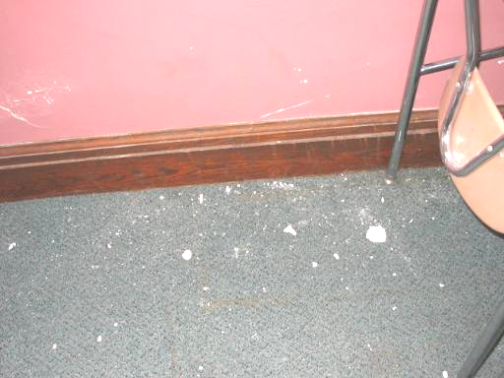

Dust/Debris on Classroom Carpet
Picture 5

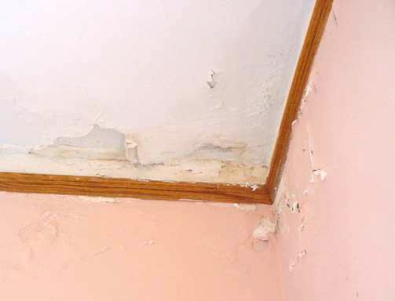

Water Damaged Ceiling and Wall Plaster

Picture 6

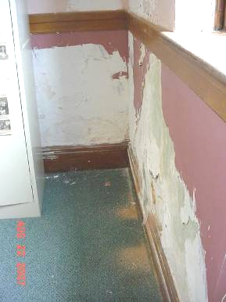

Severely Water Damaged Wall Plaster in Classroom 314
Picture 7

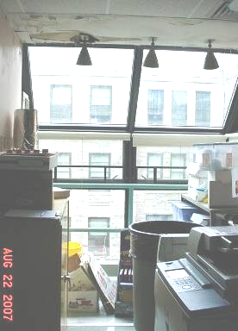

Water Damaged Ceiling and Walls around Protruding Window System in Science Storeroom

Picture 8

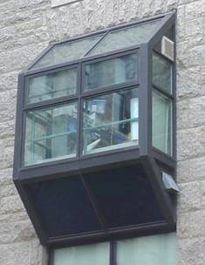

Exterior View of Protruding Window System of Science Storeroom
Picture 9

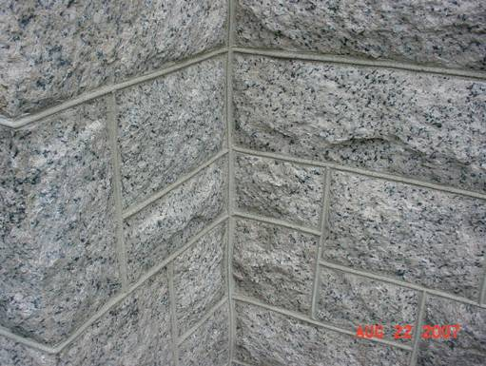

Repointed Exterior Granite Blocks

Picture 10

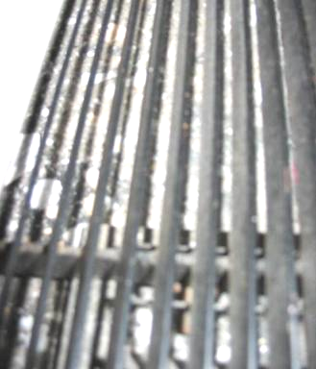

Dirt, Dust and Debris in Univent Air Diffuser
Picture 11

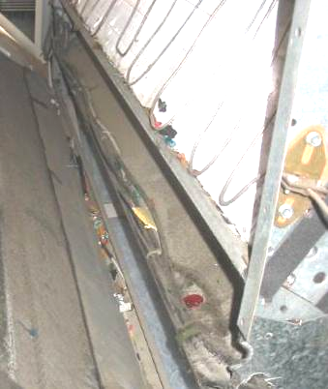

Dirt, Dust and Debris in Univent Air Handling Cabinet

Picture 12

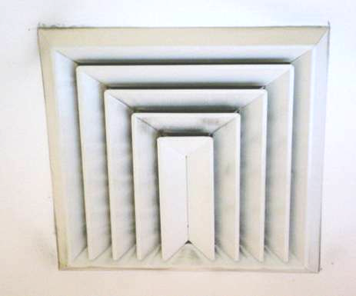

Dust/Debris Accumulation on/around Supply Diffuser
Picture 13

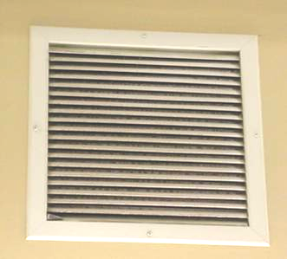

Dust/Debris Accumulation on/in Exhaust Vent

Picture 14

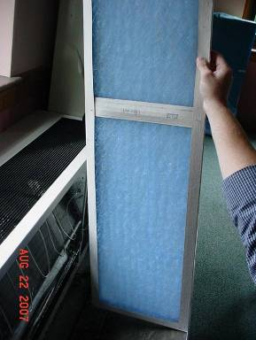

Fibrous Mesh Type Filter for Univent
Picture 15

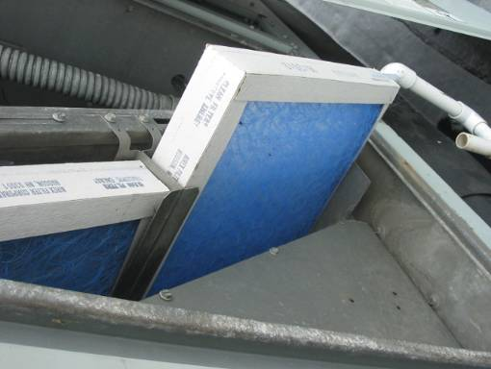

Fibrous Mesh Type Filter for Rooftop AHU

Picture 16

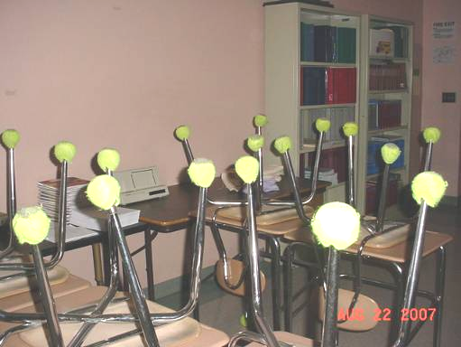

Tennis Balls on Chair Legs
Picture 17

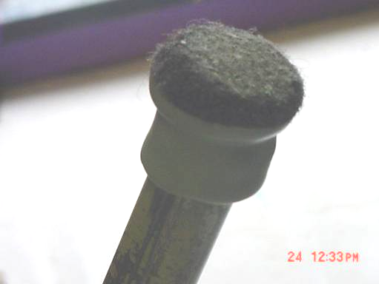

“Glides” for Chair Legs that can be used as an Alternative to Tennis Balls

Location | PM2.5*  (µg/m3) | Comments
Background | 10 | Cool, mostly cloudy, wind: 5-15 mph ENE
309 | 5 | Dirt, dust, debris-univent & exhaust cubby, water damaged ceiling/wall plaster, window open, exhaust dusty
308 | 5 | water damaged ceiling/wall plaster, window open, plaster dust on windowsills and univent, window open, exhaust dusty
304 A | 4 | Dust flat surfaces-floor, window open
304 | 5 | Dirt, dust, debris-univent & water damaged ceiling plaster, window open, exhaust dusty
301 | 8 | Dirt, dust, debris-univent, windowsills, water damaged ceiling/wall plaster, window open, exhaust dusty
302 | 5 | Dirt, dust, debris-univent, water damaged ceiling/wall plaster, window open, exhaust dusty
322 Art | 5
323 | 5
221 | 5 | Dirt/debris accumulation on air diffuser, dust flat surfaces
Prep Room |  | Water damaged ceiling/walls around protruding window
201 | 4 | Dirt, dust, debris-univent & windowsill, water damaged ceiling/wall plaster, window open
204 A | 7 | Window open
205 | 5 | Tennis balls on chair legs
206 | 6 | Dirt, dust, debris-univent & exhaust, window open
208 | 5 | Dirt, dust, debris-univent & windowsill, water damaged ceiling/wall plaster
207 | 2 | Dirt, dust, debris-univent & exhaust, window open
310 | 3 | Dirt, dust, debris-univent & exhaust, window open
312 | 3 | Dirt, dust, debris-univent & exhaust, water damage above window, peeling paint above door
313 | 5 | Dirt, dust, debris-univent, flat surfaces & exhaust, window open
314 | 4 | Dirt, dust, debris-univent, floor & exhaust, window open, severe water damaged wall plaster in corner
315 | 3 | Dirt, dust, debris-univent & windowsill, window open
214 | 3 | Dirt, dust, debris-exhaust vent, window open
215 | 4 | Dirt, dust, debris-flat surfaces, window open
213 | 5 | Dirt, dust, debris-exhaust & windowsill, window open
212 | 3 | Dirt, dust, debris-exhaust & windowsill, window open, exposed fiberglass insulation
210 | 4 | Dirt, dust, debris-univent, exhaust & windowsill, peeling paint, window open
109 | 9 | Dirt, dust, debris-univent & exhaust, water damaged ceiling/wall plaster, rattling noise from univent
108 | 5 | Dirt, dust, debris-univent & exhaust, window open
107 | 7
121 | 3 | Dirt, dust, debris-exhaust
122 A | 3 | Dirt, dust, debris-exhaust, water damaged ceiling/wall plaster near windows
124 | 2 | Dirt, dust, debris-supply
Nurse (Main Area) | 2
Nurse Office | 2
Conference | 3
Main Office | 3
22 | 4 | Dirt, dust, debris-windowsills
22 A | 5 | Dirt, dust, debris-windowsills
24 | 3 | Dirt, dust, debris-windowsills, tennis balls
23 | 5 | Tennis balls
Phys Ed | 5 | Dirt, dust, insect bodies-windowsills
Health | 4
Gym | 5
Cafeteria | 3

