
District Analysis and Review Tools (DART)

User Guide for
DART Detail: Staffing and Finance

June 2016
Massachusetts Department of Elementary and Secondary Education
75 Pleasant Street, Malden, MA 02148-4906
Phone 781-338-3000 TTY: N.E.T. Relay 800-439-2370
www.doe.mass.edu


This document was prepared by the
Massachusetts Department of Elementary and Secondary Education
Mitchell D. Chester, Ed.D.
Commissioner

The Massachusetts Department of Elementary and Secondary Education, an affirmative action employer, is committed to ensuring that all of its programs and facilities are accessible to all members of the public.
We do not discriminate on the basis of age, color, disability, national origin, race, religion, sex or sexual orientation.
Inquiries regarding the Department’s compliance with Title IX and other civil rights laws may be directed to the
Human Resources Director, 75 Pleasant St., Malden, MA 02148-4906. Phone: 781-338-6105.

© 2011 Massachusetts Department of Elementary and Secondary Education
Permission is hereby granted to copy any or all parts of this document for non-commercial educational purposes. Please credit the “Massachusetts Department of Elementary and Secondary Education.”

This document printed on recycled paper

Massachusetts Department of Elementary and Secondary Education
75 Pleasant Street, Malden, MA 02148-4906
Phone 781-338-3000 TTY: N.E.T. Relay 800-439-2370
www.doe.mass.edu



Table of Contents
Introduction to DART 1
Overview of DART Tools 2
DART Tools 2
Provide Feedback to ESE 2
Use the RSS Feed for Updates 3
Considerations in Using DART Data 3
Remember: DARTs are a snapshot. 3
Considerations for Data Analysis 3
Keep Current With Data Updates in DART Files. 3
Using the DART Detail: Staffing and Finance File 4
Download the File to Your Computer 4
Select Districts to Populate the DART Reports 5
Print Reports 6
Create Your Own Reports Using DART Data 7
Data Used in DART Detail: Staffing and Finance 8
Data Used in Reports 8
District at a Glance 8
Staffing Reports 8
District Staffing 8
Teachers 9
Special Education Staff 9
Finance Reports 10
District Finance Summary 10
Finance Charts 10
Expenditure by Source 11
Per Pupil Expenditures: Summary and Details 11
Median Expenditure Per In-district Pupil by District Type and Size 12
Out-of-district Expenditures 13
Revenues 13
Revolving Funds 13
Appendix A: Staffing Definitions 14
Appendix B: Financial Definitions 18

Introduction to DART
The Department of Elementary and Secondary Education provides a framework for both accountability and assistance for the 400 districts in the Commonwealth of Massachusetts. As part of that system, the Department seeks to make the data it receives from districts available to policymakers, parents, the public and the Department to use in assessing effectiveness and monitoring improvement in teaching and learning. From the vast amount of data available, reports offering comparisons and trends for a limited number of indicators can be a good starting point for self-assessment, inquiry, or district and school review. The Department has developed a suite of tools called the District Analysis and Review Tools (DART) to provide such reports.
DARTs provide a snapshot of school and district trends in various kinds of data and allow users to:
- Look at trends over several years
- View school and district data in charts that are easy to interpret
- Evaluate and reflect on districts and schools and their progress
- Find districts and schools with similar student demographics
- Make comparisons with a similar district(s) that has shown promising trends.
DART for Districts and DART for Schools provide charts and tables on a wide range of indicators suggested by a number of stakeholder groups around the state. Taken together, these indicators offer a snapshot of a district’s overall effectiveness across key areas including curriculum and instruction, leadership and governance, human resources, professional development, student support, and finance and asset management.
DART Detail tools support targeted inquiries in specific areas.
- DART Detail: Staffing and Finance provides reports on finance and staffing data with trends and district comparisons. They include some data that has not previously been publicly available.
- DART Detail: English Language Learners provides detailed information on English language learners in districts and their schools, including some data that has not previously been publicly available.
- DART Detail: Success After High School provides information on post-secondary and career readiness including demographics, high school indicators, programs of study, high school performance, postsecondary education outcomes, and career development education,
including some data that has not previously been publicly available.

Overview of DART Tools
DART for Districts and Schools is accessible on each district’s Profiles page on the Department website. DART Detail tools are Excel files on the Department’s website at www.mass.gov/ese/dart. See below for detailed instructions on downloading and using them.

DART Tools
DART Tool | Data included | Comparisons | Years
DART for Districts | Selected indicators on curriculum and instruction, leadership and governance, human resources, professional development, student support, and finance and asset management  Included: all districts | Compare two districts and the state | 5 years
DART for Schools | Selected indicators on curriculum and instruction, leadership and governance, human resources, professional development, student support  Included: all schools and single school districts | Compare two schools and the state | 5 years
DART Detail: Staffing and Finance | Overview—enrollment, performance, staff and finance highlights, finance charts  Selected indicators on: staff FTEs and student/staff ratios; expenditures (dollars and per pupil)  Included: municipal and regional districts* | One district  Compare four districts and the state | 5 years  3 years
DART Detail:  Success After  High School | Selected indicators on high school course-taking, performance, programs of study, post-secondary education outcomes, and career development education.  Included: all schools containing grades 9 to 12 | Compare two schools and the state | 5 years
DART Detail: English Language Learners | Selected indicators specific to English language learner students and programming, including enrollment and demographics, curriculum and assessment, English language proficiency (MEPA), staffing, and federal grants.  Included: all districts, including single school districts | Compare ten districts and the state, and all schools in one | Most recent  5 years

* Because comparable financial data is not available for charter schools, this DART does not include these districts.

Provide Feedback to ESE
Please consider taking the anonymous, 5-minute DART survey to provide feedback to ESE about the user experience and make suggestions for new indicators. Your comments are appreciated.
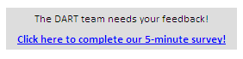

Use the RSS Feed for Updates
You can sign up for notification of DART updates by subscribing to our RSS feed. On the DART home page there is an RSS icon just above the title bar. Click on the icon, then select the DART RSS feed from the list. When you click on it, you will be invited to subscribe.

Considerations in Using DART Data

Remember: DARTs are a snapshot.
The DARTs provide a gauge of the overall condition of a district or school, but do not have all available information. They should be treated as a good starting point for exploring the data and identifying areas of focus for further inquiry. The ESE website, especially School and District Profiles, provides additional detail and should be referenced for deeper analysis. Local data is a powerful addition tool for inquiry. Users are cautioned to view the data provided in DARTs as a starting point for further investigation of relative differences and data outliers.

Considerations for Data Analysis
Districts put great effort into providing a lot of data to the Department, which is used for district self-assessment, Department reviews, legislative and grants reporting, public posting, and research. The data supports analysis and decision-making but it is not perfect. Some healthy skepticism is appropriate, for instance, when there is a real outlier in the data. The data collection process is subject to difficulties of several kinds, including simple keying errors. Other factors that affect data include:
- Without being in error, district staff may interpret the Department’s codes differently, so comparison at the detail level may make less sense than comparison at subtotal levels.
- When the Department requires a new data collection (e.g., EPIMS, course schedules), data is more inconsistent for the first year or two.
- Department coding is not perfectly aligned across different areas (e.g., staffing and finance.)
Ultimately, if data raises questions relevant to a decision-making process it is recommended that users follow up with other districts directly or to contact the Department for further information.

Keep Current With Data Updates in DART Files.
About three times a year, new data become available and the DART Excel files are updated and posted to the website again.

Files previously downloaded to local computers will not automatically update. Check the website periodically and download the current files.

Using the DART Detail: Staffing and Finance File

Download the File to Your Computer
The DART file will work better if you download it to your computer; however, DARTs are updated periodically, so check the website and download updated versions. DART files are very large and cannot be emailed. To share them, send a link to the website.

Open the DESE home page and click on the DART link in the list on the left: | then click on the link shown below:
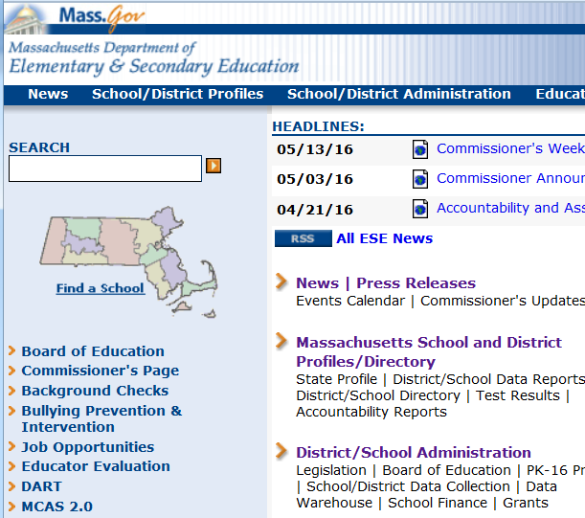 | 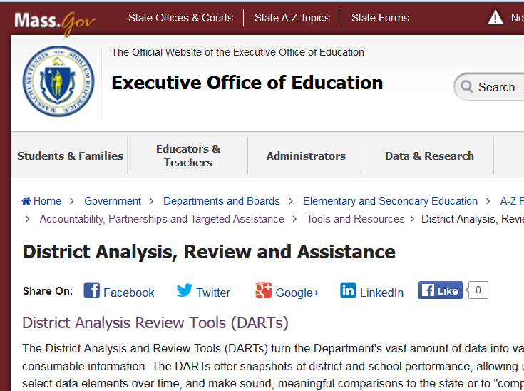
scroll down to the file, and click on it: | save the file to your computer:
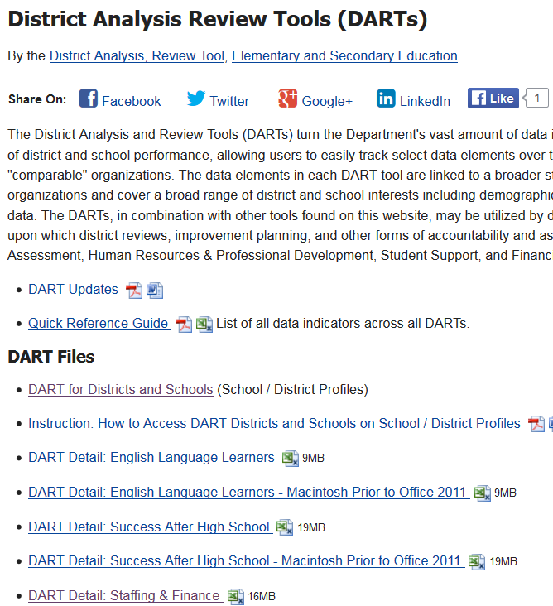 | 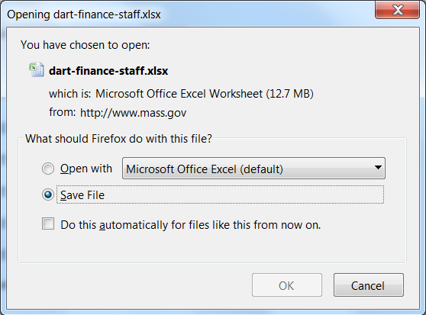

Note for Mac users: the DART Detail: Staffing and Finance file works for both PCs and Macs, but Mac users cannot open this file directly from the website. Download it before opening it.

Select Districts to Populate the DART Reports

Open the Home page (see screen shot on the following page.)

Click on the first green box and select a district from the dropdown menu.

A list of ten districts with similar student demographics will appear below with the selected district in orange and the highest performing of the other districts in blue. (Highest performance is based on achievement and growth in ELA, math, and science / technology over the past four years.)

Select three more districts in the green boxes at the top of the page if you choose to. You are not limited to the similar districts shown in the box, but they will show up at the top of the drop-down list.

Note: if a district seems to be missing from a drop-down list but is in the similar-districts box, go to the top of the drop-down list; the similar districts are pulled to the top of the list.

You can go to various reports by clicking on the links in the Table of Contents on the Home page OR by clicking on the worksheet tabs on the bottom of the screen.

Links to additional resources including other DART tools are also on the Home Page.

Home page:
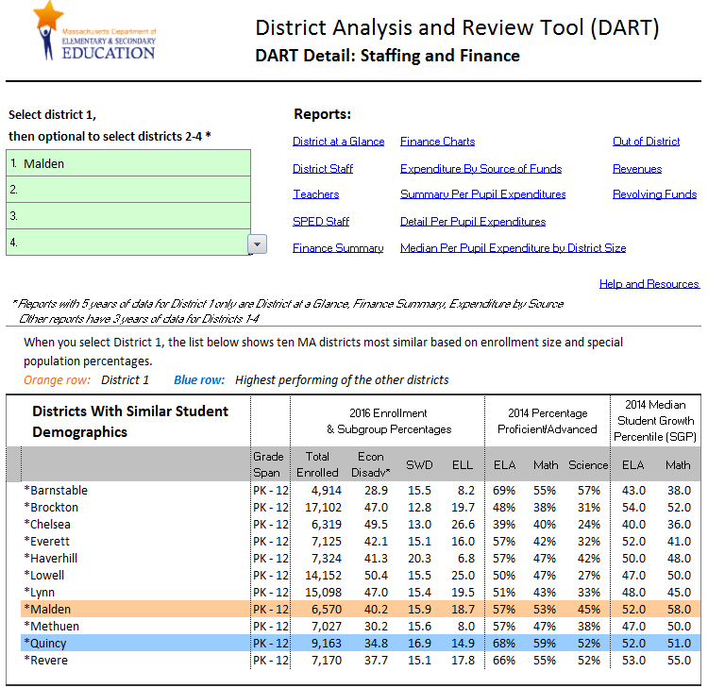

Print Reports
Reports are formatted in 8.5” x 11” for easy printing to a desktop printer or an Adobe pdf file.
If you want to share reports with others, print to Adobe Acrobat to create a pdf file. The DART file is too large to email.

Create Your Own Reports Using DART Data

Warning about copying data and reports: be sure to use Paste Special as described below. If you just copy and paste, your new file will have cumbersome formulas linked to the original DART file and/or error messages.

You need to copy the data in such a way that it is no longer based on formulas and is not linked in any way to the DART file, as follows:

- Select all the data and click on Copy
- Open a new workbook and select a cell
- Go to the Paste icon (top left) and choose Paste Special in the dropdown list
- Scroll down and select “csv” format
- Save your new file.

Data Used in DART Detail: Staffing and Finance

Data Used in Reports
Data from: End of Year Financial Reports (EOYRs), Chapter 70 program, Department of Revenue (DOR), Educational Personnel Information Management System (EPIMS), Student Information Management System (SIMS) and Massachusetts Comprehensive Assessment System (MCAS)

District at a Glance
Sources: SIMS, MCAS, EPIMS, EOYR

Description:
- Five year trends of enrollment, performance, staffing and finance highlights
- State comparison for most recent data year

Uses:
District at a Glance provides an overall picture of a district and its recent trends in key areas.

Staffing Reports
Staffing reports provide full-time-equivalents (FTEs) and student to staff ratios for various staffing categories. They compare four districts over three years. Year-to-year FTEs show hiring trends while student-to-staff ratios allow comparisons across districts. State student-to-staff ratios provide another point of comparison.

District Staffing
Sources: SIMS (Oct); EPIMS (Oct)

Description:
Staff is grouped in categories of administration and instructional leadership, instruction, student support, and clerical/technical support. The jobs included in each category are listed in Appendix A and in the Staffing Definitions worksheet in the DART file. Student-to-staff ratios in this report are based on all students.

Uses:
Use FTEs to see hiring trends over three years, and to see the impact of relative district size (for instance, lesser or greater specialization among administrators based on absolute numbers of staff.) Use student-to-staff ratios to compare relative staffing levels across districts and the state.

Teachers
Sources: SIMS (Oct); EPIMS (Oct)

Description:
Teachers are grouped by program area (general education, students with disabilities, vocational-technical, and English language learners.) General education teachers are further broken out by subject categories (ELA/reading/math/science/social studies, arts and languages, and other.) Program areas are derived from EPIMS assignment codes. Subjects are derived from EPIMS course numbers (see Appendix A, or the Staffing Definitions worksheet in the DART file.) In this report, student-to-staff ratios are based on the relevant student group (e.g. students with disabilities divided by SPED teachers.) “All students” is used in the ratio for regular education teachers because, for example, many students with disabilities are in regular education classes most of the day.

Uses:
Use FTEs to consider trends in hiring over three years and to see the impact of relative district size (for instance, lesser or greater specialization among administrators based on absolute numbers of staff.) Use student-to-staff ratios to compare relative staffing levels across districts and the state. Comparisons show the way different districts deploy their teaching workforce to cover all subjects, and to meet the needs of selected populations (students with disabilities and English language learners.)

Student-to-staff ratios are useful guides, but where student populations are heavily weighted (e.g., large vocational-technical or English language learner enrollment) the general education ratio may seem anomalous because these teachers provide less services to vocational-technical or ELL students. Data anomalies also occur in vocational-technical data because there is inconsistency in assignment coding (for instance, some vocational-technical schools report all their teachers as general education.) Common sense should guide analysis and questions when data seems highly unusual.

Special Education Staff
Sources: SIMS (Oct); EPIMS (Oct)

Description:
Staff for students with disabilities (SWD) is reported here with student-to-staff ratios based on in-district SWD students. SPED paraprofessionals are included in this report.

Uses:
FTEs show trends in hiring over three years, and the impact of relative district size (for instance, lesser or greater specialization among administrators based on absolute numbers of staff.) Use student-to-staff ratios to compare relative staffing levels across districts and the state.

Staff for students with disabilities is deployed in ways that cannot be decoded from the data in this report; for example, one cannot distinguish between a district using an inclusion approach for virtually all students with disabilities from one providing more pull-out and separate classroom services.

Finance Reports
The Finance Summary report provides 5 year trends for a number of finance data points. Finance charts present some information in another format. Other finance reports compare data for four districts over three years. Some of the data is available on the website but is presented here with trends and district comparisons. Other data is not available on the website, e.g. dollar expenditures from the complete EOYR.

District Finance Summary
Sources: EOYR, Charter/Choice reports, Chapter 70 Program, Department of Revenue (DOR)

Description:
- Five year trends of finance data including per pupil expenditures, all dollar expenditures from local appropriations and grants/revolving funds, state aid, out-of-district expenditure details, Chapter 70 details, and tax levy data (for municipal districts but not regional districts)
- State comparison for most recent year of data, where applicable

Uses:
The District Finance Summary integrates finance data from several sources into one report with five year trends for an overview of district finances.

Finance Charts
Sources: EOYR

Description:
- Five year trends for FTE pupils in-district and spending per in-district pupil are graphed in one chart with two axes of values.
- Expenditure in total dollars by source of funds, with Chapter 70 aid and NSS, is charted for five years.
- Expenditure on capital, debt and community activities and MSBA aid are charted separately for five years.
- The scatterplot compares the selected district to all others on size and per pupil expenditures, for a selected major functional areas.

Uses:
The Finance Charts provide a visual way to understand costs over five years and compared to all districts.

Expenditure by Source
Source: EOYR

Description:
- Expenditure by category from school committee, municipal, grant, and revolving funds, with percentages compared to the state
- Expenditures for all categories; those included in per pupil expenditures plus capital, debt, and community services expenditures

Uses:
The Expenditure by Source report separates general funds expenditures into school committee and municipality, and non-general funds expenditures into grants and local revolving funds. For instance, to see if municipal expenditures for administration or operations are in line, one can compare total spending in those functional areas to other districts .

Per Pupil Expenditures: Summary and Details
Sources: EOYR; SIMS (EOY); student to teacher ratio from SIMS (Oct) and EPIMS (Oct)

Description:
- Three years of per pupil expenditures for four districts and the state, including all sources of funding
- Full-time-equivalent (FTE) pupils, which are calculated from SIMS (End of Year) as all students’ days in membership divided by 180 days
- Per pupil expenditure totals for in-district (enrolled pupils), out-of-district— tuition paid for charter, choice, tuition agreements, special education out-placements, and all pupils
- Expenditures for administration, instruction and student support, pupil services, operations, benefits and fixed charges, and out-of-district tuitions and transportation
- Comparison of expenditures per in-district pupil to the median among similar size districts with the same grade-span (K-12, elementary, secondary, voc/tech/ag)
- Not included in per pupil calculations: expenditures on regional assessments, community services, fixed assets, and debt

Uses:
The summary report’s category totals are a good starting point for comparison. To drill down further, use the detail reports, but be aware that detail lines may differ across districts for reasons not directly related to budget choices. For instance, reporting may reflect different finance coding by districts rather than a different deployment of staff, particularly because definitions of staff roles in EOYR and EPIMS are not perfectly consistent. For example, a teaching role might be coded as a classroom teacher (2305) in one district and as a specialist teacher (2310) in another. Curriculum supervision might be done by an assistant superintendent or by several directors of curriculum areas. Note that there is no one right way to allocate resources. For instance, districts may have different approaches to providing instructional leadership and supervision that may be equally effective.

Analyze in-district, out-of-district and all totals separately because they have different denominators (different FTE pupils.) In-district expenditures are decided by the policy and program decisions of the school committee and superintendent—how to staff schools and the central office, provide pupil services, and so on. Out-of-district expenditures are driven by factors largely out of the district’s control, such as families choosing charter schools or using the school choice option to attend another district, and by the incidence of high-needs special education students. Further detail on out-of-district costs is available in another report.

Note that in-district pupils include both those resident in the district and those who tuition in—a few districts have a substantial percentage of tuitioned-in students. Those tuitioned-in through the choice program bring about $5,000 tuition, while those tuitioned-in by agreement typically bring a higher amount that is closer to the cost per pupil in the receiving district.

Total costs per pupil are a measure of overall spending, but because out-of-district costs vary so much, comparable total costs may not indicate comparable resources allocated to in-district students.

Per pupil expenditures data allows the user to benchmark and compare typical costs for educating locally enrolled students. Total dollars spent on schools may be considerably larger than indicated by per pupil expenditures. Regional assessments, indirect cost transfers, community services, fixed assets (capital investment) and debt service are not included because they vary widely across districts and across years, but are paid for with local appropriations and sometimes other funding sources. For example, one district may pay regional assessments to send some students to a regional vocational-technical school while another may provide vocational-technical education in its own schools. Towns and districts make decisions to build or renovate school buildings based on particular circumstances such as aging facilities or expanding enrollment.

Median Expenditure Per In-district Pupil by District Type and Size
Sources: EOYR; SIMS (Oct)

Description:
This report groups districts of similar grade-span and enrollment size and provides each group’s median, minimum and maximum expenditure per in-district pupil over three years. Districts are grouped by enrollment size (similar to in-district FTE pupils, but based on Oct SIMS.)

Uses:
District costs vary systematically by size and grade-span, so these groups provide relevant comparison information. For instance, K-12 district costs are typically lower than those of vocation-agricultural districts, and K-12 districts with the lowest median in-district per pupil expenditures are in the 1,000-3,000 enrollment range.

This report provides medians instead of averages so high-cost outliers don’t distort the numbers.. The range of expenditures within each group can be very wide, in part because districts within a size category have varying levels of wealth.

Out-of-district Expenditures
Sources: EOYR; SIMS End of Year (previously Schedule 11)

Description:
- Three years of expenditures for four districts for specific out-of-district tuition lines
- FTEs and average tuition costs for charter and choice out-of-district students
- State aid that supports out-of-district tuitions

Uses:
The Out-of-district Expenditures report helps the public understand very different levels of average cost. If a district has many choice students enrolled in other districts, its average expenditure per out-of-district pupil will be low. These tuitions are about $5,000, which is less than the cost to educate a student in-district. If there are no choice or charter options (or few students exercising these options) average expenditure per out-of-district pupil will typically be much higher, as the tuitions will be mostly for placements of high needs students with disabilities. The report includes the percentage of out-of-district students in the lower-cost choice and charter tuition categories as a rough benchmark to help compare average costs.

Revenues
Source: EOYR

Description:
- Three years of revenues as reported in the EOYR Schedule 1 for four districts

Uses:
The Revenues report provides detailed data in the categories of local general funds (excluding actual property tax levy dollars), state aid, federal and state grants and revolving funds. This level of revenues detail has not been published before.

Revolving Funds
Source: EOYR

Description:
- Three years of revenues and expenditures for revolving funds as reported in the EOYR for four districts
- Annual net amount (revenues minus expenditures)

Uses:
The Revolving Funds report provides the annual cash flow of a district’s revolving funds. Districts can roll over revolving fund balances from one year to the nexta. While expenditures must be for specific designated purposes, the rate of expenditure can be managed by the district, with negative cash flow one year and positive cash flow another year. DESE does not have data on balances.

Appendix A: Staffing Definitions
A complete description of EPIMS codes is on the ESE website in Appendix A-G of the Data Handbook: http://www.doe.mass.edu/infoservices/data/epims/ The following tables show how DART staffing reports group EPIMS codes into staff categories, teaching areas, and teaching subjects.

Staff Categories by EPIMS Job Code | Code
District Administrators
Superintendent | 1200
Asst/Assoc/Vice Superintendent | 1201
School Business Official | 1202
Other District Administrator | 1205
Supervisor/Director: Technology | 1224
School Nurse Leader | 1226
Other Instructional Leaders
Supervisor/Director of Guidance | 1210
Supervisor/Director of Pupil Personnel | 1211
Special Education Administrator | 1212
Supervisor/Director: Arts | 1213
Supervisor/Director of Assessment | 1214
Supervisor/Director: Curriculum | 1215
Supervisor/Director: English Language Learner | 1216
Supervisor/Director: English | 1217
Supervisor/Director: Foreign Language | 1218
Supervisor/Director: History/Social Studies | 1219
Supervisor/Director: Library/Media | 1220
Supervisor/Director: Mathematics | 1221
Supervisor/Director: Reading | 1222
Supervisor/Director: Science | 1223
Supervisor/Director: Professional Development | 1225
School Administrators
Principal | 1305
Asst/Vice Principal | 1310
Other School Administrator | 1320
Instructional Coaches | 2330
Teachers
Teacher | 2305
Teacher - support content instruction | 2310
Substitutes (Long-term) | 2325
Paraprofessionals | 4100
Tutors | 3323
Instructional Support
Educational Interpreter | 3324
Diagnostic and Evaluation Staff | 3325
Recreation Specialist | 3326
Rehabilitation Counselor | 3327
Work Study Coordinator | 3328
Guidance Counselor | 3329
Librarian | 3330
Junior ROTC | 3340
School Adjustment Counselor - Non-SPED | 3350
School Psychologist - Non-SPED | 3360
School Social Worker - Non-SPED | 3370
Other Professional Support (DSSR) | 3381
SPED Instructional Support
School Adjustment Counselor - SPED | 3351
School Psychologist - SPED | 3361
School Social Worker - SPED | 3371
SPED Related Staff
Audiologist | 3411
Occupational Therapist | 3421
Physical Therapist | 3431
Peripatologist | 3441
Speech Pathologist | 3451
Other Related SPED Staff | 3461
Medical/Health Services
Physician | 5010
Psychiatrist | 5015
School Nurse - Non-SPED | 5020
School Nurse - SPED | 5021
Clerical
Administrative Aides | 6100
Administrative Clerks/Secretaries | 6110
SPED Administrative Aides | 6120
SPED Clerks/Secretaries | 6130
Other Administrative Support | 6150
Tech Support
Information Services and Technical Support | 6140

Teaching Areas by EPIMS Assignment Code | Code
General education
Not available | 000
Core Subject: Non-Secondary Level Classroom Teacher | 001
Core Subject: Secondary Level Classroom Teacher | 002
Core Support Content General Education | 012
Core Subject: Reading Teacher | 017
Non-Core Subject: Non-Secondary Level Classroom Teacher | 212
Non-Core Subject: Secondary Level Classroom Teacher | 213
Non-Core Support Content General Education | 215
Vocational-technical
Non-Core Subject: Career and Technical Education | 208
Special education
Core Subject: Mild/Moderate Disabilities Sole Content | 003
Core Subject: Severe Disabilities Sole Content | 004
Core Subject: Mild/Moderate Disabilities Consultative | 005
Core Subject: Severe Disabilities Consultative | 006
Core Subject: Vision Impairments | 007
Core Subject: Deaf/Hard of Hearing | 008
Non-Core Subject: Vision Impairments | 209
Non-Core Subject: Speech/Language/Hearing Disorder | 210
Non-Core Subject: Deaf/Hard of Hearing | 211
Non-Core Subject: Other Special Education Instruction | 214
Special Ed: Shared Physical Education at Non-Secondary | 301
Special Ed: Shared Physical Education at Secondary | 302
Special Ed: Shared Vocational Education | 303
Special Ed: Other Shared Instructional Staff | 304
English as a second language
Core Subject: Non-Secondary Level ESL Teacher | 010
Core Subject: Secondary Level ESL Teacher | 011
Non-Secondary Content Support ESL Teacher | 014
Secondary Content Support ESL Teacher | 020
Sheltered content/bilingual
Core Subject: Sheltered Content Teacher > or = 50% | 009
Core Subject: Other Bilingual Education | 016
Core Subject: Sheltered Content Teacher < 50% | 019

Teaching Subjects by EPIMS Course Code | Code
ELA/Reading/Math/Science/Social Studies
English | 01
Mathematics | 02
Science | 03
History, Social Studies, Social Sciences | 04
Reading | 74
All Subjects | 99
Arts/Languages
Arts | 05
Foreign Languages | 06
Other
Not Available | 00
Religion | 07
Physical, Health and Safety Education | 08
Military Science | 09
Computer and Information Sciences | 10
Communications and A/V Technology | 11
Business and Marketing | 12
Manufacturing | 13
Health Care Sciences | 14
Public, Protective and Government Service | 15
Hospitality and Tourism | 16
Architecture and Construction | 17
Agriculture, Food and Natural Resources | 18
Human Services | 19
Transport, Distribution and Logistics | 20
Engineering and Technology | 21
Miscellaneous | 22
SPED Services | 24
CVTE (Chapter 74) courses | CIP

Appendix B: Financial Definitions
Definitions and further explanations of financial data are available on the School Finance section of the Department’s website.

Chapter 70 | State aid to public school districts based on community wealth and resident students
Community activities | Includes costs of citizen meetings, PTO activities, school councils, public forums and lectures, advisory council meetings
Debt and BANs | Payments for debt service or Bond Anticipation Notes
Federal/state grants | All grants from federal or state agencies (some administered through the Department of Elementary and Secondary Education)
Fixed assets | Includes purchase of land and buildings, equipment, capital technology, and motor vehicles; payments on loan principal, lease/purchase agreements, local school construction projects, and payments from aid provided by the MA School Building Authority
FTE pupils | Full-time equivalent pupils; calculated from the SIMS (End of Year)total of students’ days in membership (enrollment) divided by 180 days
Functions | Finance codes for functional categories, e.g. instructional equipment, assistant superintendents, psychological services, food services
In-district pupils | Pupils enrolled in a district and receiving educational services there (includes students who enroll through the choice program, tuition agreements, etc.)
In-district expenditures | Costs included in per pupil calculations: administration, instruction and student support, pupil services, operations, benefits and fixed charges
Local appropriations | Local general funds committed to the annual budget (includes state aid but not state grants)
MA School Building Authority | State agency that provides aid for construction projects, using criteria to prioritize which communities and projects receive aid
Median per pupil expenditure | Medians (the middle of a group of numbers) instead of averages reduce the impact of high outliers and are sometimes more useful benchmarks
Other district expenditures | Expenditures not included in per pupil calculations: indirect cost transfers, community activities, fixed assets, debt and BANs
Out-of-district pupils | Resident students for whom a district is financially responsible, but who are enrolled in other districts or programs such as charter schools, school choice, SPED out-placements, tuition agreements with other districts
Out-of-district transportation | Some out of district pupils are eligible for transportation, such as SPED students
Pupil transportation | Transportation is reported in Schedule 1 of the EOYR as one number; some of this total is assigned to out-of-district transportation costs based on Schedule 7.
Regional assessments | Payments by municipalities to regional districts including vocational-technical districts, and regional secondary or elementary districts (these are not included under municipalities’ expenditures because they are reported as expenditures by the regional district; a separate report is needed on the expenditure by municipalities in order to fully understand the cost of education for local taxpayers)
Revenues | Revenues reported in Schedule 1 of the EOYR; does not include local tax levy appropriations. Expenditures are also reported in terms of revenue sources, but there is not always a direct correlation of revenues and expenditures. Local revolving funds do not have to be spent in the year received, for example. Local appropriations are reported as school committee and municipal expenditures without differentiating state aid, tax levies and any other revenues that go directly to general funds.
Revolving funds | Revolving funds are local accounts for fees and payments received by the district such as lunch or athletic fees; unlike appropriations, revolving fund revenues do not have to be expended in the year they are received.
SFSF (State Fiscal Stabilization Fund) | The State Fiscal Stabilization Fund was created with American Recovery and Reinvestment Act (ARRA) funds in FY09; SFSF funds were used by the state in FY09 in lieu of some Chapter 70 payments. Expenditures of these funds were reported as federal grant expenditures instead of as local appropriations, which changed Chapter 70 aid totals and Net School Spending (federal grants do not count toward Net School Spending.) Districts used these funds for expenses that would have been covered by local appropriations if Chapter 70 aid had been paid in full.
SPED out-placements | Some special education needs cannot be met in a district’s own educational program, particularly if the district is small. These students have a right to publicly-supported education, and the district is responsible for their tuition at another districts, a collaborative, a non-public special education school or an out-of-state school. These students take the MCAS and their performance is included in the district’s performance ratings.
State aid | State aid such as Chapter 70, charter school reimbursements, and regional transportation is paid by various state budget line items through the “cherry sheet” to local general funds, then appropriated to the school budget by the school committee and municipality
State-wide average per pupil expenditure | For each category, all costs are totaled and then divided by the total of in-district, out-of-district and all full-time equivalent pupils

For the specific methodology that creates the list, see the DART for Districts User Guide at District Analysis and Review Tools (DART).

