ANNUAL REPORT 2019

Stakeholder Listening Sessions:

Springfield and Everett

Massachusetts Department of Public Health
Office of Problem Gambling Services

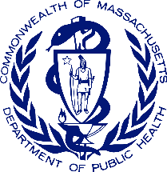

Photo Credit: Brandon Jacoby, bird’s eye view photography of houses. 2017. Unsplash.

Contents

Acknowledgements 3
Background 4
Stakeholder Listening Sessions 7
Findings 8
Discussion 14
Recommendations 17
Action taken by the Office of Problem Gambling Services and Partners 18
Appendix 1: DPH Office of Problem Gambling Community Engagement Strategies 19
Appendix 2: DPH House 20
Appendix 3: Stakeholder Listening Session Questions 21
Appendix 4: Organizations Represented at Stakeholder Listening Sessions 22

Acknowledgements
This report would not be possible without the community members and organizations in attendance at the stakeholder listening sessions in Springfield and Everett. We thank you for your time, energy, insight, and expertise.
Special thanks to Frank Robinson, Baystate Health; Giles Li, Boston Chinatown Neighborhood Center; Jessica Collins, Public Health Institute of Western Massachusetts; Richard Johnson, New North Citizen Council; Soloe Dennis, City of Springfield; the Malden Health Department; and the cities of Everett and Springfield.

Background
The Massachusetts Expanded Gaming Act of 2011 authorized the creation of three casinos and one slot parlor. The slot parlor opened in Plainville in June 2015, and the first of the three regional casinos opened in Springfield in August 2018. The Expanded Gaming Act also lead to the creation of the Public Health Trust Fund (PHTF), which was established to mitigate gambling’s negative health effects on communities throughout the state, especially those in which gambling establishments are located. The PHTF allocates resources for prevention, intervention, treatment, recovery services, and research related to problem gambling.

The Massachusetts Department of Public Health (MDPH) “promotes the health and well-being of all residents by ensuring access to high-quality public health and healthcare services, and by focusing on prevention, wellness, and health equity for all people.” It created the Office of Problem Gambling Services (OPGS) to “ensure a comprehensive and integrated public health response” to problem gambling “that uses data to inform initiatives, engages communities, and ensures cultural intelligence and humility.”

In 2016, MDPH and the Massachusetts Gaming Commission (MGC), which oversees implementation of the Expanded Gaming Act, published a strategic plan laying out potential uses of funding to mitigate problem gambling. The strategic plan’s 11 priority areas are:

- Prevention for Youth
- Prevention for High-Risk Populations
- Focus on Community-Level Interventions
- Coordination of Problem Gambling Services
- Integration of Addiction Services, Mental Health Services, and Primary Care
- Decrease in Stigma and Unsupportive Social Norms
- Increase in Availability of Support Services
- Increase in Availability of Culturally Appropriate Services
- Contribution to the Evidence Base for Problem Gambling Services
- Establishment of an Evaluation Infrastructure
- Expansion of Institutional Capacity to Address Problem Gambling and Related Issues

The strategic plan suggests that community-level prevention interventions are most effective because they originate and take place in people’s social and physical environment. Cultural humility is the idea that one must experience “a process of self-reflection and discovery in order to build honest and trustworthy relationships.” To ensure cultural humility, interventions must include input from the people they intend to benefit.
  - Community Engagement’s Role in Public Health
The Centers for Disease Control and Prevention maintains that a public health system should provide 10 essential public health services (Textbox 1). All indicated activities require community outreach, consultation, involvement, and collaboration. Additionally, with an increased focus on the social determinants of health, community engagement has become a key mechanism for gaining information about the contexts in which people live, work, and play.
Textbox 1. Ten Essential Public Health Services
- Monitor health status to identify and solve community health problems
- Diagnose and investigate health problems and health hazards in the community
- Inform, educate, and empower people about health issues
- Mobilize community partnerships and action to identify and solve health problems
- Develop policies and plans that support individual and community health efforts
- Enforce laws and regulations that protect health and ensure safety
- Link people to needed personal health services and assure the provision of health care when otherwise unavailable
- Assure competent public and personal health care workforce
- Evaluate effectiveness, accessibility, and quality of personal and population-based health services
- Research for new insights and innovative solutions to health problems

Community engagement is “the process of working collaboratively with and through groups of people affiliated by geographic proximity, special interest, or similar situations to address issues affecting the well-being of those people.” While some view community engagement as a singular task, authentic community engagement is a continuum. As illustrated in Figure 1, high-level community engagement requires empowering the community, not just informing or consulting it. MDPH adapted this model from the International Association for Public Participation and created the MDPH House (Appendix 2) to represent its vision and mission, which include “a sharp focus on using data effectively, addressing the social determinants of health, and a firm commitment to eliminate health disparities.”
Figure 1. MDPH Community Engagement Continuum

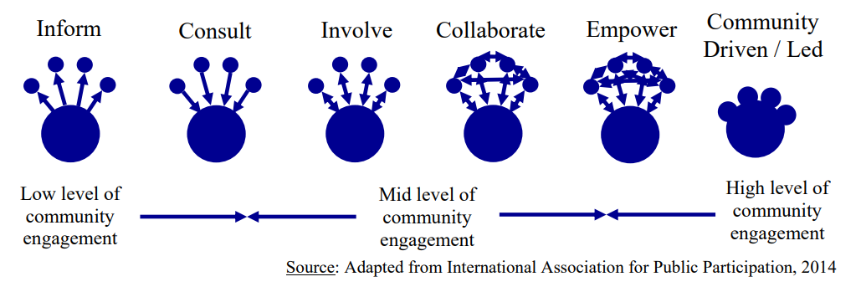

  - Community Profiles: Everett & Springfield
As of 2017, the city of Everett had a population of 46,324. The city is a racially and ethnically diverse area of Massachusetts, with 45.9% of the population identifying as white (non-Hispanic/Latino); 22.9% as Hispanic/Latino; 19.8% as black/African-American; 6.5% as Asian/Asian-American; and 5.9% identifying as two or more races. Forty-one percent of the population of Everett was born outside the United States. As a result, 56.1% of Everett residents over the age of five speak a language other than English at home. According to the U.S. Census, 13.9% of Everett residents are living in poverty, slightly higher than the state average (10.5%).

The city of Springfield’s population, as of 2017, was 154,758. The city is in a racially diverse area of Massachusetts, with 32.6% of the population identifying as white (non-Hispanic/Latino); 43.8% as Hispanic/Latino; 19.8% as black/African-American; 2.2% as Asian/Asian-American; and 4.2% identifying as two or more races. Ten percent of the population of Springfield was born outside the United States, and 38.1% of residents over the age of five speak a language other than English at home. According to the U.S. Census, 28.7% of Springfield residents are living in poverty, more than double the state average of 10.5%.

Everett’s population is much less than Springfield’s. Everett has a higher percentage of foreign-born residents (41.0% v. 10.0%), and a higher percentage of residents who speak a language other than English at home (56.1% v. 38.1%). Everett has a higher percentage of Asian-American residents (6.5% v. 2.2%), while Springfield has a higher percentage of Hispanic/Latino residents (22.9% v. 43.8%). While both cities have poverty levels above the national average, Springfield’s rate, at more than double the national average, merits special considerations for tailoring problem gambling approaches.

Stakeholder Listening Sessions
The Office of Problem Gambling Services hosted two SLSs in FY19. The first was held at the Pioneer Valley Planning Commission in Springfield on September 7, 2018. The second was at the enVision Hotel in Everett on January 24, 2019.
Stakeholders were identified by prior participation in gambling planning processes, the first annual SLS in 2017, or their role as community leaders. All were well-aware of problem gambling and related issues. In total, representatives from about 42 community, government, and service organizations participated.
Both SLSs followed the same format. OPGS Director Victor Ortiz began the meetings by stating the purpose of the listening sessions and reviewing findings from the first annual problem gambling SLS. Mr. Ortiz then gave an overview of the priority areas of the PHTF strategic plan and provided time for staff from Education Development Center (EDC) to share the results of the regional planning processes. He concluded with a review of FY18 and 19 initiatives.
Following the presentation, attendees formed three groups according to the priorities selected by the OPGS as described by the Public Health Trust Funds Strategic Plan: 1) prevention for youth and high-risk populations; 2) community-level interventions; and 3) coordination of problem gambling services. A JSI Research & Training Institute, Inc. (JSI) facilitator began each sub-session discussion with an overview of the assigned topic. Sub-sessions were audio recorded except for one group that declined to be recorded; for this group the facilitator took notes. The questions that each group discussed are in Appendix 3.
When attendees reconvened, a spokesperson from each sub-group presented the most salient points of their group’s discussion. Before closing, Mr. Ortiz answered questions and highlighted next steps.
Stakeholders
SLS participants represented community-based organizations (CBOs) (n=20); universities (n=2); service delivery organizations (n=7); government (n=13); and community members (n=8). Forty-one people attended the Springfield SLS and 33 attended the one in Everett. See Appendix 4 for a full list of the organizations from each community.

Figure 2. Types of organizations in attendance at SLSs (n=41)
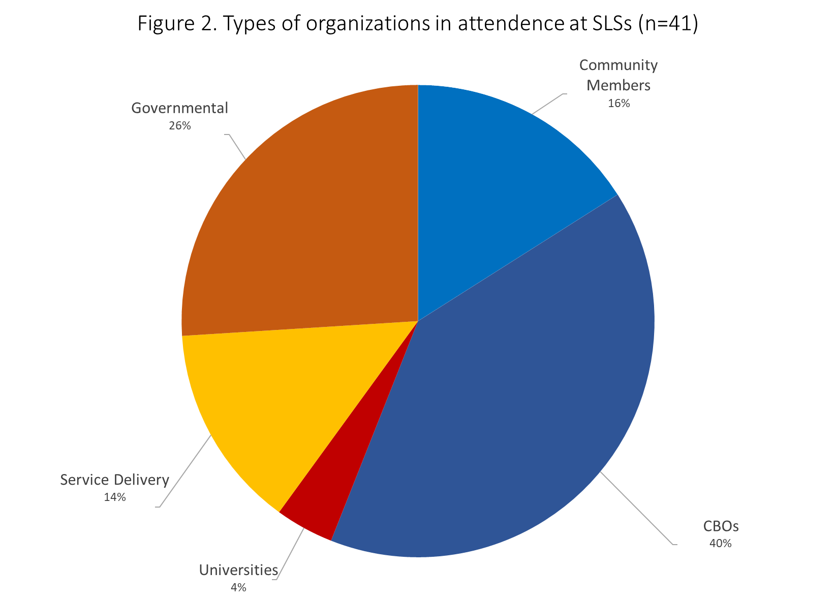
Data Analysis Methodology
JSI recorded and transcribed the content of six sub-session discussion (three from each SLS) and analyzed them with Dedoose qualitative analysis software, which yielded 160 unique excerpts.
The JSI research team analyzed and coded the transcripts through multiple readings and codings. The first level of analysis involved identifying all the themes emerging from the transcripts and developing a codebook through a series of recursive analyses. JSI developed 24 codes using a grounded-theory approach to qualitative analysis in which the researcher develops codes inductively and deductively. The second level of analysis, axial coding, focused on sorting and classifying the constructs to understand participants’ perceptions of and experiences related to this project’s thematic areas.

Findings
The discussions yielded information consistent with the basic components of a service delivery model. In such a model, there is a health condition; those affected by it; services required to address it; and how those services should be delivered. It is important to consider the context in which services are delivered to incorporate the knowledge provided from stakeholders about their communities to ensure the existing “service delivery model” can be tailored to their community’s needs. In the following sections, we report results pertinent to each of the aforementioned components. Findings specific to the Eastern (Everett) or Western (Springfield) regions of the state are highlighted in separate sections.
Who is affected?
The Asian community
There was a significant discussion about the needs of the Asian community, which comprises about 6 percent of Massachusetts’ population and represents an array of countries of origin, languages, education levels, and socio-economic statuses, all of which must be considered when collecting data and developing interventions. The problem, according to a participant, is that Asians are not part of the gambling policy-making process. Their lack of representation likely results in the collection of data that are incomplete, inaccurate, and do not contribute to culturally appropriate service provision.

Participants acknowledged that there is little understanding about how Asian communities experience problem gambling because many Asians and Asian-Americans attach stigma and shame to problem gambling.
“… there is such a heavy stigma around the issue (in the Asian community) , a lot of people with problem gambling, they don't want to admit it. So, I think that what the Asian community often faces stigma with conditions like mental health, domestic violence, that we have to find ways to talk about it without sometimes addressing it directly”
For these reasons, Asians are also reluctant to seek help.
“So they may not go through problem gambling specialists for help, they usually first go to their family or friends, and so, that's where the community-based organization like…will be crucial, because they are the front people in the community.”

Some noted that casino marketing efforts target Asian communities.
“…one thing that happens for the Chinese community and I think a lot of the Asian community is that a lot of ... sometimes the casinos market to our communities specifically. I've known that in other casinos that they'll even have a room setup like with Chinese decorations.”
Youth
A number of excerpts from the group discussion related to problem gambling among youth, an at-risk population with unique characteristics. In particular, youth experience early exposure to gambling through family members and peers. Their gambling modes are different from those of adults. Youth are exposed through video games and social betting. Several participants mentioned the need for youth-focused education on the adverse effects of gambling. Problem gambling services for youth should be coordinated and integrated with the services that they receive in schools and faith- and community-based organizations.

Participants noted that parents need to be involved. As one youth from Everett said,
“I think that education, if we can do some groups of just parents. Because the education can put the parents into talking about gambling with the kids, as it comes with parents. Because parents, they teach, what they say to the kids. And why we teach to the kids, that's where they learn that. So we have to get the groups with the parents first. And after that, we can talk to the youth.”
Similarly, grandparents should also be involved in raising gambling awareness among youth.
“We find that a lot of older people, grandparents are actually the caregivers to a lot of younger people. This is the connection that we cannot afford to miss.”
What types of services should be delivered?
Several observations emerged about the type of services that should be delivered to mitigate the effects of problem gambling. Education was identified as the primary or most important. Stakeholders emphasized the need for education on raising awareness of problem gambling, recognizing its symptoms, and understanding the risk factors. As mentioned above, education should be geared to the community in general and on youth and parents in particular.
How should they be delivered?
Stakeholders emphasized that services should be integrated, coordinated, culturally humble, and delivered by a capable workforce.

Integrated
Services related to gambling need to be well integrated into the mental health and substance use services. They must based on awareness and understanding of risk factors and include screening, assessment, referral, treatment, education, and primary prevention of gambling. Gambling-related services must also be integrated with school-based and services for young people in community settings.

Coordinated
Problem gambling-related services must involve CBOs. This could be arranged by making use of the DPH programming procurement process to ensure service providers participate in a broader collaborative where people could come together, share information, and perfect programming.

Culturally responsive
Participants emphasized the importance of involving service providers who understand the language, history, and culture of the community. One participant said the following about help-seeking behavior in the Asian community:
“What I've heard from our partners in Chinatown is that one of the culturally competent ways to work with problem gamblers, in terms of a family systems approach, or to work with the whole family, and some of them just focus on it as an individual problem, but it's a problem that affects the whole family, and often times you get ... you know about it because a family member has come in, whether there's financial problems or there's abuse in the family.”
Another person mentioned peer-to-peer recovery support:
“people [who] can identify with somebody else who had an addiction to gambling,’ who is “able to sit down and listen to them and also receive help from them. That's what recovery coaching does, somebody who's already been through it and is able to walk a person through it. You don't do it for them. They do it for themselves, because a lot of time they know what they need, but they just need help. So, somebody's suffering from gambling, they know they lost…they lost valuable things, they lost family. All they need is someone to help them.”
Another suggestion was to involve CBOs in efforts of large hospitals or institutions, which are not always rooted in the community they serve and do not have a strong connection to the priority populations. Community-based organizations could be more effective in delivering services.

From the group discussions came the notion of the need for a more nuanced approach to cultural competency. One participant said “just hiring a person who can speak a particular language is not cultural sensitivity.” Of course language availability and racial/community concordance are essential for developing and providing services, but cultural competence goes far beyond the provision of materials in multiple languages.

Language was also mentioned as a core component of cultural responsiveness. One participant said that Springfield had changed a lot in the last 10 years. As such, there are demands for language interpreters other than Spanish. Providers are now serving Nepali, Amharic, Arabic, Russian, and Portuguese speakers.

“a lot of the languages are neither written, or there's no one except for that individual that's from that culture that can even interpret. Moreover, a lot of its dialects, which may not be the official language of the country that they came from."

Another participant said that it is essential to include elements of cultural humility, and talk about the four of types of racism: internalized, intrapersonal, institutional, and structural. “Internalized or personal racism are private beliefs, prejudices, and ideas individuals have within themselves; Interpersonal racism is the expression of racism between individuals; Institutional racism is discriminatory treatment, policies and practices, within organizations and institutions; and Structural racism is the system in which public policies, institutional policies, and other norms perpetuate racial group inequity” Stakeholders emphasized that people who provide services to specific cultural groups must be genuinely aware of and sensitive to their needs, attitudes, behaviors, challenges, and care-seeking behaviors. Stakeholders emphasized the importance of hiring people from targeted communities.
“I think your point of having a service population that represents the population it’s serving is the most important. Because you look at mentors and you look at who's connecting with who, you're more likely to sit down and have a conversation with somebody who looks like you and somebody who has experienced similar things as you have.” (Everett youth)
“They need to train ... hire, and train, individuals from those communities to be community health workers.” (Springfield youth)
This point—the importance of racial-ethnic matching between the service provider and the client— came across most strongly during the discussion of a social marketing media campaign that took place in Springfield. Participants reported on the discontent with the GameSense videos showing a white educator named Chip delivering a message about healthy gambling practices. Participants felt that the spokesperson should have been someone who reflects the racial and cultural makeup of the community. As one participant said,
“I saw ... I was at the meeting at the gaming commission, had launched a snippet of it, and that turned me off. It did not make me want to go further, because the individual that they had, Chip, was the whitest white man that you could ever meet.”
Added to this discussion was the need to have service providers of similar racial and ethnic background as their clients.
“I think it's important to ensure that you are pulling in people of color to go out to talk to people of color and not rely on ... because there's normally a distrust that exists. So if you really want to drill down and address these issues, pull in an Asian- American or a black American and make them be that real mediator. As well as making sure you've got people of color delivering these services. It's not enough just to talk about it, it needs to be a real practice. …. Well I want to be clear, not just liaisons, not just somebody that could talk to the talk. Somebody who looks like the community and can deliver the services.”
Delivered by a capable workforce
One participant mentioned that existing providers know how to deal with substance addiction but not with gambling. For that reason, s/he highlighted the importance of offering:
“…significant training as to how to educate, screen…and treat those with issues in gambling, or at risk of gambling problems, in the mental health and substance use settings.”
Another called attention to the need to train community health workers:
“….support community-based organizations to get funding to support their community health workers, this work can't get done with them. It's so hard to get people to get all the training to be a community health worker, because it's such a significant amount of training.”
What is the context in which these services are being provided?
Place matters
Although the themes that emerged could be applicable to most if not all residents of Massachusetts, some were emphasized in one place more than the other. For instance, the discussion about Asians took place at the SLS in Everett, where there was substantial representation of the Asian community. In Springfield, Puerto Ricans were mentioned more frequently than they were in Everett. Additionally, participants in Springfield said that the state does not provide them with a “fair share of services and financial resources.”

Other concerns
Participants spoke about the disparity between investments to promote gambling and those to mitigate problem gambling.
“One more thing related to timing is that, I know that the Public Health Trust Fund disseminated funds that come from casino revenues, which means that there's no money in there until the casinos are opened and bringing people in. But the planning for the casino and their marketing is years in the making, and the casinos probably have tens of millions of dollars for every one of these sub-populations just to market to come into the casino. [Yet] the PHTF, they say Massachusetts is a model for the country, it's the best.”
Two participants suggested that the marketing approach used by casinos be applied to problem gambling:
“…[use] multiple pathways of community to get the message out. I was thinking in terms of how marketing strategies are used by the casino and everyone else to promote gambling or alcohol or entertainment. The same approach can be taken, and like you said, like internet, different social networks and things like that can promote awareness of problem gambling, and that's important in itself.”
“So, we have to realize that there are people who are marketing gambling and other behaviors to the communities and how that's being done, so we have to have the same approach to combating the negative impact of problem gambling or gambling period.”
Another participant recommended that we use the same strategies as mainstream marketing:
“What we're looking at with gambling, it's a form of addiction, and my job is to show the link between substance abuse disorder and problem gambling that is all here in the brain… we need to promote more initiatives in that direction, advertising, just like advertisers market Chuck E. Cheese, Dave and Busters, programming the kids from [when they are] little ... their Candy Crush, things like that. Going to the casino, you would see that represented there.”

Discussion
Stakeholders in both cities provided insight on many important topics. The themes that were most prominent and complex are discussed below.
  - Cultural Competency
There is an urgent need for cultural competence in problem gambling programs, services, and education. Stakeholders mentioned the need for linguistic competence and interpretation not only for common languages such as Spanish and Haitian Creole, but Arabic, Russian, Vietnamese, and African languages like Amharic, too. While only a small percentage of Massachusetts residents speak some of these languages (0.6% of the MA population speaks Russian, 0.5% speak Arabic, and 0.5% speak African languages including Amharic), services for at-risk populations should not neglect the needs of people who speak these languages and live in priority areas.

However, stakeholders in both Springfield and Everett noted that cultural competency goes far beyond basic language availability and translation services. It involves a deep understanding of and relationship to the community that one is serving. This true cultural competence should be reflected in program development, material content, and who is hired to deliver programs, services, and education to the community. Stakeholders correctly pointed out that people who identify and/or come from the same communities are more likely to understand the needs of, bond with, and establish trust with their clients.

Pay special attention to the disproportionately affected populations identified by the OPGS, such as youth and men of color with history of substance misuse, and people identified by stakeholders at the SLSs, such as Asian-Americans and Hampden County residents. Problem gambling programs, services, and education should be based on/acknowledge the racial and ethnic disparities in health outcomes that persist in the United States, even when insurance status, income, and age are controlled for. Specifically, in the case of problem gambling, African Americans and people of low socio-economic status gamble at lower rates than other groups but those who do gamble are far more likely to experience problem gambling.
  - Marketing & Funding
Stakeholders in Springfield and Everett expressed concerns about marketing campaigns run by casinos and their effect on marginalized populations. Most advertisements portray gambling as a glamourous leisure activity and do not mention or allude to its risks and harms. Additionally, when risks or disclaimers are included, they are asides, in small print, and/or conveyed at accelerated fleeting speed, and are not noticed or taken by audiences as seriously as they would be if presented alone. Vulnerable populations, especially youth, have been shown to be particularly influenced by pro-gambling advertisements. Stakeholders noted that casinos begin marketing before they officially open.

The OPGS has limited marketing experience and resources. That said, it could maximize effectiveness of its health promotion strategies by enhancing its cultural and linguistic responsiveness, and work with communities to develop creative messages and ways to reach target populations.

Stakeholders also said that the funding needs of CBOs that want to expand services to mitigate problem gambling must be met. Stakeholders noted that training staff to address problem gambling and develop outreach programs takes significant time and resources. They advocated for sustainable state-wide problem gambling mitigation efforts that will allow funded organizations to collaborate and adapt each other’s best practices.
  - Continued Community Engagement
In 1978, the World Health Organization sponsored a conference to ratify the Alma Ata Declaration, which states that “health requires and promotes maximum community and individual self-reliance and participation in the planning, organization, operation and control of primary health care, making fullest use of local, national and other available resources; and to this end develops through appropriate education the ability of communities to participate…” Stated more simply, community participation assures the public’s input into public health, and increases the public’s trust in government.
The stakeholder listening sessions were MDPH’s avenue for critical community contributions to its strategy for mitigating problem gambling in the state. Stakeholders discussed cultural characteristics of specific populations and the types of services they need, how those services should be delivered, the context in which to deliver them, and the resources to do so.
Stakeholders also reinforced the urgency for action: long before the casino was approved in Springfield, the need for social services to mitigate the effects of problem gambling—especially culturally competent services—were well known among stakeholders in the state. Yet seven months after the Springfield casino opened for business, those needs are unmet, and Hampden County remains a Health Resources and Services Administration-designated behavioral health shortage area.
Stakeholder listening sessions are a way to rebuild trust in public institutions, especially health institutions, which has eroded over the last several years. This is true among the general public and more so for people of color. One strategy to restore trust is by providing communities opportunity to influence decisions through collaboration. Events like the stakeholder listening session offer a small segue into this form of collaboration by letting affected communities voice their opinions and make recommendations. A core tenet of implementation practices is that the end-user of a service must inform the planning and implementation of that service.
  - Tailored approaches to Western and Eastern Massachusetts
The cities of Everett and Springfield have key differences that will directly affect problem gambling programming service delivery. While Asian-Americans were a population of concern in Everett, stakeholders at the listening session in Springfield were more concerned about the distribution of resources and access to funding in their region. Geographically speaking, Everett residents have much easier access to resources in the state capital of Boston, which is reachable by public transit, than residents of Springfield, who live more than 100 miles from Boston. These differences must inform the way that programs, services, and education are designed, funded, and delivered in the two regions.

Recommendations
The following recommendations are based on data from the SLSs and our approximation of how OPGS might respond to the needs expressed by the people who participated in them:

- Tailor interventions to the needs of the community. More specifically, expand outreach and services to the Asian community surrounding the Everett casino and the communities that feel ignored in Springfield.

- Incorporate family-level interventions to deliver education and prevention strategies.

- Integrate and coordinate problem gambling mitigation activities with existing mental health, substance abuse, primary care, and social services.

- Advocate for sustainability of CBOs that mitigate problem gambling, and invite other organizations that community members trust get involved.

- Include prevention and treatment strategies that address the entire life context of the person (as opposed to gambling-only interventions).

- Make use of innovative knowledge development strategies such as a learning collaborative to uncover ways to address problem gambling

- Create a strategic plan that counters casino marketing efforts. Apply marketing approaches used by the casino industry to reveal the downside of gambling.

Action taken by the Office of Problem Gambling Services and Partners
The actions listed below reflect the values of diversity, community centeredness, and racial equity, and may be a direct or indirect result of the Stakeholder Listening Sessions.

- OPGS has developed expanded racial equity language, which includes “services anchored in the community” and incorporated it within all of the FY 19 prevention procurements.

- OPGS awarded the Statewide Gambling Prevention Technical Assistance Center contract, which is responsible for providing technical assistance for gambling prevention programs with a specific focus on racial equity and addressing health disparities.

- OPGS awarded Project Build Up: a treatment workforce initiative, which is responsible for supporting and providing grants to 40 outpatient centers on workforce development initiatives. These initiatives include the development of recruitment and retention strategies with a specific focus on racial equity.

- OPGS awarded the Community Level Health Project: a community-based organization within the host communities of Region A and B (Greater Springfield and Greater Everett) will identify and address a specific gambling-related health concern and outline improvement initiatives to be carried out at the community level.

- The Massachusetts Gaming Commission has conducted diversity and community trainings for all GameSense Advisors.

- The Massachusetts Gaming Commission with support from the Department of Public Health awarded community engaged research grants. In FY19 three grants were awarded exploring gambling behavior and/or impacts on older adults, Hispanic and Latino communities in Greater Springfield and heterogeneous cultural and social Asian communities in Boston’s Chinatown.

- The Massachusetts Gaming Commission has translated the Voluntary Self- Exclusion program in multiple languages.

- The Massachusetts Gaming Commission with support from the Department of Public Health is re-procuring the “Gambling Research” contract, with a specific focus on the social determinants of health, racial equity, and community driven research.

Appendix 1: DPH Office of Problem Gambling Community Engagement Strategies
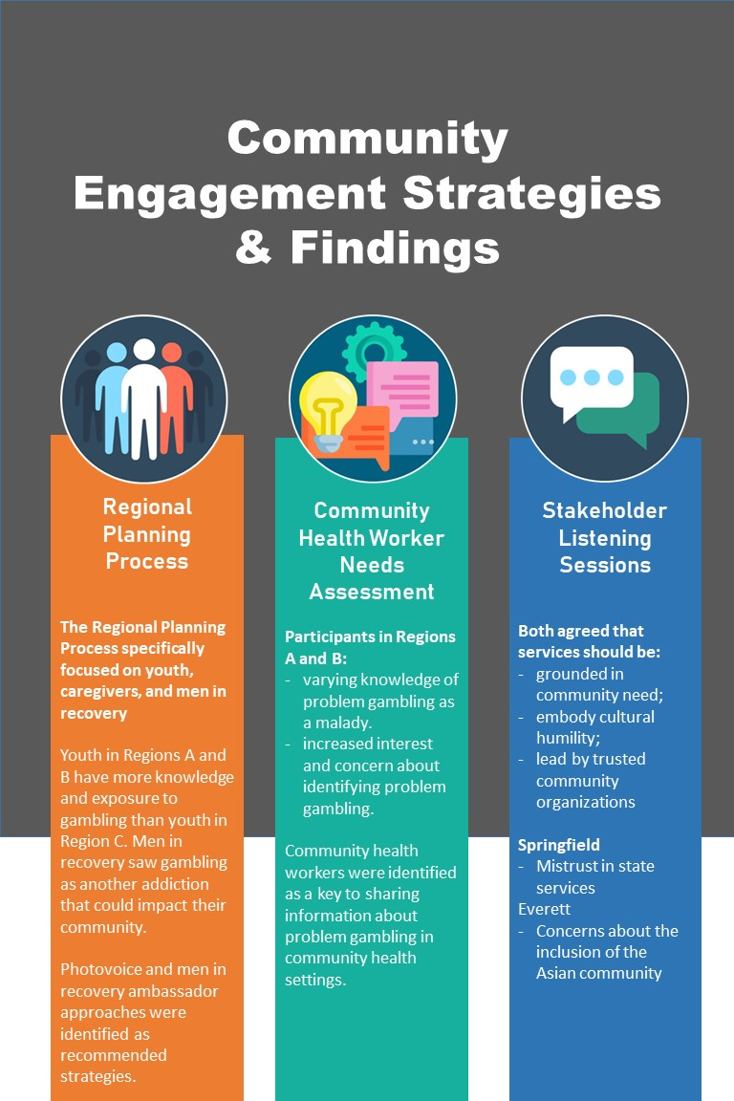

Appendix 2: DPH House
The MDPH House is built on the principles of excellence, passion, innovation, inclusiveness, and collaboration. The combination of MDPH’s vision, goals, and commitment to community engagement are also the foundation of the Office of Problem Gambling Services’ work.

VISION
Optimal health and well-being for all people in Massachusetts, supported by a strong public health infrastructure and health care delivery.

MISSION
Prevent illness, injury, and premature death; ensure access to high-quality public health and health care services; and promote wellness and health equity for all people in the Commonwealth.

DISPARITIES
We consistently recognize and strive to eliminate health disparities among populations in Massachusetts, wherever they may exist.
DETERMINANTS
We focus on the social determinants of health— the conditions in which people are born, grow, live, work, and age—that contribute to health inequities.
DATA
We provide relevant, timely access to data for researchers, press, and the general public in an effective manner to target disparities and impact outcomes.

EVERYDAY EXCELLENCE

PASSION AND INNOVATION

INCLUSIVENESS AND COLLABORATION

Appendix 3: Stakeholder Listening Session Questions
- What cultural competency and/or community approaches would you recommend to DPH’s Office of Problem Gambling Services for the implementation of the FY 19 initiatives?
- What cultural and/or communities needs are not being met/represented by the FY 19 DPH Problem Gambling Initiatives?
- Please list recommendations that can be used for future planning related to meeting the needs of priority populations and communities.

Appendix 4: Organizations Represented at Stakeholder Listening Sessions
Springfield |  | Everett
South Middlesex Opportunity Council |  | Boston Chinatown Neighborhood Center
New North Citizens Council |  | Cambridge Health Alliance
Multicultural Wellness |  | North Suffolk Public Health Collaborative
UMass School of Public Health |  | City of Everett Health Department
Springfield Department of Health and Human Services |  | Eliot-Everett Clinic
Gandara Center |  | Brookline Public Health
Choice Recovery |  | Vietnamese American Initiative for Development
Public Health Inst. of Western Mass |  | Asian Taskforce Against Domestic Violence
Sunrise Beyond Health Clinic |  | Lynn City Hall
Educational Development Center |  | City of Malden Board of Health
West Springfield Board of Health |  | Asian American Commission
AQCA SCARF |  | Tufts University
BACE-Black Counselor Education Program |  | Hampden County Probate and Family Court
Restoration Worship Center |  | Mass Men Project
African Diaspora Mental Health Association |  | La Comunidad, Inc.
Baystate Health |  | Chelsea District Court
Ready EDI |  | North Suffolk Mental Health Association
 |  | Everett Fire Department
 |  | MassTapp/Educational Development Center
 |  | Asian Women for Health
 |  | City of Everett
 |  | Southeast Asian Coalition of Massachusetts
 |  | Gandara Center

Massachusetts Department of Public Health and Massachusetts Gaming Commission (2016). Strategic Plan: Services to Mitigate the Harms Associated with Gambling in Massachusetts. Available at: https://www.mass.gov/files/documents/2016/07/st/problem-gambling-strategic-plan.pdf.
Yeager, K. A., & Bauer-Wu, S. (2013). Cultural humility: essential foundation for clinical researchers. Applied nursing research : ANR, 26(4), 251–256. doi:10.1016/j.apnr.2013.06.008
Centers for Disease Control and Prevention (2018). The Public Health System & the 10 Essential Public Health Services. Available at: https://www.cdc.gov/publichealthgateway/publichealthservices/essentialhealthservices.html.
Centers for Disease Control and Prevention (2011). Principles of Community Engagement. Available at: https://www.atsdr.cdc.gov/communityengagement/pdf/PCE_Report_508_FINAL.pdf.
Massachusetts Department of Public Health (2017). Massachusetts State Health Assessment. Available at: https://www.mass.gov/files/documents/2017/10/04/MDPH%202017%20SHA%20Intro.pdf.
Massachusetts Department of Public Health (2017). Community Engagement Standards for Community Health Planning Guideline. Available at: https://www.mass.gov/files/documents/2017/01/vr/guidelines-community-engagement.pdf
QuickFacts: Everett city, Massachusetts. (n.d.). Retrieved from United States Census Bureau website: https://www.census.gov/quickfacts/fact/table/everettcitymassachusetts/PST045217.
Income and poverty in the United States: 2017. (n.d.). Retrieved from United States Census Bureau website: https://www.census.gov/library/publications/2018/demo/p60-263.html.
QuickFacts: Springfield city, Massachusetts. Retrieved from United States Census Bureau website: https://www.census.gov/quickfacts/springfieldcitymassachusetts.
Participants did not delve into the nature of gambling as a health problem because they have discussed this on multiple previous occasions.
Phyllis Jones,C. (2000). Levels of Racism: A Theoretic Framework and a Gardener’s Tale. https://ajph.aphapublications.org/doi/pdf/10.2105/AJPH.90.8.1212.
Data USA: Massachusetts. Retrieved from https://datausa.io/profile/geo/massachusetts/.
Nelson, A. (2002). Unequal treatment: Confronting racial and ethnic disparities in health care. Journal of the National Medical Association, 94(8), 666–8.
Welte, J., Barnes, W., Tidwell, G., & Hoffman, M. (2008). The Prevalence of Problem Gambling Among U.S. Adolescents and Young Adults: Results from a National Survey. Journal of Gambling Studies, 24(2), 119–133.
Parke, A., Harris, A., Parke, J., & Rigbye, J. (2014). Responsible marketing and advertising in gambling: A critical review. The Journal of Gambling Business and Economics, 8(3), 21–35.
Friend, K., & Ladd, G. (2009). Youth gambling advertising: A review of the lessons learned from tobacco control. Drugs: Education, Prevention and Policy, 16(4), 283–297.
WHO called to return to the Declaration of Alma-Ata. Retrieved from World Health Organization website: https://www.who.int/social_determinants/tools/multimedia/alma_ata/en/.
Banks, PS. (2008). Recommendations to the Campus Committee: An Organizing Strategy for the North End of Springfield, MA (Unpublished Master Thesis in City Planning Thesis. Massachusetts Institute of Technology, Boston, MA.
https://data.hrsa.gov/tools/shortage-area/hpsa-find.
Cooper, J. (2018). Congress and the decline of public trust. Routledge.
Armstrong, K., Rose, A., Peters, N., Long, J. A., McMurphy, S., & Shea, J. A. (2006). Distrust of the health care system and self-reported health in the United States. Journal of general internal medicine, 21(4), 292.
Kennedy, B. R., Mathis, C. C., & Woods, A. K. (2007). African Americans and their distrust of the health care system: health care for diverse populations. Journal of cultural diversity, 14(2).

