Charles D. Baker  Governor  Karyn E. Polito  Lieutenant Governor  Thomas A. Turco, III  Secretary of Public Safety and Security |  |  | Terrence Reidy  Undersecretary  Chief Robert J. Ferullo, Jr. ret.  Interim Executive Director

 | Commonwealth of Massachusetts  Municipal Police Training Committee  “Training for Today, Planning for the Future” | 6 Adams Street  Randolph, MA 02368  Phone: (781) 437-0300  Fax: (781) 963-0235 | 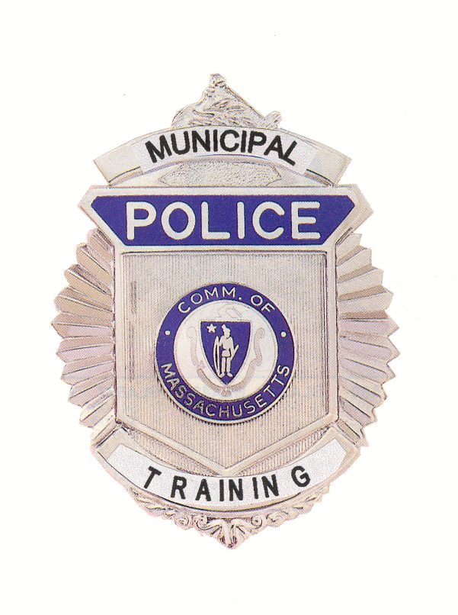
 | MEMORANDUM
TO: | Secretary of State (delivered via email to regs@sec.state.ma.us)  Department of Administration and Finance  (delivered via mail to melissa.andrade@state.ma.us)
FROM: | Chief Robert Ferullo, Interim Executive Director
DATE: | July 10, 2020
RE: | Administrative Hearing

NOTICE OF DISCIPLINARY HEARING
Under the provisions of G.L. c. 30A, the Police Standards Subcommittee of the Municipal Police Training Committee will conduct a Disciplinary Hearing virtually on Tuesday, July 14, 2019 at 10:00 am.

To view this meeting on computer, laptop, tablet or smartphone with speakers and microphone, use the link below at the above date and time:

Join Zoom Meeting
https://zoom.us/j/95253904942?pwd=NW5IYUlhM1RGdng1K3o3clFWb3RRQT09

Meeting ID: 952 5390 4942
Password: 403981

Dial by your location
+1 929 436 2866 US (New York)
Meeting ID: 952 5390 4942

Agenda

Tuesday, July 14, 2020

10:00 a.m. – Police Standards Subcommittee Meeting to consider the dismissal appeal of Mohammed Islam from the Cambridge Police Academy at Northeastern University.

