Agency Name
Safety and Security Program
Emergency Action Plan
DATE

Foreword
This template was developed by the Massachusetts Emergency Management Agency (MEMA), to be used by Executive Branch Agency partners in the development of their Facility Emergency Action Plan. It is designed to be used in accordance with requirements set forth in Executive Order 511, and relevant OSHA standards. The contents within are able to be customized by any agency, and can be expanded or contracted as necessary. As a general rule, the template follows these color conventions:
Yellow Highlighted Text: Text that must be customized by the Agency completing the Template.
Gray Highlighted Text: Guidance that can help the Agency complete a certain section of the Template, or provide insight into sample text that can be altered to match the needs of the Agency.
The list of Threats and Emergencies in Section 5.0 can be adjusted to meet the needs of your Agency. The threats and emergencies included in this template are some of the more common experienced in many facilities, but can be augmented to meet the needs of your Agency. Similarly, the Appendix template should be completed for each facility within your Agency. These Appendices take the guidance in the plan and bring it into the specifics needed for each building in your Agency. This list can be expanded as needed, based on the number of facilities covered.
This facility Emergency Action Plan can be built alongside and in conjunction with your Department/Agency’s Continuity of Operations Plan (COOP), to ensure overall preparedness for any event that may impact your department or agency.

Table of Contents
Record of Change iv
1.0 Introduction 1
1.1 Purpose 1
1.2 Scope 1
2.0 Situation and Planning Assumptions 1
2.1 Situation 1
2.2 Planning Assumptions 1
3.0 Roles and Responsibilities 2
3.1 Agency Name Safety Committee 2
3.2 Agency Name Facility Emergency Action Plan Contact 2
3.3 Agency Name Facility Emergency Liaison 2
3.4 All Agency Name Employees 2
4.0 Accountability 3
5.0 Threats and Emergencies 3
5.1 Medical Emergencies 4
5.2 Active Shooter/ Hostile Event 4
5.2.1 Active Shooter/ Hostile Event Reporting and Notification 5
5.2.2 Reacting to an Active Shooter/ Hostile Event 5
5.2.3 Individuals with Access and Functional Needs (AFN) 6
5.2.4 After an Active Shooter/ Hostile Event 6
5.2.5 Key Actions During a Hostage Situation 6
5.3 Bomb Threat 7
5.4 Fire 7
5.5 Hazardous Materials 8
5.6 Earthquake 9
6.0 Administration and Logistics 9
6.1 Plan Maintenance 9
6.2 Safety Training and Exercises 10
7.0 Plan Authorities and References 10
7.1 Authorities 10
7.2 References 11
Appendix A: Facility Emergency Action Plan 12
Appendix B: Bomb Threat Checklist 14

Record of Change

Contact/ Section | Date of Change | Page/Section Changed | Summary of Change

1.0 Introduction

The Agency Name maintains an Emergency Action Plan as part of its Safety and Security Program. This plan provides general information on what to do in the event of an emergency. There is an appendix for each Agency Name office which provides location-specific information that may be needed during an emergency. As a best practice, it is recommended that staff have their assigned office appendix printed and easily available in the event of an emergency.

Purpose
The purpose of the Emergency Action Plan is to inform and educate Agency Name employees about safety and security issues. The plan is designed to instruct employees before, during, and after an incident through awareness and training activities. It will help reduce the risk of workplace injuries and provide solutions to specific safety issues. It will ensure compliance with both federal and state health and safety standards.
As outlined, not every situation or emergency is defined in this plan. However, the framework has been developed to ensure awareness and the proper basic steps to be taken on any threats, impacts, and other emergency actions that may arise.

1.2 Scope
The Emergency Action Plan applies to all staff and visitors within Agency Name’s facilities across the Commonwealth. This plan features incident related roles, responsibilities, and/or response requirements. This document provides:
- An outline for Agency Name to identify and respond to specific risks and threats.
- Roles and responsibilities related to emergency situations.
- Region specific appendices.
- Additional Resources.

Employees in Massachusetts must comply with OSHA regulations to establish an Emergency Action Plan as part of its Safety and Security Program. Agency Name’s Safety Committee maintains this Plan and updates it regularly to ensure full compliance.

2.0 Situation and Planning Assumptions

2.1 Situation
Agency Name employees may be subject to a variety of workplace emergencies such as, medical, active shooter/ hostile event, fire, and workplace injury. In these situations, being educated on the emergency procedures of who to call, where to go, and how to act will not only improve the safety of employees but help save lives.

2.2 Planning Assumptions
- The Emergency Action Plan is intended for use by all Agency Name employees and visitors;
- Staff safety and protection of life is always the priority. Preservation of Agency Name’s essential mission functions, documents, and resources will follow life safety;
- 9-1-1 is a tool that can be utilized during an emergency by any staff member;
- Emergency responders’ directions will be followed to ensure a coordinated response;
- A variety of threats and hazards exist which could impact Agency Name’s staff and facilities;
- An incident at one facility may or may not impact all other facilities;

3.0 Roles and Responsibilities

3.1 Agency Name Safety Committee
In accordance with Executive Order 511, Agency Name established a Safety Committee in 2015. The Safety Committee consists of personnel representing different disciplines and Agency Name’s multiple work locations. This committee meets on a regular basis, and ensures that safety regulations and requirements are followed, that safe work practices are maintained, and that recommendations for continued safe work environments are made to Agency Name’s Senior Staff. The Safety Committee is tasked with ensuring this Emergency Action Plan is maintained and implemented at all of Agency Name’s facilities. Further, the Safety Committee, working with Human Resources, assists in investigating workplace accidents.

3.2 Agency Name Facility Emergency Action Plan Contact
The components of this Emergency Action Plan are maintained and managed by {Insert Appropriate Agency Name Department}. Staff who wish to ask questions, discuss concerns, or have recommendations regarding this plan can speak with the following staff positions. This is to ensure that transparency and sound lines of communication are maintained:
- {INSERT APPROPRIATE STAFF NAMES AND POSITIONS HERE}

3.3 Agency Name Facility Emergency Liaison
During events where public safety departments respond to a Agency Name Facility to provide support, a liaison should meet with the Incident Commander or first arriving public safety official to provide knowledge of the facility if needed. Additionally, this person may not be a regular Facilities contact, but could be a manager or staff member at a Regional Office or other location who would perform the same duty during an emergency.

3.4 All Agency Name Employees
Every employee is responsible for being familiar with the emergency procedures outlined in the Emergency Action Plan. In addition, each employee shall:
- Come to work each day with the expectation that the Emergency Action Plan could be activated, which could include evacuating in inclement weather or being required to alter your work schedule with little notice due to an emergency.
- Employees are responsible for their personal preparedness, including appropriate clothing, medication, and food.
- Know where the exits are located and become familiar with the best route out of the building.
- In the event of a workplace accident, staff are required to report the event to their supervisor who will then report the incident to the Human Resource department. HR must report the injury within hours of the incident.
- Talk with their manager/supervisor about evacuation rally points (see 5.0 for guidance on Evacuation Procedures) and how to maintain communication in the event of an emergency.
- In an evacuation, work to assure the following:
  - All areas are vacated (including the restrooms).
  - All electrical appliances are turned off.
  - All doors are closed.

4.0 Accountability
At all Agency Name facilities, it is critically important to ensure effective staff and visitor accountability practices are maintained. In the event of a building evacuation or emergency, these practices will help to ensure that all building occupants are safely evacuated and accounted for. It will also help rescuers focus their efforts should someone be missing. Agency Name staff are required to utilize {Insert Description of the accountability system utilized at your facility (scan in, swipe in, sign in, etc.} when entering and leaving the facility. Visitors must sign in and sign out on visitors logs at each facility when they are in the building as well.

5.0 Threats and Emergencies
While Agency Name ensures an all-hazards approach to its planning and training initiatives, there are several specific hazards which, from a safety perspective, are of a higher priority and thus are specified in this plan. Employees should be cognizant that the hazards listed in Section 5.0 are specific to Agency Name’s facilities. Safety considerations during all other hazards must also be taken into account.
For any threat or emergency, calling 9-1-1 should be a priority to ensure help is quickly requested. While additional information is provided in the following sections to describe specific information by emergency, the following general guidance can be followed when calling 9-1-1:
- Stay on the line with the dispatcher.
- Provide the address of the building involved and your exact location. This is especially important if you are calling from a cell phone.
- Provide a thorough description of the incident to ensure that proper resources are dispatched.
- When providing a description of an individual, describe from the top (head) to bottom (feet)
- Do not hang up until the dispatcher tells you to.

In the event calling 9-1-1 is not an option, “Text to 9-1-1” may be a safe alternative, especially when talking out loud may put a person in more danger, such as during an Active Shooter/Hostile Event. All 9-1-1 Call Centers in the Commonwealth now have the ability to receive a text message through their system. This allows those in need of emergency services to utilize their cell phone to contact 9-1-1 when they are unable to make a voice call.
Several of the threats and emergencies identified below consider evacuation from the building as an option to ensure staff safety. While evacuation details pertaining to each threat or emergency in the following sections give greater specific context, the following general evacuation considerations should be kept in mind during any building evacuation:
- Close, but do not lock interior doors. Locked doors can hamper rescue operations;
- Unless directed otherwise, use the nearest exit to exit the building;
- As you leave please observe the following:
  - NEVER return to your office if you are located in another part of the building. Evacuate immediately;
  - If it does not delay your evacuation take personal possessions (i.e. ID, keys, purse, valuables, etc.) with you;
  - Assist your co-workers, contractors, office visitors, and those with access and functional needs as necessary.

Workforce management has a primary responsibility for the safety and security of their staff. As individuals with Disabilities and Access and Functional Needs (AFN) are employed throughout the workforce, management needs to understand how to best integrate their needs into emergency planning, such as evacuation procedures and crisis communication.

5.1 Medical Emergencies
Medical emergencies could occur with little to no warning, and may require a swift response from rescuers. All of Agency Name’s facilities maintain a cache of first aid equipment. Additionally, each office has an Automatic External Defibrillator (AED), which can be used to treat someone who experiences sudden cardiac arrest. If any medical equipment is used or expires, it should be reported to the Safety Committee to ensure its replacement. While there are many types of medical emergencies, general guidance for responding to any of them is contained below:
- Call 9-1-1 if emergency medical services are needed to treat an ill or injured person.
- Remain calm.
  - Report your location.
  - Follow the dispatcher’s instructions and answer their questions
  - Be prepared to meet the first responders once they arrive or send someone to meet them at the entry door to be used to access the victim.

After a medical emergency, notification of the emergency must be made to your manager or supervisor. Medical emergencies should be reported to Human Resources to ensure both the victim and responders receive any follow up needed to allow for a safe return to work. The Human Resources Director is required to report a workplace injury within 48 hours of the occurrence.
The Workers' Compensation Unit manages claims for the Commonwealth's workforce (excluding the uniformed State Police) in compliance with Chapter 152 of the Massachusetts General Laws. A Notice of Injury/Illness Report is filed whenever an employee reports that he/she has suffered an industrial accident during the course of employment.

5.2 Active Shooter/ Hostile Event
When an active shooter/hostile event is in or near the building, quickly determine the most reasonable ways to protect your own life. Remember that visitors are likely to follow the lead of employees and managers during an active shooter situation.

Because active shooter/hostile event situations are often over before law enforcement arrives on the scene, the individual must be prepared both mentally and physically to deal with an active shooter/hostile event situation.

5.2.1 Active Shooter/ Hostile Event Reporting and Notification
Rapid notification of these events are critical to ensure a timely law enforcement response. While keeping safety in mind, rapid reporting should be done as soon as possible.
- Call 911 to immediately report the event:
- If placing a voice call to 9-1-1 is not safe, then consider texting 9-1-1 from a cellular phone
- See relevant appendices for additional office-specific information

Information to provide to law enforcement or 9-1-1 operator:
- Location of the active shooter/active attacker
- Number of shooters/attackers, if more than one
- Identification of the attacker if it is known
- Physical description of shooter(s)/attacker(s)
- Number and type of weapons held by the shooter(s)/attacker(s)
- Number of potential victims at the location

5.2.2 Reacting to an Active Shooter/ Hostile Event
Staff must quickly determine the most reasonable ways to protect your own life. Remember that visitors, contractors, or interns are likely to follow the lead of employees during an active shooter/ hostile event situation.

Staff should consider the following guidance, in order, when responding to such a threat:

- RUN and escape, if possible.
  - Getting away from the shooter or shooters is the top priority.
  - Leave your belongings behind and get away.
  - Help others escape, if possible, but evacuate regardless of whether others agree to follow.
  - Warn and prevent individuals from entering an area where the active shooter may be.
  - Call 911 when you are safe, and describe shooter, location, and weapons.
- HIDE if escape is not possible.
  - Get out of the shooter’s view and stay very quiet.
  - Silence all electronic devices and make sure they won’t vibrate.
  - Lock and block doors, close blinds, and turn off lights.
  - Don’t hide in groups- spread out along walls or hide separately to make it more difficult for the shooter.
  - Try to communicate with police silently. Use text message or social media to tag your location, or put a sign in a window.
  - Stay in place until law enforcement gives you the all clear. Your hiding place should be out of the shooter's view and provide protection if shots are fired in your direction.
- FIGHT as an absolute last resort.
  - Commit to your actions and act as aggressively as possible against the shooter.
  - Recruit others to ambush the shooter with makeshift weapons like chairs, fire extinguishers, scissors, books, etc.
  - Be prepared to cause severe or lethal injury to the shooter.
  - Throw items and improvise weapons to distract and disarm the shooter.

5.2.3 Individuals with Access and Functional Needs (AFN)
The current mantra taught for personal protection during an active shooter/hostile event attack is “Run, Hide, Fight.” While reasonable and appropriate, each of those steps has AFN related implications. Persons with disabilities and AFN should ensure their individual needs are integrated into their organization’s emergency evacuation plan, develop a buddy system for assistance evacuating or concealing themselves to avoid an attacker, and think creatively about how to use personal assistance devices (e.g., canes, crutches) as weapons during an Active Shooter/ Hostile Event type of attack.

5.2.4 After an Active Shooter/ Hostile Event
- Follow law enforcement instructions and evacuate in the direction they come from, unless otherwise instructed.
- Keep hands visible and empty.
- Know that law enforcement’s first task is to end the incident, and they may have to pass injured along the way.
- Officers may be armed with rifles, shotguns, and/or handguns and may use pepper spray or tear gas to control the situation.
- Officers will shout commands and may push individuals to the ground for their safety.
- Take care of yourself first, and then you may be able to help the wounded before first responders arrive.
- If the injured are in immediate danger, help get them to safety.
- While you wait for first responders to arrive, provide first aid. Apply direct pressure to wounded areas and use tourniquets if you have been trained to do so.
- Turn wounded people onto their sides if they are unconscious and keep them warm.
- Consider seeking professional help for you and your family to cope with the long-term effects of the trauma.

5.2.5 Key Actions During a Hostage Situation
Hostage situations are incredibly stressful scenarios. The following items outline some considerations in the rare event that such a situation presents itself at a facility.
- Be patient. Avoid drastic action.
- The initial 45 minutes are the most dangerous. Follow instructions and be alert. The captor is often emotionally unstable. Don’t make mistakes that could jeopardize your well-being.
- Don’t speak unless spoken to and then only when necessary. Don’t talk down to the captor, who may be agitated. Avoid appearing hostile.
- Maintain eye contact with the captor at all times, if possible, but do not stare. Treat the captor respectfully.
- Comply with instructions as best you can and avoid arguments.
- Be observant. You may be released or have an opportunity to escape. The personal safety of others may depend on your memory.
- If medications, first aid, or restroom privileges are needed by anyone, say so.

5.3 Bomb Threat
A bomb threat can be made in multiple ways, including by phone or email, and includes a threat to a facility to detonate an explosive or incendiary device to cause property damage, death, or injuries. Whether or not a device actually exists, all threats must all be taken seriously. It is up to responding law enforcement to determine if a bomb threat is legitimate or is a hoax. All threats will be treated the same way by staff, utilizing the following guidance.
- Remain calm.
- If the bomb threat is received over the telephone, take notes during or immediately after the call.
  - Keep the caller on the line as long as possible. Be polite, show interest, and try to keep the caller talking.
  - DO NOT HANG UP, even if the caller does.
  - If possible, signal or pass a note to other staff to listen and help notify authorities.
  - Write down as much information as possible (such as caller ID number, the exact wording of threat, and type of voice or behavior).
    - Please reference Appendix F for detailed guidance
  - Record the call, if possible.
- Do not activate the fire alarm.
- Notify authorities immediately
  - Call 9-1-1. Seek immediate guidance from law enforcement over the phone regarding evacuation.
    - If you are told to evacuate, do so immediately. Assist co-workers, contractors, visitors, and those with access and functional needs as necessary.
- If practical, notify your supervisor or any Manager who is in the building.

5.4 Fire
The risk from fire poses a threat at each Agency Name Facility. Good fire safety practices should be maintained, including maintaining familiarity with facility evacuation and assembly plans. In addition, knowing the locations of installed fire extinguishers at each facility can save critical time in the event they are needed.
In the event of a fire, the following guidance can be considered:
- Call 9-1-1 any time there is a fire, you need help, or you are not sure what to do
- If the fire has just started, is still contained and has not spread to other materials, locate the closest portable fire extinguisher and utilize it following these steps:
  - Pull the Pin
  - Aim the fire extinguisher at the base of the fire
  - Squeeze the trigger
  - Sweep the fire extinguisher stream from side the side
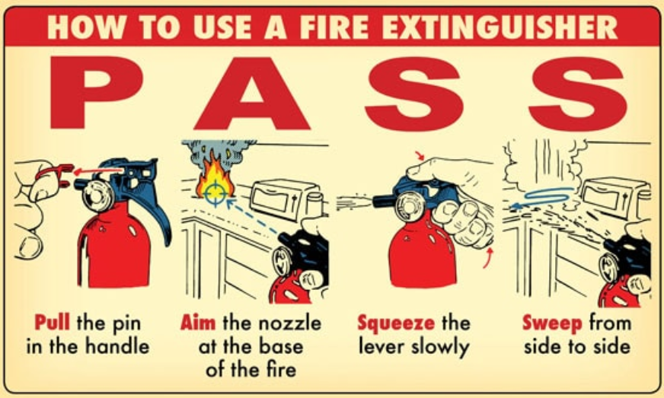
- If you are unable to extinguish the fire, or there is smoke, locate the nearest exit and evacuate the area.
- Assist co-workers, contractors, visitors, and those with access and functional needs as necessary.
- Pull the fire alarm to notify other occupants of the need to evacuate if the alarms have not already activated automatically. Horns and strobes will activate to provide audible and visual warning.
- Close doors behind you as you leave
- Meet at your established assembly point and ensure that all staff and visitors are accounted for.
- Report any missing people and fire conditions when you evacuated to arriving fire personnel.
- Once all staff are safe and emergency services are on scene, notify senior staff, and your supervisor or manager

5.5 Hazardous Materials
{Provide a description of the types and quantities of hazardous materials stored or used by your Agency. This section can also describe various safety precautions and emergency notifications that need to be taken based on these quantities and any potential spill or release. Safety Date Sheets (SDS) can also be referenced in this section. Some agencies may have little or no hazardous materials stored on site, while others maintain large quantities. The language in the paragraph below is a sample to summarize an Agency with small quantities of hazardous materials}
Agency Name’s facilities do not typically store large quantities of hazardous materials on the property. However, various fuels, lubricants, and solvents are kept at each facility to ensure continued operation and maintenance. Staff should not use these materials unless they are trained and approved for their use. In the event of a spill or fire, staff should consider the following:
- Immediately report the spill of any hazardous materials to Facilities;
- If necessary, call 9-1-1;
- If a spill warrants an evacuation, the fire alarm shall be pulled to notify staff to evacuate;
- Assist co-workers, contractors, visitors, and those with access and functional needs as necessary.

5.6 Earthquake
An earthquake is a shaking of the surface of the Earth resulting in the sudden release of energy. This release creates seismic waves, which are felt by those in the vicinity. Depending on the strength of the earthquake, impacts can range from minor shaking to violent shaking and severe structural damage.
If staff are inside of a facility when an earthquake begins, stay inside. Do not go outside or stand in a doorway, as this does not provide protection from falling or flying objects, and you might not be able to remain standing. Instead, perform the following:
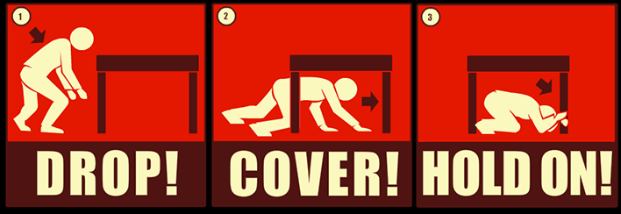
- Drop down to the ground so the earthquake doesn’t knock you down.
- Cover your head and neck with your arms to protect you from falling debris. If possible, crawl under a sturdy desk, table or another piece of furniture for additional protection. Stay away from other items that could fall.
- Hold on to any sturdy item you can until the shaking stops.

This position should be maintained until the shaking stops. Once the shaking has stopped, staff should begin to further assess the situation and determine the most appropriate next steps, using the following as guidance:
- Call 9-1-1 to report emergencies.
- If possible, evacuate the building.
- Assist co-workers, contractors, visitors, and those with access and functional needs as necessary.
- After exiting the building, all staff and visitors should follow the identified evacuation route to the pre-arranged assembly area. The specific assembly location for each facility is contained in this plan, in the appropriate Appendix by facility.
- If you are trapped, call or text for help.
- To help rescuers locate you, tap on a pipe or wall or use a whistle.
- Stay away from exposed utility wires. Always assume wires are live.
- Do not turn electrical switches or appliances on or off.
- If phone lines are down, use social media or texting to let others know you are safe.

6.0 Administration and Logistics

6.1 Plan Maintenance
This plan will be reviewed every two years at a minimum by participating agencies and organizations in a manner conforming to the review and maintenance guidelines contained in the State CEMP Base Plan. The Agency Name Safety Committee will provide administrative support for the review process, including securing meeting space, inviting participants, developing meeting agendas, facilitating meetings, compiling and distributing meeting notes/minutes, and developing draft plan updates.

6.2 Safety Training and Exercises
To ensure this plan is effectively circulated and understood by Agency Name’s employees, regular training and exercises will be conducted. Training and exercises are critical to ensure the plan can be implemented appropriately, and can also identify any gaps or problems that need to be addressed. The plan should be reviewed and practices regularly by all staff, to include employees with Disabilities and Access and Functional Needs (AFN). Each employee should work with their manager/supervisor to ensure they attend these events when offered.
Copies of this plan should be made available to all employees and municipal departments who may be first responders.
Several specific training events will be conducted in support of this plan, which includes the following:
- Training Program updates at staff events and all hands meetings
- Fire Drills
- Fire Extinguisher Training
- Active Shooter/ Hostile Event Training
- Hand Only CPR/AED Awareness Training
- Until Help Arrives Training
- Hazardous Materials Awareness Training
- Ladder Safety Training (as needed per job requirement)
- Snow Blower Safety Training(as needed per job requirement)
- Lawn Equipment Safety Training (as needed per job requirement)
- Lock Out/ Tag Out Program Training (as needed per job requirement)
- Confined Space Training (as needed per job requirement)
In addition to regularly offered trainings, employees are encouraged to empower themselves to be prepared as individuals for an emergency. There are several online courses that can be taken to ensure staff are ready to respond and remain safe while at the workplace. Some of these trainings include:
- FEMA IS 907: Active Shooter
- FEMA IS 35.20: Safety Orientation
- Hands Only CPR Awareness

7.0 Plan Authorities and References

7.1 Authorities
- Executive Order 511
- Massachusetts General Law, Chapter 149, Section 6-1/2
- Massachusetts General Law, Chapter 152
- 454 CMR 25
- Americans with Disabilities Act (ADA)

7.2 References
- Agency Name Safety Committee
- Massachusetts Emergency Management Agency Continuity Guidance
  - https://www.mass.gov/info-details/continuity-planning-guidance
- Massachusetts Department of Fire Services (DFS)
  - https://www.mass.gov/dfs
- Massachusetts Human Resources Division (HRD)
  - https://www.mass.gov/topics/workplace-injuries-illnesses
- Massachusetts Department of Labor Standards (DOL) Workplace Safety and Health Program (WSHP)
  - https://www.mass.gov/workplace-safety-and-health-program-wshp
- Occupational Safety and Health Administration (OSHA)
  - https://www.osha.gov/SLTC/etools/evacuation/eap.html
- Department of Homeland Security (DHS)
  - https://www.cisa.gov/active-shooter-preparedness
  - https://www.ready.gov/active-shooter
  - https://www.cisa.gov/what-to-do-bomb-threat
- Federal Emergency Management Agency (FEMA)
  - https://www.fema.gov/earthquake
- National Fire Protection Association (NFPA) Emergency Evacuation Planning Guide for People with Disabilities
  - https://www.nfpa.org/Public-Education/Fire-causes-and-risks/Specific-groups-at-risk/People-with-disabilities
- California Office of Emergency Services (CalOES) Active Shooter Guide
  - https://www.caloes.ca.gov/AccessFunctionalNeedsSite/Documents/CalOES-active-shooter-awareness-Feb-2018.pdf

Appendix A: Facility Emergency Action Plan
(Complete one for each facility)

Facility Name
Facility Address
Safety and Security Details
- For any active emergency situation that requires the immediate response of police, fire or EMS, including any situation involving an active or imminent threat, immediately call 9-1-1.
- To report a past event (such as vandalism that has already occurred), or a situation that does not require an emergency police response, call the local Police Department; or
- For non-emergency assistance from fire or EMS, call the local Fire Department

Important Public Safety Phone Numbers:

Automatic External Defibrillator Location (AED)
The nearest AED is located:
- INSERT LOCATION

Rescue and First Aid
Agency Name’s relies on EMS Paramedics and the {Insert local EMS responder} to provide emergency medical response and rescue. However, the table below includes Agency Name staff that are able to perform CPR and possibly administer other medical services beyond CPR such as AED administration.
Name | Office | Work Number | Level of Training (EMT, First Aid/CPR)
Staff Paging and Notification
{Insert information regarding the system used to page and/ or notify staff of an emergency. Does this include an overhead Public Address System, a paging system, or an alert and notification system that is used? How do you notify staff of an emergency?}

Evacuation Procedures
{Describe the evacuation process, including any special notes about facility egress, main exist to keep in mind, hazards upon evacuating, etc.}
Assembly Locations:
After exiting the building, all staff and visitors should follow the evacuation route to the pre-arranged assembly area. The assembly area is the initial location to complete an accounting of building occupants and to determine whether evacuees should move to another location.
Primary Assembly –
{Provide description and map highlighting the assembly location}

Secondary Assembly –
{Provide description and map highlighting the assembly location, if a secondary location is identified}

Facility Evacuation Map
{Insert Facility floorplan map showing the evacuation plan for the building}

Building Access and Security
{Insert guidance on the means by which employees and visitors should enter the building (through a main business, or through a security checkpoint, etc.). This should include contractors and vendors. Depending on the facility, some visitors or contractors may need to be badged or escorted prior to being given access to the facility. This section should include guidance for access during both business hour and after-hours access and entry, if applicable}
All employees are asked to be diligent about building security. Do not allow someone into the building, especially beyond a security door, until you or the receptionist has determined the purpose of the visit. If the receptionist is busy and you are unable to connect them with the appropriate staff, politely ask them to wait outside of the security door until they can be helped. If you come across someone in the halls that is not familiar, please ask if the person needs assistance. Someone who is unknown to the facility should not be wandering the halls without an escort. Also, be diligent about our parking lots as well. If you see someone who appears suspicious report him/her immediately.

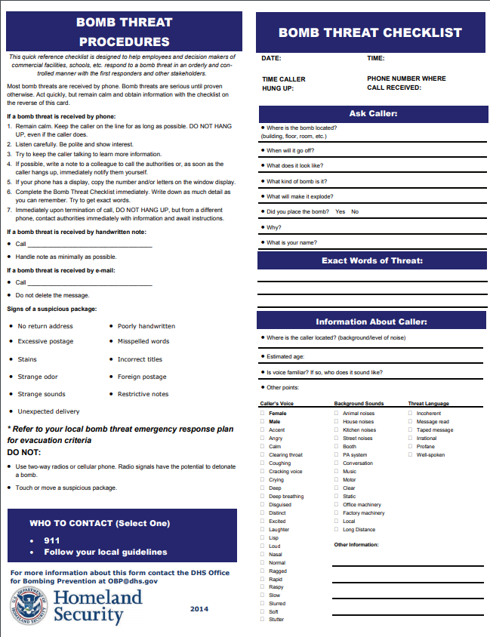
Appendix B: Bomb Threat Checklist

