**POST-OCCUPANCY**

**INDOOR AIR QUALITY ASSESSMENT**

**Office of the State Auditor**

**500 Belmont Street**

**Brockton, MA**

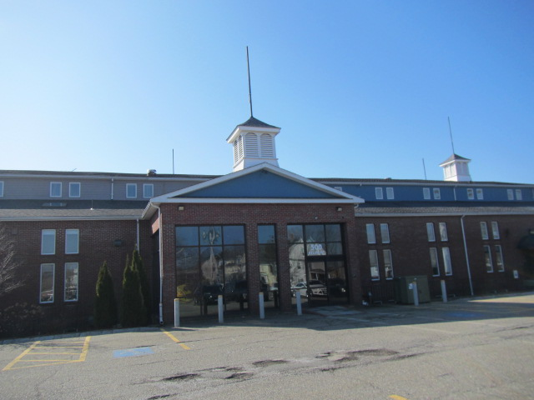

Prepared by:

Massachusetts Department of Public Health

Bureau of Climate and Environmental Health

Division of Environmental Health and Standards

March 2025

# BACKGROUND

|  |  |
| --- | --- |
| Building: | Office of the State Auditor (SAO) |
| Address: | 500 Belmont Street, Brockton, MA |
| Assessment Requested by: | Kendra Howes, Senior Project Manager, Division of Capital Asset Management & Maintenance  Office of Leasing and State Office Planning |
| Reason for Request: | Post-occupancy indoor air quality (IAQ) assessment of leased space |
| Date of Assessment: | March 14, 2025 |
| Massachusetts Department of Public Health/Bureau of Climate and Environmental Health (MDPH/BCEH) Staff Conducting Assessment: | Cory Holmes, Senior Advisor for Indoor Air Quality Inspections, Audits, Outreach and Training |
| Building Description: | The SAO occupies the ground floor of a modern two-story brick office building. The renovated space has new carpet tiles, painted gypsum wallboard, and suspended ceiling tiles. |
| Windows: | Windows in the space are openable |

# METHODS

Please refer to the IAQ Manual for methods, sampling procedures, and interpretation of results (MDPH, 2015).

# RESULTS AND DISCUSSION

The following is a summary of indoor air testing results (Table 1).

* ***Carbon dioxide*** measurements were below the MDPH guideline of 800 parts per million (ppm) in all areas assessed.
* ***Temperature*** was within the recommended range of 70°F to 78°F in all areas tested.
* ***Relative humidity*** was below the recommended range of 40% to 60% in all areas tested, which is common during winter months in New England.
* ***Carbon monoxide*** levels were non-detectable (ND) in all areas tested.
* ***Fine particulate matter (PM2.5)*** concentrations were below the National Ambient Air Quality Standard (NAAQS) level of 35 μg/m3 in all areas tested.
* ***Total Volatile Organic Compounds (TVOC)*** were ND in all areas tested.

## Ventilation

A heating, ventilation, and air conditioning (HVAC) system has several functions. First, it provides heating and, if equipped, cooling. Second, it is a source of fresh air. Finally, an HVAC system will dilute and remove normally occurring indoor environmental pollutants by not only introducing fresh air, but also filtering the airstream and ejecting stale air to the outdoors via exhaust ventilation. Even if an HVAC system is operating as designed, point sources of respiratory irritation may exist and affect symptoms in sensitive individuals.

The HVAC system uses air handling units (AHU) on the roof. Fresh air is drawn into the units, conditioned, and delivered to offices and other areas through ceiling-mounted supply vents (Picture 1). Typical central HVAC systems have either ducted return vents or grates installed, which allow air to be pulled into the ceiling plenum. No return vents had been installed at the time of assessment, however several of them were noted in the space (Picture 2). It was reported that the installation of return vents was scheduled within the next few weeks as a punch-list item.

## Microbial/Moisture Concerns

One lightly stained ceiling tile was observed in the 1st office (Picture 3). Water-damaged ceiling tiles can provide a source of mold and should be replaced after a water leak is discovered and repaired.

## Other IAQ Concerns

Some areas in this office are carpeted. Carpets should be vacuumed regularly with a high efficiency particulate arrestance (HEPA) filter equipped vacuum cleaner and cleaned annually (or semi-annually in soiled/high traffic areas) in accordance with Institute of Inspection, Cleaning and Restoration Certification (IICRC) recommendations (IICRC, 2012).

Some of the supply vents had accumulations of dust and debris (Picture 1). This dust/debris can be aerosolized under certain conditions, and should be cleaned periodically (e.g., during regular filter changes).

# RECOMMENDATIONS

The following are recommendations made to maintain IAQ:

1. Operate supply and exhaust ventilation in all areas during occupied periods.
2. Continue with plans to install return vents.
3. Ensure filters are replaced on HVAC units at least twice a year. Use filters with a minimum efficiency rating value (MERV) of 8 or better.
4. It is recommended that HVAC systems be re-balanced every five years to ensure adequate air systems function (SMACNA, 1994).
5. Ensure any roof/plumbing leaks are repaired and replace water-damaged ceiling tile.
6. Clean carpeting in accordance with IICRC recommendations (IICRC, 2012). Clean upholstered furniture regularly as well.
7. Clean dust and debris from vents periodically.
8. Refer to resource manual and other related IAQ documents located on the MDPH’s website for further building-wide evaluations and advice on maintaining public buildings. These documents are available at: <http://mass.gov/dph/iaq>.

# REFERENCES

ICRC. 2012. Institute of Inspection, Cleaning and Restoration Certification. Carpet Cleaning: FAQ.

MDPH. 2015. Massachusetts Department of Public Health. Indoor Air Quality Manual: Chapters I-III. Available at: <https://www.mass.gov/lists/indoor-air-quality-manual-and-appendices>.

SMACNA. 1994. HVAC Systems Commissioning Manual. 1st ed. Sheet Metal and Air Conditioning Contractors’ National Association, Inc., Chantilly, VA.

**Picture 1**

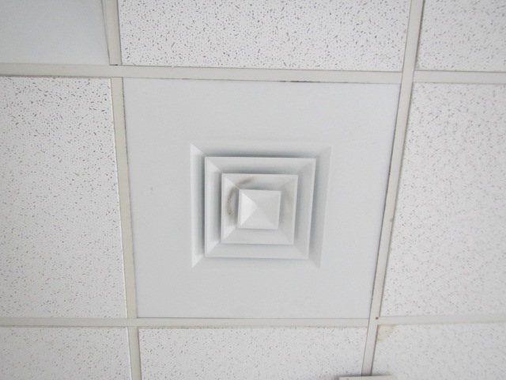

**Typical supply vent, note dust/debris buildup on louvers**

**Picture 2**

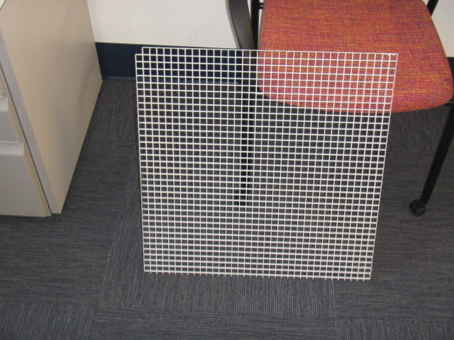

**Typical return grate, not yet installed**

**Picture 3**

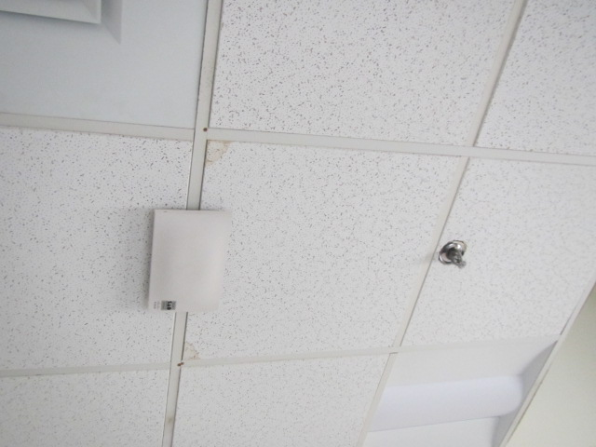

**Water-damaged ceiling tile (light staining at corners)**

| **Location** | **Carbon**  **Dioxide**  **(ppm)** | **Carbon Monoxide**  **(ppm)** | **Temp**  **(°F)** | **Relative**  **Humidity**  **(%)** | **PM2.5**  **(µg/m3)** | **TVOC**  **(ppm)** | **Occupants**  **in Room** | **Windows**  **Openable** | **Ventilation** | | **Remarks** |
| --- | --- | --- | --- | --- | --- | --- | --- | --- | --- | --- | --- |
| **Supply** | **Exhaust** |
| Background | 410 | ND | 50 | 50 | ND | ND |  |  |  |  | Warm & sunny |
| Main Work Area (West) | 654 | ND | 72 | 26 | ND | ND | 1 | Y | Y | N | Dust and debris on supply vent, PF, rodent trap |
| Main Work Area (East) | 650 | ND | 71 | 26 | ND | ND | 0 | Y | Y | N | Dust and debris on supply vent |
| 1st Office | 640 | ND | 71 | 26 | ND | ND | 0 | Y | Y | N | WD CT, rodent trap |
| Burrowes Office | 616 | ND | 74 | 24 | ND | ND | 0 | N | Y | N | PF (2), computers/lamination machine - heat |
| Anzalone | 579 | ND | 74 | 24 | ND | ND | 0 | Y | Y | N |  |