# Business Log In: How to Log In to Virtual Gateway with Multiple Virtual Gateway Accounts

**This reference guide should be used by Commonwealth of Massachusetts state employees who have multiple VG User IDs linked to their Mass.Gov email.**

Table of Contents

Business Log In: How to Log In to Virtual Gateway with Multiple Virtual Gateway Accounts 1

Business Log In as Mass.Gov Employee 1

How to Switch Accounts (Log In under different VG User ID) 4

## Business Log In as Mass.Gov Employee

1. Log In to Virtual Gateway Application(s): <https://virtualgateway.mass.gov/VGPortal5/>
2. Click the **Business Log In** button
3. Read Security Warning
4. Click the **Proceed** button

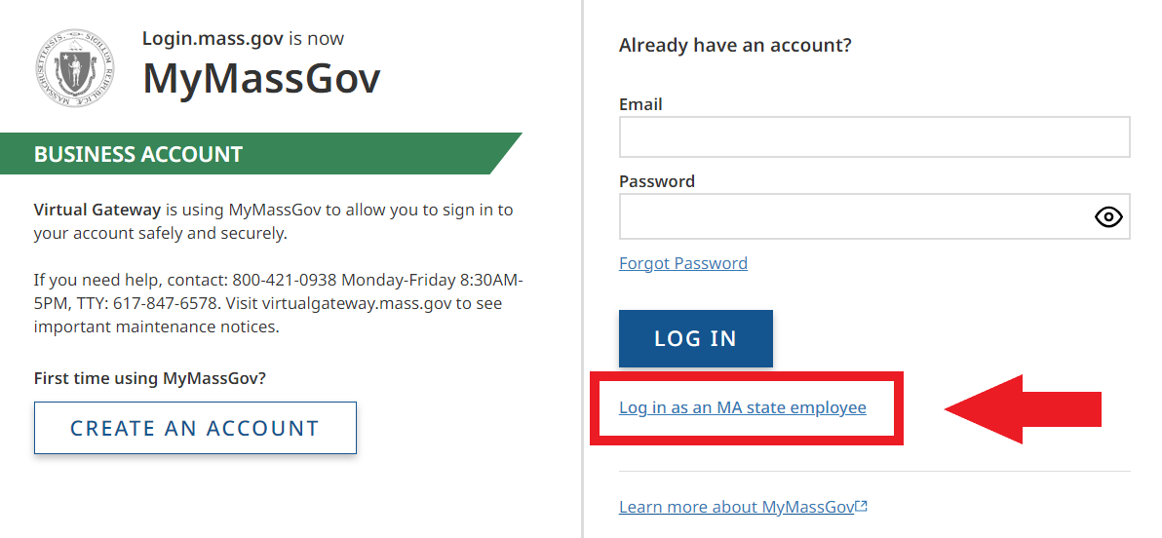

1. If asked, enter verification code (authenticator app, phone, text message).
2. Click **Verify**.

Note: For state employees who have multiple Virtual Gateway accounts linked to the same email (must be a Mass.gov email) the AZURE User field has been updated from ‘NO’ to ‘MULTI’ to allow a user with multiple accounts/same email to log in under the Business Log In option.

1. User will be redirected to the **Select User ID** page. This page will display the email that is associated to multiple accounts. The user will need to select a Virtual Gateway ID from the list.

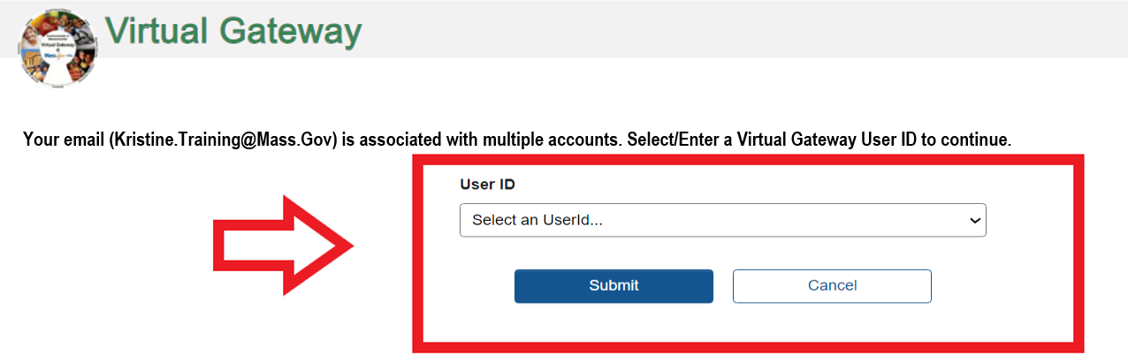

Note: A drop-down menu will list the VG User IDs associated to the email displayed on this page. The maximum number of IDs that can appear in this list is 4. If you have more than 4 VG User IDs, you will need to type in the User ID you want to log in under.

1. User selects the VG User ID that they want to link to/access. Note: User will need to switch/link each time they need to access a different VG User ID.
2. Click the **Select** button.

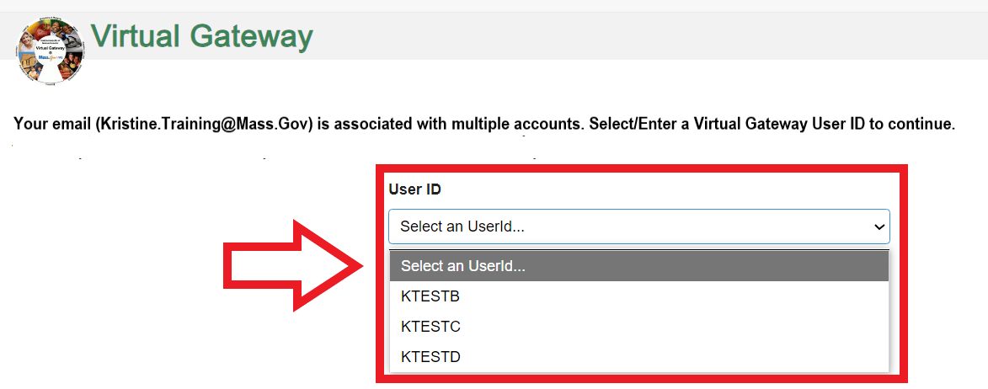

The user receives the successfully linked message. Once the VG User ID has been linked, the user will need to log into their account again, as directed on the screen.

1. Click the **Virtual Gateway Home** button.

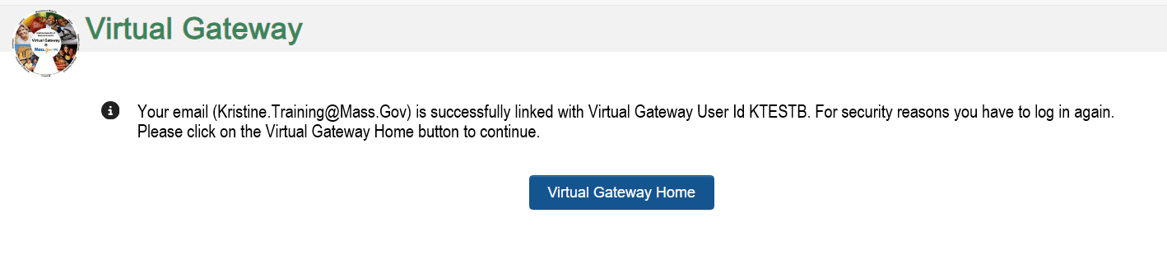

Note: If you have access to more than 1 organization, the **Select Organization** page will appear. Note: Skip this section if you only have access to 1 organization/Select Organization page does not appear on your page.

1. Select **Organization** from drop down menu

The first-time logging into the Virtual Gateway under the Business Log In the user will be taken to the Accept/Update Agreement page. All Virtual Gateway users must accept the terms and conditions to proceed to the Applications page.

1. Review Terms and Conditions.
2. Check the checkbox next to ‘**I agree to terms and conditions**’
3. Click the **Complete Log In** button

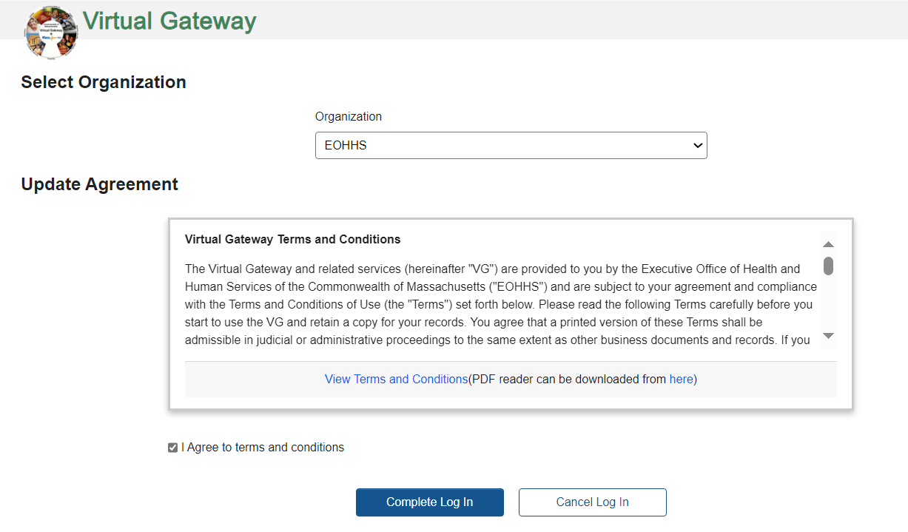

The Virtual Gateway Applications page appears. This page will display the following message/or similar message:

‘Your email is associated with Virtual Gateway User Id - **KTESTB**.’

1. To switch to another Virtual Gateway ID select **Manage My Account** -> **Switch User Id** and follow the instructions.’

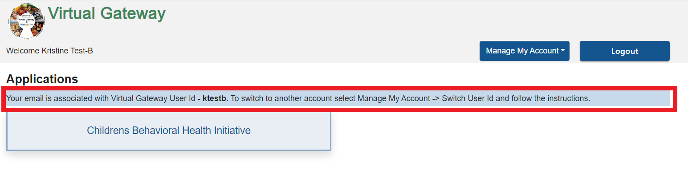

## How to Switch Accounts (Log In under different VG User ID)

1. Click **Manage My Account**.

The menu will display Update Profile and Switch User Id.

1. Click **Switch User Id**.

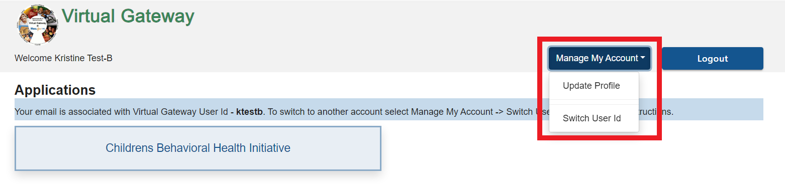

User will be taken to User ID page.

1. Click drop-down menu for User ID. The User IDs not currently linked will appear in the drop-down menu. Notice that KTESTB is not listed and that is because that ID is currently associated/linked – as noted in message on screen.
2. Select a different User ID from list.
3. Click the **Submit** button.

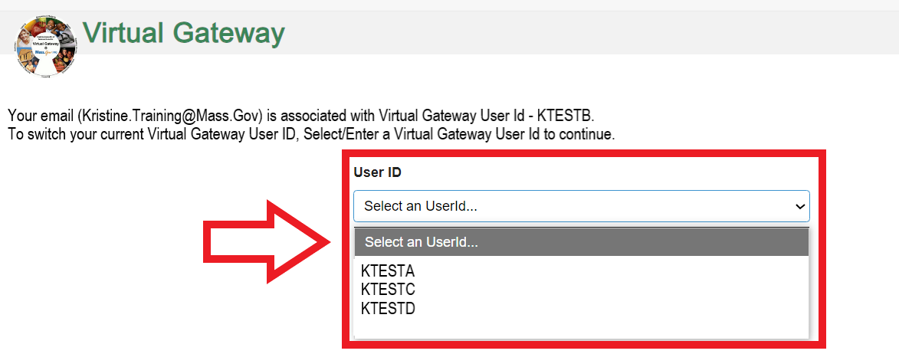

The user is now associated to the selected VG User ID.

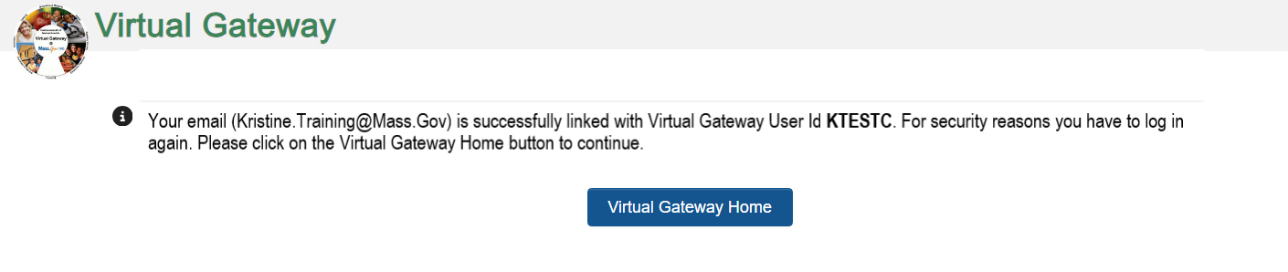

User will need to log in again after linking.

1. Click the **Virtual Gateway Home** button.

If you have access to more than 1 organization, the Select Organization page will appear. Note: Skip this section if you only have access to 1 organization/Select Organization does not appear on your page.

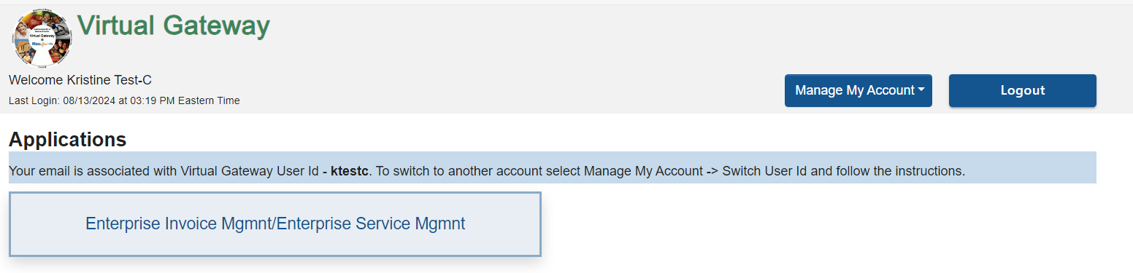

Applications page appears.

This page will display the following message/or similar message:

‘Your email is associated with Virtual Gateway User Id – **KTESTC**. To switch to another account select Manage My Account -> Switch User Id and follow the instructions.’

Repeat as needed to associate all VG User IDs.

Click on the application that you need to access/work in.