State Employee Log In: How to Log In to Virtual Gateway
This reference guide should only be used by Commonwealth of Massachusetts state employees who have a Virtual Gateway account.
State Employee Log In 1
State Employee with Multiple Virtual Gateway User IDs (Switch Profile) 3
View Account Settings 4
Virtual Gateway Customer Service 6
Last Updated: May 17, 2026

State Employee Log In
- Click https://virtualgateway.mass.gov.
- Click the Log In button.
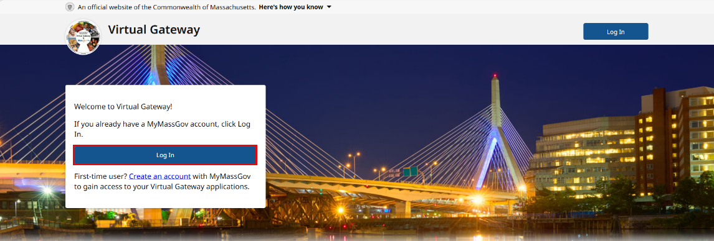
- Click the MA State Employee Log In button. Note: Do Not Select Business Log In.
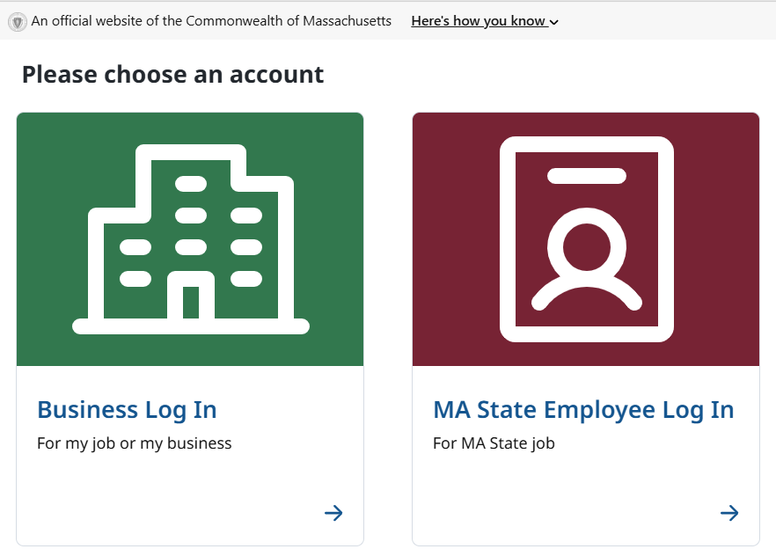
- Read Security Warning.
- Click the Proceed button.
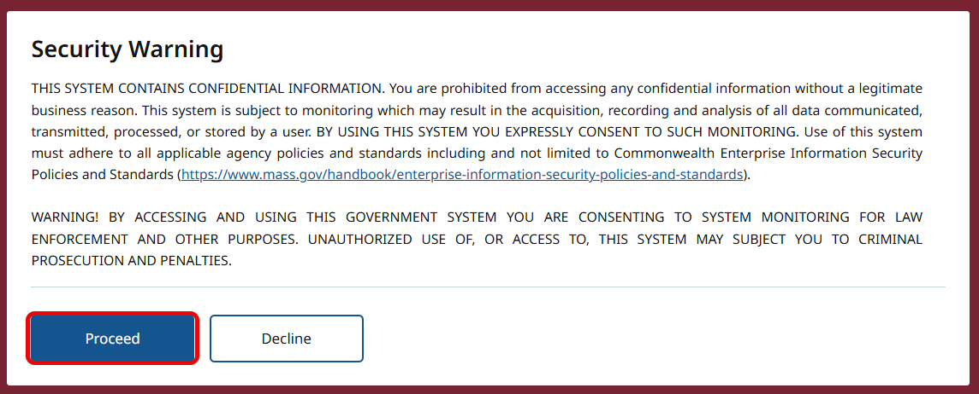
- If asked, enter verification code (authenticator app, phone, text message).
- Click Verify.
The first-time logging into the Virtual Gateway you will be taken to the Accept/Update Agreement page. All Virtual Gateway users must accept the terms and conditions to proceed to the Dashboard page.
- Review Terms and Conditions.
- Check the checkbox next to ‘I agree to the Terms and Conditions’.
- Click the Accept button.
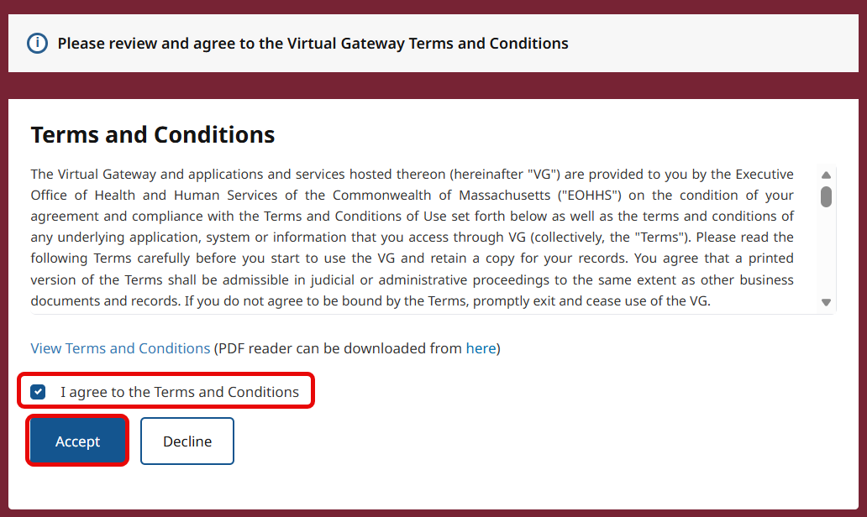
If you have access to more than 1 organization, you will be taken to the Choose Organization page. Note: Skip this section if you only have access to 1 organization.
- Select Organization from drop down menu.
- Click Proceed button.
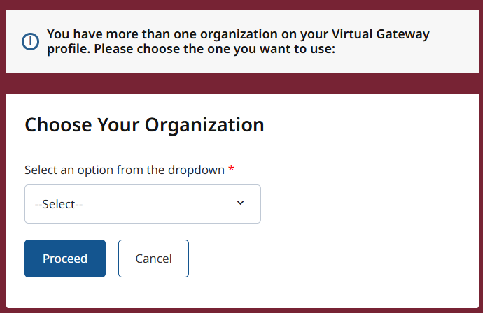
The Virtual Gateway Dashboard appears. Click on the application that you need to access/work in.

State Employee with Multiple Virtual Gateway User IDs (Switch Profile)
For state employees who have multiple Virtual Gateway accounts linked to the same email (must be a Mass.gov email) you will need to use the Switch Profile option to move between your accounts. The Switch Profile option is found on the Virtual Gateway Dashboard page. If you have more than 1 VG account, you will see the Switch Profile option as soon as you go to the Dashboard page.
- Click the Switch Profile link.
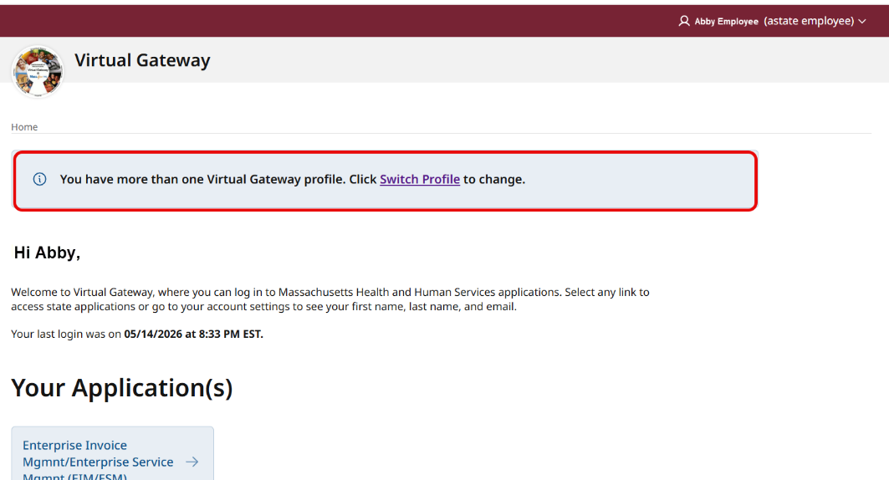
- User will be taken to the Change your profile page. This page will display the current user id you are logged in as. The user will need to select a Virtual Gateway ID from the list.
Note: A drop-down menu will list the VG User IDs associated with email.

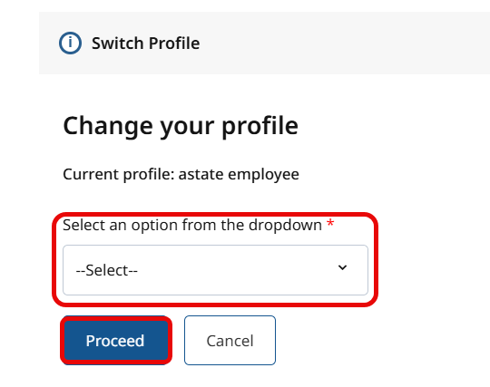
- User selects the VG User ID that they want to link to/access. Note: User will need to switch profiles each time they need to access a different VG User ID.
- Click the Proceed button.
The user receives the successfully linked message. Once the VG User ID has been linked, the user will need to log into their account again, as directed on the screen.
- Click the Continue button.
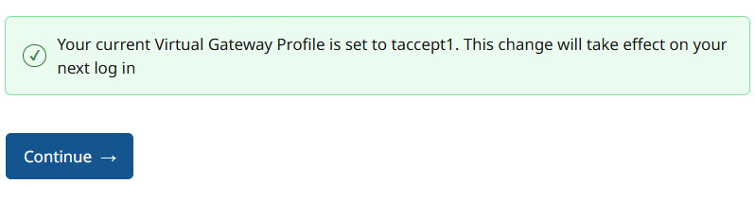
Follow instructions ‘State Employee Log In’ in this guide to log back into your account.

View Account Settings
To view your profile information, you go to the Account Settings found on the Dashboard.
- Click drop-down menu on the upper right next to your name.
- Click Account Settings.
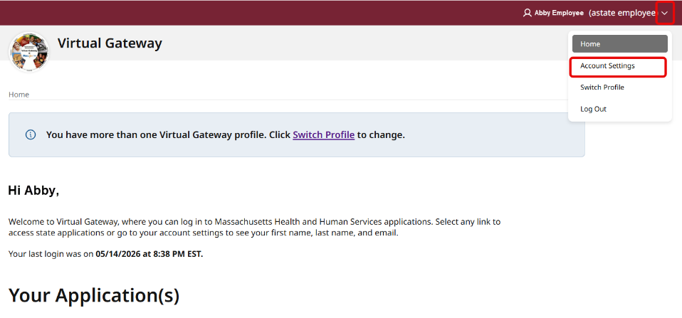

Under Account Settings you can view the following:
- First Name
- Last Name
- Email
- Display Name
- Account Verification Information
- Username
Note: State Employees should not use the ‘Click here to manage your profile at MyMassGov’. MyMassGov profile information comes from your Human Resource department for automatic updates.
- Click the Home button to return to the Dashboard page.
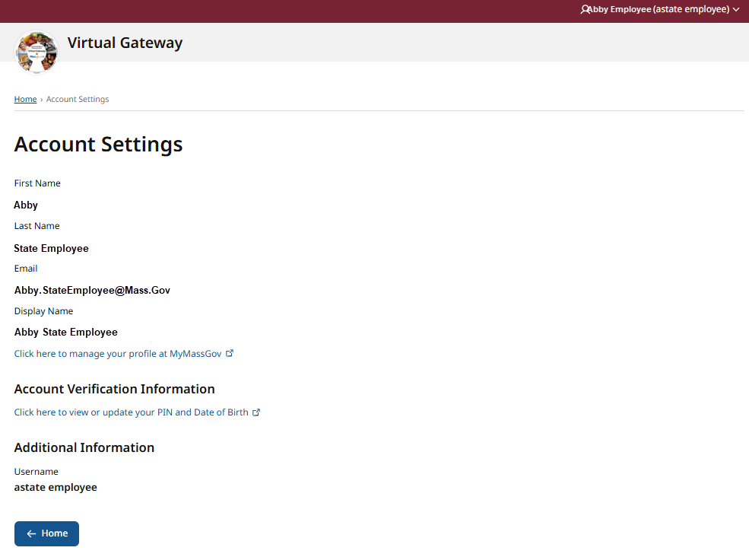

To access your assigned applications, click on the application name under the Your Application(s) section on the Dashboard.
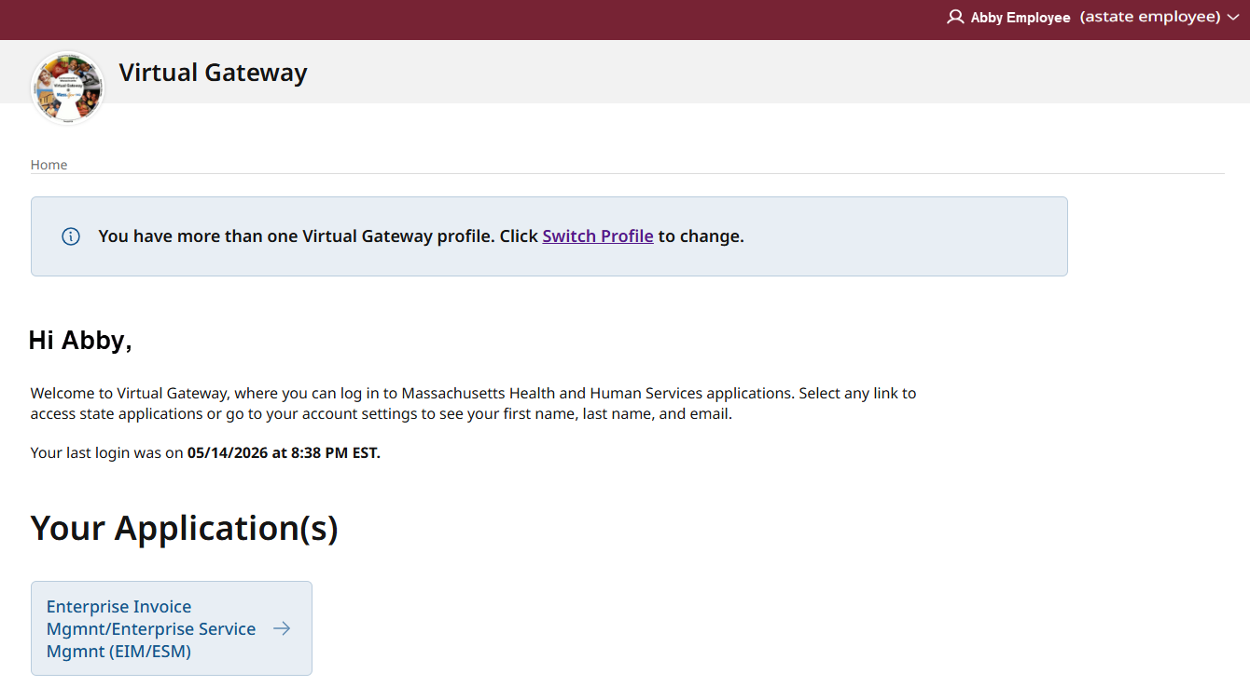

Virtual Gateway Customer Service
If assistance is needed, contact Virtual Gateway Customer Service.
Virtual Gateway Customer Service: (800) 421-0938 - TTY (617) 847-6578
Monday - Friday 8:30 am - 5:00 pm

