INDOOR AIR QUALITY ASSESSMENT

State Ethics Commission
Room 619
One Ashburton Place
Boston, MA 02108

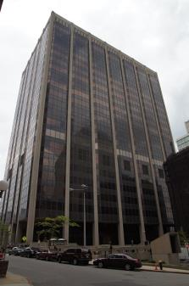

Prepared by:
Massachusetts Department of Public Health
Bureau of Environmental Health
Indoor Air Quality Program
July 2016

Background
Building: | State Ethics Commission
Address: | One Ashburton Place, Boston, MA (Room 619)
Assessment Requested by: | John O’Donnell, Deputy Director, DCAMM
Reason for Request: | General assessment
Date of Assessment: | May 24, 2016
Massachusetts Department of Public Health/Bureau of Environmental Health (MDPH/BEH) Staff Conducting Assessment: | Sharon Lee, Environmental Analyst, Indoor Air Quality (IAQ) Program
Building Description: | Multi-story concrete building
Office Population: | Approximately 30 staff
Year of Construction: | 1975
Windows: | Not openable

Methods
Please refer to the IAQ Manual for methods, sampling procedures, and interpretation of results (MDPH, 2015).

Results and Discussion
The following is a summary of indoor air testing results (Table 1).
- Carbon dioxide levels were below 800 parts per million (ppm) in all areas tested, indicating adequate fresh air.
- Temperature was within the recommended range of 70°F to 78°F in all areas tested.
- Relative humidity was within or close to the lower level of the recommended range of 40% to 60% in all areas tested.
- Carbon monoxide was not detected in any areas tested.
- Fine particulate matter (PM2.5) concentrations measured were below the National Ambient Air Quality Standard (NAAQS) level of 35 μg/m³ in all but two areas tested.

Ventilation
A heating, ventilating and air conditioning (HVAC) system has several functions. First it provides heating and, if equipped, cooling. Second, it is a source of fresh air. Finally, an HVAC system will dilute and remove normally occurring indoor environmental pollutants by not only introducing fresh air, but by filtering the airstream and ejecting stale air to the outdoors via exhaust ventilation. Even if an HVAC system is operating as designed, point sources of respiratory irritation may exist and cause symptoms in sensitive individuals. The following analysis examines and identifies components of the HVAC system and likely sources of respiratory irritant/allergen exposure due to water damage, aerosolized dust and/or chemicals found in the indoor environment.
Fresh air is provided by air-handling units (AHU). Air is supplied to and returned from office areas via ducted vents around light fixtures (Picture 1). Air circulation in perimeter offices is provided by wall-mounted induction units (Picture 2).
Some areas, including the large conference room, have grated vents that open to the ceiling plenum (Picture 3). The ceiling plenum is an open space between the ceiling tile system and the structural ceiling that provides space for ductwork, cables, pipes, and other building infrastructure. The plenum can also facilitate air movement and return to the AHU. Dusts and debris can gather in the plenum area and, under certain conditions, can migrate into occupied space. Measures should be taken to examine the function of the return plenum for this space. If the ducted ventilation system can operate independent of the plenum space and without disruption, consideration should be given to replacing plenum grates with ceiling tiles to separate the plenum area from occupied spaces which may help to reduce irritants to sensitive individuals.
To maximize air exchange, the BEH recommends that mechanical ventilation systems operate continuously during periods of occupancy. Without the system operating as designed, normally occurring pollutants cannot be diluted or removed, allowing them to build up and lead to IAQ/comfort complaints. It is recommended that HVAC systems be re-balanced every five years to ensure adequate air systems function (SMACNA, 1994).

Microbial/Moisture Concerns
Signs of water leakage were observed in a number of areas, including peeling and rippled vinyl-covered wall partitions and cement walls (Pictures 4 and 5; Table 1). Water damage observed near windows indicates that water penetration is likely occurring though the window systems. Vinyl wall coverings can hold moisture against the wall surface, preventing the material from drying. Wall partitions typically consist of a metal frame and engineered wood fiberboards. Wall partitions that remain wet for more than 48 hours may become colonized with mold. While mold spores would likely remain trapped behind the vinyl covering, repeated moisture exposure may cause the vinyl covering to peel, which can result in mold exposure.
Cement exposed to chronic moisture may develop efflorescence (Picture 6). Efflorescence is a characteristic sign of water damage caused by salts and mineral deposits from water filtrating through materials such as brick and concrete. Water containing salts and minerals appears to drip onto the induction units (Picture 2), which may become aerosolized, and be a contributing source to eye and respiratory system irritation.
One area appeared to have water-damaged gypsum wallboard (Picture 7), which is a porous material that can support mold growth. This wall area should be examined. If the wallboard consists of gypsum or similar porous material, measures should be taken to replace it.
Water-damaged ceiling tiles were observed in one office (Picture 6; Table 1). Water sources moistening tiles may include pipes and infiltration through the building exterior. Stained tiles should be replaced after appropriate repairs are made. Ceiling tiles should be monitored, and water stains should be reported.
Sealants around windows appeared to be failing in some areas (Picture 8). Gaskets are important for preventing water penetration and drafts. Measures should be taken to resealing damaged gaskets/caulking to prevent water and air infiltration.
The US Environmental Protection Agency (US EPA) and the American Conference of Governmental Industrial Hygienists (ACGIH) recommend that porous materials be dried with fans and heating within 24 to 48 hours of becoming wet (US EPA, 2008; ACGIH, 1989). If porous materials are not dried within this time frame, mold growth may occur. Once mold has colonized porous materials, they are difficult to clean and should be removed and discarded.
Plants were observed in a number of offices (Table 1). In some areas, plants are located in close proximity to ventilation equipment (Picture 9). Plants, soil, and drip pans can serve as sources of mold/bacterial growth, pollens, and dusts. Plants should be properly maintained, over-watering of plants should be avoided, and drip pans should be inspected periodically for mold growth. Plants should be placed away from the airstream of ventilation equipment to prevent distribution of particulate matter.

Particulate Matter
Dust and other debris (including that resulting from efflorescence) was observed on flat surfaces, including induction units (Picture 2; Table 1). Books, papers, and personal items are additional surfaces on which dust can collect. Measures should be taken to clean these and other flat surfaces to prevent continued distribution of dust and particulate matter, which can cause eye and respiratory irritation.

Volatile Organic Compounds (VOCs)
Exposure to low levels of total VOCs (TVOCs) may produce eye, nose, throat, and/or respiratory irritation in some sensitive individuals. To determine if VOCs were present, BEH/IAQ staff examined rooms for products containing VOCs. BEH/IAQ staff noted hand sanitizers, cleaners, air deodorizing materials, nail polish remover, and dry erase materials in use within the building (Table 1). All of these products have the potential to be irritants to the eyes, nose, throat, and respiratory system of sensitive individuals. Air deodorizers, in particular, can serve as a continual source TVOCs, since the products are designed to continually emit scents.
Photocopiers were observed in areas lacking dedicated exhaust capabilities. Photocopiers can be sources of pollutants such as VOCs, ozone, heat and odors, particularly if the equipment is older and in frequent use. Both VOCs and ozone are respiratory irritants (Schmidt Etkin, 1992). Photocopiers should be located in well-ventilated rooms/areas.

Other Concerns
Other conditions that can affect IAQ were observed during the assessment. Wall-to-wall carpeting was observed in a number of areas. The Institute of Inspection, Cleaning, and Restoration Certification (IICRC) recommends that carpeting be cleaned annually (or semi-annually in soiled high traffic areas) (IICRC, 2012). Regular cleaning with a high efficiency particulate air (HEPA) filtered vacuum in combination with an annual cleaning will help to reduce accumulation and potential aerosolization of materials from carpeting.
Several supply diffusers (and surrounding ceiling tiles), personal fans, exhaust/return vents were observed to have accumulated dust/debris (Pictures 10 and 11). Supply vents and personal fans can aerosolize accumulated dust when the system is activated. If exhaust vents are not functioning, backdrafting can occur, which can re-aerosolize accumulated dust particles.
Vinyl base coving is peeling from walls in some areas (Picture 12). Vinyl coving is designed protect the base of a wall from damage; however, when the coving is no longer adhered the wall, dirt and debris can become trapped behind the coving. Materials trapped behind vinyl coving can be source of mold growth when water from leaks moistens these materials. Measures should be taken to clean behind vinyl coving and reattach base cove to the wall.
Broken ceiling tiles were observed in a number of areas. Broken and ajar ceiling tiles create a non-continuous drop ceiling system, which can allow debris that can collect above the ceiling tiles to be aerosolized in occupant spaces.
Spaces were observed around wiring for electrical conduits (Picture 13). These breaches provide pathway for odors, particulates, and pests to migrate from utility spaces into occupant areas. Measures should be taken to reduce pathways.
In some areas, accumulations of items were seen on floors, windowsills, tabletops, counters, bookcases, and desks. Accumulated items (e.g., papers, folders, boxes) make cleaning difficult. Items should be relocated and/or be cleaned periodically to avoid excessive dust build up. Cardboard, paper, cloth and other porous items should not be stored in contact with floors.
Food and kitchen appliances were observed in a number of offices (Table 1). Appliances and food crumbs can attract rodents. Rodent wastes can contribute to indoor environmental concerns.

Conclusions/Recommendations
A number of conditions contribute to the irritant symptoms reported by staff. Staff in offices seated in close proximity to the induction units may experience irritation from aerosolization of dust/debris that may settle onto the surface of units. Based on observations at the time of assessment, the following is recommended:
- Operate supply and exhaust ventilation in all areas during occupied periods.
- Have the HVAC system balanced every 5 years in accordance with SMACNA recommendations (SMACNA, 1994).
- Examine space above grated return vents (Picture 3) and determine whether removing these grated vents would hinder ventilation function. If function is not disrupted, consider replacing grated vents with ceiling tiles.
- Clean flat surfaces and air diffusers/returns on a regular basis using a high efficiency particulate arrestance (HEPA) filtered vacuum and damp cloth.
- Clean fan blades of personal fans periodically. If not used during heating season, consider storing
- Increase water intake during periods of low humidity. The sensation of dryness and irritation is common in a low relative humidity environment. Low relative humidity conditions occur during the heating season in the northeast part of the United States.
- Replace water-damaged porous materials (e.g. gypsum wallboard, ceiling tiles) and monitor area for future leaks.
- Consider removing vinyl wallpaper from cement walls, since the wallpaper holds water against the wall. Clean efflorescence using a stiff brush and water. Monitor areas for future leakage.
- Examine window frames, and ensure windows are sealed properly to prevent air and moisture infiltration.
- Assess offices periodically to prevent water damage and microbial growth. Refer to US EPA’s Mold Remediation in Schools and Commercial Buildings Guide for assessing water-damaged materials (EPA, 2008). The guidance is available at https://www.epa.gov/mold/mold-remediation-schools-and-commercial-buildings-guide.
- Ensure plants are well maintained, not overwatered, and away from sources of air movement.
- Reduce the use of cleaning products, sanitizers, and other products containing VOCs. Considering adopting green cleaning procedures. Ensure cleaning products are properly labeled, and keep material safety sheets on file.
- Remove air deodorizers and other scented products to prevent respiratory irritation.
- Clean behind vinyl coving and reattach to the wall to prevent potential for microbial growth.
- Consider reducing the amount of stored materials to allow for more thorough cleaning. Clean items regularly with a wet cloth or sponge to prevent excessive dust build-up.
- Ensure shared and individual spaces are free of food debris.
- Replace broken ceiling tiles, and ensure all tiles are flush with the ceiling tile system.
- Seal breaches around utility holes to prevent migration of particulates and odors to occupant space.
- Refer to resource manual and other related IAQ documents located on the MDPH’s website for further building-wide evaluations and advice on maintaining public buildings. These documents are available at: http://mass.gov/dph/iaq.

References
ACGIH. 1989. Guidelines for the Assessment of Bioaerosols in the Indoor Environment. American Conference of Governmental Industrial Hygienists, Cincinnati, OH.
IICRC. 2012. Institute of Inspection, Cleaning and Restoration Certification. Carpet Cleaning: FAQ. Retrieved from http://www.iicrc.org/consumers/care/carpet-cleaning/#faq.
MDPH. 2015. Massachusetts Department of Public Health. Indoor Air Quality Manual: Chapters I-III. Available at: http://www.mass.gov/eohhs/gov/departments/dph/programs/environmental-health/exposure-topics/iaq/iaq-manual/.
Schmidt Etkin, D. 1992. Office Furnishings/Equipment & IAQ Health Impacts, Prevention & Mitigation. Cutter Information Corporation, Indoor Air Quality Update, Arlington, MA.
SMACNA. 1994. HVAC Systems Commissioning Manual. 1st ed. Sheet Metal and Air Conditioning Contractors’ National Association, Inc., Chantilly, VA.
US EPA. 2008. “Mold Remediation in Schools and Commercial Buildings”. Office of Air and Radiation, Indoor Environments Division, Washington, DC. EPA 402-K-01-001. September 2008. Available at: http://www.epa.gov/mold/mold-remediation-schools-and-commercial-buildings-guide.
Picture 1
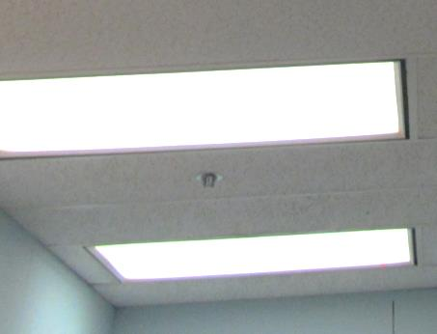
Air supply and return vents around lights
Picture 2
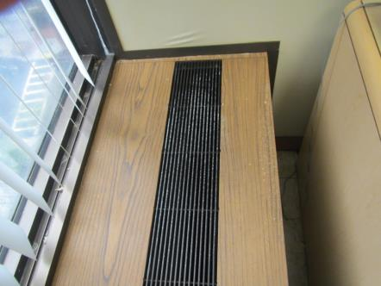
Induction unit, note white dust/debris (efflorescence) from water damage to wall
Picture 3
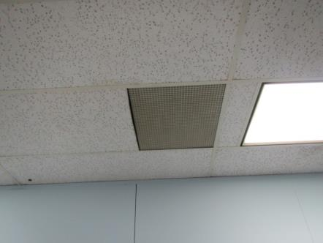
Passive return vent in conference room
Picture 4
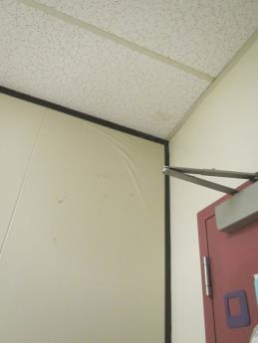
Damaged vinyl on partition wall
Picture 5
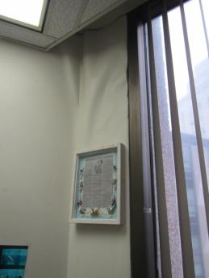
Damaged vinyl on exterior cement wall
Picture 6
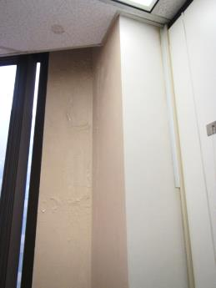
Efflorescence on cement wall
Picture 7
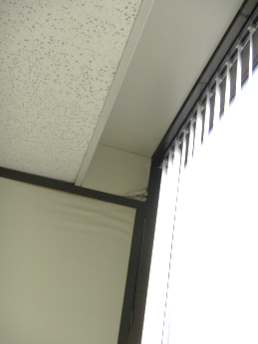
Water-damaged gypsum wallboard
Picture 8
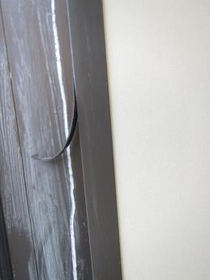
Peeling/damaged window sealant
Picture 9
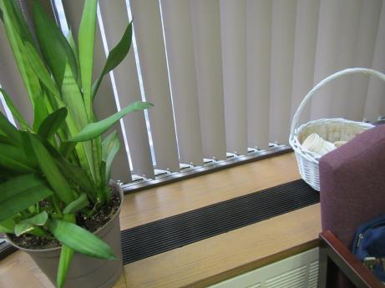
Plant placed near air induction unit
Picture 10
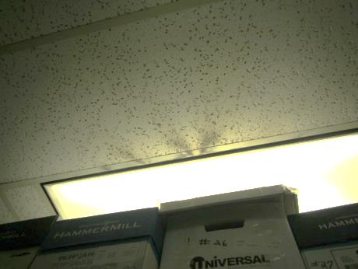
Dust/debris collected around supply diffuser and ceiling tile
Picture 11
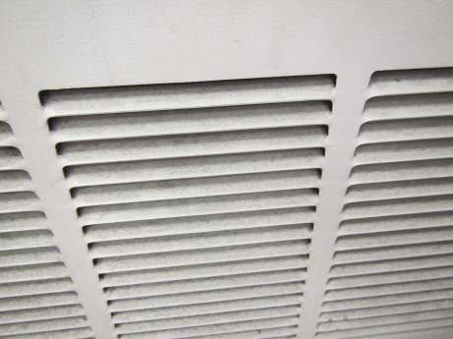
Dust on induction unit return vent
Picture 12
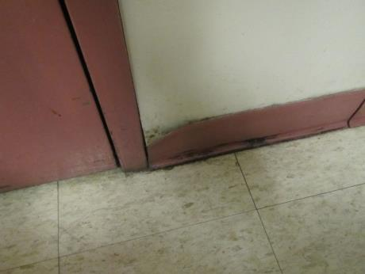
Dirt/debris trapped on and behind vinyl base coving
Picture 13
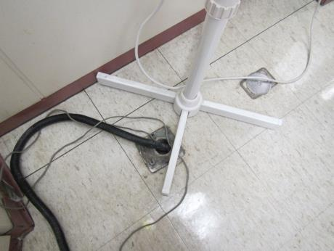
Spaces around tubing/wires in utility opening

Location | Carbon  Dioxide  (ppm) | Carbon Monoxide  (ppm) | Temp  (°F) | Relative  Humidity  (%) | PM2.5  (µg/m³) | Occupants  in Room | Windows  Openable | Ventilation |  |  | Remarks
 |  |  |  |  |  |  |  | Intake | Exhaust
Background | 370 | 1 | 62 | 64 | 21 |  |  |  |  |  | Light rain, idling vehicles, cigarette smoke
Large conference room | 462 | ND | 73 | 39 | 16 | 0 | N | Y |  | Y | 4 WD-CT, old books./newspapers, dust on shelves, upholstered chairs
Murray | 490 | ND | 73 | 38 | 10 | 1 | N | Y |  | Y | DO, PF
File/storage area | 507 | ND | 73 | 44 | 10 | 0 | N | Y  Dusty |  | Y | PF – dusty, refrigerator
Teehan | 559 | ND | 73 | 47 | 10 | 0 | N | Y |  | N | Plants, DO, water-stained wall paneling
McWilliams | 504 | ND | 74 | 47 | 25 | 0 | N | Y |  | N | DO, AD, PF
Cole | 561 | ND | 74 | 47 | 25 | 1 | N | Y |  | N | Excessive items, water-stained wall paneling, broken CT
Small conference room | 698 | ND | 73 | 51 | 101 | 0 | N | Y  Dusty |  | N | DO
Gallant | 664 | ND | 73 | 50 | 5 | 2 | N | Y  Items |  | N | DO, items, PF, plants
Slattery | 562 | ND | 72 | 52 | 5 | 1 | N | Y |  | N | PF, AD, DO, water staining
Vacant – 1 | 521 | ND | 71 | 51 | 5 | 0 | N | Y  Dusty |  | N | Historic water damage, damaged window gasket
Giannotti | 636 | ND | 72 | 52 | 8 | 1 | N | Y  Dusty, plants |  | N | AD, CTs, items, historic water infiltration
Pruitt-Doncaster | 601 | ND | 72 | 51 | 5 | 0 | N | Y  Blocked/items |  | N | DO, plants
Vacant-2 | 514 | ND | 71 | 51 | 5 | 0 | N | Y |  | N | DO, WD-CT
Farago | 569 | ND | 71 | 57 | 5 | 1 | N | Y  Dusty |  | N | DO, PF
Nober | 500 | ND | 70 | 51 | 9 | 1 | N | Y |  | Y | DO, PF
Mallam | 645 | ND | 71 | 52 | 8 | 1 | N | Y  Debris |  | N | DO, CPs, plants, debris on flat surfaces
Webb | 541 | ND | 72 | 51 | 5 | 1 | N | Y |  | N | AD, DEM, items, food, plants
Memmolo | 631 | ND | 72 | 50 | 7 | 0 | N | Y  Dusty |  | N | CPs, historic water infiltration
Meli-Omodei | 585 | ND | 73 | 50 | 8 | 1 | N | Y |  | N | Items, nail polish remover
Nee | 599 | ND | 72 | 50 | 7 | 1 | N | Y |  | N | PF, area rug, food
Duca | 744 | ND | 72 | 50 | 8 | 0 | N | Y  Items |  | N | DO, items
Milt | 571 | ND | 73 | 50 | 8 | 1 | N | Y  Dusty |  | N | DO
Nguyen | 771 | ND | 73 | 50 | 10 | 2 | N | Y  Dusty |  | N | AD
Wilson | 575 | ND | 73 | 52 | 7 | 0 | N | Y  Dusty |  | N | WD-walls, PF, items, DO
Server area | 670 | ND | 73 | 48 | 7 | 0 | N | Y |  | N | Dusty, stored items
Small copy room | 546 | ND | 74 | 48 | 23 | 0 | N | Y |  | N | DO, copier
Roney | 588 | ND | 73 | 52 | 5 | 1 | N | Y  Dusty |  | N | Plants, items, PF, WD-CTs
Reception | 550 | ND | 73 | 49 | 28 | 1 | N | Y |  | N | PF, high traffic area

