INDOOR AIR QUALITY ASSESSMENT

Massachusetts State Lottery
151 West Boylston Street
Worcester, Massachusetts

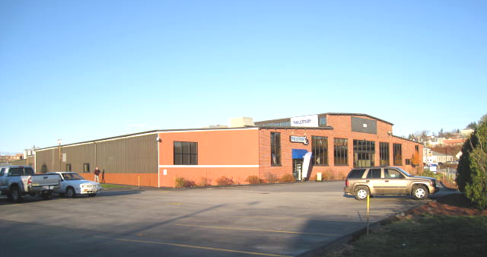

Prepared by:
Massachusetts Department of Public Health
Bureau of Environmental Health
Indoor Air Quality Program
January 2011

Background/Introduction
In response to a request from Lisa Verrochi, Project Manager, Division of Capital Asset Management, the Massachusetts Department of Public Health (MDPH), Bureau of Environmental Health (BEH), provided assistance and consultation regarding indoor air quality concerns at the Massachusetts State Lottery (MSL) office located at 151 West Boylston Street, Worcester, Massachusetts. The request was prompted by occupant complaints/concerns of tiredness towards the end of the work day. On November 19, 2010, a visit to conduct an indoor air quality assessment was made by Michael Feeney, Director, of BEH’s Indoor Air Quality (IAQ) Program. Mr. Feeney was accompanied by Ms. Verrochi during the assessment.
The MSL occupies office and warehouse space in a converted industrial building. Other tenants in the building include the US Department of Agriculture and a local utility company that uses the space for records storage. The MSL is physically separated from adjacent businesses by floor to ceiling walls constructed of gypsum wallboard. The MSL is made up of a waiting room, office space, a training room for lottery agents, a repair shop and warehouse. The MSL space has no openable windows.

Methods
Air tests for carbon dioxide, carbon monoxide, temperature and relative humidity were taken with the TSI, Q-Trak, IAQ Monitor model 7565. Air tests for airborne particle matter with a diameter less than 2.5 micrometers were taken with the TSI, DUSTTRAK™ Aerosol Monitor Model 8520. BEH staff also performed visual inspection of building materials for water damage and/or microbial growth.

Results
The MSL has an employee population of approximately 30 and can be visited by up to several hundred individuals daily. The tests were taken during normal operations. Test results appear in Table 1.

Discussion

Ventilation
It can be seen from Table 1 that carbon dioxide levels were below 800 parts per million (ppm) in all areas, indicating adequate air exchange at the time of the assessment. It is important to note however, that a number of areas were sparsely populated or unoccupied at the time carbon dioxide measurements were taken, which generally results in reduced carbon dioxide levels. Carbon dioxide levels would be expected to be higher with full occupancy.
At the time of the assessment the heating, ventilating, and air-conditioning (HVAC) system was deactivated. The office space appears to have a ceiling plenum that is at least 30 feet higher than the suspended ceiling in some areas. This open space provides an extremely large volume of air that would likely result in low carbon dioxide levels in the MSL, despite the fact that HVAC system was not operating during the assessment. However, without the HVAC system operating, normally occurring environmental pollutants can build up and result in typical indoor air quality related symptoms (e.g,. tiredness, eye irritation, lethargy) as the day progresses.
Mechanical ventilation is provided by rooftop air-handling units (AHUs) (Picture 1). Fresh air is drawn into the AHUs and delivered to occupied areas via ductwork. Return air is drawn into vents connected to the rooftop AHUs by ductwork in the ceiling plenum. As noted previously, the system did not appear to be activated at the time of the IAQ assessment. In order to ascertain that supply diffusers were distributing heated air during the assessment, surface temperatures of the vents were measured using a laser thermometer. In the heating mode, the temperature of the supply vents should be roughly 20° higher that the measured air temperature. The supply vents had a temperature equal to or less than room temperature, indicating that the HVAC system was not providing heated air during the assessment.
Digital wall-mounted thermostats control the HVAC system. Of note was the temperature readings of wall-mounted thermostats. The thermostat in the main meeting room measured temperature at 70°F, with a room temperature of 65°F. Since the HVAC system was not operating, the thermostat was the same temperature as the wall to which it was affixed (Picture 2), indicating that either the thermostat was deactivated due to the wall temperature or that the HVAC system was deactivated for some unknown reason.
To maximize air exchange, the MDPH recommends that both supply and exhaust ventilation operate continuously during periods of occupancy. In order to have proper ventilation with a mechanical supply and exhaust system, the systems must be balanced to provide an adequate amount of fresh air to the interior of a room while removing stale air from the room. It is recommended that HVAC systems be re-balanced every five years to ensure adequate air systems function (SMACNA, 1994). The date of the last balancing of these systems was not available at the time of the assessment.
The Massachusetts Building Code requires a minimum ventilation rate of 20 cubic feet per minute (cfm) per occupant of fresh outside air or have openable windows in each room (SBBRS, 1997; BOCA, 1993). The ventilation must be on at all times that the room is occupied. Providing adequate fresh air ventilation with open windows and maintaining the temperature in the comfort range during the cold weather season is impractical. Mechanical ventilation is usually required to provide adequate fresh air ventilation.
Carbon dioxide is not a problem in and of itself. It is used as an indicator of the adequacy of the fresh air ventilation. As carbon dioxide levels rise, it indicates that the ventilating system is malfunctioning or the design occupancy of the room is being exceeded. When this happens, a buildup of common indoor air pollutants can occur, leading to discomfort or health complaints. The Occupational Safety and Health Administration (OSHA) standard for carbon dioxide is 5,000 parts per million parts of air (ppm). Workers may be exposed to this level for 40 hours/week, based on a time-weighted average (OSHA, 1997).
The MDPH uses a guideline of 800 ppm for publicly occupied buildings. A guideline of 600 ppm or less is preferred in schools due to the fact that the majority of occupants are young and considered to be a more sensitive population in the evaluation of environmental health status. Inadequate ventilation and/or elevated temperatures are major causes of complaints such as respiratory, eye, nose and throat irritation, lethargy and headaches. For more information concerning carbon dioxide, please see Appendix A.
Temperature readings ranged from 59° F to 66° F during the assessment, which were below the MDPH recommended comfort guidelines in all areas surveyed. The MDPH recommends that indoor air temperatures be maintained in a range of 70 º F to 78 º F in order to provide for the comfort of building occupants. In many cases concerning indoor air quality, fluctuations of temperature in occupied spaces are typically experienced, even in a building with an adequate fresh air supply. In addition, it is difficult to control temperature and maintain comfort without operating the ventilation equipment as designed (e.g., HVAC system deactivated).
The relative humidity measured during the assessment ranged from 21 to 27 percent, which was also below the MDPH recommended comfort range in all areas surveyed. The MDPH recommends a comfort range of 40 to 60 percent for indoor air relative humidity. Relative humidity levels in the building would be expected to drop during the winter months due to heating. Relative humidity levels in the building would be expected to drop during the heating season. The sensation of dryness and irritation is common in a low relative humidity environment. Low relative humidity is a common problem during the heating season in the northeast part of the United States.

Microbial/Moisture Concerns
No water damage was noted during the assessment. When the building was constructed, metal cladding was installed along the south wall, which serves to prevent water impingement on the exterior brick and therefore decreases the likelihood of water penetration (Picture 3).

Other IAQ Evaluations
Indoor air quality can be negatively influenced by the presence of respiratory irritants, such as products of combustion. Common combustion emissions include carbon monoxide, carbon dioxide, water vapor and smoke (fine airborne particle material). To determine whether combustion products were present in the indoor environment, BEH staff obtained measurements for carbon monoxide and particulate matter.

Carbon Monoxide
Carbon monoxide is a by-product of incomplete combustion of organic matter (e.g., gasoline, wood and tobacco). Exposure to carbon monoxide can produce immediate and acute health affects. Several air quality standards have been established to address carbon monoxide and prevent symptoms from exposure to these substances. The MDPH established a corrective action level concerning carbon monoxide in ice skating rinks that use fossil-fueled ice resurfacing equipment. If an operator of an indoor ice rink measures a carbon monoxide level over 30 ppm, taken 20 minutes after resurfacing within a rink, that operator must take actions to reduce carbon monoxide levels (MDPH, 1997).
The American Society of Heating Refrigeration and Air-Conditioning Engineers (ASHRAE) has adopted the National Ambient Air Quality Standards (NAAQS) as one set of criteria for assessing indoor air quality and monitoring of fresh air introduced by HVAC systems (ASHRAE, 1989). The NAAQS are standards established by the US EPA to protect the public health from six criteria pollutants, including carbon monoxide and particulate matter (US EPA, 2006). As recommended by ASHRAE, pollutant levels of fresh air introduced to a building should not exceed the NAAQS levels (ASHRAE, 1989). The NAAQS were adopted by reference in the Building Officials & Code Administrators (BOCA) National Mechanical Code of 1993 (BOCA, 1993), which is now an HVAC standard included in the Massachusetts State Building Code (SBBRS, 1997). According to the NAAQS, carbon monoxide levels in outdoor air should not exceed 9 ppm in an eight-hour average (US EPA, 2006).
Carbon monoxide should not be present in a typical, indoor environment. If it is present, indoor carbon monoxide levels should be less than or equal to outdoor levels. Outdoor carbon monoxide concentrations were non-detect (ND) the day of the assessment (Table 1). No measureable levels of carbon monoxide were detected in the building during the assessment (Table 1).

Particulate Matter
The US EPA has established NAAQS limits for exposure to particulate matter. Particulate matter is airborne solids that can be irritating to the eyes, nose and throat. The NAAQS originally established exposure limits to particulate matter with a diameter of 10 μm or less (PM10). According to the NAAQS, PM10 levels should not exceed 150 micrograms per cubic meter (μg/m³) in a 24-hour average (US EPA, 2006). These standards were adopted by both ASHRAE and BOCA. Since the issuance of the ASHRAE standard and BOCA Code, US EPA established a more protective standard for fine airborne particles. This more stringent PM2.5 standard requires outdoor air particle levels be maintained below 35 μg/m³ over a 24-hour average (US EPA, 2006). Although both the ASHRAE standard and BOCA Code adopted the PM10 standard for evaluating air quality, MDPH uses the more protective PM2.5 standard for evaluating airborne particulate matter concentrations in the indoor environment.
Outdoor PM2.5 concentrations were measured at 4 μg/m³ (Table 1). PM2.5 levels measured indoors ranged from 2 to 6 μg/m³ (Table 1), which were below the NAAQS PM2.5 level of 35 μg/m³. Frequently, indoor air levels of particulates (including PM2.5) can be at higher levels than those measured outdoors. A number of mechanical devices and/or activities that occur indoors can generate particulate during normal operations. Sources of indoor airborne particulates may include but are not limited to particles generated during the operation of fan belts in the HVAC system, use of stoves and/or microwave ovens in kitchen areas; use of photocopiers, fax machines and computer printing devices; operation of an ordinary vacuum cleaner and heavy foot traffic indoors.

Conclusions/Recommendations
In view of the findings at the time of the visit, the following recommendations are made:
- Set thermostats to the fan “on” position to operate the ventilation system continuously during business hours.
- Ensure that thermostats are operable and are placed in a location to readily measure room temperature. The areas around and beneath thermostats should be clear of obstructions and should not have any heat-producing office equipment located in close proximity.
- For buildings in New England, periods of low relative humidity during the winter are often unavoidable. Therefore, scrupulous cleaning practices should be adopted to minimize common indoor air contaminants whose irritant effects can be enhanced when the relative humidity is low. To control for dusts, a high efficiency particulate arrestance (HEPA) filter equipped vacuum cleaner in conjunction with wet wiping of all surfaces is recommended. Drinking water during the day can help ease some symptoms associated with a dry environment (throat and sinus irritations).
- Refer to resource manuals and other related indoor air quality documents for further building-wide evaluations and advice on maintaining public buildings. Copies of these materials are located on the MDPH’s website: http://mass.gov/dph/iaq.

References
ASHRAE. 1989. Ventilation for Acceptable Indoor Air Quality. American Society of Heating, Refrigeration and Air Conditioning Engineers. ANSI/ASHRAE 62-1989.

BOCA. 1993. The BOCA National Mechanical Code/1993. 8th ed. Building Officials and Code Administrators International, Inc., Country Club Hill, IL. Section M-308.1.1.

MDPH. 1997. Requirements to Maintain Air Quality in Indoor Skating Rinks (State Sanitary Code, Chapter XI). 105 CMR 675.000. Massachusetts Department of Public Health, Boston, MA.

OSHA. 1997. Limits for Air Contaminants. Occupational Safety and Health Administration. Code of Federal Regulations. 29 C.F.R 1910.1000 Table Z-1-A.

SBBRS. 1997. Mechanical Ventilation. State Board of Building Regulations and Standards. Code of Massachusetts Regulations. 780 CMR 1209.0.

SMACNA. 1994. HVAC Systems Commissioning Manual. 1st ed. Sheet Metal and Air Conditioning Contractors’ National Association, Inc., Chantilly, VA.

US EPA. 2006. National Ambient Air Quality Standards (NAAQS). US Environmental Protection Agency, Office of Air Quality Planning and Standards, Washington, DC. http://www.epa.gov/air/criteria.html.
Picture 1

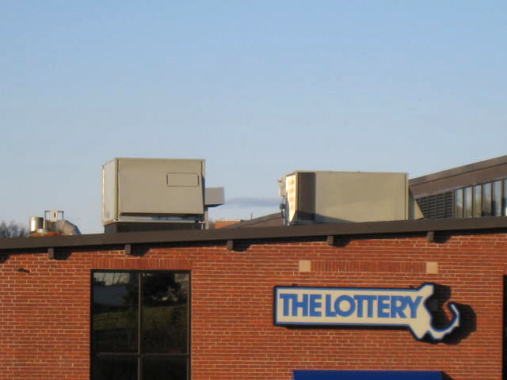

Rooftop Air Handling Units

Picture 2

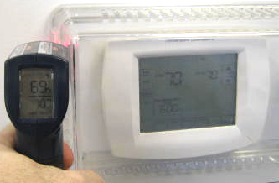

Thermostat Temperature Roughly Matches Temperature Readout of
Air Testing Equipment
Picture 3

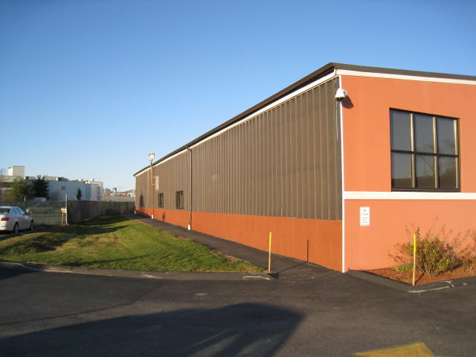

Metal Covering Exterior Brick
Location | Occupants  in Room | Temp  (°F) | Relative  Humidity  (%) | Carbon  Dioxide  (ppm) | Carbon Monoxide  (ppm) | PM2.5 (ug/m3) | Windows  Openable | Ventilation |  | Remarks
Outside  (Background) |  | 43 | 25 | 379 | ND | 4
Trading room | 0 | 65 | 25 | 587 | ND | 2 | N | Y | Y
Front desk | 2 | 66 | 26 | 685 | ND | 3 | N | Y | Y
Cubicles center of room | 1 | 65 | 25 | 644 | ND | 2 | N | Y | Y
Cubicles back of room | 0 | 64 | 24 | 670 | ND | 3 | N | Y | Y
Front lobby | 3 | 62 | 27 | 558 | ND | 3 | N | Y | Y
Training room | 3 | 65 | 27 | 593 | ND | 4 | N | Y | Y
102 | 1 | 65 | 26 | 661 | ND | 3 | N | Y | Y
103 | 0 | 64 | 26 | 610 | ND | 2 | N | Y | Y
104 | 0 | 64 | 26 | 649 | ND | 2 | N | Y | Y
105 | 1 | 66 | 25 | 601 | ND | 2 | N | Y | Y
107 | 0 | 63 | 24 | 561 | ND | 2 | N | Y | Y
108 | 0 | 62 | 24 | 573 | ND | 2 | N | Y | Y
111 | 4 | 62 | 25 | 511 | ND | 3 | N | Y | Y
112 | 0 | 63 | 25 | 604 | ND | 4 | N | Y | Y
113 | 0 | 64 | 25 | 579 | ND | 3 | N | Y | Y
114 | 0 | 65 | 25 | 599 | ND | 3 | N | Y | Y
120 | 0 | 61 | 26 | 534 | ND | 3 | N | Y | Y
121 | 0 | 62 | 20 | 556 | ND | 4 | N | Y | Y
123 | 0 | 62 | 26 | 532 | ND | 3 | N | Y | Y
124 | 0 | 62 | 26 | 574 | ND | 3 | N | Y | Y
127 | 0 | 65 | 25 | 535 | ND | 3 | N | Y | Y
Warehouse East | 0 | 61 | 24 | 515 | ND | 4 | N | Y | Y
Warehouse Center | 0 | 63 | 24 | 501 | ND | 6 | N | Y | Y
Warehouse West | 0 | 59 | 21 | 407 | ND | 5 | N | Y | Y

