**INDOOR AIR QUALITY ASSESSMENT**

**State Police Crime Laboratory**

**59 Horse Pond Road**

**Sudbury, Massachusetts**

Prepared by:

Massachusetts Department of Public Health

Bureau of Climate and Environmental Health

Indoor Air Quality Program

March 2024

**BACKGROUND**

|  |  |
| --- | --- |
| **Building:** | Massachusetts State Police Crime Laboratory (MSPCL) |
| **Address:** | 59 Horse Pond Road |
| **Assessment Requested by:** | Division of Capital Asset Management and Maintenance (DCAMM) |
| **Dates of Assessment:** | January 26, 2024, and January 31, 2024 |
| **Bureau of Climate and Environmental Health/Indoor Air Quality (BCEH/IAQ) Program Staff Conducting Assessment:** | Michael Feeney, Director, Indoor Air Quality Program |
| **Date of Building Construction:** | Unknown, originally built as a school. Remodeled in 1992 |
| **Reason for Request:** | Odors and health concerns due to a heating pipe leak within the room inside the Room 1 laboratory. |

# BUILDING DESCRIPTION

The MSPCL is a single-story building with mezzanine/attic areas originally built as a school. Most of the roof is peaked with shingles, but there is a flat portion cut into the roof where a peak would typically exist. The building contains offices, laboratories, storage areas, and conference rooms. Windows are not openable in the building.

# RESULTS AND DISCUSSION

Approximately 50 employees work in this building. Testing was conducted during normal operations. Methods and indoor air related sampling information can be found in the IAQ Manual and Appendices for IAQ Reports, which can be found at <https://www.mass.gov/lists/indoor-air-quality-manual-and-appendices>.

The following is a summary of testing results (Table 1):

* ***Carbon dioxide*** was below the MDPH guideline of 800 parts per million (ppm) in all but one area.
* ***Temperature*** was mostly within the recommended comfort range of 70°F to 78°F.
* ***Relative humidity*** was below the recommended range of 40% to 60% in all areas assessed. This is typical of the heating season in New England.
* ***Carbon monoxide*** levels were non-detectable (ND) in all areas assessed.
* ***Fine particulate matter (PM2.5)*** concentrations were below the National Ambient Air Quality Standard (NAAQS) level of 35 μg/m3.
* ***Total Volatile Organic Compounds (TVOC)*** inside the building ranged from 0.2 to 0.5 ppm.

## Ventilation

It can be seen from Table 1 that carbon dioxide levels were below 800 parts per million (ppm) in all but one area, which was a conference room with six occupants present for an undetermined amount of time.

Fresh air ventilation for the building is provided by a centralized heating, ventilation, and air-conditioning (HVAC) system that delivers fresh air from vents located on the roof to supply vents and returns/exhausts air through exhaust vents. Unit ventilators (univents), which were originally installed to provide fresh air, appear to have air intakes sealed (Picture 1). With sealed intakes, univents function to provide heat and air circulation similar to a radiator/fan coil unit. The univent air intakes were likely sealed along the west wall with insulation board to prevent frozen heating coils in winter month. As noted by carbon dioxide measurements, there appears to be sufficient fresh air in most of the building even with the univent air intakes sealed.

Room 1, an adjunct office area used for storage, has an abandoned exhaust vent sealed with cardboard and tape (Picture 2). This vent corresponds to an unused exhaust vent on the roof at the southwest roof corner of the building (Picture 3).

Many of the laboratories have chemical hoods (Picture 4), which also directly vent outside. Some of the laboratory analysis instruments also have direct vents to contain and remove pollutants and waste heat. The vent hoods also serve to exhaust air from the building and, when operating correctly, produce negative pressure that keeps laboratory pollutants from passing into other occupied areas. Laboratory hoods require yearly certification to ensure appropriate function; the hoods examined had stickers certifying compliance.

## Temperature and Relative Humidity

Temperature readings during the assessment ranged from 69ºF to 73ºF, which were mostly within the MDPH recommended comfort guidelines (Table 1). The MDPH recommends that indoor air temperatures be maintained in a range of 70ºF to 78ºF in order to provide for the comfort of building occupants. In many cases concerning indoor air quality, fluctuations of temperature in occupied spaces are typically experienced, even in a building with an adequate fresh air supply. Note that laboratory spaces are often kept slightly cooler due to the activities and use of protective equipment by occupants.

The relative humidity measured in occupied areas during the assessment ranged from 24 to 28 percent (Table 1), which were below or within the MDPH recommended comfort range. The MDPH recommends a comfort range of 40 to 60 percent for indoor air relative humidity. The outdoor relative humidity on the day of assessment was 51 percent. Relative humidity levels in the building would be expected to drop during the winter months due to heating. The sensation of dryness and irritation is common in a low relative humidity environment. Low relative humidity is a very common problem during the heating season in the northeast part of the United States.

## Microbial/Moisture Concerns

For building materials to support mold growth, a source of water exposure is necessary. Identification and elimination of the source of water moistening building materials is necessary to control mold growth. If sufficiently moist for long enough, porous materials such as gypsum wallboard, insulation and carpeting can support mold growth. The U.S. Environmental Protection Agency (US EPA) and the American Conference of Governmental Industrial Hygienists (ACGIH) recommend that porous materials be dried with fans and heating within 24 to 48 hours of becoming wet (US EPA, 2008; ACGIH, 1989). If porous materials are not dried within this time frame, they should be removed and discarded.

Water-damaged pipe insulation was observed in Room 23 on a disconnected HVAC pipe that had previously supplied chilled water (Picture 5, Table 1). This water damage likely occurred due to either a leak from the end of the pipe or condensation due to chilling of the pipe when it was in use. The water leak or condensation also has caused damage to a hanging light fixture (Picture 6). No leaking was observed during this assessment, which suggests this problem may be related to condensation.

## Other IAQ Evaluations

Indoor air quality can be negatively influenced by the presence of respiratory irritants, such as products of combustion. The process of combustion produces a number of pollutants. Common combustion emissions include carbon monoxide, carbon dioxide, water vapor, and smoke (fine airborne particle material). Of these materials, exposure to carbon monoxide and particulate matter with a diameter of 2.5 micrometers (μm) or less (PM2.5) can produce immediate, acute health effects upon exposure. To determine whether combustion products were present in the indoor environment, BCEH/IAQ staff obtained measurements for carbon monoxide and PM2.5.

### Carbon Monoxide

*Carbon monoxide should not be present in a typical, indoor environment*. If it *is* present, indoor carbon monoxide levels should be less than or equal to outdoor levels. On the day of the assessment, outdoor carbon monoxide concentrations were non-detect (ND) (Table 1). No measurable levels of carbon monoxide were detected inside the building during the assessment (Table 1).

### Particulate Matter

Outdoor PM2.5 concentrations were ND. PM2.5 levels in occupied areas ranged from non-detectable (ND) to 1 μg/m3 which were all below the NAAQS PM2.5 level of 35 μg/m3. Frequently, indoor air levels of particulates (including PM2.5) can be at higher levels than those measured outdoors. Sources of indoor airborne particulates may include but are not limited to particles generated during the operation of fan belts in the HVAC system, use of stoves and/or microwave ovens in kitchen areas; use of photocopiers, fax machines and printers; operation of an ordinary vacuum cleaner and heavy foot traffic.

### Volatile Organic Compounds

Volatile organic compounds (VOCs) were measured throughout the building to ascertain if the propylene glycol leak migrated beyond the Room 1 evidence area. All other measurements were equal to the outdoor measurement (Table 1) apart from the conference room. VOCs there were traced to use of sanitizing wipes prior to testing.

### Odors

The odor of marijuana was noted in Room 15 which contains evidence drying cabinets. As noted in a previous report, the evidence dry cabinets were venting directly into this room. Such drying activities resulted in tiles in the suspended ceiling becoming coated with oils associated with marijuana, which may cause this residual odor. To reduce odors, replace the affected suspended ceiling tiles.

### Hazardous Substance Use in Laboratories

Chemicals were in use in many parts of this building. Many chemicals can be sources of respiratory irritation upon exposure, and some have established US Occupational Safety Administration (OSHA) permissible exposure limits (PELs). PELs in OSHA regulations establish a limit for chemical exposure that a worker may be exposed to continuously for eight hours (OSHA, 2024).

* The vault within Room 15 contains an ozone generator to reduce odors. Ozone is a respiratory irritant (US EPA, 2003). As a general recommendation, air purifiers that produce ozone are not to be used in occupied areas. Given that this generator is used for odor control, a number of precautions should be considered to protect employees. The US Occupational Safety Administration (OSHA) established a permissible exposure limit (PEL) for ozone of 0.1 ppm over an 8-hour work period. It is unknown whether monitoring is conducted in the vault to determine whether equipment in maintaining ozone levels below OSHA regulations.
* Room 23 contains a series of analysis machines that reportedly use carbon disulfide during the analysis of residues. The US Occupational Safety Administration (OSHA) established a permissible exposure limit (PEL) of 20 ppm for this material over an 8-hour work period.
* N-hexane is in use in Room 20. How n-hexane is used was not determined by IAQ staff. The US Occupational Safety Administration (OSHA) established a permissible exposure limit (PEL) of 500 ppm for this material over an 8-hour work period.

A number of organic solvents are used in Room 1. Of note was a waste bottle in chemical hood #1 that was labelled with a number of chemicals, some of which may adversely react when combined (Picture 7). The materials listed on the waste bottle label also have OSHA PELs, which include:

* Acetone- PEL is 1000 ppm over an 8-hour work period.
* Methanol- PEL is 200 ppm over an 8-hour work period.
* Hydrochloric acid- is a ceiling limit of 5 ppm.
* Nitric Acid- PEL of 2 ppm over an 8-hour work period.
* Sulfuric Acid - PEL of 1 mg/m3 over an 8-hour work period.
* De-ionized water- reacts violently when added to acid

In general, organic compounds and acids should be disposed of separately to prevent chemical reactions. In addition, it is not clear how these materials are placed inside the waste jar including the order by which each is added to the waste bottle or the quantity/volume. Such information should be readily discernable to a non-lab technician in case of chemical spill.

IAQ staff observed possible practices that would result in the inadvertent mixing of residual chemicals as detailed in the previous report. Other possible chemical odor sources exist in Room 1.

For best practice, organic compounds (e.g., methanol and acetone) and acids (e.g., hydrochloric, nitric, and sulfuric) are separated to prevent chemical interactions. As noted regarding the waste container in chemical hood #1, strong acids may violently react with water under certain conditions or combine with organic compounds to produce odors. A violent reaction will occur if water is mixed into acid.

Other conditions were noted in Room 1 regarding storage of chemicals and chemical waste. Actions to reduce or eliminate these conditions are highly recommended:

* Flammable chemicals should be stored in a flameproof cabinet. No flameproof cabinet exists in Room 1. Stock bottles were stored in a cabinet beneath a chemical hood nearest to the hallway in Room 1 that has no flameproof cabinet features. The rear of this cabinet is open to the room’s wall (Picture 8).
* Materials used in the lab should be stored and disposed of in a proper manner. The following conditions were noted:
  + An intact bottle of methanol was disposed of in a cardboard disposal unit intended for discarding broken, clean glass (Picture 9). In this condition, vapors from the bottle would be drawn to the user of chemical hood #1 or sink. This condition also poses a fire hazard for technicians and emergency responders.
  + A red bag waste container with used swabs was found open on the floor at the base of chemical hood #2 (Picture 10). The purpose of red bag containers is to dispose of biological hazards and to prevent exposure to individuals. With the bag open, technicians using chemical hood #2 may be exposed to hazards from the red bag container.
  + Acids with a low pH should be stored in a cabinet that is designed for acid storage.
  + Chemicals that can react violently were found stored together. Such materials should be stored separately.
  + Flammable materials should be stored with labels facing forwards for ready identification in case of an emergency. Stock bottle labels were found facing backwards or sideways (Picture 8).
  + Evidence processing was conducted on an open table with the technician standing between the process and chemical hoods. In this position, the chemical hoods draw the used materials across the technician’s breathing zone, which may cause eye and respiratory irritation. Significant levels of VOCs were measured around this equipment after use. Chemicals that produce flammable gases or vapors should be used in an area with proper exhaust ventilation, such as the chemical hood, to prevent exposure.

As noted in the previous report, acetone and bleach may produce chloroform (DPH, 2024). If this interaction of residual chemical were to occur during the evidence photography process, the technicians would be in the pathway of airflow to the chemical hoods.

Room 23 contained an ammonia-contain product stored in a flame proof cabinet (Picture 11). Ammonia can be reactive with organic solvents and is not a flammable material.

# CONCLUSSIONS AND RECOMMENDATIONS

The indoor air quality issues in the MSPCL are complicated. The processing of evidence in the MSPCL requires the use of flammable chemicals that require storage in appropriate flameproof cabinets. Based on observations made during the two visits, the IAQ Program recommends that the MSPCL consider retaining the services of a certified industrial hygienist (CIH) to provide recommendations, which may include regular air sampling for hazardous materials used at the MSPCL. If contracted, the industrial hygiene analysis should include recommendations of the best working practices for MSPCL to meet worker safety standards for hazardous materials handling, venting, storage, and disposal practices as outlined in OSHA regulations for laboratories. If retained, the CIH should examine at minimum, the following:

* The use and venting of carbon disulfide.
* The use of an ozone generator in the vault.
* All practices for the use of chemical that have an OSHA PEL.
* The function of chemical hoods.
* Proper storage methods for organic compounds and acids.
* Proper disposal methods for chemical wastes.

Other conditions that may affect IAQ in the building were noted. In view of the findings at the time of the visit, the following additional recommendations are made:

## Ventilation Recommendations

1. Ensure that laboratory hoods are checked and certified annually as required.
2. Ensure that equipment and task-based exhaust vents are functional and on when needed.
3. Operate general supply and return ventilation at all times that the building is occupied.
4. For buildings in New England, periods of low relative humidity during the winter are often unavoidable. Therefore, scrupulous cleaning practices should be adopted to minimize common indoor air contaminants whose irritant effects can be enhanced when the relative humidity is low. To control for dust, a high efficiency particulate arrestance (HEPA) filter equipped vacuum cleaner in conjunction with wet wiping of all surfaces is recommended. Avoid the use of feather dusters. Drinking water during the day can help ease some symptoms associated with a dry environment (throat and sinus irritations).
5. Examine the vent above the ceiling in Picture 2. Consider removing the equipment and permanently seal any openings associated with this equipment.

## Water Damage Recommendations

1. Remove water-damaged pipe insulation in Room 23. If this portion of pipe is no longer needed, ensure it is no longer supplied with chilled water. If it will continue to be used, ensure replacement insulation is of sufficient R value to prevent condensation on the outside of the pipe.

## Other Recommendations

1. Remove the suspend ceiling tiles outside the drug storage vault. Replace with new ceiling tiles to remove marijuana odor.
2. Remove the stored materials inside the Room 1 suite formerly used for administrative staff. Have the floor vacuumed once the materials are removed.
3. As recommended in previous reports, processing of evidence using acetone should be done inside chemical hoods to reduce technician exposure.
4. Remove ammonia-containing products from the flameproof cabinet in Room 23.
5. Do not dispose of empty chemical bottles into the clean glass disposal box.
6. Clean carpeting annually or semi-annually in soiled high traffic areas as per the recommendations of the Institute of Inspection, Cleaning and Restoration Certification (IICRC, 2012).
7. Refer to resource manuals and other related indoor air quality documents for further building-wide evaluations and advice on maintaining public buildings. Copies of these materials are located on the MDPH’s website: <http://mass.gov/dph/iaq>.

# REFERENCES

ACGIH. 1989. Guidelines for the Assessment of Bioaerosols in the Indoor Environment. American Conference of Governmental Industrial Hygienists, Cincinnati, OH.

MDPH. 2024. ODOR ASSESSMENT State Police Crime Laboratory Room 1, 59 Horse Pond Road, Sudbury, Massachusetts. MA Department of Public Health, Boston, MA.

MDPH. 2015. Indoor Air Quality Manual. Available at: [Indoor air quality - manual and appendices | Mass.gov](https://www.mass.gov/lists/indoor-air-quality-manual-and-appendices#indoor-air-quality-manual-)

OSHA. 2024. Permissible Exposure Limits – Annotated Tables. Occupational Safety and Health Administration. <https://www.osha.gov/annotated-pels>.

US EPA. 2003. “Ozone Generators that are Sold as Air Cleaners: An Assessment of Effectiveness and Health Consequences”. United States Environmental Protection Agency, Office of Air and Radiation, Indoor Environments Division, Washington, DC. Last updated September, 2018. <https://www.epa.gov/indoor-air-quality-iaq/ozone-generators-are-sold-air-cleaners>

US EPA. 2008. “Mold Remediation in Schools and Commercial Buildings”. EPA 402-K-01-001. United States Environmental Protection Agency, Office of Air and Radiation, Indoor Environments Division, Washington, DC. September 2008. <http://www.epa.gov/mold/mold-remediation-schools-and-commercial-buildings-guide>.

**Picture 1**

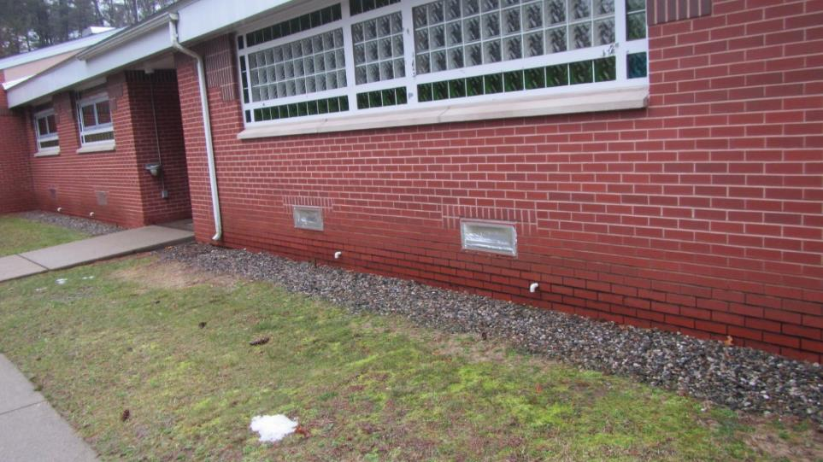

**Sealed univent fresh air intakes**

**Picture 2**

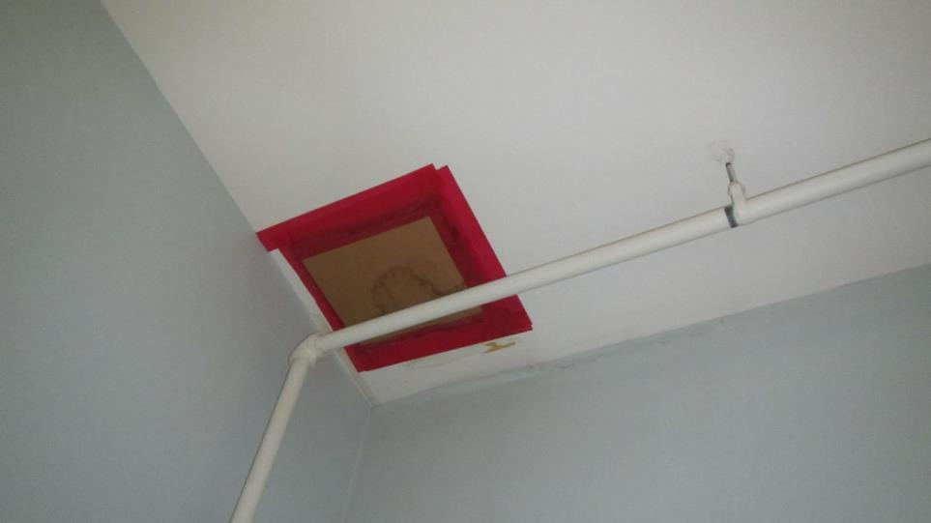

**Sealed exhaust vent in Room 1**

**Picture 3**

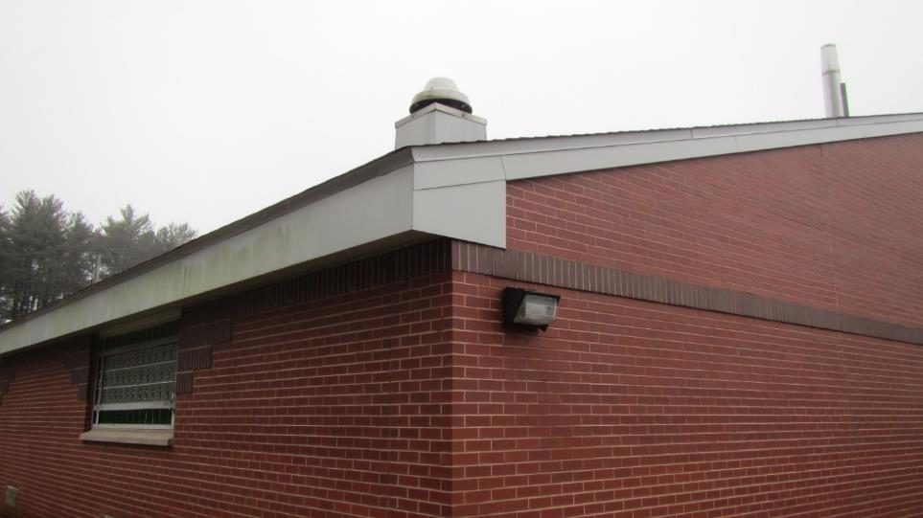

**Rooftop equipment that is likely associated with the vent in Picture 2**

**Picture 4**

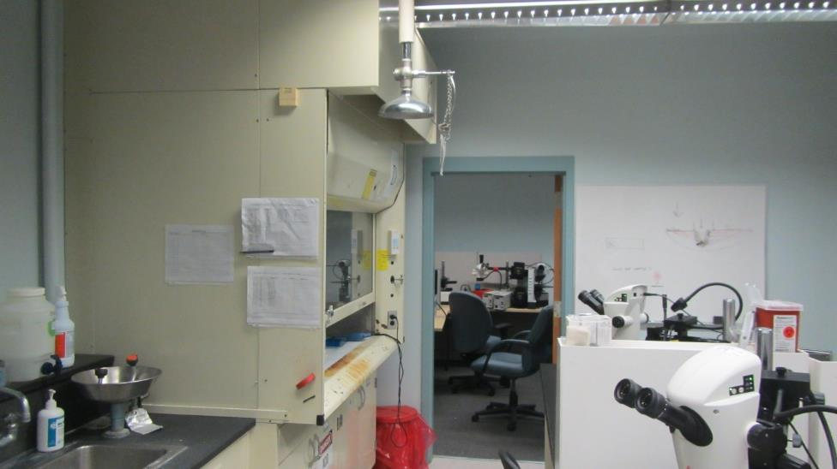

**Example of chemical hood**

**Picture 5**

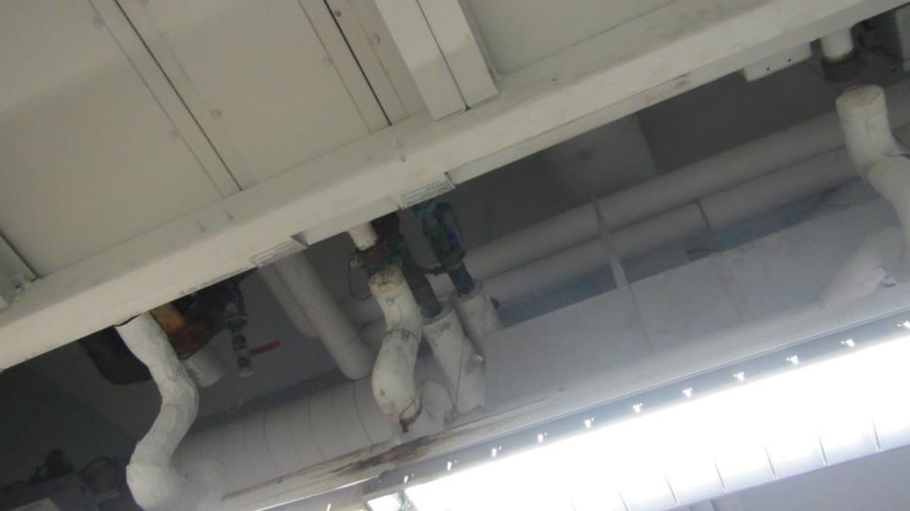

**Water-damaged pipe insulation in Room 23; pipe appears to be an abandoned part of the HVAC system**

**Picture 6**

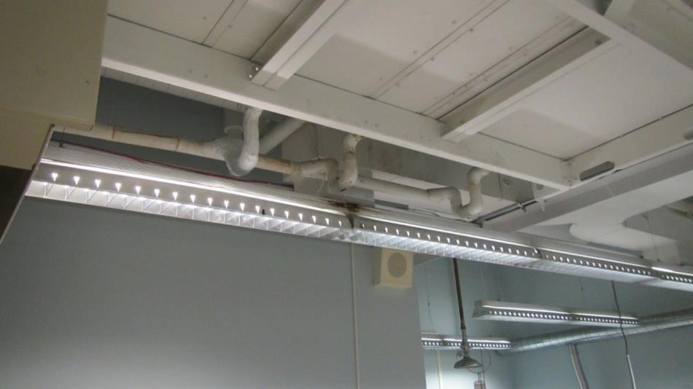

**Water-damaged light fixture below pipe in Picture 5**

**Picture 7**

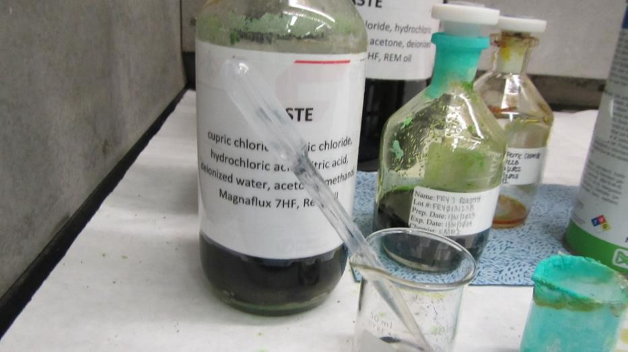

**Chemical waste bottle in Room 1**

**Picture 8**

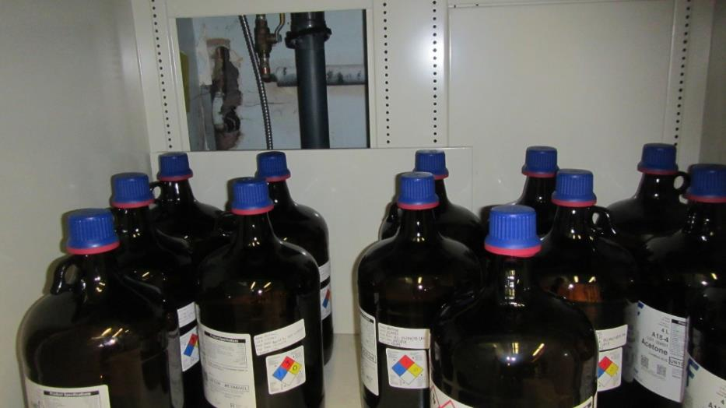

**Flammable chemicals stored beneath chemical hood in Room 1; note rear of cabinet open to the wall and stock bottle labels not all facing front**

**Picture 9**

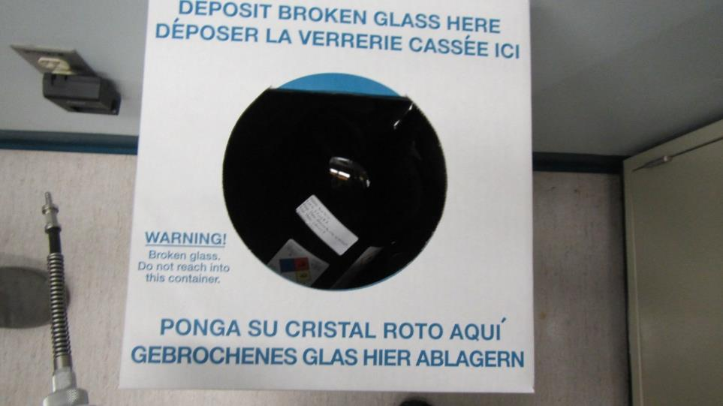

**Intact methanol bottle disposed of in container for clean broken glass**

**Picture 10**

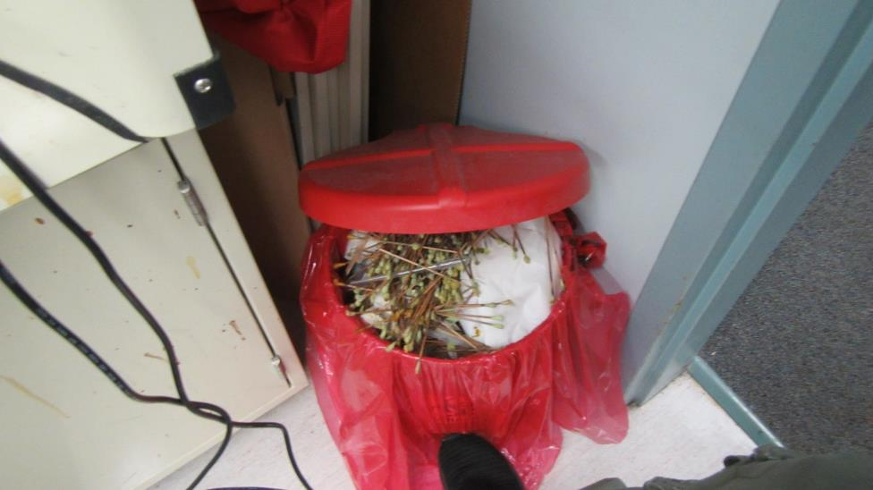

**Overfilled red bag waste container containing used cotton swabs**

**Picture 11**

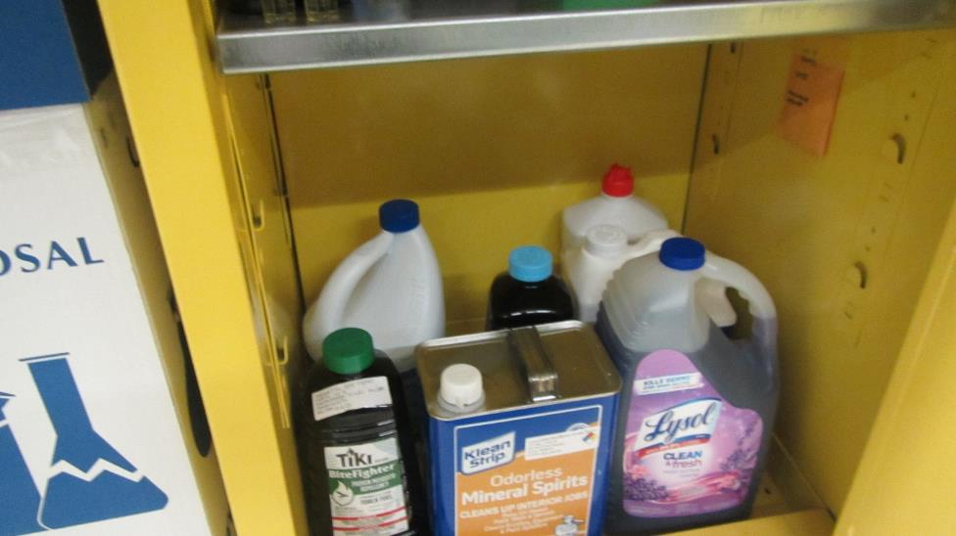

**Lysol, which contains ammonia, stored inside flameproof cabinet**

| **Location** | **Carbon**  **Dioxide**  **(ppm)** | **Carbon Monoxide**  **(ppm)** | **Temp**  **(°F)** | **Relative**  **Humidity**  **(%)** | **PM2.5**  **(µg/m3)** | **TVOCs**  **(ppm)** | **Occupants**  **in Room** | **Windows**  **Openable** | **Ventilation** | | **Remarks** |
| --- | --- | --- | --- | --- | --- | --- | --- | --- | --- | --- | --- |
| **Intake** | **Exhaust** |
| Background (outdoors) | 344 | ND | 41 | 51 | ND | 0.2 |  |  |  |  |  |
| Conference room | 862 | ND | 71 | 28 | ND | 0.5 | 6 | Y | Y | N | 1 water-damaged ceiling tile. VOCs likely due to cleaning wipes used in the room |
| 11 | 467 | ND | 71 | 25 | ND | 0.2 | 1 | Y | Y | Y |  |
| 13 | 458 | ND | 71 | 24 | ND | 0.2 | 0 | N | Y | Y |  |
| 15 | 494 | ND | 71 | 25 | ND | 0.2 | 3 | N | Y | Y | Odor of marijuana residue on suspended ceiling tiles |
| 17 cubicles east | 499 | ND | 72 | 25 | ND | 0.2 | 2 | N | Y | Y |  |
| 17 cubicles north | 480 | ND | 72 | 25 | ND | 0.2 | 4 | N | Y | Y |  |
| 17 cubicles west | 512 | ND | 72 | 25 | ND | 0.2 | 2 | N | Y | Y |  |
| 23 | 421 | ND | 71 | 24 | ND | 0.2 | 2 | N | Y | Y | Chemical hoods, carbon disulfide used in analyzers, ammonia-containing cleaner stored in flame proof cabinet, water damage to pipe insulation, water damage to hanging light fixture |
| 22 | 434 | ND | 72 | 24 | ND | 0.2 | 0 | N | Y | Y | Chemical hoods, analyzers in use, n-hexane use in this room |
| 20 | 417 | ND | 71 | 24 | ND | 0.2 | 0 | N | Y | Y | Vented flame-proof cabinet |
| 16 | 413 | ND | 72 | 24 | ND | 0.2 | 0 | N | Y | Y | Chemical hoods |
| 1 chemical hood section | 450 | ND | 71 | 24 | ND | 0.2 | 0 | N | Y | Y | Chemical hoods, odor above sink, acetone and ethanol use |
| 1 unused area formerly used for administration | 453 | ND | 70 | 22 | ND | 0.2 | 0 | N | Y | Transfer air vent | Cubicle divider against univent, univent deactivated, clutter |
| 1 evidence | 410 | ND | 70 | 25 | 1 | 0.5 | 0 | N | Y | Transfer air vent | Location of propylene glycol heating system leak; VOCs attributed to spraying of pipe chase walls from leak |
| 1 room outside evidence | 451 | ND | 69 | 25 | 1 | 0.2 | 0 | N | Y | Y |  |
| 1 SEM | 456 | ND | 71 | 24 | 1 | 0.2 | 0 | N | Y | N |  |
| 2 office | 478 | ND | 71 | 24 | 1 | 0.2 | 0 | N | Y | Y |  |
| 2 office | 477 | ND | 72 | 24 | 1 | 0.2 | 0 | N | Y | Y |  |
| 4 | 528 | ND | 72 | 24 | 1 | 0.2 | 4 | N | Y | Y |  |
| 5 | 552 | ND | 73 | 24 | 1 | 0.2 | 5 | N | Y | Y |  |
| 5 office | 538 | ND | 73 | 24 | 1 | 0.2 | 1 | N | Y | N |  |
| Lobby | 482 | ND | 72 | 24 | 1 | 0.2 | 0 | N | Y | Y |  |