**INDOOR AIR QUALITY**

**ODOR ASSESSMENT**

**State Police Crime Laboratory**

**59 Horse Pond Road**

**Sudbury, Massachusetts**

Prepared by:

Massachusetts Department of Public Health

Bureau of Climate and Environmental Health

Indoor Air Quality Program

March 2024

# BACKGROUND

|  |  |
| --- | --- |
| **Building:** | Massachusetts State Police Crime Laboratory (MSPCL) |
| **Address:** | 59 Horse Pond Road, Sudbury, MA |
| **Assessment Requested by:** | Division of Capital Asset Management and Maintenance (DCAMM) |
| **Dates of Assessment:** | January 26, 2024, and January 31, 2024 |
| **Bureau of Climate and Environmental Health/Indoor Air Quality (BCEH/IAQ) Program Staff Conducting Assessment:** | Michael Feeney, Director, Indoor Air Quality Program |
| **Date of Building Construction:** | Unknown, originally built as a school. Remodeled in 1992 |
| **Reason for Request:** | Odors and health concerns due to a heating pipe leak within the room inside the Room 1 laboratory. |

# ODOR INCIDENT

Room 1 was the focus of reports of an unusual odor centered around a sink that occurred after the evidence room leak. Above the Room 1 sink (Picture 1) is an exhaust vent that appears to be part of the main heating, ventilating, and air-conditioning (HVAC) system. This exhaust vent draws air from the sink area and is above the location where lab technician reported an unusual odor. The sink is flanked by two chemical hoods (Picture 1). The chemical hoods form walls around the sink, beneath the exhaust vent.

Concerns about a heating water leak were addressed in an earlier report, and an additional report on general indoor air quality will be issued subsequently.

# BUILDING DESCRIPTION

The MSPCL is a single-story building with mezzanine/attic areas originally built as a school. Most of the roof is peaked with shingles, but there is a flat portion cut into the roof where a peak would typically exist. The building contains offices, laboratories, storage areas, and conference rooms. Windows are not openable in the building.

# RESULTS AND DISCUSSION

Approximately 50 employees work in this building. Testing was conducted during normal operations, and test results are presented in Table 1. Methods and indoor air related sampling information can be found in the IAQ Manual and Appendices for IAQ Reports, which can be found at <https://www.mass.gov/lists/indoor-air-quality-manual-and-appendices>.

The following is a summary of indoor air testing results relevant to the odor investigation (Table 1):

* ***Total volatile organic compounds (TVOCs)*** levels were equal to outdoor measurements in all areas measured with the exception of The Evidence Room and the Conference Room. Source of the VOCs in the conference room was traced to use of disinfectant wipes.

MSPCL staff in the Room 1 lab reported an unusual odor around a sink that is flanked by two operating chemical hoods (Picture 1). IAQ staff conducted volatile organic compound (VOC) air sampling in Room 1 including measurements in areas around the sink and the drain openings. No elevated VOC levels compared to outdoor concentrations were found in these areas. In addition, no unusual odors were detected by IAQ staff when the lab was not in use during the first visit, or during the second visit when evidence was processed. Based on IAQ staff measurements and observations, no source of odor could be identified from conditions in Room 1 on either day.

Based on these observations, the reported odor does not appear to be related to the sink, the sink cabinet, chemical hoods, dry sink drain traps, connections to the drain plumbing in this area or any operations that exist outside of Room 1 where the pair of chemical hoods are located.

IAQ staff noted the presence of some products (bleach solution) and chemicals (acetone) that can adversely interact if mixed. Items with possible residues may have inadvertently mixed to become the odor source.

A product called Bleach-Rite (Picture 2, Appendix A) was present. Laboratory staff identified this as a material used for biological decontamination of evidence. Bleach-Rite is a solution of sodium hypochlorite 0.9% mixed in water (CTI, 2015). Bleach products are reactive materials and can react with acidic materials and organic solvents. Also noted were stock bottles of acetone, which are used in the evidence process. Based on descriptions of laboratory operations from staff, a possible odor source may be an inadvertent mixing of chemical residues.

Evidence that is contaminated with bodily fluids is required to be decontaminated prior to processing. As described by the Room 1 lab technicians, Bleach-Rite is used to disinfect the evidence before laboratory analysis is conducted. If bleach residue comes into contact with an acetone residue, the materials may interact to produce chloroform as well as other chlorinated compounds (Flinn Scientific, 2014). The following is a description of safety precautions if bleach and acetone are mixed as a controlled experiment for demonstration purposes.

*This demonstration* ***must be done*** *in a fume hood (emphasis added). One of the products of this reaction is chloroform which is a possible carcinogen. Prolonged inhalation may be fatal; toxic and narcotic by inhalation, ingestion may be fatal. Sodium hypochlorite solution is a corrosive liquid; causes skin burns; reacts with acid to evolve chlorine gas; evolves chlorine when heated; moderately toxic by ingestion and inhalation; avoid contact with organic material. Acetone is a dangerous fire risk; flammable; slightly toxic by ingestion and inhalation. Wear chemical splash goggles, chemical-resistant gloves, and a chemical-resistant apron. Wash hands thoroughly with soap and water before leaving the laboratory.* (Flinn Scientific, 2014)

If the combination of acetone and bleach residues caused a chemical interaction that occurred around the sink, odors may be drawn into the lab technician’s breathing zone by the operation of the exhaust vent above the sink. Given that no odors were noted during either of the IAQ Program visits, that no VOCs were measured around the sink, and determination that the odor incident is unrelated to the propylene glycol leak, the most likely source of the reported odors would appear to be residual chemical interactions. The accidental mixing of acetone with bleach-treated evidence items is a likely source of this transient odor.

# CONCLUSIONS AND RECOMMENDATIONS

As discussed above, no odors were noted or elevated VOCs measured during either visit. This would eliminate the building and its drain system as possible odor sources. As identified by MSPCL staff, the odor was unrelated to the heating system leak as described in a previous report. Based on the processes described by Room 1 staff and assessment of the chemicals used, it is feasible that an interaction of chemical residues may be the source of the odor.

In view of the findings at the time of the visit, the following recommendations are made:

1. Separate evidence disinfection activities/chemical use from areas where acetone is used.
2. Consider relocating evidence decontamination to the evidence room which contains an operating sink. Confine bleach use to this location.
3. Once disinfected, remove bleach residue from treated evidence with an appropriate diluting agent (e.g., distilled water).
4. Ensure that evidence that has been cleaned is completely dry prior to acetone application.
5. To prevent possible residual chemical exposure, application of acetone should occur inside chemical laboratory hoods.
6. Ensure that chemical laboratory hoods are calibrated and certified as required by law.
7. Refer to resource manuals and other related indoor air quality documents for further building-wide evaluations and advice on maintaining public buildings. Copies of these materials are located on the MDPH’s website: <http://mass.gov/dph/iaq>.

# REFERENCES

CTI. 2015. Bleach-Rite® Disinfecting Spray with Bleach. Current Technologies, Inc., Crawfordsville, IN. <https://www.statlab.com/pdfs/sds/Bleach-RiteSpray_SDS.pdf>

Flinn Scientific. 2016. Oxidation of Acetone by Bleach. Flinn Scientific Canada. Publication No. 91271. [650c3e8ed0574ed18c7b37b8832cccae (flinnsci.ca)](https://www.flinnsci.ca/api/library/Download/650c3e8ed0574ed18c7b37b8832cccae)

MDPH. 2015. Indoor Air Quality Manual. Available at: <https://www.mass.gov/lists/indoor-air-quality-manual-and-appendices>.

**Picture 1**

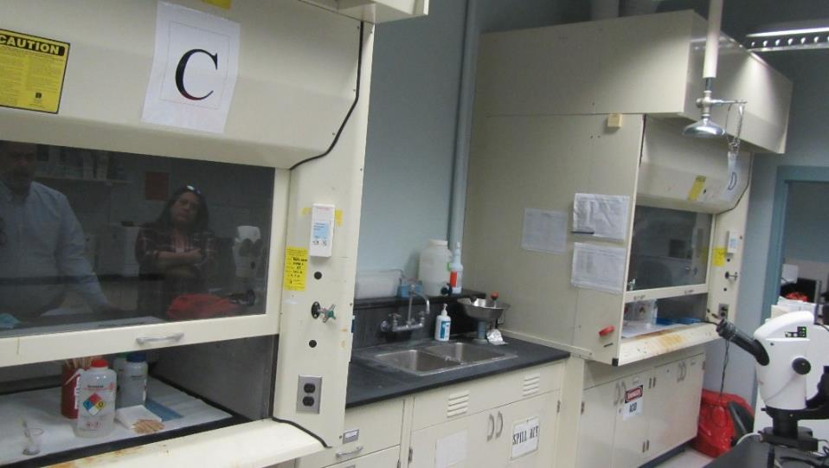

**Room 1 sink where odor reported, flanked by chemical hoods**

**Picture 2**

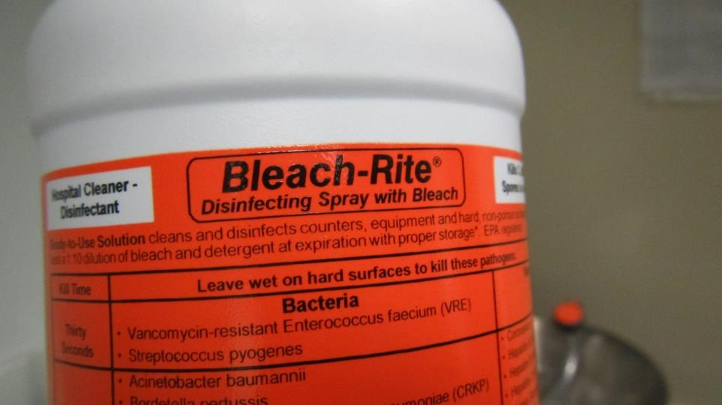

**Bleach-Rite disinfectant label**

| **Location** | **Carbon**  **Dioxide**  **(ppm)** | **Carbon Monoxide**  **(ppm)** | **Temp**  **(°F)** | **Relative**  **Humidity**  **(%)** | **PM2.5**  **(µg/m3)** | **TVOCs**  **(ppm)** | **Occupants**  **in Room** | **Windows**  **Openable** | **Ventilation** | | **Remarks** |
| --- | --- | --- | --- | --- | --- | --- | --- | --- | --- | --- | --- |
| **Intake** | **Exhaust** |
| Background (outdoors) | 344 | ND | 41 | 51 | ND | 0.2 |  |  |  |  |  |
| Conference room | 862 | ND | 71 | 28 | ND | 0.5 | 6 | Y | Y | N | 1 water-damaged ceiling tile. VOCs likely due to cleaning wipes used in the room |
| 11 | 467 | ND | 71 | 25 | ND | 0.2 | 1 | Y | Y | Y |  |
| 13 | 458 | ND | 71 | 24 | ND | 0.2 | 0 | N | Y | Y |  |
| 15 | 494 | ND | 71 | 25 | ND | 0.2 | 3 | N | Y | Y | Odor of marijuana residue on suspended ceiling tiles |
| 17 cubicles east | 499 | ND | 72 | 25 | ND | 0.2 | 2 | N | Y | Y |  |
| 17 cubicles north | 480 | ND | 72 | 25 | ND | 0.2 | 4 | N | Y | Y |  |
| 17 cubicles west | 512 | ND | 72 | 25 | ND | 0.2 | 2 | N | Y | Y |  |
| 23 | 421 | ND | 71 | 24 | ND | 0.2 | 2 | N | Y | Y | Chemical hoods, carbon disulfide used in analyzers, ammonia-containing cleaner stored in flame proof cabinet, water damage to pipe insulation, water damage to hanging light fixture |
| 22 | 434 | ND | 72 | 24 | ND | 0.2 | 0 | N | Y | Y | Chemical hoods, analyzers in use, n-hexane use in this room |
| 20 | 417 | ND | 71 | 24 | ND | 0.2 | 0 | N | Y | Y | Vented flame-proof cabinet |
| 16 | 413 | ND | 72 | 24 | ND | 0.2 | 0 | N | Y | Y | Chemical hoods |
| 1 chemical hood section | 450 | ND | 71 | 24 | ND | 0.2 | 0 | N | Y | Y | Chemical hoods, odor above sink, acetone and ethanol use |
| 1 unused area formerly used for administration | 453 | ND | 70 | 22 | ND | 0.2 | 0 | N | Y | Transfer air vent | Cubicle divider against univent, univent deactivated, clutter |
| 1 evidence | 410 | ND | 70 | 25 | 1 | 0.5 | 0 | N | Y | Transfer air vent | Location of propylene glycol heating system leak; VOCs attributed to spraying of pipe chase walls from leak |
| 1 room outside evidence | 451 | ND | 69 | 25 | 1 | 0.2 | 0 | N | Y | Y |  |
| 1 SEM | 456 | ND | 71 | 24 | 1 | 0.2 | 0 | N | Y | N |  |
| 2 office | 478 | ND | 71 | 24 | 1 | 0.2 | 0 | N | Y | Y |  |
| 2 office | 477 | ND | 72 | 24 | 1 | 0.2 | 0 | N | Y | Y |  |
| 4 | 528 | ND | 72 | 24 | 1 | 0.2 | 4 | N | Y | Y |  |
| 5 | 552 | ND | 73 | 24 | 1 | 0.2 | 5 | N | Y | Y |  |
| 5 office | 538 | ND | 73 | 24 | 1 | 0.2 | 1 | N | Y | N |  |
| Lobby | 482 | ND | 72 | 24 | 1 | 0.2 | 0 | N | Y | Y |  |

**Date: April 10, 2015**

**SAFETY DATA SHEET**

**Section 1. Identification**

**Product name: Bleach-Rite® Disinfecting Spray with Bleach**

**Product Numbers:** BRSPRAY16, BRSPRAY32, BRSPRAY64, BRSPRAY128

**EPA Registration #:** 70590-2

**Product description /**

**recommended use:** Bleach solution for cleaning / disinfection in bottles (with / without sprayers).

**Manufacturer:** Current Technologies, Inc.

P.O. Box 21

439 N 525 E

Crawfordsville, IN 47933

**Phone:** 765-364-0490

**Emergency Phone:** Contact your Regional Poison Control Center or doctor

**Section 2. Hazard Identification**

**Classification:** This product is not considered hazardous by the 2012 OSHA Hazard

Communication Standard (29 CFR 1910.1200).

**Signal Word / Precautions:** Caution; Keep out of reach of children.

**Precautionary Statement:** Physical and Chemical Hazards: Do not use this product with ammonia, acids (such as vinegar), rust removers, toilet bowl cleaners, or heavy metals such as copper or iron. Will corrode aluminum. For stainless steel, follow equipment manufacturers' directions; those may direct surface to be rinsed after disinfection.

**Section 3. Composition / Information on ingredients**

**Chemical Name:** Sodium hypochlorite

**Common Name/ Synonym:** Bleach spray, 1:10 dilution of bleach

**CAS#:** 7681-52-9

**% (by weight):** ˂ .94% (.0094 sodium hypochlorite by weight)

**Note:** All ingredients in this product, at their stated concentrations, are non-hazardous as defined in the OSHA hazard communication standard 29 CFR 1910.1200.

**Safety Data Sheet**

**Bleach-Rite® Disinfecting Spray with Bleach**

**Section 4. First-Aid Measures**

**Eyes:** If in eyes, hold eye open and rinse slowly and gently with water for 15-20 minutes. Call a poison control center or doctor for treatment advice.

**Skin:** Promptly rinse skin with water. If irritated, call a poison control center or doctor for treatment advice.

**Ingestion:** If swallowed, immediately call a poison control center or doctor for treatment advice. Have person drink a glass of water if able to swallow. Do not induce vomiting unless told to do so by poison control center or doctor. Do not give anything by mouth to an unconscious person.

**Inhalation:** If inhaled, move person to fresh air. If person is not breathing call 911. Call a poison control center or doctor for further treatment advice.

**Section 5. Fire-Fighting Measures**

**Suitable Extinguishing Media:** Use extinguishing measures appropriate for the situation and

environment.

**Unsuitable Extinguishing Media:** Water spray may not be sufficient when fighting fire.

**Specific Hazards arising**

**from the Chemical:** Hazardous Combustion Products: Oxides of carbon.

**Specific Protective Equipment** Wear self-contained breathing apparatus that is MSHA/NIOSH approved

**& Precautions for Fire-Fighters:** or equivalent, and full protective gear.

**Section 6. Accidental Release Measures**

**Personal precautions, protective equipment and emergency procedures:**

**Personal precautions:** Avoid contact with eyes. If using this product to clean / disinfect a

potential bio-contaminated surface, use Universal Precautions and gloves.

**Other information:** Product may cause damage to fabric/clothing (bleaching), remove cap

from bottle carefully. Refer to protective measures in Sections 7 and 8.

**Methods and material for containment and cleaning up:**

**Methods for Containment:** If bottle is leaking, place in a bag or container that is impermeable to

liquids (e.g., plastic bag or garbage bag).

**Methods for Cleaning Up:** If surface is bio-contaminated, use Universal Precautions for handling

(e.g., use gloves). Wipe up the spilled liquid with a paper towel or wiper; place bottle and paper towel / wiper in container for contaminated waste. Rinse surface with water.

**Safety Data Sheet**

**Bleach-Rite® Disinfecting Spray with Bleach**

**Section 7. Handling and Storage**

**Precautions for safe handling:** Use good industrial hygiene / safety practices when handling; if using this

product to clean / disinfect a bio-contaminated surface, then follow Universal Precautions. Avoid contact with eyes, skin and clothing. Do not eat, drink or smoke when using this product. Keep caps / sprayers on this product tightly closed. Expiration Date is listed on back panel of every bottle and on outside of each case; do not use this product beyond the expiration date.

**Conditions for safe storage:** Store in a well-ventilated place at room temperature (68-77°F); do not

expose to excessive heat, direct sunlight, or UV light or else sodium hypochlorite (bleach) efficacy may deteriorate. Keep caps / sprayers tightly closed.

**Incompatible Products:** Do not mix with ammonia, acids (such as vinegar), rust removers, toilet

bowl cleaners. Do not use on heavy metals such as copper and iron; will corrode aluminum. For stainless steel, follow equipment manufacturers' directions; those may direct surface to be rinsed after disinfection.

**Section 8. Exposure Controls / Personal Protection**

**Control Parameters:**

**Exposure Guidelines:** Ingredients in this product with occupational exposure limits are not at concentrations in excess of permissible exposure limits.

**Appropriate engineering controls:**

**Engineering Measures:** Showers, eyewash stations, ventilation systems should be at usage site.

**Individual protection measures, such as personal protective equipment:**

**Eye / Face Protection:** No special protective equipment required.

**Skin and Body Protection:** Gloves are recommended, particularly when using this product repeatedly or when product is used for cleaning / disinfection of potentially bio-contaminated surfaces.

**Respiratory Protection:** No protective equipment is needed under normal use conditions. If irritation is experienced, ventilation and leaving the area may be required.

**Hygiene Measures:** Use good industrial hygiene and safety practices; if using to clean / disinfect a bio-contaminated surface, then follow Universal Precautions.

**Safety Data Sheet**

**Bleach-Rite® Disinfecting Spray with Bleach**

**Section 9. Physical and Chemical Properties**

**Appearance:** White plastic bottle bottle filled with clear, colorless liquid.

**pH:** 12 – 12.5 (liquid)

**Odor:** Mild bleach odor

**Odor Threshold:** No Data Available

**Specific gravity: ~** 1.0

**Evaporation Rate:** N/A

**Solubility in Water:** Completely miscible

**Flammability (solid, gas):** No Data Available

**Flammable Limits:** LFL: N/A ; UFL: N/A

**Decomposition Temperature:** Decomposes as heated

**Fire & Explosion Hazard:** Not flammable

**Flash Point:** N/A

**Physical State:** Plastic bottle filled with liquid.

**Vapor Pressure:** No Data Available

**Vapor Density:** No Data Available

**Melting / Freezing Point:** No Data Available

**Boiling Point / Boiling Range:** No Data Available

**Relative Density:** No Data Available

**Auto-Ignition Temperature:** No Data Available

**Viscosity:** No Data Available

**Partition Coefficeient: n-octanol/water:** No Data Available

**Safety Data Sheet**

**Bleach-Rite® Disinfecting Spray with Bleach**

**Section 10. Stability and Reactivity**

**Reactivity:** Sodium hypochlorite reacts with ammonia, acids (such as vinegar), rust removers, toilet bowl cleaners to produce hazardous gases such as chlorine and other chlorinated components. Do not use with heavy metals such as copper or iron as sodium hypochlorite may degrade / lose efficacy. Will corrode aluminum. For stainless steel, follow equipment manufacturers' directions; those may direct surface to be rinsed after disinfection.

**Chemical Stability:** Stable when handling and storage recommendations followed; efficacious through expiration date. (See Section 7).

**Possibility of Hazardous Reactions:** None if directions for use, storage and handling are followed (see Section 7).

**Conditions to Avoid (e.g., static** Avoid exposure to sunlight, UV light, heat. Do not mix with

**discharge, shock, or vibration):** products listed below as incompatible, or use on incompatible

surfaces listed below.

**Incompatible Materials:** Acids, ammonium compounds, organics, other oxidizers are

incompatible; if product mixed with these incompatible materials, chlorine gas and other chlorinated components may be produced; will corrode aluminum. Do not use product on heavy metals such as iron or copper. For stainless steel, follow equipment manufacturers' directions; those may direct surface to be rinsed after disinfection.

**Hazardous Decomposition Products:** None known.

**Safety Data Sheet**

**Bleach-Rite® Disinfecting Spray with Bleach**

**Section 11. Toxicological Information**

**Information on the likely route of exposure:**

**Inhalation:** Adverse effects unlikely; some individuals may have slight irritation to mild bleach odor.

**Ingestion (oral):** Ingestion of liquid may cause slight gastrointestinal irritation.

**Skin:** Very slight irritant; assigned to U.S. EPA Toxicity Category IV (lowest level).

**Eye Contact:** Slight irritation (redness); resolved within 24 hours in test animals.

**Symptoms related to the physical and chemical characteristics:**

**Symptoms:** - If ingested orally, slight gastrointestinal irritation.

- If in eyes, slight redness.

**Delayed, immediate and chronic effects from short- and long-term exposure:**

**Sensitization:** No data available.

**Carcinogenicity:** Sodium hypochlorite (CAS# 7681-52-9) categorized by the following organizations: ACGIH – not classified as a carcinogen.

IARC – Group 3; not classified as a carcinogen in humans. NTP – not classified as a carcinogen.

OSHA – not classified as a carcinogen.

**Numerical measures of toxicity:**

**Inhalation:** Acute inhalation: LC50 > 2.23 mg/L (rat) **Ingestion (oral):** Acute Oral: LD50 > 5050 mg/kg (rat) **Skin:** Acute Dermal: LD50 ˃ 5050 mg/kg (rabbit) **Reproductive:** No data available.

**STOT (Specific Target Organ Systemic Toxicity):**

**Single exposure:** No data available. **Chronic exposure:** No data available. **Repeated exposure:** No data available.

**Section 12. Ecological Information**

**Ecotoxicity:** Does not contain mercury; (below detectable limits).

**Persistence and degradability:** No data available. **Bioaccumulative potential:** No data available. **Mobility in soil:** No data available.

**Other adverse effects:** No data available.

**Safety Data Sheet**

**Bleach-Rite® Disinfecting Spray with Bleach**

**Section 13. Disposal Considerations**

**Safe handling / methods of disposal:** Product or rinsates that are to be discarded must be diluted with

water before disposal in a sanitary sewer. Nonrefillable container. Do not reuse or refill this container. Offer for recycling if available, or puncture and dispose of in a sanitary landfill. Follow all applicable federal, state and local regulations for disposal.

**Disposal of contaminated packaging:** Do not reuse this container when empty. Dispose of in accordance

with federal / state / local regulations.

**Section 14. Transport Information**

**U.S. DOT (Department of Transportation):** Not regulated. **IATA (International Air Transport Association):** Not regulated **TDG (Transportation of Dangerous Goods):** Not regulated **ICAO (International Civil Aviation Organization):** Not regulated **IATA (International Air Transport Association):** Not regulated **IMDG (International Maritime Dangerous Goods):** Not regulated **IMO (International Maritime Organization):** Not regulated **UN Number:** N/A

**UN proper shipping name:** N/A

**Transport Hazard Class(es):** N/A

**Packing group:** DOT HAZARD CLASS I Pack Group: Not regulated

**Environmental hazards:** N/A

**Transport in bulk:** N/A

**Hazard symbols:** None

**Special precautions:** N/A

**Reference:** 49 CFR 172, 49 CFR 173

**Note:** Information in this section is for reference only. See 49 CFR 172 and 49 CFR 173.

**Safety Data Sheet**

**Bleach-Rite® Disinfecting Spray with Bleach**

**Section 15. Regulatory Information**

**U.S. Federal Regulations:**

**TSCA (U.S. Toxic Substances Control Act):** Ingredients of this product are on the TCSA 8(b) Inventory or otherwise exempt.

**SARA TITLE III, Section 311/312/313 Superfund Amendments and Reauthorization Act of 1986:** This product does not contain any chemicals which are subject to SARA Title 40 of the Code of Federal Regulations, Part 372.

Acute Health Hazard: No

Chronic Health Hazard: No

Fire Hazard: No

Sudden Release of Pressure Hazard: No

Reactive Hazard: No

**CWA (Clean Water Act):**

This product contains the following substances which are regulated pollutants pursuant to the Clean Water Act (40 CFR 122.21 and 40 CFR 122.42)

Chemical name: sodium hypochlorite (CAS# 7681-52-9)

CWA – Reportable Quantities: 100 lb

CWA – Toxic Pollutants: N/A

CWA – Priority Pollutants: N/A

CWA – Hazardous Substances: X

**CERCLA (USA – Comprehensive Response Compensation and Liability Act):**

This material, as supplied, contains one or more substances regulated as a hazardous substance under the Comprehensive Environmental Response Compensation and Liability Act (CERCLA) (40 CFR 302).

Chemical name: sodium hypochlorite (CAS# 7681-52-9)

Hazardous Substances RQs: 100 lb

Extremely Hazardous Substances RQs: N/A

RQ (Reportable Quantity): 100 lb final RQ; 45.4 kg final RQ

**EPA:**

This product is regulated as a pesticide by the U.S. EPA Antimicrobials Division. In accordance with EPA directives, the product label states: 'Caution: Keep out of reach of children. Read and follow directions and precautions on back panel.'

**U.S. State Regulations:**

**California Propostion 65:** Product does not contain any Proposition 65 chemicals.

**Massachusetts:** Product does not contain mercury; (below detectable limits).

**Safety Data Sheet**

**Bleach-Rite® Disinfecting Spray with Bleach**

**Section 16. Other Information**

|  |  |  |  |
| --- | --- | --- | --- |
| **NFPA Hazard ratings** | Health: | 1 | 0 = none |
|  | Flammability: | 0 | 1 = slight/little |
|  | Reactivity: Special hazards: | 0  OX – Oxidizer | 2 = moderate  3 = high/serious  4 = extreme |
| **HMIS Hazard ratings** | Health: | 1 | 0 = insignificant |
|  | Flammability: | 0 | 1 = slight |
|  | Physical hazard: Personal protection: | 0  P (gloves) | 2 = moderate  3 = high  4 = extreme |

**Preparation / Revision Date: April 10, 2015**

**General Disclaimer:**

This Safety Data Sheet (SDS) is prepared to comply with the OSHA Hazard Communication Standard (29 CFR 1910.1200). The information in this SDS is correct to the best of our knowledge and information as of the preparation / revision date. The information in this SDS is to be used only as guidance for the safe use, handling, storage, transportation, and disposal of this product. This SDS is not a warranty or a quality specification, and Current Technologies makes no representations as to its accuracy or sufficiency. Conditions of use for this product are beyond the control of Current Technologies and therefore users are responsible for determining whether the product is suitable for their particular purposes. Users of this product assume all risks of use, handling, storage and disposal. The information in this SDS relates only to the product designated herein, and may not be accurate or relate to its use in combination with other materials or any other processes.

End of Safety Data Sheet