**PROPYLENE GLYCOL RELEASE**

**ASSESSMENT**

**State Police Crime Laboratory**

**59 Horse Pond Road**

**Sudbury, Massachusetts**

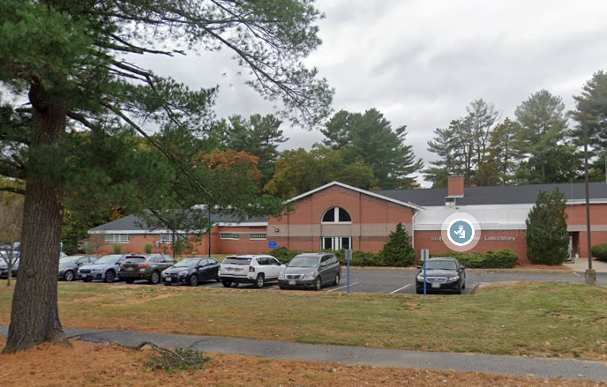

Prepared by:

Massachusetts Department of Public Health

Bureau of Climate and Environmental Health

Indoor Air Quality Program

February 2024

# BACKGROUND

|  |  |
| --- | --- |
| **Building:** | Massachusetts State Police Crime Laboratory (MSPCL) |
| **Address:** | 59 Horse Pond Road, Sudbury, MA |
| **Assessment Requested by:** | Division of Capital Asset Management and Maintenance (DCAMM) |
| **Dates of Assessment:** | January 26 and January 31, 2024 |
| **Bureau of Climate and Environmental Health/Indoor Air Quality (BCEH/IAQ) Program Staff Conducting Assessment:** | Michael Feeney, Director, Indoor Air Quality Program |
| **Date of Building Construction:** | Unknown, originally built as a school. Remodeled in 1992 |
| **Reason for Request:** | Odors and health concerns due to a heating pipe leak within the room inside the Room 1 laboratory. |

# ODOR INCIDENT

A leak from a heating system supply pipe in the evidence area of Room 1 caused a release of water mixed with an antifreeze product (subsequently referred to as the water leak). This product, called DOWFROST™ HD Heat Transfer Fluid, Dyed (Dowfrost), contains propylene glycol. A Safety Data Sheet (SDS) is attached as Appendix A. This water leak occurred inside an enclosed pipe chase that is constructed of gypsum wallboard affixed to a metal frame that exists in the evidence room.

In addition to the heating water leak, concerns were reported about a chemical odor and general air quality; these will be addressed in separate reports.

# BUILDING DESCRIPTION

The MSPCL is a single-story building with mezzanine/attic areas originally built as a school. Most of the roof is peaked with shingles, but there is a flat portion cut into the roof where a peak would typically exist. The building contains offices, laboratories, storage areas, and conference rooms. Windows are not openable in the building.

# RESULTS AND DISCUSSION

Approximately 50 employees work in this building. Testing was conducted during normal operations, and test results are presented in Table 1. Methods and indoor air related sampling information can be found in the IAQ Manual and Appendices for IAQ Reports, which can be found at <https://www.mass.gov/lists/indoor-air-quality-manual-and-appendices>.

The following is a summary of indoor air testing results relevant to the water leak (Table 1):

* ***Total volatile organic compounds (TVOCs)*** levels were equal to outdoor measurements in all areas measured with the exception of Room 1 (Evidence) and the conference room. Source of the VOCs in the conference room was traced to use of disinfectant wipes.

## Heating system leak assessment

As reported by MSPCL staff, a water puddle was noted in the evidence room within Room 1 suite of laboratories. This puddle was traced to a leak from a pipe of the heating system that exists in a pipe chase (Picture 1). As noted, the heating system contains a mixture of water and a propylene glycol antifreeze called DowFrost. Based on information available from the manufacturer, the heating system leak would not be expected to be an inhalation exposure. As noted in the product SDS, DowFrost has a boiling point of 152°C (306°F). Based on the conditions noted where the release occurred, descriptions if the incident from MSPCL staff, and review of the Dowfrost SDS information, the follow information can be discerned:

* No MSPCL lab technicians or administrative staff had direct contact with the liquid, were sprayed with pipe leak water, or handled removed pipe chase gypsum wallboard.
* As reported by MSPCL staff, the operating temperature of the heating system is approximately 160°F. At this temperature, the heating system water will not form steam (water vapor). In addition, the antifreeze will not form a vapor since its boiling point is 306°F. Without a vapor that can be inhaled, the symptoms listed on the SDS are not likely to occur.
* As the leak occurred, the walls of the pipe chase intercepted sprayed materials, preventing direct contact with the surface inside lab rooms.
* Information provided in the SDS assumes the material spilled is undiluted antifreeze from the stock container unlike the mixture with water released from the heating pipe. It is important to note that the DowFrost SDS Health information is designed to provide medical staff treating an incident with information that assumes:
  + direct contact by ingestion;
  + an individual had been splashed/misted as the leak occurred;
  + direct skin contact with the product or building surfaces that came into contact with the antifreeze.
* An SDS is designed to provide information to individuals who are likely to be routinely exposed to a product, such as heating system technicians, facilities maintenance staff, or individuals transporting the product.
* Typically, the water from a heating system is 25% antifreeze in water. The undiluted antifreeze is a mixture containing between 93.5% and 94.5% propylene glycol (Dow, 2023).

In this case, the mixture is 85% water and 15% antifreeze. Therefore, the water puddle found from this leak in this heating system would be just under 15% propylene glycol.

As noted, the leak occurred inside of an enclosed pipe chase. If the leak from the heating pipe occurred as sprayed mist, the pipe chase walls would intercept the mist, which would drip down to form a puddle. White stains were found on the horizontal surfaces of the pipe chase metal support (Picture 2), which is unusual inside a dry interior wall. Such staining may indicate moistening and drying of a water mixture, which may indicate water spraying inside the pipe chase. It is important to note that no other signs of roof or wall leaks were found in the pipe chase. In addition, the slight elevation of VOCs compared to the rest of the MSPCL can be attributed to the wetting of pipe chase walls with heating water.

Room 1 is subdivided into 5 locations that are designed to be depressurized by air drawn into chemical hoods located in the southernmost portion of the MSPCL (Picture 3). Due to this design, any odors produced in the evidence room (including the heating system leak) would be confined to the Room 1 suite and would not be a source of odor or exposure to any other location within the MSPCL, including the main hallway.

# CONCLUSIONS AND RECOMMENDATIONS

The heating water leak was limited to a single room within the Room 1 suite. Due to the existence of chemical hoods in Room 1, any residual heating water odor would be limited to the Room 1 suite.

In view of the findings at the time of the visit, the following additional recommendations are made:

1. Remove all wall material from the pipe chase where the heating water leak occurred.
2. Remove all pipe insulation in the pipe chase to remove any residual odor due to heating water exposure.
3. Clean the floor of the pipe chase in a manner consistent with SDS recommendations to remove residual heating water odor.
4. Refer to resource materials on the MDPH’s website: <http://mass.gov/dph/iaq>.

**Picture 1**

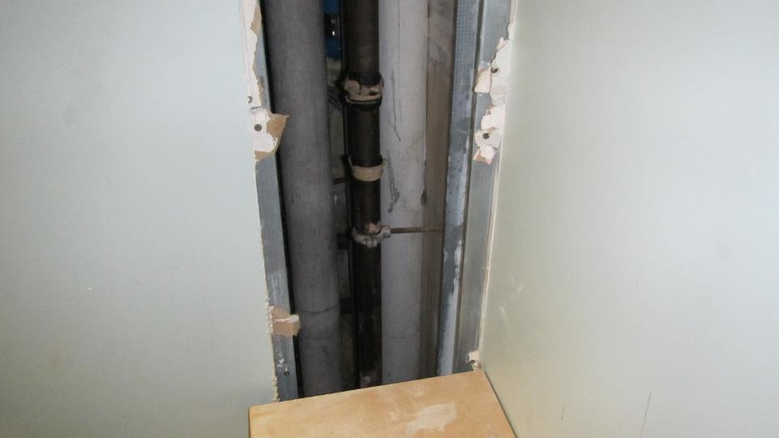

**Pipe chase walls where heating water leak occurred**

**Picture 2**

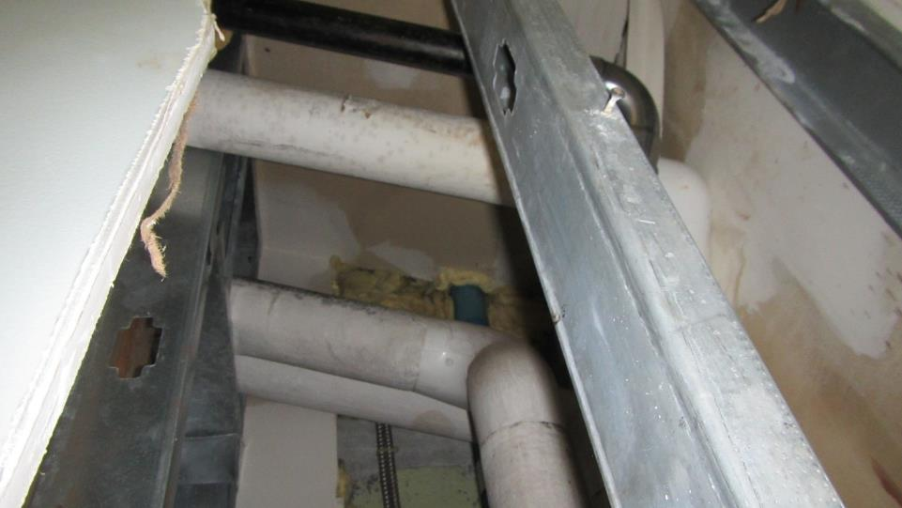

**Insulation in pipe chase**

**Picture 3**

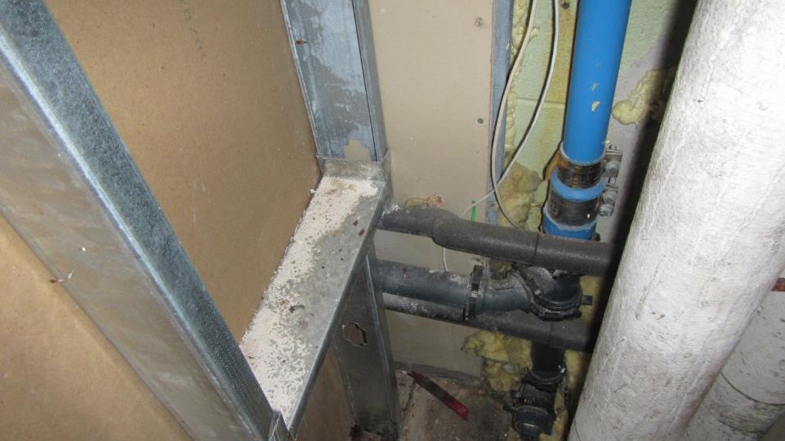

**Staining of metal support in pipe chase, indicating possible liquid exposure**

**Picture 4**

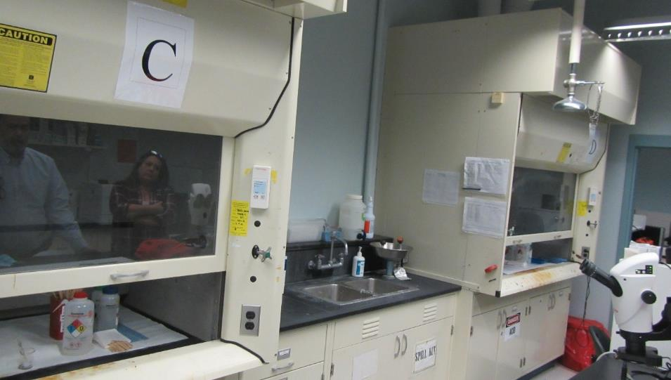

**Chemical hoods in Room 1 that draw air from the entire suite, including the evidence room**

| **Location** | **Carbon**  **Dioxide**  **(ppm)** | **Carbon Monoxide**  **(ppm)** | **Temp**  **(°F)** | **Relative**  **Humidity**  **(%)** | **PM2.5**  **(µg/m3)** | **TVOCs**  **(ppm)** | **Occupants**  **in Room** | **Windows**  **Openable** | **Ventilation** | | **Remarks** |
| --- | --- | --- | --- | --- | --- | --- | --- | --- | --- | --- | --- |
| **Intake** | **Exhaust** |
| Background (outdoors) | 344 | ND | 41 | 51 | ND | 0.2 |  |  |  |  |  |
| Conference room | 862 | ND | 71 | 28 | ND | 0.5 | 6 | Y | Y | N | 1 water-damaged ceiling tile. VOCs likely due to cleaning wipes used in the room |
| 11 | 467 | ND | 71 | 25 | ND | 0.2 | 1 | Y | Y | Y |  |
| 13 | 458 | ND | 71 | 24 | ND | 0.2 | 0 | N | Y | Y |  |
| 15 | 494 | ND | 71 | 25 | ND | 0.2 | 3 | N | Y | Y | Odor of marijuana residue on suspended ceiling tiles |
| 17 cubicles east | 499 | ND | 72 | 25 | ND | 0.2 | 2 | N | Y | Y |  |
| 17 cubicles north | 480 | ND | 72 | 25 | ND | 0.2 | 4 | N | Y | Y |  |
| 17 cubicles west | 512 | ND | 72 | 25 | ND | 0.2 | 2 | N | Y | Y |  |
| 23 | 421 | ND | 71 | 24 | ND | 0.2 | 2 | N | Y | Y | Chemical hoods, carbon disulfide used in analyzers, ammonia-containing cleaner stored in flame proof cabinet, water damage to pipe insulation, water damage to hanging light fixture |
| 22 | 434 | ND | 72 | 24 | ND | 0.2 | 0 | N | Y | Y | Chemical hoods, analyzers in use, n-hexane use in this room |
| 20 | 417 | ND | 71 | 24 | ND | 0.2 | 0 | N | Y | Y | Vented flame-proof cabinet |
| 16 | 413 | ND | 72 | 24 | ND | 0.2 | 0 | N | Y | Y | Chemical hoods |
| 1 chemical hood section | 450 | ND | 71 | 24 | ND | 0.2 | 0 | N | Y | Y | Chemical hoods, odor above sink, acetone and ethanol use |
| 1 unused area formerly used for administration | 453 | ND | 70 | 22 | ND | 0.2 | 0 | N | Y | Transfer air vent | Cubicle divider against univent, univent deactivated, clutter |
| 1 evidence | 410 | ND | 70 | 25 | 1 | 0.5 | 0 | N | Y | Transfer air vent | Location of propylene glycol heating system leak; VOCs attributed to spraying of pipe chase walls from leak |
| 1 room outside evidence | 451 | ND | 69 | 25 | 1 | 0.2 | 0 | N | Y | Y |  |
| 1 SEM | 456 | ND | 71 | 24 | 1 | 0.2 | 0 | N | Y | N |  |
| 2 office | 478 | ND | 71 | 24 | 1 | 0.2 | 0 | N | Y | Y |  |
| 2 office | 477 | ND | 72 | 24 | 1 | 0.2 | 0 | N | Y | Y |  |
| 4 | 528 | ND | 72 | 24 | 1 | 0.2 | 4 | N | Y | Y |  |
| 5 | 552 | ND | 73 | 24 | 1 | 0.2 | 5 | N | Y | Y |  |
| 5 office | 538 | ND | 73 | 24 | 1 | 0.2 | 1 | N | Y | N |  |
| Lobby | 482 | ND | 72 | 24 | 1 | 0.2 | 0 | N | Y | Y |  |

|  |  |
| --- | --- |
| **SAFETY DATA SHEET**  **THE DOW CHEMICAL COMPANY** | |
| **Product name: DOWFROST™ HD Heat Transfer Fluid, Dyed** | **Issue Date:** 04/13/2022 |
|  | **Print Date:** 10/03/2023 |

THE DOW CHEMICAL COMPANY encourages and expects you to read and understand the entire (M)SDS, as there is important information throughout the document. We expect you to follow the precautions identified in this document unless your use conditions would necessitate other appropriate methods or actions.

1. **IDENTIFICATION**

**Product name:** DOWFROST™ HD Heat Transfer Fluid, Dyed

**Recommended use of the chemical and restrictions on use**

**Identified uses:** Intended as a heat transfer fluid for closed-loop systems. We recommend that you use this product in a manner consistent with the listed use. If your intended use is not consistent with the stated use, please contact your sales or technical service representative.

**COMPANY IDENTIFICATION** THE DOW CHEMICAL COMPANY 2211 H.H. DOW WAY

MIDLAND MI 48674 UNITED STATES

|  |  |
| --- | --- |
| **Customer Information Number:** | 800-258-2436  [SDSQuestion@dow.com](mailto:SDSQuestion@dow.com) |

**EMERGENCY TELEPHONE NUMBER**

**24-Hour Emergency Contact:** CHEMTREC +1 800-424-9300

**Local Emergency Contact:** 800-424-9300

1. **HAZARDS IDENTIFICATION**

**Hazard classification**

GHS classification in accordance with the OSHA Hazard Communication Standard (29 CFR 1910.1200)

Reproductive toxicity - Category 2

**Label elements Hazard pictograms**

® ™ Trademark of The Dow Chemical Company ("Dow") or an affiliated company of Dow

Page 1 of 17

Signal word: **WARNING! Hazards**

Suspected of damaging fertility or the unborn child.

**Precautionary statements Prevention**

Obtain special instructions before use.

Do not handle until all safety precautions have been read and understood.

Wear protective gloves, protective clothing, eye protection and/or face protection.

**Response**

IF exposed or concerned: Get medical advice/ attention.

**Storage**

Store locked up.

**Disposal**

Dispose of contents and/or container to an approved waste disposal plant.

**Other hazards**

No data available

1. **COMPOSITION/INFORMATION ON INGREDIENTS**

This product is a mixture.

|  |  |  |
| --- | --- | --- |
| **Component** | **CASRN** | **Concentration** |

|  |  |  |
| --- | --- | --- |
| Propylene glycol | 57-55-6 | > 93.5 - < 94.5 % |

|  |  |  |
| --- | --- | --- |
| Water | 7732-18-5 | >= 1.0 - < 5.0 %* |

|  |  |  |
| --- | --- | --- |
| Dipotassium hydrogen phosphate | 7758-11-4 | >= 1.0 - < 5.0 %* |

|  |  |  |
| --- | --- | --- |
| Sodium tolyltriazole | 64665-57-2 | >= 0.1 - < 0.25 %* |

*Note*

Actual concentration is withheld as a trade secret

1. **FIRST AID MEASURES**

**Description of first aid measures**

**General advice:**

If potential for exposure exists refer to Section 8 for specific personal protective equipment. **Inhalation:** Move person to fresh air and keep comfortable for breathing; consult a physician.

**Skin contact:** Wash off with plenty of water.

**Eye contact:** Flush eyes thoroughly with water for several minutes. Remove contact lenses after the initial 1-2 minutes and continue flushing for several additional minutes. If effects occur, consult a physician, preferably an ophthalmologist.

**Ingestion:** Rinse mouth with water. No emergency medical treatment necessary.

**Most important symptoms and effects, both acute and delayed:**

Aside from the information found under Description of first aid measures (above) and Indication of immediate medical attention and special treatment needed (below), any additional important symptoms and effects are described in Section 11: Toxicology Information.

**Indication of any immediate medical attention and special treatment needed**

**Notes to physician:** No specific antidote. Treatment of exposure should be directed at the control of symptoms and the clinical condition of the patient.

1. **FIREFIGHTING MEASURES**

**Extinguishing media**

**Suitable extinguishing media:** Water fog or fine spray. Dry chemical fire extinguishers. Carbon dioxide fire extinguishers. Foam.. Alcohol resistant foams (ATC type) are preferred. General purpose synthetic foams (including AFFF) or protein foams may function, but will be less effective..

**Unsuitable extinguishing media:** Do not use direct water stream.. May spread fire..

**Special hazards arising from the substance or mixture**

**Hazardous combustion products:** During a fire, smoke may contain the original material in addition to combustion products of varying composition which may be toxic and/or irritating.. Combustion products may include and are not limited to:. Carbon monoxide.. Carbon dioxide..

**Unusual Fire and Explosion Hazards:** Container may rupture from gas generation in a fire situation.. Violent steam generation or eruption may occur upon application of direct water stream to hot liquids..

**Advice for firefighters**

**Fire Fighting Procedures:** Keep people away. Isolate fire and deny unnecessary entry.. Use water spray to cool fire exposed containers and fire affected zone until fire is out and danger of reignition has passed.. Fight fire from protected location or safe distance. Consider the use of unmanned hose holders or monitor nozzles.. Immediately withdraw all personnel from the area in case of rising sound from venting safety device or discoloration of the container.. Burning liquids may be extinguished by dilution with water.. Do not use direct water stream. May spread fire.. Move container from fire area if this is possible without hazard.. Burning liquids may be moved by flushing with water to protect personnel and minimize property damage..

**Special protective equipment for firefighters:** Wear positive-pressure self-contained breathing apparatus (SCBA) and protective fire fighting clothing (includes fire fighting helmet, coat, trousers, boots, and gloves).. If protective equipment is not available or not used, fight fire from a protected location or safe distance..

1. **ACCIDENTAL RELEASE MEASURES**

**Personal precautions, protective equipment and emergency procedures:** Keep unnecessary and unprotected personnel from entering the area. Use appropriate safety equipment. For additional information, refer to Section 8, Exposure Controls and Personal Protection.

**Environmental precautions:** Prevent from entering into soil, ditches, sewers, waterways and/or groundwater. See Section 12, Ecological Information.

**Methods and materials for containment and cleaning up:** Small spills: Absorb with materials such as: Cat litter. Sawdust. Vermiculite. Zorb-all®. Collect in suitable and properly labeled containers. Large spills: Dike area to contain spill. See Section 13, Disposal Considerations, for additional information.

1. **HANDLING AND STORAGE**

**Precautions for safe handling:** No special precautions required. Keep container closed. Spills of these organic materials on hot fibrous insulations may lead to lowering of the autoignition temperatures possibly resulting in spontaneous combustion. See Section 8, EXPOSURE CONTROLS AND PERSONAL PROTECTION.

**Conditions for safe storage:** Do not store in: Galvanized steel. Opened or unlabeled containers. Store in the following material(s): Carbon steel. Stainless steel. Store in original unopened container. See Section 10 for more specific information. Additional storage and handling information on this product may be obtained by calling your sales or customer service contact.

**Storage stability**

**Shelf life: Use within** 60 Month

1. **EXPOSURE CONTROLS/PERSONAL PROTECTION**

**Control parameters**

If exposure limits exist, they are listed below. If no exposure limits are displayed, then no values are applicable.

|  |  |  |  |
| --- | --- | --- | --- |
| **Component** | **Regulation** | **Type of listing** | **Value** |
| Propylene glycol | US WEEL | TWA | 10 mg/m3 |

**Exposure controls**

**Engineering controls:** Use local exhaust ventilation, or other engineering controls to maintain airborne levels below exposure limit requirements or guidelines. If there are no applicable exposure limit requirements or guidelines, general ventilation should be sufficient for most operations. Local exhaust ventilation may be necessary for some operations.

**Individual protection measures**

**Eye/face protection:** Use safety glasses (with side shields).

**Skin protection**

**Hand protection:** Use gloves chemically resistant to this material when prolonged or frequently repeated contact could occur. Examples of preferred glove barrier materials include: Butyl rubber. Natural rubber ("latex"). Nitrile/butadiene rubber

("nitrile" or "NBR"). Polyethylene. Ethyl vinyl alcohol laminate ("EVAL"). Polyvinyl alcohol ("PVA"). Polyvinyl chloride ("PVC" or "vinyl"). Examples of acceptable glove barrier materials include: Neoprene. NOTICE: The selection of a specific glove for a particular application and duration of use in a workplace should also take into account all relevant workplace factors such as, but not limited to: Other chemicals which may be handled, physical requirements (cut/puncture protection, dexterity, thermal protection), potential body reactions to glove materials, as well as the instructions/specifications provided by the glove supplier.

**Other protection:** Wear clean, body-covering clothing.

**Respiratory protection:** Respiratory protection should be worn when there is a potential to exceed the exposure limit requirements or guidelines. If there are no applicable exposure limit requirements or guidelines, wear respiratory protection when adverse effects, such as respiratory irritation or discomfort have been experienced, or where indicated by your risk assessment process. In misty atmospheres, use an approved particulate respirator.

The following should be effective types of air-purifying respirators: Organic vapor cartridge with a particulate pre-filter.

1. **PHYSICAL AND CHEMICAL PROPERTIES**

**Appearance**

|  |  |
| --- | --- |
| **Physical state** | Liquid. |
| **Color** | Yellow to green |
| **Odor** | Characteristic |
| **Odor Threshold** | No test data available |
| **pH** | 8.5 - 10.5 50% *ASTM D1287* |
| **Melting point/range** | Not applicable to liquids |
| **Freezing point** | supercools |
| **Boiling point (760 mmHg)** | 152 °C ( 306 °F) *Literature* |
| **Flash point** | **closed cup** 104 °C ( 219 °F) *Pensky-Martens Closed Cup ASTM D 93* Propylene glycol, (based on major component) |
| **Evaporation Rate (Butyl Acetate**  **= 1)** | < 0.5 *Estimated.* |
| **Flammability (solid, gas)** | Not applicable to liquids |
| **Flammability (liquids)** | Not expected to be a static-accumulating flammable liquid. |
| **Lower explosion limit** | 2.6 % vol *Literature* Propylene glycol |
| **Upper explosion limit** | 12.5 % vol *Literature* Propylene glycol |
| **Vapor Pressure** | 2.2 mmHg *Literature* |
| **Relative Vapor Density (air = 1)** | >1.0 *Literature* |
| **Relative Density (water = 1)** | 1.06 at 20 °C (68 °F) / 20 °C *Literature* |
| **Water solubility** | *Literature* completely soluble |
| **Partition coefficient: n- octanol/water** | No data available |
| **Auto-ignition temperature** | 371 °C (700 °F) *Literature* Propylene glycol |
| **Decomposition temperature** | No test data available |
| **Kinematic Viscosity** | 43.4 cSt at 20 °C (68 °F) *Literature* |

|  |  |
| --- | --- |
| **Explosive properties** | No data available |
| **Oxidizing properties** | No data available |
| **Molecular weight** | No data available |

NOTE: The physical data presented above are typical values and should not be construed as a specification.

1. **STABILITY AND REACTIVITY**

**Reactivity:** No data available

**Chemical stability:** Stable under recommended storage conditions. See Storage, Section 7. Hygroscopic

**Possibility of hazardous reactions:** Polymerization will not occur.

**Conditions to avoid:** Exposure to elevated temperatures can cause product to decompose. Generation of gas during decomposition can cause pressure in closed systems. Avoid direct sunlight or ultraviolet sources.

**Incompatible materials:** Avoid contact with: Strong acids. Strong bases. Strong oxidizers.

**Hazardous decomposition products:** Decomposition products depend upon temperature, air supply and the presence of other materials.. Decomposition products can include and are not limited to:.

Aldehydes.. Alcohols.. Ethers.. Organic acids..

1. **TOXICOLOGICAL INFORMATION**

*Toxicological information appears in this section when such data is available.*

**Information on likely routes of exposure**

Ingestion, Inhalation, Skin contact, Eye contact.

**Acute toxicity (represents short term exposures with immediate effects - no chronic/delayed effects known unless otherwise noted)**

**Acute oral toxicity**

**Information for the Product:**

Very low toxicity if swallowed. Harmful effects not anticipated from swallowing small amounts.

For the major component(s): Propylene glycol. LD50, Rat, > 20,000 mg/kg

**Information for components:**

**Propylene glycol**

LD50, Rat, > 20,000 mg/kg

**Dipotassium hydrogen phosphate**

LD50, Rat, female, > 2,000 mg/kg No deaths occurred at this concentration.

**Sodium tolyltriazole**

LD50, Rat, male, 930 mg/kg OECD 401 or equivalent LD50, Rat, female, 735 mg/kg OECD 401 or equivalent

**Acute dermal toxicity Information for the Product:**

Prolonged skin contact is unlikely to result in absorption of harmful amounts.

For the major component(s): Propylene glycol. LD50, Rabbit, > 2,000 mg/kg

**Information for components:**

**Propylene glycol**

LD50, Rabbit, > 2,000 mg/kg No deaths occurred at this concentration.

**Dipotassium hydrogen phosphate**

LD50, Rabbit, > 5,000 mg/kg

**Sodium tolyltriazole**

LD50, Rabbit, male and female, > 2,000 mg/kg OECD 402 or equivalent No deaths occurred at this concentration.

**Acute inhalation toxicity Information for the Product:**

At room temperature, exposure to vapor is minimal due to low volatility. Mist may cause irritation of upper respiratory tract (nose and throat).

For the major component(s): Propylene glycol.

LC50, Rat, 2 Hour, vapour, 317.042 mg/l No deaths occurred following exposure to a saturated atmosphere.

**Information for components:**

**Propylene glycol**

LC50, Rabbit, 2 Hour, dust/mist, 317.042 mg/l No deaths occurred at this concentration.

**Dipotassium hydrogen phosphate**

For similar material(s): Maximum attainable concentration. LC50, Rat, male and female, 4 Hour, dust/mist, > 0.83 mg/l No deaths occurred at this concentration.

**Sodium tolyltriazole**

The LC50 has not been determined.

**Skin corrosion/irritation**

**Information for the Product:**

Based on information for component(s):

Prolonged contact is essentially nonirritating to skin. Repeated contact may cause flaking and softening of skin.

**Information for components: Propylene glycol**

Prolonged contact is essentially nonirritating to skin. Repeated contact may cause flaking and softening of skin.

**Dipotassium hydrogen phosphate**

Prolonged contact may cause slight skin irritation with local redness.

**Sodium tolyltriazole**

Brief contact may cause severe skin burns. Symptoms may include pain, severe local redness and tissue damage.

**Serious eye damage/eye irritation Information for the Product:**

Based on information for component(s):

May cause slight temporary eye irritation. Corneal injury is unlikely.

**Information for components: Propylene glycol**

May cause slight temporary eye irritation.

Corneal injury is unlikely. Mist may cause eye irritation.

**Dipotassium hydrogen phosphate**

May cause slight eye irritation.

May cause slight temporary corneal injury. Dust may irritate eyes.

Mist may cause eye irritation.

**Sodium tolyltriazole**

May cause severe irritation with corneal injury which may result in permanent impairment of vision, even blindness. Chemical burns may occur.

**Sensitization**

**Information for the Product:**

For the major component(s):

Did not cause allergic skin reactions when tested in humans.

For respiratory sensitization: No relevant data found.

**Information for components: Propylene glycol**

Did not cause allergic skin reactions when tested in humans.

For respiratory sensitization:

No relevant data found.

**Dipotassium hydrogen phosphate**

For similar material(s):

Did not demonstrate the potential for contact allergy in mice.

For respiratory sensitization:

No relevant data found.

**Sodium tolyltriazole**

For skin sensitization:

For similar material(s):

Did not cause allergic skin reactions when tested in guinea pigs.

For respiratory sensitization:

No relevant data found.

**Specific Target Organ Systemic Toxicity (Single Exposure) Information for the Product:**

Evaluation of available data suggests that this material is not an STOT-SE toxicant.

**Information for components: Propylene glycol**

Evaluation of available data suggests that this material is not an STOT-SE toxicant.

**Dipotassium hydrogen phosphate**

Evaluation of available data suggests that this material is not an STOT-SE toxicant.

**Sodium tolyltriazole**

Material is corrosive. Material is not classified as a respiratory irritant; however, upper respiratory tract irritation or corrosivity may be expected.

**Aspiration Hazard**

**Information for the Product:**

Based on physical properties, not likely to be an aspiration hazard.

**Information for components: Propylene glycol**

Based on physical properties, not likely to be an aspiration hazard.

**Dipotassium hydrogen phosphate**

Based on physical properties, not likely to be an aspiration hazard.

**Sodium tolyltriazole**

Aspiration into the respiratory system may occur during ingestion or vomiting. Due to corrosivity, tissue damage or lung injury may occur.

**Chronic toxicity (represents longer term exposures with repeated dose resulting in chronic/delayed effects - no immediate effects known unless otherwise noted)**

**Specific Target Organ Systemic Toxicity (Repeated Exposure) Information for the Product:**

In rare cases, repeated excessive exposure to propylene glycol may cause central nervous system effects.

**Information for components: Propylene glycol**

In rare cases, repeated excessive exposure to propylene glycol may cause central nervous

system effects.

**Dipotassium hydrogen phosphate**

Based on available data, repeated exposures are not anticipated to cause significant adverse effects.

**Sodium tolyltriazole**

For similar material(s):

Based on available data, repeated exposures are not anticipated to cause significant adverse effects.

**Carcinogenicity**

**Information for the Product:**

Similar formulations did not cause cancer in laboratory animals.

**Information for components: Propylene glycol**

Did not cause cancer in laboratory animals.

**Dipotassium hydrogen phosphate**

No relevant data found.

**Sodium tolyltriazole**

No relevant data found.

**Teratogenicity**

**Information for the Product:**

Contains component(s) which caused birth defects in laboratory animals.

**Information for components:**

**Propylene glycol**

Did not cause birth defects or any other fetal effects in laboratory animals.

**Dipotassium hydrogen phosphate**

For similar material(s): Did not cause birth defects or any other fetal effects in laboratory animals.

**Sodium tolyltriazole**

For this family of materials: Has caused birth defects in laboratory animals.

**Reproductive toxicity**

**Information for the Product:**

For the major component(s): In animal studies, did not interfere with reproduction. In animal studies, did not interfere with fertility.

**Information for components: Propylene glycol**

In animal studies, did not interfere with reproduction. In animal studies, did not interfere with

fertility.

**Dipotassium hydrogen phosphate**

For similar material(s): In animal studies, did not interfere with reproduction.

**Sodium tolyltriazole**

For similar material(s): In animal studies, did not interfere with reproduction.

**Mutagenicity**

**Information for the Product:**

In vitro genetic toxicity studies were negative. For the major component(s): Animal genetic toxicity studies were negative.

**Information for components:**

**Propylene glycol**

In vitro genetic toxicity studies were negative. Animal genetic toxicity studies were negative.

**Dipotassium hydrogen phosphate**

In vitro genetic toxicity studies were negative.

**Sodium tolyltriazole**

For similar material(s): In vitro genetic toxicity studies were negative.

1. **ECOLOGICAL INFORMATION**

*Ecotoxicological information appears in this section when such data is available.*

**Toxicity Propylene glycol**

**Acute toxicity to fish**

Material is practically non-toxic to aquatic organisms on an acute basis (LC50/EC50/EL50/LL50 >100 mg/L in the most sensitive species tested).

LC50, Oncorhynchus mykiss (rainbow trout), static test, 96 Hour, 40,613 mg/l, OECD Test Guideline 203

**Acute toxicity to aquatic invertebrates**

LC50, Ceriodaphnia dubia (water flea), static test, 48 Hour, 18,340 mg/l, OECD Test Guideline 202

**Acute toxicity to algae/aquatic plants**

ErC50, Pseudokirchneriella subcapitata (green algae), 96 Hour, Growth rate inhibition, 19,000 mg/l, OECD Test Guideline 201

**Toxicity to bacteria**

NOEC, Pseudomonas putida, 18 Hour, > 20,000 mg/l

**Chronic toxicity to aquatic invertebrates**

NOEC, Ceriodaphnia dubia (water flea), semi-static test, 7 d, number of offspring, 13,020 mg/l

**Dipotassium hydrogen phosphate Acute toxicity to fish**

Material is practically non-toxic to aquatic organisms on an acute basis (LC50/EC50/EL50/LL50 >100 mg/L in the most sensitive species tested).

LC50, Leuciscus idus (Golden orfe), static test, 48 Hour, > 900 mg/l, Method Not Specified.

**Sodium tolyltriazole**

**Acute toxicity to fish**

Material is slightly toxic to aquatic organisms on an acute basis (LC50/EC50 between 10 and 100 mg/L in the most sensitive species tested).

For similar material(s):

LC50, Zebra fish (Danio/Brachydanio rerio), semi-static test, 96 Hour, > 173 mg/l, OECD Test Guideline 203 or Equivalent

For similar material(s):

LC50, Sheepshead minnow (Cyprinodon variegatus), semi-static test, 98 Hour, 55 mg/l, OECD Test Guideline 203 or Equivalent

**Acute toxicity to aquatic invertebrates**

For similar material(s):

EC50, Daphnia galeata (water flea), static test, 48 Hour, 8.58 mg/l, OECD Test Guideline 202 or Equivalent

For similar material(s):

LC50, Marine copepod (acartia tonsa), Static, 48 Hour, 55 mg/l

**Acute toxicity to algae/aquatic plants**

For similar material(s):

NOEC, Skeletonema costatum (marine diatom), Static, 72 Hour, Growth rate, 1.18 mg/l For similar material(s):

ErC50, Skeletonema costatum (marine diatom), Static, 72 Hour, Growth rate, 53 mg/l For similar material(s):

ErC50, Pseudokirchneriella subcapitata (green algae), Static, 72 Hour, Growth rate, 75 mg/l, OECD Test Guideline 201 or Equivalent

For similar material(s):

NOEC, Pseudokirchneriella subcapitata (green algae), Static, 72 Hour, Growth rate, 10 mg/l, OECD Test Guideline 201 or Equivalent

**Toxicity to bacteria**

For similar material(s):

EC50, Bacteria (active sludge), Static, 1 d, Respiration rates., 1,060 mg/l

**Chronic toxicity to aquatic invertebrates**

For similar material(s):

EC10, Daphnia galeata (water flea), semi-static test, 21 d, number of offspring, 0.4 mg/l For similar material(s):

NOEC, Daphnia magna (Water flea), semi-static test, 21 d, number of offspring, 18.4 mg/l

**Persistence and degradability Propylene glycol**

**Biodegradability:** Material is readily biodegradable. Passes OECD test(s) for ready

biodegradability. Biodegradation may occur under anaerobic conditions (in the absence of oxygen).

10-day Window: Pass **Biodegradation:** 81 % **Exposure time:** 28 d

**Method:** OECD Test Guideline 301F or Equivalent 10-day Window: Not applicable

**Biodegradation:** 96 %

**Exposure time:** 64 d

**Method:** OECD Test Guideline 306 or Equivalent **Theoretical Oxygen Demand:** 1.68 mg/mg **Chemical Oxygen Demand:** 1.53 mg/mg **Biological oxygen demand (BOD)**

|  |  |
| --- | --- |
| **Incubation Time** | **BOD** |
| 5 d | 69.000 % |
| 10 d | 70.000 % |
| 20 d | 86.000 % |

**Photodegradation Atmospheric half-life:** 10 Hour **Method:** Estimated.

**Dipotassium hydrogen phosphate**

**Biodegradability:** Biodegradability is not applicable to inorganic substances.

**Sodium tolyltriazole**

**Biodegradability:** Material is expected to biodegrade very slowly (in the environment). Fails to pass OECD/EEC tests for ready biodegradability.

For similar material(s):

**Biodegradation:** 4 %

**Exposure time:** 28 d

**Method:** OECD Test Guideline 301F or Equivalent

**Bioaccumulative potential Propylene glycol**

**Bioaccumulation:** Bioconcentration potential is low (BCF < 100 or Log Pow < 3).

**Partition coefficient: n-octanol/water(log Pow):** -1.07 Measured

**Bioconcentration factor (BCF):** 0.09 Estimated.

**Dipotassium hydrogen phosphate**

**Bioaccumulation:** No bioconcentration is expected because of the relatively high water solubility.

**Sodium tolyltriazole**

**Bioaccumulation:** Bioconcentration potential is low (BCF < 100 or Log Pow < 3).

**Partition coefficient: n-octanol/water(log Pow):** 1.087 at 25 °C OECD Test Guideline 117 or Equivalent

**Mobility in soil Propylene glycol**

Given its very low Henry's constant, volatilization from natural bodies of water or moist soil is

not expected to be an important fate process.

**Partition coefficient (Koc):** < 1 Estimated.

**Dipotassium hydrogen phosphate**

No relevant data found.

**Sodium tolyltriazole**

**Partition coefficient (Koc):** 100 Estimated.

1. **DISPOSAL CONSIDERATIONS**

**Disposal methods:** DO NOT DUMP INTO ANY SEWERS, ON THE GROUND, OR INTO ANY BODY

OF WATER. All disposal practices must be in compliance with all Federal, State/Provincial and local laws and regulations. Regulations may vary in different locations. Waste characterizations and compliance with applicable laws are the responsibility solely of the waste generator. AS YOUR SUPPLIER, WE HAVE NO CONTROL OVER THE MANAGEMENT PRACTICES OR MANUFACTURING PROCESSES OF PARTIES HANDLING OR USING THIS MATERIAL. THE INFORMATION PRESENTED HERE PERTAINS ONLY TO THE PRODUCT AS SHIPPED IN ITS INTENDED CONDITION AS DESCRIBED IN MSDS SECTION: Composition Information. FOR

UNUSED & UNCONTAMINATED PRODUCT, the preferred options include sending to a licensed, permitted: Recycler. Reclaimer. Incinerator or other thermal destruction device.

1. **TRANSPORT INFORMATION**

**DOT**

Not regulated for transport

**Classification for SEA transport (IMO-IMDG):**

|  |  |
| --- | --- |
|  | Not regulated for transport |
| **Transport in bulk according to Annex I or II of MARPOL 73/78 and the**  **IBC or IGC Code** | Consult IMO regulations before transporting ocean bulk |

**Classification for AIR transport (IATA/ICAO):**

Not regulated for transport

This information is not intended to convey all specific regulatory or operational requirements/information relating to this product. Transportation classifications may vary by container volume and may be influenced by regional or country variations in regulations. Additional transportation system information can be obtained through an authorized sales or customer service representative. It is the responsibility of the transporting organization to follow all applicable laws, regulations and rules relating to the transportation of the material.

1. **REGULATORY INFORMATION**

**Superfund Amendments and Reauthorization Act of 1986 Title III (Emergency Planning and Community Right-to-Know Act of 1986) Sections 311 and 312**

Reproductive toxicity

**Superfund Amendments and Reauthorization Act of 1986 Title III (Emergency Planning and Community Right-to-Know Act of 1986) Section 313**

This material does not contain any chemical components with known CAS numbers that exceed the threshold (De Minimis) reporting levels established by SARA Title III, Section 313.

**Pennsylvania Worker and Community Right-To-Know Act:**

The following chemicals are listed because of the additional requirements of Pennsylvania law:

|  |  |
| --- | --- |
| **Components** | **CASRN** |
| Propylene glycol | 57-55-6 |

**California Prop. 65**

This product does not contain any chemicals known to State of California to cause cancer, birth defects, or any other reproductive harm.

**United States TSCA Inventory (TSCA)**

All components of this product are in compliance with the inventory listing requirements of the U.S. Toxic Substances Control Act (TSCA) Chemical Substance Inventory.

1. **OTHER INFORMATION**

**Hazard Rating System NFPA**

|  |  |  |
| --- | --- | --- |
| **Health** | **Flammability** | **Instability** |
| 0 | 1 | 0 |

**Revision**

Identification Number: 38763 / A001 / Issue Date: 04/13/2022 / Version: 12.0

Most recent revision(s) are noted by the bold, double bars in left-hand margin throughout this document.

**Legend**

|  |  |
| --- | --- |
| TWA | 8-hr TWA |
| US WEEL | USA. Workplace Environmental Exposure Levels (WEEL) |

**Full text of other abbreviations**

AIIC - Australian Inventory of Industrial Chemicals; ASTM - American Society for the Testing of Materials; bw - Body weight; CERCLA - Comprehensive Environmental Response, Compensation, and Liability Act; CMR - Carcinogen, Mutagen or Reproductive Toxicant; DIN - Standard of the German Institute for Standardisation; DOT - Department of Transportation; DSL - Domestic Substances List (Canada); ECx - Concentration associated with x% response; EHS - Extremely Hazardous Substance; ELx - Loading rate associated with x% response; EmS - Emergency Schedule; ENCS - Existing and New Chemical Substances (Japan); ErCx - Concentration associated with x% growth rate response; ERG - Emergency Response Guide; GHS - Globally Harmonized System; GLP

- Good Laboratory Practice; HMIS - Hazardous Materials Identification System; IARC - International Agency for Research on Cancer; IATA - International Air Transport Association; IBC - International Code for the Construction and Equipment of Ships carrying Dangerous Chemicals in Bulk; IC50 - Half maximal inhibitory concentration; ICAO - International Civil Aviation Organization; IECSC - Inventory of Existing Chemical Substances in China; IMDG - International Maritime Dangerous Goods; IMO - International Maritime Organization; ISHL - Industrial Safety and Health Law (Japan); ISO - International Organisation for Standardization; KECI - Korea Existing Chemicals Inventory; LC50 - Lethal Concentration to 50 % of a test population; LD50 - Lethal Dose to 50% of a test population (Median Lethal Dose); MARPOL - International Convention for the Prevention of Pollution from Ships; MSHA - Mine Safety and Health Administration; n.o.s. - Not Otherwise Specified; NFPA - National Fire Protection Association; NO(A)EC - No Observed (Adverse) Effect Concentration; NO(A)EL - No Observed (Adverse) Effect Level; NOELR - No Observable Effect Loading Rate; NTP - National Toxicology Program; NZIoC - New Zealand Inventory of Chemicals; OECD - Organization for Economic Co-operation and Development; OPPTS - Office of Chemical Safety and Pollution Prevention; PBT - Persistent, Bioaccumulative and Toxic substance; PICCS - Philippines Inventory of Chemicals and Chemical Substances; (Q)SAR - (Quantitative) Structure Activity Relationship; RCRA - Resource Conservation and Recovery Act; REACH - Regulation (EC) No 1907/2006 of the European Parliament and of the Council concerning the Registration, Evaluation, Authorisation and Restriction of Chemicals; RQ - Reportable Quantity; SADT - Self-Accelerating Decomposition Temperature; SARA - Superfund Amendments and Reauthorization Act; SDS - Safety Data Sheet; TCSI - Taiwan Chemical Substance Inventory; TECI - Thailand Existing Chemicals Inventory; TSCA - Toxic Substances Control Act (United States); UN - United Nations; UNRTDG - United Nations Recommendations on the Transport of Dangerous Goods; vPvB - Very Persistent and Very Bioaccumulative

**Information Source and References**

This SDS is prepared by Product Regulatory Services and Hazard Communications Groups from information supplied by internal references within our company.

THE DOW CHEMICAL COMPANY urges each customer or recipient of this (M)SDS to study it carefully and consult appropriate expertise, as necessary or appropriate, to become aware of and understand the data contained in this (M)SDS and any hazards associated with the product. The information herein is provided in good faith and believed to be accurate as of the effective date shown above. However, no warranty, express or implied, is given. Regulatory requirements are subject to change and may differ between various locations. It is the buyer's/user's responsibility to ensure that his activities comply with all federal, state, provincial or local laws. The information presented here pertains only to the product as shipped. Since conditions for use of the product are not under the control of the manufacturer, it is the buyer's/user's duty to determine the conditions necessary for the safe use of this product. Due to the proliferation of sources for information such as manufacturer- specific (M)SDSs, we are not and cannot be responsible for (M)SDSs obtained from any source other than ourselves. If you have obtained an (M)SDS from another source or if you are not sure that the (M)SDS you have is current, please contact us for the most current version.

US