**INDOOR AIR QUALITY ASSESSMENT**

**Massachusetts State Police**

**H-9 Ted Williams Tunnel Building**

**100 Massport Haul Road, Boston**



Prepared by:

Massachusetts Department of Public Health

Bureau of Environmental Health

Indoor Air Quality Program

December 2022

# BACKGROUND

|  |  |
| --- | --- |
| Building: | Massachusetts State Police H-9 Ted Williams Tunnel Building |
| Address: | 100 Massport Haul Road, Boston, MA |
| Assessment Requested by: | Paul Hession, Director of Facilities, MA State Police |
| Reason for Request: | General Indoor Air Quality (IAQ) concerns |
| Date of Assessment: | November 17, 2022 |
| Massachusetts Department of Public Health/Bureau of Environmental Health (MDPH/BEH) Staff Conducting Assessment: | Ruth Alfasso, Environmental Engineer/Inspector, Indoor Air Quality (IAQ) Program |
| Building Description: | The H-9 Tunnels Building is a square building with a flat roof originally designed and built in the 1990s for use by emergency response vehicles/drivers for the Boston tunnels. It contains offices, locker rooms, a detainee lockup, and accessory areas. |
| Windows: | Not openable |

This building was visited by the IAQ program in 2014, and that report is available on request.

# METHODS

Please refer to the IAQ Manual for methods, sampling procedures, and interpretation of results (MDPH, 2015).

# RESULTS AND DISCUSSION

The following is a summary of indoor air testing results (Table 1).

* ***Carbon dioxide*** was below the MDPH guideline of 800 ppm in all areas visited indicating adequate fresh air in the space for the occupancy.
* ***Temperature*** was within or slightly below the recommended comfort range of 70°F to 78°F. Many thermostats in the building were set to 68 degrees, which may be preferred by occupants.
* ***Relative humidity*** was below the recommended range of 40% to 60% in all areas assessed.
* ***Carbon monoxide*** levels were non-detectable (ND) in all areas assessed.
* ***Fine particulate matter (PM2.5)*** concentrations were below the National Ambient Air Quality Standard (NAAQS) level of 35 μg/m3.
* ***Total volatile organic compounds (TVOCs)*** were ND in all areas tested.

## Ventilation

A heating, ventilating, and air conditioning (HVAC) system has several functions. First, it provides heating and, if equipped, cooling. Second, it is a source of fresh air. Finally, an HVAC system will dilute and remove normally occurring indoor environmental pollutants by not only introducing fresh air, but also filtering the airstream and ejecting stale air to the outdoors via exhaust ventilation. Even if an HVAC system is operating as designed, point sources of respiratory irritation may exist and affect symptoms in sensitive individuals. The following analysis examines and identifies components of the HVAC system and likely sources of respiratory irritant/allergen exposure due to water damage, aerosolized dust, and/or chemicals found in the indoor environment.

Fresh air is provided by air handling units (AHUs) located on roof segments of the building (Picture 1). Air from the AHUs is filtered, heated/cooled, and delivered to rooms via ducted supply vents (Picture 2). In many areas there were several vents of the same type, a louvered style typically used for supply vents. Given the number and location of the vents in some rooms, it is possible that some of these are used as return vents for the system.

The ventilation system should be on and operating to supply fresh air continuously during occupied periods. Without adequate fresh air supply and removal of stale air, common indoor air pollutants can build up and cause irritation. Temperature and airflow are controlled by digital thermostats. These only showed a target temperature, and no indication of whether the fan is set to be on continuously rather than only when temperature needs to be adjusted. Continuous ventilation is preferred in occupied areas.

It is recommended that HVAC systems be re-balanced every five years to ensure adequate air systems function (SMACNA, 1994). It is not known when the last time these systems were balanced.

While the interior of HVAC units could not be examined, various sizes and types of filters for these units were found in locations around the building (Picture 3). Some of these were stored in open or water-damaged boxes, which can compromise the effectiveness of filters. Filters should be changed in accordance with manufacturer's instructions, 2-4 times a year or more often when in a high-pollutant area. If possible, select filters with the highest minimum efficiency rating value (MERV) that can be used with the equipment. Filter efficiency is important in protecting occupants from outdoor pollutants in a high-traffic area.

## Microbial/Moisture Concerns

Water-damaged ceiling tiles were noted in several rooms and hallways (Table 1, Picture 4). These reportedly come from roof leaks. Water-damaged ceiling tiles can be a source of mold and odors and should be replaced when the source of the water has been removed.

Plants were observed growing out of roof drains (Picture 5), which is an indication that they need cleaning and may be clogged. Roof drains should be cleaned and maintained so that water can be drained from the roof during wet weather.

There are several locker rooms in the building. If showers or other fixtures in these rooms are not used regularly, the drain traps can dry out, which would allow sewer gases and odors into the building. Seldom-used drains should have water poured down them periodically, such as during cleaning, to maintain an adequate trap seal. In addition, one toilet was found covered in plastic and labeled “out of order” (Picture 6). Plumbing fixtures should be repaired, or the water and drains to them shut off, to prevent leaks and sewer gas infiltration. Fixtures that are no longer needed should be properly cut and capped.

A water cooler was noted in a carpeted area. Spills/leaks from water dispensers and refrigerators can moisten carpet, leading to odors and microbial growth if not dried promptly.

## Other IAQ Concerns

Exposure to low levels of TVOCs may produce eye, nose, throat, and/or respiratory irritation in some sensitive individuals. Although no measurable levels of TVOCs were detected, BEH/IAQ staff examined rooms for products containing VOCs. BEH/IAQ staff noted hand sanitizers, cleaning products, and dry erase materials in use within the building. All of these products have the potential to be irritants to the eyes, nose, throat, and respiratory system of sensitive individuals.

This building has a multi-bay garage. Parts of the garage are currently used as storage and for a workout area (Picture 7). However, vehicles are reportedly brought into the space on occasion. No tailpipe emissions collection system is present, and no direct-vented exhaust vent was noted in the space. Given these conditions, driving vehicles into the space could expose occupants, particularly in the workout area, to combustion-related pollutants from vehicles, including carbon monoxide and particulate matter. Use of this area for vehicles should be kept to an absolute minimum, and the doors to outside should remain open until all engines have been turned off and for a period of time afterwards. All doors that lead into the rest of the building from the garage should be equipped with weatherstripping and kept closed to prevent migration of pollutants.

This building has a kitchen which includes a stove (Picture 8). The stove appears to be equipped with an exhaust hood that only recirculates air, rather than removing it from the room to outside. There does not appear to be a general exhaust vent from the room, either. Smoke and odors from cooking can therefore penetrate into other occupied areas.

Dust/debris was noted on surfaces, including carpeted floors. A low-efficiency carpet cleaner was noted in a hallway (Picture 9). In general, it is not recommended for police departments and other emergency response agencies to have carpeted floors due to the possible cross-contamination that may occur from footwear contact with automotive products, chemicals, or biological contamination. In addition, the Institute of Inspection, Cleaning and Restoration Certification (IICRC) discusses floor covering in its guideline, “Standard for Professional Cleaning of Textile Floor Coverings” (IICRC, 2015). Based on this standard, the IICRC recommends twice-daily vacuuming and/or pile-lifting cleaning for commercial carpeting in heavy traffic areas. This frequency of cleaning of the building as well as the use of vacuum cleaners equipped with high-efficiency particulate arrestance (HEPA) filters would remove respirable dust from the indoor air. Avoid the use of low-efficiency carpet cleaners, as they may serve to redistribute or aerosolize dust rather than capturing and removing it.

A large box-type fan unit was noted in the second-floor hallway (Picture 10). The purpose of this unit was not known by occupants. If this unit is needed, for example, to provide air circulation, it should be maintained in accordance with manufacturer’s instructions, including cleaning and changing of any filters. Small air purifiers were also noted in a few areas. One of them had a blinking light indicating that the filter needs changing (Picture 11). Air purifiers need to be maintained regularly, including filter changes.

Several areas in the building have beds that are used occasionally. Bedding should be laundered frequently to prevent odors.

# CONCLUSIONS/RECOMMENDATIONS

The following is recommended to improve IAQ in the building:

## Ventilation recommendations

1. Operate supply and exhaust ventilation in all areas during occupied periods. This includes exhaust ventilation in restrooms/shower rooms/locker rooms.
2. Have the HVAC system balanced every 5 years in accordance with SMACNA recommendations (SMACNA, 1994). In the interim, it may be helpful to determine whether supply and return vents are both present in rooms with only a single style of vent and add return vents where needed.
3. Ensure filters are replaced on HVAC units at least twice a year. Use the best quality/highest minimum efficiency reporting value (MERV) rated filters that can be used with current equipment. If filters are found very soiled when changed, consider changing more frequently.
4. Store filters in closed containers in clean, dry areas.
5. Ensure air purifying units used in the building are maintained in accordance with manufacturer’s instructions, including filter changes.

## Water damage recommendations

1. Replace water-damaged ceiling tiles.
2. Ensure roof drains are kept clear of debris.
3. Ensure drains in bathrooms/locker rooms are moistened periodically to maintain trap seals.
4. Repair broken plumbing fixtures or shut off water to units. Properly cut and cap any unwanted plumbing fixtures.
5. Consider moving water dispensers and small refrigerators to areas without carpeting or use a waterproof mat underneath.

## Other recommendations

1. Use VOC-containing products in areas with good ventilation.
2. If the garage area needs to be used for vehicles, keep the bay doors open while idling, and for a period of time afterwards for ventilation. Consider adding a carbon monoxide sensor to the area if one is not already present.
3. Ensure all doors between the garage area and the rest of the building are kept closed, and that they are outfitted with weatherstripping to render them airtight.
4. Use the stove in the kitchen area sparingly, and keep appliances clean to prevent smoke and odors from penetrating to other occupied areas.
5. Clean carpeting frequently in accordance with IICRC recommendations (IICRC, 2012) using a HEPA-filter equipped vacuum.
6. Launder bedding regularly.
7. For buildings in New England, periods of low relative humidity during the winter are often unavoidable. Therefore, scrupulous cleaning practices should be adopted to minimize common indoor air contaminants whose irritant effects can be enhanced when the relative humidity is low. To control for dusts, a high efficiency particulate arrestance (HEPA) filter equipped vacuum cleaner in conjunction with wet wiping of all surfaces is recommended. Avoid the use of feather dusters. Drinking water during the day can help ease some symptoms associated with a dry environment (throat and sinus irritations).
8. Refer to resource manual and other related IAQ documents located on the MDPH’s website for further building-wide evaluations and advice on maintaining public buildings. These documents are available at: <http://mass.gov/dph/iaq>.

# REFERENCES

IICRC. 2012. Institute of Inspection, Cleaning and Restoration Certification. Carpet Cleaning: FAQ.

IICRC. 2015. ANSI/IICRC S001. Reference Guideline for Professional On-Location Cleaning of Textile Floor Covering Materials, 6th edition. Institute of Inspection, Cleaning and Restoration Certification, Vancouver, WA.

MDPH. 2015. Massachusetts Department of Public Health. Indoor Air Quality Manual: Chapters I-III. Available at: <https://www.mass.gov/lists/indoor-air-quality-manual-and-appendices>.

SMACNA. 1994. HVAC Systems Commissioning Manual. 1st ed. Sheet Metal and Air Conditioning Contractors’ National Association, Inc., Chantilly, VA.

**Picture 1**

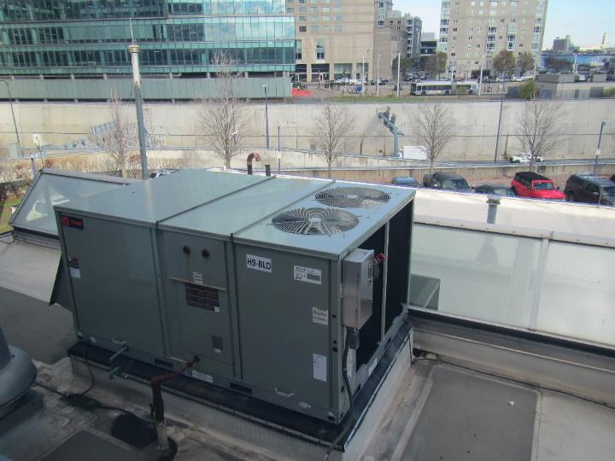

**Rooftop unit on lower-level roof**

**Picture 2**

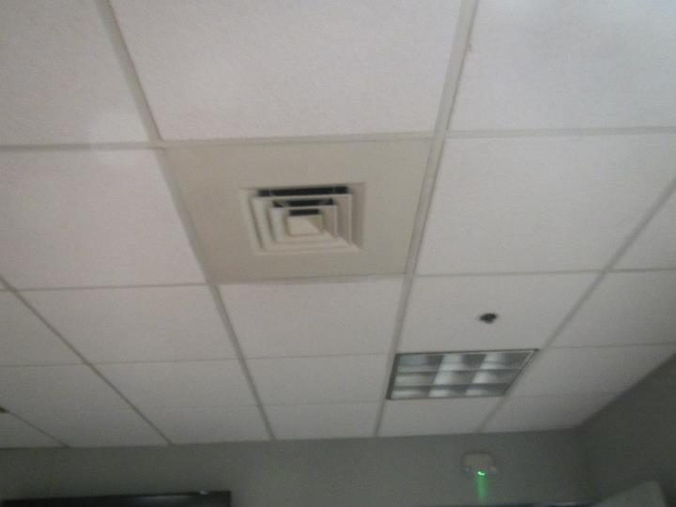

**Supply-style ceiling-mounted vent**

**Picture 3**

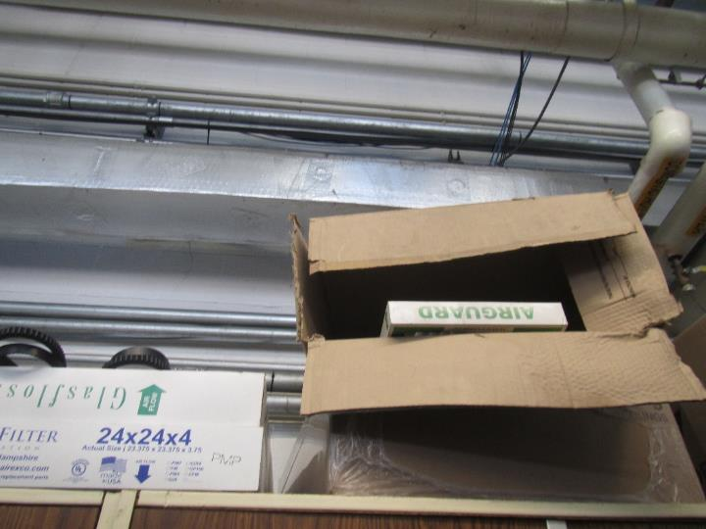

**HVAC filters stored in water-damaged boxes in the garage**

**Picture 4**

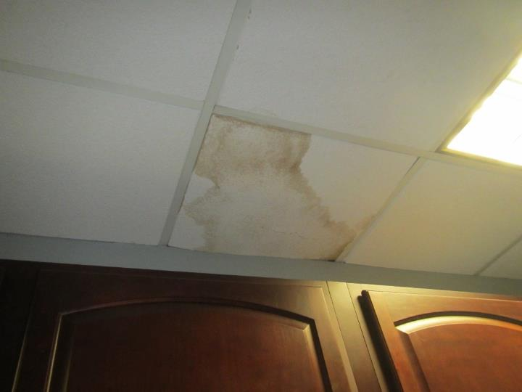

**Water-damaged ceiling tile**

**Picture 5**

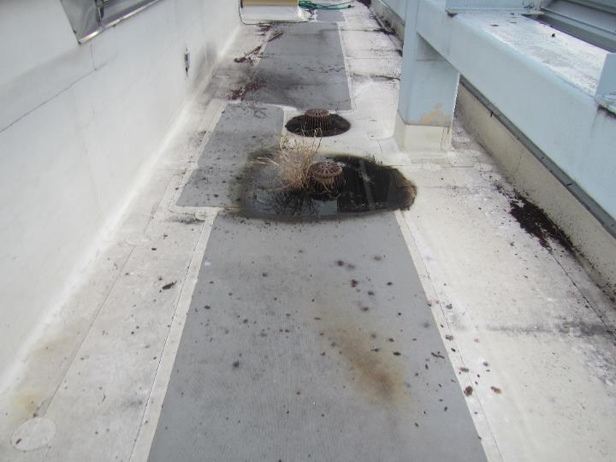

**Plants growing from roof drain**

**Picture 6**

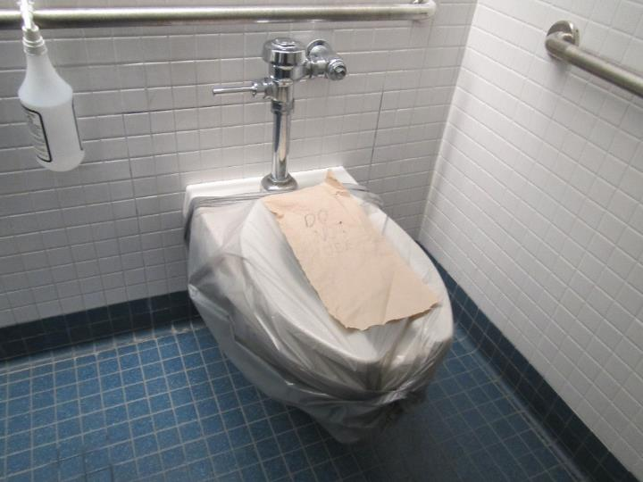

**Toilet marked “out of order” and covered in plastic**

**Picture 7**

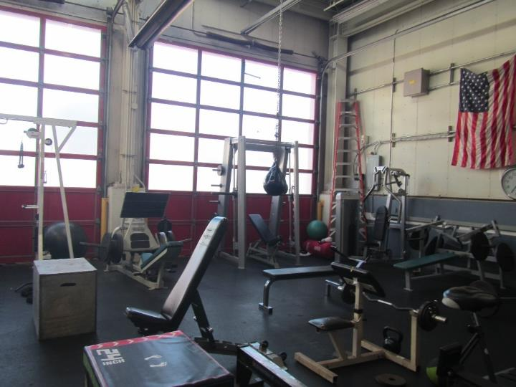

**Workout area inside the multi-bay garage**

**Picture 8**

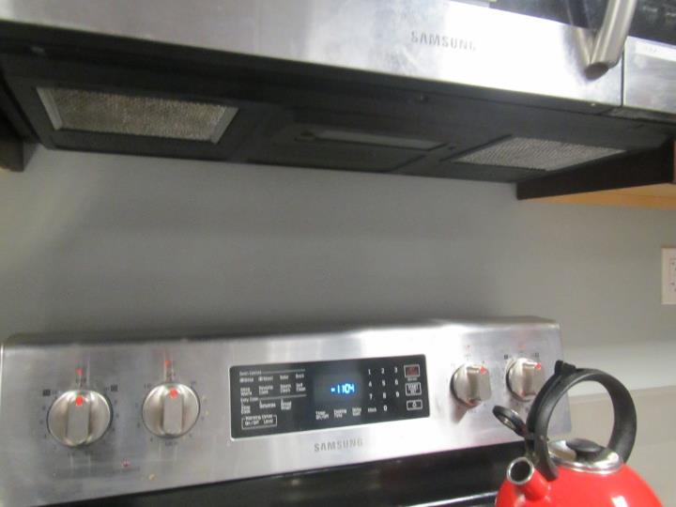

**Full-sized stove with recirculating exhaust vent**

**Picture 9**

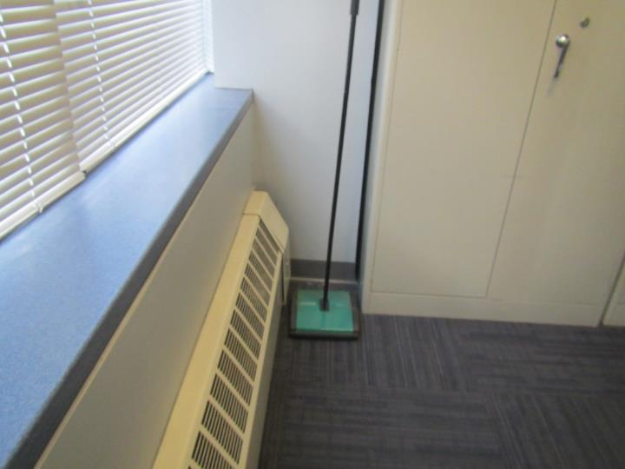

**Low-effectiveness floor cleaner**

**Picture 10**

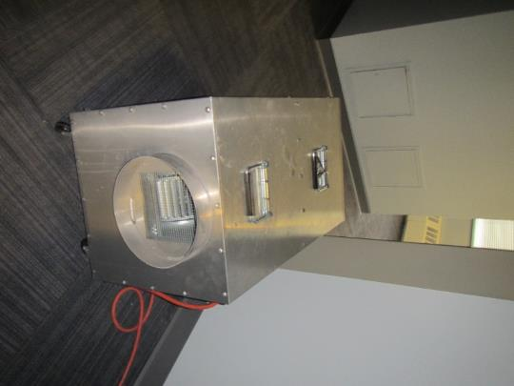

**Heavy-duty fan unit in third floor hallway**

**Picture 11**

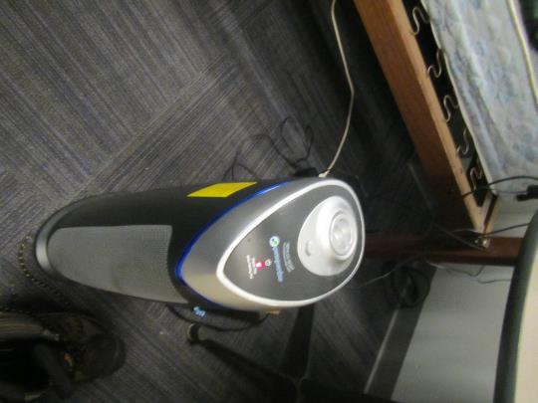

**Air purifier with “change filter” light on, note bed in background**

| Location | **Carbon**  **Dioxide**  **(ppm)** | **Carbon Monoxide**  **(ppm)** | **Temp**  **(°F)** | **Relative**  **Humidity**  **(%)** | **PM2.5**  **(µg/m3)** | **VOC**  **(ppm)** | **Occupants in Room** | **Windows**  **Openable** | **Ventilation** | | **Remarks** |
| --- | --- | --- | --- | --- | --- | --- | --- | --- | --- | --- | --- |
| **Intake** | **Exhaust** |
| Background | 359 | ND | 46 | 51 | 10 |  |  |  |  |  | In front of building next to road, weather was sunny and clear |
| Kitchen | 441 | ND | 66 | 36 | 2 | ND | 2 | N | Y |  | 1 WD CT, 1 missing tile, all ceiling vents look like supply vents |
| Garage Area | 407 | ND | 67 | 32 | 1 | ND | 0 | N | Y | Y | Ceiling fan (on), bay doors, gym equipment |
| Report writing | 457 | ND | 67 | 33 | 2 | ND | 2 | N | Y |  | NC |
| Booking | 417 | ND | 67 | 32 | 2 | ND | 0 | N | Y |  | NC, next to Sally Port |
| Dispatch | 470 | ND | 68 | 32 | 2 | ND | 2 | N | Y | Y | 1 WD CT, ajar tile, NC |
| Sergeant’s Office | 494 | ND | 69 | 31 | 2 | ND | 0 | N | Y |  | DEM, NC |
| Women’s Restroom |  |  |  |  |  |  | 0 | N |  | Y | Exhaust dusty |
| Men’s Restroom |  |  |  |  |  |  | 0 | N |  | Y | Exhaust dusty |
| 2nd floor | | | | | | | | | | | |
| Men’s Locker | 457 | ND | 71 | 28 | 2 | ND | 0 | N | Y | Y | All vents look the same. NC, missing tile, WD CT |
| MSP Locker | 432 | ND | 71 | 30 | 1 | ND | 0 | N | Y | Y | PF on, toilet out of order and covered with plastic |
| Locker | 525 | ND | 71 | 29 | 1 | ND | 1 | N | Y | Y | PF |
| Locker | 418 | ND | 68 | 30 | 1 | ND | 0 | N | Y | Y | Beds, carpet |
| 2nd floor Hallway |  |  |  |  |  |  |  |  |  |  | WD CT, a heavy fan unit is operating, floor is carpeted |
| 3rd floor | | | | | | | | | | | |
| Elevator hallway area | 444 | ND | 70 | 29 | 1 | ND | 0 | N | Y |  | 2 WD CT |
| 301 | 445 | ND | 69 | 31 | ND | ND | 1 | N | Y |  | 1 WD CT, carpet, personal heater/fan, plush chair |
| 306 | 445 | ND | 69 | 31 | 2 | ND | 0 | N | Y |  | Carpet |
| Storage room | 428 | ND | 69 | 31 | ND | ND | 0 | N | Y |  | 1 WD CT, carpet |
| Station commander | 413 | ND | 72 | 28 | 1 | ND | 0 | N | Y |  | Carpet, PF, plush chair, DEM |
| 304 | 413 | ND | 70 | 30 | 2 | ND | 0 | N | Y | Y | 3 WD CT, dust/debris on floor, carpet, beds, air purifier with change filter light on |
| Vacant office (truck room) | 409 | ND | 70 | 29 | 1 | ND | 0 | N | Y |  | Carpet, food, fridge on carpet |