INDOOR AIR QUALITY ASSESSMENT

State Reclamation Board
Norfolk County Mosquito Control
144 Production Road, Walpole, MA

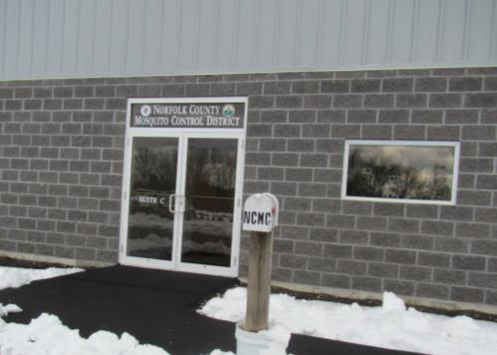

Prepared by:
Massachusetts Department of Public Health
Bureau of Environmental Health
Indoor Air Quality Program
March 2018
BACKGROUND
Building: | State Reclamation Board Norfolk County Mosquito Control
Address: | 144 Production Road, Walpole, MA
Assessment Coordinated via: | DCAMM, Peter Woodford
Reason for Request: | Post-occupancy indoor air quality (IAQ) assessment
Date of Assessment: | March 9, 2018
Massachusetts Department of Public Health/Bureau of Environmental Health (MDPH/BEH) Staff Conducting Assessment: | Ruth Alfasso, Environmental Engineer/Inspector, IAQ Program
Date Building Constructed: | 2017
Building Description: | This is a new single-story building located in an industrial and wooded area of Walpole. The building contains a garage area and an office area which also includes a small laboratory.
Building Population: | Approximately 10 employees are in offices; more employees and visitors are present during the mosquito season
Windows: | Some openable

Methods
Please refer to the IAQ Manual for methods, sampling procedures, and interpretation of results (MDPH, 2015).

IAQ Testing Results
The following is a summary of indoor air testing results (Table 1).
- Carbon dioxide levels were below the MDPH recommended level of 800 parts per million (ppm) in most occupied areas tested.
- Temperature in office areas was within or close to the MDPH recommended range of 70°F to 78°F in most occupied areas surveyed.
- Relative humidity was below the MDPH recommended range of 40 to 60% in all areas tested the day of assessment which is typical of indoor air during the heating season.
- Carbon monoxide levels were non-detectable in all areas tested.
- Particulate matter (PM2.5) concentrations measured were below the National Ambient Air Quality (NAAQS) level of 35 μg/m³ in all areas tested.

Ventilation
A heating, ventilating, and air conditioning (HVAC) system has several functions. First it provides heating and, if equipped, cooling. Second, it is a source of fresh air. Finally, an HVAC system will dilute and remove normally-occurring indoor environmental pollutants not only by introducing fresh air, but also by filtering the airstream and ejecting stale air to the outdoors via exhaust ventilation. Even if an HVAC system is operating as designed, point sources of respiratory irritation may exist and cause symptoms in sensitive individuals. The following analysis examines and identifies components of the HVAC system and likely sources of respiratory irritant/allergen exposure from water damage, aerosolized dust, and/or chemicals found in the indoor environment.
Mechanical ventilation for the office areas is provided by two small air handling units (AHU) along the wall of the garage (Picture 1). The sealed combustion AHU unit draws combustion air from an intake on the roof through a PVC pipe and then exhausts emissions through a second PVC exhaust pipe (Picture 2). The AHUs deliver conditioned (i.e., heated/cooled) air to occupied areas via ceiling-mounted supply vents in occupied areas (Picture 3). Air is returned to the AHU through exhaust grates located in the hallway and conference room (Picture 4).
The garage has a wall-mounted exhaust vent as well as large garage doors. The pesticide storage room located inside the garage also has a wall-mounted exhaust vent (Picture 5). These vents should be activated whenever pollutant-generating activities may be present such as vehicle idling, pesticide handling, and maintenance activities. Note that there are cylinders of carbon dioxide present in the garage area (Picture 6), as this gas is used in mosquito lures; carbon dioxide levels near the cylinders were slightly higher than nearby areas. Canisters of gas should be kept tightly closed and used in well-ventilated conditions only.
Note that there is no exhaust vent, either direct or an AHU return, in the lab area. While the mosquito control lab does not have a heavy use of chemicals, reagents such as acetone are used (Picture 7) which is volatile, and can produce irritating vapors. Since exhaust/return vents are located in hallways, and use undercut doors to vent stale air from offices, the lack of exhaust vents in the lab may allow the ventilation system to distribute chemical odors throughout the office. In addition, a chest freezer is present (Picture 8) which will produce heat when in use. An exhaust vent that removes chemical vapors and waste heat from this area directly outside is recommended. An additional exhaust vent may also be useful in the kitchen area to help remove cooking odors and smoke from occupied areas.

Microbial/Moisture Concerns
No water-damaged materials were observed in the building at the time of the assessment. As the building is new, landscaping is still to be added to the outside. It is recommended that shrubs are kept away from the building by five feet to prevent the retention of water against the building and root damage to the foundation.
A few plants were observed in the offices (Picture 9). They should be kept in good condition, not overwatered, and not placed on porous materials.

Other Conditions
Doors between the garage area and the offices have gaps, which can allow unconditioned air and pollutants from the garage into occupied areas (Picture 10). These doors should be sealed with weather stripping as if they were doors to outside.
The conference room has wall-to-wall carpeting. Area rugs are present in some other areas. The Institute of Inspection, Cleaning and Restoration Certification (IICRC), recommends that carpeting be cleaned annually (or semi-annually in soiled high traffic areas) (IICRC, 2012).
In order to have proper ventilation with a mechanical supply and exhaust system, the systems must be balanced to provide an adequate amount of fresh air to the interior of a room while removing stale air from the room. It is recommended that HVAC systems be re-balanced every five years to ensure adequate air systems function (SMACNA, 1994).

CONCLUSIONS/RECOMMENDATIONS
Based on the observations made during the visit, the following is recommended:
- Operate the HVAC system to provide for continuous fresh air ventilation during occupied hours.
- Use wall-mounted exhaust vents (and doors when possible) to remove pollutants from the garage area and pesticide preparation area when activities such as vehicle idling, pesticide handling and equipment maintenance are occurring.
- Ensure containers of pesticide and cylinders of carbon dioxide are in good condition and tightly sealed when they are inside the building.
- Consider adding direct-vented exhaust to the laboratory area to remove odors, volatile organics and waste heat. Consider adding another to the kitchen to remove smoke and cooking odors.
- For buildings in New England, periods of low relative humidity during the winter are often unavoidable. Therefore, scrupulous cleaning practices should be adopted to minimize common indoor air contaminants whose irritant effects can be enhanced when the relative humidity is low. Drinking water during the day can help ease some symptoms associated with a dry environment (throat and sinus irritations). Use a vacuum cleaner equipped with a high efficiency particulate arrestance (HEPA) filter in conjunction with wet wiping to remove dust from all surfaces. Avoid the use of feather dusters.
- Use care when adding landscaping to maintain drainage away from the building. Do not plant shrubs or trees within five feet of the building to avoid moisture accumulation, root damage to the wall/foundation and debris on the roof.
- Keep office plants in good condition and do not overwater them. Use drip pans to contain water and avoid placing plants on porous materials.
- Seal any doors between garage areas and occupied areas with weather-stripping so that no light is visible under or around the door. Keep them closed whenever possible.
- Clean carpeting at least once per year according to IICRC recommendations (IICRC 2012).
- Consider adopting a balancing schedule of every 5 years for all mechanical ventilation systems, as recommended by ventilation industrial standards (SMACNA, 1994).
- Refer to resource manual and other related indoor air quality documents located on the MDPH’s website for further building-wide evaluations and advice on maintaining public buildings. These documents are available at http://mass.gov/dph/iaq.

REFERENCES
IICRC. 2012. Institute of Inspection, Cleaning and Restoration Certification. Carpet Cleaning: FAQ. Retrieved from http://www.iicrc.org/consumers/care/carpet-cleaning/#faq.
MDPH. 2015. Massachusetts Department of Public Health. “Indoor Air Quality Manual: Chapters I-III”. Available from http://www.mass.gov/eohhs/gov/departments/dph/programs/environmental-health/exposure-topics/iaq/iaq-manual/
SMACNA. 1994. HVAC Systems Commissioning Manual. 1st ed. Sheet Metal and Air Conditioning Contractors’ National Association, Inc., Chantilly, VA.

Picture 1
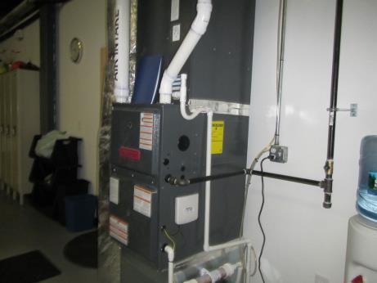
Air-handling unit (AHU) along wall of garage
Picture 2
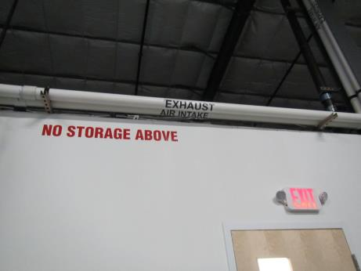
Combustion air intake and exhaust piping for sealed combustion AHU
Picture 3
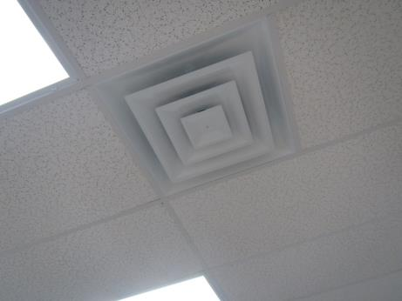
Typical supply vent
Picture 4
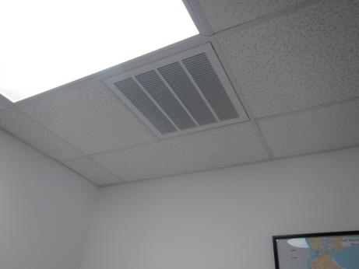
Exhaust/return vent
Picture 5
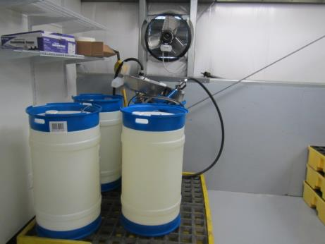
Pesticide preparation area with exhaust vent
Picture 6
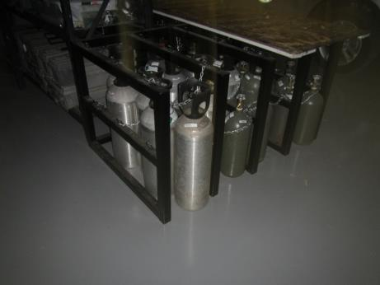
Carbon dioxide cylinders
Picture 7
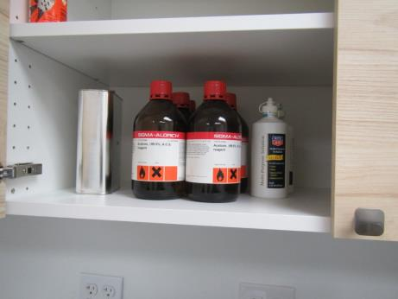
Acetone used in laboratory area
Picture 8
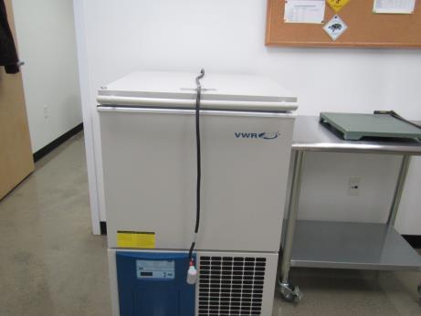
Chest freezer in laboratory area, not yet in service
Picture 9
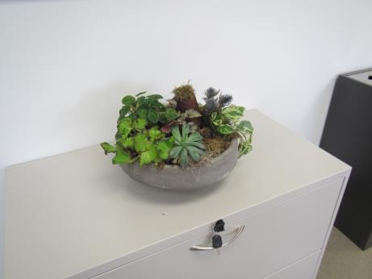
Plants, note no drip pan
Picture 10
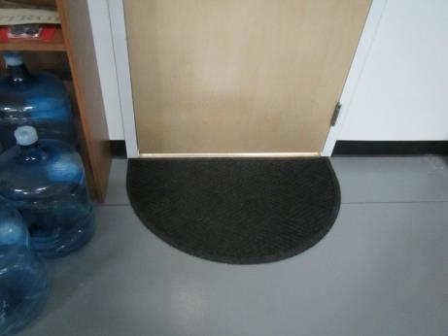
Door between garage and offices, note large gap underneath
Location | Carbon  Dioxide  (ppm) | Carbon Monoxide  (ppm) | Temp  (°F) | Relative  Humidity  (%) | PM2.5  (µg/m³) | Occupants  in Room | Windows  Openable | Ventilation |  |  | Remarks
 |  |  |  |  |  |  |  | Intake | Exhaust
Background (outdoors) | 321 | ND | 50 | 24 | 3 |  |  |  |  |  | Cloudy
Kitchen | 606 | ND | 68 | 38 | 5 | 3 | N | Y |  | N | Fridges and microwave
Garage area | 846 | ND | 69 | 30 | 4 | 0 | N | N |  | Y | Wall-mounted exhaust fans, ceiling-mounted heaters, units for HVAC for rest of office located in back wall of garage.
Lab | 441 | ND | 67 | 31 | 5 | 0 | N | Y |  | N | Ultra-cool freezer, no exhaust vents, reagents (acetone) in cabinet
Lab office | 899 | ND | 72 | 30 | 6 | 1 | N | Y |  | N
Field Ops Manager | 640 | ND | 73 | 30 | 7 | 1 | Y | Y |  | N | CP, DO, area rug
Director | 653 | ND | 75 | 28 | 6 | 0 | Y | Y |  | N | Heater
GIS coordinator | 604 | ND | 74 | 27 | 7 | 1 | N | Y |  | N | Rocks in boxes, HS, DO
GIS office | 721 | ND | 75 | 27 | 7 | 0 | N | Y |  | N | Plotter, DO
Hallway | 629 | ND | 75 | 26 | 7 | 2 | N | Y |  | Y | Area rug
Reception | 510 | ND | 75 | 25 | 9 | 1 | N | Y |  | Y | Area rug, PC, plants
Conference room | 493 | ND | 74 | 25 | 12 | 0 | N | Y |  | Y | Carpeted
Storage | 398 | ND | 72 | 25 | 7 | 0 | N | Y |  | N | Also has door to garage. Items up on shelving, electric water heater in corner.
Women’s Room | 481 | ND | 71 | 29 | 10 | 0 | N | Y |  | Y | Switch-activated exhaust
Foreman’s Office | 478 | ND | 71 | 28 | 8 | 0 | N | Y |  | N | DO
Men’s room | 489 | ND | 71 | 29 | 11 | 0 | N | Y |  | Y | Switch-activated exhaust
MDF | 495 | ND | 71 | 29 | 9 | 0 | N | Y |  | N | No additional air conditioning

