Massachusetts Department of public health
State Systemic Improvement Plan
MA Early Intervention
4/1/2015

In developing, implementing, and evaluating the SSIP, OSEP expects that a State’s focus on results will drive innovation in the use of evidence-based practices in the delivery of services to children with disabilities, which will lead to improved results for children with disabilities.

Table of Contents
SSIP Overview 4
Description of the SIMR 4
Description of the State Program 5
Process Used for Developing Phase I of the SSIP 6
Overview of Stakeholder Involvement 8
Component #1: Data Analysis 10
1(a) How Key Data were Identified and Analyzed 10
Program-level Analysis 15
1(b) How Data were Disaggregated 17
EI Programs 17
Poverty Level 19
Gender by Race/ Ethnicity 19
Length of Time in EI Service 20
Eligibility 20
Federal Family Outcomes Reporting 22
State Regions 23
Stakeholder Decision regarding Sub-populations 23
1(c) Data Quality 23
General Data Quality Issues 24
Data Quality Issues with Outcome Results 24
Data Quality Issues with Poverty Level 26
Data Quality Issues with Federal Family Outcome Reporting 27
Data Quality Next Steps 27
1(d) Considering Compliance & Other Federal Data 27
1(e) Additional Data 29
1(f) Stakeholder Involvement in Data Analysis 31
Component #2: Analysis of State Infrastructure to Support Improvement and Build Capacity 33
2(a) How Infrastructure Capacity was Analyzed 33
Broad SWOT (Strengths, Weaknesses, Opportunities, Threats) Analysis: 33
Comprehensive Review of Massachusetts State Systems 34
Local Onsite Data Collection 37
SWOT Analysis of Identified Practices: 39
2(b) Description of the State Systems 39
Governance 39
Fiscal 41
Quality Standards 42
Professional Development 44
Data 46
Technical Assistance 47
Accountability/Monitoring 50
2(c) Systems Strengths and Areas for Improvement 51
System Strengths 51
Areas of Weakness 53
2(d) State-level Improvement Plans and Initiatives 53
Current Initiatives 54
Professional Development & Technical Assistance 56
Accountability & Monitoring 58
Data Systems and Frameworks 59
Communication and Coordination (e.g. intra- and inter-agency, regional, and local) 60
2(e) Representatives Involved 61
2(f) Stakeholder Involvement in Infrastructure Analysis 62
Component #3: SIMR 64
3(a) SIMR Statement 64
3(b) Data and Infrastructure Analyses Substantiating the SIMR 65
3(c) SIMR as Child-Family Level Outcome 66
3(d) Stakeholder Involvement in Selecting the SIMR 67
3(e) Baseline Data and Targets 69
Component #4: Selection of Coherent Improvement Strategies 69
4(a) How Improvement Strategies Were Selected 69
4(b) How Improvement Strategies are Sound, Logical, and Aligned 72
4(c) Strategies that Address Root Causes and Build Capacity 73
4(d) Strategies Based on Data and Infrastructure Analysis 75
4(e) Stakeholder Involvement in Selecting Improvement Strategies 77
Component #5: Theory of Action 79
5(a) Graphic Illustration 79
5(b) How Improvement Strategies Will Lead to Improved Results 82
5(c) Stakeholder Involvement in Developing the Theory of Action 82
Appendices 85
Local Onsite Data Collection Results 85

SSIP Overview

Description of the SIMR

The Massachusetts Part C/Early Intervention (EI) system will focus its efforts on improving the statewide percentage of children showing positive growth in Child Outcome 1: social-emotional skills (including social relationships), as measured by Summary Statement 1 in the State’s Performance Plan.

The Massachusetts EI system supports each child and family’s social-emotional wellbeing and assists in achieving positive development in all children by recognizing and promoting children’s earliest relationships and learning within the context of their family, community, and culture. As the lead agency in Massachusetts, the Department of Public Health (DPH) is committed to implementing strategies throughout the EI system that will improve social-emotional development of children enrolled in EI.
It is Massachusetts’s intent that of those children who enter Early Intervention below age expectations in social-emotional skills, the percent who substantially increase their rate of growth by the time they exit the program will be increased. This child-level outcome has been unanimously approved by the SSIP State Leadership Team and Massachusetts’s Early Intervention stakeholders.
In Massachusetts, the Battelle Developmental Inventory 2nd Edition (BDI-2) is used for federal child outcome reporting. The BDI-2 is the universal developmental assessment tool utilized to determine initial and ongoing eligibility for EI services in Massachusetts and these results are being used to calculate the Summary Statements for child outcome reporting. The progress categories for the Summary Statement 1 for Social-Emotional Skills (including social relationships) are defined below: (A Developmental Quotient [DQ] of 80 is considered typical to same age peers):

- The exit DQ is less than 80 and all exit raw subdomain scores are less than or equal to entry raw subdomain scores
- The exit DQ is less than 80 and less than or equal to entry DQ and one or more exit raw subdomain scores are greater than the entry raw subdomain score
- The exit DQ is less than 80 and greater than entry DQ and one or more exit raw subdomain scores are greater than the entry raw subdomain score
- The entry DQ is less than 80 and the exit DQ is greater or equal to 80
- The entry and exit DQs are greater than or equal to 80

The State Identified Measurable Result (SIMR) will be measured using Summary Statement 1 for Child Outcome 1: positive social-emotional skills (including social relationships). Targets have been set for the measure. Massachusetts will also monitor other measures during the SSIP implementation that will be more sensitive to practice changes.

Progress category percentages for Outcome 1 will be monitored. Massachusetts will look for progress category (b) percentages to decrease and for progress category (c) and (d) percentages to increase. Massachusetts will also analyze the subdomain scaled scores of the Personal-Social domain of the BDI-2 (Adult Interaction, Peer Interaction, and Self-concept/Social Role). Further analysis and drill down of these standard scores at entry and exit will demonstrate trends across the system as changes in practice are implemented. Massachusetts will look for an increase in the mean of the subdomain scaled scores at exit.
Massachusetts will focus strategies on four main strands of improvement to positively impact the SIMR:

- Practice Quality & Consistency
- Collaboration
- Professional Development
- Data Quality

Description of the State Program

The Massachusetts Department of Public Health (DPH) is the state lead agency that has the responsibility for administering and overseeing the statewide system of Early Intervention (EI) services. Activities include certifying programs, coordinating funding sources, and carrying out monitoring and technical assistance activities. The state currently has awarded contracts to 60 certified community-based programs to provide Early Intervention/Part C services throughout the Commonwealth.

Massachusetts provides Early Intervention services to children who are experiencing developmental delays and to children at risk for delay. Since 2000, MA EI has grown over 60% serving 17,542 active children on October 1, 2013. The total number served, including assessments, increased 57% from 29,289 to 46,102. The program growth has both taxed program resources and made standardizing evidence-based approaches and practices ever more important.
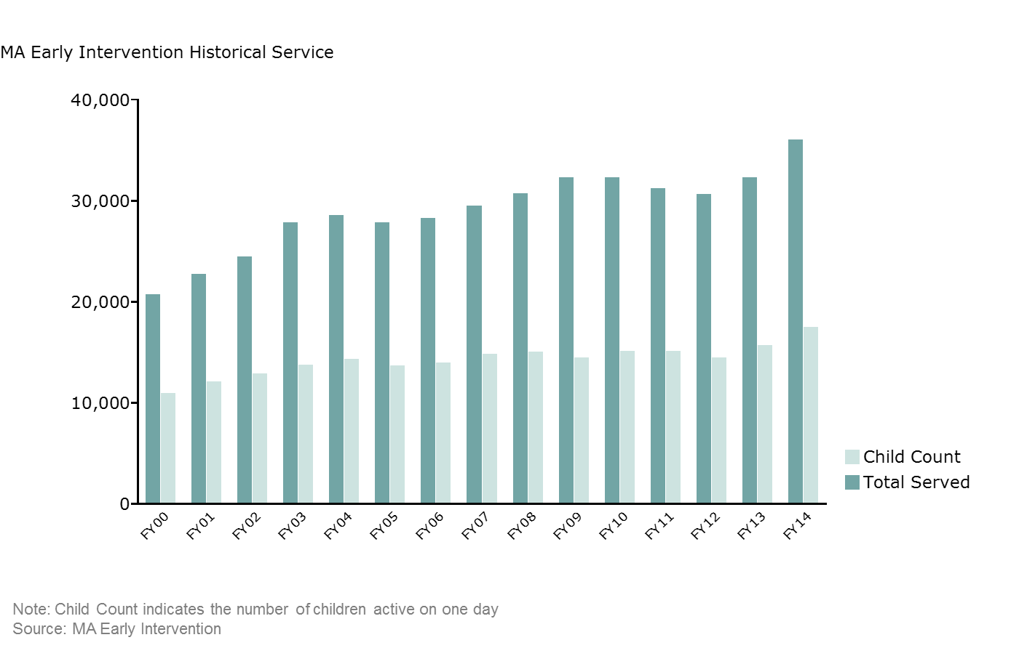

In order to ensure the quality of services provided to children and families enrolled in Massachusetts Early Intervention, DPH designed its General Supervision system to promote the Massachusetts EI Mission, Key Principles, and Core Values and to ensure compliance with federal and state requirements through training, technical assistance, and monitoring. The SSIP supports this effort by focusing on an area of lower performance with a systematic improvement approach. The following graphic illustrates the Massachusetts Early Intervention Mission and Key Principles:

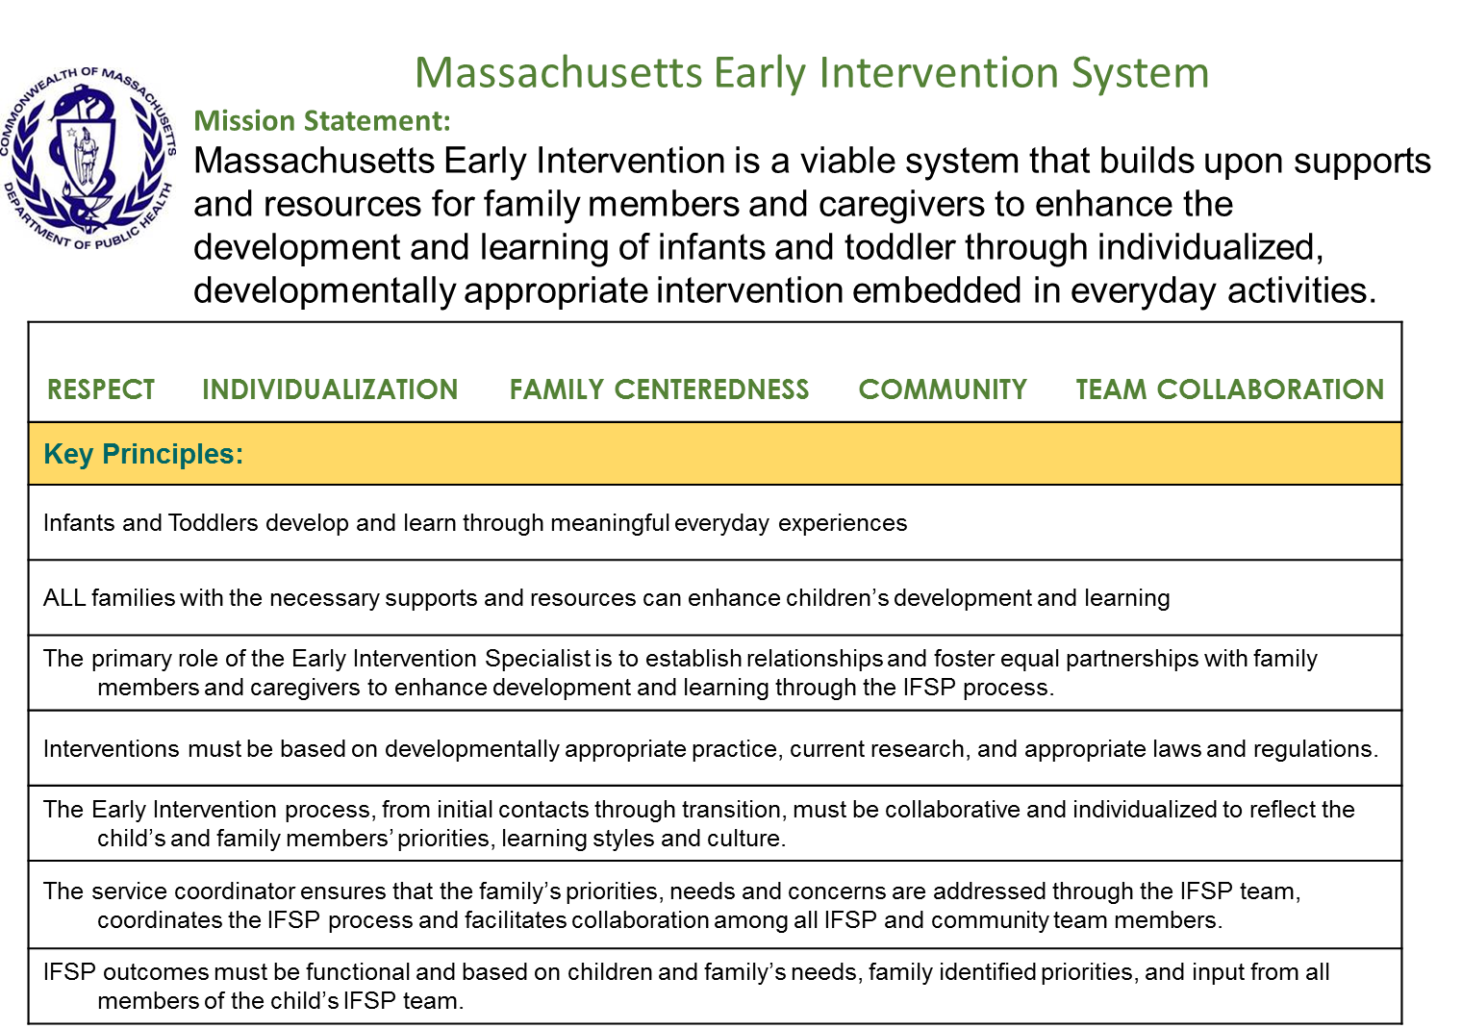

Process Used for Developing Phase I of the SSIP

Massachusetts took a comprehensive approach to developing Phase I of the SSIP, starting before the SSIP timeline release by engaging stakeholders, initiating planning, and beginning with broad infrastructure analysis. Massachusetts EI has engaged stakeholders through every step of the process with stakeholder meetings held every other month along with SSIP State Leadership Team meetings held every other week. The following provides an overview of all SSIP activities during Phase 1:
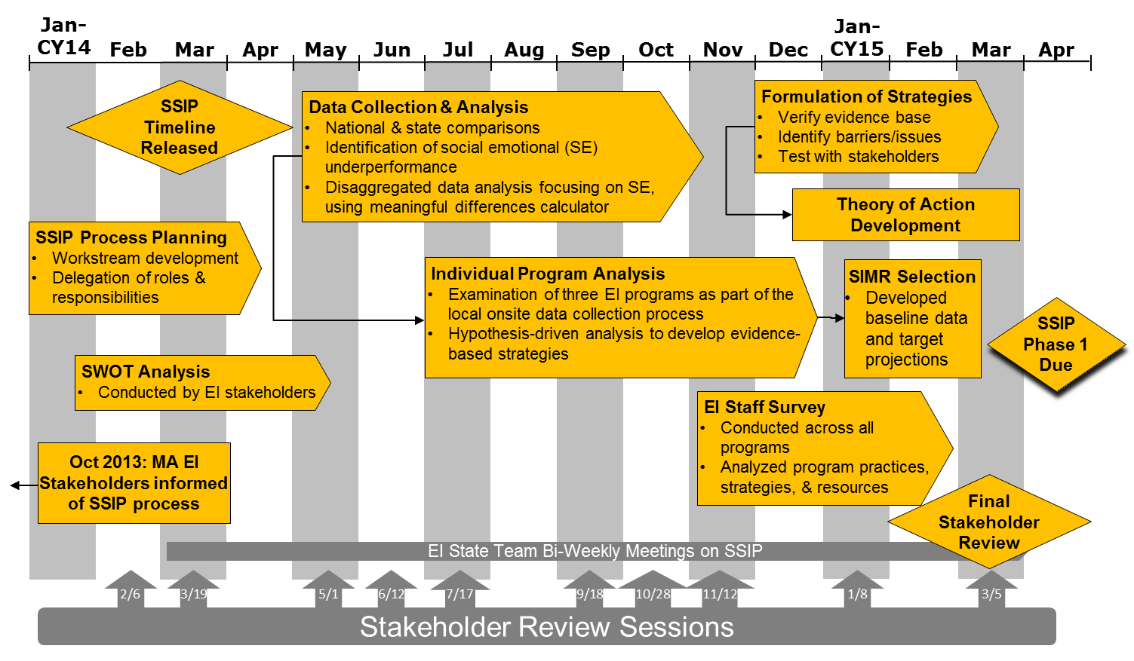

Following the initial planning process with stakeholders and delegation of roles, the EI SSIP State Leadership Team began its review of data and identification of areas of under-performance compared to both state and national statistics. Disaggregation of the EI system data revealed that more was needed to be done in the state to support social-emotional skills development. Further review of the data also showed that there were potential quality issues with the BDI-2 assessment data regarding accuracy and the timing of exit assessments (see 1(c) for further details).

In order to better understand programmatic factors influencing social-emotional (SE) progress, the SSIP State Leadership Team reviewed individual program results under the social-emotional skills outcome area and selected three local programs to acquire additional program-level data around program practices. Programs selected included:

- Program with low Summary Statement 1 over two consecutive fiscal years (FY2013, FY 2014)
- Program with high Summary Statement 1 in FY2013 and low Summary Statement 1 in FY2014
- Program with high Summary Statement 1 over two consecutive fiscal years (FY2013, FY 2014)

This local onsite data collection included an administrative interview with local program leaders, record review, BDI-2 data audit, and a follow-up online survey with local staff. The onsite data collection process supported the identification of evidence-based strategies to impact the SIMR.

The SSIP State Leadership Team sought feedback from stakeholders on which strategies or combinations of strategies best supported social-emotional development and which could be effectively implemented given the infrastructure of the Massachusetts EI system. Consequently, the SSIP State Leadership Team was able to develop a draft Theory of Action that was reviewed by stakeholders. Stakeholders provided input on targets for the next five years.

Overview of Stakeholder Involvement

Massachusetts stakeholders have been involved throughout the SSIP process, and their input and guidance has been critical to the selection of Summary Statement 1: Positive Social-Emotional Skills as the SIMR. The state has identified four levels of Stakeholder involvement: the Interagency Coordinating Council (ICC), Early Intervention Provider Community, Early Childhood Outcomes (ECO) Stakeholder, and the SSIP State Leadership Team.

Stakeholder Group | Roles/ Responsibilities
Interagency Coordinating Council (ICC) | Provides broad input and feedback on the SSIP process and focus area
Early Intervention Provider Community (agency representatives, local program directors, and supervisory staff) | Provides broad input, feedback, and guidance throughout SSIP process
Early Childhood Outcomes (ECO) Stakeholders | Provides oversight to the SSIP process and activities (see 2(e) for further details)
SSIP State Leadership Team | Provides direct oversight of the data collection and analysis, infrastructure analysis, development of Theory of Action, etc.

Stakeholder engagement began in September of 2013, and they have been involved consistently in the process of data collection and analysis, infrastructure analysis, SIMR selection, selection of strategies, and development of the Theory of Action.

Formal stakeholder engagement meetings were held on the following dates:

Date | Activities
September 24, 2013 | DPH EI Webinar explaining the SSIP and its purpose.
October 9, 2013 | EI Program Director Session to provide an overview of RDA and SSIP. Solicited input on implications for Massachusetts EI and potential areas of improvement.
November 7, 2013 | Early Childhood Outcomes (ECO) Stakeholders group input on areas of suggested improvement, review of data reports, expansion of stakeholder involvement, and additional data sources for review.
February 6, 2014 | ECO Stakeholders reviewed current infrastructure (initiatives and practices) and initiated the SWOT Infrastructure Analysis.
March 19-20, 2014 | State SSIP Leadership Team attended a two day SSIP-focused meeting for action planning and agreed on direction of improving positive social-emotional relationships.
May 1, 2014 | ECO Stakeholders discussed potential hypotheses to verify during onsite data collection visits.
June 12, 2014 | Interagency Coordinating Council (ICC) reviewed the SSIP data analysis, preliminary infrastructure analysis, and discussed selection of positive social-emotional skills (including social relationships) as the SIMR.
July 17, 2014 | ECO Stakeholders reviewed results of original data analyses and disaggregated data analyses, and they provided input on areas for further drill down. Stakeholders brainstormed potential root causes of poor social-emotional performance.
September 18, 2014 | ECO Stakeholders discussed the cohort of children included in Massachusetts federal reporting and potential data quality issues. In addition, stakeholders reviewed the Meaningful Difference Calculator results as part of the disaggregated data analysis. Stakeholders agreed to onsite information gathering visits.
October 28, 2014 | DPH Webinar to update EI Program Directors on the status of the SSIP.
November 12, 2014 | SSIP presentation at the ICC meeting.
January 8, 2015 | Infrastructure Analysis document distributed electronically to ECO stakeholders. ICC provided input to draft the Theory of Action.
March 5, 2015 | ECO Stakeholders reviewed progress to-date. They brainstormed strategies to improve social-emotional outcomes (as well as data quality) and potential issues that may be encountered during implementation. Formally, the stakeholders unanimously agreed to the SIMR and identified baseline and targets.
March 25, 2015 | Local EI Program Directors/Provider community reviewed the nearly-finalized SSIP draft and provide the last set of feedback for SSIP Phase 1 submission, including infrastructure analysis on the identified strategies to improve the SIMR.

In addition, the Lead Agency convened an additional SSIP State Leadership Team at DPH consisting of central administration staff who oversee monitoring, training, and data. An EI program director and a parent are included as part of this group to represent the broader EI community. Bi-weekly meetings were established to discuss SSIP data and activities. Full membership of the SSIP State Leadership Team is detailed below:

Name | Title | Role
Patti Fougere | Assistant Director, Massachusetts DPH, Division of EI | Provides oversight of EI day-to-day operations with regard to monitoring, training, and technical assistance to ensure implementation of IDEA
Jean Shimer | Data Manager, Massachusetts DPH, Division of EI | Responsible for ongoing data collection, management, and analysis
Jean Nigro | Director, DPH, EI Training Center | Direct oversight of the CSPD and ensures training capacity to meet the needs of the system
Noah Feldman | Associate Director, DPH, EI Training Center | Provides oversight of professional development implementation and BDI-2 Assessment fidelity
Michelle Conlon | EI Regional Specialist | Provides technical assistance and support to local EI programs
Barbara Prindle-Eaton | Local EI Program Director | Brings provider community perspective in SSIP implementation
Faith Bombardier | Statewide Monitoring Coordinator, Massachusetts DPH, Division of EI | Ensures data collection and information gathering from onsite visits are considered in the SSIP process
Darla Gundler | Director, EI Parent Leadership Project, Massachusetts DPH | Provides parent perspective through the SSIP implementation

Component #1: Data Analysis

1(a) How Key Data were Identified and Analyzed

In order to meet the requirements of the State Systemic Improvement Plan (SSIP) as established by the Office of Special Education Programs (OSEP), Massachusetts began gathering input regarding process and where to focus state efforts on a child-focused measurable result. In October 2013, Massachusetts met with EI Provider Community, at the EI Program Directors’ meeting, to present an overview of the multi-year SSIP process and requirements, review state outcome methodology, identify a stakeholder group for Phase I planning, and gather information about potential focal areas for initial data analyses.

At this meeting participants were asked to reflect on the following questions:

- Possible areas of improvement?

- What data would be helpful for information gathering and analysis for the areas of improvement?

- What evidence-based practices might be implemented to support the areas of improvement?

- Who are the stakeholders that should be involved?

Participants identified four main topic areas for further analysis:

- Use of technology in the Massachusetts EI system: analyze and evaluate the technology needs of the EI system with regard to electronic record keeping, EI information systems (EIIS), and other systemic databases.

- Child Find: Are there underserved or marginal populations of children that are not being identified early on for referral to Early Intervention?

- Impact of Early Childhood Trauma: Do children suffering from the impact of early childhood trauma and loss have poorer outcomes? If so, are there effective methods that can improve outcomes for them?

- Parent Engagement: Are there effective ways to increase parent engagement that will result in better family and child outcomes?

One of the recommendations from this meeting was to use the existing Early Childhood Outcomes (ECO) Stakeholders group (see 2(e) for further details) to further advise the state on the SSIP process, oversee SSIP activities and initiatives and help in determining the state’s focus area. The ECO Stakeholders group was an existing group that was initially formed to advise the lead agency on child outcome data collection, measurement, and training to support the EI system in improving child outcomes and was in agreement to take on this initiative. In moving forward with preparations for the SSIP, the Lead Agency broadened the ECO Stakeholder group to include representation from the following groups:

- Higher Education Task Group
- Department of Elementary and Secondary Education
- Department of Early Education and Care
- Parents

EI convened an additional SSIP State Leadership Team at DPH consisting of lead agency staff who oversee monitoring, professional development, data, and parent engagement. An EI program director and a parent are included as part of this group to represent the broader EI community. Bi-weekly meetings were established to discuss SSIP data and activities. The SSIP State Leadership Team discussed data inferences, reviewed data reports, set up timelines and gathered other relevant information prior to presenting to the ECO Stakeholders group meetings.

The first ECO Stakeholder meeting to provide input to the SSIP was in November 2013. Multiple data reports were produced to present to participants for review of data sets related to the topic areas identified at the October 2013 Program Director meeting. Stakeholders reviewed the following data sets:

- Use of technology: Determined that this would be analyzed through infrastructure analysis
- Child Find: FY2013 State Summation report-summary of demographic, referral, eligibility, transition data for children and families enrolled in Massachusetts EI during FY2013
- Impact of early childhood trauma: Data from the Massachusetts EI Information System (EIIS) for children who had the risk factor of ‘multiple trauma/loss’ present at initial eligibility evaluation was provided. Referral source, eligibility, poverty level and race/ethnicity for these children were examined by looking at state aggregate numbers and percentages under this at risk criteria
- Parent engagement: Data related to children referred from the Child Welfare System [Department of Children and Families (DCF)] was provided. Referral source, eligibility, poverty level and race/ethnicity for these children were examined by looking at state aggregate numbers and percentages under this at risk criteria

The following questions served as a guide for reviewing the data with the ECO Stakeholders group:

- Are meaningful efforts currently or soon to be underway to address this issue?

- Will focusing efforts on this issue affect a significant proportion of Massachusetts Early Intervention children and families?

- Are there established evidence-based strategies that could improve the issue?

- Are resources available to support a state focus on this issue?

ECO stakeholders reviewed these data sets and concluded the following:

- Child Find was eliminated, given the high percentage of children served, by the stakeholders as a potential area of concern after a review of Child Count data. Child Count percentages in Massachusetts have consistently been one of the nation’s highest percentages for child find and is not an area of concern in Massachusetts.
- The Impact of Early Childhood trauma interested stakeholders, however this initial data analysis revealed only 5% of the children enrolled in Massachusetts EI indicated this risk factor. Stakeholders felt a broader population group would need to be the target of the SSIP.

- Stakeholder discussion regarding parental engagement began with how to define “parent engagement”. Consensus was not reached regarding whether participation in the IFSP service provision or parents taking on leadership roles within the broader Early Intervention system defined “parent engagement”. Discussion ultimately led to agreement by stakeholders that parent engagement, in both forms, should be a strategy to improve child outcomes but was not, in itself, sufficient to fully focus state efforts. As a result the SSIP State Leadership Team and stakeholders agreed to rule out parent engagement as the focus area.

The Massachusetts Early Intervention Information System (EIIS) is rich in referral, socio-demographic, eligibility, assessment, IFSP, transition and service data that can be sorted across many variables. Data reports were overwhelming for stakeholders to review and led to additional questions about accuracy and quality due to varied program practices. The SSIP State Leadership Team requested technical assistance from Center for IDEA Early Childhood Data Systems (DaSy). The DaSy team provided technical assistance to the lead agency regarding creating a Data Analysis Plan, developing data inferences prior to data review, using the Meaningful Differences calculator, and using the data to make decisions. As a result, the state and stakeholders began to look back at the data already collected in a way that looked at comparisons and statistical differences.

In March 2014, the SSIP State Leadership Team attended the Northeast Regional Resource Center (NERRC) conference focused on Phase I of the SSIP. Following additional guidance from OSEP and National Technical Assistance providers, the SSIP State Leadership Team refocused data analysis on the three child outcomes. State-level performance for Summary Statement 1 (of those children who entered the program below age expectations in each outcome, the percent who substantially increased their growth by the time they exited the program) and Summary Statement 2 (the percent of children who were functioning within age expectations in each outcome by the time they exited the program) were presented to the ECO Stakeholders group for each of the three outcome areas:

- Positive social-emotional skills (including social relationships)
- Acquisition and use of knowledge and skills (including early language/ communication)
- Use of appropriate behaviors to meet their needs

In analyzing this data, Massachusetts compared its performance in each of the outcome areas to the national average, data provided by the Early Childhood Technical Assistance Center (ECTA). The percent of children under social-emotional skills that make greater than expected growth is the only area where Massachusetts performed lower than the national average. Massachusetts’s percentages were higher than national percentages under all other areas. The following graph provides this comparison for children exiting EI between July 2012 and June 2013.

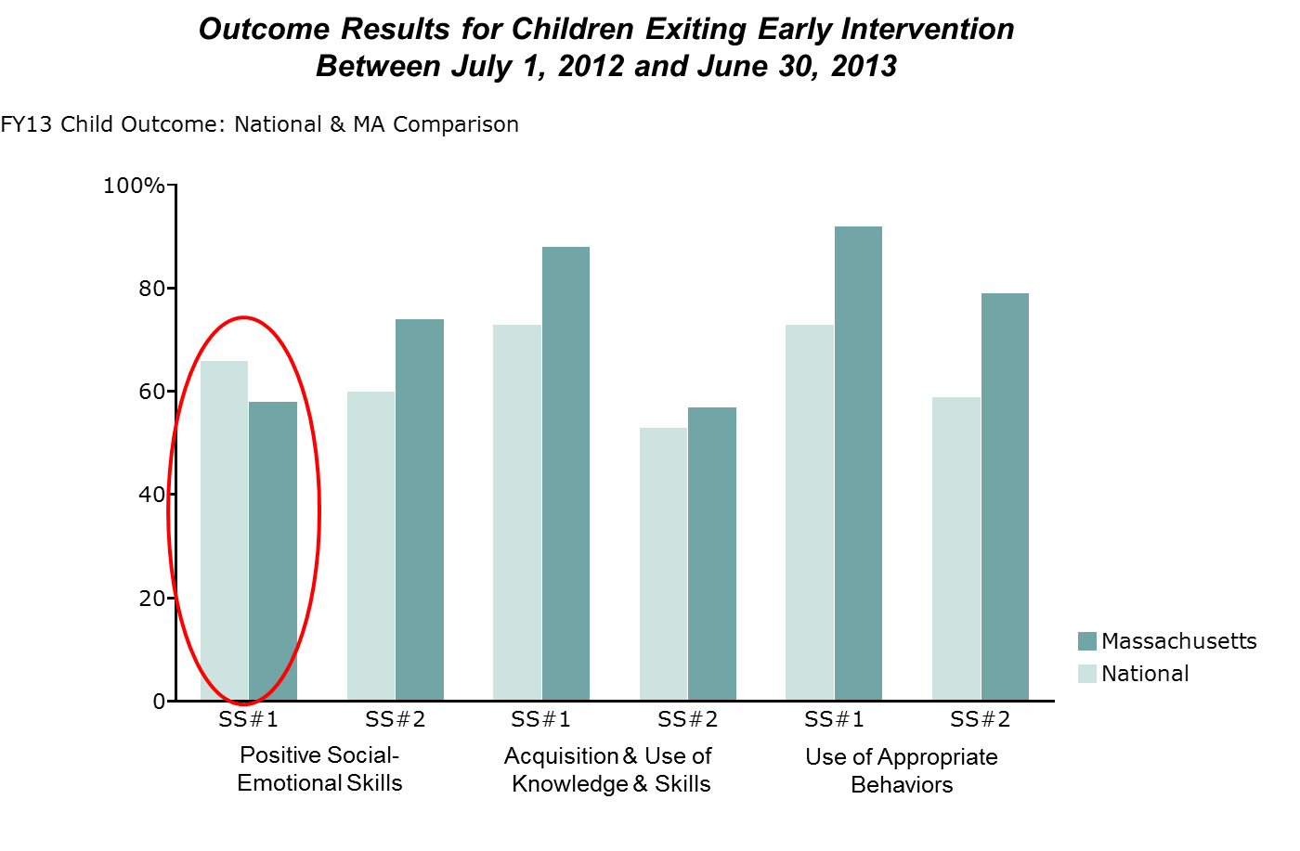

Outcome results over time that were reviewed for state fiscal years 2012, 2013, and 2014 show that the percent of children in Massachusetts EI that made greater than expected growth in positive social-emotional skills is lower than most all of the other Summary Statements across the three outcome areas. This data appears in the table below.

 | Positive social-emotional skills | Acquisition & use of knowledge & skills | Use of appropriate behaviors to meet their needs
Summary Statement 1: Projected growth - FY14 | 56.7% | 87.6% | 94.7%
Summary Statement 1: Projected growth - FY13 | 57.3% | 89.6% | 96.4%
Summary Statement 1: Projected growth - FY12 | 60.7% | 88.8% | 95.7%
Summary Statement 2: Age-appropriate - FY14 | 70.9% | 51.6% | 73.7%
Summary Statement 2: Age-appropriate - FY13 | 74.5% | 56.7% | 78.9%
Summary Statement 2: Age-appropriate - FY12 | 84.2% | 64.2% | 83.3%

As demonstrated in the above table, social-emotional skills outcomes have decreased in each fiscal year between fiscal year 2012 and 2014 in Massachusetts. Lead Agency staff, as well as relevant stakeholders, identified the following potential reasons for this decline:

- Change in methodology of measuring child outcomes (Massachusetts moved to the BDI-2 as the only tool to be used for eligibility and federal outcome reporting in January 2012; previously, scores from the Michigan Early Intervention Developmental Profile [Michigan] evaluation tool were used for outcome reporting)

- Fewer total counts of exiting children between fiscal years 2012 and 2014 included in child outcome totals due to the absence of at least two BDI-2 assessments by the time of exit as the Michigan was being phased out (the percentage of children exiting EI who were included in federal child outcome reporting went from 68% of all discharged children in fiscal year 2011 to 23% in fiscal year 2013)

- Outcome data is collected at different times prior to a child exiting EI services. Children with an established condition will have an exit evaluation closest to their third birthday while other children included in the outcome analysis will have received up to as much as 11 additional months of service after their most recent evaluation. If the exit assessment occurred closer to the time of exit for all children there may be differences in child outcome results.

- Potential data quality issues regarding the use of the BDI-2.
  - There is a lack of consistency in the use of the BDI-2 evaluation tool across all programs. The BDI-2 is administered by multi-disciplinary teams at the local program that is also providing IFSP services to the family. This model of evaluation/assessment involves almost all of the EI specialists working in the Massachusetts EI system. The need for continuous training for new staff and to update skills of experienced staff is critical. In the three programs involved in the onsite data collection visits (see Program-level Analysis below) 25% of the clinicians had worked at the program for less than 2 years.
  - The Personal/Social domain of the BDI-2 is primarily administered using a standardized interview procedure. Through observations in the field, videotaping evaluations, and client record reviews the lead agency and Early Intervention Training Center (EITC) have identified inconsistencies in the administration of the personal-social domain resulting in inaccurate data. Stakeholders agree that this domain is a challenge for EI staff to administer and interpret accurately.

  - The BDI-2 data audit has identified inconsistencies and errors in the manual calculations on the paper record. EI staff use a paper record form to record data for the BDI-2 and manually calculate scores. This data is later inputted into Early Intervention Information System (EIIS).

The Michigan Early Intervention Developmental Profile (Michigan) was phased out entirely in January 2015, therefore it is expected that in following fiscal years the percentage of children exiting EI who are included in the child outcomes totals will reach 60%. In addition, Massachusetts continues to audit assessments and provide training to clinical staff on the use of the BDI-2 but expects that the decline in social-emotional skills percentages will continue decreasing for the next two years before increasing. One project that is currently underway is the University of Massachusetts-Boston BDI-2 Fidelity Study, a grant awarded to the University of Massachusetts-Boston (UMASS Boston) to code and analyze video-taped BDI-2 administrations for voluntary programs and consenting families. UMASS Boston will provide feedback to the lead agency and the Early Intervention Training Center (EITC) regarding training, best practice, guidance, and recommendations on how to properly administer this tool. More consistent administration and interpretation of the BDI-2 will result in improved data accuracy.

This broad based analysis provided evidence to the SSIP State Leadership Team and the ECO Stakeholders group that Massachusetts’s attention for SSIP efforts should be focused on social-emotional skills: infants and toddlers who substantially increase their rate of growth by the time they turned three years of age or exited the program. Although Summary Statement 2 under Acquisition and Use of Knowledge and Skills shows lower percentages than social-emotional skills and has decreased over the years, it was above the national average. Given that Summary Statement 1 under social-emotional skills was below the national average and because the state had a number of current initiatives addressing social-emotional issues, the ECO Stakeholders, along with the SSIP State Leadership Team, unanimously agreed upon Summary Statement 1: positive social-emotional skills growth as the state’s SIMR.

The ICC was informed of the selected state SIMR and was provided with data and reports regarding the process that lead to this decision.

Program-level Analysis

The SSIP state leadership team and ECO stakeholders brainstormed possible contributing factors impacting the SIMR. Additional data analyses were completed to identify root causes.

Child level data was disaggregated and counts and percentages of children were analyzed based on the following factors:

- Local EI program performance
- Poverty level
- Gender by race/ ethnicity
- Length of time in EI service
- Eligibility
- Federal family outcomes reporting

Local program child outcome results were compared for each of the Massachusetts EI local programs for FY2013 and FY2014. Through this process, three local EI programs were selected for onsite data collection visits in order to analyze the local practices. Programs selected met one of the following criteria:

- Program with low Summary Statement 1 over two consecutive fiscal years (FY2013, FY 2014)
- Program with high Summary Statement 1 in FY2013 and low Summary Statement 1 in FY2014
- Program with high Summary Statement 1 over two consecutive fiscal years (FY2013, FY 2014)

Data was collected from individual local programs through an onsite process in order to identify the root causes of varied performance in Summary Statement 1 for Positive Social-emotional Skills. This process identified strategies and practices that were in place at different local programs and how they contributed to improving the SIMR.

Data was collected through:

- Administrative interviews
- Record review
- BDI-2 data audit (comparison of the BDI-2 scores in the paper record at the local program and scores entered into EIIS)
- Staff online survey

Data was collected and organized in a rubric developed by the Data Accountability Center (DAC). Using the Division of Exceptional Children (DEC) Recommended Practices, the SSIP State Leadership Team used data collected during the onsite data collection process to determine which practices were implemented at each of the programs.

Targeted attention went to the different practices related to evaluation/assessment, IFSP process, intervention and parent engagement strategies, and use and access to the multidisciplinary EI team for children who fell into progress categories (b) (Improved functioning but not comparable to same-aged peers) and (d) (Improved functioning to reach a level comparable to same-aged peers) for positive social-emotional skills. Statewide, almost 40% of the children included under Summary Statement 1 for social-emotional skills were in the (b) progress category with another 40% under the (d) progress category. The three programs participating in the review had the following percentages under the Summary Statement 1 categories:

 | SE SS#1: Progress Categories
 | a | b | c | d
Program A/Low performing | 5.3% | 50.0% | 15.8% | 28.9%
Program B/High to Low performing | 0% | 41% | 8.8% | 50%
Program C/High performing | 1.4% | 25.7% | 12.9% | 60%

The high performing program had the fewest percentage of children of all three programs under progress category (b) and the highest percentage of children under progress category (d). The Lead Agency was interested in identifying program practices that would impact children enough to move into category c or d from category b. Through this process, the SSIP State Leadership Team was able to narrow the focus of the improvement strategies for the SIMR (see 4(c) for further details).

1(b) How Data were Disaggregated

There were a number of reports that were developed for the SSIP State Leadership Team and the ECO Stakeholders group that provided child counts, percentages and/or statistical differences between comparison groups in both table and graph form. The Data Analysis Plan, as recommended by DaSy technical support, served to spotlight and organize not only the major data inferences and data results but also the major findings and discussion points.

Further data disaggregation was needed after selection of the SIMR in order to identify root causes and possible population subsets that may be driving underperformance in social-emotional skills. Data inferences were generated by the SSIP State Leadership Team and ECO stakeholders based on observation, clinical knowledge and past data knowledge prior to the data being examined for root causes so that the data would then prove or disprove the inference.

In moving forward with examining social-emotional skills the use of the DaSy Meaningful Difference calculator proved very useful in identifying if any subpopulations of children were the cause for the state performing poorly under this area. The Meaningful Difference Calculator shows if there is a statistical difference between the Summary Statement percent of a subpopulation or category of children (e.g., Hispanic boys) compared to the state’s Summary Statement percent or other comparison group (e.g., white boys). Potential areas of concern are those categories having a lower or higher statistical difference. The Meaningful Differences calculator was used on the following data:

- Local EI program performance
- Poverty level
- Gender by race/ ethnicity
- Length of time in EI service
- Eligibility
- Federal family outcomes reporting

EI Programs

Summary Statement percentages for social-emotional skills growth by EI program were reviewed in order to identify low, average and high performing programs. Only those programs having 35 or more children were included in this analysis due to the fact that percentages stabilize after a count of at least 35 children. The results for fiscal year 2013 Summary Statement 1: social-emotional skills follows:

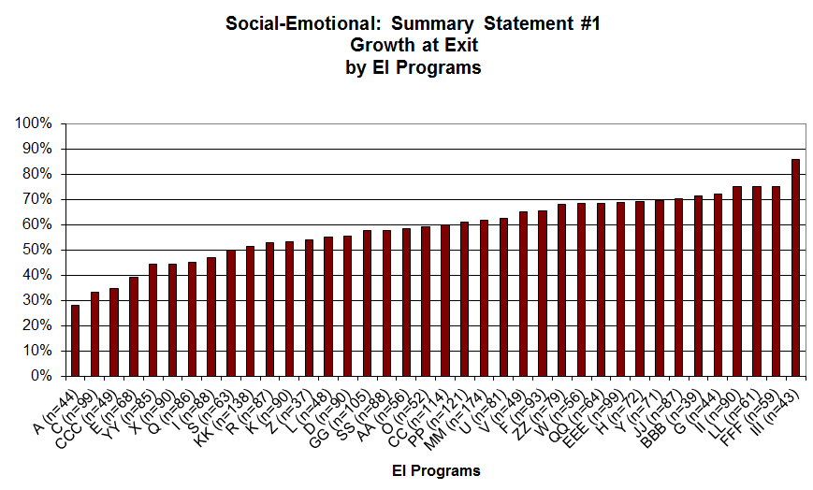
• Only EI programs having a count of 35 or more children are included
• EI programs ranged from 28% to 86%

The number of children included in child outcome results on the above graph for each program is identified by (n=##) so that the state could identify small, medium and large child outcome counts. This analysis revealed a lot of variation across programs regardless of program size or location. Program percentages ranged from 28% to 86%, the longest range between the highest and lowest EI programs of any of the Summary Statements. The state looked at both of the social-emotional skills Summary Statements by program in order to identify programs for additional data gathering. Programs selected included:

- Program with low Summary Statement 1 over two consecutive fiscal years (FY2013, FY 2014)
- Program with high Summary Statement 1 in FY2013 and low Summary Statement 1 in FY2014
- Program with high Summary Statement 1 over two consecutive fiscal years (FY2013, FY 2014)

Additional data was gathered at these programs through administrative interview, client record reviews, BDI-2 data audit, and staff online surveys over a three month period between November 2014 and January 2015. Data was collected and organized in a rubric developed by the Data Accountability Center (DAC). Using the Division of Exceptional Children (DEC) Recommended Practices, the SSIP State Leadership Team used data collected during the local onsite data collection process to determine which practices were implemented at each of the programs. Practices were then compared to the Child Outcome results to narrow the practices that impact the SIMR. This data analysis led to the identification of the following five DEC Recommended Practices to use as strategies to improve the SIMR.

- Practitioners work as a team with the family and other professionals to gather assessment information.
- Practitioners obtain information about the child’s skills and daily activities, routines and environments, such as home, center and community.
- Practitioners support family functioning, promote family confidence and competence, and strengthen family-child relationships by acting in ways that recognize and build on family strengths and capacities.
- Practitioners representing multiple disciplines and families work together as a team to plan and implement supports and services to meet the unique needs of each child and family.
- Practitioners and the family work together to create outcomes, develop individualized plans, and implement practices that address the family’s priorities and concerns and the child’s strengths and needs.

Poverty Level

The SSIP State Leadership Team hypothesized that children in the poorest families would have the lowest Summary Statement 1 positive social-emotional skills largely due to these children having multiple environmental risk factors. The findings in fiscal year 2013 showed that children below 200% of poverty level demonstrated significantly lower Summary Statement 1 positive social-emotional skills than the state mean. Conversely, among fiscal year 2014 participants, children below 550% poverty level did not have a significant difference from the state mean.

 | FY13 State: 57.40% | State Confidence Interval:  ± 1.55% |  | FY14 State: 55.80% | State Confidence Interval:  ± 1.21%
Poverty Level | SS1 % | Confidence Interval | Meaningful Difference? | SS1 % | Confidence Interval | Meaningful Difference?
Below 200% PL | 55.16% | ± 2.05% | Yes | 55.10% | ± 1.51% | No
Between 200% and 300% PL | 55.17% | ± 4.8% | No | 56.10% | ± 3.7% | No
Between 301% and 400% PL | 63.25% | ± 4.55% | Yes | 58.10% | ± 4.06% | No
Between 401% and 550% PL | 63.55% | ± 4.43% | Yes | 57.70% | ± 3.89% | No
Between 551% and 750% PL | 70.31% | ± 5.57% | Yes | 50.50% | ± 5.19% | Yes
Over 750% PL | 53.33% | ± 9.31% | No | 75.00% | ± 6.83% | Yes

Poverty level showed meaningful difference but due to the fact that these differences differed between the two fiscal years and approximately 20% of families do not provide adequate family size and annual income it was determined that the data quality was not reliable enough to justify further analysis.

Gender by Race/ Ethnicity

The SSIP State Leadership Team inferred that minority males would have a poorer outcome when compared to white males. This was not true for all minority groups but there was a significant difference between black and Hispanic vs. white males with the minority males performing poorer. Results of this analysis demonstrated that both Hispanic and black males had significantly lower Summary Statement 1 positive social-emotional skills when compared to white males. Interestingly enough Hispanic and black females were not significantly different from white females. This is true for both fiscal years 2013 and 2014. The fiscal year 2014 results are shown in the table below:

 | White Males: 58.70% | State Confidence Interval:  ± 1.72% |  | White Females: 59.40% | State Confidence Interval:  ± 2.32%
Race/Ethnicity | SS1 % | Confidence Interval | Meaningful Difference? | SS1 % | Confidence Interval | Meaningful Difference?
Am Indian/Alaskan Native | 75.0% | ± 23.9% | No | 0.0% | ± 23.7% | No
Asian | 58.8% | ± 6.2% | No | 55.6% | ± 8.1% | No
Black | 50.2% | ± 4.4% | Yes | 63.9% | ± 5.7% | No
Hispanic | 49.8% | ± 2.9% | Yes | 59.3% | ± 3.7% | No
Multi-Race | 53.8% | ± 7.3% | No | 62.1% | ± 9.3% | No
Pacific Isl./Nat. Hawaiian | 66.7% | ± 33.4% | No | 50.0% | ± 31.8% | No

Since race/ethnicity did not contribute a meaningful difference across both genders it was eliminated for further examination.

Length of Time in EI Service

The length of time in service was another factor that the SSIP State Leadership Team considered important to understand. The team hypothesized that a greater length of time in service will have a positive social-emotional impact on children due to the additional length of time in establishing a relationship with service providers and having more of an opportunity for proper closure, including a smooth transition at the time of program exit. Assuming that length of time in service predicts better family engagement and therapeutic relationship building, it was expected that a longer time in service would also predict higher positive social-emotional skills for Summary Statement 1. In analyzing the data by length of time in service, the average length of stay in Early Intervention was found to be 17 months. As was expected, children receiving less than six months of service reported the lowest Summary Statement 1 positive social-emotional scores (FY13: 27.4%; FY14: 27%) and one of the highest under Summary Statement 2 positive social-emotional scores (FY13: 83.4%; FY14: 84.3%). This could, then, indicate that a longer length of stay could be an effective improvement strategy. It is unclear whether the high Summary Statement 2 scores for short length of stay could be a result of parent self-selection or due to difficulty with family engagement. Analysis will be done to examine this further. However, the Lead Agency and stakeholders recognize that length of stay can be a difficult factor to influence.

Eligibility

Eligibility in Massachusetts consists of the following categories:

- Established condition (medical diagnosis)
- Established delay (one or more developmental domains greater than 1.5 standard deviations from the norm)
- At risk (4 or more risk criteria out of 20)
- Clinical judgment (qualitative concern about the child’s development)

The initial hypothesis by the SSIP State Leadership Team was that children who were eligible for services based upon “delay in multiple developmental domains” would be the lowest performing group, children with “established condition” would be the next lowest performing group, and children with “delay in only one domain” will be the highest performing of the three categories. Data analysis revealed that children with two or more delays or children with an established condition significantly performed under the Massachusetts mean performance for Summary Statement 1 positive social-emotional skills.

 |  | State:  56.70% | State Confidence Interval:  ±1.07% |  | State:  70.5% | State Confidence Interval:  ±0.99%
Eligibility status | # | SS1 % | Confidence Interval | Meaningful Difference? | SS2 % | Confidence Interval | Meaningful Difference?
Established Condition | 227 | 49.50% | ± 5.43% | Yes | 69.60% | ± 5% | No
Established Condition-Autism | 370 | 41.10% | ± 4.2% | Yes | 24.90% | ± 3.69% | Yes
Est Delay & At risk | 216 | 53.00% | ± 5.56% | No | 50.90% | ± 5.56% | Yes
Est Delay Only - 1 area | 1,102 | 66.10% | ± 2.35% | Yes | 78.50% | ± 2.04% | Yes
Est Delay only - 2 areas | 603 | 48.00% | ± 3.34% | Yes | 50.20% | ± 3.35% | Yes
Est Delay only - 3+ areas | 725 | 25.50% | ± 2.66% | Yes | 7.90% | ± 1.66% | Yes
Clinical judgment | 590 | 92.30% | ± 1.82% | Yes | 96.90% | ± 1.19% | Yes
Ineligible | 1,957 | 97.40% | ± 0.6% | Yes | 98.30% | ± 0.49% | Yes

Of the established condition children, the percentage of children with autism was lower than all other established condition children. Stakeholders noted the high number of children under the “Est Delay only – 3+ areas” category and the fact that their percentage was the lowest under both Summary Statement 1 and 2. The group saw this as a potential area for further examination that could be done during Phase 2 of the SSIP process.

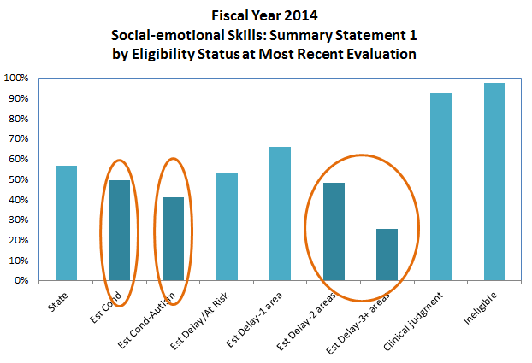

The graphic above shows those eligibility types in fiscal year 2014 that were shown to have a statistically significant difference from the Massachusetts mean. Stakeholders noted this as a potential area for further examination.

Federal Family Outcomes Reporting

The other result area that was further examined as part of the SSIP was the percent of families participating in Part C who report that Early Intervention services have helped the family based on the National Center for Special Education Accountability Monitoring (NCSEAM) Family Survey. Massachusetts does not have the ability at this point in time to link the NCSEAM survey results with individual clients so the Lead Agency, instead, compared family survey results and child outcome results at the program level. Family survey results are so high across all programs that parallels between family and child outcome results were difficult to make. Data analysis at the program level did reveal four programs with low percentages for Summary Statement 1 in social-emotional skills that also had low family outcome percentages. This is an area that the ECO Stakeholders group wanted to see further follow-up and analysis.

The Lead Agency did review the family survey results under each of the items for the individual programs involved in the local onsite data collection. The program having the highest percentage over two years of all three programs under Summary Statement 1: social-emotional skills also had the highest average rating under all 23 family survey items compared to the other two programs. Further analysis is needed on the family survey at the item level to better understand potential impact on child outcome.

State Regions

The SSIP State Leadership Team hypothesized that programs whose performance is statistically lower than the state in Summary Statement 1 positive social-emotional skills may be explained by regional differences due to fewer resources in the more isolated regions of the state such as Cape Cod and the Berkshires. These areas may find it difficult to hire new staff (due to the pool of available employees), to provide services where travel is a challenge due to distance, and to provide specialty services due to fewer providers. This analysis was never completed because of the challenge in defining state regions within Massachusetts, a fairly homogenous state when compared to most others (most “rural” areas are within 1-1/2 hours from a major city). In addition, Early Intervention programs serve multiple cities and towns that cross geographic areas, making it difficult to separate out program practice differences from geographic differences.

Stakeholder Decision regarding Sub-populations

The disaggregated data was presented to ECO Stakeholders in July 2014. Collectively, the disaggregated data analysis informed the selection of the SIMR in several ways. Firstly, significant differences in the Summary Statement 1 positive social-emotional skills across sub-populations revealed a need to focus efforts on Hispanic males, black males, children with autism, and children with 2 or more established delays all of whom are underperforming in this area. Stakeholders provided feedback that they were concerned about targeting a specific population of families for intervention even if, eventually, the intervention would reach all families. Stakeholders felt strongly that if the state initiated practices at a state level to improve child outcome that all children would benefit and be impacted positively. They felt that Massachusetts had an infrastructure with enough resources and current initiatives in place to handle the tasks and activities needed to implement practices to improve social-emotional skills for all children. Therefore, the decision was made by the SSIP State Leadership Team and the ECO Stakeholders group that any initiative to help social-emotional skills improvement should be directed to all children in Massachusetts.

1(c) Data Quality

Massachusetts has a strong system for the collection of both client and service delivery data but continues to attempt to improve the quality and reliability of the data through monthly program Error reports, follow-up with specific programs for specific issues and webinar trainings and discussions. The EIIS application has a myriad of built-in validations to ensure accurate data entry. Service delivery is validated and transmitted through the Transaction Validation Program (TVP) website, a state website designed for the submission of EI client-level claims and service delivery records. At the state level client data is validated against service delivery data to ensure that service dates have been entered correctly (e.g., a service date should not occur prior to the EI referral date). Validation continues at the state level with help desk support providing distribution of monthly Error reports and access to questions from providers about any aspect of the data and data systems.

General Data Quality Issues

Massachusetts has 60 community-based programs providing EI services for eligible children. Five state regional specialists oversee specified programs to ensure compliance in accordance to the EI Operational Standards. Client record reviews and BDI-2 data audits are done as part of general supervision. A Data Verification report is generated annually for programs so that they can see how well they are doing with the accuracy of entering data into the EIIS system from the child’s record. Additional verification percentages are included as part of each program’s annual Local Determinations report. However, one of the largest areas of data quality has to do with the fact that each of the 60 programs may have their own way of collecting data. Some programs or clinicians may hand the data form to the family to fill out while others will ask the family the questions and complete the form themselves. Additionally, the interpretation of what something means on the form may differ from program to program or even clinician to clinician. For example, the at-risk category on the form that states “Multiple trauma/losses experienced by the child” has a specific definition according to the EI Operational Standards. Consistent training by the state and supervision at the program is needed to ensure that definitions mean the same to all programs and all clinicians.

Massachusetts EI has instituted a monthly newsletter (see 2(c) for further details) that is received by all local program directors. The newsletter oftentimes includes messages from the Part C data manager regarding some aspect of data and data accuracy. Additionally, monthly webinars are provided to the general EI community. A webinar on data accuracy was provided to programs in March 2014. Another webinar by the Part C data manager will be presented to new EI program directors in April 2015. Webinars that focus on supervision include the need to ensure that all program staff are fully informed about information coming from the state.

Data Quality Issues with Outcome Results

Massachusetts uses the Battelle Developmental Inventory 2nd Edition (BDI-2) for eligibility determination and federal child outcome reporting. The Lead Agency provides training to programs on the administration, interpretation, and scoring of the BDI-2.

Data analyses demonstrated that social-emotional skills outcome results have decreased in each fiscal year from fiscal year 2012 to fiscal year 2014 in Massachusetts as depicted in the graphic below:

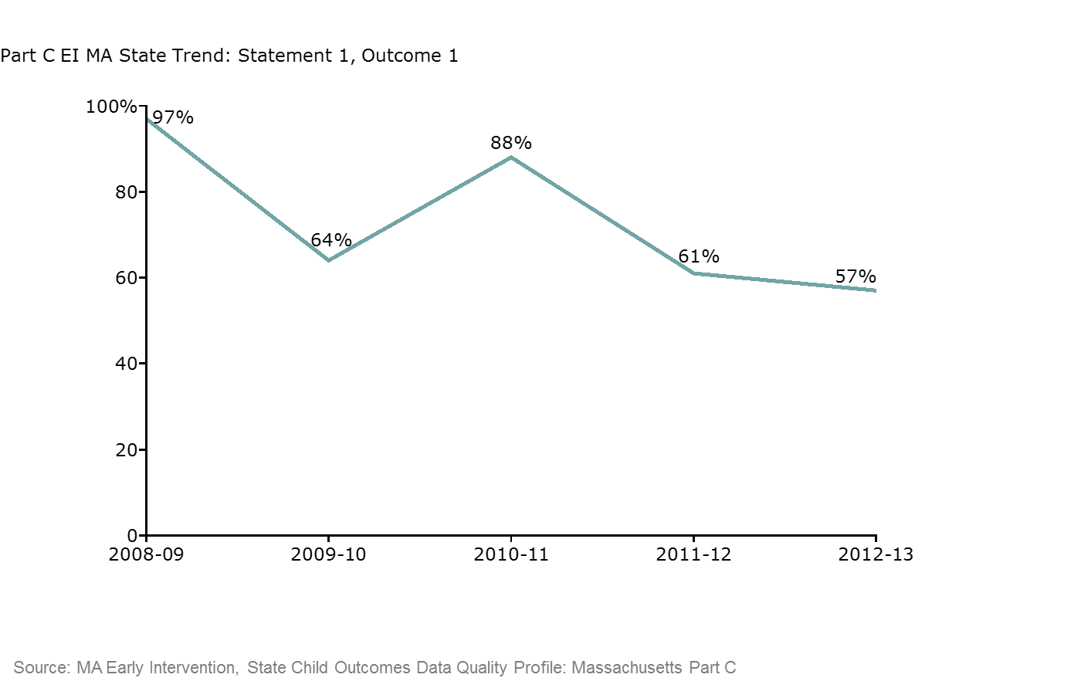

There are several data quality concerns that may be contributing to this decline:

- Change in methodology of measuring child outcomes (Massachusetts moved to the BDI-2 as the only tool to be used for eligibility and federal outcome reporting in January 2012; previously, scores from the Michigan Early Intervention Developmental Profile [Michigan] evaluation tool were used for outcome reporting)

- Fewer total counts of exiting children between fiscal years 2012 and 2014 included in child outcome totals due to the absence of at least two BDI-2 assessments by the time of exit as the Michigan was being phased out (the percentage of children exiting EI who were included in federal child outcome reporting went from 68% of all discharged children in fiscal year 2011 to 23% in fiscal year 2013)

- Outcome data is collected at different times prior to a child exiting EI services. Children with an established condition will have an exit evaluation closest to their third birthday while other children included in the outcome analysis will have received up to as much as 11 additional months of service after their most recent evaluation. If the exit assessment occurred closer to the time of exit for all children there may be differences in child outcome results.

- Potential data quality issues regarding the use of the BDI-2.

- There is a lack of consistency in the use of the BDI-2 evaluation tool across all programs. The BDI-2 is administered by multi-disciplinary teams at the local program that is also providing IFSP services to the family. This model of evaluation/assessment involves almost all of the EI specialists working in the Massachusetts EI system. The need for continuous training for new staff and to update skills of experienced staff is critical. In the three programs involved in the onsite data collection visits (see Program-level Analysis below) 25% of the clinicians had worked at the program for less than 2 years.

- The Personal/Social domain of the BDI-2 is primarily administered using a standardized interview procedure. Through observations in the field, videotaping evaluations, and client record reviews the lead agency and Early Intervention Training Center (EITC) have identified inconsistencies in the administration of the personal-social domain resulting in inaccurate data. Stakeholders agree that this domain is a challenge for EI staff to administer and interpret accurately.

- The BDI-2 data audit has identified inconsistencies and errors in the manual calculations on the paper record. EI staff use a paper record form to record data for the BDI-2 and manually calculate scores. This data is later inputted into Early Intervention Information System (EIIS).

Massachusetts data has not included all exiting children due to the fact that it has only been using BDI-2 data for outcome reporting since fiscal year 2012. As the Michigan was phased out entirely in January 2015, it is expected that in the following one to two fiscal years the percentage of children exiting EI who are included in child outcome totals will reach 60%.

Massachusetts is currently discussing with providers the data quality concerns related to the timing of the exit assessment. The ECO Stakeholders group does feel that a change in program practice around timing of exit assessments would be a significant challenge for the local EI programs to undertake. Further discussion will occur with stakeholders and the EI Provider Community.

Outcome percentages have decreased in all Summary Statements under all three domains since Massachusetts Early Intervention started using BDI-2 data in fiscal year 2012 for child outcome results. The Lead Agency has provided increased training and auditing of all programs to identify gaps and errors in the application of the tool for each EI program. The individual BDI-2 audits will continue through general supervision. Given the need for continued training and auditing the state expects that these percentages may continue to decrease during the next one to two years until all EI programs are consistently applying the tool in the same manner. One project that is currently underway is the University of Massachusetts-Boston BDI-2 Fidelity Study, a grant awarded to the University of Massachusetts-Boston (UMASS Boston) to code and analyze video-taped BDI-2 administrations for voluntary programs and consenting families. UMASS Boston will provide feedback to the lead agency and the EITC regarding training, best practice, guidance, and recommendations on how to properly administer this tool. More consistent administration and interpretation of the BDI-2 will result in improved data accuracy.

Massachusetts is exploring opportunities to begin piloting the electronic scoring products for the BDI-2. The electronic scoring products would allow clinicians to have access to electronic forms on a laptop that is brought into the home at the time that the tool is being administered to the child and family. Clinicians would no longer need to manually calculate raw scores, subdomain scaled scores or Developmental Quotients and this process would eliminate the need for data entry at the local program from paper record forms. The onsite data collection process showed an average of 63% of BDI-2 record forms reviewed contained some sort of calculation error while 41% had a scoring protocol error.

Data Quality Issues with Poverty Level

Poverty level analysis resulted in contradictory results when disaggregating social-emotional skills outcomes. Fiscal year 2013 data demonstrated a correlation between lower poverty levels and social-emotional skills, whereas fiscal year 2014 data did not demonstrate a correlation. The reason for this discrepancy may be explained, in part, on data quality issues. There are approximately 20% of children’s records whose poverty level is unknown due to missing or unknown family size or income data.

The collection of annual income for providers has always been a challenging area for the state. The state has provided programs with ways to approach families with this question but, aside from these recommendations, there are no current plans to address this issue.

Data Quality Issues with Federal Family Outcome Reporting

Federal Family Outcome percentages are high across all programs. Program strategies for sharing the information about the NCSEAM survey and encouraging the completion by families is varied. The EI Parent Leadership Project (EIPLP) has developed training tools and modules to increase understanding for both parents and providers on how the survey results data is utilized in ongoing program improvement and federal reporting.

Massachusetts does not have the ability at this point in time to link the NCSEAM survey results with individual clients so the state, instead, compared family survey results and child outcome results at the program level. As previously stated, family survey results are so high across all programs that it is difficult to see any parallels between family and child outcome results.

The state did review the family survey scores under each of the items for the individual programs involved in the local onsite data collection. The program having the highest percentage over two years of all three programs under Summary Statement 1: social-emotional skills also had the highest score under all 23 family survey items compared to the other two programs. Further analysis is needed on the family survey at the item level to better understand potential impact on child outcome.

Data Quality Next Steps

Massachusetts has identified data quality as one of the main strands of improvement which will focus on improving data collection practices and accuracy. Increased communication through the monthly newsletter and monthly webinar series will provide information about priority data issues and the development of protocols and definitions to increase data accuracy. Continued in-depth BDI-2 training will be offered so that evaluations and assessments are implemented consistently and results are interpreted uniformly across programs. Technical assistance through the Early Childhood Personnel Center (ECPC) will focus on the effectiveness of EITC activities in changing practice. A full description of these initiatives and their intended outcomes are discussed in section 5(a).

1(d) Considering Compliance & Other Federal Data

The SSIP State Leadership Team analyzed its federally-required compliance data in its process to identify program performance that may be affecting child outcome. In many of the compliance indicators, Massachusetts outperformed its own target and/or was higher than the national average. Full FFY 2013 compliance data results are detailed in the table below:

Percent | Indicator
100% | 1: Percent of infants and toddlers with IFSPs who received IFSP services in a timely manner (timely is defined by Massachusetts as within 30 calendar days of the IFSP signature date for all IFSPs).
98.4% | 2: Percent of infants and toddlers with IFSPs who primarily receive Early Intervention services in the home or programs for typically developing children.
 | 4: Percent of families participating in Part C who report that Early Intervention services have helped the family:
85.4% | - Know their rights
82.7% | - Effectively communicate their children's needs
92.3% | - Help their children develop and learn
4.04% | 5: Percent of MA population of infants and toddlers birth to one with IFSPs compared to National data.
8.02% | 6: Percent of MA population of infants and toddlers birth to three with IFSPs compared to National data.
99.6% | 7: Percent of eligible infants and toddlers with IFSPs for whom an evaluation and assessment and an initial IFSP meeting were conducted within 45 days of the date of referral to an Early Intervention program.
 | 8: Percent of all infants and toddlers leaving Early Intervention who received timely transition planning to support the child’s transition to preschool and other appropriate community services, including:
99.9% | a. Completed individual transition plan with steps & services documented on the IFSP
85.9% | b. Notification to LEA, if child potentially eligible for Part B
99.5% | c. Transition conference occurs prior to third birth date, if child potentially eligible for Part B
 | 9: General supervision system (including monitoring, complaints, hearings, etc.) identifies and corrects noncompliance as soon as possible but in no case later than one year from identification:
100% | a. Noncompliance related to monitoring priority areas and indicators;
100% | b. Noncompliance related to areas not included in monitoring priorities & indicators;
100% | c. Noncompliance identified through other mechanisms
100% | 10: Percent of signed written complaints with issued reports within 60-day timeline, including a timeline extended for exceptional circumstances with respect to a particular complaint.

As mentioned earlier there was an interest in identifying underserved or marginal populations of children that are not being identified early on for referral to Early Intervention. Child Find was eliminated by the SSIP State Leadership Team as a potential area of concern after a review of Child Count data. Child Count percentages in Massachusetts have consistently been one of the nation’s highest percentages for child find and is not an area of concern in Massachusetts.

Timeliness of services, IFSPs and transitions as well as children receiving services in natural settings is also very high in Massachusetts and are all considered strengths in the system. The majority of programs who were issued a Correct Action Plan (CAP) for being under 100% in a compliance area were performing at 100% within a year. General supervision and the state’s Dispute Resolution system are also seen as strengths of the system.

The one area that was further examined as part of the SSIP was the percent of families participating in Part C who report that Early Intervention services have helped the family based on the National Center for Special Education Accountability Monitoring (NCSEAM) Family Survey. Massachusetts does not have the ability at this point in time to link the NCSEAM survey results with individual clients so the state, instead, compared family survey results and child outcome results at the program level. Family survey results are so high across all programs that parallels between family and child outcome results were difficult to make. Data analysis at the program level did reveal four programs with low percentages for Summary Statement 1 in social-emotional skills that also had low family outcome percentages.

Program compliancy in the above areas will help support the implementation of SIMR activities in that the faster that an IFSP is in place and services begin the more time that clinicians will have with children and their families to build relationships and implement new practices.

1(e) Additional Data

As noted in the overview, the State supports programs in developing a universal approach to social-emotional screening using either the Ages or Stages Questionnaire: Social-emotional or the Greenspan Social-Emotional Growth Chart.

The SSIP State Leadership Team discussed acquiring additional data from EI programs regarding their use of social-emotional screening tools [the Ages and Stages Questionnaire: Social-emotional (ASQ-SE) and the Greenspan Social-Emotional Growth Chart (Greenspan)], questionnaires used to enhance clinician and family awareness of a child’s social-emotional skills. The ASQ-SE and Greenspan provide an additional reference point for program staff to consider when assessing children’s developmental progress but it was unknown if the use of these tools benefited the IFSP process in establishing social-emotional outcomes. The Annual Report/Self-Assessment that is sent out to EI programs each fall was used to acquire additional information about how these tools are used by EI programs. The following questions were asked of all programs on the Annual Report in September 2014:

Social-Emotional Screening Tool(s)
Are you using the ASQ-SE? (Yes/No))

Are you using the Greenspan? (Yes/No)

Who administers the tool? (select all that apply)
O Service coordinator
O Evaluation team member
O Other EI service provider

How often is the tool administered?
O Annual
O Every 6 months

How is the information used in the IFSP process? (text response)

What support does your program need from DPH regarding the use of these tools? (text response

Annual Report data was collated in October 2014 and reviewed by the SSIP State Leadership Team. The SSIP State Leadership Team discussed the use of the ASQ-SE and the Greenspan with the ECO Stakeholders group as a strategy for program improvement and as an additional reference point for staff in evaluating child and family progress. The ASQ-SE and the Greenspan are not being used consistently across all programs. 85% of programs use these tools to help in the development of IFSP goals and strategies with 65% stating a need for technical assistance from the state. It was not clear from the data that the use of these tools by programs was having an impact on the social-emotional skills status of their children. This data will continue to be evaluated against child outcome data and Massachusetts will discuss best practice recommendations regarding the use of the ASQ-SE and the Greenspan for individual development of the IFSP and will incorporate this as an improvement strategy during Phase 2 of the SSIP.

Additional analysis is planned that may inform Massachusetts in its Phase 2 activities and recommended practices. These include the following:

- Intensity of services. The state hypothesizes that children who receive more services with greater intensity or frequency will demonstrate positive progress in social-emotional skills.

- Age at entry. The Lead Agency hypothesizes that the BDI-2 is less sensitive to social-emotional skills delay in children that enter EI between the age of birth and one year. The Lead Agency will look at this cohort of children in comparison to children who enter EI services between age one and two and between age two and three.

- Family survey items. Further analysis is needed on the family survey at the item level to better understand potential impact on child outcome. Analysis was done for three programs but further analysis can be done for all programs. This analysis will also help to provide guidance to programs on how to analyze their own family data.

- Progress category analysis for Outcome 1: Positive social skills: Progress category percentages for Outcome 1 will be monitored. Massachusetts will look for progress category b percentages to decrease and for progress category c and d percentages to increase.

- BDI-2 subdomain scaled scores. The personal/social domain of the BDI-2 includes scaled scores for three domains: Adult Interaction, Peer Interaction and, Self-Concept and Social Role. The SSIP State Leadership Team began to review this data by eligibility at the child’s last evaluation, length of stay, child’s age at initial evaluation, and child’s age at last evaluation. The Lead Agency may not see an improvement in their Summary Statement 1 percentage but the scaled scores may show improvement.

Additionally, there are initiatives underway that will provide Massachusetts with information and data regarding outcomes and data improvement strategies. These include the following:

Massachusetts Outcomes Research Project: Classifying Infants and Toddlers with Developmental Vulnerability, University of Colorado
The Massachusetts Outcomes Research Project is an outside research project using Massachusetts Part C early intervention program data to conduct an outcomes research project. Specifically, the research seeks to tackle important questions related to outcomes, cost-effectiveness, and return on investment of early intervention service delivery in order to make important clinical, programmatic and policy contributions for children with disabilities and their families. The purpose of the study is to 1) describe sub-groups of infants and toddlers with developmental vulnerability consistent with EI eligibility characteristics and 2) determine which sub-groups are most likely to receive EI services. Researchers hypothesize that young children with developmental vulnerability will fall into four groups along the domains of increasing social and biological/functional risk. Researchers hypothesize that there will be a gradient in likelihood for receiving EI services whereby children in sub-groups characterized by highest social and biological/functional risk will be most likely to receive EI and children in the sub-group characterized by lowest biological/functional and social risk will be least likely to receive services.

The project manager received EI data from Massachusetts in January 2015.

University of Massachusetts-Boston BDI-2 Fidelity Study
The University of Massachusetts-Boston (UMASS Boston) was awarded a grant to code and analyze video-taped BDI-2 administrations for voluntary programs and consenting families. UMASS Boston will provide feedback to the lead agency and the EITC regarding training, best practice, guidance, and recommendations on how to properly administer this tool. More consistent administration and interpretation of the BDI-2 will result in improved data accuracy.

SASID Project
Inter-agency project between the Massachusetts Department of Public Health (Part C) and the Massachusetts Department of Elementary and Secondary Education (Part B) to assign a State Assigned Student ID (SASID) to children enrolled in EI in order to track and evaluate educational and developmental outcomes. This project has been implemented and is currently being piloted by seven EI programs and is projected to be fully implemented at all programs by the end of calendar year 2016. Preliminary reports will not be available for at least three years.

Additional data analyses and initiative statuses will be shared with the ECO Stakeholders Group in June of 2015.

1(f) Stakeholder Involvement in Data Analysis

Massachusetts established multiple levels of stakeholder involvement and engaged stakeholders starting early on in the SSIP process. Information was first shared with the EI Provider Community in October 2013 at the EI Program Director meeting. Program directors, agency representatives, and supervisory staff were present at this day-long meeting. The state provided an overview of the multi-year SSIP process and obtained input from the broad EI field on the potential focal areas.

The larger EI provider community recommended that the existing Early Childhood Outcomes (ECO) Stakeholders group serve as the stakeholder group to the lead agency on the SSIP process, help in determining the state’s focus area through data and infrastructure analysis, and provide feedback to root cause and improvement strategies. The ECO Stakeholders group was an existing group that was already involved in child outcome issues and was in agreement to take on this initiative. In moving forward with preparations for the SSIP, the Lead Agency broadened the ECO Stakeholder group to include representation from the following groups:

- Higher Education Task Group
- Department of Elementary and Secondary Education
- Department of Early Education and Care
- Parents

EI convened an additional small SSIP State Leadership Team at DPH consisting of central administration staff who oversee monitoring, training, and data. A community EI provider and a parent are included as part of this to represent the broader EI community. The SSIP State Leadership Team gathered and reviewed data, discussed data inferences and prepared reports prior to presenting to the ECO Stakeholders group. Bi-weekly meetings were established to discuss SSIP data and activities. The SSIP State Leadership Team reviewed data reports, timelines and other relevant information prior to presentation at each ECO Stakeholders meeting. In addition to this stakeholder group the Inter-Agency Coordinating Council (ICC) provides broader input and feedback on the SSIP process and focus area. Each ICC meeting includes an update on the SSIP process and its timelines. A full list of these stakeholders is detailed in the table below:

Representative/ Organization | Part C Stakeholder Group
Coordinator of Education of Homeless Children & Youth | Interagency Coordinating Council (ICC)
Commission for the Deaf and Hard of Hearing | Interagency Coordinating Council (ICC)
Commission for the Blind | Interagency Coordinating Council (ICC)
Department of Developmental Services | Interagency Coordinating Council (ICC)
Department of Early Education and Care | Interagency Coordinating Council (ICC)
Department of Children & Families | Interagency Coordinating Council (ICC)
Division of Medical Assistance | Interagency Coordinating Council (ICC)
Division of Insurance | Interagency Coordinating Council (ICC)
Department of Mental Health | Interagency Coordinating Council (ICC)
Massachusetts Developmental Disabilities Council | Interagency Coordinating Council (ICC)
Department of Elementary & Secondary Education | Interagency Coordinating Council (ICC)
Federation for Children with Special Needs | Interagency Coordinating Council (ICC)
United Way of Massachusetts Bay and Merrimack Valley | Interagency Coordinating Council (ICC)
Justice Resource Institute, Inc. | Interagency Coordinating Council (ICC)
Early Headstart Representative | Interagency Coordinating Council (ICC)
Institute of Health & Recovery (IHR) | Interagency Coordinating Council (ICC)
Regional Parent representatives | Interagency Coordinating Council (ICC)
Regional Provider representative | Interagency Coordinating Council (ICC)
Physician | Interagency Coordinating Council (ICC)
Legislator | Interagency Coordinating Council (ICC)
MEIC representative | Interagency Coordinating Council (ICC)
619 Coordinator, Department of Elementary & Secondary Education | Early Childhood Outcomes (ECO) Stakeholder group
Educator Provider Support Specialist, Department of Early Education & Care | Early Childhood Outcomes (ECO) Stakeholder group
Education Specialist, Department of Elementary & Secondary Education | Early Childhood Outcomes (ECO) Stakeholder group
Director, Office of Family Initiatives (DPH) | Early Childhood Outcomes (ECO) Stakeholder group
Assistant Director, Massachusetts Early Intervention (DPH) | Early Childhood Outcomes (ECO) Stakeholder group
Early Childhood Mental Health Specialist, Department of Public Health | Early Childhood Outcomes (ECO) Stakeholder group
EI Program Directors (five total) | Early Childhood Outcomes (ECO) Stakeholder group
Director & Associate Director, Early Intervention Training Center (DPH) | Early Childhood Outcomes (ECO) Stakeholder group
ICC Co-Chair | Early Childhood Outcomes (ECO) Stakeholder group
Co-Directors, Massachusetts Home Visiting (DPH) | Early Childhood Outcomes (ECO) Stakeholder group
Early Intervention Certificate Program Instructor, Northeastern University | Early Childhood Outcomes (ECO) Stakeholder group
Regional Specialist, Department of Public Health | Early Childhood Outcomes (ECO) Stakeholder group
Statewide Monitoring Coordinator (DPH) | Early Childhood Outcomes (ECO) Stakeholder group
Project Staff, Early Intervention Parent Leadership Project | Early Childhood Outcomes (ECO) Stakeholder group
Assistant Director, Massachusetts DPH, Division of EI | Massachusetts SSIP State Leadership Team
Data Manager, Massachusetts DPH, Division of EI | Massachusetts SSIP State Leadership Team
Director, DPH, EI Training Center | Massachusetts SSIP State Leadership Team
Associate Director, DPH, EI Training Center | Massachusetts SSIP State Leadership Team
EI Regional Specialist | Massachusetts SSIP State Leadership Team
Local EI Program Director | Massachusetts SSIP State Leadership Team
Statewide Monitoring Coordinator, Massachusetts DPH, Division of EI | Massachusetts SSIP State Leadership Team
Director, EI Parent Leadership Project, Massachusetts DPH | Massachusetts SSIP State Leadership Team
Early Intervention Program Directors | Early Intervention Provider Community

As described in section 1(a), the SSIP State Leadership Team worked closely with these stakeholders in ruling out the original potential focus areas. These stakeholders actively participated in the review of multiple datasets, data disaggregation, and discussions to ultimately select and unanimously agree upon Summary Statement 1 positive social-emotional skills as the SIMR.

Component #2: Analysis of State Infrastructure to Support Improvement and Build Capacity

2(a) How Infrastructure Capacity was Analyzed

Massachusetts utilized multiple methods for analyzing the state infrastructure including an initial broad SWOT (Strengths, Weaknesses, Opportunities, Threats) analysis completed by the ECO stakeholders group, lead agency-led comprehensive internal infrastructure analysis, local onsite data collection visits at select EI programs to learn about current practices, and a final SWOT analysis by EI providers on the selected practices and strategies to address the SIMR.

Broad SWOT (Strengths, Weaknesses, Opportunities, Threats) Analysis:

The ECO Stakeholder group completed an initial SWOT analysis as part of a larger capacity discussion in order to identify and analyze the Massachusetts EI systems’ strengths, weaknesses, opportunities, and threats in preparation for initiating a change in practice. This SWOT analysis was completed early in the process after sharing information about the SSIP process with the larger provider group.

Massachusetts modified its SWOT analysis worksheet to better concentrate focus on integrating existing initiatives. The Lead Agency was interested in looking at how existing initiatives connect and support each other in order to identify ways to incorporate these initiatives into the SSIP process. MA used the following questions in adapting the SWOT analysis:

- What aspects of the MA Early Intervention Program (EIP) current initiatives make it unique?
- How does the MA EIP system leverage its resources (fiscal, material, personnel, etc.) to build capacity at the local system level?
- What are challenges with regard to the MA EIP ability to support local systems in efforts to implement sustainable new initiatives?

Stakeholders were provided with a list and description of initiatives that are currently occurring either as part of the Massachusetts EI system or at the lead agency prior to completing the SWOT analysis. This provided an opportunity to enhance stakeholder understanding of the coherence/linkages across initiatives and identify which efforts stand out as strengths or weaknesses. This initial SWOT analysis guided later data and infrastructure analysis activities, including looking at data collection and quality.

A summary of the initial SWOT analysis completed by Massachusetts Early Intervention stakeholders is depicted below.

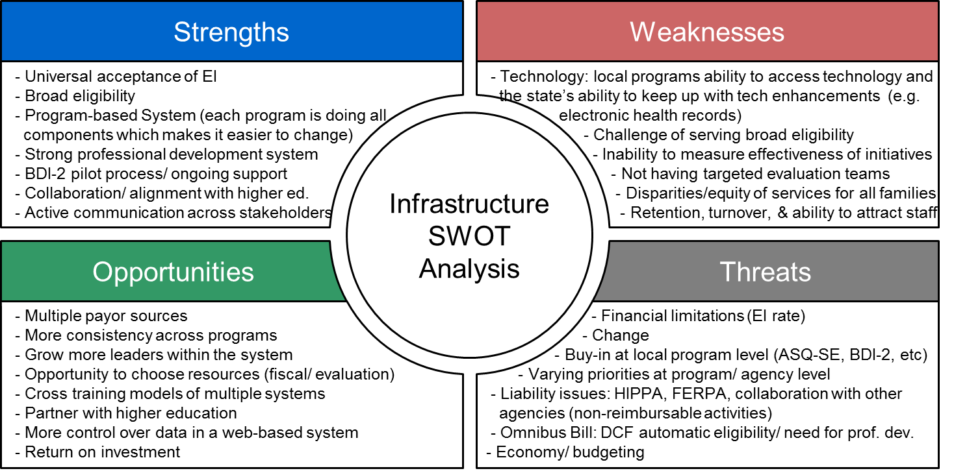

Comprehensive Review of Massachusetts State Systems

Following the initial SWOT analysis which was completed by Massachusetts Early Intervention stakeholders, the lead agency started a more comprehensive review of state systems. Through this infrastructure analysis, the lead agency identified leverage points or opportunities within the system that are currently in place to support positive social-emotional skills for infants and toddlers in seven component areas:

- Governance and advisory bodies
- Current initiatives
- Professional development and technical assistance
- Accountability and monitoring systems
- Data systems
- Communication and coordination
- Fiscal/financial resources

After identifying leverage points, the full lead agency team identified and discussed the following questions:

- What challenges do these leverage points not address?
- What barriers are there for successfully supporting positive social-emotional skills for infants and toddlers?
- Which practices do these leverage points support?

This infrastructure analysis led to the identification of areas of strength within the system that can continue to be leveraged in order to effectively manage change in the system. The SSIP State Leadership Team identified its collaborative relationships with other agencies in the Commonwealth and DPH initiatives (many within its own Bureau of Family and Community Health) as strengths of the Massachusetts EI system. Massachusetts Early Intervention maintains strong working relationships with the Department of Elementary and Secondary Education (DESE) and the Department of Early Education & Care (EEC). It also utilizes its connection to federal partners and access to national research to embed Part C foundational concepts into all Early Intervention Training Center (EITC) workshops. In addition, the service delivery model is supported by funding through multiple payor sources, including state Medicaid and commercial insurers, as mandated by state statutes. The focused client base of eligible children, birth to three year olds, was a strength of the system as it defined a clear directive and facilitated a family-centered approach to services. Lastly, the current Early Intervention programs were identified as a strength of the system, as many are long standing programs within their communities, they have developed an understanding of the community and its available resources, and their staff represent multiple disciplines that are used in service delivery. Each EI program is embedded within a well-functioning monitoring system that collects data, offers technical assistance, and works to improve all state programs.

Challenges within the system were also identified in the Massachusetts EI system. The lack of consistency across programs and their individualized processes at the local level for training and professional development, procedures on how to implement EI operational standards, clinical team approach to intervention for children and families, and supervision practices results in a system that is difficult to evaluate and to manage change within. Access to community-based services and initiatives outside of the EI system is varied between local programs. Because many state and community-based initiatives that support positive social-emotional skills are often siloed from one another so it creates an inconsistent engagement at most Massachusetts Early Intervention programs and can be a barrier to family participation. These inconsistencies have led, in part, to data quality issues and ineffective practices. Although the state has made an effort to implement new, best practices, new initiatives are often difficult to implement across the system and lack a well-defined evaluation process to determine efficacy or impact to children and families. While these are current weaknesses of Massachusetts Early Intervention, a more focused proactive approach to data analysis and implementation of evidence-based practices provide opportunities for improvement.

Through this process there have been continued identification of opportunities within the EI system to build in and allocate resources to support practices that will improve positive social-emotional skills for infants and toddlers. Through its robust monitoring system, the state may focus its evaluation on clinical practices that improve children and family outcomes. For example, the DAC pilot rubric would provide a template for Massachusetts to use data in order to rate the implementation and efficacy of certain program practices. In fact, the SSIP onsite process has already identified initial data points to use for such an analysis. The Early Childhood Personnel Center (see section 2(d) for further detail) offers an opportunity to provide technical assistance which would improve the evaluation component of trainings measuring the impact of best practices. Our multiple payor system also allows the lead agency to assess the use of Federal Part C funding to support and enhance professional development and the implementation of effective practices across the system.

The primary threat to the Massachusetts Early Intervention system, especially at the local program level is the limitations of the rates for unit reimbursement. The reimbursement rate is considered to be in need of an increase, reimburses only for face-to-face intervention, excludes supervision and collateral collaboration, and limits the number of co-treatments. Consequently, local programs struggle to meet the demands of the program and staff with regard to supervision and collaboration time within their teams and between community-based members of a child’s Individualized Family Service Plan (IFSP) team. At the state level, resources for data collection, creation of reports, data analysis, general supervision and monitoring and professional development are strained due to the lack of resources in staff and the budget to meet the needs of the more than 60 Massachusetts-certified Early Intervention programs. And finally, the SSIP State Leadership Team agreed with stakeholders that the system is hesitant to accept change and adopt new practices.

Overall, the SSIP State Leadership Team’s more in-depth analysis was consistent with the earlier stakeholder-led SWOT analysis. The primary conclusions that the SSIP State Leadership Team reached in regards to the infrastructure analyses were:

- SSIP efforts may be most effective by focusing more narrowly on a small number of practices that are demonstrated to be successful and implementing consistently across Early Intervention programs.

- In order to identify these best practices, Massachusetts should develop a clear evaluation methodology for practice efficacy so that results are standardized.

- Threats were consistently identified both across stakeholders and within the SSIP State Leadership Team. Massachusetts must ensure that Early Intervention programs are able to adopt new best practices within the confines of the reimbursement rate, and the SSIP State Leadership Team must provide guidance and technical assistance to programs within the existing capacity.

Local Onsite Data Collection

Following the completion of the more comprehensive analysis in March 2014, Massachusetts analyzed and disaggregated multiple datasets, as earlier mentioned in sections 1(a) and 1(b). Specifically, through the program level disaggregated analysis, Massachusetts identified three programs for an onsite data collection process. Local program child outcome results were compared for each of the Massachusetts EI local programs for FY2013 and FY2014. Through this process, three local EI programs were selected for onsite data collection visits in order to analyze the local practices. Programs selected met one of the following criteria:

- Program with low Summary Statement 1 over two consecutive fiscal years (FY2013, FY 2014)
- Program with high Summary Statement 1 in FY2013 and low Summary Statement 1 in FY2014
- Program with high Summary Statement 1 over two consecutive fiscal years (FY2013, FY 2014)

Data was collected through:

- Administrative interviews
- Record review
- BDI-2 data audit (comparison of the BDI-2 scores in the paper record at the local program and scores entered into EIIS)
- Staff online survey

Data was collected and organized in a rubric developed by the Data Accountability Center (DAC). Using the Division of Exceptional Children (DEC) Recommended Practices, the SSIP State Leadership Team used data collected during the onsite data collection process to determine which practices were implemented at each of the programs. Practices were then compared to the Child Outcome results to narrow the practices that impact the SIMR.

Targeted attention to the different practices related to evaluation/assessment, IFSP process, intervention and parent engagement strategies, and use and access to the EI team for children who fell into progress categories b and d for positive social-emotional skills.

Through this process, the SSIP State Leadership Team was able to narrow the focus of the improvement strategies for the SIMR.

The SSIP State Leadership Team used the following questions to drive their onsite interviews and data collection:

- Was the program maintaining fidelity to BDI-2?
- Is the program involved in other social-emotional issues?
- Does the program offer training(s) to staff?
- What is the discipline and/or background of staff administering the ASQ-SE?
- Who on the team has received training to address social-emotional well-being? Specifically, what training?
- What supervision practices does the program have in place?
- How do the programs perform in terms of IFSP outcomes?
- What is the program culture related to the administration of the ASQ-SE?
- What is the program’s model of service delivery?
- Who receives group services?
- Are there opportunities for peer interactions?

The findings of the local onsite data collection and interviews were compiled and reviewed by stakeholders to understand root causes of the programs’ impact. Data elements collected during the local onsite visits included:

- BDI administration and interpretation
- ASQ-SE administration (and other SE tools used)
- ASQ-SE training
- Use of social-emotional screening in the IFSP process
- Staff meeting & supervision practices
- Other evidence-based models used in practice
- Programmatic changes made at the site
- Staffing (total, supervision, and service provision staffing)
- Caseload & consultations data
- NCSEAM family survey results

In addition to compiling information on practices and program administration, the team collected information on external factors such as populations served, referral sources, and additional community resources. The full onsite visit data and results are included in the Appendices.

Key findings from the program onsite visits were that their staff receive greater access to supervision, staff more consistently interpret eligibility results, and families are more engaged throughout the Early Intervention process. The local onsite data collection demonstrated positive NCSEAM family survey scores in correlation with positive social-emotional skills that further reiterated the importance of engagement and education of parents. Each of these findings provided a template through which Massachusetts could better implement uniform practices to positively impact social-emotional outcomes. Altogether, the infrastructure analysis helped the state to connect its ongoing work, initiatives, and processes with some of the weaknesses or challenges that were identified in the data analysis.

By coupling this information with the disaggregated data analysis, Massachusetts began identifying which strategies, implemented consistently, may positively impact social-emotional outcomes. Stakeholders helped to identify already existing strategies and initiatives that could tie to the SIMR. Though onsite visits and SWOT analysis further demonstrated the challenges of serving a broad population with differing traits & program challenges in each Early Intervention catchment area, the visits led to greater insight into best practices that could improve social-emotional outcomes across all programs.

DEC Recommended Practices chosen to focus on in Massachusetts:
- Practitioners work as a team with the family and other professionals to gather assessment information.
- Practitioners obtain information about the child’s skills and daily activities, routines and environments, such as home, center and community.
- Practitioners support family functioning, promote family confidence and competence, and strengthen family-child relationships by acting in ways that recognize and build on family strengths and capacities.
- Practitioners representing multiple disciplines and families work together as a team to plan and implement supports and services to meet the unique needs of each child and family.
- Practitioners and the family work together to create outcomes, develop individualized plans, and implement practices that address the family’s priorities and concerns and the child’s strengths and needs.

SWOT Analysis of Identified Practices:

Following the onsite data gathering process and analysis, practices from the DEC recommended practices were identified as strategies to improve the Massachusetts SIMR. As the final step of SSIP Phase I Stakeholder input and infrastructure analysis, the lead agency presented the SSIP Phase I process and plan to the EI provider community at an EI program director full day meeting. After review of the process, the identified practices were reviewed and individual participants completed a SWOT analysis for each of the practices.

For all of the practices identified, stakeholders agreed on the strengths within the Massachusetts EI system to implement them in practice. Stakeholders noted that the current system has the foundation in place to support the practices, through the requirements set forth by the Massachusetts EI Operational Standards and IDEA Part C Federal Regulations programs are utilizing a Universal Individualized Family Service Plan (IFSP) document, evaluating and assessing with multidisciplinary teams, prioritizing family-centered services, and providing services in the natural environments of children and families.

Based on responses to the SWOT analysis, an identified weakness is the need to have a consistent definition and standard of practice for terms such as ‘assessment,’ ‘family engagement,’ and ‘routines.’ EI providers also noted the wide array of languages spoken by families and cultural differences is a challenge and a weakness within the system. The current reimbursement model for services does not incentivize programs to engage in collateral and collaborative processes that are non-billable in nature within our system, which includes direct supervision of staff.

Opportunities continue to exist to continue to build professional development activities around the central foundational concepts of Early Intervention and clarify the purpose and use of requirements in the field and to link the assessment activities and IFSP process together to support the interventions done with families to support their children’s development and learning, especially positive social-emotional skills.

Threats identified were consistent with prior infrastructure analyses. The reimbursement structure, although stable and consists of multiple payors, includes unit rates that are considered to be inadequate to retain qualified personnel, to meet the needs of diverse communities, and to support additional administrative functions at the program level.

2(b) Description of the State Systems

Governance

The Massachusetts Department of Public Health has the responsibility for administering and overseeing the statewide system of Early Intervention services, certifying programs and coordinating funding sources, and carrying out monitoring and technical assistance activities. As of January 1, 2015, the MA EI system has 60 certified community-based programs that align and comply with the overall EI governance and operational structure.

In order to ensure the quality of services provided to children and families enrolled in Massachusetts Early Intervention, the Lead Agency designed its General Supervision structure to promote the Massachusetts EI Mission & Key Principles and core values and to ensure compliance with federal and state requirements through training, technical assistance, and monitoring. Included in the governance structure are multiple advisory bodies which bring together key Massachusetts stakeholders. These advisory bodies consist of the following groups:

- Interagency Coordinating Council (ICC)
- Early Childhood Outcomes Stakeholders (ECO)
- Higher Education Task Group
- Early Childhood Personnel Center Stakeholders/ Task Group

The aforementioned groups provide input to the Lead Agency’s decision making for systemic improvements with regard to SSIP activities. The General Supervision system focuses on identifying commendable practices, suggesting improvements to enhance quality of services and specifying and enforcing corrective actions in areas of non-compliance. This system, including onsite monitoring, supports the program’s approach to federal and state monitoring of the implementation of the Individuals with Disabilities Education Act (IDEA). The Lead Agency utilizes information from the Early Intervention Information System (EIIS), Annual Report/Self-Assessment, and the Dispute Resolution System as criteria in making Local Program Determinations. Each local program receives a determination of “meets requirements”, “needs assistance”, “needs intervention”, or “needs substantial intervention” based on compliance with Part C of IDEA and state targets in other areas such as data completeness and timeliness.

The following Organizational Chart shows the structure of the lead agency to provide administrative oversight of the local community-based programs. The Regional Specialist team provides general supervision activities that lead to technical assistance plans or corrective action plans through monitoring, onsite activities, data collection, review and analysis of local programs to ensure compliance. The Early Intervention Training Center (EITC) provides training and technical assistance to support quality local program practice. The Director of the Office of Specialty Services provides resources to support the EI system in addressing the needs of children with hearing loss, vision loss, deaf blindness, and autism spectrum disorder. Training and TA is available to local community-based programs as needed. The EI Parent Leadership Project provides support to EI programs to recruit and engage parents, and offer technical assistance/ resources to families and staff. The Office of Family Rights and Due Process also provides training and TA to support parents and programs to understand procedural safeguards throughout the IFSP process.

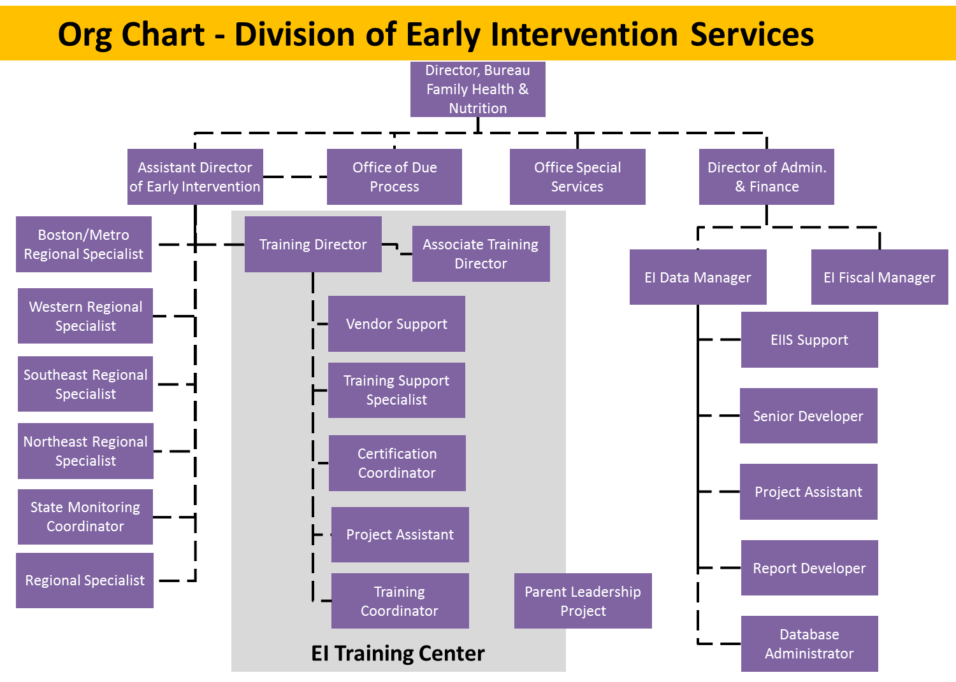

Fiscal

Early Intervention services provided to eligible infants and toddlers and their families are financed through multiple funding sources:

- Part C, Individuals with Disabilities Education Act (IDEA federal funds)
- State Appropriation
- Commercial Insurance
- MassHealth (state Medicaid)

Early Intervention services are paid for by commercial health insurers, MassHealth and the Department of Public Health. Massachusetts General Laws (MGL) chapter 721 mandates that all Massachusetts third party insurers, including HMOs and PPOs, must cover the cost of EI services as part of their basic benefits package if fully insured. However, out-of-state health plans and self-insured employer group plans are not required to follow Massachusetts state mandates, although many do. DPH pays for costs that are appropriately denied by an insurer.

The MA EI unit rate reimbursement system allows certified community-based programs to bill for face-to-face services such as Home visits, Center Individual Visit, Child Group, Parent Group, Intake and Assessment. Co-treatment is limited and a potential area of expansion, especially when related to supervision. There is no direct reimbursement for service coordination, supervision, and ongoing professional development.

Federal and State Regulations require that any and all other resources be utilized toward the cost of services. Part C funds are not used to replace other sources of payment, including funding from other governmental agencies and are used as payor of last resort. Part C funds may be used to prevent a delay in the timely provision of Early Intervention services, pending reimbursement from the responsible agency.

Massachusetts General Laws prohibit fully insured health plans from charging co-payments, co-insurance, and deductible charges for Early Intervention services. Families do not bear the cost of insurance co-payments and deductibles. The lead agency may use Part C or other funds to pay for costs such as the child’s premiums, deductibles, or co-payments. Consistent with federal and state law, the Massachusetts Early Intervention System strictly prohibits all acts that constitute fraud, waste, and abuse.

Each Early Intervention program has an organizational plan and written policies addressing processes and procedures to ensure the validity and integrity of billing to public and private insurance and the DPH. Each program conducts an annual self-evaluation. Programs encourage families to participate in the self-evaluation which includes areas such as a review to ensure the integrity and validity of billing.

If a provider agency has been found to have committed fraud, waste or abuse, the Massachusetts EI System will recoup funds linked to these activities.

Massachusetts has a strong financial foundation to not only continue to meet its fiscal responsibilities, but to expand and add initiatives at both the state and local levels.

Quality Standards

The Department of Public Health in Massachusetts serves a culturally and socioeconomically diverse population of infants and toddlers with disabilities and their families, including those children at-risk of developmental delays. Massachusetts is strongly committed to equal access and treatment for all infants and toddlers and their families who are referred to, and served in, the Part C program, as well as to the Early Intervention service providers and the general public. Massachusetts is advised by and works with its State Interagency Coordinating Council (ICC) to identify and address any barriers to service for these designated populations. Massachusetts ensures that Part C programs are a part of a statewide system of EI services, and provides an environment free from discrimination and harassment based upon gender, race, national origin, color, disability, or age.

The Individualized Family Service Plan is developed in collaboration with families and is based on the attainment of measurable results and in achieving functional outcomes determined by the family with respect to their own concerns and priorities. Services reflect the cultural, linguistic, and ethnic composition of the state and of the families enrolled. Early Intervention services focus on the family unit, utilizing family resources and daily routines to enhance the child’s growth and development. Early Intervention staff support and encourage the family’s use of and access to community-based resources that will continue to support and enhance the child’s development.

Operational Standards are developed to describe requirements of community Early Intervention programs and are used as criteria by the Lead Agency for ongoing monitoring, for contract performance review and for Early Intervention program certification. All Massachusetts DPH-certified EI programs incorporate into their practice the following core values:

- Respect: recognizing that each group of people has its own unique culture, and honoring the values and ways of each family’s neighborhood, community, extended family, and individual unit
- Individualization: tailoring supports and services with each family to its own unique needs and circumstances
- Family-Centeredness: basing decisions with each family on its own values, priorities, and routines
- Community: realizing that each family exists in the context of a greater community, and fostering those communities as resources for supports and services
- Team Collaboration: working as equal partners with each family and with the people and service systems in a family’s life
- Life-Long Learning: viewing Early Intervention supports and services as a first step on a journey for each child, family, and provider

Full details of Massachusetts’s EI Operational Standards can be found at the following link: http://www.mass.gov/eohhs/docs/dph/com-health/early-childhood/ei-operational-standards.pdf

The EIOS also includes a summary of the requirements for Certification for Early Intervention Specialists (CEIS). It is a comprehensive process to ensure that EI specialists demonstrate knowledge and skill in all competency indicators and are prepared to provide high quality EI services to children and families. Competency areas include:

- Infant and Toddler Development: EI specialists will demonstrate knowledge and skills to support each child’s development in the following domains: social-emotional/interaction, cognition, gross motor, perceptual/fine motor, communication, and self-care. This should include knowledge of common developmental disabilities and risk factors, as well as their effect on early development and child/caregiver interactions.
- Evaluation and Assessment: EI specialists will demonstrate knowledge and skills in a range of eligibility evaluations and services supported by the IFSP.
- Family Centered Services and Supports: EI specialists will demonstrate the knowledge and skills necessary to implement family-centered services and to establish and maintain trusting relationships, so that decisions made with each family are based on a family’s own unique values, culture, priorities, and routines, in order to engage families in the IFSP process and individualize supports and services.
- Individualized Family Service Plan: EI specialists will collaborate with families throughout the IFSP process, reflecting appropriate knowledge of federal and state components and requirements, procedural safeguards, and family rights throughout the family’s participation in EI services.
- Service Coordination: EI specialists will demonstrate knowledge and skills in coordinating Early Intervention and community services for children and families, including supporting the family in developing self-advocacy skills and planning for transitions.
- Intervention Strategies: EI specialists will demonstrate knowledge and skills in intervention strategies for children and families, offering a variety of techniques including activities, interventions, materials, and assistive technology during visits, in the context of daily routines, to produce positive outcomes for children and families.
- Team Collaboration: EI specialists will demonstrate knowledge and skills in working with families and other professionals using a collaborative model, so that they can provide information and methods from their own discipline to team members and evaluate the IFSP in partnership with the family and other team members.
- Policies, Procedures, and Professionalism: EI specialists will demonstrate knowledge of relevant federal and state legislation, regulations, standards, and policies so that they can provide appropriate information to families and safeguard confidentiality, and they will demonstrate professional conduct and leadership skills with colleagues, children and families, and community partners, including participation in life-long learning and awareness of infant/toddler research.

The full CEIS manual and process details can be found at the following link: http://www.eitrainingcenter.org/pd/EIManual2014_Interactive_Restricted.pdf

Lastly, the Department of Public Health and relevant stakeholders have developed a process for EI program directors to become certified. This process requires the completion of an application comprised of two entries which document evidence of Formal Knowledge and professional practice through written narrative and work samples. Individuals are required to substantiate competence in 5 topic areas: Part C systems, Program Administration, Personnel Management, Clinical Management, and Financial Management. The Certification for Early Intervention Directors (CEID) process is currently being piloted by selected EI program directors, and the Commonwealth will fully rollout the CEID following completion of the pilot.

Professional Development

The Massachusetts Early Intervention professional development infrastructure is based on a sustainable framework that builds and supports a qualified workforce using evidence-based standards of practice promoting community inclusion and life-long learning. The Early Intervention Training Center (EITC) is located at the MA Department of Public Health, Bureau of Family Health and Nutrition, Division of Early Intervention. The mission of the EITC is to provide support and professional development opportunities to the Massachusetts Early Intervention community, including those seeking certification through the Department of Public Health.

EITC develops and delivers professional development opportunities that advance the well-being of families with young children, and address the needs of children with disabilities and those at-risk. Core training and mentorship ensure that all team members share a common knowledge-skill base and values – a prerequisite to providing consistent messages and services. EI parents are integral members of EITC training teams.

The “Building a Community Workshop” is an orientation for EI specialists which is comprised of a series of online learning modules followed by two days of face-to-face instruction and discussion. The series provides an overview of the MA EI system and provides a philosophical context within which new EI providers can learn new skills and reflect on their practice. Opportunities to enhance the knowledge base and skills needed for supporting infants, toddlers, and their families are included. The orientation series is presented by a team of facilitators (EITC staff, consultants, parents, and Lead Agency staff).” Building a Community” is required of all newly-hired EI specialists working 20 or more hours per week. It is recommended that new EI specialists complete the entire orientation within nine months of first entering the EI system. The orientation curriculum includes:

- Massachusetts Mission and Key Principles
- Massachusetts EI core values
- Massachusetts EI Operational Standards
- The development and implementation of the Individualized Family Service Plan as the process for planning and implementing services
- The role of the Service Coordinator in his/her ongoing relationship with the family
- The identification of families’ supports, resources, and priorities

Participants have the opportunity to connect with colleagues in the EI community and learn together through interactive activities, sharing of perspectives, and facilitated discussion. For each part of the orientation, participants must complete prerequisite trainings that are available online.

In addition to the Building a Community Workshop, the “Family-Centered Service Coordination” workshop focuses on a family-centered approach to service provision. Staff sometimes find family-centered service provision challenging to accomplish when families have diverse and oftentimes overwhelming stresses in their lives. Using family systems theory and a relationship-based philosophy, this workshop explores how to develop relationships with families that support them in becoming critical partners in enhancing their child’s development.

The workshop addresses the following outcomes and competency areas:

- EI Specialists identify how children learn through relationships and demonstrate knowledge of a relationship-based approach to interventions and outcomes
- EI Specialists demonstrate an understanding of family dynamics and the impact on a family of having a child with a developmental delay or disability
- EI Specialists demonstrate knowledge of, and ability to network with, public and private public and private providers in order to assist the family in accessing a variety of individualized services and resources, including but not limited to financial, specialty service, health, social, and development
- EI Specialists demonstrate an understanding of roles, functions, and dynamics of teams within Early Intervention

“Supporting Children's Play” explores the concept and meaning of play and play interactions for young children, their families and caregivers. Participants develop skills and strategies in observing and interpreting play behaviors as well as applying information gathered through play observation in the assessment process. The workshop supports caregivers in creatively adapting natural learning environments and developing strategies for play that support infant and toddler development. The relationship-based nature of play experiences and the interactions of parent and child in the context of play are a focus.

The workshop addresses the following outcomes/competency areas:

- EI Specialists identify how children learn through play within and across developmental domains, based on individual learning styles and temperament
- EI Specialists utilize and/or modify natural settings in order to promote infant/toddler learning opportunities in collaboration with families and other providers
- EI Specialists design and/or implement appropriate positioning, adaptive strategies, and/or assistive technology to facilitate an infant/toddler's independence and engagement with others
- EI Specialists design and/or modify interventions that consider infant/toddler sensory processing to promote child and family outcomes

“Special Sessions” are individual face-to-face workshops that address specific topics of interest to the EI community. Several special sessions are offered every year throughout the state. Presenters include a variety of professionals with content knowledge and EI related experience. Many special sessions are co-presented by parents. Some Special Sessions are presented in collaboration with other agencies. Topics range from the clinical, e.g. “Strategies for Infant Feeding” to the theoretical, e.g. “Routines Based Intervention”.

“Mentorship on The Battelle Developmental Inventory” offers mentorship to support programs/ regions and staff in implementing and developing best practice techniques in utilizing the Battelle Developmental Inventory - 2. This is an opportunity to develop a supportive professional relationship with an experienced clinician who has training and experience with the BDI-2 and has completed the EI Training Center's mentor training course.

Mentorship Details

- Eight hours of mentorship is available per program
- Programs pooling resources will be eligible for more mentorship hours
- Mentorship is individualized so that it is flexible and designed to meet program and staff needs
- Mentors are available to provide training, technical assistance, shadowing, coaching and ongoing support to individual staff and/or evaluation teams

Online Offerings

In additional to face-to-face sessions and mentorship the EITC offers a variety of online offerings that may be accessed in an asynchronous format. Some of these offerings serve as pre-requisites for the face-to-face orientation sessions. Others are optional trainings that are available to EI providers, parents, and others in the early childhood community. Topics of these trainings include "The Process of Developing an IFSP”, “Early Intervention Home Visiting”, and “Infant Brain Development”.

A full list of available offerings and additional information related to the Massachusetts Professional Development System may be found at the following link: http://www.eitrainingcenter.org

Data

The Massachusetts Early Intervention Information system (EIIS) is a client-based data system that collects referral, evaluation, IFSP, service, transition and discharge data on every enrollment into EI. It is the main data source for child outcome and SIMR data and information.

Certain evaluation data from the BDI-2 is entered into the client EIIS system for all children receiving an evaluation. The BDI-2 is the universal tool utilized to determine initial and ongoing eligibility for Early Intervention services and is used to determine developmental improvement for child outcome reporting. Battelle Criteria for each indicator category are as follows (A Developmental Quotient [DQ] of 80 is considered typical to same age peers):

- The exit DQ is less than 80 and all exit raw subdomain scores are less than or equal to entry raw subdomain scores
- The exit DQ is less than 80 and less than or equal to entry DQ and one or more exit raw subdomain scores are greater than the entry raw subdomain score
- The exit DQ is less than 80 and greater than entry DQ and one or more exit raw subdomain scores are greater than the entry raw subdomain score
- The entry DQ is less than 80 and the exit DQ is greater or equal to 80
- The entry and exit DQs are greater than or equal to 80

The data collection methodology utilizes BDI-2 data from all domains and defines the progress categories utilizing the Developmental Quotient and raw scores. This is in line with recommendations from Early Childhood Outcomes Center. The Michigan, the previous assessment tool used for child outcome reporting, is not a normed tool and calculated child outcome according to the child’s developmental age when compared to chronological age. The EIIS system will continue to be the major data system used for gathering and measuring child outcome and SIMR results. The data system provides an environment for additional questions to be captured in data collection to support of SIMR improvement efforts. In the future, both clinicians and families will have access to child-level outcome data as well.

Massachusetts utilizes the NCSEAM Family Survey Impact on Family Scale (IFS) developed and validated by the National Center for Special Education Accountability Monitoring (NCSEAM). The 23-item IFS measures the extent to which Early Intervention helped families achieve positive outcomes in three outcome areas as specified under Indicator #4. Surveys are printed each year in English, Spanish, Haitian Creole, Portuguese, and Vietnamese and distributed by all 60 EI programs to all active families. Cover letters as well as postage-paid business reply envelopes are included with the surveys. Service Coordinators at the local programs distribute the surveys individually to parents of children enrolled in EI for at least 6 months. This data provides programs with families’ perceptions of progress and satisfaction. The state will be doing further analysis with the NSCEAM data as part of the SSIP process, especially in regard to analysis of the 23-item list by EI programs and providing programs on how to use family survey results within their own program.

Technical Assistance

DPH EI Regional Specialists

Massachusetts Early Intervention Lead Agency’s primary providers of technical assistance are its Regional Specialists. Regional Specialists are responsible for oversight of EI programs within a defined region, linkage between DPH and local EI programs, technical assistance and training to EI programs, annual report review and follow up, and management of corrective action plans. Regional Specialists work with both DPH and EI programs to develop a Technical Assistance Plan which leads to the identification of activities that both the Lead Agency and the EI program must complete. Regional Specialists bring program needs to DPH at the EI Regional Meetings, where issues are prioritized and resources are allocated for the plan. The following graphic provides a depiction of the Massachusetts Early Intervention technical assistance system.

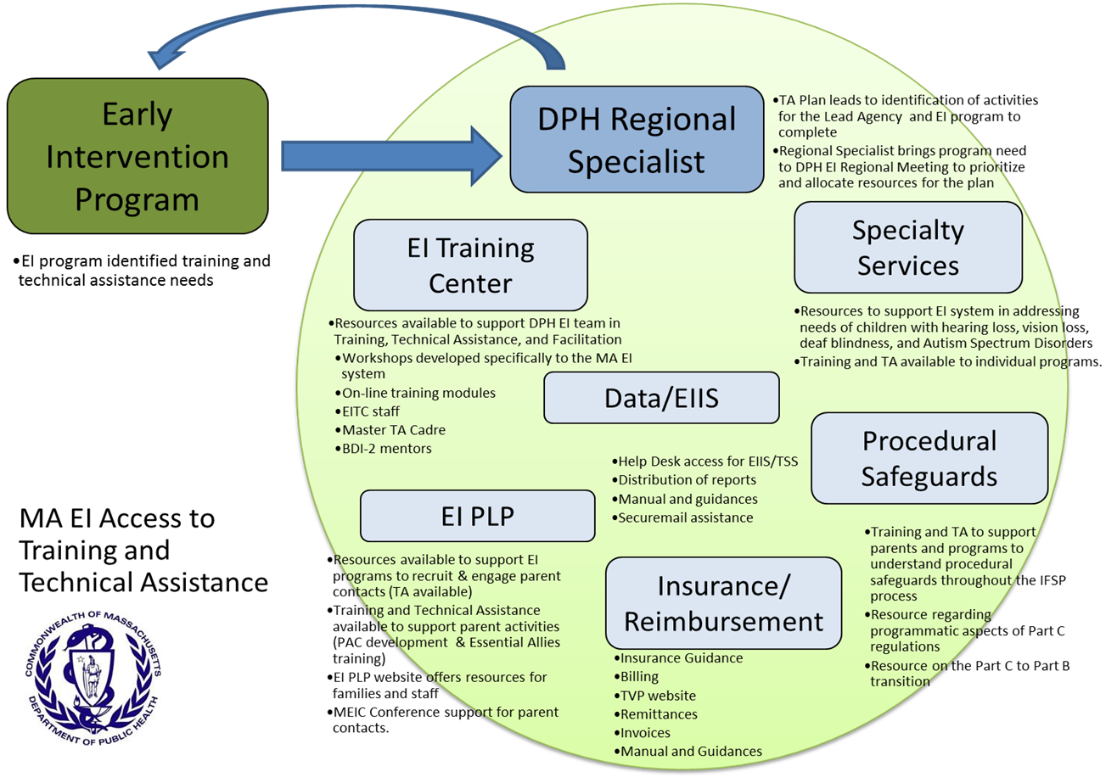

DPH Regional Team

DPH staff utilize a coordinated technical assistance model to improve outcomes for infants and toddlers. The goal of DPH technical assistance is to work collaboratively with providers to build clinical and administrative capacity at the program level to improve effectiveness in Early Intervention services and develop best practices for the MA EI system in a specific target area.

- Program and Regional Specialists discuss goals for technical assistance
- Development of an Action Plan for Program training on onsite technical assistance including:
  - Determination of current functioning
  - Identification of desired functioning
  - List of resources
  - Content-based training identified for participants
  - Identification of key coaches and mentors to come to program from resource pool
  - Identification of program participants and program resources
  - Determination of meeting schedule
- Determine evaluation and measurement

Benefits of the model to improve DPH-provided technical assistance include:

- Create opportunities to work collaboratively with programs
- Pool resources between DPH and vendor agencies to increase capacity at the program level
- Engage in professional development that is initiated by programs
- Create opportunities to learn from each other
- Provide more individualized training and support

Technical assistance priorities often fall into six overarching categories:

- Early Intervention Training Center
- Specialty Services
- Procedural Safeguards
- Insurance and reimbursement
- Early Intervention Parent Leadership Project
- Early Intervention Information System/ Data

Early Intervention Training Center (EITC)

The Early Intervention Training Center provides technical assistance on all clinical, administrative, and procedural EI-related topics. EITC makes resources available to support DPH’s EI Team in training, technical assistance, and facilitation. Its workshops are designed specifically for the Massachusetts EI system so that the curricula can be easily translated into practice. For example, BDI-2 mentors are available to assist EI programs in the proper use and interpretation of the tool. As well, online training modules allow users to access training and technical assistance remotely and at their convenience. Finally, DPH is developing a Master TA Cadre which will be a new resource to the EI Training Center in FY16. The Master TA Cadre will be a group of selected consultants that are intensively trained to provide onsite training, coaching, and mentoring on specified topics to be selected by DPH.

Other DPH EI Resources

Specialty services and resources are available to support the Massachusetts Early Intervention system. Specifically, supports have been developed to assist programs in addressing the needs of children with hearing loss, vision loss, deaf blindness, and Autism Spectrum Disorder. Training and technical assistance are available to individual programs, as necessary.

The Lead Agency has also developed technical assistance and training which assists programs and parents in understanding procedural safeguards throughout the IFSP process. Supports include resources regarding programmatic aspects of Part C regulations, as well as technical assistance in EI programs’ facilitation of the Part C to Part B transition.

Technical assistance related to working with insurance payors and securing third party reimbursement has been developed. EI programs may receive guidance on billing procedures, the creation of remittances and invoices, and use of the EI Transaction Validation Program (TVP) website which provides reports and validations for claims and service delivery records submitted to DPH. DPH has developed manuals and other written guidance on these and other procedures.

The Early Intervention Parent Leadership Project at DPH recruits, supports, and provides training for families to be meaningfully engaged at all levels. Resources are available to support EI programs in recruiting and engaging parent contacts, as well as supporting parent activities (e.g. PAC development, Essential Allies training). The Early Intervention Parent Leadership Project has a website that offers further resources for both family and staff.

Accountability/Monitoring

The purpose of the Massachusetts Monitoring Process is to:

- Monitor and evaluate program compliance with federal Part C IDEA regulations
- Monitor program compliance with DPH Early Intervention Operational Standards to ensure that eligible children and families receive timely, comprehensive, community-based services that enhance the developmental progress of children birth to three
- Monitor and evaluate contract activities with both vendor agencies and individual EI programs
- Monitor ongoing quality improvement of programs and vendors to assure a baseline of quality services that reflect evidence based practice for all families participating in the Massachusetts Early Intervention system

There are five components of the Massachusetts Monitoring System: 1) Annual Report/Self-Assessment; 2) Onsite Monitoring Visit; 3) Data Verification Process; 4) Dispute Resolution System; and 5) Local Determinations.

EIPs are required to complete the Annual Report/Self-Assessment every year, which provides key data for federal and state reporting requirements. The information requested annually is based on the federal indicators that have been selected as target areas of the State Performance Plan, as well as information on program practice regarding specific areas of interest to DPH, for example, program’s use of practices to support social-emotional development. The information obtained from the Annual Report/Self-Assessment is used to report on Indicators of the SPP/APR, in making Local Program Determinations and in identifying areas in need of technical assistance that can be provided by Regional Specialists and DPH staff.

Onsite Monitoring Visits are conducted annually by Lead Agency staff to ensure adherence to compliance and quality standards through systemic technical assistance processes. During onsite monitoring visits agency and program practices, policies and internal/external collaborations are analyzed for quality evidence-based practices in working with children and families. In addition to comprehensive onsite monitoring, focused monitoring protocols are in place to provide quality assurance to programs that have reported or have been identified as needing specific technical assistance. These processes will identify both best practice as well as areas in need of further technical assistance within individual programs.

Throughout the year, additional activities are completed by DPH staff to verify the reliability, accuracy, and timeliness of data reported by providers. Several methods for data verification are utilized, such as EIIS error reports, Service Delivery Report, verification of selected indicators during onsite monitoring, and data reports summarizing contract performance.

In terms of the Dispute Resolution System, written complaints are investigated to determine whether there are any findings of non-compliance with IDEA. The Director of the Office of Family Rights and Due Process also provides technical assistance and support to both families and providers when questions related to day to day practice are brought forward. The Director also promotes the collaborative relationship between families and providers when providing all forms of technical assistance that tie into the Massachusetts Mission and Key Principles.

DPH, as the lead agency for Early Intervention in Massachusetts, sends a written response to the family, the program, and the DPH Regional Specialist within 60 days. If an area of non-compliance is identified, a corrective action plan is requested by the Regional Specialist to the program in question. Programs have one year to come into compliance.

In making annual Local Program Determinations, DPH uses the four compliance indicators, six measures for Timely and Accurate Data, and two for Dispute Resolution issues. The program is notified in June of each year of their status. This information is also publicly reported on the DPH website.

2(c) Systems Strengths and Areas for Improvement

System Strengths

The Department's new communication protocol includes a monthly EI Newsletter to improve the flow of information to providers regarding upcoming initiatives, events, data requests, etc. The intent is to streamline information being sent to providers and offer opportunity for input on upcoming initiatives, respond to provider questions, offer technical assistance, and facilitate collaboration across programs, agencies, and stakeholders. The communication protocol also includes a monthly webinar to share information about upcoming initiatives, requirements, resources, etc. As mentioned in section 2(b), Massachusetts uses multiple advisory bodies to facilitate communication, coordination, and collaboration between the state, EI providers, families, and other relevant stakeholders. These advisory bodies include:

- Interagency Coordinating Council (ICC)
- Early Childhood Outcomes Stakeholders (ECO)
- Higher Education Task Group
- Early Childhood Personnel Center Stakeholders/ Task Group

In addition to these advisory bodies, there are numerous working groups and task forces that have been assembled to address the implementation of specific initiatives. For example, an ICC subgroup is currently working to revise the current universal IFSP to reflect federal and state requirements, child & family outcomes, and current practices. The ICC Program Planning committee has been focusing on the following objectives:

- Provide materials to EI community on best practices in infant mental health, reflective practice, & maternal depression.
- Provide ongoing guidance/resources to the field on embedding the core message of relationship-based practice.
- Support the DPHs implementation of the universal social-emotional approach.
- Work collaboratively with the EITC to support the use of the Supervisor Training Model to address key components of recognizing the interrelatedness of family-centered care, routines based practice, family and child outcomes and home visiting.
- Track and monitor the impact of training on practice.
- Review data regarding children who are being served in EI. Consider the best ways to address the needs of the children and families currently in the system.

Also, Massachusetts is currently engaged in strategic planning with ECPC to ensure that the CSPD reflects national standards and the effectiveness of ongoing professional development. Additional work groups and their associated tasks are detailed in section 2(d).

One of the key findings resulting from the SWOT analysis was that Massachusetts’s capacity for Early Intervention program enrollment is capable of fully meeting demand. Because Massachusetts laws mandate that all Massachusetts third party insurers cover the cost of EI services as part of their basic benefits package, Early Intervention programs are able to adequately provide services with reduced financial constraints as compared to many other states. Stakeholders did not identify program capacity as a threat or a weakness of the Massachusetts system. However, stakeholders did acknowledge that the EI reimbursement rate limits the extent to which providers may add additional services, particularly if those services are non-reimbursable.

Collaborative relationships with other state agencies is a strength for EI. The Massachusetts Early Intervention system has numerous initiatives which require collaboration both within the Department of Public Health and with other state agencies, and community-based programs. This high level of existing collaboration will help to set the standard by which many of the selected improvement strategies must meet, in terms of collaboration across entities.

In addition, Massachusetts’s professional development infrastructure provides a strong foundation from which many improvement strategies may be based. For example, the BDI-2 Fidelity training offers Massachusetts a means to create more consistency in the practice and interpretation of its assessments. This provides the potential, not only to improve data quality, but to improve program practice, as well. Other improvement strategies may be related to staff knowledge regarding social-emotional outcomes, identification of “typical” and “non-typical” behavior, how to navigate cultural variances, and evidence-based best practices.

The Early Intervention Parent Leadership Project at the Department of Public Health recruits, supports and provides training for families to be meaningfully engaged at all levels. One strategy used is to build strong working relationships with EI families and encourage them to be involved in many stakeholder groups, advisory groups and committees throughout the early intervention system. In fact, as one example during the re-procurement of Early Intervention programs in the state, each RFR review team included at least one parent representative. Massachusetts will continue to build upon the strong working relationship with parents to increase the frequency of parent engagement in EI services and improve the quality of those interactions by drawing upon these parental perspectives.

The Department of Public Health maintains a strong working relationship with the Department of Early Education & Care, Massachusetts’s Part B lead agency. The Department of Public Health and the Department of Early Education & Care created a document for early childhood educators and Early Intervention specialists to support children in being fully active participants in all environments with the various important adults in their lives. The document, entitled the Valuable Collaboration Document, identifies relevant providers and community supports to include in services. In addition, multiple Part C lead agency staff participated in the Part B SSIP as key stakeholders, and the Part C SSIP process included representatives from the Department of Early Education & Care.

Areas of Weakness

Massachusetts faces difficulties in the standardization and implementation of evidence-based practices across its programs due to its extensive eligibility and broad reach across the state population. With 60 programs which often serve multiple communities, the Lead Agency has identified a large degree of variation in Early Intervention services across programs. This is often a result of differing demographics and geographies related to the population served and the desire to orient programs around local needs. Massachusetts believes that this lack of centralization has offered a unique opportunity to analyze the differences between programs with varying social-emotional outcomes. Many stakeholders voice that the program could benefit from increased use of evidence-based practices across the system. Massachusetts, therefore, plans to improve rollout of those practices across its programs to improve positive social-emotional skills outcomes. Many of the selected improvement strategies stem from the onsite visits that took place as part of the state’s efforts in identifying root causes for poor social-emotional outcomes.

The Early Intervention Information System (EIIS) has been identified as both a current strength and opportunity for improvement of the Massachusetts system. It is used by DPH, program staff, evaluators, and payors to capture registration, evaluation, IFSP, service, transition, and discharge data. Massachusetts is committed to providing the resources needed to improve the EIIS system by moving it from a stand-alone application to a web-based system with the opportunity to more accurately collect data and reduce staff time spent on data entry. DPH is currently working to redesign the EIIS and implement a web-based platform that will incorporate user feedback and streamline processes. Within 1.5 to 2 years, Massachusetts should be able to migrate its operations to the new system. The DaSy framework for IDEA Data Systems will be used as an evaluation tool to ensure that governance, stakeholder engagement, system design, data accuracy, and sustainability are addressed appropriately. EI providers will be contributors in providing the state with input and feedback regarding this new system. In addition, parents will be able to view certain parts of their child’s record online along with their child’s progress category.

Massachusetts DPH and Early Intervention stakeholders have based many of its selected improvement strategies on this combination of state and local strengths and opportunities for improvement. It is probable that by building upon the existing state infrastructure, Massachusetts will be able to demonstrate an increase in its SIMR and provide higher quality Early Intervention services to children and families.

2(d) State-level Improvement Plans and Initiatives

Massachusetts is engaged in numerous initiatives, professional development and monitoring activities that can be leveraged to support the implementation of the SSIP. These initiatives provide an opportunity to foster consistency across programs regarding evaluation practices, enhance collaboration and partnership with families, expands evidence-based training and technical assistance opportunities, and ensures accurate data collection and management. The following initiatives are directly related to the improvement of service provision to improve social-emotional outcomes.

In analyzing the state-level improvement plans and initiatives, Massachusetts has grouped its work into the following categories to support the improvement of social-emotional outcomes:

- Current Initiatives
- Professional Development & Technical Assistance
- Accountability & Monitoring
- Data Systems and Framework
- Communication and Coordination (e.g. intra- and inter-agency, regional, and local)

Current Initiatives

The following programs and initiatives provide Massachusetts EI with a network of opportunities to engage EI providers, parents, and early childhood professionals from other health and education systems. These initiatives individually and collectively support a family centered philosophy of service and provide MA EI with a foundation of supports from which to draw.

Early Intervention Training Center

DPH and the Early Intervention Training Center (EITC) will continue to work collaboratively with the Connected Beginnings Training Institute (CBTI) to support staff in participating in the online module: “Using Social-Emotional Screening: Tools to Build Understanding of the Child and Foster a Connection with the Family”. The module is designed to fit into a continuum of professional development offered to early childhood providers using a Teach Coach Teach Model. CBTI, DPH, and the EITC will work together in identifying the appropriate staff to provide the coaching or mentoring component of the model.

Early Intervention Parenting Program

The Early Intervention Parenting Program (EIPP) is a subset program of the Massachusetts Early Intervention program. EIPP focuses on ensuring families screened positive for social isolation, depression, substance use or severe social stress will be linked with community resources and support groups.

Early Intervention Parent Leadership Project

Massachusetts Early Intervention will continue to enlist the support of the Early Intervention Parent Leadership Project (EIPLP) to promote parental response to NCSEAM Family Survey (EI’s methodology for collecting family outcome data) and various activities to support parent engagement and leadership opportunities, such as the distribution of the quarterly Parent Perspective Newsletter.

Regional Consultation Program

RCPs provide consultation to families and children and to programs in their communities where young children and families typically access services, and they assist Early Intervention programs to meet the complex medical needs of eligible children. They also support early education and care programs to build community capacity by expanding the skills and knowledge necessary to ensure the inclusion of young children with special health care needs with typically developing peers. In addition, each RCP will administer a Family Support Fund that will be available to eligible children and families to meet short-term needs such as respite, education, parent-to-parent connections, and social activities.

Program Planning – Social-Emotional Well-Being (ICC initiative)

The Department in collaboration with the Program Planning committee has rolled out the “Universal Approach to Addressing the Social-Emotional Needs of Children and Families enrolled in Massachusetts EI”. Program Planning will continue to work with DPH to ensure available training opportunities and resources are available to the field.

IFSP Task Group (ICC initiative)

In addition, the IFSP Task Group, a subset of the ICC, is currently charged with revising the current universal IFSP to reflect federal and state requirements, child and family outcomes, and current practice.

Maternal and Infant Mental Health

Strategies, approaches, and materials will be incorporated into all other DPH programs with a particular emphasis on including these elements in Early Intervention, MHVI, Welcome Family, EIPP, and FRESH Start (should the program be funded).

Massachusetts Home Visiting Initiative

The Massachusetts Home Visiting Initiative (MHVI) is the DPH-led effort funded through the Maternal, Infant, and Early Childhood Home Visiting (MIECHV) federal grant. MHVI implements home visiting program in 17 high risk communities by expanding the capacity and scope of evidence-based home visiting programs. Specifically, DPH provides extensive training on mental health and social connectedness and screening for depression, unhealthy use of substances, and domestic violence. Early Intervention has partnered with MHVI in the coordination of cross-training and referral sources to both programs.

Infant Safe Sleep Program

The Injury Prevention and Control Program will continue its work and will partner with Early Intervention on the Infant Safe Sleep Initiative to provide a consistent public health message on creating and supporting safe sleep environments for all infants. The program also provides strategies for parents to engage with their infants socially during awake times, and discourages co-sleeping as an engagement strategy. All 60 EIPs home visiting staff are receiving training on the DPH Safe Sleep policy and strategies to improve safety and prevention of infant fatalities.

Welcome Family

As part of MHVI, DPH has developed, implemented, and monitored Welcome Family pilots in Fall River, Boston, Lawrence, and Lowell. Welcome Family is a new program that provides a universal, one-time nurse visit to all moms with newborns in the specified community. The visit focuses on mother and baby’s physical and mental health needs. Discussion related to certified EI programs becoming Welcome Family programs are ongoing.

Early Childhood Statewide Systems: MECCS pilot

Massachusetts Early Childhood Comprehensive Systems (MECCS) works both within and outside the Department of Public Health to coordinate services for young children birth to five. Focus areas for MECCS include access to health insurance and medical homes, social-emotional development and mental health, early care and education, parenting education, and family support. MECCS will pilot an early Childhood Trauma Community Learning Collaborative in one of the high-needs MHVI communities. The learning collaborative model will be adopted from the National Child Traumatic Stress Network’s Learning Collaborative toolkit. Early childhood stakeholders will be engaged in the learning series to address obstacles to collaborative, trauma-informed practice and will develop an actionable plan for a seamless system of care for young children and families.

The Current Initiatives support service quality by emphasizing the critical nature of family engagement in service delivery. Each of these initiatives has at its core the role of the family and supports service provision by emphasizing the use of family support resources within the Massachusetts EI system as well as those available from other disciplines and systems.

Professional Development & Technical Assistance

A well-qualified and skilled workforce is central to the Massachusetts EI infrastructure and is necessary in order to ensure that there is capacity to initiate practices to improve social-emotional outcomes. The following resources are available to provide, in some cases, a framework for Massachusetts EI professional development, and in other cases expertise in specific areas that have the potential to positively impact the social-emotional development of EI-enrolled children.

Early Intervention Training Center

The EITC is implementing Training for Supervisors Series. The training opportunity consists of 4 monthly face-to-face sessions targeted for team leaders/supervisors who provide direct supervision to front line staff. The sessions focus on incorporating the key principles of Massachusetts EI into practice, utilizing reflective practice activities. Strategies are provided for embedding the global child and family outcomes into practice, and recognize the interrelatedness of family centered care, routines based practice, family and child outcomes and home visiting. As demonstrated during the local onsite data collection, staff with greater access to supervision appear to demonstrate more positive social-emotional skills outcomes.

Comprehensive System of Personnel Development (CSPD)

Massachusetts EI is working on a long range three to five year plan to review and revise the Massachusetts CSPD. The plan will develop a sustainable framework that builds and supports a qualified workforce using evidence-based standards of practice promoting community inclusion and life-long learning. The components of this framework are applicable across disciplines and encompass teaming/partnerships, ongoing self-reflection and meaningful supervision. In addition to better outcomes, these evidence-based standards are expected to increase uniformity in the provision of EI services across programs.

Certification for Early Intervention Directors (CEID) Process

DPH and relevant stakeholders have developed a process for EI program directors to become certified. The process requires the completion of two Entries documenting– Formal Knowledge Sources & Narratives and Work Samples. Individuals will be required to document competence in five topic areas: Part C systems, Program Administration, Personnel Management, Clinical Management, and Financial Management.

BDI-2 Fidelity

The Department is engaged in ongoing activities to support programs in the successful implementation of the BDI-2 evaluation tool and evaluation practices. BDI-2 audits and ongoing discussions with other states will provide data to inform the Department on areas of need with regard to fidelity of the administration, and interpretation of the tool. More consistent use and interpretation of the BDI-2 results will also improve data quality to allow for more comparable comparisons across EI programs.

Early Childhood Trauma Support

DPH is collaborating with the Institute for Health & Recovery to support the development of a trauma-informed approach and build capacity for trauma-informed care within Early Intervention programs. IHR will offer EI programs the skills and strategies’ to support children’s development of social-emotional competence and resiliency. The Department is supporting five EIPs this year in becoming a “trauma-informed organization”; through training and support for staff, and work on identifying a “Trauma Champion” within their organization.

Moving Beyond Depression

Moving Beyond Depression (MBD) provides 15 In-Home Cognitive Behavioral Therapy sessions, plus a one month booster session, to mothers with clinical depression, delivered by a masters-level clinical therapist. The MBD team is augmented by doctoral-level clinicians with experience in CBT and perinatal depression who serve as team leaders. MBD is uniquely and specifically adapted to meet the needs of pregnant women and mothers in home visiting programs, and addresses issues common to this population including trauma, relationship problems, and poverty. In MBD, therapists and home visitors work together to help mothers recover from maternal depression and optimally benefit from home visiting. As demonstrated in a clinical trial, MBD has been found to be highly effective in reducing depressive symptoms and their associated clinical complications. The Department of Public Health is working collaboratively with MBD to bring this model to EIPs. One EI program is piloting the project with the goal to expand to additional EIPs in the next year.

Early Childhood Personnel Center (ECPC)

Massachusetts is currently working with the ECPC on the development and implementation of an integrated and Comprehensive System of Personnel Development (CSPD) in Early Childhood. The goal of a Technical Assistance State Partnership is to build capacity to support the initial and continuing education of the early childhood workforce, with a particular emphasis on the role of program supervisors. The outcome will improve the overall quality of services offered to children and families by Early Intervention programs.

Mass FOCUS Academy

Mass FOCUS Academy (MFA) is a statewide professional development system designed to improve the outcomes for all students while increasing the retention of highly qualified personnel. The MFA includes cost-free, online, three credit graduate courses. In addition to MFA, DPH works closely with national technical assistance centers such as NERRC and ECTA to access and develop professional development resources related to social-emotional screening tools, relationship based practice and family engagement for use by EIPs. By leveraging the resources of professional development programs and initiatives available to Massachusetts EI, our system has the benefit of enhancing service provision and service quality. These resources have the potential to improve practices related to family engagement, assessment and evaluation, the IFSP process, service coordination and supervision. Each of these activities of service provision provides a base for the potential application of practices to effect positive changes in social-emotional development.

Accountability & Monitoring

The Massachusetts model of accountability and monitoring provides programs with a structure that assists them in recognizing and evaluating the quality of their service provision, data reporting, and self-evaluation systems.

Massachusetts Monitoring System

The Massachusetts monitoring system incorporates multiple approaches to monitoring of EI Programs and agency vendors to adequately provide technical assistance and support, and identify areas of commendable practices in administration of programs and service provision within programs.

Comprehensive Monitoring

This process looks at billing systems, data systems, administrative oversight of the programs and agency interaction with the programs. Individual programs chosen to receive an onsite visit must complete a self-assessment before the scheduled onsite visit to examine policies and procedures related to service provision, data management processes, and oversight of the program. Information from the self-assessment helps inform the DPH team in planning the onsite visit. DPH utilizes this process to gather additional information from local programs related to practices that impact child outcomes. Data gathered may include: record review, billing reviews, and policy reviews. Interviews are also held with staff, families, and administrative staff, including vendor agency staff.

Focused Monitoring

This process looks at the aspects of the program related to the indicator area for which the program was chosen for. Initial information gathering from appropriate sources (program and DPH) informs the onsite visit to focus on the specific reason the program was chosen. Programs are chosen based on priority areas of focus within DPH. These areas may change from year to year. Data related to the priority areas are used to choose which programs will participate in these visits. Visits include multiple days of data gathering by a DPH team including staff and family members with a variety of areas of expertise. Data gathered may include: record review, staff interviews, administration interviews, parent interviews, and policy reviews. Additionally, observations of activities related to the area chosen may be requested as part of the onsite visit. Agencies and programs are given verbal and written information regarding strengths of the program as well as concerns that may have arisen. If needed, programs may receive a Corrective Action Plan. Technical assistance is made available to programs when improvement activities are suggested.

Through this monitoring infrastructure, programs are provided with the resources needed to enhance their utilization of statewide and program data, and to build systems within their agencies to better track the parameters of service delivery. These processes support their development of improvement strategies to enhance data quality and accuracy, and to build systems to enhance the overall quality of services.

Data Systems and Frameworks

The Massachusetts Early Intervention Information system (EIIS) is the main data source for child outcome and provides the environment for the collection of additional questions for data collection in support of SIMR improvement efforts. As Massachusetts moves forward with replacing this system with a web-based system the DaSy Framework for IDEA Data Systems will be used to evaluate all aspects of this process and to identify potential areas to improve data quality and accuracy. The SASID project, which eventually will become part of the EIIS system, will provide educational outcome results of children through high school for identifying both the strengths and gaps in EI service provision and program practice.

Massachusetts Early Intervention Information System (EIIS)

The Early Intervention Information System (EIIS) is a client based data system that captures registration, evaluation, IFSP, service, transition and discharge data. The EIIS is utilized to capture entering and exiting data used for federal child outcomes reporting. DPH is currently working on the design and implementation of a web-based version of EIIS which is projected to take approximately 1.5 to 2 years to complete implementation. EI providers will be contributors in providing the state with input and feedback regarding this new system. The evaluation component will calculate which child outcome category the child is in for the second and subsequent evaluations so that clinicians and program directors have direct access to this information immediately. Additionally, parents will be able to view certain parts of their child record online along with their child’s progress category. Full implementation will result in increased commitment to more accurate data because outcome information will be available that is not currently available.

State-Assigned Student Identification (SASID) Project

The purpose of the Early Intervention/SASID project is to issue a state assigned student identifier (SASID) to children participating in Early Intervention programs with the long-term goal of tracking and evaluating educational and developmental outcomes for these children, improving delivery of services, and determining cost savings. This effort is one of many longitudinal projects that will create stronger programs for young children across the Commonwealth by identifying both the strengths and gaps in service provision. It is possible that Massachusetts Early Intervention may be able to secure additional funding to improve its program, if it is able to demonstrate a strong return on investment through the tracking of educational and developmental outcomes.

DaSY Framework for IDEA Data Systems

Massachusetts collaborated with six other states on the development of a framework for quality early childhood data systems for Part C and Section B 619 programs. The framework is currently being used as a national resource for states to evaluate and identify enhancements to their states data system. This framework will be used by Massachusetts as they move forward with updating EIIS to a web-based system.

Communication and Coordination (e.g. intra- and inter-agency, regional, and local)

All communication and coordination efforts by the Lead Agency will be used to provide information regarding SSIP efforts and activities. The general EI community will be kept aware of these initiatives through the Lead Agency’s various communication channels.

EI System Communication Protocol

The Department’s new communication protocol includes a monthly Newsletter to improve the flow of information to providers regarding upcoming initiatives, events, data requests, etc. The Intent is to streamline information being sent to providers and offer the opportunity for input on upcoming initiatives. The communication protocol also includes monthly webinars that provide information about upcoming initiatives, requirements, resources, etc.

ICC Meetings

The Massachusetts Interagency Coordinating Council (ICC) is a federally mandated statewide inter-agency group that advises and assists the Department of Public Health on Early Intervention. The ICC is comprised of parents, professionals and providers. Members of this dynamic group include representatives of state agencies (Department of Early Education and Care, Department of Elementary & Secondary Education, Department of Developmental Services, and others), higher education, one State legislator, one medical professional, EI providers, early childhood service providers, as well as parents. Staff from the Department of Public Health attend ICC Meetings on a regular basis. It is important that voices from all of these perspectives are shared and valued.

Early Education & Care
Our partnerships across agencies have afforded Massachusetts the opportunity to utilize the professional development and clinical expertise of colleagues across agencies to build strong early childhood resources for collaboration

Transition Forums

The Departments of Early Education and Care, Elementary and Secondary Education and Department of Public Health host regional forums for Public School districts and Early Intervention programs to discuss Regulations and to develop plans to support effective strategies around Transition.

Valuable Collaboration Document

The Department of Public Health and the Department of Early Education & Care created a document for early childhood educators and Early Intervention specialists to support children in being fully active participants in all environments with the various important adults in their lives. The document identifies relevant providers and community supports to include in services.

These two initiatives are examples of partnerships upon which Massachusetts can build to support children’s social-emotional development in natural environments. These initiatives build the capacity within early childhood environments to provide consistency and support for improved social-emotional outcomes and to support families in carrying over support strategies during their own family routines.

2(e) Representatives Involved

Representatives involved in the infrastructure analysis for Phase 1 of the SSIP were stakeholders across the Massachusetts EI system including Lead Agency Early Intervention staff, ICC membership, the EI Provider Community, and ECO Stakeholders. Massachusetts began gathering input regarding the SSIP process and how to best focus state efforts in October of 2013. Program directors recommended that the Lead Agency use the existing Early Childhood Outcomes (ECO) Stakeholders group to advise the state on the SSIP process, oversee SSIP activities and initiatives, and help to determine the state’s focus area. The ECO Stakeholders group was an existing group that was already involved in addressing issues related to child outcomes. Additional stakeholders were added to this group as necessary to reach a full spectrum of Massachusetts Early Intervention viewpoints. Representatives included the following:

Title/ Organization | Involved in Phase 1? | Phase II Role
619 Coordinator, Department of Elementary & Secondary Education | Yes | Provide Section 619 (preschool) perspective and feedback on implementation
Educator Provider Support Specialist, Department of Early Education & Care | Yes | Partner with DPH on collaborative strategies that address social-emotional wellbeing
Education Specialist, Department of Elementary & Secondary Education | Yes | Continue work on SASID Project and facilitate efficacy of EI and cost savings study
Director, Office of Family Initiatives (DPH) | Yes | Project manage parent and family engagement strategies
Assistant Director, Massachusetts Early Intervention (DPH) | Yes | Lead SSIP Phase II Process
Early Childhood Mental Health Specialist, Department of Public Health | Yes | Oversee implementation of mental health-focused initiatives (e.g. EIPP, Maternal & Infant Mental Health, Moving Beyond Depression)
EI Program Directors (five total) | Yes | Provide feedback on implementation efforts. Pilot strategies to prove efficacy (if applicable)
Director & Associate Director, Early Intervention Training Center (DPH) | Yes | Project manage training strategies
ICC Co-Chair | Yes | Represent ICC perspectives and manage ICC work groups' implementation of select strategies
Co-Directors, Massachusetts Home Visiting (DPH) | Yes | Facilitate EI referrals into Moving Beyond Depression and Welcome Family
Early Intervention Certificate Program Instructor, Northeastern University | Yes | Provide higher education perspective and feedback on implementation
Regional Specialist, Department of Public Health | Yes | Provide support to EIPs as necessary
Statewide Monitoring Coordinator (DPH) | Yes | Oversee implementation of statewide monitoring and technical assistance to improve data collection and SIMR outcomes
Project Staff, Early Intervention Parent Leadership Project | Yes | Facilitate and expand family engagement opportunities in Early Intervention

2(f) Stakeholder Involvement in Infrastructure Analysis

Stakeholders were critical to the infrastructure analysis and capacity assessment for the SSIP in Massachusetts. Findings in the initial SWOT analysis that was completed by the ECO Stakeholder group were shared with the Interagency Coordinated Council (ICC) and with local EI program directors. This SWOT analysis led the SSIP State Leadership Team to additional data drill down and influenced decisions to look at data collection and quality issues with regard to the BDI-2 and the cohort of children included in outcomes reporting in Massachusetts.

The ECO Stakeholder group determined the need to investigate individual program practices to further differentiate root causes to varied child outcomes. Findings were reviewed with relevant stakeholder groups and committees and used to inform the selection of improvement strategies.

Lead agency staff presented SSIP to the Massachusetts Early Intervention Consortium Board of Directors to obtain feedback and respond to questions regarding the process.

Comprehensive infrastructure analysis on the state wide EI system by the lead agency identified a number of initiatives and leverage points within Massachusetts to support positive social-emotional skills. This analysis was shared with the ECO Stakeholder group for review.

The full EI program director group actively participated in completing a SWOT analysis to determine the strengths, weaknesses, opportunities, and threats in the Massachusetts EI system to implement the identified practices.

Finally, many of the existing, state-level initiatives and improvement plans, which may be used to improve positive social-emotional outcomes, are being implemented in coordination with stakeholders in the Department of Public Health, other state agencies, various EI programs, and nonprofit entities. The full list of internal and external stakeholders involved in the infrastructure analysis is detailed below:

Representative/ Organization | Part C Stakeholder Group
Coordinator of Education of Homeless Children & Youth | Interagency Coordinating Council (ICC)
Commission for the Deaf and Hard of Hearing | Interagency Coordinating Council (ICC)
Commission for the Blind | Interagency Coordinating Council (ICC)
Department of Developmental Services | Interagency Coordinating Council (ICC)
Department of Early Education and Care | Interagency Coordinating Council (ICC)
Department of Children & Families | Interagency Coordinating Council (ICC)
Division of Medical Assistance | Interagency Coordinating Council (ICC)
Division of Insurance | Interagency Coordinating Council (ICC)
Department of Mental Health | Interagency Coordinating Council (ICC)
Massachusetts Developmental Disabilities Council | Interagency Coordinating Council (ICC)
Department of Elementary & Secondary Education | Interagency Coordinating Council (ICC)
Federation for Children with Special Needs | Interagency Coordinating Council (ICC)
United Way of Massachusetts Bay and Merrimack Valley | Interagency Coordinating Council (ICC)
Justice Resource Institute, Inc. | Interagency Coordinating Council (ICC)
Early Headstart Representative | Interagency Coordinating Council (ICC)
Institute of Health & Recovery (IHR) | Interagency Coordinating Council (ICC)
Regional Parent representatives | Interagency Coordinating Council (ICC)
Regional Provider representative | Interagency Coordinating Council (ICC)
Physician | Interagency Coordinating Council (ICC)
Legislator | Interagency Coordinating Council (ICC)
MEIC representative | Interagency Coordinating Council (ICC)
619 Coordinator, Department of Elementary & Secondary Education | Early Childhood Outcomes (ECO) Stakeholder group
Educator Provider Support Specialist, Department of Early Education & Care | Early Childhood Outcomes (ECO) Stakeholder group
Education Specialist, Department of Elementary & Secondary Education | Early Childhood Outcomes (ECO) Stakeholder group
Director, Office of Family Initiatives (DPH) | Early Childhood Outcomes (ECO) Stakeholder group
Assistant Director, Massachusetts Early Intervention (DPH) | Early Childhood Outcomes (ECO) Stakeholder group
Early Childhood Mental Health Specialist, Department of Public Health | Early Childhood Outcomes (ECO) Stakeholder group
EI Program Directors (five total) | Early Childhood Outcomes (ECO) Stakeholder group
Director & Associate Director, Early Intervention Training Center (DPH) | Early Childhood Outcomes (ECO) Stakeholder group
ICC Co-Chair | Early Childhood Outcomes (ECO) Stakeholder group
Co-Directors, Massachusetts Home Visiting (DPH) | Early Childhood Outcomes (ECO) Stakeholder group
Early Intervention Certificate Program Instructor, Northeastern University | Early Childhood Outcomes (ECO) Stakeholder group
Regional Specialist, Department of Public Health | Early Childhood Outcomes (ECO) Stakeholder group
Statewide Monitoring Coordinator (DPH) | Early Childhood Outcomes (ECO) Stakeholder group
Project Staff, Early Intervention Parent Leadership Project | Early Childhood Outcomes (ECO) Stakeholder group
Assistant Director, Massachusetts DPH, Division of EI | Massachusetts SSIP State Leadership Team
Data Manager, Massachusetts DPH, Division of EI | Massachusetts SSIP State Leadership Team
Director, DPH, EI Training Center | Massachusetts SSIP State Leadership Team
Associate Director, DPH, EI Training Center | Massachusetts SSIP State Leadership Team
EI Regional Specialist | Massachusetts SSIP State Leadership Team
Local EI Program Director | Massachusetts SSIP State Leadership Team
Statewide Monitoring Coordinator, Massachusetts DPH, Division of EI | Massachusetts SSIP State Leadership Team
Director, EI Parent Leadership Project, Massachusetts DPH | Massachusetts SSIP State Leadership Team
Early Intervention Program Directors | Early Intervention Provider Community

Component #3: SIMR

3(a) SIMR Statement

The Massachusetts Part C SIMR is the State’s Performance Plan, Indicator 3a, Summary Statement 1: the statewide percentage of children showing positive growth in social-emotional skills (including social relationships). It is Massachusetts’s intent that of those children who enter Early Intervention below age expectations in social-emotional skills, the percent who substantially increase their rate of growth by the time they exit the program will be increased as a result of state and local effort over the next five years.

The ECO Stakeholders group felt strongly in the selection of only Summary Statement 1 under social-emotional skills due to the fact that it was the only Summary Statement below the national average. Summary Statement 2 under social-emotional was approximately 10% above the national average. The state has a number of current initiatives addressing social-emotional issues and, so, this group, along with the State Team, unanimously agreed upon Summary Statement 1: social-emotional skills growth as the state’s SIMR.

Stakeholders provided feedback that they were concerned about targeting a specific population of families for intervention even if, eventually, the intervention would reach all families. Stakeholders felt strongly that if the state initiated practices at a state level to improve child outcome that all children would benefit and be impacted positively. They felt that Massachusetts had enough resources and current initiatives in place to handle the tasks and activities needed to implement improved social-emotional practices for all children. Therefore, the decision was made by the SSIP State Leadership Team and the ECO Stakeholders group that any initiative with a focus on improving social-emotional skills should be directed to all children in Massachusetts.

3(b) Data and Infrastructure Analyses Substantiating the SIMR

Massachusetts reviewed numerous datasets, at the national, state, and local program levels, in order to identify those child outcomes that were most in need of improvement. The SSIP State Leadership Team and stakeholders ruled out other potential foci (child find, parent engagement, early childhood trauma, etc.) due to data and infrastructure analysis findings that did not substantiate a coordinated statewide effort for improvement.

However, when reviewing its outcome data, Massachusetts noted that its social-emotional skills outcomes had decreased in each fiscal year from FY2012 to FY2014. The percent of children under social-emotional skills that make greater than expected growth is the only outcome area where Massachusetts performed lower than the national average. Fortunately, Massachusetts’s percentages were higher than the national percentages under all other outcome areas. This data analysis identified social-emotional outcomes as a key candidate for SIMR consideration.

During the infrastructure and capacity analysis, stakeholders noted that Massachusetts Early Intervention was supported by a robust fiscal system that provided Medicaid and third party reimbursement to programs for Early Intervention services. Consequently, the volume capacity of Massachusetts EI was not seen in great need of a focused SSIP effort. Rather, the quality of EI services and their resultant impact on child outcomes appeared to be most appropriate for SSIP focus.

Given its expansive coverage and broad service population, Massachusetts EI programs are each unique in their practices. The onsite data collection process narrowed effective practices to five of the DEC Recommended Practices that can be implemented at local programs to achieve better social-emotional outcomes.

- Practitioners work as a team with the family and other professionals to gather assessment information.
- Practitioners obtain information about the child’s skills and daily activities, routines and environments such as home, center and community.
- Practitioners and the family work together to create outcomes, develop individualized plans, and implement practices that address the family’s priorities and concerns and the child’s strengths and needs.
- Practitioners support family functioning, promote family confidence and competence, and strengthen family-child relationships by acting in ways that recognize and build on family strengths and capacities
- Practitioners representing multiple disciplines and families work together as a team to plan and implement supports and services to meet the unique needs of each child and family

Along with these practices, the lead agency will focus on strategies in four main strands of improvement:

- Practice Quality & Consistency
- Collaboration
- Professional Development
- Data Quality

These practices may be implemented across all programs in Massachusetts to improve child level outcomes. As mentioned in Section 2(d), DPH and stakeholders were able to identify many existing initiatives and efforts (in addition to those identified by the programs who participated in the onsite data collection process) that may positively impact social-emotional skills development:

- Early Intervention Training Center
- Early Intervention Parenting Program
- Early Intervention Parent Leadership Project
- Regional Consultation Program
- Program Planning – Social-Emotional Well-Being
- IFSP Task Group
- Maternal and Infant Mental Health
- Massachusetts Home Visiting Initiative
- SIDS Program
- Welcome Family
- Early Childhood Statewide Systems: MECCS pilot

By learning from and building upon these initiatives, Massachusetts will be capable of creating impactful strategies and changes to child outcomes around social-emotional skills.

3(c) SIMR as Child-Family Level Outcome

The Massachusetts SIMR is a child-level outcome as it measures each individual child’s growth in social-emotional skills from program entry to program exit. An improvement in the SIMR will demonstrate a higher percentage of children that have entered Massachusetts Early Intervention programs below age expectations in social relationships who then exit with substantially improved positive social-emotional skills growth rates.

Positive social-emotional skills are critical to a child’s learning as it relates to positive interaction with others, the ability to follow directions, participate in dialogue, persist on tasks, and correctly interpret others’ behavior and emotions. By improving child outcomes in social-emotional skills, Massachusetts will facilitate further learning for Early Intervention children and assist in establishing positive child-family interactions. Furthermore, an improvement in the SIMR will not be restricted to a subset of the state population. Rather, coordinated state efforts to improve the SIMR will positively impact children, families, and programs regardless of age, region, or developmental delay.

Although the SIMR is not a process outcome, it may be supported by process alterations that facilitate children’s learning and development. Such process alterations are discussed in further detail in section 4(c).

3(d) Stakeholder Involvement in Selecting the SIMR

Massachusetts stakeholders have been involved throughout the SSIP process, and their input and guidance has been critical to the selection of Summary Statement 1: Positive social-emotional skills (including social relationships) as the SIMR. Stakeholders identified potential focal areas for data analysis and, brainstormed potential root causes for data outcomes.

Stakeholders first agreed on the direction of pursuing a SIMR related to social-emotional outcomes in March 2014, as mentioned previously in Sections 1(a) and 1(f). Over the following months, stakeholders reviewed datasets, disaggregated data, performed infrastructure analysis, drafted the Theory of Action, and formally approved Summary Statement 1: Social Relationships as the SIMR on March 5, 2015. Approval of the SIMR was unanimous.

Stakeholder representation included the following:

Representative/ Organization | Part C Stakeholder Group
Coordinator of Education of Homeless Children & Youth | Interagency Coordinating Council (ICC)
Commission for the Deaf and Hard of Hearing | Interagency Coordinating Council (ICC)
Commission for the Blind | Interagency Coordinating Council (ICC)
Department of Developmental Services | Interagency Coordinating Council (ICC)
Department of Early Education and Care | Interagency Coordinating Council (ICC)
Department of Children & Families | Interagency Coordinating Council (ICC)
Division of Medical Assistance | Interagency Coordinating Council (ICC)
Division of Insurance | Interagency Coordinating Council (ICC)
Department of Mental Health | Interagency Coordinating Council (ICC)
Massachusetts Developmental Disabilities Council | Interagency Coordinating Council (ICC)
Department of Elementary & Secondary Education | Interagency Coordinating Council (ICC)
Federation for Children with Special Needs | Interagency Coordinating Council (ICC)
United Way of Massachusetts Bay and Merrimack Valley | Interagency Coordinating Council (ICC)
Justice Resource Institute, Inc. | Interagency Coordinating Council (ICC)
Early Headstart Representative | Interagency Coordinating Council (ICC)
Institute of Health & Recovery (IHR) | Interagency Coordinating Council (ICC)
Regional Parent representatives | Interagency Coordinating Council (ICC)
Regional Provider representative | Interagency Coordinating Council (ICC)
Physician | Interagency Coordinating Council (ICC)
Legislator | Interagency Coordinating Council (ICC)
MEIC representative | Interagency Coordinating Council (ICC)
619 Coordinator, Department of Elementary & Secondary Education | Early Childhood Outcomes (ECO) Stakeholder group
Educator Provider Support Specialist, Department of Early Education & Care | Early Childhood Outcomes (ECO) Stakeholder group
Education Specialist, Department of Elementary & Secondary Education | Early Childhood Outcomes (ECO) Stakeholder group
Director, Office of Family Initiatives (DPH) | Early Childhood Outcomes (ECO) Stakeholder group
Assistant Director, Massachusetts Early Intervention (DPH) | Early Childhood Outcomes (ECO) Stakeholder group
Early Childhood Mental Health Specialist, Department of Public Health | Early Childhood Outcomes (ECO) Stakeholder group
EI Program Directors (five total) | Early Childhood Outcomes (ECO) Stakeholder group
Director & Associate Director, Early Intervention Training Center (DPH) | Early Childhood Outcomes (ECO) Stakeholder group
ICC Co-Chair | Early Childhood Outcomes (ECO) Stakeholder group
Co-Directors, Massachusetts Home Visiting (DPH) | Early Childhood Outcomes (ECO) Stakeholder group
Early Intervention Certificate Program Instructor, Northeastern University | Early Childhood Outcomes (ECO) Stakeholder group
Regional Specialist, Department of Public Health | Early Childhood Outcomes (ECO) Stakeholder group
Statewide Monitoring Coordinator (DPH) | Early Childhood Outcomes (ECO) Stakeholder group
Project Staff, Early Intervention Parent Leadership Project | Early Childhood Outcomes (ECO) Stakeholder group
Assistant Director, Massachusetts DPH, Division of EI | Massachusetts SSIP State Leadership Team
Data Manager, Massachusetts DPH, Division of EI | Massachusetts SSIP State Leadership Team
Director, DPH, EI Training Center | Massachusetts SSIP State Leadership Team
Associate Director, DPH, EI Training Center | Massachusetts SSIP State Leadership Team
EI Regional Specialist | Massachusetts SSIP State Leadership Team
Local EI Program Director | Massachusetts SSIP State Leadership Team
Statewide Monitoring Coordinator, Massachusetts DPH, Division of EI | Massachusetts SSIP State Leadership Team
Director, EI Parent Leadership Project, Massachusetts DPH | Massachusetts SSIP State Leadership Team
Early Intervention Program Directors | Early Intervention Provider Community

Massachusetts Part C/ Early Intervention will continue to work with these established groups of committed stakeholders in Phase II and Phase III of the SSIP. The state has developed a strong working relationship with these groups who will continue to play a critical role in the ongoing work of the SSIP.

3(e) Baseline Data and Targets

FFY13 established the baseline performance for Summary Statement 1: Social Relationships at 56.67%. The SSIP State Leadership Team and stakeholders agreed that a substantial increase in the SIMR would be unlikely until FFY16, as state strategies and data quality initiatives will require a startup period for implementation and adoption at programs. Based upon the data and infrastructure analysis, stakeholders and the Lead Agency staff agreed to align the targets with the agreed-upon federal child outcome reporting targets. Baseline data and ensuing targets are depicted in the table below:

 | FFY13 | FFY14 | FFY15 | FFY16 | FFY17 | FFY18
SIMR | 56.67% | 56.70% | 56.70% | 56.70% | 56.80% | 56.90%

Through a combination of the improvement strategies and consistent data collection and increased data quality, the SIMR will demonstrate a .20% statewide increase from its baseline in FFY 2013 to FFY 2018. An estimated 6,700 children in FFY 2018 will experience substantial growth in their social-emotional skills prior to exiting EI services.

The baseline and targets for the Massachusetts SIMR were established in collaboration with stakeholders at the March 5, 2015 ECO Stakeholders meeting. Stakeholders were informed of the change to align the baseline and targets with the states federal child outcome reporting targets and were in agreement based on the fact that the same cohort of children and data point will be utilized for both measurements of progress.

Component #4: Selection of Coherent Improvement Strategies

4(a) How Improvement Strategies Were Selected

Much of the data and infrastructure analysis that led to the selection of positive social-emotional skills as the Massachusetts’s SIMR, also directed the SSIP State Leadership Team to its selected improvement strategies. Stakeholder input supported the strategies selected and informed the SSIP State Leadership Team of realistic strategies for the Massachusetts EI system. The DEC Recommended Practices were narrowed through the onsite data collection process using the DAC implementation rubric. Practices were reviewed based on the data collected at the three local programs visited and the level of implementation was determined at the following programs:

- Program with low Summary Statement 1 over two consecutive fiscal years (FY2013, FY 2014)
- Program with high Summary Statement 1 in FY2013 and low Summary Statement 1 in FY2014
- Program with high Summary Statement 1 over two consecutive fiscal years (FY2013, FY 2014)

Practices identified to address the SIMR were deemed fully implemented at the high performing program. These practices were:

- Practitioners work as a team with the family and other professionals to gather assessment information.
- Practitioners obtain information about the child’s skills and daily activities, routines and environments, such as home, center and community.
- Practitioners and the family work together to create outcomes, develop individualized plans, and implement practices that address the family’s priorities and concerns and the child’s strengths and needs.
- Practitioners support family functioning, promote family confidence and competence, and strengthen family-child relationships by acting in ways that recognize and build on family strengths and capacities.
- Practitioners representing multiple disciplines and families work together as a team to plan and implement supports and services to meet the unique needs of each child and family.

Massachusetts grouped program strategies into four higher-level “Strands of Action”:

- Practice Quality & Consistency
- Collaboration
- Professional Development
- Data Quality

In March 2015, the SSIP state leadership team reviewed selected strategies to address root causes and positively impact social-emotional skills to finalize the Massachusetts Theory of Action. The lead agency also reviewed the strategies selected with the broad EI provider community and completed a SWOT analysis on the recommended practices to ensure the EI system has the capacity to implement.

Practice Quality & Consistency includes strategies that are designed to improve the quality and methodology of service delivery. By adopting these strategies consistently across Massachusetts Early Intervention programs, it is expected that children and families will experience higher quality EI services, resulting in improved outcomes, particularly around positive social-emotional skills. The following strategies are included in the Practice Quality & Consistency Strand of Action:

- Encourage consistency across programs through implementation of evidence-based best practices – Best practices include the selected recommended practices and strategies to review and revise the Comprehensive System of Personnel Development (CSPD) using evidence based standards of practice.
- Prioritize standardized evaluation and functional assessment procedures – Use of BDI-2 fidelity checklist and results of the UMASS Boston BDI-2 fidelity study to inform ongoing professional development activities and inclusion of nationally developed curriculum in EITC trainings to support comprehensive assessment practices.
- Develop culturally appropriate practices – EITC trainings focus on reflective practices that support EI services that are respectful towards the individual needs of children and families.
- Build system capacity to support the infant/toddler and parent/caregiver relationship – The lead agency will establish consistent definitions of parent engagement and EITC activities include focus on the partnership between EI staff and parents and caregivers.

The Collaboration Strand of Action largely consists of program approaches revealed during the local onsite data collection process. Family engagement and IFSP outcomes development are key foci of the Collaboration strategies:

- Define family engagement consistently across the system – Massachusetts Early Intervention programs report varying frequencies of parent interaction, and NCSEAM Family Survey results are inconsistent in family satisfaction (percent of families who report that EI services have helped their family). Massachusetts will establish clear guidelines and expectations for family engagement so that programs are consistent in family engagement activities while still allowing for the individualization of services.
- Improve development of outcomes on the IFSP that address family’s priorities and concerns and their child’s strengths and needs – Provide consistent professional development for IFSP development by the IFSP team that prioritizes the development of activity and participation based IFSP outcomes.
- Include participation and activity-based outcomes as part of the IFSP – Focusing on participation-based outcomes will improve the SIMR, as key social skills associated with learning in group settings are based upon a child’s ability to communicate with others, understand others, and regulate his/her emotions.
- Include EI teams that have a full range of disciplines to support the needs of infants and toddlers and their families – Identifying consistent supervision practices that support reflection and collaboration within the EI and IFSP team.
- Clearly defines the IFSP teams – In keeping with the importance of family engagement and its effects on a child’s development, this strategy is meant to facilitate how best to enhance parent engagement, so that EI supports and services align with families’ individualized priorities and build upon their strengths.

The Professional Development Strand of Action builds upon the existing state infrastructure of the Early Intervention Training Center. By expanding upon the training opportunities available to programs, DPH can ensure that EI specialists are receiving consistent information and support for skill building. This will be particularly important for those areas in which program practice is varied and not necessarily based on research.

- Expand training and TA to improve the fidelity of administration of the BDI-2 and the use of informed clinical opinion in the evaluation and assessment process – Discussions with stakeholders have identified varying interpretations of ‘typical’ and ‘atypical’ behavior. Expanding training around the BDI-2 will help to ensure that it is administered and interpreted consistently across Early Intervention programs.
- Develop training and TA to support evidence-based strategies to improve engagement and support collaboration within the IFSP team – Trainings to improve family engagement and partnership are expected to increase family involvement during service provision.
- Support supervisors in developing reflective practice strategies – local onsite data collection identified a correlation between increased frequency of supervision and positive social-emotional skills. By expanding training for supervisors, Massachusetts expects that supervisors will be better able to develop positive and supportive relationships with staff that will have an impact on family engagement.
- Establish training on development of the IFSP process with a focus on high-quality outcomes – The IFSP Task Group is currently revising IFSP practice guidance to reflect federal and state requirements, child and family outcomes, and best practice. The resultant IFSP development will focus on engaging in an equal partnership with the family to address all outcomes. EITC will support this effort with training that will result in increased levels of knowledge on social-emotional development among staff.

The Data Quality Strand of Action intends to improve data management efforts to more accurately capture child/family conditions and outcomes. Massachusetts has identified social-emotional skills development as its SIMR, however there are concerns that data quality may be impacting Massachusetts’s performance in this area. The following strategies were selected to improve data quality in Massachusetts:

- Expand training and TA to improve the fidelity of administration of the BDI-2 and the use of informed clinical opinion in the evaluation and assessment process to ensure accurate data collection – Stakeholders have voiced concerns that there is inconsistent interpretation of ‘typical’ vs. ‘atypical’ behavior, particularly during initial assessments. In order for program-level data to be consistent across programs, EIP staff must have an accurate understanding of these behaviors and record such behaviors accordingly. EITC trainings will review and reinforce these concepts.
- Monitor the impact of timing administration of assessment tools -- The timing of exit assessments is variable for children.
- Develop process protocols for data management – By establishing data quality controls and protocols at the local programs, the quality of data submitted to EIIS is expected to improve.

4(b) How Improvement Strategies are Sound, Logical, and Aligned

The improvement strategies identified are based on a thorough review of state systems and infrastructures affecting how children and families are served through Early Intervention and how those interactions are measured. Each Strand of Action is intended to advance separate aspects of EI services.

Practice Quality & Consistency strategies focus on those service strategies that are proven to produce the best possible child and family outcomes. Existing Massachusetts Early Intervention practices have a large range of variability between programs. The use of consistent best practices is intended not only to improve services, but also to create more comparable data while still maintaining a high degree of individualization of services. Massachusetts will draw upon existing initiatives and develop new trainings in order to incorporate evidence-based best practices into EIP practices. The lead agency has the professional development infrastructure through the EITC to embed national curricula into training opportunities that focus on practice quality and consistency. The monitoring system in Massachusetts has protocols in place to identify strengths and challenges with local programs and each local program has a regional specialist from the lead agency to develop technical assistance plans. Infrastructure analysis yielded strengths in the system around this strand of improvement.

Collaboration strategies are aimed at heightening Early Intervention programs’ inclusion of families as partners during service provision. In addition, these strategies intend to promote wider degrees of interaction between EI Specialists and other adults, providers, and professionals that are relevant to a child’s growth and development. These strategies build upon the state’s existing collaborative infrastructure with the Department of Early Education & Care, Department of Elementary & Secondary Education, primary care providers and other medical personnel, as well as public school representatives. The Individualized Family Service Plan (IFSP) is the basis to EITC trainings where the focus is on the process that occurs between parents, caregivers, EI service coordinator and EI team. The Massachusetts state system for Early Childhood has solid relationships and tools to increase collaboration to address individualized outcomes for children and families. The Valuable Collaboration document focuses on the provision on EI services in child care and is a tool to support on-going collaboration between EI specialists, child care providers and the parents. Cross system forums allow space for the development of transition practices for children exiting the EI system to other service models.

Professional Development strategies build upon the existing infrastructure to develop new staff competencies and best practices. The Early Intervention Training Center will be integral in the development and delivery of these trainings, however additional resources and experts will be brought in as necessary. The Professional Development strategies should result in an Early Intervention workforce that is more knowledgeable, particularly around social-emotional development, having access to a wide array of trainings. The resultant outcome of more knowledgeable staff should be higher quality relationships and services provided to children and families. The EITC uses multiple modalities for building knowledge and skill, including online modules, regional workshops, mentoring on specific topics, and targeted technical assistance at local programs.

Data Quality strategies are aimed to more accurately capture the existing status of children and families at the time of program entry, their progression and development over time, and their standing at the time of program exit. More accurate measures will allow Massachusetts to conduct further data analyses to inform its best practices and conduct continuous quality improvement efforts. BDI-2 data audits, evaluation of the fidelity of administration, and the use of electronic forms will improve accuracy of data in EIIS for child outcomes measurement. Determining consistent practices for data collection and entry at the local program level will allow the lead agency to make comparisons across programs to continue to identify root causes of underperformance and challenges.

4(c) Strategies that Address Root Causes and Build Capacity

As mentioned in Section 4(a), strategies were selected, with stakeholder input, based upon their ability to address root causes and enhance Massachusetts’s capacity to provide higher-quality Early Intervention services to children and families. In accordance with implementation science, Massachusetts utilized the data and infrastructure analysis to identify effective evidence-based practices to implement in Phase 2 of the SSIP. Massachusetts will continue to monitor ongoing professional development to ensure implementation of practices/strategies that have an impact on positive social-emotional outcomes. The following grid identifies the root causes and expected outcomes for each strategy:

Root Cause(s) Being Addressed | Strategy | Expected Outcome(s)
Inconsistent program practice in evaluation/ assessments and development of IFSPs | Encourages consistency across programs through implementation of evidence-based best practices | 1) Programs will implement evidence-based best practices for producing positive child development outcomes  2) Programs will maintain fidelity of administration of the BDI-2 for determining eligibility
Inconsistent assessment practices during initial and on-going eligibility evaluation | Prioritizes standardized evaluation and functional assessment procedures | Staff will complete a functional assessment for each child and family to learn about daily activities, routines, and environments
Incomplete guidance around culturally appropriate practices for certain demographics | Develops culturally appropriate practices | EI staff will use culturally appropriate practices
Underperformance in social-emotional development for children with multiple eligibility criteria (2+ est. delays, etc.) | Builds system capacity to support the infant/ toddler and parent/ caregiver relationship | Programs will have the capacity to support families with compounding eligibility criteria
Inconsistent family involvement in Early Intervention services and definitions for family engagement across the EI system. | Defines family engagement consistently across the system | The IFSP team will work together to develop individualized strategies that support the child’s development
Inconsistent family involvement as an equal partner in Early Intervention services | Improves development of outcomes on the IFSP that address family’s priorities and concerns and their child’s strengths and needs | IFSPs will reflect the individualized priorities and concerns of the family through a focus on participation and activity-based outcomes
State underperformance in significant progress under social-emotional skills development | Includes participation and activity-based outcomes as part of the IFSP | Staff will provide more focus on participation-based outcomes
Incomplete inclusion of individuals, whose perspectives would be beneficial to a child’s development | Includes EI teams that have a full range of disciplines to support the needs of infants and toddlers and their families | Multiple professional perspectives be available to the IFSP team on how to best improve child development
Variable engagement for families across Massachusetts EI programs | Clearly defines the IFSP team | Families will be more engaged in and informed about interactions that support their child’s social-emotional needs
Timing of exit data collection is variable and interpretation of the BDI-2 results across programs is inconsistent | Expands training and TA to improve the fidelity of administration of the BDI-2 and the use of informed clinical opinion in the evaluation and assessment process | 1) BDI-2 evaluations will be administered and interpreted consistently across programs  2) Staff will interpret ‘typical’ vs. ‘atypical’ development and behaviors in infants and toddlers consistently
Variable engagement for families across Massachusetts EI programs | Develops training and TA to support evidence-based strategies to improve engagement and support collaboration within the IFSP team | Family engagement and partnership will increase including more family involvement during service provision
Inconsistent approach to supervision for some Massachusetts EI Specialists | Supports supervisors in developing reflective practice strategies | Supervisors will develop positive and supportive relationships with staff
1) Lack of involvement of some families in IFSP development  2) Lack of universal training specifically focused on social-emotional development | Establishes training on development of the IFSP process with a focus on high-quality outcomes | IFSP development will focus on creating an equal partnership with the family to address all outcomes
Inconsistent administration and interpretation of BDI-2 across sites | Expands training and TA to improve the fidelity of administration of the BDI-2 and the use of informed clinical opinion in the evaluation and assessment process to ensure accurate data collection | BDI-2 data will be more consistent and comparable across programs
Timing of exit data collection is variable | Monitors the impact of timing administration of assessment tools | Outcome measurement will be consistent and comparable between local programs.
Inconsistent data management at the Early Intervention program-level | Develops process protocols for data management | 1) Programs will develop and adhere to data quality controls and protocols  2) Determine consistent timing of administration of assessment tools

4(d) Strategies Based on Data and Infrastructure Analysis

The strategies under 4(c) were created based upon the findings resulting from the data and infrastructure analysis. Some strategies were identified as specific concerns or key issues drawn from the local program onsite review analyses.

Data Analysis Concern | Strategy(s) Needed
Performance below the national average in positive social-emotional skills outcomes | 1) Build system capacity to support the infant/ toddler and parent/ caregiver relationship  2) Include participation and activity-based outcomes as part of the IFSP
Underperformance of black and Hispanic males in the SIMR | Develop culturally appropriate practices
Underperformance of children with Autism and/or 2+ established delays in the SIMR | Build system capacity to support the infant/ toddler and parent/ caregiver relationship
Underperformance by children at or below 200% of the poverty level | Build system capacity to support the infant/ toddler and parent/ caregiver relationship
Data quality concerns | 1) Expand training and TA to improve the fidelity of administration of the BDI-2 and the use of informed clinical opinion in the evaluation and assessment process  2) Monitor the impact of timing administration of assessment tools  3) Develop process protocols for data management

Similarly, some strategies were developed based upon Local Onsite Data Collection at the three selected programs that were identified through the program level disaggregated data analysis. In addition to the site visits, the infrastructure analysis provided Massachusetts with key competencies from which to build multiple strategies. The most prevalent example would be the identification of a strong professional development infrastructure existing within Massachusetts Early Intervention – Early Intervention Training Center (EITC). Many of the selected strategies are based on the strength of the existing professional development infrastructure.

Conversely, the infrastructure analysis also indicated where some strategies would not be needed. For example, given the robust fiscal infrastructure for EI services within Massachusetts, expanding program capacity for enrollment was not identified as a major priority. However, programs are constrained by the reimbursement unit rate to add non-reimbursable activities.

Massachusetts will continue to build upon and collaborate with other state-level initiatives taking place throughout Massachusetts. The infrastructure analysis identified which programs Massachusetts EI is already working well with, as well as which programs offer potential for mutual benefit. These existing initiatives/programs which Massachusetts Early Intervention plans to leverage in its SSIP work include:

- Early Intervention Training Center
- Early Intervention Parenting Program
- Massachusetts Home Visiting Initiative
- Welcome Family
- SIDS Program
- MECCS Early Childhood Trauma Community Learning Collaborative
- Early Intervention Parent Leadership Project
- Let’s Participate
- Early Childhood Personnel Center
- Comprehensive System of Personnel Development
- IHR – Early Childhood Trauma Support
- Moving Beyond Depression
- Certification for Early Intervention Directors
- BDI-2 Fidelity
- Development of a new EIIS
- SASID Project
- DaSY
- Valuable Collaboration

By collaborating with these initiatives, Massachusetts EI will be able to implement new trainings, referral sources, and system supports that it would otherwise not have been able to fully develop.

4(e) Stakeholder Involvement in Selecting Improvement Strategies

All strategies were developed in consultation with EI stakeholders. Massachusetts utilized its already existing Early Childhood Outcomes (ECO) stakeholders to create an initial draft of these strategies. This was possible due to the stakeholders’ participation and guidance throughout the data and infrastructure analysis workstreams. Stakeholder discussion was facilitated by DPH; an initial review of data and infrastructure analysis findings was presented to stakeholders in order to frame the discussion around what strategies would be most appropriate to effectively improve the SIMR. Stakeholders identified strategies, corresponding root causes, and expected outcomes.

DPH refined the initial draft of the strategies, which were created at the March 5, 2015 stakeholder meeting, and submitted the final draft strategies with the full SSIP draft for stakeholder review and approval at the March 25, 2015 meeting. The full list of stakeholders involved in the selection of improvement strategies is detailed below:

Representative/ Organization | Part C Stakeholder Group
Coordinator of Education of Homeless Children & Youth | Interagency Coordinating Council (ICC)
Commission for the Deaf and Hard of Hearing | Interagency Coordinating Council (ICC)
Commission for the Blind | Interagency Coordinating Council (ICC)
Department of Developmental Services | Interagency Coordinating Council (ICC)
Department of Early Education and Care | Interagency Coordinating Council (ICC)
Department of Children & Families | Interagency Coordinating Council (ICC)
Division of Medical Assistance | Interagency Coordinating Council (ICC)
Division of Insurance | Interagency Coordinating Council (ICC)
Department of Mental Health | Interagency Coordinating Council (ICC)
Massachusetts Developmental Disabilities Council | Interagency Coordinating Council (ICC)
Department of Elementary & Secondary Education | Interagency Coordinating Council (ICC)
Federation for Children with Special Needs | Interagency Coordinating Council (ICC)
United Way of Massachusetts Bay and Merrimack Valley | Interagency Coordinating Council (ICC)
Justice Resource Institute, Inc. | Interagency Coordinating Council (ICC)
Early Headstart Representative | Interagency Coordinating Council (ICC)
Institute of Health & Recovery (IHR) | Interagency Coordinating Council (ICC)
Regional Parent representatives | Interagency Coordinating Council (ICC)
Regional Provider representative | Interagency Coordinating Council (ICC)
Physician | Interagency Coordinating Council (ICC)
Legislator | Interagency Coordinating Council (ICC)
MEIC representative | Interagency Coordinating Council (ICC)
619 Coordinator, Department of Elementary & Secondary Education | Early Childhood Outcomes (ECO) Stakeholder group
Educator Provider Support Specialist, Department of Early Education & Care | Early Childhood Outcomes (ECO) Stakeholder group
Education Specialist, Department of Elementary & Secondary Education | Early Childhood Outcomes (ECO) Stakeholder group
Director, Office of Family Initiatives (DPH) | Early Childhood Outcomes (ECO) Stakeholder group
Assistant Director, Massachusetts Early Intervention (DPH) | Early Childhood Outcomes (ECO) Stakeholder group
Early Childhood Mental Health Specialist, Department of Public Health | Early Childhood Outcomes (ECO) Stakeholder group
EI Program Directors (five total) | Early Childhood Outcomes (ECO) Stakeholder group
Director & Associate Director, Early Intervention Training Center (DPH) | Early Childhood Outcomes (ECO) Stakeholder group
ICC Co-Chair | Early Childhood Outcomes (ECO) Stakeholder group
Co-Directors, Massachusetts Home Visiting (DPH) | Early Childhood Outcomes (ECO) Stakeholder group
Early Intervention Certificate Program Instructor, Northeastern University | Early Childhood Outcomes (ECO) Stakeholder group
Regional Specialist, Department of Public Health | Early Childhood Outcomes (ECO) Stakeholder group
Statewide Monitoring Coordinator (DPH) | Early Childhood Outcomes (ECO) Stakeholder group
Project Staff, Early Intervention Parent Leadership Project | Early Childhood Outcomes (ECO) Stakeholder group
Assistant Director, Massachusetts DPH, Division of EI | Massachusetts SSIP State Leadership Team
Data Manager, Massachusetts DPH, Division of EI | Massachusetts SSIP State Leadership Team
Director, DPH, EI Training Center | Massachusetts SSIP State Leadership Team
Associate Director, DPH, EI Training Center | Massachusetts SSIP State Leadership Team
EI Regional Specialist | Massachusetts SSIP State Leadership Team
Local EI Program Director | Massachusetts SSIP State Leadership Team
Statewide Monitoring Coordinator, Massachusetts DPH, Division of EI | Massachusetts SSIP State Leadership Team
Director, EI Parent Leadership Project, Massachusetts DPH | Massachusetts SSIP State Leadership Team
Early Intervention Program Directors | Early Intervention Provider Community

The following provides an overview of all SSIP activities during Phase 1:

Component #5: Theory of Action

5(a) Graphic Illustration

In developing its Theory of Action, Massachusetts referred to the OSEP Theory of Action as a template. Using this example, four Strands of Action were identified which addressed key clusters of action: Practice Quality & Consistency, Collaboration, Professional Development, and Data Quality. Using the strategies, root causes, and expected outcomes developed in collaboration and consultation with EI stakeholders, the SSIP State Leadership Team developed the first “if-then” statements.

Nearly all of the strategies require that the state enhance its infrastructure or make existing infrastructure more available to Early Intervention programs (evidence-based best practices, training capacity and curricula, data protocols, etc.) Specifically, Massachusetts will create expanded infrastructure in the following areas:

- Culturally appropriate practices
- Fidelity of administration of the BDI-2 and the use of informed clinical opinion
- Newly developed system capacity to support participants’ multiple risk factors
- Consistent family engagement models
- Revised IFSP requirements, outcomes, and practice
- Monitoring of timing regarding exit assessments
- Supervision guidelines
- Data management protocols

With this expanded state infrastructure, programs are expected to utilize the new information and resources to improve their own practices. The expected subsequent outcome is that children and families will experience higher quality services which would result in improved outcomes, particularly in positive social-emotional skills development. The Theory of Action graphic illustration is included on the next page.

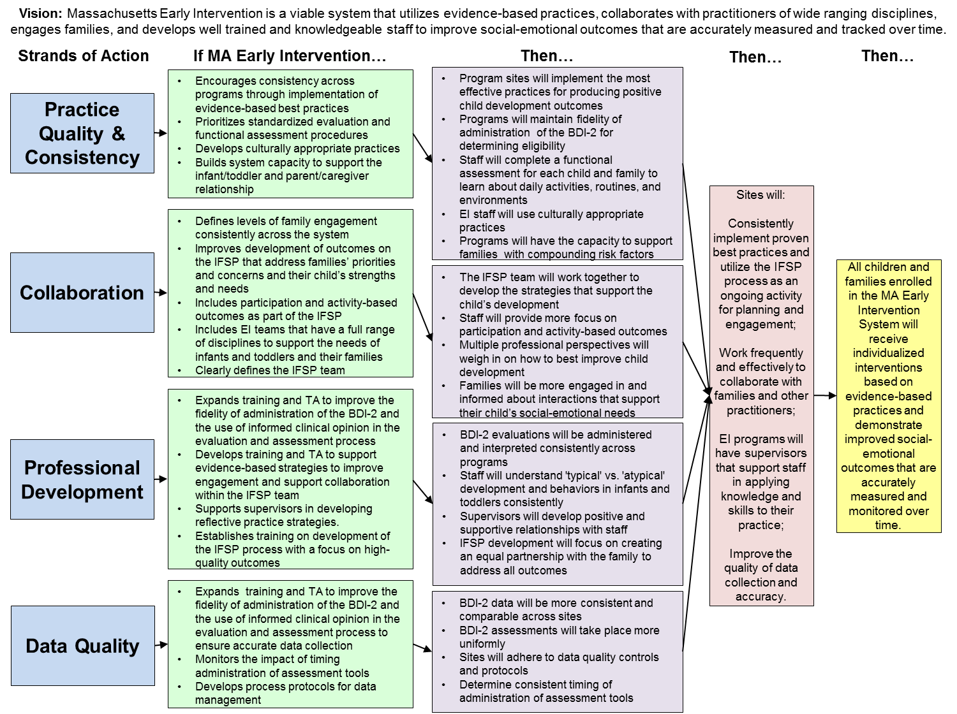

5(b) How Improvement Strategies Will Lead to Improved Results

As much as possible, Massachusetts tried to keep a 1:1 ratio of MA Early Intervention strategies and expected outcomes, with only a few exceptions. These initial outcomes were then summarized in terms of how programs will be impacted in the following if-then statement: “Sites will consistently implement proven best practices and utilize the IFSP as an ongoing tool for planning and engagement; work frequently and effectively to collaborate with families and other practitioners; support staff to be knowledgeable professionals with access to a wide array of trainings and guidance; and improve the quality of data collection and accuracy.” Essentially, this statement summarizes the collective impact of the strategies for each Strand of Action.

Under the assumption that the strategies in each Strand of Action category will be successful, Massachusetts expects that its SIMR will show measurable improvement over time. Specifically, “All children and families enrolled in the Massachusetts Early Intervention System will receive individualized, evidence-based services and demonstrate improved social-emotional outcomes that are accurately measured and tracked over time.” This statement summarizes how the strategies and expected outcomes affect each child and family’s experience with Massachusetts Early Intervention; they will receive individualized services that use evidence-based best practices which will result in better social-emotional outcomes. With improved data quality practices and standards, these outcomes will be accurately measured and reported in conjunction with the SIMR and SSIP implementation.

5(c) Stakeholder Involvement in Developing the Theory of Action

Similar to section 4(e), stakeholders played a key role in developing the Massachusetts Theory of Action. Massachusetts engaged stakeholders throughout the SSIP Phase I development process, including data and infrastructure analyses, identifying methods to measure progress, root causes that impact the SIMR, and strategies to improve the SIMR. All of these activities led to the development of the Theory of Action. Stakeholders developed the initial draft of strategies and their subsequent outcomes. The lead agency grouped strategies into the four identified Strands of Action. DPH then refined the Theory of Action to create a clear plan for Phase I of the SSIP.

Drafts of the Theory of Action were shared and discussed with our various groups of stakeholders.

Date | Activities
January 2015 | Draft Theory of Action was presented and discussed at an ICC meeting
March 2015 | ECO Stakeholder group reviewed Strands of Action, strategies associated with each Strand, and the draft Theory of Action
March 2015 | Full Early Intervention provider community reviewed and discussed the final draft of the Theory of Action for the SSIP Phase 1 submission

The full list of stakeholders involved in these meetings is detailed below:

Representative/ Organization | Part C Stakeholder Group
Coordinator of Education of Homeless Children & Youth | Interagency Coordinating Council (ICC)
Commission for the Deaf and Hard of Hearing | Interagency Coordinating Council (ICC)
Commission for the Blind | Interagency Coordinating Council (ICC)
Department of Developmental Services | Interagency Coordinating Council (ICC)
Department of Early Education and Care | Interagency Coordinating Council (ICC)
Department of Children & Families | Interagency Coordinating Council (ICC)
Division of Medical Assistance | Interagency Coordinating Council (ICC)
Division of Insurance | Interagency Coordinating Council (ICC)
Department of Mental Health | Interagency Coordinating Council (ICC)
Massachusetts Developmental Disabilities Council | Interagency Coordinating Council (ICC)
Department of Elementary & Secondary Education | Interagency Coordinating Council (ICC)
Federation for Children with Special Needs | Interagency Coordinating Council (ICC)
United Way of Massachusetts Bay and Merrimack Valley | Interagency Coordinating Council (ICC)
Justice Resource Institute, Inc. | Interagency Coordinating Council (ICC)
Early Headstart Representative | Interagency Coordinating Council (ICC)
Institute of Health & Recovery (IHR) | Interagency Coordinating Council (ICC)
Regional Parent representatives | Interagency Coordinating Council (ICC)
Regional Provider representative | Interagency Coordinating Council (ICC)
Physician | Interagency Coordinating Council (ICC)
Legislator | Interagency Coordinating Council (ICC)
MEIC representative | Interagency Coordinating Council (ICC)
619 Coordinator, Department of Elementary & Secondary Education | Early Childhood Outcomes (ECO) Stakeholder group
Educator Provider Support Specialist, Department of Early Education & Care | Early Childhood Outcomes (ECO) Stakeholder group
Education Specialist, Department of Elementary & Secondary Education | Early Childhood Outcomes (ECO) Stakeholder group
Director, Office of Family Initiatives (DPH) | Early Childhood Outcomes (ECO) Stakeholder group
Assistant Director, Massachusetts Early Intervention (DPH) | Early Childhood Outcomes (ECO) Stakeholder group
Early Childhood Mental Health Specialist, Department of Public Health | Early Childhood Outcomes (ECO) Stakeholder group
EI Program Directors (five total) | Early Childhood Outcomes (ECO) Stakeholder group
Director & Associate Director, Early Intervention Training Center (DPH) | Early Childhood Outcomes (ECO) Stakeholder group
ICC Co-Chair | Early Childhood Outcomes (ECO) Stakeholder group
Co-Directors, Massachusetts Home Visiting (DPH) | Early Childhood Outcomes (ECO) Stakeholder group
Early Intervention Certificate Program Instructor, Northeastern University | Early Childhood Outcomes (ECO) Stakeholder group
Regional Specialist, Department of Public Health | Early Childhood Outcomes (ECO) Stakeholder group
Statewide Monitoring Coordinator (DPH) | Early Childhood Outcomes (ECO) Stakeholder group
Project Staff, Early Intervention Parent Leadership Project | Early Childhood Outcomes (ECO) Stakeholder group
Assistant Director, Massachusetts DPH, Division of EI | Massachusetts SSIP State Leadership Team
Data Manager, Massachusetts DPH, Division of EI | Massachusetts SSIP State Leadership Team
Director, DPH, EI Training Center | Massachusetts SSIP State Leadership Team
Associate Director, DPH, EI Training Center | Massachusetts SSIP State Leadership Team
EI Regional Specialist | Massachusetts SSIP State Leadership Team
Local EI Program Director | Massachusetts SSIP State Leadership Team
Statewide Monitoring Coordinator, Massachusetts DPH, Division of EI | Massachusetts SSIP State Leadership Team
Director, EI Parent Leadership Project, Massachusetts DPH | Massachusetts SSIP State Leadership Team
Early Intervention Program Directors | Early Intervention Provider Community

Appendices

Local Onsite Data Collection Results

The following attachments represent the forms collected during the local onsite data collection process which was a subset of the Massachusetts infrastructure analysis. Lead Agency staff noted which effective practices were in place across the three programs, taking into account program variations and population demographics, in order to better understand drivers of success and identify what strategies would make the most positive impact on the Massachusetts’s SIMR.
Effective Practice #1 | Level of Implementation
 | Program A |  |  | Program B |  |  | Program C
Assessment | Not | Partial | Full | Not | Partial | Full | Not | Partial | Full
Practitioners work as a team with the family and other professionals to gather assessment information. |  |  | x |  | x |  |  |  | x
NOTES:  Staff Questions:  - How do you use the information collected at the intake in your IFSP development?  - How do you use the information collected during the evaluation/assessment appointment in your IFSP development? | - 3-4 team members at evaluation  - Intake packet questionnaire to gather information from family  - Use a routines checklist with the family  - Get releases and gather medical records  - Evidence that they gather the above info not sure how it is used during assessment process |  |  | - Do an intake prior to assessment to gather info- questionnaire medical records  - Not clear how they are completing assessment activities given their dislike of the evaluation tool and S/E screening tool  - 3 team members on evaluation team  - Program does not support use of ASQ-SE- does not trust parent interviews in all tools |  |  | - 4 team members on eval team  - skilled intake workers separate intake and has a questionnaire  - requests medical records

Effective Practice #2 | Level of Implementation
 | Program A |  |  | Program B |  |  | Program C
Assessment | Not | Partial | Full | Not | Partial | Full | Not | Partial | Full
Practitioners obtain information about the child’s skills in daily activities, routines, and environments such as home, center, and community. |  |  | x |  | x |  |  |  | x
NOTES:  Staff Survey Questions:  - Daily routines and activities, who collects it, etc. | - ASQ SE  - Program based survey of need  - Interest survey given to families/ routines based intervention  - routine based checklist  - family page  - outcomes saw different environments listed |  |  | - ASQ-SE  - Program uses no other tools with family  - Have a separate intake appointment but admin. Interview did not reveal a consistent format.  - Different people may do different things.  - All staff do intakes |  |  | - ASQ-SE  - Day in the life used

Effective Practice # 3 | Level of Implementation
 | Program A |  |  | Program B |  |  | Program C
Environment | Not | Partial | Full | Not | Partial | Full | Not | Partial | Full
Practitioners provide services and supports in natural and inclusive environments during daily routines and activities to promote the child’s access to and participation in learning experiences. |  | x |  |  | x |  |  | x
NOTES:  - Give 1 example of how you used daily routine information in your strategies with a family. | - Home  - Daycare  - Group  - Shelter  - Obtain the information with things routine based checklist.  - See them providing supports in natural environments  - Didn’t consistently see the routines part or evidence of promoting access to and participation in learning experiences. |  |  | - Home  - Daycare,  - Shelter  - Group  - home visits occurring in natural environments  - ? promoting access |  |  | - HV  - Daycare  - Group  - Parent group  - Saw HV is all different environments, not enough info to know if promoting access

Effective Practice #4 | Level of Implementation
 | Program A |  |  | Program B |  |  | Program C
Environment | Not | Partial | Full | Not | Partial | Full | Not | Partial | Full
Practitioners work with the family and other adults to modify and adapt the physical, social, and temporal environments to promote each child’s access to and participation in learning experiences. |  | x |  |  | x |  |  | x
NOTES: | - Strategies  - Use of consult |  |  | - Strategies and use of consults |  |  | - Strategies  - Use of consult  - Carryover recommendations on progress note

Effective Practice #6 | Level of Implementation
 | Program A |  |  | Program B |  |  | Program C
Family | Not | Partial | Full | Not | Partial | Full | Not | Partial | Full
Practitioners provide the family with up-to-date, comprehensive and unbiased information in a way that the family can understand and use to make informed choices and decisions. |  | x |  | x |  |  |  | x
NOTES:  Staff Survey Questions:  - What do you do at an IFSP Review meeting/IFSP meeting with families?  - How is the family involved and participating?  - How are you giving unbiased information: how to ask the question without it being subjective  - how do you strengthen family-child relationships and recognize family strengths and capacities  - think about bias and other qualitative issues  - how are you promoting family confidence/competence  Additional Data: length of time spent on IFSP meetings, initial, 6-month, annual? | - BDI 2  - ASQ SE  - Eligibility form  - ASQ  - Concern about quality of the program practice, however having a program practice that has a systematic way to review the IFSP eliminates bias against particular families |  |  | - NOT unbiased- BDI, ASQ-SE = Resistance to DPH mandates  - Overall administrative interview was more about how they felt about certain things vs. what they did in |  |  | - BDI used  - ASQ used at intake only  - Eligibility form

Effective Practice #7 | Level of Implementation
 | Program A |  |  | Program B |  |  | Program C
Family | Not | Partial | Full | Not | Partial | Full | Not | Partial | Full
Practitioners and the family work together to create outcomes or goals, develop individualized plans, and implement practices that address the family’s priorities and concerns and the child’s strengths and needs. |  | x |  |  | x |  |  | x
NOTES: | - Outcomes often in the words of the parents, no evidence of the team developing them (past reviews)  - Priorities to outcomes and services  - Interview from ASQ and other tools |  |  | - priorities lead to outcomes and services  - separate IFSP meeting |  |  | - Priorities lead to outcomes  - Some charts missing defined priorities, concerns on family page  - IFSP outcomes and family pages and their Service delivery seemed very individualized

Effective Practice #8 | Level of Implementation
 | Program A |  |  | Program B |  |  | Program C
Family | Not | Partial | Full | Not | Partial | Full | Not | Partial | Full
Practitioners support family functioning, promote family confidence and competence, and strengthen family-child relationships by acting in ways that recognize and build on family strengths and capacities. |  | x |  |  | x |  |  |  | x
NOTES: | - Priorities lead to outcomes and services  - Frequent reviews and changes to outcomes and services |  |  | - Priorities lead to outcomes and services |  |  | - Priorities lead to outcomes and services

Effective Practice #9 | Level of Implementation
 | Program A |  |  | Program B |  |  | Program C
Family | Not | Partial | Full | Not | Partial | Full | Not | Partial | Full
Practitioners work with the family to identify, access, and use formal and informal resources and supports to achieve family-identified outcomes or goals. |  | x |  |  | x |  |  | x
NOTES:  Staff Survey Questions:  - how do you support families in identifying and accessing community resources? How do you identify resources with families? How is the family involved in this process?  - learning and using formal and informal supports to achieve IFSP outcomes | - b kids had child skill IFSP outcomes and d kids had family related outcomes  - Referrals to other resources both within agency and beyond |  |  | - Few consults  - ? referrals to agency and community programs |  |  | - Consult model  - Family pages were not that great

Effective Practice #10 | Level of Implementation
 | Program A |  |  | Program B |  |  | Program C
Instruction | Not | Partial | Full | Not | Partial | Full | Not | Partial | Full
Practitioners, with the family, identify each child's strengths, preferences, and interests to engage the child in active learning. |  | x |  |  | x |  |  | x
NOTES:  Staff Questions:  - How do you incorporate child strengths into your intervention strategies? | - Saw family pages that noted child’s strengths but not necessarily child’s preference or interests.  - Assessment would also identify child’s strengths |  |  | - Family page and assessment identifies strengths |  |  | - Priorities lead to outcomes and services  - Identify strengths in assessment and family page but did not see evidence of identifying preferences and interests

Effective Practice #11 | Level of Implementation
 | Program A |  |  | Program B |  |  | Program C
Instruction | Not | Partial | Full | Not | Partial | Full | Not | Partial | Full
Practitioners, with the family, identify skills to target for instruction that help a child become adaptive, competent, socially connected, and engaged and that promote learning in natural and inclusive environments. |  | X |  |  | x |  |  | x
NOTES: | - Use of consult  - Strategies  - Use of progress note with recommendations for carryover |  |  | - Strategies  - Leave progress note no plan for carryover |  |  | - Strategies  - Carryover recommendations on progress note

Effective Practice #12 | Level of Implementation
 | Program A |  |  | Program B |  |  | Program C
Instruction | Not | Partial | Full | Not | Partial | Full | Not | Partial | Full
Practitioners plan for and provide the level of support, accommodations, and adaptations needed for the child to access, participate, and learn within and across activities and routines. |  |  |  |  |  |  |  | x
NOTES:  Too difficult to measure? Eliminate from this process? |  |  |  |  |  |  | - Outcomes  - Child group  - Parent group

Effective Practice #13 | Level of Implementation
 | Program A |  |  | Program B |  |  | Program C
Instruction | Not | Partial | Full | Not | Partial | Full | Not | Partial | Full
Practitioners implement the frequency, intensity, and duration of instruction needed to address the child’s phase and pace of learning or the level of support needed by the family to achieve the child’s outcomes or goals. |  | x |  |  |  | x |  | x
NOTES:  - How do you determine the frequency of services with a family? | - Frequency and intensity of service  - Use of progress note with recommendations for carryover |  |  | - Addition of services when needed- child group |  |  | - saw in Service delivery- individualized services  - Addition of services when needed  - Multiple service providers for children with increased needs

Effective Practice #14 | Level of Implementation
 | Program A |  |  | Program B |  |  | Program C
Instruction | Not | Partial | Full | Not | Partial | Full | Not | Partial | Full
Practitioners use coaching or consultation strategies with primary caregivers or other adults to facilitate positive adult-child interactions and instruction intentionally designed to promote child learning and development. |  | x |  |  | x |  |  | x
NOTES:  Staff questions:  - find link to interests leading to engagement to increased participation in daily activities  - how are you using of IFSP outcomes in planning for home visits  - how do you determine frequency and duration of services as well as number of services providers?  - are you coaching… what does this mean… intervention strategies? Coaching during home visits?  - planning of visits linked to IFSP outcomes? | - Use of progress note with recommendations for carryover  - Did see evidence of consults used – unknown if used to facilitate positive adult –child interaction and instruction |  |  | Leave progress note no plan for carryover  NF 50% consultations  - MC/MS Did not feel like I saw a lot of consults in general occurring on S.D page of IFSP- only single person working with family |  |  | - Carryover recommendations on progress note  - We did see some consults but also then the adding of that services to the child’s regular service plan as a weekly visit

Effective Practice #15 | Level of Implementation
 | Program A |  |  | Program B |  |  | Program C
Teaming and Collaboration | Not | Partial | Full | Not | Partial | Full | Not | Partial | Full
Practitioners representing multiple disciplines and families work together as a team to plan and implement supports and services to meet the unique needs of each child and family. | x |  |  |  | x |  |  |  | x
NOTES:  Staff Survey Questions:  - What do you do if you want a consult by someone but that discipline is not available?  - Define the role of the Service coordinator at your program. | - Decreased availability of all disciplines on team (55% DS, 14% SW, 8% or less other disciplines)  - Frequent turnover  - decreased # of long term staff (42% 0-1 years, 34% 1-3 years)  - IFSP Meetings and evaluations multidisciplinary  - Some evidence of consults on IFSP’s .  - ? multiple discipline part as sometimes the consult would be with another DS who may have a specialty more then seeing a variety of different discipline staff (b=63%, d=75%) |  |  | - Service Delivery often only saw one person on the plan.  - consults used 50% for b and d in FY14  - May be matching correct discipline to needs to family.  - IFSP Meetings and evaluations/ multidisciplinary  - Multidisciplinary team has full complement of disciplines in personnel database (12% DS, 27% SW, 22% SLP, 18% OT, 10% CS, 8% or less other disciplines)  - 40% staff 5-10+ years |  |  | - Full complement of disciplines available to support families (21% DS, 9% SW, 27% SLP, 14% OT, 14% PT, 7% or less other disciplines)  - saw in S.C wide variety of disciplines specific to the needs of the child.  - Talked more in interview about providing parents what the family is asking for  - Identify as trans-disciplinary model with data to support (44% consults completed for d)  - 45% staff 5-10+ years

Effective Practice #16 | Level of Implementation
 | Program A |  |  | Program B |  |  | Program C
Teaming and Collaboration | Not | Partial | Full | Not | Partial | Full | Not | Partial | Full
Practitioners and families may collaborate with each other to identify one practitioner from the team who serves as the primary liaison between the family and other team members based on child and family priorities and needs. |  | x |  |  | x |  |  | x
NOTES: | - SC for family  - A lot of turnover  - # of service coordinators 58% had a SC change, b=5 [3 in 25 mo, 3 in 18 mo, 2 in 17 mo, 4 in 18 mo] d=2 [2 in 19 mo, 5 in 14 mo]  - Each family having a primary liaison, S.C  - Consults completed by a full complement/ variety of disciplines is lacking, b=50%, d=25% for PSP |  |  | - Seem to be using a primary service provider as a singular liaison, more so then the other 2 programs  - SC with low turnover.  - Most families have one main services provider  - 50% of kids have PSP |  |  | - Team meeting  - Supervision structure  - Orientation structure  - Primary service provider model  - Identify SC to meet needs of family  - 89% of kids in d = PSP

