INDOOR AIR QUALITY ASSESSMENT

State Transportation Building
Suite 3510
10 Park Plaza
Boston, MA

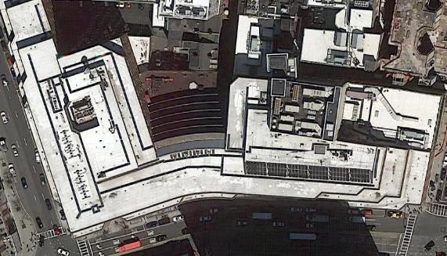

Prepared by:
Massachusetts Department of Public Health
Bureau of Environmental Health
Indoor Air Quality Program
May 2019

Background
Building: | Department of Transportation Offices on the 3rd floor of the State Transportation Building (STB)
Address: | 10 Park Plaza, Boston
Assessment Requested by: | Christine A. Escott, Facility Manager, Division of Capital Asset Management and Maintenance (DCAMM)
Reason for Request: | Concerns about indoor air quality (IAQ) and health
Date of Assessment: | April 30, 2019
Massachusetts Department of Public Health/Bureau of Environmental Health (MDPH/BEH) Staff Conducting Assessment: | Ruth Alfasso, Environmental Engineer, IAQ Program
Building Description: | The STB is an 8-story concrete and brick building constructed in the 1980s. It has a large food court on the ground level, a parking garage underneath, and state offices above.
Windows: | Not openable

Methods
Please refer to the IAQ Manual for methods, sampling procedures, and interpretation of results (MDPH, 2015).

IAQ Testing Results
The following is a summary of indoor air testing results in both suites (Table 1).
- Carbon dioxide levels were below the MDPH guideline of 800 parts per million (ppm) in all areas surveyed, indicating adequate air exchange for the population in the building at the time of the assessment.
- Temperature was within the recommended range of 70°F to 78°F in all areas tested.
- Relative humidity was slightly below the recommended range of 40 to 60%.
- Carbon monoxide levels were non-detectable (ND) in all areas tested.
- Fine particulate matter (PM2.5) concentrations measured were below the National Ambient Air Quality Standard (NAAQS) limit of 35 μg/m³ in all areas tested.

Ventilation
A heating, ventilating, and air conditioning (HVAC) system has several functions. First it provides heating and, if equipped, cooling. Second, it is a source of fresh air. Finally, an HVAC system will dilute and remove normally-occurring indoor environmental pollutants by not only introducing fresh air, but by filtering the airstream and ejecting stale air to the outdoors via exhaust ventilation. Even if an HVAC system is operating as designed, point sources of respiratory irritation may exist and cause symptoms in sensitive individuals.
Fresh air is supplied by induction units near windows (Picture 1). Return air is drawn through vents around light fixtures using ducted returns (Picture 2). Fresh air is supplied around some lights as well. In some areas, items were on the induction unit cabinets, including plants (Picture 3). This can block the supply of fresh air as well as aerosolize odors and particulates such as dust, mold spores, and pollen. Vents should be kept clear of items.
It is recommended that HVAC systems be re-balanced every five years to ensure adequate air systems function (SMACNA, 1994). It was unknown when the last time these systems had been balanced.

Microbial/Moisture Concerns
Light water stains could be seen on a ceiling tile in the General Counsel’s office (Picture 5; Table 1). This likely is the result of a leak/condensation in the HVAC or sprinkler system. The area above this ceiling tile should be examined for the source of the leak and for any additional water-damaged materials. Once the leak is repaired, the ceiling tile should be replaced.
As shown in Picture 3, plants were noted in many areas. Some were in poor condition or on porous materials. Plants/flowers can be a source of pollen and mold, which can be respiratory irritants to some individuals. Plants should be properly maintained and equipped with drip pans and should be located away from airflow to prevent the aerosolization of dirt, pollen, and mold.
Refrigerators and water dispensers were located on carpet (Picture 4). Refrigerators and water dispensing equipment should be located in a non-carpeted area or on a waterproof mat to prevent damage to carpet and subsequent odors.

Other Concerns
Exposure to low levels of total volatile organic compounds (TVOCs) may produce eye, nose, throat, and/or respiratory irritation in some sensitive individuals. BEH/IAQ staff examined spaces for products containing VOCs. BEH/IAQ staff noted hand sanitizers, cleaning products, and dry erase materials in the office space (Picture 6; Table 1). All of these products have the potential to be irritants to the eyes, nose, throat, and respiratory system of sensitive individuals. There are also photocopiers in the suite, which can give off odors, particulates and ozone, particularly older models that are heavily used (Schmidt Etkin, 1992).
Food and food preparation equipment was observed in some offices and common areas. Food should be kept tightly sealed to prevent pest access and food preparation equipment should be kept clean to prevent smoke, odors and pests.
Items were observed on flat surfaces, such as windowsills, tabletops, counters, bookcases, and desks (Table 1). Items, including boxes, were also stored on the floor. Items stored in offices provide a source for dusts to accumulate. These items also make it difficult for custodial staff to clean. Items should be relocated and/or be cleaned periodically to avoid excessive dust build up.
In a few areas, ceiling tiles were ajar (Table 1), which can allow dust and debris from above the ceiling tiles into occupied spaces. Ceiling tiles should be flush in the ceiling tile grid.
The offices were mostly carpeted. Carpets should be cleaned annually (or semi-annually in soiled/high traffic areas) in accordance with Institute of Inspection, Cleaning and Restoration Certification (IICRC) recommendations, (IICRC, 2012). Offices have cloth curtains over interior windows for privacy (Picture 7). These should be cleaned or laundered periodically to remove dust.

Conclusions/Recommendations
Based on observations at the time of assessment, the following is recommended:
- Operate supply and exhaust ventilation continuously in all areas during occupied periods. Ensure all HVAC equipment is cleaned/maintained in accordance with manufacturer’s instructions.
- Balance the HVAC system every 5 years in accordance with Sheet Metal and Air Conditioning Contractors’ National Association (SMACNA) recommendations (SMACNA, 1994).
- Regularly clean supply and return vents and vent cabinets.
- Remove items from the top and front of induction unit cabinets to allow for air flow.
- Replace water-damaged ceiling tiles. Repair any source of leaks as they are discovered.
- Keep plants and flowers in good condition, avoid overwatering, and remove from the airstream of heating and ventilation equipment.
- Consider the use of waterproof mats underneath refrigerators and water dispensers to protect carpet from leaks and spills.
- For buildings in New England, periods of low relative humidity during the winter are often unavoidable. Therefore, scrupulous cleaning practices should be adopted to minimize common indoor air contaminants whose irritant effects can be enhanced when the relative humidity is low. To control for dusts, a high efficiency particulate arrestance (HEPA) filter equipped vacuum cleaner in conjunction with wet wiping of all surfaces is recommended. Avoid the use of feather dusters. Drinking water during the day can help ease some symptoms associated with a dry environment (throat and sinus irritations).
- Reduce the use of cleaning products, sanitizers, and other items that contain VOCs.
- Keep food preparation equipment clean and clean out the refrigerators, including the gaskets, regularly.
- Reduce the amount of items stored on flat surfaces to allow regular cleaning.
- Clean supply vents, personal fans and other equipment to prevent aerosolizing dust.
- Ensure all ceiling tiles are in place in the ceiling tile grid.
- Clean carpeting in accordance with IICRC recommendations (IICRC, 2012).
- Clean cloth curtains in offices periodically to remove dust.
- Refer to resource manual and other related IAQ documents located on the MDPH’s website for further building-wide evaluations and advice on maintaining public buildings. These documents are available at: http://mass.gov/dph/iaq.

References
IICRC. 2012. Institute of Inspection, Cleaning and Restoration Certification. Carpet Cleaning: FAQ.
MDPH. 2015. Massachusetts Department of Public Health. Indoor Air Quality Manual: Chapters I-III. Available at: http://www.mass.gov/eohhs/gov/departments/dph/programs/environmental-health/exposure-topics/iaq/iaq-manual/.
Schmidt Etkin, D. 1992. Office Furnishings/Equipment & IAQ Health Impacts, Prevention & Mitigation. Cutter Information Corporation, Indoor Air Quality Update, Arlington, MA.
SMACNA. 1994. HVAC Systems Commissioning Manual. 1st ed. Sheet Metal and Air Conditioning Contractors’ National Association, Inc., Chantilly, VA.
Picture 1
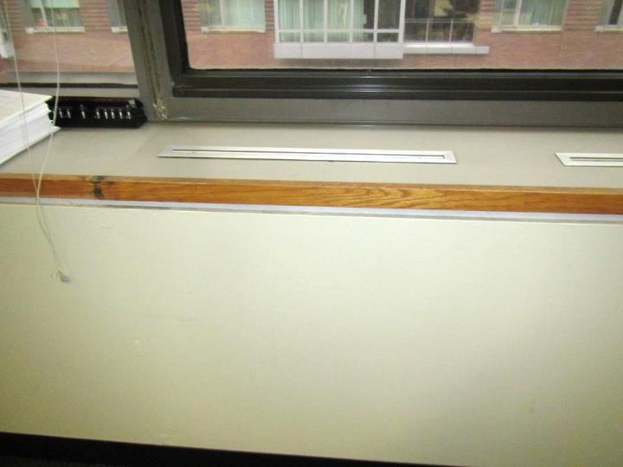
Induction unit next to window
Picture 2
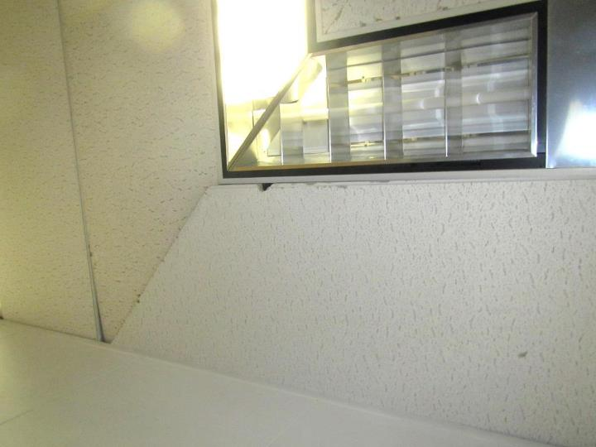
Space around light fixture for ducted return
Picture 3
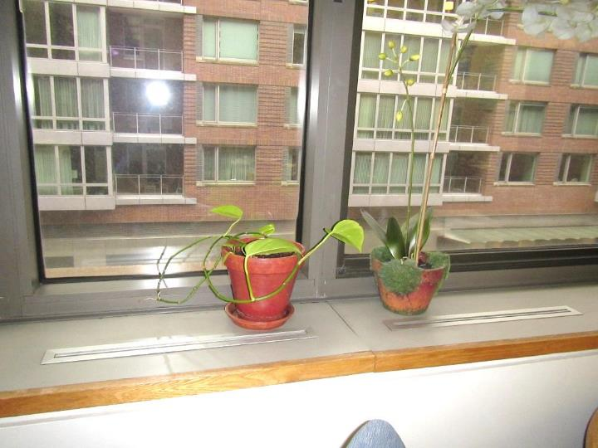
Plants on induction unit
Picture 4
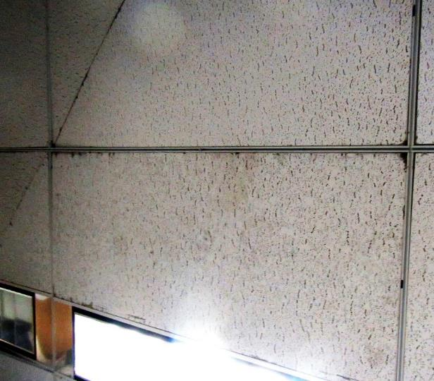
Light water staining on ceiling tile
Picture 5
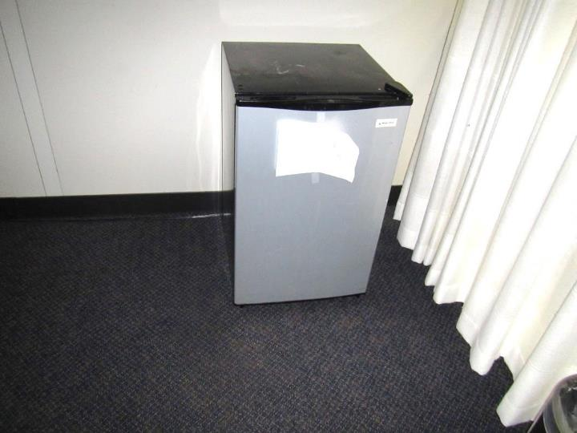
Refrigerator on carpet in meeting room
Picture 6
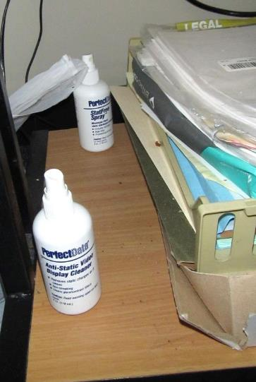
Cleaning products
Picture 7
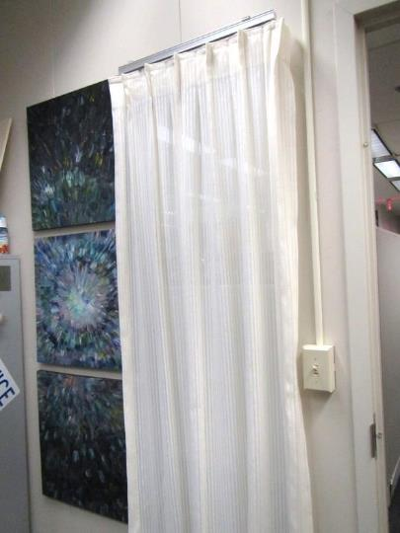
Cloth curtains covering office window

Location | Carbon  Dioxide  (ppm) | Carbon Monoxide  (ppm) | Temp  (°F) | Relative  Humidity  (%) | PM2.5  (µg/m³) | Occupants  in Room | Windows  Openable | Ventilation |  | Remarks
 |  |  |  |  |  |  |  | Supply | Exhaust
Caldarelli office | 674 | ND | 70 | 39 | 4 | 0 | N | Y | Y | Food, induction unit on
DaSilva cube area | 651 | ND | 73 | 33 | 4 | 0 | N | Y | Y | Plant, boxes on floor
2328 | 664 | ND | 73 | 33 | 4 | 0 | N | Y | Y | Area rug, plants, on induction unit
2176 | 651 | ND | 73 | 32 | 3 | 1 | N | Y | Y | Paper and items on induction unit, plant
Fitzgerald Cube area | 657 | ND | 73 | 32 | 3 | 2 | N | Y | Y | HS
Doyle | 632 | ND | 73 | 32 | 3 | 0 | N | Y | Y
3533 | 654 | ND | 72 | 32 | 4 | 0 | N |  | Y | Boxes on floor
3541 | 636 | ND | 72 | 32 | 2 | 0 | N |  | Y | DEM
3542 | 686 | ND | 73 | 32 | 2 | 0 | N |  | Y
3531 | 663 | ND | 73 | 32 | 2 | 1 | N |  | Y
3516 | 652 | ND | 72 | 32 | 1 | 0 | N |  | Y | Conference/meeting space, fridge on carpet
3517 | 650 | ND | 72 | 32 | 2 | 0 | N | Y | Y | Personal fan, books
Kane | 643 | ND | 73 | 32 | 2 | 1 | N | Y | Y | Items on induction unit
3575 | 665 | ND | 73 | 32 | 2 | 1 | N |  | Y | Items on floor, DEM
Interior waiting | 654 | ND | 73 | 32 | 2 | 0 | N | Y | Y | Leather furniture, HS, water cooler on carpet
Conference room | 650 | ND | 72 | 32 | 2 | 0 | N | Y | Y | Large TV screens
3534 | 681 | ND | 73 | 32 | 1 | 1 | N |  | Y | Boxes on floor
General Counsel | 699 | ND | 72 | 32 | 1 | 4 | N | Y | Y | Items on induction unit, DEM, small water stains on CT and CT ajar

