INDOOR AIR QUALITY ASSESSMENT

State Transportation Building
Suites 4470 and 5510
10 Park Plaza
Boston, MA

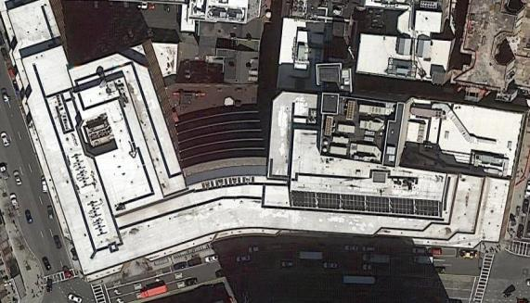

Prepared by:
Massachusetts Department of Public Health
Bureau of Environmental Health
Indoor Air Quality Program
October 2018

Background
Building: | Department of Transportation Offices on the 4th and 5th floor of the State Transportation Building (STB)
Address: | 10 Park Plaza, Boston
Assessment Requested by: | Christine A. Escott, Facility Manager, Division of Capital Asset Management and Maintenance (DCAMM)
Reason for Request: | General indoor air quality (IAQ) concerns
Date of Assessment: | October 9, 2018
Massachusetts Department of Public Health/Bureau of Environmental Health (MDPH/BEH) Staff Conducting Assessment: | Ruth Alfasso, Environmental Engineer, IAQ Program
Building Description: | The STB is an 8-story concrete and brick building constructed in the 1980s. It has a large food court on the ground level, a parking garage underneath, and state offices above.
Windows: | Not openable

Methods
Please refer to the IAQ Manual for methods, sampling procedures, and interpretation of results (MDPH, 2015).

IAQ Testing Results
The following is a summary of indoor air testing results in both suites (Table 1).
- Carbon dioxide levels were below the MDPH guideline of 800 parts per million (ppm) in all areas surveyed, indicating adequate air exchange for the population in the building at the time of the assessment.
- Temperature was within the recommended range of 70°F to 78°F in all areas tested.
- Relative humidity was within or slightly above the recommended range of 40 to 60% which is reflective of outdoor conditions.
- Carbon monoxide levels were non-detectable (ND) in all areas tested.
- Fine particulate matter (PM2.5) concentrations measured were below the NAAQS limit of 35 μg/m³ in all areas tested.

Ventilation
A heating, ventilating, and air conditioning (HVAC) system has several functions. First it provides heating and, if equipped, cooling. Second, it is a source of fresh air. Finally, an HVAC system will dilute and remove normally-occurring indoor environmental pollutants by not only introducing fresh air, but by filtering the airstream and ejecting stale air to the outdoors via exhaust ventilation. Even if an HVAC system is operating as designed, point sources of respiratory irritation may exist and cause symptoms in sensitive individuals.
Fresh air is supplied by vents located in the ceiling and from units near windows (Picture 1). Return air is drawn through vents around light fixtures using ducted returns (Picture 2). It is also possible that fresh air is supplied around some lights as well. In some areas, items were on the vent cabinets, including plants (Pictures 1 and 3). This can block the supply of fresh air as well as aerosolize odors and particulates such as dust, mold spores, and pollen. Vents should be kept clear of items.
It is recommended that HVAC systems be re-balanced every five years to ensure adequate air systems function (SMACNA, 1994). It was unknown when the last time these systems had been balanced.

Microbial/Moisture Concerns
A water-damaged ceiling tile was observed in suite 4470 (Table 1). It appears that this stems from a leak/condensation in the sprinkler system. Water-damaged tiles should be changed when a water leak is discovered and repaired; it is possible that the location of the sprinkler head makes this tile difficult to change.
As shown in Pictures 1 and 3, plants were noted in many areas, particularly in suite 5510 (Table 1). Some were in poor condition or on porous materials. Plants/flowers can be a source of pollen and mold, which can be respiratory irritants to some individuals. Plants should be properly maintained and equipped with drip pans and should be located away from airflow to prevent the aerosolization of dirt, pollen, and mold.
Refrigerators and water dispensers were located on carpet (Picture 4). Refrigerators and water dispensing equipment should be located in a non-carpeted area or on a waterproof mat to prevent damage to carpet and subsequent odors.

Other Concerns
Exposure to low levels of total volatile organic compounds (TVOCs) may produce eye, nose, throat, and/or respiratory irritation in some sensitive individuals. BEH/IAQ staff examined spaces for products containing VOCs. BEH/IAQ staff noted air fresheners, hand sanitizers, cleaning products, dry erase materials and a scent diffuser in the office space (Picture 5; Table 1). All of these products have the potential to be irritants to the eyes, nose, throat, and respiratory system of sensitive individuals.
Food and food preparation equipment was observed in some offices and common areas. Food should be kept tightly sealed to prevent pest access and food preparation equipment should be kept clean to prevent smoke, odors and pests.
Items were observed on flat surfaces, such as windowsills, tabletops, counters, bookcases, and desks (Pictures 4 and 6). Items, including boxes, were also stored on the floor (Picture 7). Items stored in offices provide a source for dusts to accumulate. These items also make it difficult for custodial staff to clean. Items should be relocated and/or be cleaned periodically to avoid excessive dust build up.
In a few areas, ceiling tiles were missing (Picture 8) or ajar/damaged (Table 1), which can allow dust and debris from above the ceiling tiles into occupied spaces. Ceiling tiles should be flush in the ceiling tile grid.
The offices were mostly carpeted. The carpeting in suite 5510 is reportedly original to the building and thus over 30 years old. This carpeting appeared worn, stained and in some places torn (Pictures 9 and 10; Table 1). Some carpeting in suite 4470 is also old and worn. The usable life of carpeting is approximately 10-11 years (IICRC, 2002). Carpeting of this age and condition cannot be adequately cleaned and may become a source of particulates and odors. Replacement of old carpeting should be considered. Carpets should be cleaned annually (or semi-annually in soiled/high traffic areas) in accordance with Institute of Inspection, Cleaning and Restoration Certification (IICRC) recommendations, (IICRC, 2012).

Conclusions/Recommendations
Based on observations at the time of assessment, the following is recommended:
- Operate supply and exhaust ventilation continuously in all areas during occupied periods. Ensure all HVAC equipment is cleaned/maintained in accordance with manufacturer’s instructions.
- Balance the HVAC system every 5 years in accordance with Sheet Metal and Air Conditioning Contractors’ National Association (SMACNA) recommendations (SMACNA, 1994).
- Regularly clean supply and return vents and vent cabinets on a regular basis.
- Remove items from the top and front of vent cabinets to allow for air flow.
- Replace water-damaged ceiling tiles. Repair any source of leaks as they are discovered.
- Keep plants and flowers in good condition, avoid overwatering, and remove from the airstream of heating and ventilation equipment.
- Consider the use of waterproof mats underneath refrigerators and water dispensers to protect carpet from leaks and spills.
- For buildings in New England, periods of low relative humidity during the winter are often unavoidable. Therefore, scrupulous cleaning practices should be adopted to minimize common indoor air contaminants whose irritant effects can be enhanced when the relative humidity is low. To control for dusts, a high efficiency particulate arrestance (HEPA) filter equipped vacuum cleaner in conjunction with wet wiping of all surfaces is recommended. Avoid the use of feather dusters. Drinking water during the day can help ease some symptoms associated with a dry environment (throat and sinus irritations).
- Reduce the use of cleaning products, sanitizers, and other items that contain VOCs.
- Keep food preparation equipment clean and clean out the refrigerators, including the gaskets, regularly.
- Reduce the amount of items stored on flat surfaces to allow regular cleaning.
- Clean supply vents, personal fans and other equipment to prevent aerosolizing dust.
- Ensure all ceiling tiles are in place in the ceiling tile grid.
- Clean carpeting in accordance with IICRC recommendations (IICRC, 2012). Consider the use of plastic chair mats under desks to protect carpeting.
- Consider a plan to replace worn out carpeting in the building. When carpeting is replaced, carpet squares should be used to allow for easier replacement of small sections if they get damaged.
- Refer to resource manual and other related IAQ documents located on the MDPH’s website for further building-wide evaluations and advice on maintaining public buildings. These documents are available at: http://mass.gov/dph/iaq.

References
IICRC. 2002. Institute of Inspection, Cleaning and Restoration Certification. A Life-Cycle Cost Analysis for Floor Coverings in School Facilities.
IICRC. 2012. Institute of Inspection, Cleaning and Restoration Certification. Carpet Cleaning: FAQ.
MDPH. 2015. Massachusetts Department of Public Health. Indoor Air Quality Manual: Chapters I-III. Available at: http://www.mass.gov/eohhs/gov/departments/dph/programs/environmental-health/exposure-topics/iaq/iaq-manual/.
SMACNA. 1994. HVAC Systems Commissioning Manual. 1st ed. Sheet Metal and Air Conditioning Contractors’ National Association, Inc., Chantilly, VA.
Picture 1
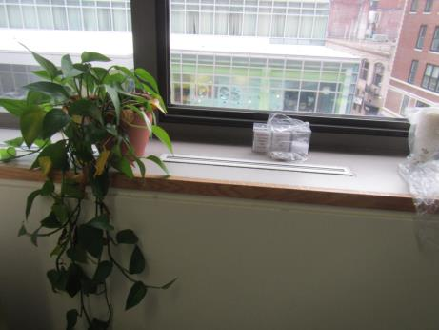
Air vent unit near window, note plants and other items on top
Picture 2
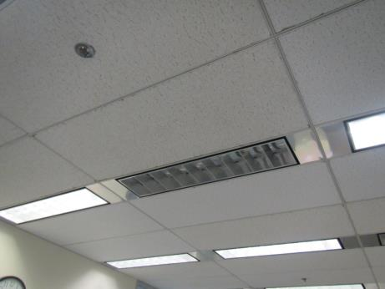
Return vent around light
Picture 3
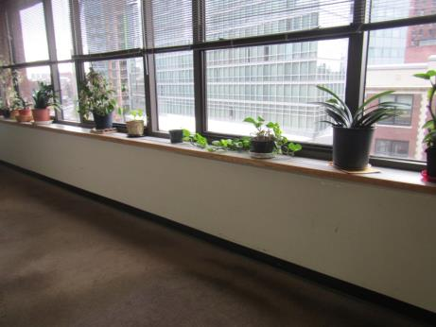
Plants on vents next to window
Picture 4
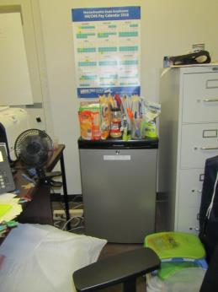
Refrigerator in carpeted area, also note food, personal fan and other items
Picture 5
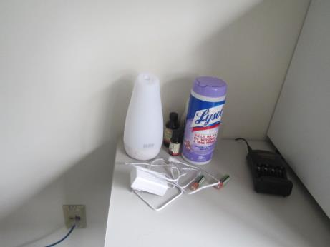
Cleaning wipes and scented oil diffuser
Picture 6
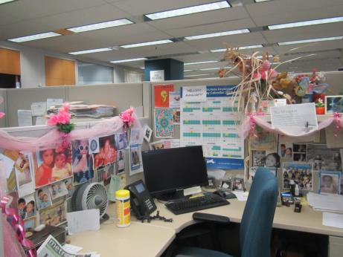
Decorative items in a cubicle
Picture 7
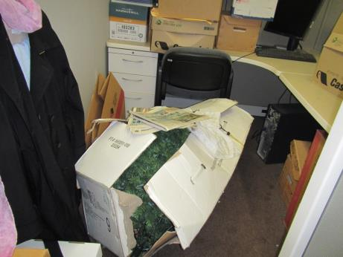
Stored items on the floor
Picture 8
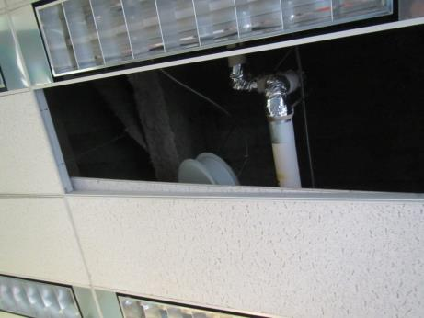
Missing/displaced ceiling tile
Picture 9
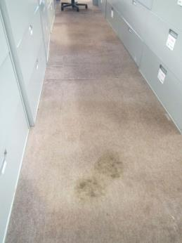
Stained, worn carpeting in suite 5510
Picture 10
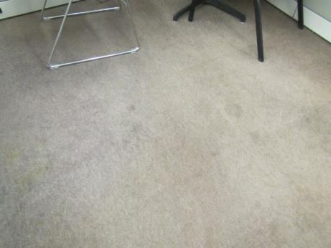
Worn, stained carpeting in suite 5510
Location | Carbon  Dioxide  (ppm) | Carbon Monoxide  (ppm) | Temp  (°F) | Relative  Humidity  (%) | PM2.5  (µg/m³) | Occupants  in Room | Windows  Openable | Ventilation |  | Remarks
 |  |  |  |  |  |  |  | Supply | Exhaust
Background (outside) | 411 | ND | 73 | 73 | 11 |  |  |  |  | Mostly sunny
Suite 4470 (MBTA system-wide accessibility)
Main room | 638 | ND | 71 | 61 | ND | 1 | N |  | Y
Kitchen/copy | 612 | ND | 71 | 61 | ND | 0 | N | Y | Y | Photocopier, refrigerator, food equipment
Office | 609 | ND | 71 | 60 | ND | 0 | N |  | Y | DO, PF – on, heater, food, DEM
Brelsford | 636 | ND | 71 | 61 | ND | 0 | N | Y | Y | WD CT (around sprinkler head), food, plant, PF
Director | 591 | ND | 70 | 61 | ND | 0 | N | Y | Y | Refrigerator, HS/CP, fragrances, plants
Office | 631 | ND | 70 | 64 | ND | 2 | N | Y | Y | Plants on radiator/airflow
Hart | 608 | ND | 70 | 62 | ND | 0 | N |  | Y | DEM, MT, heater
Conference | 595 | ND | 70 | 63 | ND | 0 | N |  | Y | DEM, PF
Day use office | 615 | ND | 71 | 62 | ND | 0 | N |  | Y | Printer
Hallway office | 612 | ND | 71 | 62 | 1 | 1 | N |  | Y | Ajar ceiling tile, old carpet
Rear office | 601 | ND | 71 | 61 | ND | 0 | N | Y | Y | CTs have been damaged (hanging items or access above?)
Suite 5510 (MBTA internal audit)
Cassidy (cubes) | 676 | ND | 74 | 58 | ND | 0 | N | Y | Y | Food, items, plants on vents near windows
Moreton (cubes) | 695 | ND | 74 | 58 | ND | 3 | N |  | Y | Items on floor
Mears (cubes) | 638 | ND | 74 | 57 | 2 | 1 | N | Y | Y | Plants on vents near windows, boxes on floor
Chan (cubes) | 631 | ND | 73 | 57 | ND | 0 | N |  | Y | Plants on radiator, some CT bowed
Cathy (cubes) | 645 | ND | 73 | 58 | 1 | 1 | N |  | Y
Sin (cubes) | 651 | ND | 73 | 58 | ND | 1 | N | Y | Y
Cubes | 717 | ND | 73 | 58 | 1 | 1 | N | Y | Y
Poindexter (cubes) | 655 | ND | 73 | 58 | 1 | 0 | N | Y | Y | Decorative items, HS, PF
Pereira (cubes) | 660 | ND | 73 | 58 | 12 | 2 | N |  | Y
Felicia (cubes) | 670 | ND | 73 | 57 | 1 | 0 | N |  | Y | Items on floor
Conference | 642 | ND | 72 | 58 | ND | 0 | N |  | Y | DEM, a few bowed CT
Contract records room | 648 | ND | 72 | 58 | 1 | 0 | N |  | Y | Printer, copier
Lidy Chan (office) | 743 | ND | 74 | 60 | ND | 0 | N |  | Y | Plants, PF, fridge
Office 5522 | 691 | ND | 72 | 60 | 1 | 1 | N |  | Y | DO
Office 5521 | 679 | ND | 72 | 60 | ND | 0 | N |  | Y | Fridge, food, DEM
Office 5512 | 699 | ND | 73 | 60 | ND | 1 | N |  | Y | Dusty PF
Office 5511 | 703 | ND | 73 | 59 | ND | 1 | N |  | Y | Plants, DEM, area rug, fridge

