INDOOR AIR QUALITY ASSESSMENT

State Transportation Building
Suite 4150 and other rooms on the 4th and 2nd floor
10 Park Plaza
Boston, MA

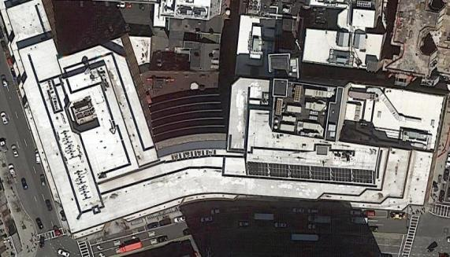

Prepared by:
Massachusetts Department of Public Health
Bureau of Environmental Health
Indoor Air Quality Program
September 2018

Background
Building: | Division of Capital Asset Management and Maintenance (DCAMM) Offices on the 2nd and 4th floor of the State Transportation Building (STB)
Address: | 10 Park Plaza, Boston
Assessment Requested by: | Parrish Rossi, DCAMM and Christine A. Escott, Facility Manager, DCAMM
Reason for Request: | General indoor air quality (IAQ) and water damage concerns
Date of Assessment: | August 31, 2018
Massachusetts Department of Public Health/Bureau of Environmental Health (MDPH/BEH) Staff Conducting Assessment: | Ruth Alfasso, Environmental Engineer, IAQ Program
Building Description: | The STB is an 8-story concrete and brick building constructed in the 1980s. It has a large food court on the ground level, a parking garage underneath, and state offices above.
Windows: | Not openable

Methods
Please refer to the IAQ Manual for methods, sampling procedures, and interpretation of results (MDPH, 2015).

IAQ Testing Results
The following is a summary of indoor air testing results (Table 1).
- Carbon dioxide levels were below 800 parts per million (ppm) in almost all areas surveyed, indicating adequate air exchange for the population in the building at the time of the assessment.
- Temperature was within the recommended range of 70°F to 78°F in all areas tested.
- Relative humidity was within or slightly above the recommended range of 40 to 60%.
- Carbon monoxide levels were non-detectable (ND) in all areas tested.
- Fine particulate matter (PM2.5) concentrations measured were below the NAAQS limit of 35 μg/m³ in all areas tested.

Ventilation
A heating, ventilating, and air conditioning (HVAC) system has several functions. First it provides heating and, if equipped, cooling. Second, it is a source of fresh air. Finally, an HVAC system will dilute and remove normally-occurring indoor environmental pollutants by not only introducing fresh air, but by filtering the airstream and ejecting stale air to the outdoors via exhaust ventilation. Even if an HVAC system is operating as designed, point sources of respiratory irritation may exist and cause symptoms in sensitive individuals.
Fresh air is supplied by vents located in the ceiling, the upper portions of walls (Picture 1), or from units near windows (Picture 2). Return air is drawn through vents around light fixtures using ducted returns (Picture 3). Some rooms on the second floor had supplemental heaters built into the walls (Picture 4). In some areas, items were on the vent cabinets, including plants (Picture 5). This can block the supply of fresh air as well as aerosolize odors and particulates such as dust, mold spores, and pollen. Vents should be kept clear of items.
In the reception area in suite 4160, the occupant had complaints regarding drafts from the ventilation system. The location of the reception desk is directly in the path of the vents along the top part of the walls (Picture 1) and is a large space that requires fresh air distribution. It may be possible to install baffles on these vents to redirect air such that it is not blowing directly on the reception desk. In addition, regular cleaning of supply and return vents should be conducted to prevent a built up of dust that can be reaerosolized or become a medium for mold growth.
It is recommended that HVAC systems be re-balanced every five years to ensure adequate air systems function (SMACNA, 1994). It was unknown when the last time these systems had been balanced.

Microbial/Moisture Concerns
Water damage and musty/moldy odors were a concern in some areas examined. Room 2161 had been left closed to concentrate any odors, and a slight musty odor was detected on entry. No direct source of the odor could be found. Two potential sources include worn and degraded carpeting that had a small refrigerator on it (Picture 6) which may have been subject to spills and paper/books on shelving and surfaces that may have become wet in the past. The ceiling plenum could not be accessed for assessment of odor. The ceiling plenum should be inspected by building maintenance staff to determine if any water-damaged materials such as insulation are present. The built-in heater (Picture 4) should also be maintained and cleaned. A similar odor was also reported in nearby room 2174, however this room was occupied, the door was open, and no odor was noticeable at the time of the visit. Also note that the carbon dioxide readings in these two offices were higher than most other areas tested in the building, and above the recommended value of 800 ppm, even though room 2161 was unoccupied. This suggests there may be insufficient air circulation to these offices. Increasing fresh air may reduce odors and improve perception of IAQ in these offices.
The plotter area in suite 4150 had several water-damaged ceiling tiles and other ceiling tiles bowed from moisture exposure (Picture 7). This area reportedly had a water leak from the roof in the past. The carpet was dry at the time of the visit, and no musty odors were detected. Another area in the suite had reportedly been subject to a leak from the HVAC or plumbing system through a structural column. This leak had reportedly been cleaned up, and no signs of water damage were noticeable during the visit. In addition, a few water-damaged ceiling tiles were observed elsewhere in the office. Water-damaged ceiling tiles should be replaced.
Plants were noted in a few areas (Table 1; Picture 5). Cut flowers in water were also noted (Table 1). Plants/flowers can be a source of pollen and mold, which can be respiratory irritants to some individuals. Plants should be properly maintained and equipped with drip pans and should be located away from airflow to prevent the aerosolization of dirt, pollen, and mold.
Refrigerators and water dispensers were located on carpet (Picture 8). Refrigerators and water dispensing equipment should be located in a non-carpeted area or on a waterproof mat to prevent damage to carpet and subsequent odors.

Other Concerns
Exposure to low levels of total volatile organic compounds (TVOCs) may produce eye, nose, throat, and/or respiratory irritation in some sensitive individuals. BEH/IAQ staff examined spaces for products containing VOCs. BEH/IAQ staff noted air fresheners, hand sanitizers, cleaning products, and dry erase materials in the office space (Picture 9; Table 1). All of these products have the potential to be irritants to the eyes, nose, throat, and respiratory system of sensitive individuals.
Food preparation equipment in the lounge in suite 4150 had food debris (Pictures 10 through 12). The refrigerator was crowded with items and the gasket needed cleaning (Picture 13). Food debris can be a source of odors, and is attractive to pests. Food preparation equipment should be cleaned regularly.
Items were observed on flat surfaces, such as windowsills, tabletops, counters, bookcases, and desks. Items stored in offices provide a source for dusts to accumulate. These items (e.g. papers, folders, boxes) also make it difficult for custodial staff to clean. Items should be relocated and/or be cleaned periodically to avoid excessive dust build up.
Air purifying units were observed in room 2174 and other offices. These units have filters that need to be changed in accordance with manufacturer’s instructions. No units that create ozone should be used in occupied spaces. In addition, personal fans in the office had accumulated dust which can be reaerosolized when they are used.
The offices were carpeted. In some places the carpeting is worn and damaged (Pictures 14 and 15; Table 1). Some of the carpeting examined appears to be original to the building, and thus over 30 years old. Carpeting of this age and condition often cannot be adequately cleaned and may become a source of particulates and odors. Replacement of old carpeting should be considered. Carpets should be cleaned annually (or semi-annually in soiled/high traffic areas) in accordance with Institute of Inspection, Cleaning and Restoration Certification (IICRC) recommendations, (IICRC, 2012).

Conclusions/Recommendations
Based on observations at the time of assessment, the following is recommended:
- Operate supply and exhaust ventilation continuously in all areas during occupied periods. Ensure all HVAC equipment is cleaned/maintained in accordance with manufacturer’s instructions.
- Balance the HVAC system every 5 years in accordance with Sheet Metal and Air Conditioning Contractors’ National Association (SMACNA) recommendations (SMACNA, 1994).
- Investigate if there is a lack of supply or return ventilation in offices 2161 and 2174 and correct to improve circulation.
- Regularly clean supply and return vents, vent cabinets and heaters on a regular basis.
- Remove items from the top and front of vent cabinets to allow for air flow.
- Consider adding baffles or changing the vent configuration in the reception area in suite 4160 to reduce drafts.
- Have maintenance personnel examine the space above the ceiling tiles in rooms 2161 and 2174 for water-damaged materials and any other sources of odors.
- Have the carpeting in rooms 2161 and 2174 cleaned, including moving furniture. Ensure carpeting is completely dry before replacing furniture. Examine items in both rooms for water damage and odors and discard any found to be water-damaged.
- Replace water-damaged ceiling tiles. Repair any source of leaks as they are discovered.
- Keep plants and flowers in good condition, avoid overwatering, and remove from the airstream of heating and ventilation equipment.
- Consider the use of waterproof mats underneath refrigerators and water dispensers to protect carpet from leaks and spills.
- For buildings in New England, periods of low relative humidity during the winter are often unavoidable. Therefore, scrupulous cleaning practices should be adopted to minimize common indoor air contaminants whose irritant effects can be enhanced when the relative humidity is low. To control for dusts, a high efficiency particulate arrestance (HEPA) filter equipped vacuum cleaner in conjunction with wet wiping of all surfaces is recommended. Avoid the use of feather dusters. Drinking water during the day can help ease some symptoms associated with a dry environment (throat and sinus irritations).
- Reduce the use of cleaning products, sanitizers, and other items that contain VOCs.
- Keep food preparation equipment clean and clean out the refrigerators, including the gaskets, regularly.
- Reduce the amount of items stored on flat surfaces to allow regular cleaning.
- Clean supply vents, personal fans and other equipment to prevent aerosolizing dust.
- Ensure that air purifying units used in offices are maintained in accordance with manufacturer’s instructions, including filter changes. Remove any units which produce ozone.
- Clean carpeting in accordance with IICRC recommendations (IICRC, 2012). Consider the use of plastic chair mats under desks to protect carpeting.
- Consider a plan to replace worn out carpeting in the building. When carpeting is replaced, carpet squares should be used to allow for easier replacement of small sections if they get damaged.
- Refer to resource manual and other related IAQ documents located on the MDPH’s website for further building-wide evaluations and advice on maintaining public buildings. These documents are available at: http://mass.gov/dph/iaq.

References
IICRC. 2012. Institute of Inspection, Cleaning and Restoration Certification. Carpet Cleaning: FAQ.
MDPH. 2015. Massachusetts Department of Public Health. Indoor Air Quality Manual: Chapters I-III. Available at: http://www.mass.gov/eohhs/gov/departments/dph/programs/environmental-health/exposure-topics/iaq/iaq-manual/.
SMACNA. 1994. HVAC Systems Commissioning Manual. 1st ed. Sheet Metal and Air Conditioning Contractors’ National Association, Inc., Chantilly, VA.
Picture 1
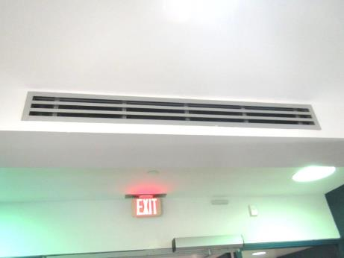
Supply vent in 4160 reception area
Picture 2
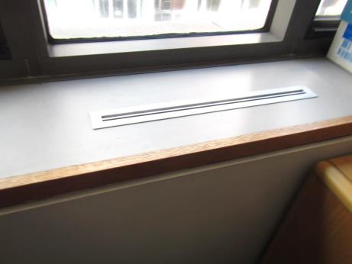
Cabinet-unit supply
Picture 3
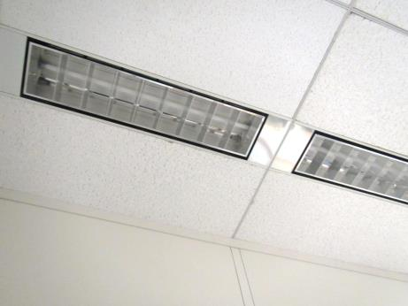
Return vents around light fixtures
Picture 4
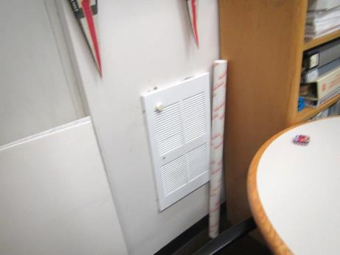
Heater built into wall
Picture 5
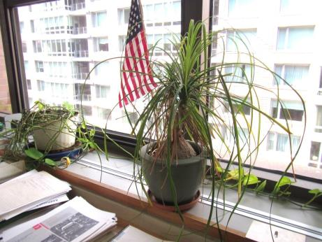
Plants on vent
Picture 6
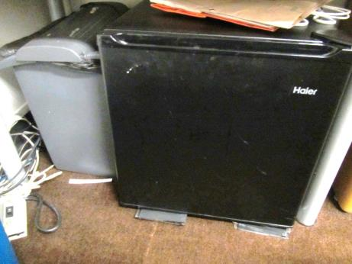
Small refrigerator on worn carpeting
Picture 7
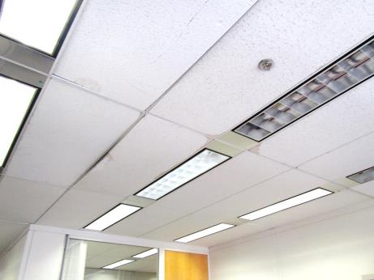
Water-damaged and bowed ceiling tiles in the plotter area
Picture 8
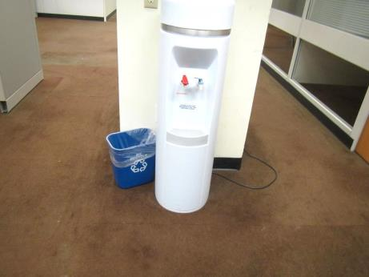
Water cooler on carpeting
Picture 9
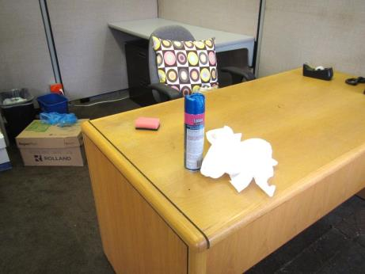
Spray cleaning product in use in the office
Picture 10
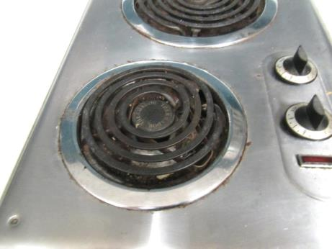
Electric cooktop with debris
Picture 11
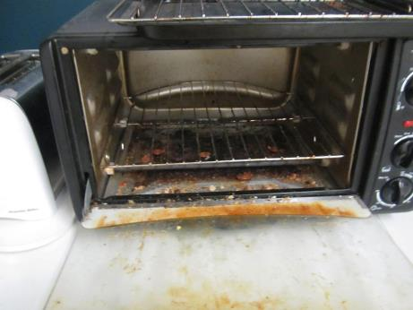
Debris in toaster oven
Picture 12
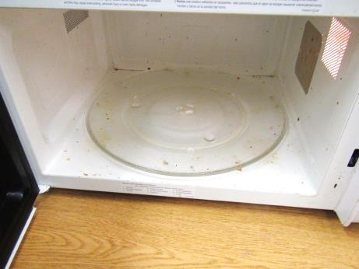
Debris in microwave
Picture 13
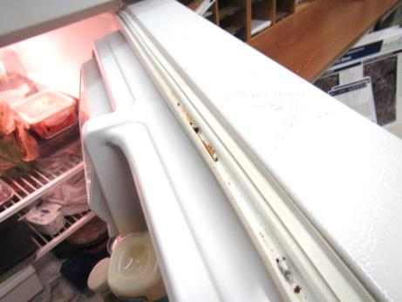
Debris in refrigerator gasket
Picture 14
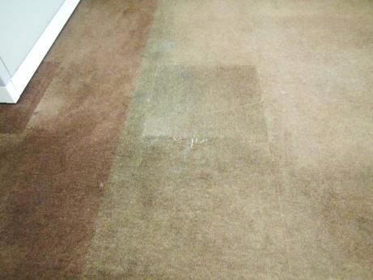
Worn carpeting with patch
Picture 15
Soiled, worn carpeting

Location | Carbon  Dioxide  (ppm) | Carbon Monoxide  (ppm) | Temp  (°F) | Relative  Humidity  (%) | PM2.5  (µg/m³) | Occupants  in Room | Windows  Openable | Ventilation |  | Remarks
 |  |  |  |  |  |  |  | Supply | Exhaust
Background (outside) |  |  | 72 | 61 |  |  |  |  |  | Sunny, breezy. Info from https://www.wunderground.com/histor
Suite 4150
Jessa | 716 | ND | 72 | 60 | 1 | 0 | N | Y | Y
Empty office | 684 | ND | 71 | 63 | 1 | 0 | N | Y | Y
Mier | 672 | ND | 71 | 63 | 1 | 1 | N | Y | Y | Cube area
Office | 704 | ND | 71 | 64 | 2 | 1 | N | Y | Y | DEM, DO
Pollock | 695 | ND | 71 | 64 | 1 | 0 | N | Y | Y | DEM
Office with pillar | 683 | ND | 70 | 64 | 1 | 0 | N | Y | Y | New carpet
Cubes | 747 | ND | 71 | 65 | 1 | 2 | N | Y | Y
Interior office | 708 | ND | 70 | 63 | 1 | 0 | N | Y | Y | DO
Fagerlund | 696 | ND | 71 | 63 | 0 | 0 | N | Y | Y | PF, DEM
Interior office | 624 | ND | 70 | 65 | 12 | 0 | N | Y | Y | DO
Fielding | 678 | ND | 70 | 65 | 1 | 0 | N | Y | Y
Foley | 707 | ND | 71 | 65 | 2 | 1 | N | Y | Y | DEM, PF on
Palladino | 688 | ND | 70 | 65 | 1 | 0 | N | Y | Y | DEM, items on floor
Office |  |  |  |  | 1 | 1 | N | Y | Y | DEM
Margolin | 693 | ND | 71 | 67 | 2 | 0 | N | Y | Y | Cube area
Fox | 733 | ND | 71 | 67 | 2 | 1 | N | Y | Y | DEM, food
Mohler | 720 | ND | 71 | 63 | 1 | 0 | N | Y | Y | DEM
Woelfel | 681 | ND | 71 | 63 | 1 | 0 | N | Y | Y | WD CT, DEM, curtains
Reception | 701 | ND | 71 | 64 | 1 | 0 | N | Y | Y
Frey | 691 | ND | 71 | 64 | 1 | 1 | N | Y | Y | Plants, DEM
Ho | 725 | ND | 72 | 64 | 1 | 0 | N | Y | Y | Worn carpet, DEM
Zotos | 769 | ND | 73 | 63 | 2 | 0 | N | Y | Y | Cubes
Paudel | 728 | ND | 73 | 62 | 2 | 0 | N | Y | Y | Cube area, worn carpet
Molloy | 711 | ND | 73 | 62 | 2 | 0 | N | Y | Y | Cube area, dusty PF
Plotter area |  |  |  |  |  |  | N | Y | Y | Many WD CT and bowed tiles due to reported roof leak, old carpet (dry)
Lopes | 777 | ND | 74 | 61 | 2 | 0 | N | Y | Y | Fridge on carpet, toaster, DEM
Sosa | 755 | ND | 74 | 60 | 2 | 1 | N | Y | Y | Cubes
Greenwelt | 841 | ND | 74 | 59 | 2 | 1 | N | Y | Y | Plants in nearby cube area
Olbrich | 754 | ND | 73 | 59 | 1 | 1 | N | Y | Y | DEM, cube area
Hamney | 751 | ND | 73 | 59 | 1 | 0 | N | Y | Y | Cube area, Items
Vanasse | 752 | ND | 73 | 59 | 1 | 0 | N | Y | Y | Cube area, DEM, food
Slesinger | 726 | ND | 73 | 559 | 2 | 1 | N | Y | Y | Cube area, plant pots (empty)
Interns | 732 | ND | 73 | 60 | 2 | 1 | N | Y | Y | Large cube area
Wilson | 716 | ND | 74 | 59 | 2 | 0 | N | Y | Y | DEM, HS, AP, dusty PF, Keurig
Goddard | 743 | ND | 74 | 59 | 1 | 1 | N | Y | Y | Cube area, flowers in water (several vases), PF
Sherman | 730 | ND | 74 | 58 | 1 | 2 | N | Y | Y | Cube area, items/paper on surfaces
Lucien | 723 | ND | 73 | 59 | 2 | 1 | N | Y | Y | Papers
Britland | 742 | ND | 73 | 59 | 2 | 0 | N | Y | Y
Sutton | 825 | ND | 74 | 60 | 1 | 1 | N | Y | Y | Cube area
Clark | 754 | ND | 74 | 59 | 1 | 1 | N | Y | Y | Cube area
Krevat | 765 | ND | 74 | 59 | 2 | 1 | N | Y | Y | Cube area
Pounds | 728 | ND | 73 | 59 | 1 | 0 | N | Y | Y | DEM, cloth on cubicle dividers
Boston Common conference | 697 | ND | 72 | 59 | 1 | 0 | N | Y | Y | Worn carpet
Lounge | 692 | ND | 72 | 62 | 1 | 0 | N | Y | Y | NC, fridge dirty, toaster and microwave with crumbs
Way | 718 | ND | 72 | 62 | 2 | 0 | N | Y | Y
Riley | 707 | ND | 71 | 62 | 2 | 1 | N | Y | Y | DEM
Other areas tested
2161 | 872 | ND | 74 | 58 | 0 | 0 | N | Y | Y | Old carpet, DEM, Fridge on carpet, built-in heater
2174 | 838 | ND | 75 | 60 | 2 | 1 | N | Y | Y | PF, items, old carpet
4160 | 767 | ND | 74 | 61 | 0 | 1 | N | Y |  | Reception area, vents blow directly on receptionist, vents reportedly recently cleaned, carpet reportedly new, but looks worn

