INDOOR AIR QUALITY ASSESSMENT

State Transportation Building
Suite 5750
10 Park Plaza
Boston, MA

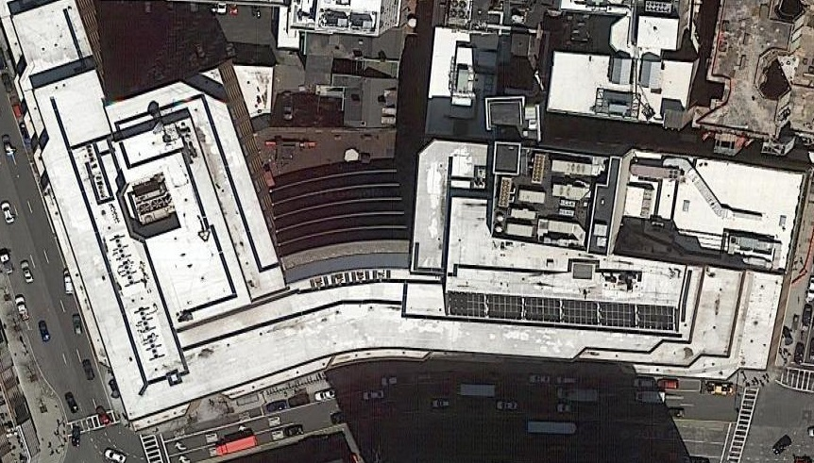

Prepared by:
Massachusetts Department of Public Health
Bureau of Environmental Health
Indoor Air Quality Program
August 2019

Background
Building: | MBTA Offices on the 5th floor of the State Transportation Building (STB)
Address: | 10 Park Plaza, Boston
Assessment Requested by: | Christine A. Escott, Facility Manager, Division of Capital Asset Management and Maintenance (DCAMM)
Reason for Request: | Concerns about indoor air quality (IAQ) and health
Date of Assessment: | August 1, 2019
Massachusetts Department of Public Health/Bureau of Environmental Health (MDPH/BEH) Staff Conducting Assessment: | Ruth Alfasso, Environmental Engineer, IAQ Program and Rachel Rochelson, IAQ intern
Building Description: | The STB is an 8-story concrete and brick building constructed in the 1980s. It has a large food court on the ground level, a parking garage underneath, and state offices above.
Windows: | Openable in a few areas

Methods
Please refer to the IAQ Manual for methods, sampling procedures, and interpretation of results (MDPH, 2015).

IAQ Testing Results
The following is a summary of indoor air testing results (Table 1).
- Carbon dioxide levels were below the MDPH guideline of 800 parts per million (ppm) in all areas surveyed, indicating adequate air exchange for the population in the building at the time of the assessment.
- Temperature was within the recommended range of 70°F to 78°F in all areas tested.
- Relative humidity was slightly above the recommended range of 40 to 60%. This reflects a period of high outdoor relative humidity and heavy rain over the previous several days.
- Carbon monoxide levels were non-detectable (ND) in all areas tested.
- Fine particulate matter (PM2.5) concentrations measured were below the National Ambient Air Quality Standard (NAAQS) limit of 35 μg/m³ in all areas tested.
- Total Volatile Organic Compounds (TVOCs) were ND in the areas examined.

Ventilation
A heating, ventilating, and air conditioning (HVAC) system has several functions. First it provides heating and, if equipped, cooling. Second, it is a source of fresh air. Finally, an HVAC system will dilute and remove normally-occurring indoor environmental pollutants by not only introducing fresh air, but by filtering the airstream and ejecting stale air to the outdoors via exhaust ventilation. Even if an HVAC system is operating as designed, point sources of respiratory irritation may exist and cause symptoms in sensitive individuals.
Fresh air is supplied by induction units near windows (Picture 1). Return air is drawn through vents around light fixtures using ducted returns (Picture 2). Fresh air is supplied around some lights as well. In some areas, items were on the induction unit cabinets (Picture 3), including plants. This can block the supply of fresh air as well as aerosolize odors and particulates such as dust, mold spores, and pollen. Vents should be kept clear of items. Occupants reported that in some areas the vents were blocked deliberately because of drafts and uncomfortable temperatures. In other areas, occupants reported a lack of airflow from the units, and one person reported that maintenance had been called to repair the unit and needed replacement parts in order to return the system in that office to functioning. Temperature complaints were also made by several occupants.
Facility staff reported that renovations and reconfigurations of space occurred in the suite without changes to the HVAC system layout, which may account for some of the difficulties in controlling airflow and temperature. It is recommended that HVAC systems be re-balanced every five years, or more frequently when layouts/uses are changed to ensure adequate air systems function (SMACNA, 1994). It was unknown when the last time these systems had been balanced. In addition, the equipment in the building is original and thus over 30 years old. As equipment ages, maintenance becomes increasingly difficult, including replacement parts becoming more difficult to obtain. Efficient function of equipment of this age is difficult to maintain, since compatible replacement parts are often unavailable. According to the American Society of Heating, Refrigeration, and Air-Conditioning Engineering (ASHRAE), the service life for a unit heater, hot water or steam is 20 years, assuming routine maintenance of the equipment (ASHRAE, 1991).
Note that this office has a spiral staircase to the next level up located near the reception area (Picture 4). The floor above is used by a different department and was not examined during this assessment. However, this open channel between floors likely complicates airflow balancing.
Note that relative humidity inside the office was slightly higher than outside (Table 1). The assessment was conducted on a day following several days of high temperature and humidity, with rain the previous afternoon. If a building does not have adequate exhaust ventilation and air chilling capacity to remove/reduce relative humidity from outside air, then hot, moist air can be introduced into a building and linger to increase occupant discomfort as well as possibly moisten materials that may lead to mold growth.

Microbial/Moisture Concerns
Light water stains were noted in two areas (Picture 5; Table 1). This likely is the result of a leak/condensation in the HVAC or sprinkler system. The area above this ceiling tile should be examined for the source of the leak and for any additional water-damaged materials. Once the leak is repaired, the affected ceiling tiles should be replaced.
As shown in Picture 3, plants were noted in a few areas. Plants should be properly maintained and equipped with drip pans and should be located away from airflow to prevent the aerosolization of dirt, pollen, and mold.
Refrigerators and water dispensers were located on carpet, including in the kitchen (Picture 6). Refrigerators and water dispensing equipment should be located in a non-carpeted area or on a waterproof mat to prevent damage to carpet and subsequent odors.

Other Concerns
Exposure to low levels of total volatile organic compounds (TVOCs) may produce eye, nose, throat, and/or respiratory irritation in some sensitive individuals. BEH/IAQ staff took measurements for TVOCs and examined spaces for products containing VOCs. While VOC levels were not detected (ND) in the areas examined, BEH/IAQ staff noted hand sanitizers, air fresheners, and dry erase materials in the office space (Picture 7; Table 1). All of these products have the potential to be irritants to the eyes, nose, throat, and respiratory system of sensitive individuals. Note that this office provides services to people with disabilities, some of whom visit the office for hearings or meetings. Conditions such as asthma, migraine headaches or chemical sensitivity issues can be exacerbated by exposure to TVOCs. Fragrances used in air freshener products in particular can be an irritant and trigger for other health problems. Note that fragranced products do not remove odors, but merely mask them with another scent. For more information, the MDPH guidance “Clean Air is Odor Free” is attached as Appendix A.
There are also photocopiers in the suite, which can give off odors, particulates and ozone, particularly older models that are heavily used (Schmidt Etkin, 1992). Photocopiers should be placed in well-ventilated areas away from occupants.
Food and food preparation equipment was observed in some offices and common areas. Food should be kept tightly sealed to prevent pest access and food preparation equipment should be kept clean to prevent smoke, odors and pests. Pest control equipment such as rodent bait traps and sticky traps were seen in various locations in the office (Pictures 8 and 9). If pests are an issue in this office, it is even more important to keep food tightly sealed and food preparation equipment clean. Harborage/nesting areas, such as papers and boxes should be removed, and any gaps between occupied and unoccupied spaces should be sealed to further discourage rodents. Note that rodents can be a source of allergens from their dander and wastes. Even if the rodents are removed, additional cleaning is required to remove the materials that may lead to allergic reactions.
The carpeting in this area of the building appears to be original to the building. It is in poor condition, with numerous stains, tears and uneven areas (Pictures 6 and 10). Carpeting deteriorates over time, and becomes increasingly difficult to clean. This leads to a buildup of dirt, dust, odors and possible microbial contamination. Deteriorating carpeting can also become a source of irritating fiber dust. Carpeting is specifically not recommended in kitchens or other areas where spills, crumbs or similar issued are common. Also note that many of the visitors to this office use wheelchairs. Wheelchairs put additional wear on carpeting due to the increased weight of motorized units, pressure from the relatively small surface area of the wheels on some units, and shear forces from turning. Wheelchair users may also be exposed to carpet-related contaminants on hands used to operate non-motorized units. In addition, worn and wrinkled carpeting can be difficult for those using wheelchairs or other mobility aids (walkers, canes) to traverse.
In general, carpets should be cleaned annually (or semi-annually in soiled/high traffic areas) in accordance with Institute of Inspection, Cleaning and Restoration Certification (IICRC) recommendations, (IICRC, 2012).
Note that this office is undergoing some reorganization and renovations. A large number of files which had been stored in two rooms had recently been removed and additional files were scheduled to be removed soon after the assessment. Papers and files can be a source of dust, particularly if files are older or have not been stored properly. Additional cleaning, including vacuuming with high efficiency particulate arrestance (HEPA)-equipped vacuum cleaners, should be conducted during and after the sorting and removal of files and associated movement of furniture and other items to prevent large amounts of dust from causing irritation for occupants.
Walls were also scheduled to be changed in some areas of the office. It is important that activities which may product large amounts of noise, dust or odors be conducted away from occupants and preferable when the office is unoccupied. When renovation activities need to take place during occupied periods, care should be taken to isolate renovation from occupied areas. Barriers made from plastic sheeting can be used to separate out areas under construction. The HVAC system supply and returns should also be turned off or blocked to prevent distribution of dust and odors to occupied areas. In addition, occupants should be kept informed of construction schedules, and have a way to report issues/concerns with construction activities so that they can be resolved quickly. The MDPH guidance “Construction and renovation generated pollutants in occupied buildings” is attached as Appendix B for more information.
Items were observed on flat surfaces, such as windowsills, tabletops, counters, bookcases, and desks (Table 1). Items stored in offices provide a source for dusts to accumulate. These items also make it difficult for custodial staff to clean. Items should be relocated and/or be cleaned periodically to avoid excessive dust build up. Some offices have cloth curtains over interior windows for privacy. These should be cleaned or laundered periodically to remove dust.

Conclusions/Recommendations
Based on observations at the time of assessment, the following is recommended:
- Operate supply and exhaust ventilation continuously in all areas during occupied periods. Ensure all HVAC equipment is cleaned/maintained in accordance with manufacturer’s instructions. Ensure there is sufficient capacity for cooling and exhaust to remove excess relative humidity.
- Regularly clean supply and return vents and vent cabinets.
- Remove items from the top and front of vent cabinets to allow for airflow.
- Balance the HVAC system every 5 years in accordance with Sheet Metal and Air Conditioning Contractors’ National Association (SMACNA) recommendations (SMACNA, 1994).
- Ensure that new uses of the space and the presence of the staircase of the next level are taken into account when airflow is modified and balanced.
- Replace water-damaged ceiling tiles. Repair any source of leaks as they are discovered.
- Keep plants and flowers in good condition, avoid overwatering, and remove from the airstream of heating and ventilation equipment.
- Consider placing refrigerators and water dispensers in areas without carpeting, or use a waterproof mat to protect carpeting.
- For buildings in New England, periods of low relative humidity during the winter are often unavoidable. Therefore, scrupulous cleaning practices should be adopted to minimize common indoor air contaminants whose irritant effects can be enhanced when the relative humidity is low. To control for dusts, a high efficiency particulate arrestance (HEPA) filter equipped vacuum cleaner in conjunction with wet wiping of all surfaces is recommended. Avoid the use of feather dusters. Drinking water during the day can help ease some symptoms associated with a dry environment (throat and sinus irritations).
- Reduce the use of cleaning products, sanitizers, and other items that contain VOCs.
- Consider the use of a “scent free” office policy to protect occupants and visitors. Review Appendix A (“Clean Air is Odor Free”) for more information on fragrances.
- Keep photocopiers in well-ventilated areas and away from occupants where possible.
- Keep food preparation equipment clean, and clean out the refrigerators, including the gaskets, regularly.
- Use the services of a licensed pest contractor to control rodents and other pests as needed. Increase cleaning in areas where rodents/pests were present to remove allergens.
- Consider replacement of carpeting in the office suite, including the use of non-porous flooring in areas such as the kitchen.
- Reduce the amount of items stored on flat surfaces to allow regular cleaning.
- Clean carpeting in accordance with IICRC recommendations (IICRC, 2012). Consider a plan for replacement of carpeting in this office suite. The plan should include the use of non-porous flooring (e.g. floor tile) in areas such as kitchens.
- Clean cloth curtains in offices periodically to remove dust.
- Conduct renovations in accordance with “Methods Used to Reduce/Prevent Exposure to Construction/Renovation Generated Pollutants in Occupied Buildings” attached as Appendix B.
- Refer to resource manual and other related IAQ documents located on the MDPH’s website for further building-wide evaluations and advice on maintaining public buildings. These documents are available at: http://mass.gov/dph/iaq.

References
ASHRAE. 1991. ASHRAE Applications Handbook, Chapter 33 “Owning and Operating Costs”. American Society of Heating, Refrigeration and Air Conditioning Engineers, Atlanta, GA.
IICRC. 2012. Institute of Inspection, Cleaning and Restoration Certification. Carpet Cleaning: FAQ.
MDPH. 2015. Massachusetts Department of Public Health. Indoor Air Quality Manual: Chapters I-III. Available at: http://www.mass.gov/eohhs/gov/departments/dph/programs/environmental-health/exposure-topics/iaq/iaq-manual/.
Schmidt Etkin, D. 1992. Office Furnishings/Equipment & IAQ Health Impacts, Prevention & Mitigation. Cutter Information Corporation, Indoor Air Quality Update, Arlington, MA.
SMACNA. 1994. HVAC Systems Commissioning Manual. 1st ed. Sheet Metal and Air Conditioning Contractors’ National Association, Inc., Chantilly, VA.
Picture 1
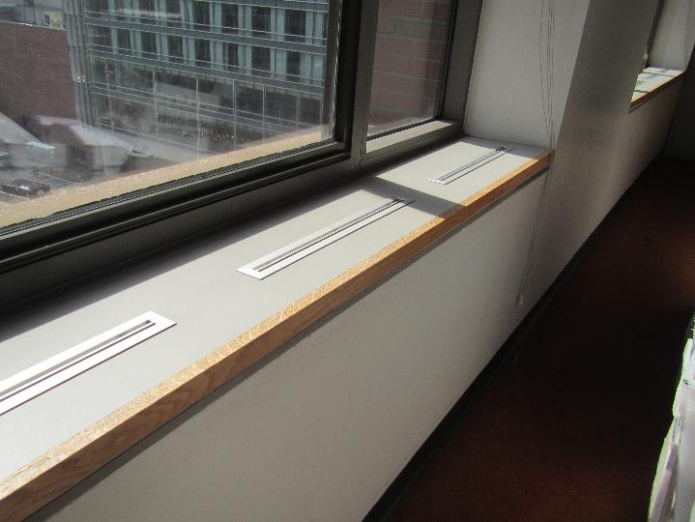
Vents along windows
Picture 2
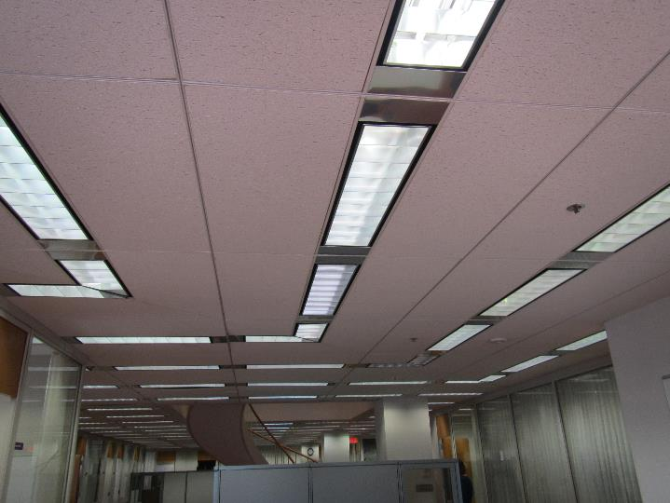
Light fixtures with supply and return vents around them
Picture 3
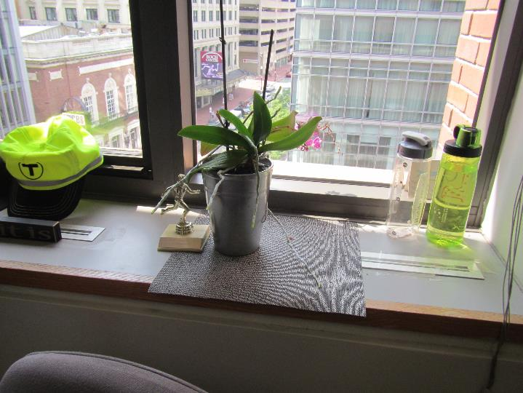
Items, including plants, on vents
Picture 4
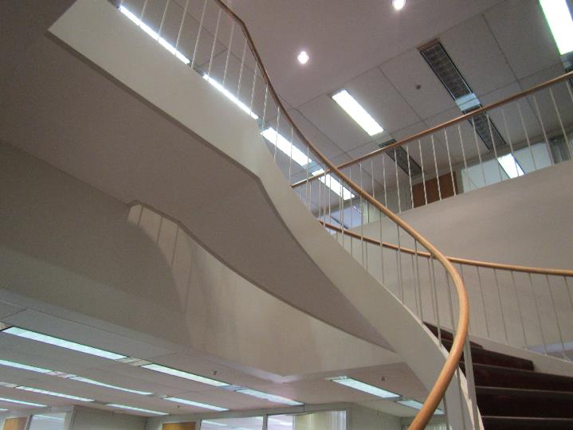
Spiral staircase to floor above
Picture 5
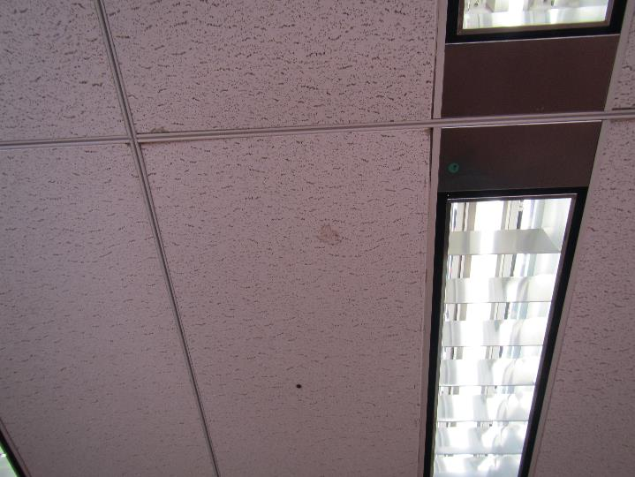
Small water stain on ceiling tile
Picture 6
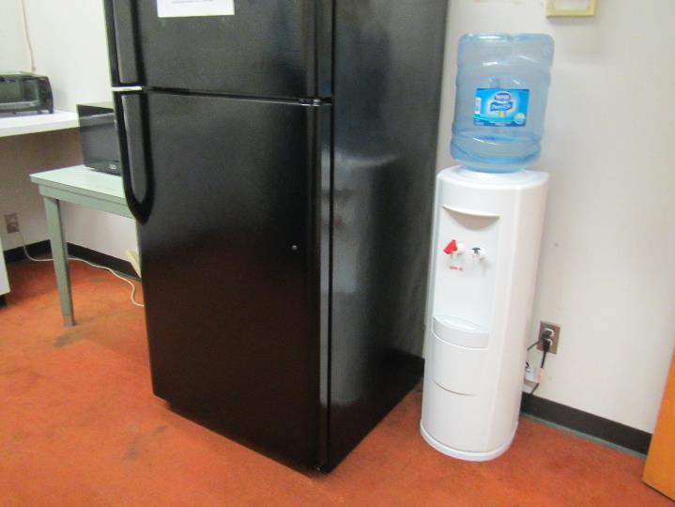
Refrigerator and water dispenser on carpet in kitchen area, note poor condition of carpet
Picture 7
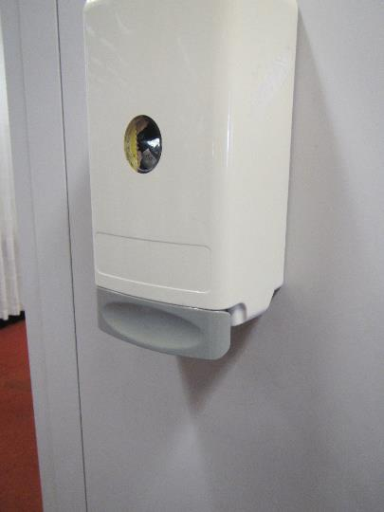
Hand sanitizer dispenser in the office
Picture 8
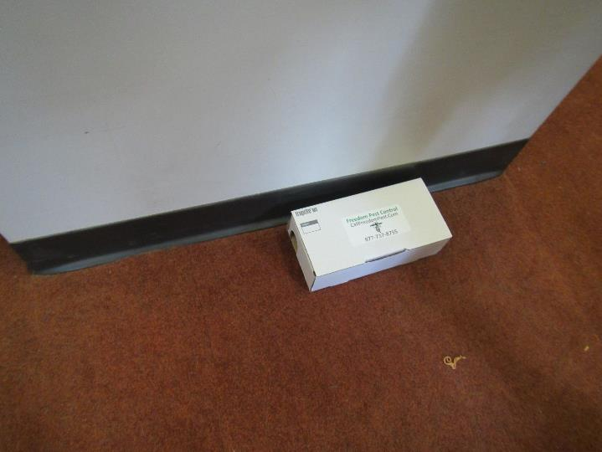
Pest control rodent trap
Picture 9
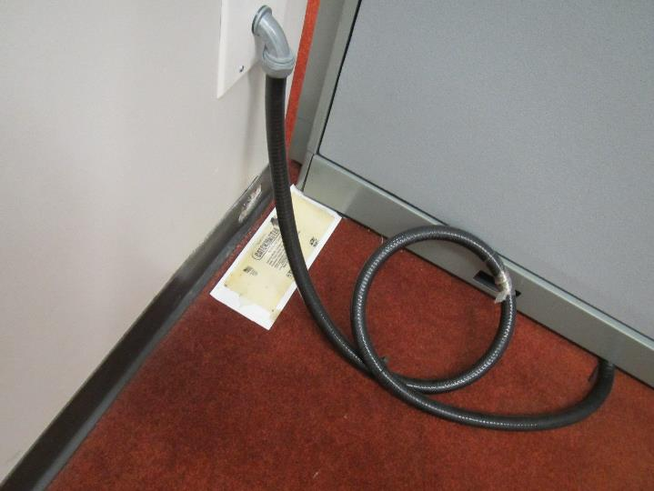
Sticky trap for rodents and insects
Picture 10
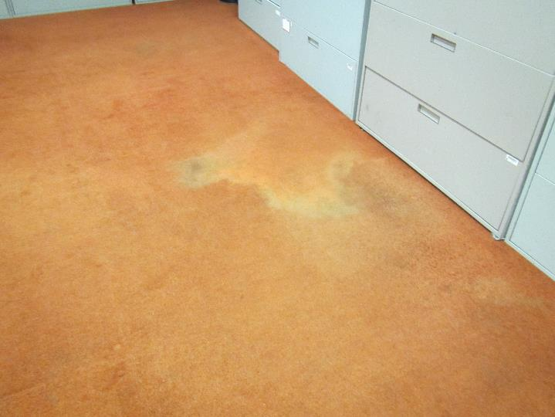
Stained, wrinkled, worn carpeting
Location | Carbon  Dioxide  (ppm) | Carbon Monoxide  (ppm) | Temp  (°F) | Relative  Humidity  (%) | PM2.5  (µg/m³) | TVOC (ppm) | Occupants  in Room | Windows  Openable | Ventilation |  | Remarks
 |  |  |  |  |  |  |  |  | Supply | Exhaust
Background | 396 | ND | 79 | 60 | 13 | -- |  |  |  |  | Street level
Back hallway | 685 | ND | 73 | 64 | 4 | ND | 0 | Y | Y | Y
Corner office | 619 | ND | 74 | 64 | 3 | ND | 1 | Y | Y | Y
Paci office | 673 | ND | 73 | 63 | 4 | ND | 1 | N | Y | Y | 1 WD CT (small)
5473 | 628 | ND | 74 | 63 | 4 | ND | 0 | N | Y | Y | DEM
5761 | 627 | ND | 74 | 63 | 4 | ND | 0 | N | Y | Y | DEM
5762 | 611 | ND | 73 | 64 | 4 | ND | 0 | N | Y | Y | Items on vent, boxes on floor, area rug
Cube area | 634 | ND | 73 | 64 | 4 | ND | 0 | N | Y | Y | Items on vent to block, heater
Hatch office | 655 | ND | 73 | 64 | 4 | ND | 1 | N | Y | Y
Ahmad Office | 656 | ND | 73 | 64 | 4 | ND | 1 | N | Y | Y | Reports of dust (shown on a piece of paper), curtains, DEM
Ahola office | 701 | ND | 73 | 65 | 4 | ND | 1 | N | Y | Y | Plant on vent, PF – on, DEM
Cube area | 654 | ND | 74 | 64 | 5 | ND | 1 | N | Y | Y | Vent off (needs maintenance), plant on vent, PF – on
5742 | 667 | ND | 73 | 64 | 5 | ND | 2 | N | Y | Y | DEM, items on vent and floor
5743 | 677 | ND | 73 | 66 | 10 | ND | 0 | N | Y | Y | Vacant
Cube area | 710 | ND | 73 | 66 | 4 | ND | 1 | N | Y | Y
5751 Kitchen | 641 | ND | 73 | 66 | 4 | ND | 0 | N | Y | Y | Carpet stained and worn, kitchen appliances including 2 unit stovetop, water dispenser, dirt under sink, rodent traps
Office | 655 | ND | 73 | 65 | 4 | ND | 0 | N | Y | Y | Curtains
Reception cube area | 634 | ND | 73 | 64 | 4 | ND | 1 | N | Y | Y | Plants, stairwell to floor above
5763 | 669 | ND | 73 | 65 | 4 | ND | 1 | N | Y | Y | DEM, curtains
5764 | 662 | ND | 73 | 65 | 4 | ND | 1 | N | Y | Y | Items hanging from sprinkler head, DEM, PF – on, AF
Cube area | 663 | ND | 73 | 64 | 3 | ND | 2 | N | Y | Y
5782 | 648 | ND | 73 | 64 | 4 | ND | 1 | N | Y | Y | AF, items, PF on
Conference room | 693 | ND | 73 | 64 | 4 | ND | 0 | N | Y | Y | DEM
5761 | 647 | ND | 73 | 65 | 4 | ND | 1 | Y | Y | Y
Files | 629 | ND | 73 | 64 | 4 | ND | 0 | N | Y | Y | Files/cabinets, in process of being removed
5791 | 612 | ND | 73 | 64 | 3 | ND | 0 | N | Y | Y
Files (rear) | 612 | ND | 72 | 65 | 3 | ND | 0 | Y | Y | Y | File cabinets
Rear conference room | 683 | ND | 74 | 65 | 5 | ND | 4 | N | Y | Y | DEM

The service life is the median time during which a particular system or component of …[an HVAC]… system remains in its original service application and then is replaced. Replacement may occur for any reason, including, but not limited to, failure, general obsolescence, reduced reliability, excessive maintenance cost, and changed system requirements due to such influences as building characteristics or energy prices (ASHRAE, 1991).

