Outline for Acquisition Process:
- Agency identifies a need for a vehicle, whether through:
  - Review of a replacement criteria and/or idle violation report from OVM
    - OVM may direct replacement of such vehicles
    - See page 2 (decision tree)
  - Total loss of an existing vehicle
  - Additional headcount in positions which require vehicles to complete the job function
    - No increases to fleet vehicle count allowed at this time – Agency should seek vehicles from other areas within the Agency and/or Secretariat
  - New vehicle function (business need) created
    - No increases to fleet vehicle count allowed at this time – Agency should seek vehicles from other areas within the Agency and/or Secretariat
    - If Agency is unable to shift vehicles within the Secretariat to cover the new business need, reach out to OVM for next steps
- Agency submits vehicle request workbook to OVM
  - Review the instructions tab within the applicable workbook for further information
- OVM reviews workbook and provides feedback, including but not limited to:
  - Requests for expanded justification or other information
  - Providing utilization report which may identify potential redeployments (instead of acquiring a new vehicle)
- OVM will define the category, size/type, and engine designation of vehicle(s) to fulfill the need(s), based on the justification provided
  - Environmental guidelines, such as the EV First Policy, EO594, and FES, will be applied
  - Agency will have the ability to select the specific make/model of vehicle within the defined category, size/type, and engine designation
- Continued discussions and iterations of workbook between Agency and OVM
  - Quotes should not be obtained until after the vehicle category, size/type, and engine designation are approved by OVM
  - Once a quote is obtained, similar discussions and iterations may occur
- Workbook and quote form finalized and agreed between OVM and Agency

If direct purchase, following will occur:
- OVM issues approval via email, including next steps
  - Vendor is copied for reference
- Agency issues PO via COMMBUYS
  - If order acknowledgement from vendor is not received within expected time frame, Agency should follow-up with vendor
- Agency provides copy of COMMBUYS PO to OVM

If lease request, following will occur:
- Signed Master Lease Agreement must be on file (may occur during previous steps)
- OVM sends email to Agency CFO for repayment commitment
- OVM issues PO via COMMBUYS
  - If order acknowledgement from vendor is not received within expected time frame, OVM will follow-up with vendor
- A copy of COMMBUYS PO is available to Agency

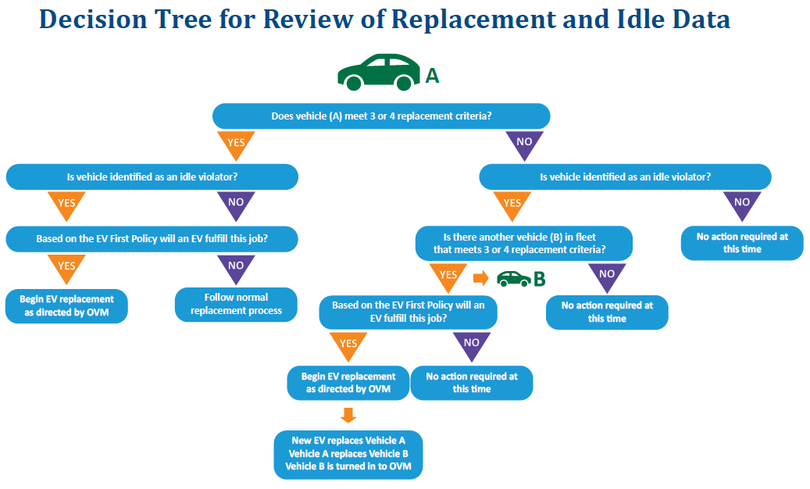

Outline for Delivery:
- Dealer receives vehicle from OEM or otherwise has vehicle in stock
- Upfitting or additional non-OEM options are installed, if applicable
  - If work is done off-site, vehicle is returned to dealer when complete
- Dealer completes registration paperwork and provides to OVM
  - If Dealer contacts Agency for information during this process, direct them to OVM
- OVM reviews paperwork and provides registration and plates to Dealer
  - OVM may contact Agency to confirm all details are correct, such as:
    - Unit code
    - Garage location
  - Additional iterations may occur if inaccuracies are discovered
- OVM may receive registration paperwork for an asset which has not been reviewed and vetted, such as:
  - Non-Executive Branch Agency acquisitions
  - Executive Branch OVM-managed Agency acquisitions of equipment, trailers, or heavy-duty vehicles
    - All Light-Duty and Medium-Duty vehicle acquisitions by Executive Branch OVM-managed Agencies MUST be reviewed and vetted by OVM prior to acquisition
  - Additional details may be required to proceed with registration, such as:
    - Validated vendor quote
    - Delivery location
- Dealer obtains state inspection sticker and schedules delivery of fully fueled vehicle to Commonwealth
  - All OVM-managed assets are delivered to the OVM lot in Westboro
    - If Dealer contacts Agency to schedule delivery of such an asset, direct them to OVM
- Assets delivered to the OVM lot are reviewed, inspected, and additional steps are completed, as applicable:
  - Fuel card is ordered
  - Telematics device is installed
  - Decals are applied (1-800-How Am I Driving, POW/MIA, Telematics)
- OVM contacts Agency to coordinate pickup of vehicle from OVM lot
  - Turn-in should occur at this time, unless already completed
  - Maintenance packet will arrive to Agency within 2-3 weeks of pick-up of new vehicle

