
The Commonwealth of Massachusetts
Fire and EMS Mobilization Plan
December 2019

Table of Contents
Record of Change 4
Executive Summary 4
1. Introduction 5
1.1 Purpose 5
1.2 Scope 5
1.3 Goals and Objectives 5
2.0 Situation and Plan Assumptions 7
2.1 Situation 7
2.2 Plan Assumptions 7
3.0 Concept of Operations 8
3.1 General 8
3.2 Plan Activation 8
3.2.A Key Players during Activation 8
3.2.B Stages of Statewide Mobilization 9
3.2.C Main Activation Activities including Immediate Deployment 10
3.2.D Information Provided During Local Activation 11
3.2.E MEMA Dispatch Instructions 12
3.2.F Unfilled Task Force/Strike Team Procedure 13
3.2.G Sending Department Unable to Respond 14
3.2.H Request for Multiple Task Forces/Strike Teams 15
3.2.I Non-Immediate Deployment 16
3.2.J Mobilization: Transit and Staging 17
3.2.K Resource Manifests 18
3.2.L Resource Check-in Procedure 19
3.2.M Fire Mobilization Resource Management 20
3.2.N Demobilization 21
3.2.O Post-Mobilization Activities 22
5.0 Administration and Logistics 24
5.1 Plan Maintenance 24
5.2 Training and Exercises 24
5.3 Expenditures and Reimbursements 24
5.4 Responder Protection 24
6.0 Communications 26
6.1 Communications in Transit (Vehicle-to-Vehicle) 26
6.2 Statewide Radio System Resources 27
6.2.1 MEMA VHF System 27
7.0 Authority and References 27
7.1 Authorities 27
7.2 References 27
Appendix A: Additional Resources 28
A.1 MEMA Resources 28
A.2 Regional CMED Centers 28
A.2.1 Regional Mass Casualty Support Unit (RMCSU) 28
A.2.2 MCI Trailers 28
A.3 Department of Fire Service (DFS) Resources 29
A.4 Regional Communication Units 29
A.5 Mass Decontamination Units (MDU) 29
A.6 Massachusetts Technical Rescue 30
A.7 Massachusetts Urban Search and Rescue Task Force 34
Appendix B: Fire Mobilization Resource Definitions 35
B.1 Ambulance Task Force/Strike Team 35
B.2 Structural Task Force 35
B.3 Structural Strike Team 36
B.4 Forestry Task Force 36
B.5 Forestry Strike Team 36
B.6 Structural Tender Task Force 37
B.7 Structural Tender Strike Team 37
B.8 Structural Hand Crew 38
B.9 Forestry Hand Crew 38
Appendix C: Organization 40
C.1 Mobilization Regions and Districts 40
C.2 District Control Center Contacts 41
C.3 Maps 42
C.3.A Fire Districts Map 42
C.3.B EMS Regions Map 42
C.4 Mobilization Governing Bodies 43
Appendix D: Resource Inventory Responsibilities 44
D.1 Resource Inventory and Run Cards 44
D.2 Resource Tracking 44
D.3 Responsibilities of Deploying Agencies 44
D.4 Individual Responsibilities 46
D.5 Training Responsibilities 46
Appendix E: Levels of Response (Federal Designations) 47
Appendix F: Other MEMA Emergency Plans 48
F.1 MEMA Mission 48
F.2 Massachusetts Comprehensive Emergency Management Plan (CEMP) 48
F.3 Emergency Support Functions (ESF) and SEOC 49
F.4 Fire Mobilization Presence in the SEOC 49
F.5 Massachusetts Emergency Support Functions (MAESF) 49
Appendix G: Inventory and Run Card Samples 51
Appendix H: Liability 52
Appendix I: Federal Reimbursement & Documentation Procedures 53
I.1 Eligibility 53
I.2 Categories of Work 53
I.3 Expenses for Personnel 54
I.4 Expenses for Equipment 54
I.5 Damage / Loss of Equipment 54
I.6 Rented Equipment 55
I.7 Forms 55
Appendix J: Mobilization Committee Detailed Job Descriptions 56
J.1 Chairman, Mobilization Committee 56
J.2 Regional Coordinator 57
J.3 District Coordinator 58
J.4 Task Force/Strike Team Leader 59
J.5 District Communications Specialist 60
Appendix K: Definitions 62
Appendix L: NIMS Resource Typing 66

Record of Change
Date  of Change | Page/Section  Changed | Summary of Change
12/2019 | Plan | Plan developed
9/23/2021 | Section 6.2.2  Appendix A.6 | Removed CoMIRS placeholder  Added MA Tech Rescue
3/23/2022 | Appendix A.2  Appendix C.2 | Updated Bristol County control phone number
9/1/2022 | Appendix C.3A | Map updated (Athol moved from D9 to D8)
10/13/2023 | Appendix C.3A | Map updated (Brimfield, Holland and Wales moved from D11 to D7)
12/5/2023 | Section 2.2 | Ambulance required on-scene during Fire Mobilization activations
3/18/2025 | Appendix C.2 | D7 control point number updated
3/31/2025 | ICS Form Links | Links updated throughout plan
4/7/2025 | Appendix C.2 | D14 control point number updated

Executive Summary

The Massachusetts Fire Service and EMS Mobilization Plan (hereafter known as the Plan) is a tool to provide communities with easy access to resources located outside of their district in the event that district mutual aid has been exhausted or will soon be exhausted. Please note that this version of the Plan explicitly enables mobilization of Strike Teams in addition to Task Forces.

Introduction

Purpose
- The Plan is a mechanism, distilled from past experiences, that provides a large pool of Fire and EMS resources in organized units beyond the means of any single fire department.
- The Plan can be utilized in two scenarios: (1) for an unplanned situation, ranging from small incidents to catastrophic events, or (2) for pre-planned events.
- The Plan is a coordinated effort between MEMA, local fire departments, and EMS and related stakeholders.
- The Plan is overseen by the Mobilization Committee, with the assistance of MEMA.
- This Plan is completely separate from normal local or district mutual aid operations or agreements as utilized on a daily basis by Fire and EMS Services.

1.2 Scope
- Fire Departments, DFS, DPH, and MEMA, through the Fire District Control Centers, the State Emergency Operations Center (SEOC), and its authorized agents, shall utilize this Plan to coordinate and initiate all fire and EMS-related resources throughout the Commonwealth of Massachusetts.
- The Plan provides for the activation and sustained response of aid to a community in the event of a localized incident or a preplanned event. These events may overwhelm the local fire department serving the community and its normal mutual aid resources and can include, but are not limited to, large public gatherings, major fires, tornadoes, train derailments, hazardous materials incidents, wildland fires, or domestic terrorism.
- The Plan acknowledges the State’s Home Rule and recognizes that the control of an incident will remain in the hands of the local jurisdiction under all circumstances.

1.3 Goals and Objectives
- Provide a simple method to activate adequate units of fire, EMS, and specialized personnel and resources necessary. Please note that this version of the Plan explicitly enables mobilization of Strike Teams in addition to Task Forces.
- Serve as the main mechanism for the mobilization of resources in a coordinated manner with various state and local agencies.
- Provide the interface between the Local and Regional Mutual Aid Systems and the State of Massachusetts Emergency Response Plan in an effort to mobilize fire, rescue, EMS, and specialized fire resources statewide.
- Provide a mechanism to interface with other recognized state plans.
- Ensure that local command and control of the incident and the initial response of local and regional resources are not diminished by activating the Plan.
- Ensure that an activation procedure is followed to provide an orderly response and prevent self-dispatching.
- Require all communities to retain a reasonable level of fire and EMS protection for their own coverage.
- Establish the positions, roles, and responsibilities necessary to activate and maintain this Plan.
- Complement other emergency plans at the local and state levels.
- Utilize the Incident Command System (ICS) and the principles of the National Incident Management System (NIMS) that have been adopted by the Commonwealth of Massachusetts.

2.0 Situation and Plan Assumptions

2.1 Situation
Large-scale fires, or other large-scale incidents, may require additional resources after the depletion of local resources. The coordination, management, and utilization of additional resources from outside of one’s District or Region is complex and can involve multiple agencies and jurisdictions.

2.2 Plan Assumptions
- Most incidents that require fire service or EMS assets are local in scope and can be addressed by local resources as part of their normal day-to-day operations or existing local or fire district mutual aid systems.
- Local jurisdictions will use their own resources first, then request district mutual aid, and only then request assistance in the event that the impact of an incident exceeds or is expected to exceed the local and fire district capability to respond to it.
- All vehicles that are part of the plan will be equipped as outlined in NFPA requirements, ready and safe for long distance travel, and capable of 2-way radio communications as outlined in this document.
- All fire personnel being deployed during a mobilization will be at least Firefighter 1-2 trained and EMS personnel will be certified as an Emergency Medical Technician or Paramedic as required by OEMS.
- Each person being deployed during a mobilization will be properly outfitted with Personal Protective Equipment for the type of incident they are responding to.
- The Requesting Community is required to have an ambulance on-scene for the duration of a Fire Mobilization activation.

3.0 Concept of Operations

3.1 General
When the Plan should be activated:
- When local jurisdiction is impacted by an incident which has exhausted or will soon exhaust additional assistance through the local, district, or regional mutual aid systems.
- In preparation for a large, pre-planned or long duration event that could potentially require a large number of fire or EMS resources.
Types of Activation:
- Immediate Deployment
  - Immediate deployment of resources anticipates a direct response to the staging area of the incident.
  - Time of deployment is expected to be one Operational Period of approximately 12 hours or less.
- Non-immediate Deployment
  - The resources to be activated are to report to the incident at a specific time to work an Operational Period and then be demobilized and return to their departments.
  - If equipment resources are to be held for multiple operational periods, then personnel will be rotated.

3.2 Plan Activation

3.2.A Key Players during Activation
The six key players during an activation are listed below.
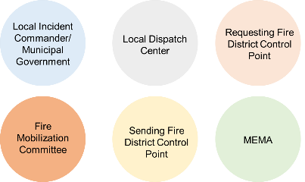

3.2.B Stages of Statewide Mobilization
The four main stages of mobilization are activation, mobilization/incident management, demobilization, and post-mobilization. Each stage contains several activities which are listed on the right side of the page. More detail about each stage and activity is included in the flows in this section.
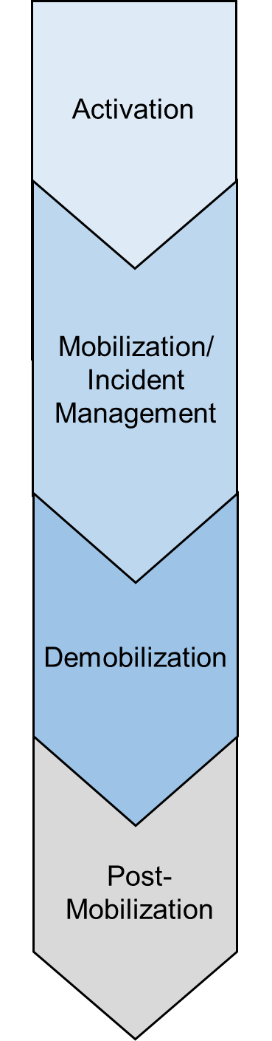
- Activate Plan
  - Immediate Deployment
  - Non-Immediate Deployment
- Request resources
- Initiate communication to and from sending and receiving parties via MEMA, district- and regional-coordinators
- Assemble resources
  - Task Forces
  - Strike Teams / other resources
- Immediate Response: travel to assembly point and then travel to staging area
- Non-Immediate Response: travel to assembly point and then travel to incident in convoy
- Report to staging/incident command
- Check-in
- Receive assignment
- Execute on-scene
- Track resources and document
- Document the incident
- Complete reports and assessments
- Initiate possible reimbursement
- Conduct a debriefing and/or after-action process
- Receive demobilization order
- Check out of incident/demobilize
- Travel back to demobilization location or local community

3.2.C Main Activation Activities including Immediate Deployment

The following business process flow details the procedure for activation of the Plan, when an Incident Commander (IC) determines that statewide fire mobilization is needed. The first step in the process starts with local IC reaching out to their local dispatch center, the local dispatch center then contacts their District Control Point who then contacts MEMA. MEMA subsequently contacts the appropriate sending fire district and the resources are mobilized. In the case that the first Task Force/Strike Team cannot be filled, the Unfilled Task Procedure should be followed.
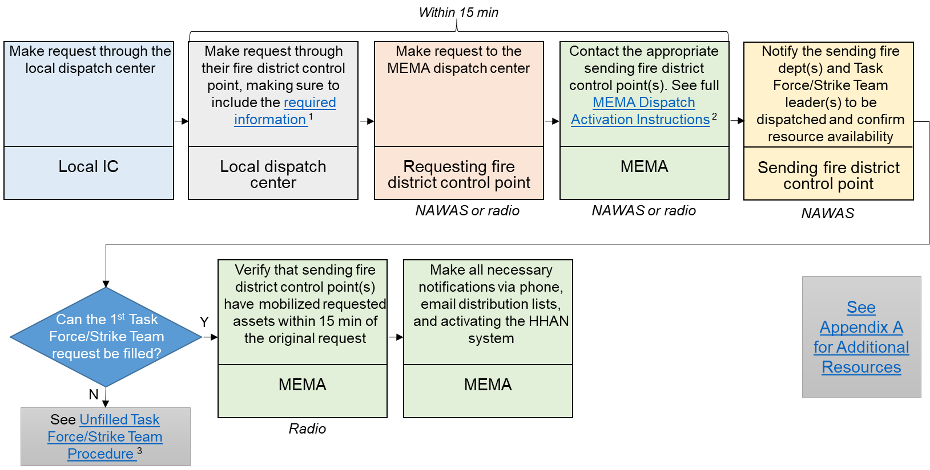
1 Required information 2 MEMA Dispatch Instructions 3 Unfilled Task Force/Strike Team Procedure Additional Resources can be found in Appendix A

3.2.D Information Provided During Local Activation
The following list captures information that Local Dispatch should provide to District Control during activation:
  - Requesting Fire District #
  - Requesting City/Town
  - IC and Dispatch Number
  - On-scene Radio Channel Assignment (preferably ICS 205 if available)
  - Activation Type
    - Task Force or Strike Team
    - Structural, Forestry, Tender, and/or Ambulance
  - Incident Location
  - Reporting Location (specify staging or incident)
  - Immediate Response or future Operational Period/Coverage
  - Additional Info/Notes
    - Deviation Request/Customized Response

The following list captures information that the Requesting Fire District Control Center should give to MEMA during activation:
- Requesting Fire District #
- Requesting City/Town
- IC and Dispatch Number
- On-scene Radio Channel Assignment (preferably ICS 205 if available)
  - Activation Type
    - Task Force or Strike Team
    - Structural, Forestry, Tender, and/or Ambulance
- Incident Location
- Reporting Location (specify staging or incident)
- Immediate Response or future Operational Period/Coverage
- Additional Info/Notes
  - Deviation Request/Customized Response

3.2.E MEMA Dispatch Instructions

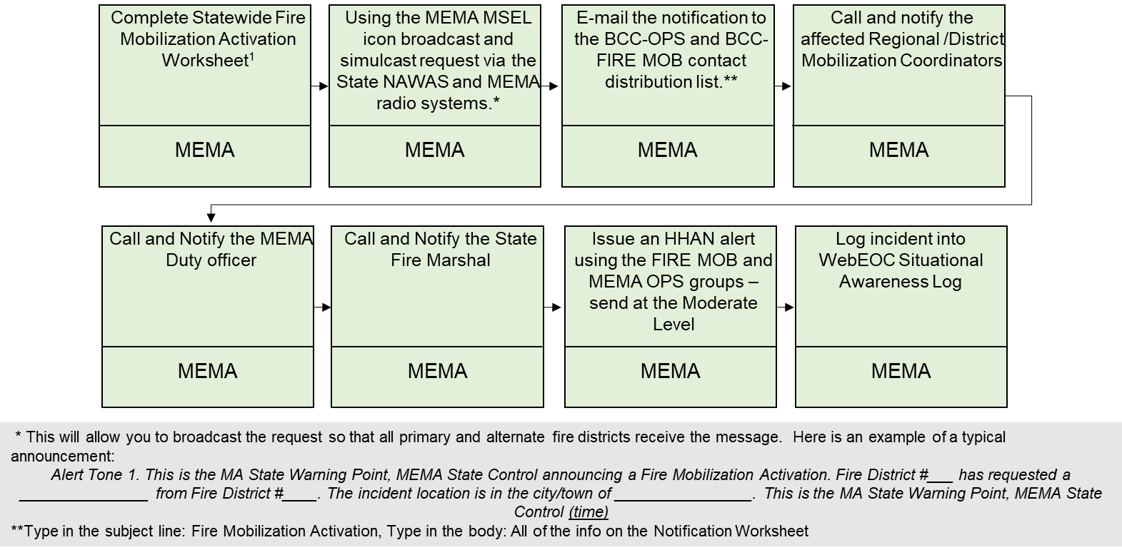
The business process flow below details the activities to be completed by MEMA Dispatch during activation of the Plan. Using NAWAS and MEMA radio systems, MEMA notifies the resources being requested for mobilization. MEMA then notifies the MEMA Duty officer and State Fire Marshall and creates an entry in WebEOC.
1 State Mobilization Worksheet

3.2.F Unfilled Task Force/Strike Team Procedure - 1st Task Force/Strike Team only
Upon the activation of a Task Force/Strike Team for IMMEDIATE deployment, it is assumed that the 1st due Task Force/Strike is needed on scene as quickly as possible. If the 1st due Task Force/Strike Team for the appropriate Run Card cannot be completely filled through the activation by the sending District Control point, then the provisions below shall apply.
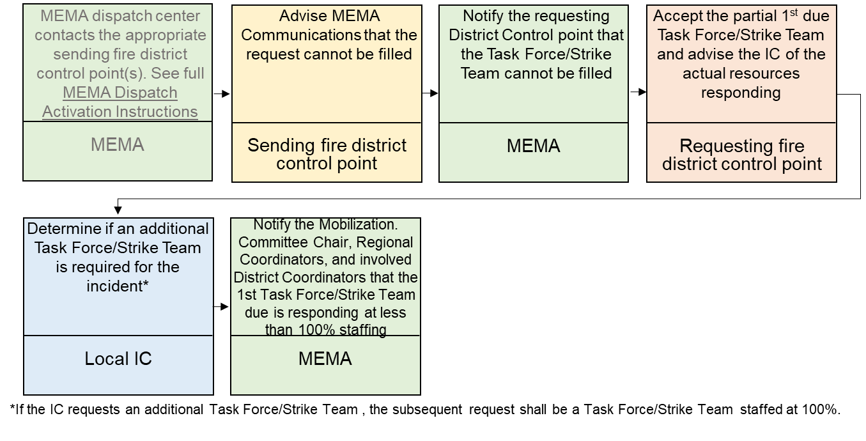

3.2.G Sending Department Unable to Respond

If a Fire Department or Ambulance Service is unable to send a requested resource, the business process flow below shall apply. A department or service that is unable to fulfill a request notifies their District Control point. The District Control point then contacts the alternate resource as listed on the run card and notifies MEMA of the result.
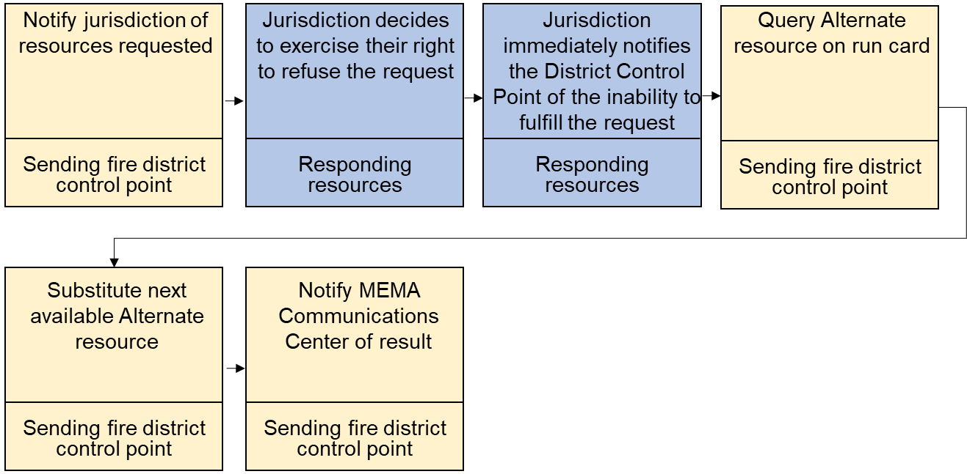

3.2.H Request for Multiple Task Forces/Strike Teams with Resources from the Same Department

In the Plan, the same department can be listed to supply resources for different types of Task Forces/Strike Teams and there are situations in which the different types of Task Forces/Strike Teams may be required to be activated simultaneously or over a short period of time. In such cases, the following procedure will be followed by District Control Centers, MEMA Communications Center, and Mobilization Coordinators. No Department will be bypassed when pieces of apparatus are assigned to or required on multiple Task Forces/Strike Teams.

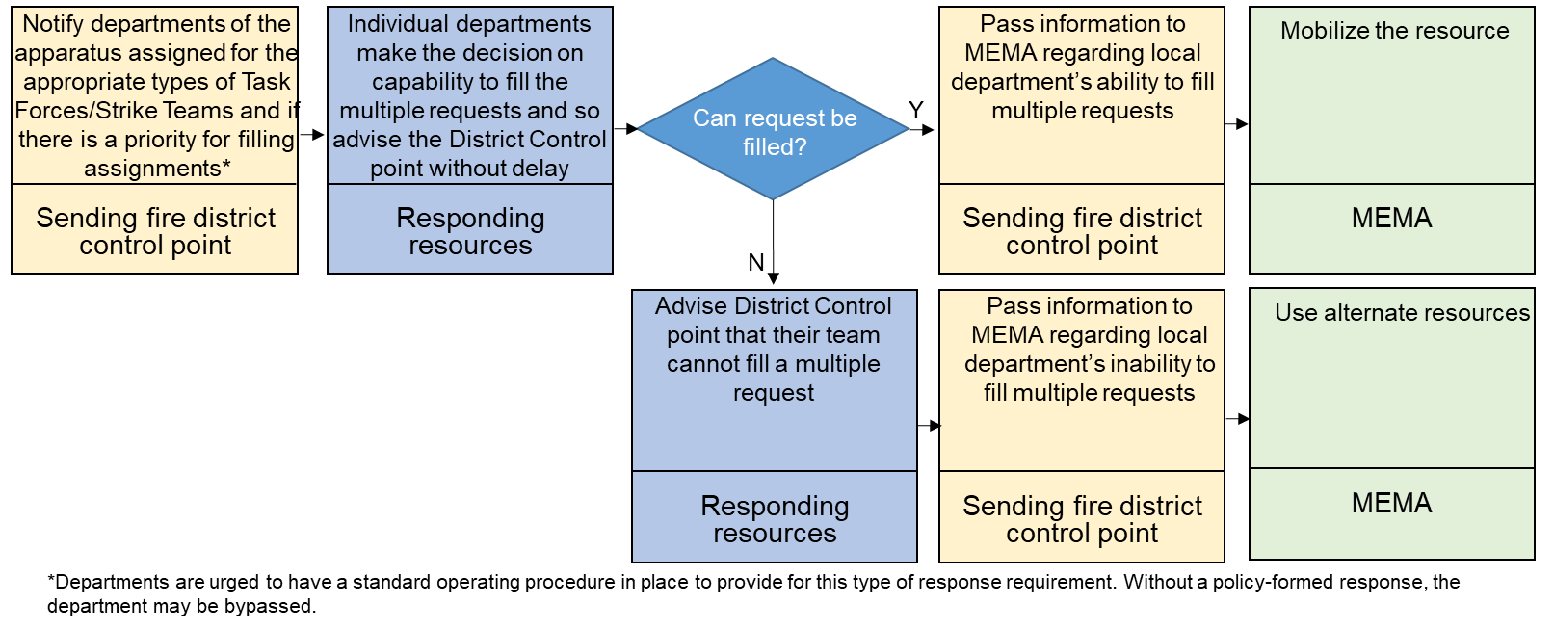

3.2.I Non-Immediate Deployment

For non-immediate deployment, MEMA contacts the local IC to determine the order in which resources will be activated for future operational periods. Once confirmed, MEMA contacts the District/Regional coordinator of those assets and inform them of their potential to be activated. The Control Point then contacts the resources directly to inform them of the Alert Notice.
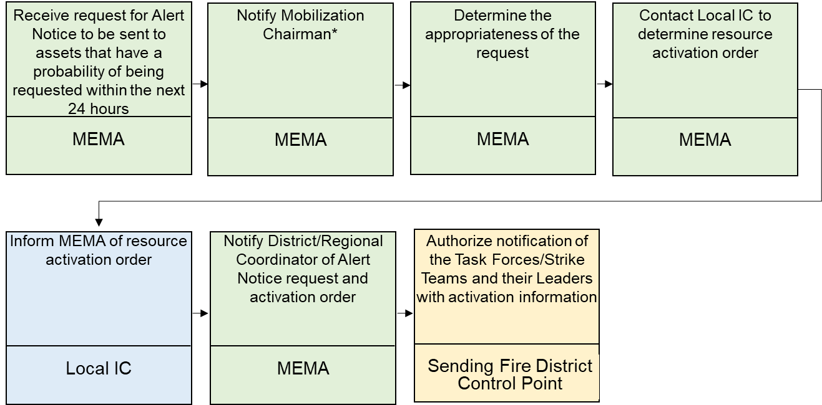

3.2.J Mobilization: Transit and Staging

Once resources have been requested and confirm their ability, they begin travel towards the incident location using the business process flow below. Resources gather at an assembly point and travel to the incident staging area together. Once at the staging area, the resources check in and provide the local IC with the necessary documentation. Throughout the process, responding resources remain in contact with MEMA to provide updates on their status.
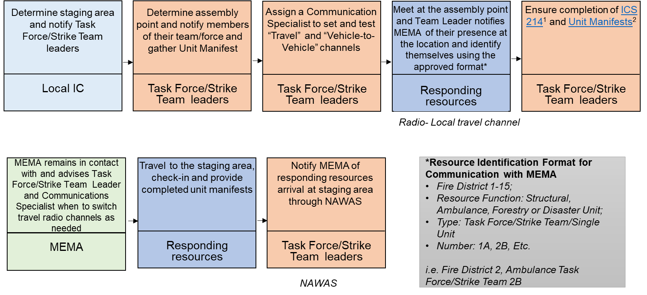
1 ICS Form 214 2 Resource Manifests

3.2.K Resource Manifests

Prior to leaving the assembly point, resources are required to complete a resource manifest associated with their specific assets. The information required for all manifests includes the Task Force/Strike Team number, incident name, reporting location, date/time, department providing the resource, and cell phone # for each vehicle in mobilization. Asset-specific information (such as pump specifications or personnel provided) is also included.

- Ambulance Manifest
- Engine Manifest
- Forestry Manifest
- Hand Crew Manifest
- Ladder Manifest
- Leader-Utility Manifest
- Tender Manifest
- Marine Manifest

3.2.L Resource Check-in Procedure
Role | Check-in Procedure
Single Resources | - Resource provides an appropriate Manifest to Staging Manager or Resource Check-in recorder.  - Resource Unit creates or adds to the Incident Check-in List (ICS 211) to show the single resource.  - Resource maintains its own Activity Log (ICS 214) for activities.
Task Force/Strike Team or Strike Team | - Task Force/Strike Team Leader provides a Manifest for each unit in the Task Force/Strike Team or Strike Team including Leader’s vehicle to Staging Manager or Resource Check-in recorder.  - Resource Unit creates or adds to the Incident Check-in List (ICS 211) to show the Task Force/Strike Team or Strike Team information.  - Task Force/Strike Team Leader maintains an Activity Log (ICS 214) for the activities of the units.  - Each Unit in the Task Force/Strike Team maintains its own ICS 214 as required by the Leader.
Communications Specialist | - Communications Specialist establishes contact with Incident Communications Unit for any updates to incident communications assignment.  - Communications Specialist maintains their own ICS 214.
Staging Manager | - Staging Manager uses manifests to select equipment and/or skills to fill requests from the Operations Chief or Incident Commander where incoming resources are reporting directly to Staging.  - Staging Manager provides the manifests or copies to the Resource Unit Check-In Recorder to complete check-in.
Resource unit: Check-in/ Status Recorder | - Resource Unit records check-in information on Check-in Lists ICS 211.  - Resource Unit prepares and maintains the Command Post display to include organization chart and resource location and deployment.  - A Check-in/Status Recorder reports to the Resource Unit Leader and assists with the accounting of all incident-assigned resources.

3.2.M Fire Mobilization Resource Management

The business process flow below details the resource management approach for after a resource has checked-in at the scene of the incident. The first step after reaching the incident is for the responding resource to check-in with the local IC. The local IC then provides instructions to the responding resource. The responding resource follows the instructions of the local IC until it is notified of demobilization.
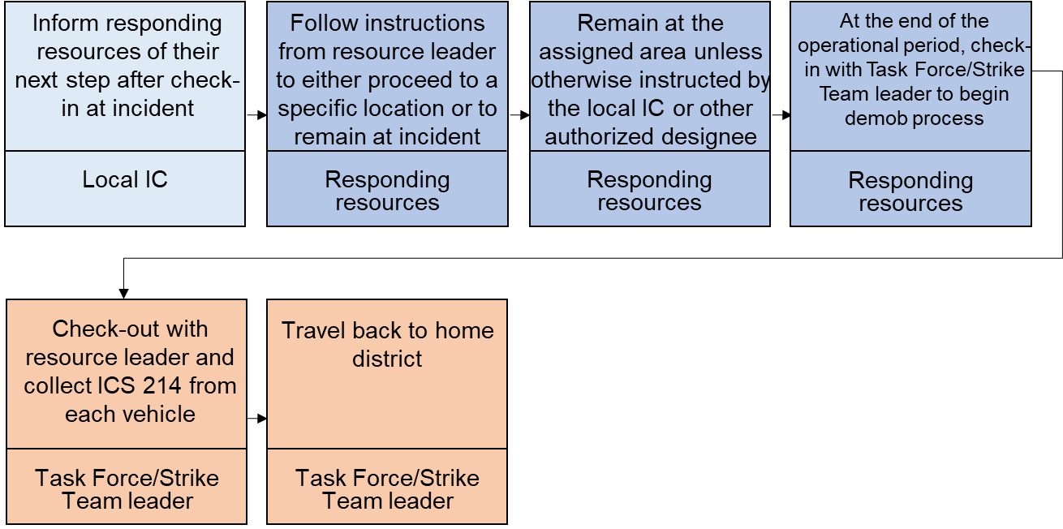

3.2.N Demobilization

When a resource is no longer needed, either at the end of an incident or at the end of an operational period, the local IC informs resources of demobilization, and resources determine their ability to travel back to their jurisdiction. If they are able to travel home, they formally check out with the local IC and then inform MEMA of their travel home, including their arrival in their home jurisdiction.
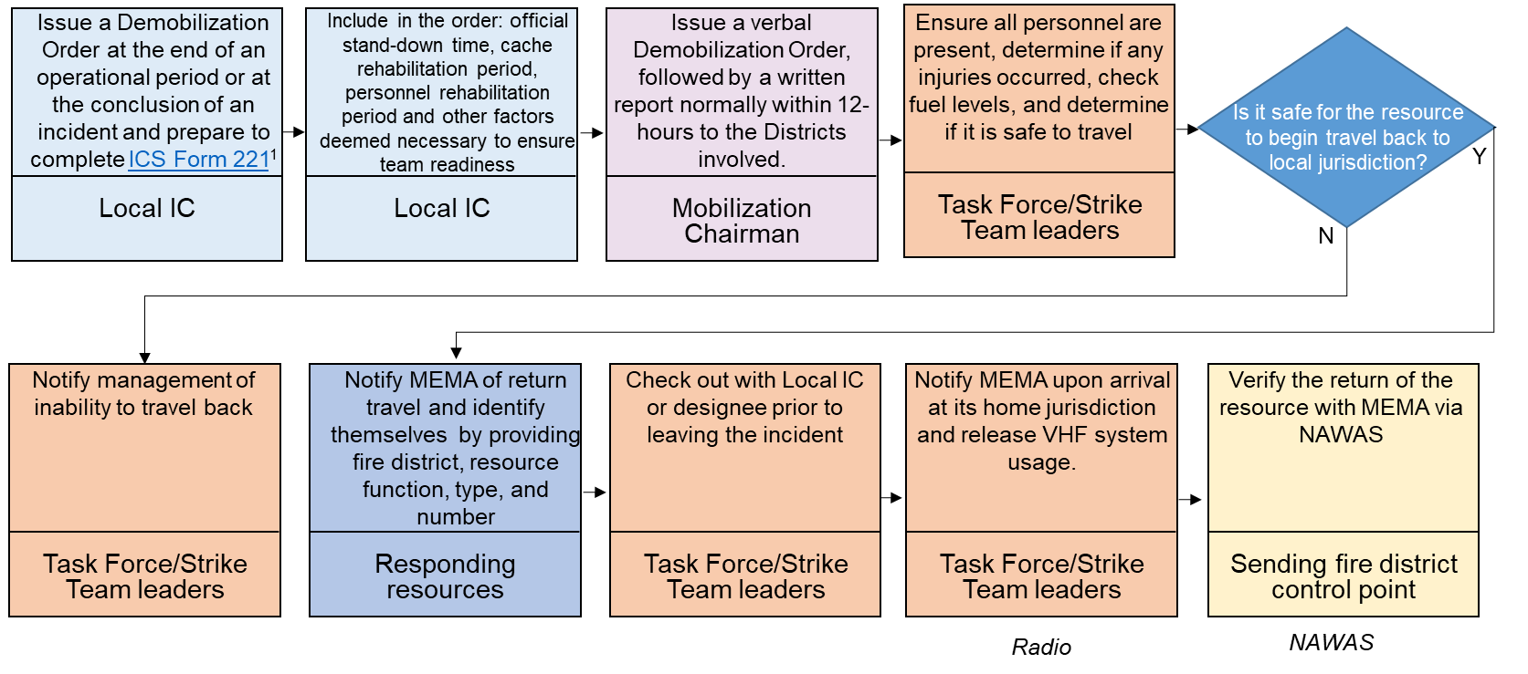
1 ICS Form 221

3.2.O Post-Mobilization Activities

The procedure for documentation activities after an incident is outlined in the business process flow below. Task Force/Strike Team leaders complete forms which are forwarded to the District Control points and then to the Regional Coordinators. The Regional Coordinators collect the forms and submit them to the Mobilization Chairman.
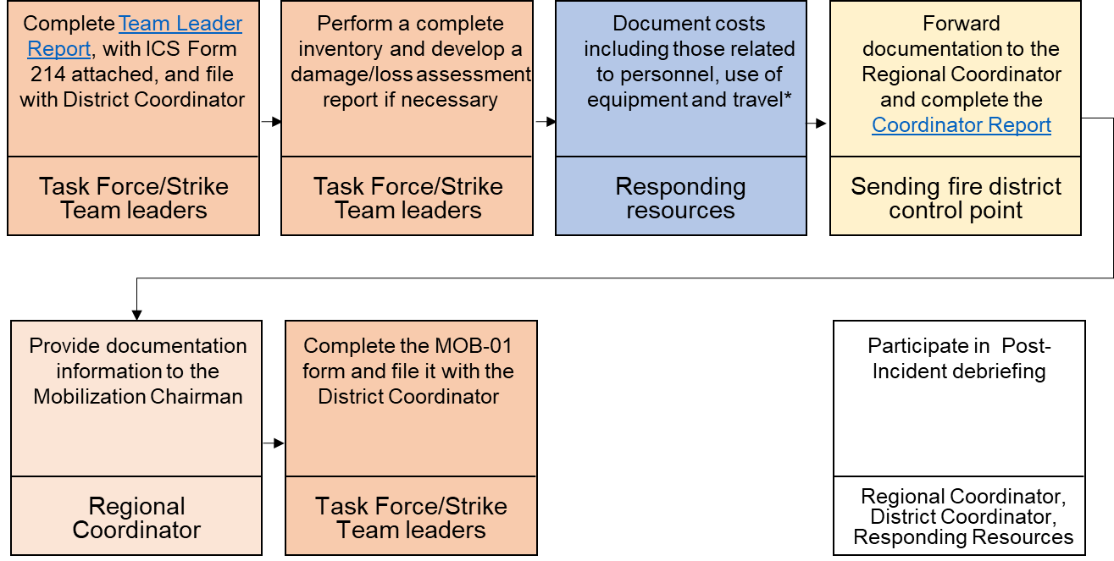
* Complete and submit reimbursement forms to the district coordinator and any other relevant ICS Forms, see Appendix I for more details

1 Team Leader Report 2 Coordinator Report 3 Mobilization Deployment Form
4.0 Administrative Roles and Responsibilities

State Mobilization Chairman: Recommended by FCAM and appointed by the MEMA Director, this position is responsible for the chairing of the Mobilization Committee and overseeing the operation and maintenance of the Plan. The Mobilization Chairman will be either an active or retired fire chief, preferably with experience in the coordination of local/regional mutual aid systems. The Mobilization Chairman shall be a member of the Fire Chiefs Association of Massachusetts. The Chairman may recommend with the approval of FCAM the appointment of a Vice-Chairman of the Mobilization Committee. The Mobilization Chairman is also responsible for training and exercising of the Plan of the state level.

Vice-Chairman Mobilization Committee: Recommended with the approval of FCAM and appointed by the MEMA Director, this position serves as the Vice-Chairman of the Mobilization Committee. The Mobilization Vice-Chairman will be either an active or retired fire chief, preferably with experience in the coordination of local/regional mutual aid systems. The Mobilization Vice-Chairman shall be a member of the Fire Chiefs Association of Massachusetts. The position is responsible for the coordinating of all grants and training programs in support of the Plan. The Vice-Chairman functions as the liaison to external agencies and associations.

Regional Coordinators: Recommended by the Fire Districts within the Region, approved by FCAM and appointed by the MEMA Director, this position is responsible for coordinating the operation, maintenance, training and exercising of the Plan at the regional level with the assistance of the District Coordinators. The Regional Coordinator will be either an active or retired fire chief, preferably with experience in the coordination of local/regional mutual aid systems. The Regional Coordinator shall be a member of the Fire Chiefs Association of Massachusetts. There are a total of 4 Regional Coordinators, one per each region. The Regional coordinator will appoint at least one alternate Regional Coordinator from the District Coordinators.

District Coordinators: There are 15 District Coordinators, each recommended for appointment by their Fire District. The recommendation is approved by FCAM with appointment by MEMA Director. The District Coordinator will be either an active or retired fire chief, preferably with experience in the coordination of local/regional mutual aid systems. The District Coordinator shall be a member of the Fire Chiefs Association of Massachusetts. The District Coordinator will recommend a fire chief with the approval of the District as an alternate. The District Coordinator is responsible for the operation, resource inventory, run cards, training, and exercising of the Plan on the District level.

Detailed job descriptions for the mentioned roles and information on Task Force/Strike Team Leaders and Communications Specialists can be found in Appendix J.

5.0 Administration and Logistics

5.1 Plan Maintenance
The coordination responsibility, which includes the development, revision, maintenance, distribution, training, and exercising of the Plan, rests with the Massachusetts Fire and EMS Mobilization Committee with the assistance of the Fire Chiefs Association of Massachusetts, Department of Fire Services, Department of Public Health, and MEMA. The Mobilization Executive Committee will ensure that the Plan is reviewed on an annual basis.

Revision process
- The Mobilization Executive Committee with its advisory board will conduct an annual review of the Plan.
- Any proposed changes or revisions to the Plan shall be made available to the members of the Executive Boards of each agency for review and comment.
- The Mobilization Executive Board shall then approve or disapprove any recommended changes to the Plan at a regularly scheduled Mobilization Executive Board Meeting. Copies of the revised Plan will be placed on the website and disseminated widely.

5.2 Training and Exercises
Individual agencies and organizations are encouraged to provide regular training to their members on the Plan and agency protocols for deployment. Regular testing of the Plan through exercises developed based on this will provide an opportunity to improve all aspects of the Plan.

5.3 Expenditures and Reimbursements
Individual agencies and organizations will be responsible for tracking costs incurred and maintaining associated supporting documentation for possible reimbursement via applicable funding sources.

5.4 Responder Protection
When local protection resources have been exhausted, protection of responders will be coordinated with ESF 13 (Public Safety and Security) based on the nature of the mission and extent of risk to those responders. This protection shall include but not be limited to:

- Protection of personnel and equipment while in transit
- Perimeter and access security to the incident area
- Security at the base of operations
- Protection during search & rescue operations
- Protection during EMS triage, treatment and transport operations
- Protection during fire operations
- Detainment of self-dispatched apparatus and personnel

The primary mission of the responder protection resources is to assess and detect hostile activity before it becomes a risk to operations. The law enforcement officer must assess, evaluate, and then advise the Task Force/Strike Team Leader or the senior operations officer regarding risk associated with criminal or hostile individuals or groups.

All security, incident status, risk information, and press releases will be directed to and disseminated from the Incident Public Information Officer.

6.0 Communications

6.1 Communications in Transit (Vehicle-to-Vehicle)
Effective interoperable communication between agencies is a requirement for the success of an operation. During incidents, communication systems may be inoperable or severely compromised and may require the use of disaster network communications. It remains the responsibility of the requesting jurisdiction to make arrangements for effective communications. Plain language shall be utilized for all voice transmissions.

All mobile and portable radios shall be programmed in accordance with the Massachusetts Tactical Channel Plan (MTCP). The most current version of the Massachusetts Interoperability Field Operations Guide (MIFOG) shall be used to reference current radio frequencies available for mobilization use.

There are three distinct communications needs for Mobilized Task Forces/Strike Teams:

Communications while Traveling Statewide: Travel Channels
- Use the VHF or 800 Trunked Statewide radio system as outlined in the flows.
- All Task Force or Strike Team Leaders shall have access to the VHF FAMTRAC, State 800 Trunk System mobilization channels, and /or a cell phone with the ability to communicate to MEMA Communications Center and Incident Communication from any location in Massachusetts.
- Redundant capabilities are recommended.

Communications in-transit: Vehicle-to-Vehicle
- Task Force/Strike Team units must be able to communicate directly with each other while enroute to incidents.
- Options include common radio frequencies, cell phones, simplex common channel, UTAC, VTAC, etc.

Incident Communications
- A VHF or UHF programmable hand-held radio is better suited for responding to a disaster.
- A mobile radio is also recommended, in addition to the hand-held programmable radio, due to increased output power.
- All radios should have the National Radio Channels preinstalled: V-TAC, U-TAC, or I-TAC.

6.2 Statewide Radio System Resources
- These systems are to be used only by Task Force/Strike Team leaders for contact with control points, incident staging managers, or incident communications.
- These systems shall be used when resources are ordered to respond outside of the mutual aid radio capability of the Task Force/Strike Team leader or team leader – i.e. where the Task Force/Strike Team leader cannot communicate with both the sending district control point and the requesting control point at the same time.

6.2.1 MEMA VHF System
- The MEMA VHF Radio System makes available a common VHF radio net to provide instructions and maintain central control of resources without interrupting or tying up emergency operations channels.
  - This channel is to be used only by Task Force/Strike Team leaders for contact with control points, incident staging managers, or incident communications.
  - This system is not to be used as an operations channel or a unit-to-unit channel except where authorized.

7.0 Authority and References

7.1 Authorities
The detailed Executive Order and the Massachusetts General Laws that constitute the basis of this Plan can be found at the links below:
- Executive Order #221 (1982)
- Massachusetts General Law Chapter 48 Section 59A (Mutual Aid)

7.2 References
- Massachusetts Comprehensive Emergency Management Plan

Appendix A: Additional Resources

A.1 MEMA Resources
During mobilization, resources can be requested that are outside of the Plan. To access resources from MA Emergency Support Function Agencies or Organizations, the following procedure is used:
- Local IC determines that an incident requires additional assets outside of those provided in the Plan or a deviation and calls MEMA Communications at 508-820-2000.
- MEMA Communications Center will properly direct the request internally at MEMA and MEMA will notify the Mobilization Chairman.
- The Mobilization Chairman, in coordination with MEMA, will inform:
- District Coordinator for the District the request is coming from
- Regional Coordinator for the Region the request is coming from
- Regional and District Coordinators of Districts that may be activated
- For pre-positioning, the Requesting Organization shall provide the following information:
- Estimated length of mobilization
- Assurance that all levels of the Mobilization Chain of Command have participated in the development of and approved the pre-positioning plan
- Controlling Authority while in pre-positioning
- Communication Plan ICS 205 completed
- Location of staging
- Information on the base camp/incident staging
- Security details
- Method of reimbursement
- Basis of reimbursement
- Formal assurance of reimbursement

In any situation outside of normal activation of the Fire & EMS Mobilization Plan, requests shall be directed to the Mobilization Chairman or Reginal Coordinator for approval of the deviation. The Mobilization Committee may provide a representative to the State EOC to work with the ESF Units to effectively and efficiently allocate and assign appropriate resources from the Mobilization Plan.

A.2 Regional CMED Centers

A.2.1 Regional Mass Casualty Support Unit (RMCSU)

A.2.2 MCI Trailers

A.3 Department of Fire Service (DFS) Resources
Requested through MEMA, 508-820-2000

A.4 Regional Communication Units

Contact should be made to appropriate Fire District:

Contact Name | District # | Contact Number
Bristol County Control | 3 | 508-543-8073
Westford Control | 6 | 978-399-2345
Southbridge Control | 7 | 508-764-4877
Shelburne Control | 9 | 413-625-8200
Berkshire County Control | 12 | 413-445-4559
Metro Fire | 13 | 617-343-2880

A.5 Mass Decontamination Units (MDU)

A.6 Massachusetts Technical Rescue
Requests for In-Region shall be channeled through control points following traditional mutual aid requests. This would include single discipline events i.e. trench collapse, rope rescue etc. or events that do not need outside assets of personnel and equipment the Region has the equipment and personnel capability for duration of event.
Requests for Major events outside a Technical Rescue Region shall follow the run cards.
This shall also serve as a guide for planning purposes in anticipation of major natural disaster i.e. pending hurricane.

Region I: Southeast consists of Plymouth, Bristol, Norfolk, Barnstable, Dukes, Nantucket Counties
Fire Districts 1,2,3,4,

Region II: MetroBoston / UASI consists of 9 UASI communities surrounding Boston
Fire District 13

Region III: Central Mass consists of Worcester County
Fire Districts 7, 8, 14

Region IV: Western Mass consists Franklin, Hampshire, Hampden, Berkshire
Fire Districts 9, 10, 11, 12
Region V: Northeast Mass consists of Essex County
Fire Districts 5, 6, 15

URBAN SEARCH AND RESCUE TEAM
Conducts search, rescue, and recovery for humans and animals from heights, below grade trench, confined spaces, structural collapse environments
REGION | # | TYPE 1 | TYPE 2 | TYPE 3 | TYPE 4
SOUTHEASTERN | I |  | 1
METRO BOSTON | II |  | 1
CENTRAL | III |  |  | 1
WESTERN | IV |  |  |  | 1
NORTHEASTERN | V |  | 1
Function Summary
1. Conducts search, rescue, recovery including:
a. Wide-area search
b. Structural collapse assessment, search, rescue, and rigging in light through heavy frame construction, including reinforced concrete
c. Associated technical rope rescue including highlines
d. Confined space search and rescue, non-cave, non-mine
e. Trench and excavation rescue
f. Mass transportation vehicle, subway, rail, bus etc.
2. Coordinate and conduct search and rescue response efforts for all hazards including locating, accessing, medically stabilizing and extricating survivors from compromised structural areas
3. Operates in environments with and without infrastructure, including compromised access to roadways, utilities, transportation and limited availability for shelter, food and water
4. Type 1, 2 and 3 are capable of continuous 24-hour operations which can split into two 12-hour operational periods
USAR Typing Definitions
“Type 1 Team,” is a team consisting of 80 personnel. These teams can work 24 hours a day and can do complete building collapse search and rescue functions in all building types. Type 1 has a physician based medical component and structural collapse rated engineer component.
“Type 2 Team,” is a team consisting of 70 personnel. Same as Type 1 without Physician medical component and structural engineer.
“Type 3 Team,” is a team consisting of 35 personnel. Same as Type 2, normally work 12 hour shifts and are more suited for wide area search and medium to light construction search and rescue.
“Type 4 Team,” is a team consisting of 22 personnel. Same as Type 3 They are suited for light construction search and rescue. No heavy lifting or breaching capabilities. Limited to no search technology and K9.

All Type Teams are capable of trench, confined space and rope rescue capabilities
SWIFTWATER/FLOODSEARCH AND RESCUE TEAM
Conducts search, rescue, and recovery for humans and animals in swiftwater, swiftwater/flood, and stillwater/flood environments
REGION | # | TYPE 1 | TYPE 2 | TYPE 3 | TYPE 4
SOUTHEASTERN | I | 1 | 1
METRO BOSTON | II |  | 2
CENTRAL | III |  |  | 2
WESTERN | IV
NORTHEASTERN | V |  | 1 | 1
Function Summary
1. Conducts search, rescue, and recovery for humans and animals in swiftwater, swiftwater/flood, stillwater/flood environments
a. Searches for and rescues individuals who may be injured or in need of medical attention
b. Provides emergency medical care including ALS
c. Transports humans and animals to nearest location for secondary air or land transport
d. Provides shore-based and boat-based water rescue
e. Provides animal rescue
2. Supports helicopter rescue operations and urban SAR in water environments.
3. Operates in environments with or without infrastructure, including those with compromised access to roadways, utilities, transportation, and medical facilities and with limited availability of shelter, food and water.
Swift/Flood Water Rescue Typing Definitions

“Type 1 Team,” is a team consisting of 14 personnel and 2 boats and helicopter water rescue operations capability. Performs class 3 water operations. offensive water rescue, flood response operations. performs low angle rope rescue. Operates in a hazardous materials contaminated environment. Provides ALS level care.

“Type 2 Team,” is a team consisting of 12 personnel and 2 boats. Same as Type 1 except no helicopter operations.

“Type 3 Team,” is a team consisting of 6 personnel and 1 boat. Same as Type 2, except BLS level care.

“Type 4 Team,” is a team consisting of 3 personnel and 1 boat. Same as Type 2, limited operational period and capability

A.7 Massachusetts Urban Search and Rescue Task Force: Massachusetts Task Force/Strike Team 01
Requested through MEMA, 508-820-2000

Appendix B: Fire Mobilization Resource Definitions

A Task Force/Strike Team is a group of fire or EMS apparatus and personnel that can be ordered in the event that local mutual aid has been exhausted. Task Forces/Strike Teams travel to the incident staging area together and travel home from the incident staging area together.

B.1 Ambulance Task Force/Strike Team

Equipment:
- 6 Ambulances, ALS or BLS: Any combination, ALS preferred

Personnel:
- 1 Task Force/Strike Team Leader
- 1 Task Force/Strike Team Asst. Leader
- Ambulance Staffing: Minimum 2 EMTs, Paramedics or Combination (Preferred 3 personnel total)
- Task Force/Strike Team Leader Aide

B.2 Structural Task Force

Equipment:
- 6 Type I Engines
- 2 Type I or Type II Ladder Trucks (ladder, platform, or tower)

Personnel:
- 1 Task Force Leader
- 1 Task Force Asst. Leader
- Engines and Ladders:
  - Minimum: 1 Officer, 2 Firefighters
  - Recommended: 1 Officer, 3 Firefighters
- Task Force/Strike Team Leader Aide

B.3 Structural Strike Team

Equipment:
- 6 Type I Engines

Personnel:
- 1 Strike Team Leader
- 1 Strike Team Asst. Leader
- Engines:
  - Minimum: 1 Officer, 2 Firefighters
  - Recommended: 1 Officer, 3 Firefighters
  - Task Force/Strike Team Leader Aide

B.4 Forestry Task Force

Equipment:
- 6 Forestry Units, specify breaker or forestry with tank and pump size
- 2 Tenders/Tankers 1500 Gallon minimum
- Optional: Vehicles to carry personnel

Personnel:
- 1 Task Force Leader
- 1 Task Force Asst. Leader
- Forestry Units: Normal Departmental Staffing of Unit
- Tender: 2 Firefighters
- Task Force/Strike Team Leader Aide
- Optional: 1 Mechanic with support vehicle

B.5 Forestry Strike Team

Equipment:
- 6 Forestry Units, specify breaker or forestry with tank and pump size
- Optional: Service vehicles to carry personnel

Personnel:
- 1 Strike Team Leader
- Strike Team Asst. Leader
- Forestry Units: Normal Departmental Staffing of Unit
- Task Force/Strike Team Leader Aide

B.6 Structural Tender Task Force

Equipment:
- 6 Type I Tenders
- 2 Type I Engines
Personnel:
- 1 Task Force Leader
- 1 Task Force Asst. Leader
- Engines:
  - Minimum: 1 Officer, 2 Firefighters
  - Recommended: 1 Officer, 3 Firefighters
Tenders: 2 Firefighters
- Task Force/Strike Team Leader Aide

B.7 Structural Tender Strike Team

Equipment:
- 6 Type I Tenders

Personnel:
- 1 Strike Team Leader
- 1 Strike Team Asst. Leader
- Tenders: 2 Firefighters
- Task Force/Strike Team Leader Aide

B.8 Structural Hand Crew

Equipment and Personnel
- 1 Crew Leader
- 10-20 Firefighters
- Transportation vehicle(s)

Personal Protective Equipment (PPE) Recommended | Ensemble includes helmet, protective hood, coat, trousers, gloves and boots
PPE Criteria | NFPA 1971: Standard on Protective Ensemble for Structural Firefighting and Proximity Fire Fighting  OSHA 29 CFR 1910.156(e) (2) (iii)
Qualifications | Completion of the Massachusetts Career Firefighter Training Program OR the Massachusetts Call / Volunteer Firefighter Training Program OR (290) - Structural Firefighting Practices OR Certification - Firefighter I/II OR validation from sending organization the individual has received training to meet the performance objectives of the relevant sections of the current edition of National Fire Protection Association Standard 1001 to the level of Firefighter I (Fire Behavior, Rescue, Fire Streams, Safety, Fire Hose and Nozzles, Forcible Entry, Ventilation, Self-contained Breathing Apparatus)

B.9 Forestry Hand Crew

Equipment and Personnel
- 1 Crew Leader
- 10-20 Firefighters
- Transportation vehicle(s)

Personal Protective Equipment (PPE) Recommended | Ensemble includes helmet, coat, trousers, gloves and boots. Protective helmet shroud suggested.
PPE Criteria | NFPA 1977, Standard on Protective Clothing and Equipment for Wildland Firefighters. If no NFPA 1977 compliant PPE is available, station uniforms compliant with NFPA 1975, Standard on Emergency Services Work Apparel may be worn with approval of Incident Safety Officer. Structural ensembles should not be worn unless there is a structural interface concern.
Crew Qualifications | Prior to January 1, 2021 these qualifications are recommended. As of January 1, 2021, they will be required.  Successful completion of the following National Wildfire Coordinating Group (NWCG) courses:  - S-130, Basic Wildland Fighter Training (30-35 Hrs, including a required field session)  - S-190, Introduction to Wildland Fire Behavior (6 Hrs)  - L-180, Human Factors in Wildland Fire (4 Hrs)  OR  Successful completion of the Massachusetts DCR Basic Wildland Firefighting Course  - DCR Bureau of Forest Fire Control Basic Wildfire Course (8 – 12 Hrs classroom)  - DCR Bureau of Forest Fire Control Basic Wildfire Course Field Session (4 Hrs)
Crew Leader Qualifications | Prior to January 1, 2021 these qualifications are recommended. As of January 1, 2021, they will be required.  National Wildfire Coordinating Group (NWCG) course:  - S-131, Wildland Firefighter Type 1 (12 Hrs, all classroom)  - Endorsement from Chief Officer from a Massachusetts Fire response agency.

Appendix C: Organization

Districts:
- Fire Districts are groups of towns which are located in the same geographical region and share a common District Control point.
- The Commonwealth is divided into 15 Fire Districts.
- A District Coordinator is appointed for each District and is responsible for maintaining a current listing of available fire service resources within their respective District.
Regions:
- A Region is a grouping of Fire Districts in a geographic area that have been designed for deployment of resources within the Region and to other Regions.
- The Commonwealth is divided into 4 Fire Regions.
- A Regional Coordinator is appointed to oversee regional activities and training.

C.1 Mobilization Regions and Districts
Fire Region | Districts within Region
Region 1: Northeast | District 5, Southern Essex  District 6, Northern Middlesex  District 13, Metro-Boston  District 15 Northern Essex
Region 2: Southeast | District 1, Barnstable, Dukes, and Nantucket  District 2, Plymouth  District 3, Bristol  District 4, Norfolk
Region 3: Central | District 7, Southern Worcester  District 8, Northern Worcester  District 14 Southern Middlesex
Region 4: Western | District 9, Franklin  District 10, Hampshire  District 11, Hamden  District 12 Berkshire

C.2 District Control Center Contacts
District # | Location | Phone Number
1 | Barnstable County Control | 508-563-4200
1A | Nantucket Police | 508-228-1212
2 | Plymouth County Control | 508-830-6200
3 | Bristol County Control | 508-543-8073
4 | Norfolk County Control | 781-767-6830
5 | Beverly Control | 978-922-2424
6 | Westford Control | 978-399-2345
7 | Southbridge Control | 508-764-5430
8 | Fitchburg Fire | 978-343-4801
9 | Shelburne Control | 413-625-8200
10 | State Police Northampton | 413-586-1508
10A | Amherst Fire | 413-256-4080
11 | Holyoke Fire | 413-534-4515
12 | Berkshire County Control | 413-445-4559
13 | Metro Fire | 617-343-2880
14 | Holbrook Regional Comms Center | 781-767-6820
15 | Andover Control | 978-475-1212

C.3 Maps

C.3.A Fire Districts Map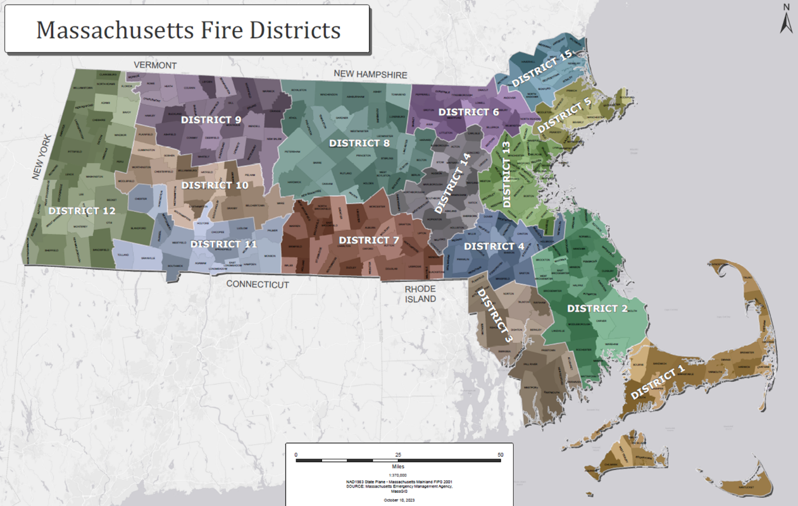

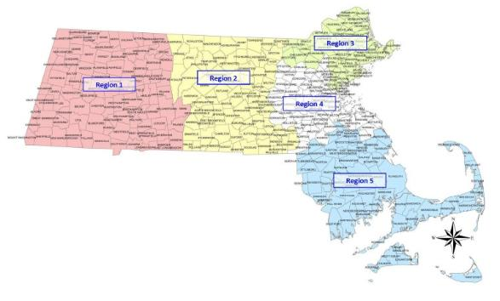
C.3.B EMS Regions Map

C.4 Mobilization Governing Bodies
The governing bodies for Mobilization are listed below.

Mobilization Executive Committee
- Mobilization Chairman
- Regional Mobilization Coordinators
- DFS Representative
- MEMA Representative
- FCAM President or representative

Mutual Aid and Mobilization Advisory Group
- Mobilization Chairman
- Regional Mobilization Coordinators
- District Coordinators and Alternates
- DFS Representative
- MEMA Representative
- FCAM President or representative
- EMCAB Representative
- Chief Fire Warden
- Hazmat Representative
- Communications/Control Center Representative
- Mobile Decontamination Unit Coordinator

Appendix D: Resource Inventory Responsibilities

D.1 Resource Inventory and Run Cards
An inventory of each department’s resources is used by District Coordinators to create run cards that are used in the event that activation is requested. It is essential that these inventories are kept up to date to ensure that resources listed on run cards are available when called upon.
- The Task Forces/Strike Teams are established based on working relationships and close location to enable rapid assembly. The types of Task Forces/Strike Teams are Ambulance, Structural, Forestry and Tender.
- The District Coordinators are responsible for inventorying the appropriate resources in their district to determine how many Task Forces/Strike Teams of each type may be created.
- The Task Force/Strike Team Inventories are then reviewed by the Regional Coordinators for staffing and coverage ability.
- Once approved, these inventories are to be used to establish Run Cards for each district based on distance and practical response routes. This information is then placed on the MEMA website for access by Coordinators, Fire Chiefs, District Control Centers, and other stakeholders.
- An additional section of the Plan identifies special resources which may be activated under the Plan. (Appendix A)
- The District may decide how many of its assets may be deployed under the Plan.

D.2 Resource Tracking
- Resource tracking will begin at the time of dispatch and continues throughout the incident using NIMS guidelines and ICS forms.
- Resource tracking will end when the deployed resource is recorded as having returned to its respective station.
- The Mobilization Deployment Sheet (MOB-01) will be used to track Resource Activations and Deployment.

D.3 Responsibilities of Deploying Agencies

Run Card Usage - Policy/Procedure Change
- A change or deviation from established Mobilization Run Card Procedures or Policies can only be made by the Mobilization Chairman or the Regional Coordinators and shall not be made unless agreed upon by the Regional and District Coordinators whose regions and/or districts would be involved in said deviation or change.
  - District Coordinators and Alternates may authorize changes as long as the Regional Coordinator or the Mobilization Coordinator agrees to the deviation.
  - This policy may require Regional and/or District Coordinators to make decisions for regions or districts other than their own. This action is fully authorized.
  - Any deviation from established procedure and policy may only be made due to unexpected, unplanned for, or exceptionally unusual circumstances.
  - The Regional or District Coordinator making the deviation or change must provide a complete written report with full explanation and justification within one week of the occurrence.
  - The change or deviation will be noted on an ICS-201 (Incident Objectives) and ICS-202 (Comment Section) and signed by those involved.
- In all situations, the coordinators involved shall work with Incident Command, Planning Section, and/or Logistics Section as determined by incident complexity to fulfill the mobilization role and responsibility.
- Districts may also wish to have certain Ambulance Task Forces/Strike Teams designated for primary use for prescheduled events. This is an approved policy.

Self-Dispatching
- Fire Department and EMS units and/or individuals shall not self-dispatch to the Mobilization Plan activation.
- Reporting Location shall have a record of requested resources to validate access to the incident and to ensure proper dispatching.
  - Units or individuals that cannot provide proof of dispatch shall not be utilized at the incident and will be directed to return to their respective communities.
- It will be the position of Incident Command, Fire Chiefs Association of Massachusetts, and the Mobilization Committee to take appropriate action to ensure that such resources are not utilized by denying logistical support, funding, and reimbursement to self-dispatched units or personnel.

Self-Sustaining
The logistical support of mutual aid resources is critical in the management of a disaster effort. Logistical support will be established as soon as possible and will be maintained by the agency requesting the resources. Responding resources should be prepared to self-sustain for one operational period and the associated travel time.

D.4 Individual Responsibilities

As a basic guide, all resources will base all actions and decisions on the ethical, moral, and legal consequences of those actions. It is in this manner that positive and beneficial outcomes will prevail in all events. Accordingly, all resources will:
- Prioritize the care for incident personnel safety
- Keep the value of life and welfare of the victim(s) in mind constantly
- Support the objectives of the Incident Commander
- Remain cognizant of cultural issues including race, religion, gender, and nationality
- Abide by all local law enforcement practices, including its policy regarding weapons.
- Abide by all regulations regarding the handling of sensitive information
- Follow local regulations and agency protocols regarding medical care and handling of patients and/or deceased
- Follow prescribed direction regarding dress code and personal protective equipment
- Not carry firearms
- Not be in possession of non-prescribed or illegal substances
- Not consume alcoholic beverages while on duty or when subject to call back
- Procure equipment only through appropriate channels
- Follow the local jurisdiction’s and federal regulations and restrictions regarding taking and showing pictures of victims or structures
- Not remove any items from an operational work site as souvenirs
- Not deface any property
- Transit only via approved roadways and not stray into restricted areas
- Demonstrate proper consideration for other team capabilities and operation practices
- Not accept gratuities to promote cooperation

D.5 Training Responsibilities

Competencies/Physical Capabilities
- The sending agency has the responsibility to ensure that personnel are trained to a basic level of proficiency based upon the mission and will be able to stand up to audit.
- All responding personnel must:
  - Be NIMS-compliant.
  - Meet the minimum level of certification as provided by the appropriate state agency and/or meet the appropriate nationally recognized standards for such specialty.
  - Meet home unit fitness standards.

Appendix E: Levels of Response (Federal Designations)
Response Type | Description | Method to Trigger
Type 1 or 2  (National Level) | An emergency that has exhausted state level response capabilities or is an event of national significance | Triggered by MEMA duty officer through the Emergency Management Assistance Compact
Type 3  (Mobilization Level) | An emergency that has exhausted regional, county or fire district response capabilities | Triggered by the statewide mobilization activation procedure
Type 4  (Regional, County or Fire District Level) | An emergency that has exhausted local town, city AND fire district level response capabilities | Triggered locally by the incident commander on the scene of an emergency using the Fire District Control Center to obtain the resources
Type 5 | An emergency that is a routine day-to-day event utilizing resources listed on a Run Card designed and accepted by the Fire District Mutual Aid Committee | Triggered locally by the incident commander on the scene of an emergency using the Fire District Control Center to obtain the resources

Appendix F: Other MEMA Emergency Plans

F.1 MEMA Mission
MEMA is the state agency charged with ensuring the state is prepared to withstand, respond to, and recover from all types of emergencies and disasters, including natural hazards, accidents, deliberate attacks, and technological and infrastructure failures. MEMA's staff of professional planners, communications specialists and operations and support personnel are committed to an all hazards approach to emergency management. By building and sustaining effective partnerships with federal, state and local government agencies, and with the private sector - individuals, families, non-profits and businesses - MEMA ensures the Commonwealth's ability to rapidly recover from small and large disasters by assessing and mitigating threats and hazards, enhancing preparedness, ensuring effective response, and strengthening our capacity to rebuild and recover.

F.2 Massachusetts Comprehensive Emergency Management Plan (CEMP)

- The purpose of the CEMP is to establish the overall framework for integration and coordination of the emergency management activities of all levels of government, volunteer organizations, and the private sector in the Commonwealth of Massachusetts.
- The CEMP is an all hazards plan; the structures and concepts it describes are applicable to all emergencies and disasters occurring in Massachusetts regardless of cause, location, or magnitude.
- It is intended to facilitate multi-agency and multijurisdictional coordination among local, regional, state, federal, and private sector organizations during emergencies.
- The CEMP conforms to National Incident Management System (NIMS) requirements and integrates with local and regional emergency management plans, the National Response Framework (NRF), Emergency Management Accreditation Program standards, and the Federal Emergency Management Agency (FEMA) Region I Operations Plan.
- It identifies lines of authority and organizational relationships for the management of emergency response actions, describes how people and property are protected in an emergency or disaster, and identifies legal authority.

The full CEMP can be viewed at: https://www.mass.gov/lists/comprehensive-emergency-management-plan

F.3 Emergency Support Functions (ESF) and State Emergency Operations Center (SEOC)
- State agencies will provide resources to local government according to the functional responsibilities outlined below.
- These functions are referred to as Emergency Support Functions (ESF).
- For each function, a variety of federal, state, local, volunteer and non-profit, and for-profit agencies and organizations will have responsibility for representation and will provide resources and leadership relating to that function.

F.4 Fire Mobilization Presence in the SEOC
- Massachusetts Emergency Management Agency may request a representative from the Fire Mobilization Committee to staff the MAESF04 (Firefighting) desk during an SEOC activation.
- The representative will be tasked with strategic response efforts within an incident or incidents.
- The representative will assign appropriate resources.
- The standard request process for Fire Mobilization Activation will continue through SEOC activations.

F.5 Massachusetts Emergency Support Functions (MAESF)

For listings of the agencies responsible for each MAESF please see the CEMP Annexes found at https://www.mass.gov/lists/comprehensive-emergency-management-plan

The Mobilization Committee Chair serves as the coordination representative with the various Emergency Support Functions (ESF) when assistance under the Fire and EMS Mobilization Plan is required. The coordination of the deployment of resources will be accomplished through the MEMA Communications Center as identified by the Plan Run Cards or by other instructions in accordance with the Fire Mobilization Chair or his or her designee.

For large-scale events: When the Plan is activated, the appropriate Mobilization Coordinator(s) will report to and utilize the assets of the State Emergency Operations Center through the Firefighting Representative (MAESF 4). This will provide for a seamless transition should the event become multi-discipline or multi-jurisdictional in nature.

When local and state resources are determined to be inadequate to respond to the emergency, the Governor may request assistance through the appropriate national or interstate mutual aid system.

ESF | ESF Title | Lead Agency
MAESF #1 | Transportation | DOT
MAESF #2 | Communications | MEMA
MAESF #3 | Public Works and Engineering | DCR
MAESF #4 | Firefighting | DFS
MAESF #5 | Business and Industry | INFRAGARD
MAESF #6 | Mass Care, Emergency Assistance, Housing, and Human Services | ARC
MAESF #7 | Volunteers and Donations | MA VOAD
MAESF #8 | Public Health and Medical Services | DPH
MAESF #9 | Search and Rescue | DFS
MAESF #10 | Hazardous Materials and Environmental Protection | DEP
MAESF #11 | Agriculture, Animals, and Natural Resources | AGR
MAESF #12 | Energy | DPU
MAESF #13 | Public Safety and Security | MSP
MAESF #14 | Recovery | MEMA
MAESF #15 | Public Information and External Affairs | MEMA
MAESF #16 | Military Support | MANG

Appendix G: Inventory and Run Card Samples
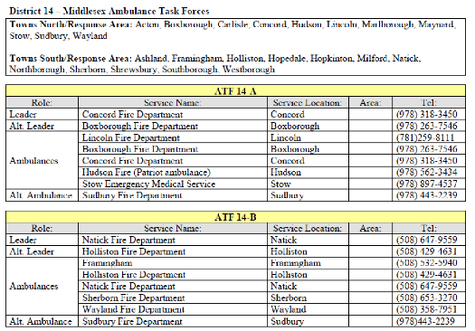
SAMPLE
SAMPLE
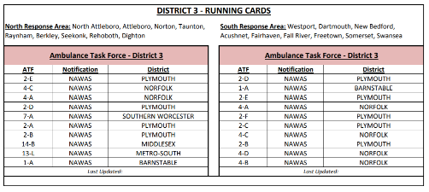
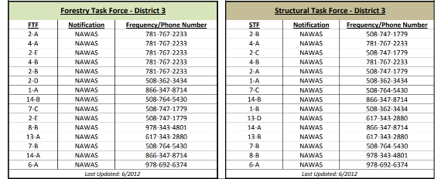

Appendix H: Liability

Workers Compensation Coverage
Each participating organization will be responsible for its own actions and those of its employees and volunteers and for complying with the Massachusetts Workman’s Compensation laws.

Automobile/Vehicle Liability Coverage
Each participating organization will be responsible for its own actions and those of its employees and volunteers and for complying with the Massachusetts Vehicle Insurance Laws.

General Liability, Public Officials, and Law Enforcement Liability
To the extent permitted by law and without waiving sovereign immunity, each participating organization will be responsible for any and all claims, demands, suits, actions, damages, and causes for action related to or arising out of or in any way connected with its own actions, and the actions of its personnel in providing mutual aid assistance rendered or performed pursuant to the terms and conditions of the Plan.

Code of Conduct
This Code of Conduct consists of the rules and standards governing the expected demeanor of members of agencies responding as part of the Plan. Each deployed member is both a representative of their response team and their sponsoring agency. Any violation of principles or adverse behavior demonstrated will be deemed unprofessional with appropriate action taken to correct such action. Such behavior may discredit the good work that the resource completes and will reflect poorly on the entire team’s performance and its sponsoring agency.
- It is the responsibility of the sponsoring agency to prepare its members before deployment regarding conduct expectations. Each deployed member is bound by their sponsoring agency’s rules, regulations, policies, and procedures.
- It is the responsibility of the Mobilization Committee with the backing of the Fire Chief’s Association of Massachusetts to enforce the Code of Conduct during all planning sessions, team meetings and briefings, and to monitor compliance. Any violations must be documented with appropriate follow-up action to be taken by the sponsoring agency.
- At no time during a mission will members take personal advantage of any situation and/or opportunity that arises. There will be absolutely no items of monetary value or souvenirs removed from the incident.
- It is the responsibility of each member to abide by this Code of Conduct.

Appendix I: Federal Reimbursement & Documentation Procedures

Reimbursement Procedure
Upon the activation of this Plan, this Reimbursement Procedure will be applicable to all on-scene and responding agencies who were authorized to deploy. The requesting organization will reimburse the responding organization for all deployment and operational costs to include those related to personnel, use of equipment, and travel. A responding organization may choose to assume or donate, in whole or in part, the costs associated with any loss, damage, expense or use of personnel, equipment and resources provided to the requesting organization. Agencies responding to incidents may or may not be reimbursed for their expenses. Reimbursement may be provided by the local entity requesting assistance or by the federal government if the incident occurs on federal land, or the incident may be covered by other statutes concerning reimbursement (e.g. hazardous materials incidents). In any case, by participating in the Massachusetts Fire Mobilization Plan, agencies assume full responsibility for tracking their costs. Furthermore, without valid documentation, no reimbursement will be made.

Documentation- Federally Declared Disaster Reimbursed by FEMA
The documentation must be able to stand the test of audit. The forms utilized are available in electronic version. Failure to properly document costs may result in part or the entire claim being ineligible for reimbursement. It is very important to document the request for mutual aid in addition to documenting costs.

I.1 Eligibility
To meet eligibility requirements for federal reimbursement, an item of work must:
- Be required as the result of the emergency or disaster event.
- Have been completed in a county where there was a Presidentially Declared Disaster.
- Have been requested by the impacted jurisdiction.
- Have been properly dispatched according to the Plan.
- Be located within a designated emergency or disaster area.
- Be the legal responsibility of the eligible applicant.
Fire service resources activated by this Plan must submit reimbursement claims to the impacted jurisdiction(s).

I.2 Categories of Work
- The work most often performed under this Plan is Emergency Work. This work is performed immediately to save lives, to protect property, for public health and safety, and/or to avert or lessen the threat of a major disaster. Emergency Work contains two categories: Debris Clearance (Category A) and Protective Measures (Category B).
- It is possible that certain types of claims may be made under Permanent Work categories. For example, certain damages or losses of facilities and equipment may fall into the Permanent Work categories.

I.3 Expenses for Personnel
- Only the actual hours worked beyond the regular duty time, either overtime or regular time hours, can be claimed for FEMA category A and B (Emergency Work). Pay rates will be in accordance with the existing Collective Bargaining Agreement (CBA), pay ordinance or plan that is in effect at the time of the Plan activation. Standby time is not eligible for reimbursement. If time and one-half or double time is paid to regular hourly employees for overtime or holiday work, these payments must be in accordance with rates established prior to the disaster (i.e. CBT).
- In some cases, FEMA may approve reimbursement for overtime costs associated with “backfilling”. If approved, this option would allow the department to be reimbursed when personnel are called back to work on an overtime basis to replace existing employees already approved to perform disaster related activities elsewhere. To facilitate this reimbursement, the responding department must have a written policy concerning “backfilling” in existence prior to the disaster.

I.4 Expenses for Equipment
- Each department may be eligible for reimbursement for the use of equipment owned (Force Account Equipment) by the department when it is used in disaster work. To assist in the reimbursement process, FEMA has developed a “Schedule of Equipment Rates”.
- The impacted jurisdiction should obtain the most recent version of the schedule, available at https://www.fema.gov/schedule-equipment-rates, prior to submitting for reimbursement.

I.5 Damage / Loss of Equipment
Equipment that is damaged and/or lost during disaster incidents may be eligible for reimbursement. The damage and/or loss must be documented along with sufficient supportive documentation such as video and/or photographs. Factors such as insurance, salvage, and age of the equipment (a Blue Book type of figure) will also be considered as a part of the review of the claim. If the documentation is not comprehensive, detailed and accurate, portions of the claim and possibly the entire claim may be disallowed.

I.6 Rented Equipment
It is possible that a department may use rented equipment for emergency work. These costs may also qualify for reimbursement. Refer the “Documenting Disaster Costs” for the proper documenting of these expenses.

I.7 Forms
It is essential that the expenses incurred in disaster response and recovery be accurately documented. Accurate documentation will help:
- Help recover all eligible costs.
- Have the information necessary to develop Project Worksheets.
- Have the information available for the state and FEMA to validate the accuracy of small projects.
- Be ready for any state or federal audits or other program or financial reviews.

There are many ways to maintain documentation. It is important to have the necessary information readily available and in a usable format. The records for the documentation must be assembled under the Project Number as shown on FEMA’s Project Worksheet. The Public Assistance Coordinator assigns project numbers. Six record forms have been developed to assist in the organizing of the project documentation. Other systems can be used if the system will provide the required information.

The forms are:
- Force Account Labor Summary Record-- used to record personnel costs.
- Fringe Benefit Rate Sheet-- used to record benefit costs.
- Force Account Equipment Summary Record -- used to record equipment use costs.
- Rented Equipment Summary Record -- used to record the costs of rented or leased equipment.
- Materials Summary Record -- used to record the supplies and materials that are taken out of stock or purchased.
- Contract Work Summary Record -- used to record work that is done by contract.

Appendix J: Mobilization Committee Detailed Job Descriptions

J.1 Chairman, Mobilization Committee
- Responsibilities
  - Provide general direction on, coordination of, implementation of, and management of the Massachusetts Fire and EMS Mobilization Plan.
  - Maintain contact with all Regional Coordinators and District Coordinators upon appointment.
  - Hold regular Mobilization Executive and Advisory Committee meetings. Meetings should be held quarterly at a minimum.
  - Encourage Regional Coordinators to have meetings with their respective District Coordinators for local training, review and update.
  - Represent the Mobilization Committee to the Fire Chiefs Association of Massachusetts Board of Directors.
  - Make reports to the membership of the Fire Chiefs Association of Massachusetts regarding the Mobilization Plan and the activities of the Mobilization Committee as needed.
  - Assist Regional and District Coordinators with planning and operations of the Plan.
  - Ensure that the Plan is regularly updated, training is provided, and that other administrative functions are ongoing.
  - Ensure the documentation and review of all activations with follow-up and quality control.
  - Coordinate Mobilization activations as necessary and delegate responsibility as necessary.
  - Serve as the Incident Commander for the Mobilization Plan when activations are requested.
  - Serve or delegate Mobilization Plan responsibility and liaison authority in the Massachusetts EOC working with ESF 4, 8 & 9.
  - Assign qualified personnel to work with ESF 4, 8 & 9 in the event of a major activation or potential disaster situation.
  - Serve as the liaison during a major activation or disaster situation to the effected Regional Coordinator in providing resources from the other regions of the state.
  - Ensure that notification policies are followed and completed in the case of an activation or potential activation of the Mobilization Plan.
  - Coordinate and manage the Massachusetts Fire & EMS Mobilization Plan when and while implemented.
  - Assign or be assigned as a liaison to Command Posts in the emergency area.
  - Coordinate response requests from outside the emergency area.
  - Coordinate demobilization of resources and deactivation of the Plan in major situations.
  - Critique response with the Mobilization Executive and Advisory Committees and work with them to make appropriate changes in the Plan.

J.2 Regional Coordinator
- Responsibilities
  - Hold administrative, technical, and supervisory responsibility in coordination, planning, operations and implementation of the Fire and Emergency Medical Mobilization Plan within the assigned Mobilization Region.
  - Provide assistance statewide while supporting and assisting the Mobilization Chairman.
  - Perform other related activities and work as required to provide an outstanding third level of Mutual Aid and Disaster Assistance.
  - Have a working knowledge of and experience in Mobilization and Mutual Aid. Must be NIMS trained to ICS-400.
  - Work under the general direction of the Mobilization Chairman in conformance with Executive Order #221
    - Supervise and work with the District Coordinators on the organization and revision of the District Mobilization Run Cards, activation procedures, and resource inventories.
    - Supervise and work with the District Coordinators in working with the Regional EMS Directors in maintaining, updating, and revising the Ambulance Tack Force Run Cards and Inventories.
    - Supervise and coordinate Fire and EMS Mobilization, Mutual Aid, and Resource activities at the Regional Level.
    - Supervise appropriate Post Incident Analysis with District Coordinators after activation.
  - Establish and conduct regular Regional meetings with District Coordinators to provide information, training, and good relations within the region.
    - Attend regular and special Mobilization Meetings with Chairman and other Regional Coordinators as well as statewide meetings.
    - Serve on the State Mobilization Committee.
    - Be responsible for compiling, reviewing, and forwarding activation reports. Also be responsible for completing a master report where multiple district activations occur.
    - Be responsible for facilitating training and education for District Coordinators and providing information, as well as training an alternate or future Regional Coordinator.
    - Coordinate Mobilization where multiple districts are involved, and resources are limited, or Area Command is activated.
    - May serve as a liaison with MEMA and the Fire District Coordinators in disaster situations with multiple activations within the Region or Statewide.
- Oversee and assist with major mobilizations as required, working with District Coordinators.
- When a District Coordinator or Alternate is not available during a major activation of the Plan, the Regional Coordinator will work with Requesting District Control Point and a designated member of the District Mutual Aid Committee to coordinate the requests and be responsible for the Mobilization Operation and Procedures.
- Monitor use and activation of the Mobilization Plan by reviewing reports and discussing situations with other Coordinators.
- Provide knowledge, experience, and energy to the Mobilization Operation and Plan.
- Confer with and assist all other coordinators and the Chairman with ideas, challenges, training, and updating of the Fire and EMS Mobilization.

J.3 District Coordinator
- Responsibilities
  - Hold technical, administrative, and supervisory responsibility in coordinating, planning, and implementing of the Fire and EMS Mobilization Plan within the Fire Control District.
  - Perform other related activities and work as required to provide outstanding third level Mutual Aid services.
  - Work under the general direction of the Regional Fire Mobilization Coordinator and Statewide Fire Mobilization Coordinator in conformance with Executive Order #221
    - Supervise the organization and revision of mobilization run cards and the activation procedures.
    - Supervise the activation of Fire and EMS Task Forces or Strike Teams with the District.
    - Coordinate the reception of incoming resources to the District under the Plan.
    - Receive and be responsible for Activation and Response Reports from Task Force or Strike Team Leaders.
  - Attend regular and special Regional and State Mobilization Group Meetings.
    - Work with the Mutual Aid Committee of the District represented to formulate and update the mobilization plans of the District.
    - Ensure that District Control points have current information and proper training with regard to the Plan and proper operation procedures.
    - Work with Chiefs in the District to ensure a good understanding, effective use, and proper activation of the Plan.
    - Monitor the use and activation of the Plan.
    - Participate in the Fire Control District Mutual Aid Planning.
    - Confer with and assist other Coordinators and Statewide Fire Control Coordinator with ideas, challenges, training and updating of the Fire and EMS Mobilization Plan.

J.4 Task Force/Strike Team Leader
- Background & Responsibilities
  - The Task Force/Strike Team Leader shall be determined by the fire district.
  - The Task Force/Strike Team Leader shall have the experience and training prerequisite to lead a Task Force/Strike Team and be operationally responsible for the Task Force/Strike Team from the time of activation to the time of demobilization and have completed an up-to-date training program.
  - The Task Force/Strike Team Leader reports to a Division Supervisor/ Group Supervisor, Branch Director, Operations Section Chief, or Incident Commander depending on the size and scale of the Operation.
  - Be responsible for performing tactical assignments assigned to the Task Force/Strike Team. The leader reports work progress and status of resources, maintains work records on assigned personnel, and relays important information to their supervisor.
  - Mobilization Responsibilities
    - Identify an assembly point and provide oversight of the Task Force/Strike Team mobilization process.
    - Inform resources of travel plan:
      - Priority of safety in all operations
      - Route of travel to the scene
      - Pre-established stops during travel
      - Vehicle to vehicle communication: radio channels or phone
      - Vehicle order/driving standards
      - Confirm requirement of manifest completion
    - Ensure that the Task Force/Strike Team proceeds to the incident or staging area in a safe and orderly fashion with a law enforcement escort, if necessary.
    - Travel to and from the active assignment area with assigned resources.
  - Supervision Responsibilities during Mobilization
    - Continually monitor work progress of Task Force/Strike Team and make changes as necessary.
    - Ensure at all times that the safety of Task Force/Strike Team personnel is of paramount concern. This includes ensuring that all personnel have the appropriate protective clothing for the mission assigned. In addition, any injuries sustained or apparatus damaged shall be reported, in writing, and a record made (Leader shall maintain a copy).
    - Continually look after the physical and emotional welfare of the personnel and seek proper care.
    - Coordinate activities with adjacent Task Force/Strike Teams, single resources, or functional groups working in the same location.
    - Retain control of assigned resources while in available or out-of-service status.
  - Reporting Responsibilities
    - Maintain and complete Unit/Activity Log (ICS Form 214). This shall be submitted to documentation/planning.
    - A Task Force/Strike Team Leader Report shall also be completed on the standard form (MM02) and filed with the Leader’s District Coordinator.
  - Demobilization Responsibilities
    - Use discretion, consider safety, and consider the well-being of personnel to decide whether, upon demobilization, the Task Force/Strike Team may convoy back or return individually.

J.5 District Communications Specialist
- Background & Responsibilities
  - The District Communications Specialist is a NIMS All-Hazard Communications Unit trained individual (COML, COMT, THSP) with experience in emergency communications and interoperability planning.
  - During activations, the District Communications Specialist reports to the Task Force/Strike Team Leader or Incident Communications Unit Leader (Incident COML) depending on the size and scale of the Operation. During non-activation periods, the District Communications Specialist reports to the District Coordinator for interoperable communications planning and coordination within the district.
  - Be responsible for evaluating the communications capabilities and subscriber equipment of district departments (with department communications personnel, if available) for correct interoperability programming utilizing the MA Tactical Channel Plan (MTCP). Identify interoperable communications gaps within the district, and communicate these gaps with recommended solutions to the District Coordinator.
  - Be responsible for identifying interoperable resources in the district, including system and channel availability (ICS 217a), cache radios, and mobile communications assets. The Massachusetts Interoperability Field Operations Guide (MIFOG) contains much of this information. Make this information available to the district departments through the District Coordinator for use during “in district” events or incidents.
  - Mobilization Responsibilities
    - Obtain incident communications plans, including the ICS 205 if available
    - Report to the designated assembly point
    - Identify and coordinate Travel channel and Vehicle-to-Vehicle channel for Task Force/Strike Team communications from assembly point to incident or staging area. Request additional channels if needed
    - Set and test Travel and Vehicle-to-Vehicle channels Task Force/Strike Team members
  - Incident Responsibilities
    - Establish contact with Incident Communications Unit (COMU) for any updates to Incident Communications assignment
    - Set and test Incident Communications assignment
  - Reporting Responsibilities
    - Maintain and complete Unit/Activity Log (ICS Form 214). This shall be submitted to Task Force/Strike Team Leader.
  - Demobilization Responsibilities
    - When resources convoy back as a group, set and test Travel channel and Vehicle-to-Vehicle channel for Task Force/Strike Team members
    - Release channel resources that are no longer needed as required

Appendix K: Definitions

Agency Representative - An individual assigned to an incident from an assisting or cooperating agency that has been delegated authority to make decisions on matters affecting that agency’s participation at the incident.

Assembly Location or Point – The district designated point or points of departure for a deployed single resource, Strike Team, and/or Task Force to the designated reception area of the mission.

Assisting Agency - An agency directly contributing tactical or service resources to another agency.

CEMP (Comprehensive Emergency Management Plan) - The purpose of the CEMP, together with its functional and incident-specific annexes, is to establish the overall framework for integration and coordination of the emergency management activities of all levels of government, volunteer organizations, and the private sector in the Commonwealth of Massachusetts. The CEMP is designed to provide guidance and a flexible framework through which the Commonwealth may work to prevent, prepare for, respond to, recover from and mitigate the potential hazards identified in the Massachusetts Threat Hazard Identification and Risk Assessment (THIRA). It is intended to facilitate multi-agency and multijurisdictional coordination among local, regional, state, federal, and private sector organizations during emergencies.

Communications Unit Leader (COML) - A NIMS All-Hazard Communications Unit trained person that plans and manages the operational aspects of the communication function during an incident or event.

Communications Unit Technician (COMT) - A NIMS All-Hazard Communications Unit trained person that supports the COML and also supports the necessary technical components by deploying advanced equipment and keeping it operational during an incident or event.

District Control point – The dispatch facility in a Fire District that dispatches and controls mutual aid within that State Fire District and acts as the pass through for information to MEMA Communications for the requesting and sending mutual aid resources that are assigned to an incident when utilizing this Plan.

Emergency Support Functions:
- MAESF 04 - Firefighting
- MAESF 08 - Public Health and Medical Services
- MAESF 09 - Search and Rescue
- MAESF 10 - Hazardous Materials and Environmental Protection

Field Resource Operations Guide (FROG) – A written guide to the various positions, functions and resources that is field deployable. (FIRESCOPE 2004)

Incident Commander (IC) – The individual responsible for the management of all incident activities, including the development of strategies and tactics and the ordering and the release of resources. The IC has overall authority and responsibility for conducting incident operations and is responsible for the management of all incident operations at the incident site.

Incident Command System (ICS) – A standardized on-scene emergency management construct specifically designed to allow its users to adopt an integrated organizational structure equal to the complexity and demands of single or multiple incidents, without being hindered by jurisdictional boundaries.

MEMA Communications Center – MEMA’s Communications Center is located at MEMA Headquarters, 400 Worcester Road Framingham. The Communications Center is staffed with experienced dispatchers 24/7, 365 days a year to provide services on a statewide basis. The dispatchers monitor and access an array of federal, state and local public safety communications systems. MEMA serves as the Primary State Warning Point, monitors two nuclear power plants (Seabrook and Pilgrim), and handles emergency calls and/or dispatch services for several agencies. MEMA Communications Center serves to dispatch resources during a Fire Mobilization Activation.

Massachusetts Interoperability Field Operations Guide (MIFOG) – A condensed collection of technical reference material to aid Communications Unit personnel in establishing solutions to support communications during emergency incidents and planned events. It contains information on regional, state, and national interoperability channels, as well as available communications systems and assets which can support interoperable communications at an incident or event. The document is a helpful tool for pre-planning and interoperable communications training and exercises.

Massachusetts Tactical Channel Plan (MTCP) – A programming guide that outlines the channels and talkgroups used for interoperability, command/control, and coordination throughout the Commonwealth of Massachusetts – as well as the United States. Each radio band template provides a minimum number of channels/talkgroups and zones for adequate capacity. These channels and talkgroups must appear in the exact order listed in each zone, within each radio band template, ensuring consistent programming for interoperability.

Mutual Aid Agreement – Written agreement between agencies and/or jurisdictions in which they agree to assist one another upon request, by furnishing personnel and equipment.

National Incident Management System (NIMS) – Developed by the U. S. Department of Homeland Security Secretary, NIMS establishes standardized incident management processes, protocols, and procedures that all responders -- Federal, state, tribal, and local -- use to coordinate and conduct response actions.

National Air Warning Alerting System (NAWAS) - A closed direct line telephone system between MEMA Control and all Fire Control Centers.

Operational Period – A defined time period in which a specific set of objectives are established for managing incident activities and for which specific resources and personnel are assigned to those activities.

Resource Type – Refers to resource capability. Generally speaking, a Type 1 resource provides a greater overall capability due to power, size, capacity, etc.., than a Type 2 resource.

Reporting Location – The location normally separate from staging areas where resources report in for in-processing and out-processing. Reception Locations provide accountability, security, situational awareness briefings, distribution of Incident Action Plans, and supplies (a.k.a. Base Camp).

Run Card - A Run Card is the listing of Task Forces/Strike Teams in the order in which they would be requested by the Fire District needing help. Run Cards are written to provide the closest practical assistance. Run Cards will be written for each of the following Task Forces/Strike Teams: Structural, Forestry, Tender, and Ambulance.

Staging Area – Locations set up at an incident where resources can be placed while awaiting immediate tactical assignment.

State Emergency Operations Center (SEOC) – A facility operated by the Massachusetts Emergency Management Agency that coordinates the overall response of state government agencies and assets in support of an incident.

Single Resource - Individual engines, equipment, and personnel that may be requested to support the incident. A single resource will include the equipment, plus the individuals required to properly utilize it.

Strike Team - A set number of resources of the same kind and type that have an established minimum number of personnel, common communications, and a designated leader.

Task Force - Multiple units, which need not be identical, e.g. 3 Type 1 Engines and 2 aerials, with common communications and an assigned Task Force/Strike Team Leader. The leader should be in a separate vehicle (Aide recommended) for mobility and will meet with the team at an Assembly Point or other designated location and coordinate their response to/from and efforts during, the incident.

Task Force/Strike Team Inventory - The Task Force/Strike Team Inventory is the listing of resources organized into Task Forces/Strike Teams by a Fire District which are available to send to a requesting Fire District. Inventories will be done for Structural, Forestry, Tender, and Ambulance Task Forces/Strike Teams.

Glossary of NIMS Terminology
Below is a link to a glossary of terms and terminology that are consistent with the National Incident Management System (NIMS) and the Incident Command System (ICS) in establishing mutual aid assistance:
https://www.fema.gov/about/glossary

Acronyms
COML – Communications Unit Leader
COMT- Communications Unit Technician
CoMIRS – Commonwealth of Massachusetts Interoperable Radio System
DCR: Department of Conservation and Recreation.
FAMTRAC: Fire and Ambulance Mobilization Travel Channel.
IC: Incident Commander
MEMA: Massachusetts Emergency Management Agency.
MIFOG – Massachusetts Interoperability Field Operations Guide
MTCP- Massachusetts Tactical Channel Plan
NAWAS: National Air Warning Alert System.
NIMS: National Incident Management System
THSP- Technical Specialist

.

Engine, Fire (Pumper)
COMPONENT | TYPE 1 | TYPE 2 | TYPE 3 | TYPE 4 | TYPE 5 | NOTES |  |  | DESCRIPTION
EQUIPMENT PUMP CAPACITY | 1,000 GPM | 500 GPM | 120 GPM | 70 GPM | 50 GPM | Not Specified |  |  | RESOURCE CATEGORY | Fire/Hazardous Materials
EQUIPMENT TANK CAPACITY | 400 Gal. | 400 Gal. | 500 Gal. | 750 Gal. | 500 Gal. | Not Specified |  |  | RESOURCE KIND | Equipment
EQUIPMENT HOSE, 2.5 INCH | 1,200 ft | 1,000 ft | Not Specified | Not Specified | Not Applicable | Not Specified |  |  | OVERALL FUNCTION
EQUIPMENT HOSE, 1.5 INCH | 400 ft | 500 ft | 1,000 ft | 300 ft | 300 ft | Not Specified |  |  | COMPOSITION AND ORDERING SPECIFICATIONS
EQUIPMENT HOSE, 1 INCH | 200 ft | 300 ft | 800 ft | 300 ft | 300 ft | Not Specified
PERSONNEL | 4 | 3 | 3 | 2 | 2 | Not Specified

Appendix L: NIMS Resource Typing

Additional information about typing can be found here: https://rtlt.preptoolkit.fema.gov/Public

Aerial Apparatus, Fire
COMPONENT | TYPE 1 | TYPE 2 | TYPE 3 | TYPE 4 | NOTES
EQUIPMENT MEETS NFPA STANDARD NOT SPECIFIED | Same as Type 4 | Same as Type 4 | Same as Type 4 | 1901 | Apparatus will meet NFPA 1901 requirements at time of manufacture and will be tested and maintained in accordance with NFPA 1911
EQUIPMENT NOT SPECIFIED AERIAL | Same as Type 2 | 76 – 100 ft. or greater Aerial Platform/Straight Ladder | Same as Type 4 | 55-75 ft. Aerial Platform/Straight ladder | Not Specified
EQUIPMENT NOT SPECIFIED PUMP | 750 – 1250 GPM | No Pump | 750 – 1250 GPM | No Pump | Not Specified
EQUIPMENT NOT SPECIFIED GROUND LADDERS | Same as Type 4 | Same as Type 4 | Same as Type 4 | 115 ft. | Not Specified
PERSONNEL STAFFING PER EQUIPMENT NOT SPECIFIED | Same as Type 4 | Same as Type 4 | Same as Type 4 | 4 personnel: 1 NIMS Type-4 Fire Officer 1 NIMS Type 1 Fire Apparatus Driver/Operator 2 NIMS Type 2 Firefighters | Not Specified

Aerial Apparatus, Fire
DESCRIPTION | A specialized fire apparatus equipped with an aerial ladder or elevated platform. If necessary, specifications for pumping capability and/or flow rates and tip load requirements above minimums described in NFPA 1901 should be specified at the time of request.
RESOURCE CATEGORY | Fire/Hazardous Materials
RESOURCE KIND | Equipment
OVERALL FUNCTION | Provides elevated stream capability and/or a working platform from which rescue or other firefighting related tasks can be performed.
COMPOSITION AND ORDERING SPECIFICATIONS | 1. If necessary, requestor should specify ladder or platform when ordering 2. If specific flow and/or tip load requirements are needed, specify when ordering 3. If specific pumping capability or specialized equipment is needed, in addition to the minimums listed in NFPA 1901 Chapter 8, specify when ordering

Water Tender, Firefighting (Tanker)
COMPONENT | TYPE 1 | TYPE 2 | TYPE 3 |  | TYPE 4 | NOTES |  |  | DESCRIPTION
EQUIPMENT 2,000 GALLON | 2,000 gallon | 1,000 gallon | 1,000 gallon |  | 2,000 gallon | Not Specified |  |  | RESOURCE CATEGORY | Fire/Hazardous Materials
EQUIPMENT 300 GPM | 300 GPM | 120 GPM | 50 GPM |  | 300 GPM | Not Specified |  |  | RESOURCE KIND | Equipment
 |  |  |  |  |  |  |  |  | OVERALL FUNCTION
 |  |  |  |  |  |  |  |  | COMPOSITION AND ORDERING SPECIFICATIONS

Brush Patrol, Firefighting (Type VI Engine)
COMPONENT | NO TYPE 1 | NO TYPE 2 | NO TYPE 3 | NO TYPE 4 | NO TYPE 5 | TYPE 6 | NOTES |  | DESCRIPTION
EQUIPMENT PUMP | Not Applicable | Not Applicable | Not Applicable | Not Applicable | Not Applicable | 15 GPM | Not Specified |  | RESOURCE CATEGORY | Fire/Hazardous Materials
EQUIPMENT HOSE | Not Applicable | Not Applicable | Not Applicable | Not Applicable | Not Applicable | 1 inch; 150 feet | Not Specified |  | RESOURCE KIND | Equipment
EQUIPMENT TANK | Not Applicable | Not Applicable | Not Applicable | Not Applicable | Not Applicable | 75 Gallons | Not Specified |  | OVERALL FUNCTION
PERSONNEL NUMBER | Not Applicable | Not Applicable | Not Applicable | Not Applicable | Not Applicable | 1 | Not Specified |  | COMPOSITION AND ORDERING SPECIFICATIONS

Ambulance
COMPONENT | TYPE 1 | TYPE 2 | TYPE 3 | TYPE 4 | NOTES
PERSONNEL PER AMBULANCE SUPPORT | 1 – NIMS Type 1 Paramedic  1 – NIMS Type 1 Ambulance Operator | 1 – NIMS Type 1 Paramedic  1 – NIMS Type 1 Ambulance Operator | 1 – NIMS Type 1  Emergency Medical Technician (EMT)  1 – NIMS Type 2  Ambulance Operator | 1 – NIMS Type 1 Emergency Medical Technician (EMT)  1 – NIMS Type 2 Ambulance Operator | Types 1 and 2 are ALS capable and  Types 3 and 4 are BLS capable ambulances.
CAPABILITY PER AMBULANCE TEAM LEVEL OF CARE | ALS | ALS | BLS | BLS | Not Specified
EQUIPMENT PER TEAM VEHICLES | 1 – NIMS Type 1 Ambulance (Ground) | 1 – NIMS Type 2 Ambulance (Ground) | 1 – NIMS Type 3 Ambulance (Ground) | 1 – NIMS Type 4 Ambulance (Ground) | Types 1 and 2 are ALS capable and  Types 3 and 4 are BLS capable ambulances.

Ambulance
COMPONENT | TYPE 1 | TYPE 2 | TYPE 3 | TYPE 4 | NOTES
EQUIPMENT PER TEAM PATIENT CARE | Not Applicable | 1. Basic ventilation and airway equipment  2. Immobilization devices 3. Automatic External Defibrillator (AED)  4. Dressings and bandages  5. Patient restraints, PLUS:  1. Advanced ventilation and airway equipment  2. Monitoring and defibrillation equipment  3. Intravenous (IV) supplies and solutions  4. Medications | Not Applicable | 1. Basic ventilation and airway equipment  2. Immobilization devices  3. Automatic External Defibrillator (AED) 4. Dressings and bandages  5. Patient restraints | Each response or mission may need additional specialized equipment or supplies.
EQUIPMENT PER TEAM PERSONAL PROTECTIVE EQUIPMENT (PPE) | PPE consistent with OSHA regulations, PLUS: Range of supplies commensurate with the mission assignment, including PPE appropriate to the Level B hazardous material (HAZMAT) threat | PPE consistent with OSHA regulations | PPE consistent with OSHA regulations, PLUS: Range of supplies commensurate with the mission assignment, including PPE appropriate to the Level B hazardous material (HAZMAT) threat | PPE consistent with OSHA regulations | 1. Types 1 and 3 are capable of operating in a hazardous materials environment.  2. PPE is mission-specific and varies with the working environment. PPE includes protective footwear, protective clothing for skin exposure, eye and hearing protection,

Ambulance continued
COMPONENT | TYPE 1 | TYPE 2 | TYPE 3 | TYPE 4 | NOTES
EQUIPMENT PER TEAM PERSONAL PROTECTIVE EQUIPMENT (PPE) CONTINUED |  |  |  |  | respirators, gloves, and masks.  3. Occupational Safety and Health Administration (OSHA) 29 Code of Federal Regulations (CFR) Part 1910.134 and Part 1910.1030 address PPE requirements.  4. National Fire Protection Association (NFPA) 471, 472, 473 and OSHA CFR 29 Part 1910.120 address HAZMAT.
EQUIPMENT PER TEAM COMMUNICATIONS | 1. Short range, two-way portable radio (one per team member)  2. Cell phone (one per unit) | 1. Short range, two-way portable radio (one per team member)  2. Cell phone (one per unit) | 1. Short range, two-way portable radio (one per team member)  2. Cell phone (one per unit) | 1. Short range, two-way portable radio (one per team member)  2. Cell phone (one per unit) | 1. Consider alternate forms of communication, such as satellite phones, based on the mission assignment and task force needs.  2. Requestor should verify interoperability of ambulance communications equipment and plan for augmenting existing communications equipment.

Ambulance
DESCRIPTION | Ambulances either Advanced Life Support (ALS) or Basic Life Support (BLS)
RESOURCE CATEGORY | Emergency Medical Services
RESOURCE KIND
OVERALL FUNCTION | Comprises EMS personnel that provide out-of-hospital emergency medical care, evacuation, and transportation services
COMPOSITION AND ORDERING SPECIFICATIONS | Task Force Specific:  1. Discuss logistics for deploying this resource, such as security, lodging, transportation, and meals, prior to deployment.  2. This team typically works 12 hours per shift, is self-sustainable for 72 hours, and is deployable for up to 14 days.  3. Request a minimum of four persons per ambulance for staffing to meet the two-personnel minimum and to provide for crew rest if the ambulance is operational 24 hours a day, seven days a week.  4. Request a minimum of six personnel for each ambulance if an operation may last five or more days.  5. The quantity of ground ambulances needed depends on the nature of the mission, logistics, intensity of demand, duration of service activity, and allowance for rest periods.  6. Requestor can order additional personnel to ensure the ongoing availability of resources to support the mission assignment safely and effectively.  7. Support elements such as logistics and maintenance are necessary if there are 11 personnel, for example if there are two crew members per ambulance and only one person for lead responsibilities.  8. Refer to the National Incident Management System (NIMS) Typed Ambulance Ground Team for staffing of individual ALS or BLS ambulances.

